

And people will come from east and west, and from north and south,
and recline at table in the kingdom of God
Luke 13:29

Our Savior Lutheran Church (LCMS)
4301 Atrisco Drive NW
Albuquerque, New Mexico
Website: OSLCNM.COM
Phone: 505.836.7007
Email: oslcabq@gmail.com

Eleventh Sunday after Pentecost
August 24th,2025
The Time of the Church (Trinitytide)
Eleventh Sunday after Pentecost
August 24th, 2025

Welcome to Our Savior Lutheran Church (LCMS).  We are glad you are here as we worship, praise, and give thanks to our loving Lord, Jesus Christ. Please join us immediately after service for fellowship and snacks. Adult Bible Study starts at 10:30. If you have any questions about our service or need other assistance, please contact one of our worship assistants. | Hymns  Opening # 804  Sermon # 550  Distribution # Near the Cross  Closing # 735
Today’s Message

The Narrow Door - Just as a popular hamburger slogan once promised, "Have it your way," our modern world encourages and enables mass customization. We've grown accustomed to getting what we want, precisely how we want it. However, this "my-way" mindset can lead to a dangerous spiritual path. If our way isn't aligned with the way of Christ, and we don't repent and turn toward Him and His teachings, our path will ultimately lead to eternal separation from the Master. Christ is clear: there is only one way, one door to eternal life, and it is through Him alone. Praise God for His grace, which allows us entry through our Redeemer, Christ the Lord.

+++
Serving Today
Guest Pastor: Rev Doyle Boykin
Music Minister: Vicar Previn Hudetz
Worship Assistant: Charlie M
Reader: Samantha Tennant
Refreshments: Angie Z
Altar Guild: Angie Z & Sheila S
Greeter: Juanita S
Welcome
Divine Service IV
804 O Worship the King sts. 1–4
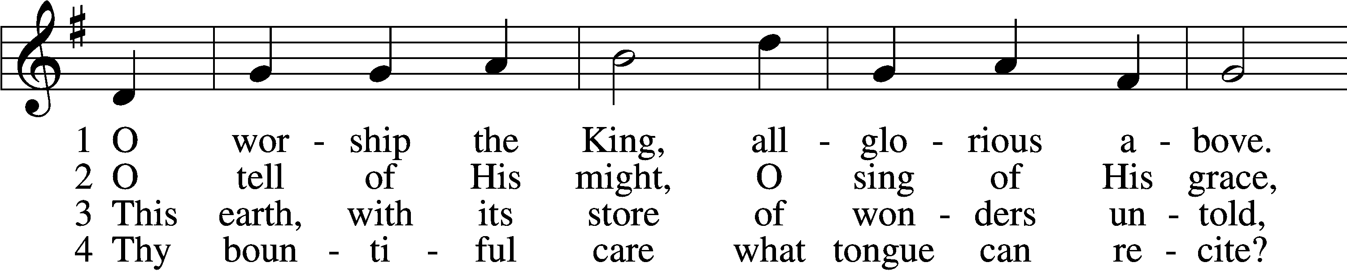
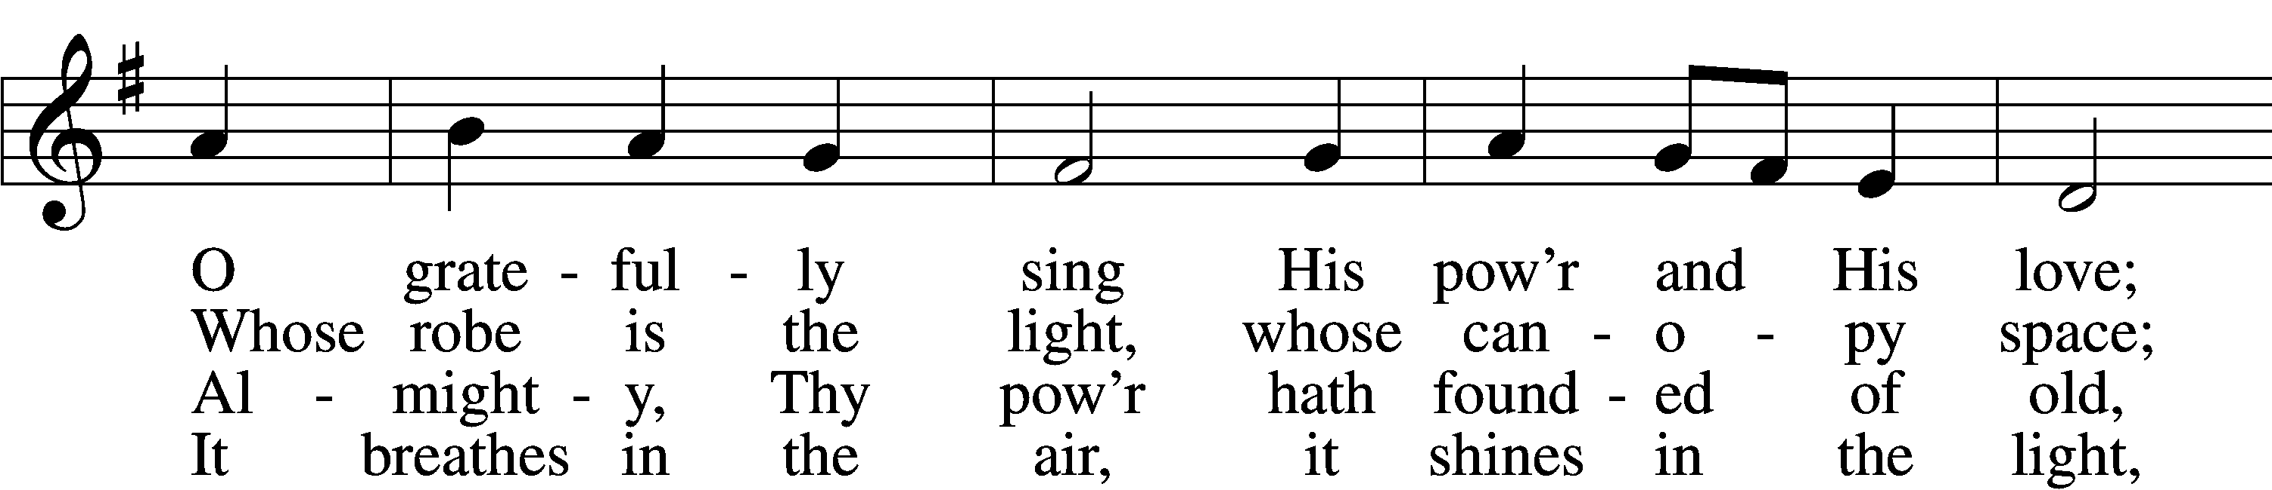
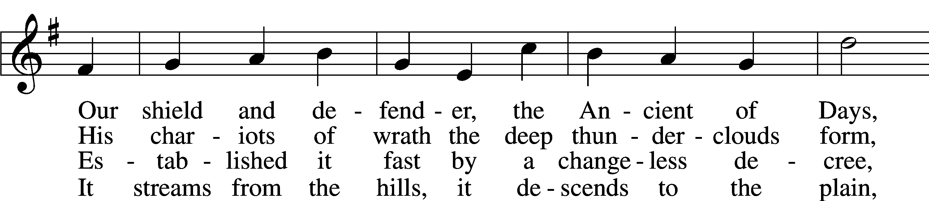
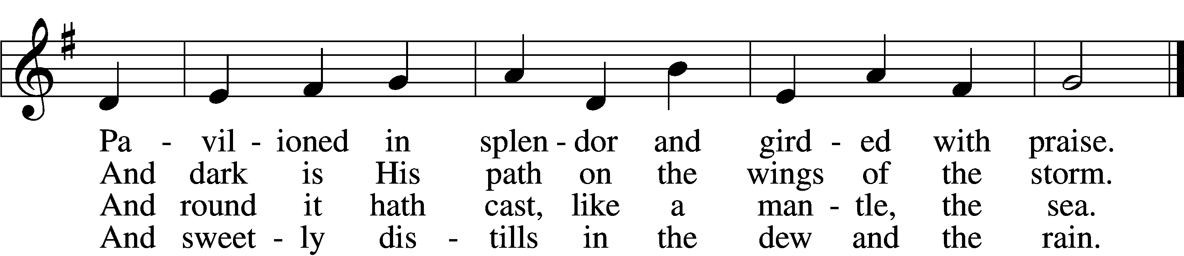
Text: Robert Grant, 1779–1838, alt. Tune: William Croft, 1678–1727 Text and tune: Public domain
Confession and Absolution
Stand
The sign of the cross may be made by all in remembrance of their Baptism.

P In the name of the Father and of the T Son and of the Holy Spirit.
C Amen.

P Our help is in the name of the Lord,
C who made heaven and earth.
P If You, O Lord, kept a record of sins, O Lord, who could stand?
C But with You there is forgiveness; therefore You are feared.

P Since we are gathered to hear God’s Word, call upon Him in prayer and praise, and receive the body and blood of our Lord Jesus Christ in the fellowship of this altar, let us first consider our unworthiness and confess before God and one another that we have sinned in thought, word, and deed, and that we cannot free ourselves from our sinful condition. Together as His people let us take refuge in the infinite mercy of God, our heavenly Father, seeking His grace for the sake of Christ, and saying: God, be merciful to me, a sinner.

Pause for reflection

C Almighty God, have mercy upon us, forgive us our sins, and lead us to everlasting life. Amen.

P Almighty God, in His mercy has given His Son to die for you and for His sake forgive you all you sins. As a called and ordained servant of Christ, and by His authority, I therefore forgive you all your sins in the name of the Father and of the T Son and of the Holy Spirit.
C Amen.

Service of the Word

Invitatory for Trinitytide
The Lord has sanctified us in the true faith,*
O come, let us worship Him *
I was glad when they said to me
“Let us go to the house of the Lord.” Psalm 72:18
Introit Psalm 117; antiphon: Psalm 96:6a; 115:18
Splendor and majesty are be- | fore him;*
we will bless the Lord from this time forth and forevermore. | Praise the Lord!
Praise the Lord, all | nations!*
Extol him, all | peoples!
For great is his steadfast | love toward us,*
and the faithfulness of the Lord endures forever. | Praise the Lord!
Glory be to the Father and | to the Son*
and to the Holy | Spirit;
as it was in the be- | ginning,*
is now, and will be forever. | Amen.
Splendor and majesty are be- | fore him;*
we will bless the Lord from this time forth and forevermore. | Praise the Lord!

Kyrie 204

P In Peace, let us pray to the Lord
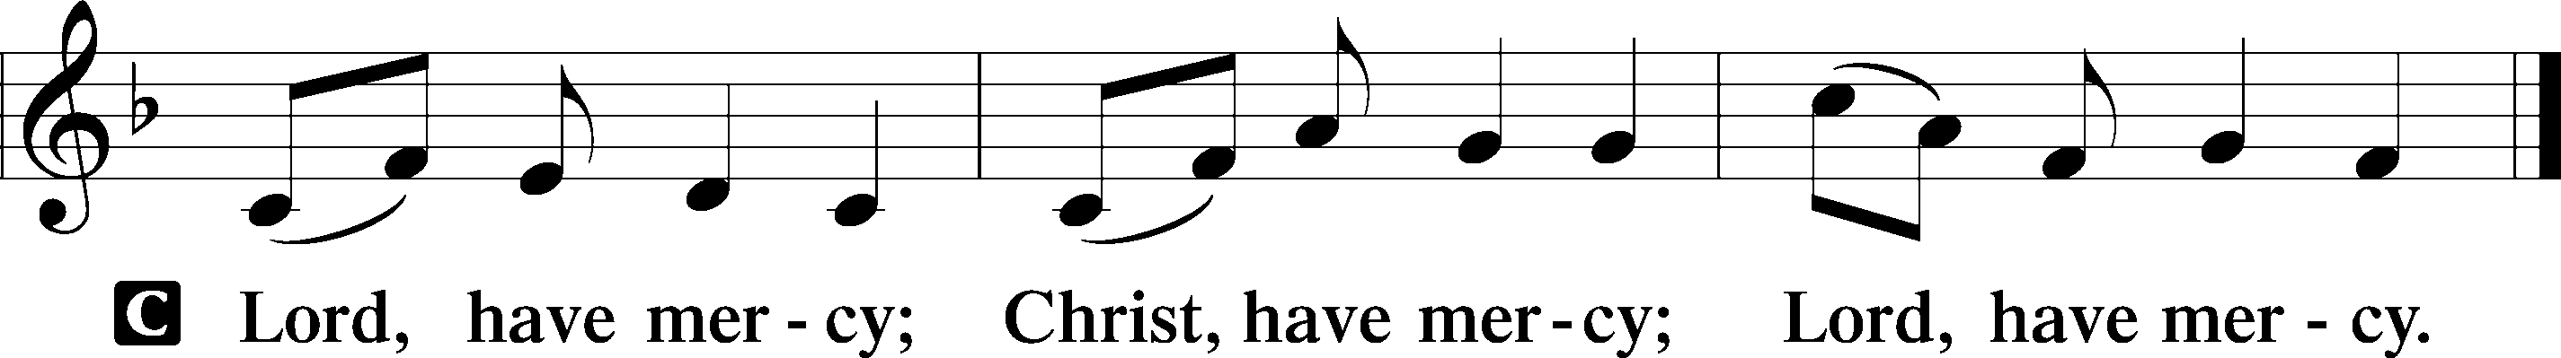

P For the peace of the whole world, for the wellbeing of the Church of God and for the unity of all; let us pray to the Lord.

P For this holy House, and all who offer here their worship and praise; let us pray to the Lord.

Gloria in Excelsis LSB 204
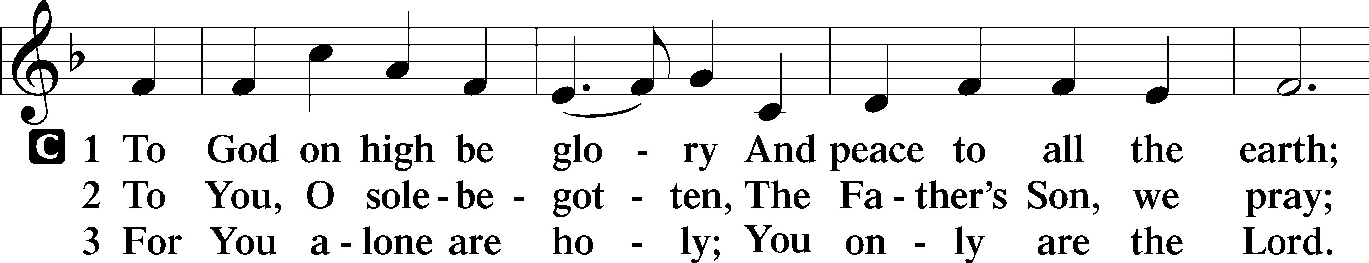
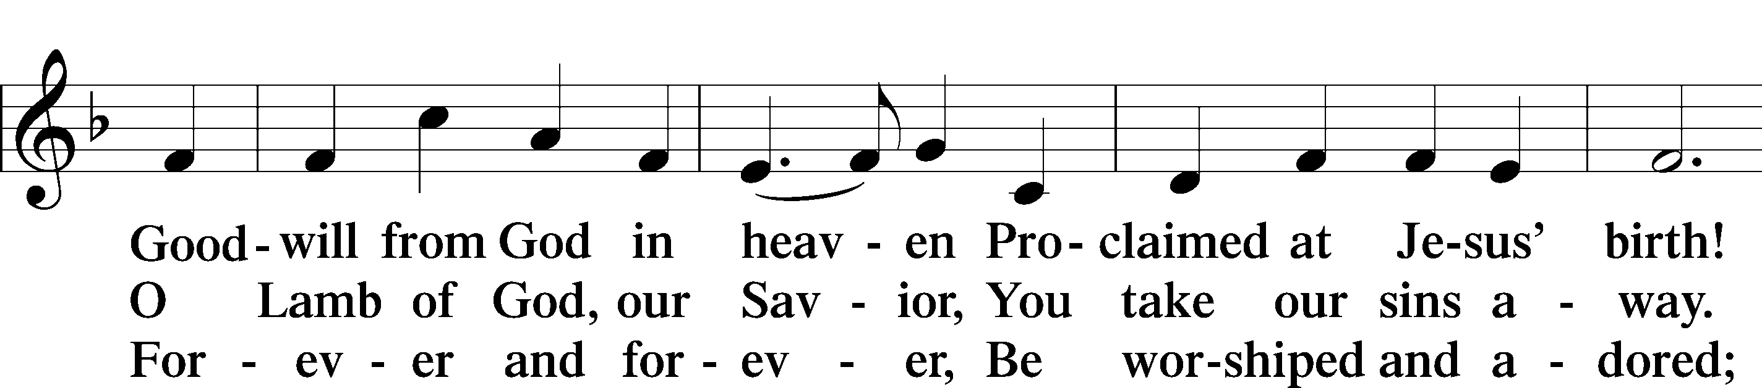
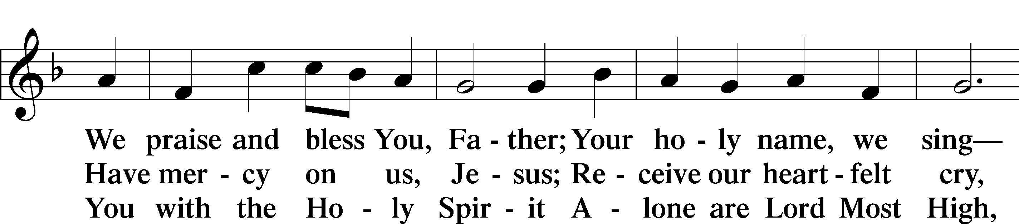
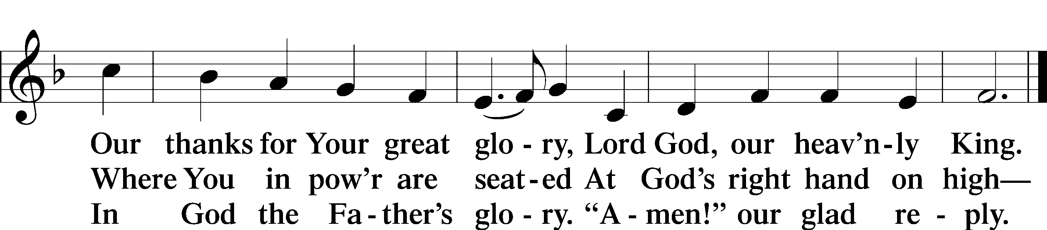
Text: Stephen P. Starke

Salutation and Collect of the Day
P The Lord be with you.
C And also with you.

P Let us pray.
O Lord, You have called us to enter Your kingdom through the narrow door. Guide us by Your Word and Spirit, and lead us now and always into the feast of Your Son, Jesus Christ, who lives and reigns with You and the Holy Spirit, one God, now and forever.

C Amen.
Sit

Old Testament Reading Isaiah 66:18–23

A The Old Testament from the 66th book of Isaiah.

18“For I know their works and their thoughts, and the time is coming to gather all nations and tongues. And they shall come and shall see my glory, 19and I will set a sign among them. And from them I will send survivors to the nations, to Tarshish, Pul, and Lud, who draw the bow, to Tubal and Javan, to the coastlands afar off, that have not heard my fame or seen my glory. And they shall declare my glory among the nations. 20And they shall bring all your brothers from all the nations as an offering to the Lord, on horses and in chariots and in litters and on mules and on dromedaries, to my holy mountain Jerusalem, says the Lord, just as the Israelites bring their grain offering in a clean vessel to the house of the Lord. 21And some of them also I will take for priests and for Levites, says the Lord.
22“For as the new heavens and the new earth
that I make shall remain before me, says the Lord,
so shall your offspring and your name remain.
23From new moon to new moon, and from Sabbath to Sabbath,
all flesh shall come to worship before me, declares the Lord.”

A This is the Word of the Lord.
C Thanks be to God.

Psalm Psalm 50:1–15; antiphon: v. 23
1The Mighty One, God the Lord,
speaks and sum- | mons the earth*
from the rising of the sun to its | setting.
2Out of Zion, the perfection of | beauty,*
God | shines forth.
3Our God comes; he does not keep | silence;*
before him is a devouring fire,
around him a mighty | tempest.
4He calls to the heav- | ens above*
and to the earth, that he may judge his | people:
5“Gather to me my | faithful ones,*
who made a covenant with me by | sacrifice!”
6The heavens declare his | righteousness,*
for God him- | self is judge!
7“Hear, O my people, and I will speak;
O Israel, I will testify a- | gainst you.*
I am | God, your God.
8Not for your sacrifices do I re- | buke you;*
your burnt offerings are continually be- | fore me.
9I will not accept a bull | from your house*
or goats | from your folds.
10For every beast of the for- | est is mine,*
the cattle on a | thousand hills.
11I know all the birds | of the hills,*
and all that moves in the | field is mine.
12“If I were hungry, I would not | tell you,*
for the world and its full- | ness are mine.
13Do I eat the | flesh of bulls*
or drink the | blood of goats?
14Offer to God a sacrifice of thanks- | giving,*
and perform your vows to the | Most High,
15and call upon me in the day of | trouble;*
I will deliver you, and you shall glo- | rify me.”

Epistle Hebrews 12:4–24

A The Epistle read from the 12th book of Hebrews.

4In your struggle against sin you have not yet resisted to the point of shedding your blood. 5And have you forgotten the exhortation that addresses you as sons?
“My son, do not regard lightly the discipline of the Lord,
nor be weary when reproved by him.
6For the Lord disciplines the one he loves,
and chastises every son whom he receives.”
7It is for discipline that you have to endure. God is treating you as sons. For what son is there whom his father does not discipline? 8If you are left without discipline, in which all have participated, then you are illegitimate children and not sons. 9Besides this, we have had earthly fathers who disciplined us and we respected them. Shall we not much more be subject to the Father of spirits and live? 10For they disciplined us for a short time as it seemed best to them, but he disciplines us for our good, that we may share his holiness. 11For the moment all discipline seems painful rather than pleasant, but later it yields the peaceful fruit of righteousness to those who have been trained by it.
12Therefore lift your drooping hands and strengthen your weak knees, 13and make straight paths for your feet, so that what is lame may not be put out of joint but rather be healed. 14Strive for peace with everyone, and for the holiness without which no one will see the Lord. 15See to it that no one fails to obtain the grace of God; that no “root of bitterness” springs up and causes trouble, and by it many become defiled; 16that no one is sexually immoral or unholy like Esau, who sold his birthright for a single meal. 17For you know that afterward, when he desired to inherit the blessing, he was rejected, for he found no chance to repent, though he sought it with tears.
18For you have not come to what may be touched, a blazing fire and darkness and gloom and a tempest 19and the sound of a trumpet and a voice whose words made the hearers beg that no further messages be spoken to them. 20For they could not endure the order that was given, “If even a beast touches the mountain, it shall be stoned.” 21Indeed, so terrifying was the sight that Moses said, “I tremble with fear.” 22But you have come to Mount Zion and to the city of the living God, the heavenly Jerusalem, and to innumerable angels in festal gathering, 23and to the assembly of the firstborn who are enrolled in heaven, and to God, the judge of all, and to the spirits of the righteous made perfect, 24and to Jesus, the mediator of a new covenant, and to the sprinkled blood that speaks a better word than the blood of Abel.

A This is the Word of the Lord.
C Thanks be to God.

Stand

Alleluia and Verse

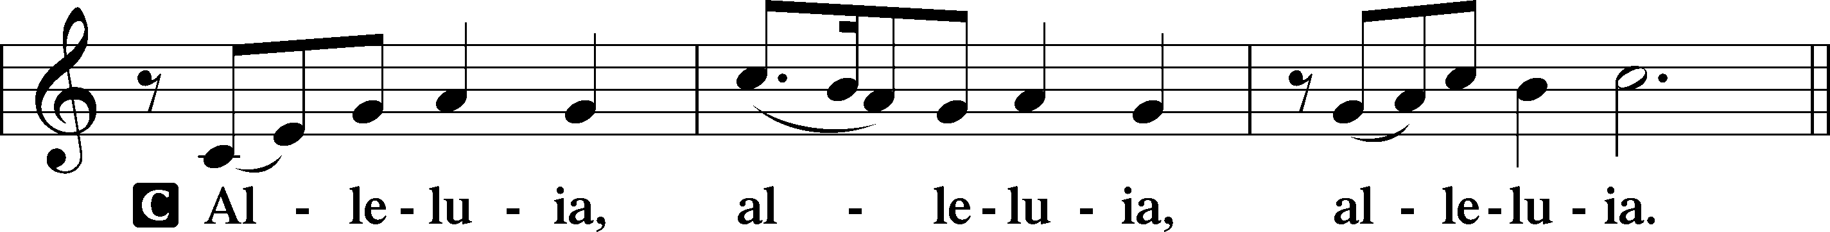
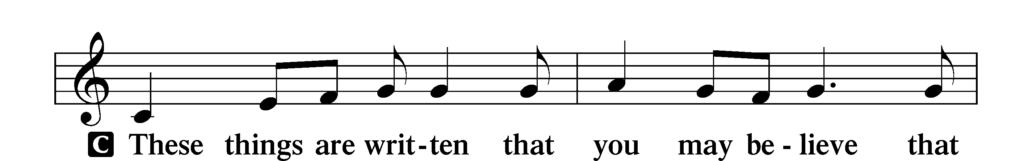
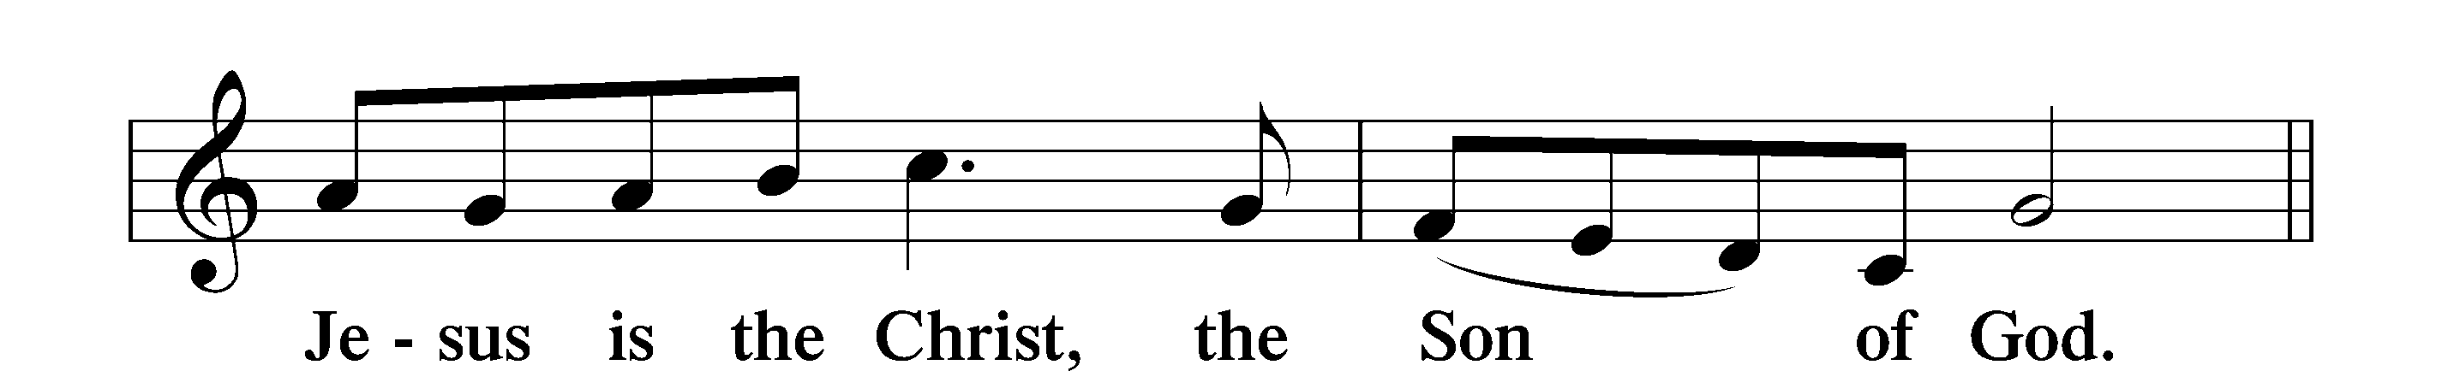
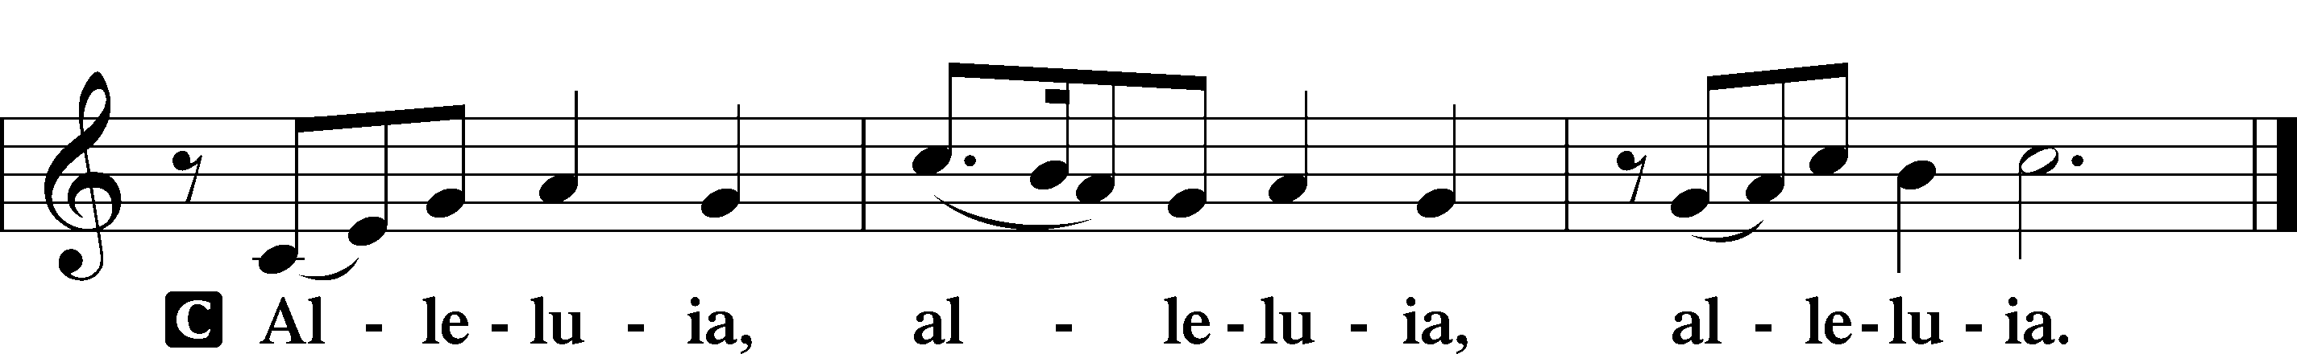

Holy Gospel Luke 13:22–30
P The Holy Gospel according to St. Luke, the thirteenth chapter.
C Glory to You, O Lord.

22[Jesus] went on his way through towns and villages, teaching and journeying toward Jerusalem. 23And someone said to him, “Lord, will those who are saved be few?” And he said to them, 24“Strive to enter through the narrow door. For many, I tell you, will seek to enter and will not be able. 25When once the master of the house has risen and shut the door, and you begin to stand outside and to knock at the door, saying, ‘Lord, open to us,’ then he will answer you, ‘I do not know where you come from.’ 26Then you will begin to say, ‘We ate and drank in your presence, and you taught in our streets.’ 27But he will say, ‘I tell you, I do not know where you come from. Depart from me, all you workers of evil!’ 28In that place there will be weeping and gnashing of teeth, when you see Abraham and Isaac and Jacob and all the prophets in the kingdom of God but you yourselves cast out. 29And people will come from east and west, and from north and south, and recline at table in the kingdom of God. 30And behold, some are last who will be first, and some are first who will be last.”

P This is the Gospel of the Lord.
C Praise to You, O Christ.

550 Lamb of God
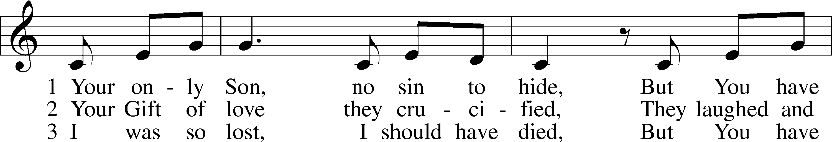
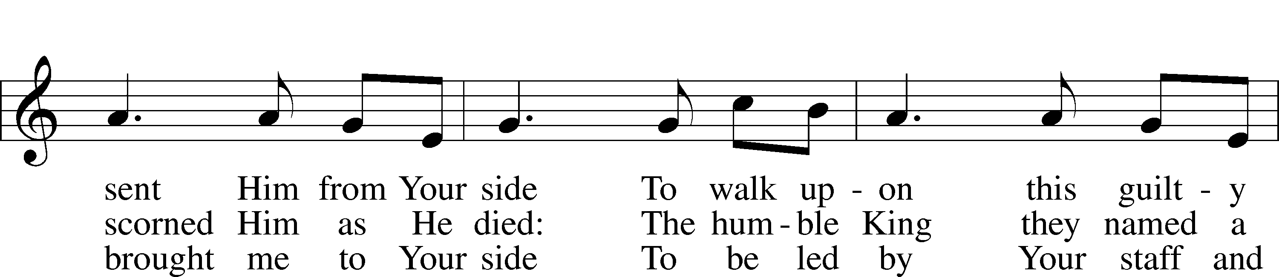
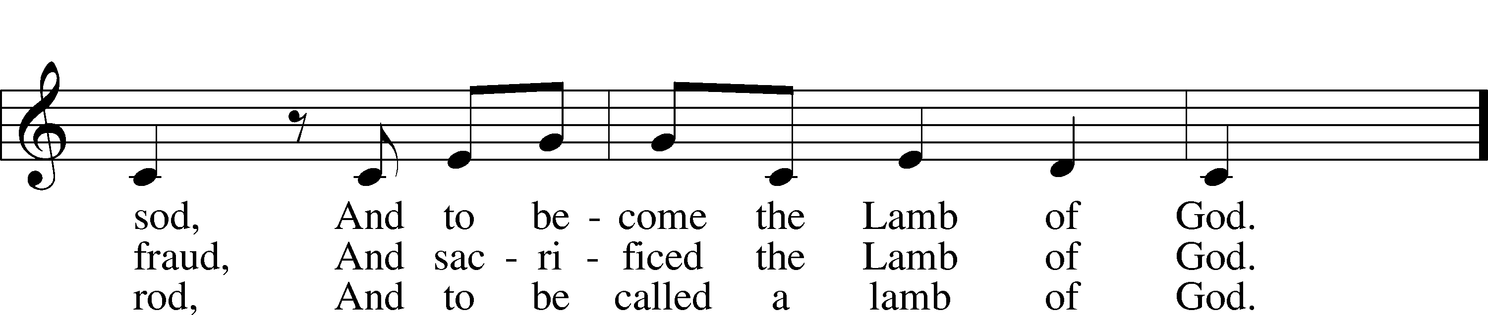
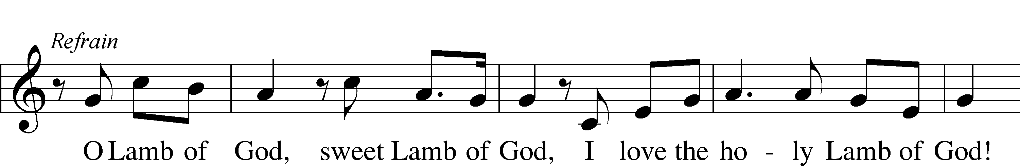
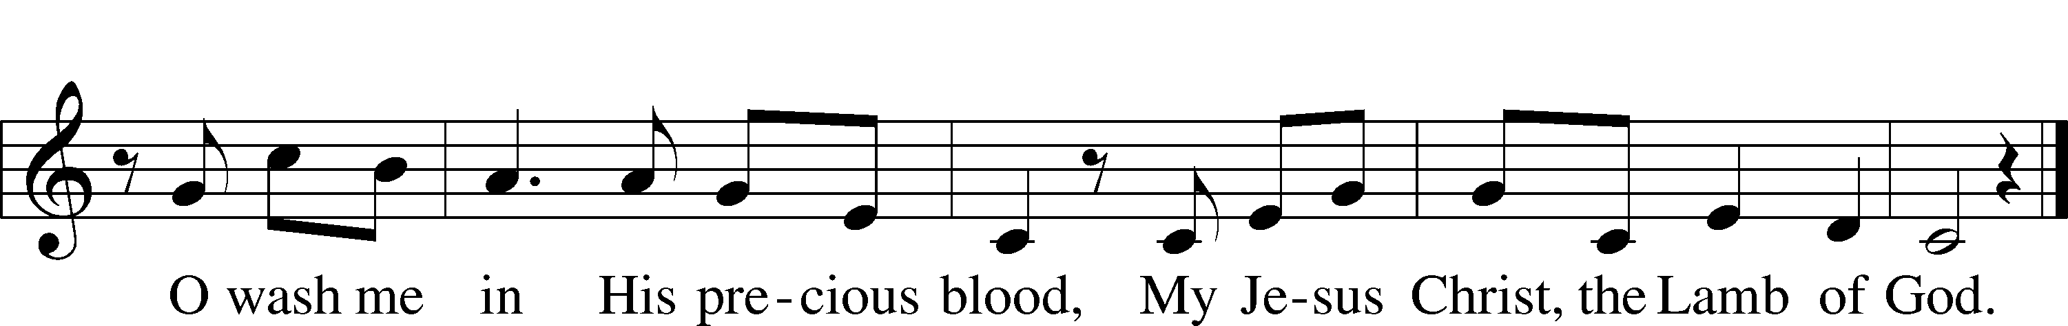
Text and tune: Twila Paris, 1958 Text and tune: © 1985 Straightway Music, admin. EMI. Used by permission: LSB Hymn License no. 110003995

Sermon

Nicene Creed
C I believe in one God, the Father Almighty,
maker of heaven and earth and of all things visible and invisible.

And in one Lord Jesus Christ, the only-begotten Son of God,
begotten of His Father before all worlds, God of God,
Light of Light, very God of very God,
begotten, not made, being of one substance with the Father,
by whom all things were made;
who for us men and for our salvation came down from heaven
and was incarnate by the Holy Spirit of the virgin Mary
and was made man;
and was crucified also for us under Pontius Pilate.
He suffered and was buried.
And the third day He rose again according to the Scriptures
and ascended into heaven and sits at the right hand of the Father.
And He will come again with glory to judge both the living and
the dead, whose kingdom will have no end.

And I believe in the Holy Spirit, the Lord and giver of life,
who proceeds from the Father and the Son,
who with the Father and the Son together is worshiped
and glorified, who spoke by the prophets.

And I believe in one holy Christian and apostolic Church,
I acknowledge one Baptism for the remission of sins,
and I look for the resurrection of the dead
and the life T of the world to come. Amen.
Stand

Prayer of the Church

Following the prayers, the people may greet one another in the name of the Lord, saying,
“Peace be with you,” as a sign of reconciliation and of the unity of the Spirit in the bond of peace
(Matt. 5:22–24; Eph. 4:1–3).

Offering & Sharing of the Peace

Offertory - Praise God, from Whom All Blessings Flow
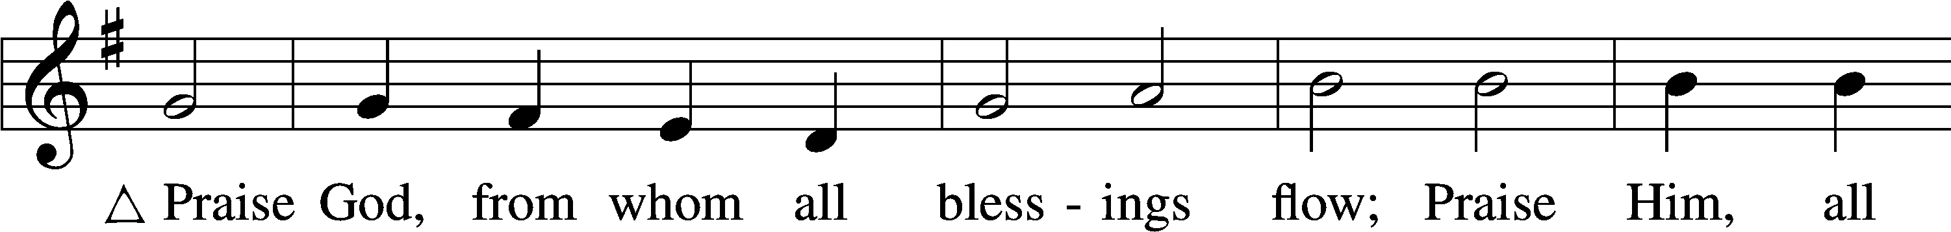
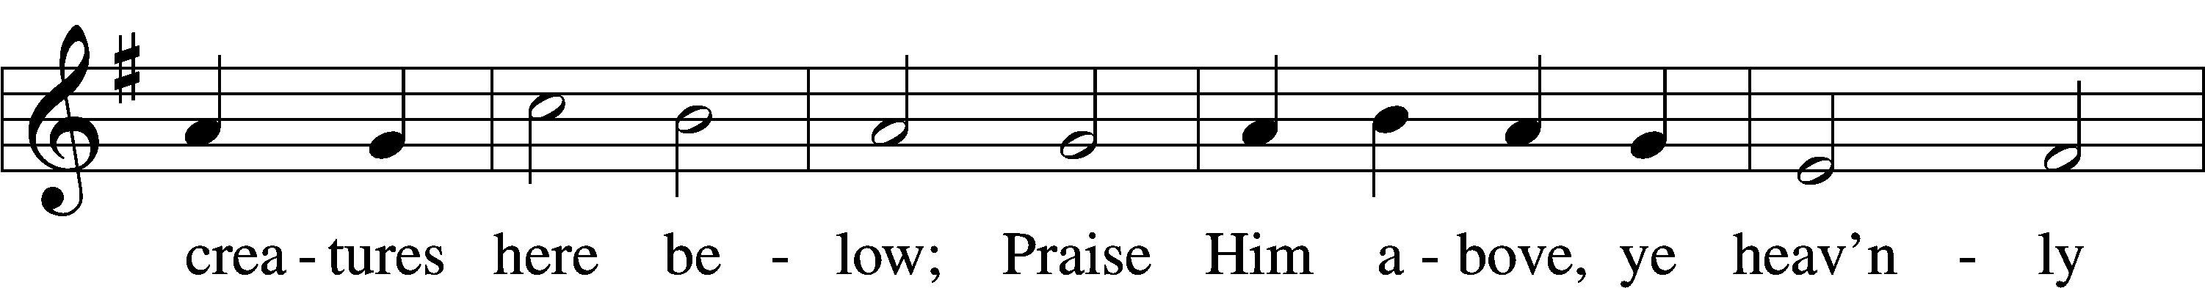
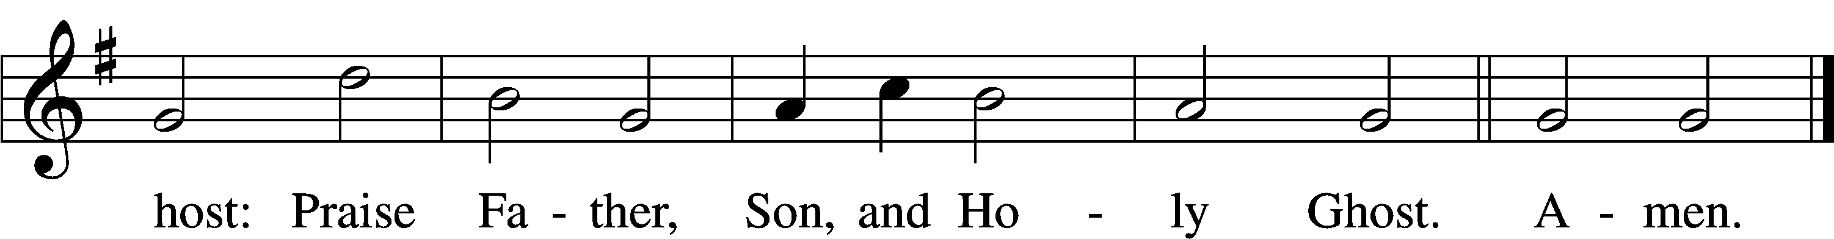
Text: Thomas Ken, 1637–1711
Tune: Trente quatre Pseaumes de David, 1551, Geneva, ed. Louis Bourgeois
Text and tune: Public domain
Service of Holy Communion
Communion Statement

The Lord’s Supper is celebrated at this congregation in the confession and glad confidence that, as He says, our Lord gives into our mouths not only bread and wine but His very body and blood to eat and to drink for the forgiveness of sins and to strengthen our union with Him and with one another. Our Lord invites to His table those who trust His words, repent of all sin, and set aside any refusal to forgive and love as He forgives and loves us, that they may show forth His death until He comes.

Because those who eat and drink our Lord’s body and blood unworthily do so to their great harm and because Holy Communion is a confession of the faith which is confessed at this altar, any who are not yet instructed, in doubt, or who hold a confession differing from that of this congregation and the Lutheran Church Missouri Synod, and yet desire to receive this sacrament, are asked to speak with the Pastor.
* See more about the Lutheran teaching on communion in the Hymnal p 329.

Stand

Preface LSB 208
P The Lord be with you.
C And also with you.

P Lift up your hearts.
C We lift them to the Lord.

P Let us give thanks to the Lord our God.
C It is right to give Him thanks and praise.
P It is truly good, right, and salutary that we should at all times and in all places give thanks to You, O Lord, holy Father, almighty and everlasting God, for the countless blessings You so freely bestow on us and all creation. Above all, we give thanks for Your boundless love shown to us when You sent Your only-begotten Son, Jesus Christ, into our flesh and laid on Him our sin, giving Him into death that we might not die eternally. Because He is now risen from the dead and lives and reigns to all eternity, all who believe in Him will overcome sin and death and will rise again to new life. Therefore with angels and archangels and with all the company of heaven we laud and magnify Your glorious name, evermore praising You and saying:

Sanctus LSB 208
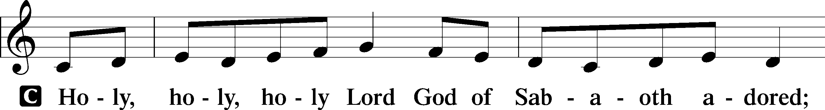
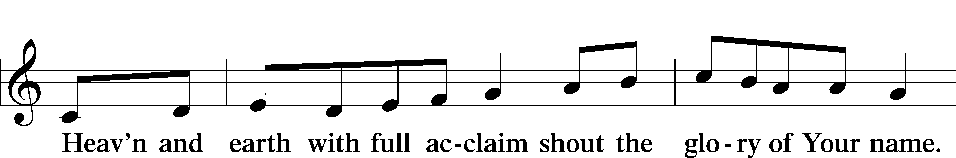
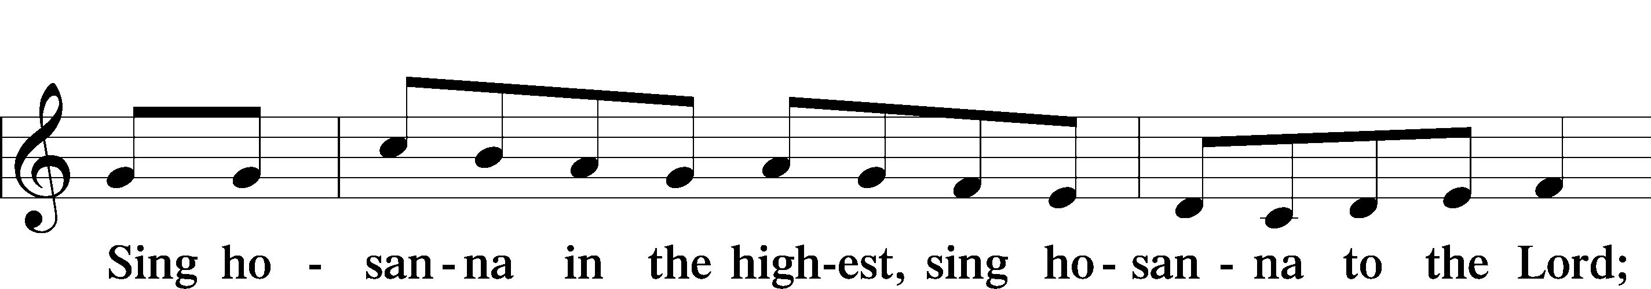
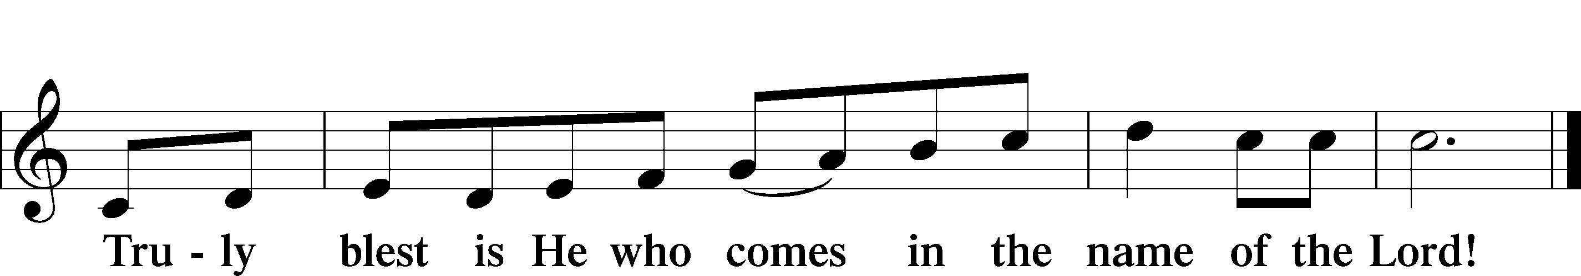
Text: Stephen P. Starke

Prayer of Thanksgiving
P Blessed are You, O Lord our God, king of all creation, for You have had mercy on us and given Your only-begotten Son that whoever believes in Him should not perish but have eternal life.

In these last days, You have poured out Your Holy Spirit on Your Church that Your sons and daughters might proclaim the wonders of Your salvation in Christ Jesus our Lord. Pour out Your Holy Spirit upon Your gathered people that, faithfully eating and drinking the body and blood of Your Son, we may go forth to proclaim His salvation to the ends of the earth.

Hear us as we pray in His name and as He has taught us:

Lord’s Prayer
C Our Father who art in heaven, hallowed be Thy name,
Thy kingdom come, Thy will be done on earth as it is in heaven;
give us this day our daily bread;
and forgive us our trespasses as we forgive those
who trespass against us;
and lead us not into temptation, but deliver us from evil.
For Thine is the kingdom and the power and the glory
forever and ever. Amen.

The Words of Our Lord
P Our Lord Jesus Christ, on the night when He was betrayed, took bread, and when He had given thanks, He broke it and gave it to the disciples and said: “Take, eat; this is My T body, which is given for you. This do in remembrance of Me.”

In the same way also He took the cup after supper, and when He had given thanks, He gave it to them, saying: “Drink of it, all of you; this cup is the new testament in My T blood, which is shed for you for the forgiveness of sins. This do, as often as you drink it, in remembrance of Me.”

Pax Domini
P The peace of the Lord be with you always.
C Amen.

Agnus Dei LSB 210
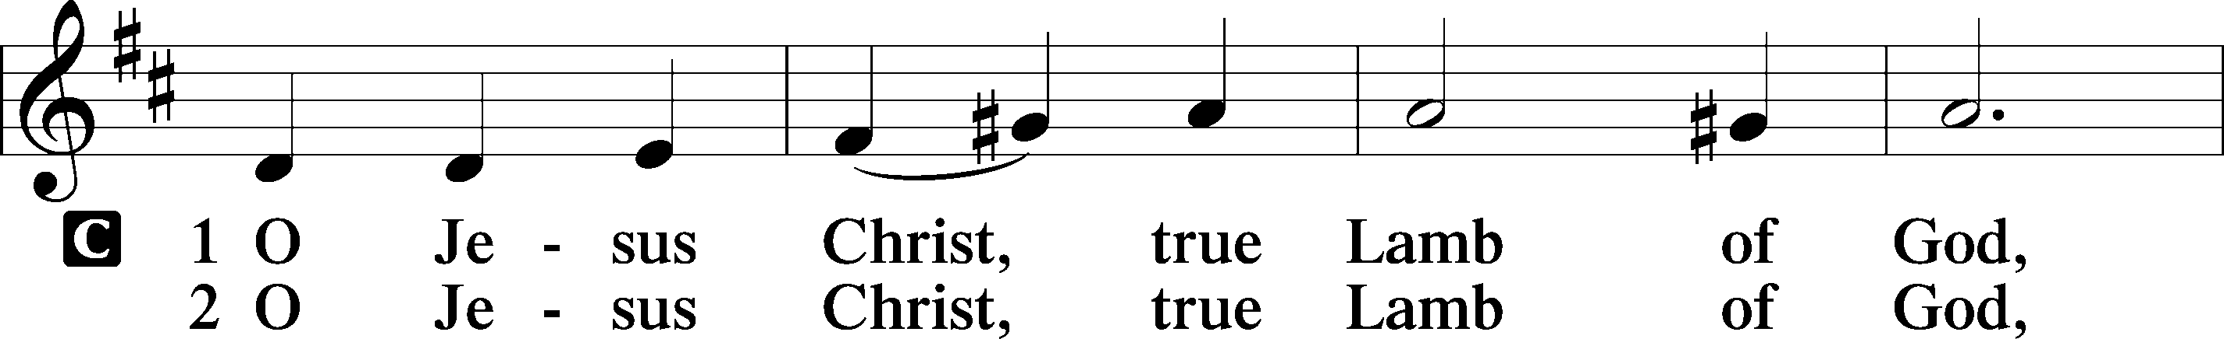
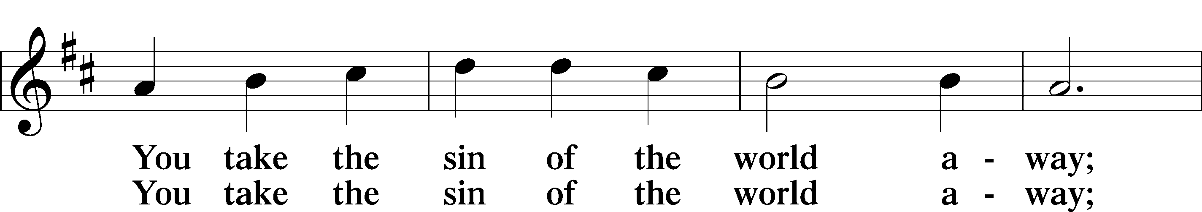
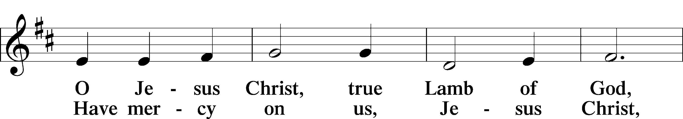
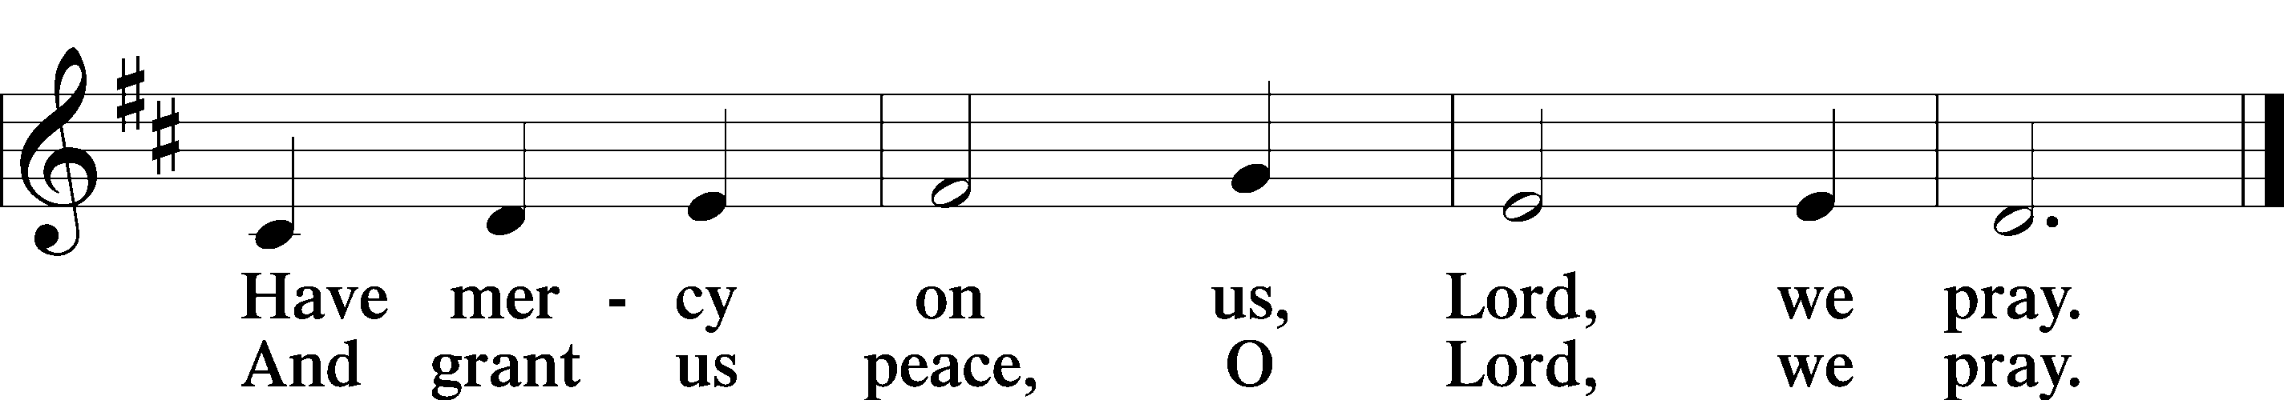
Text: Stephen P. Starke

Sit

Communion


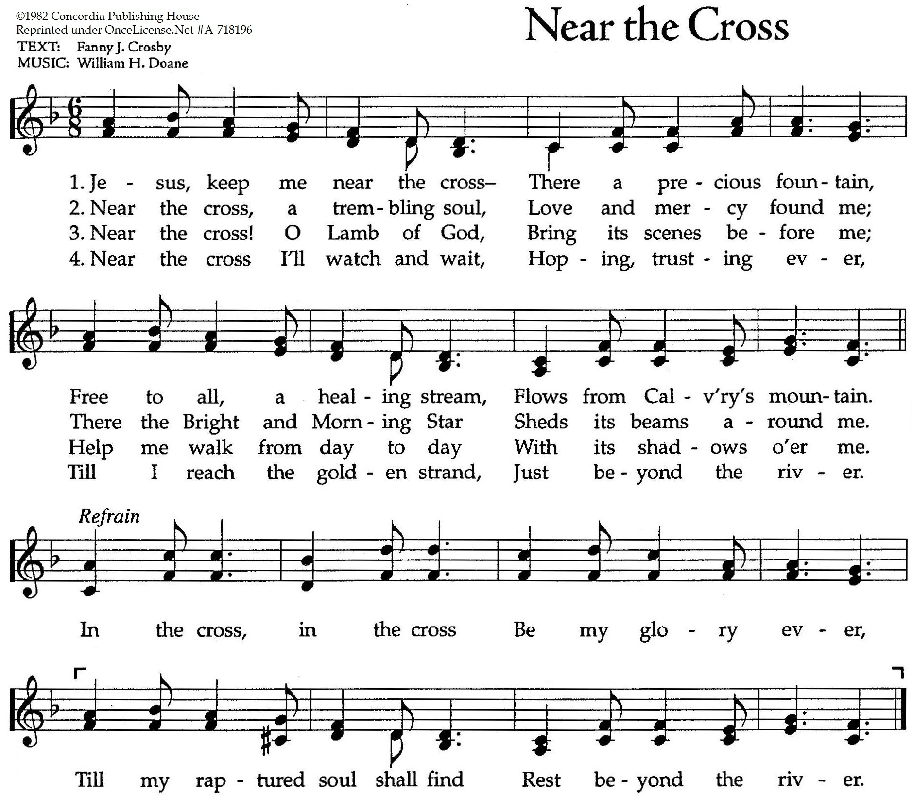

Stand

Nunc Dimittis LSB 211
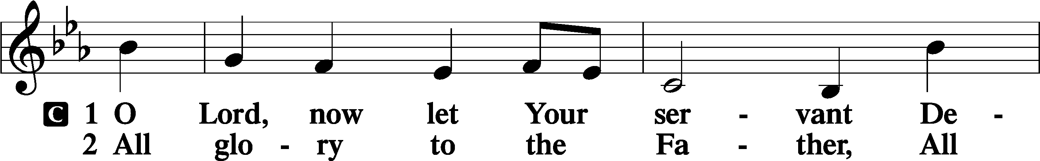
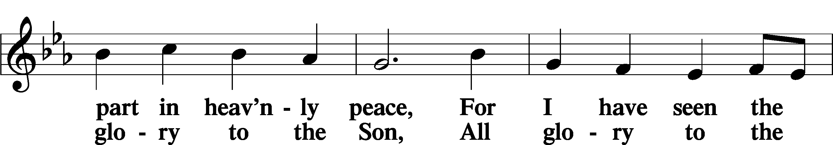
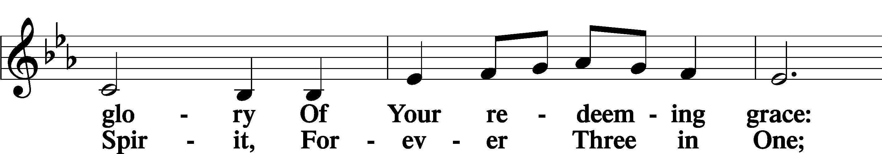
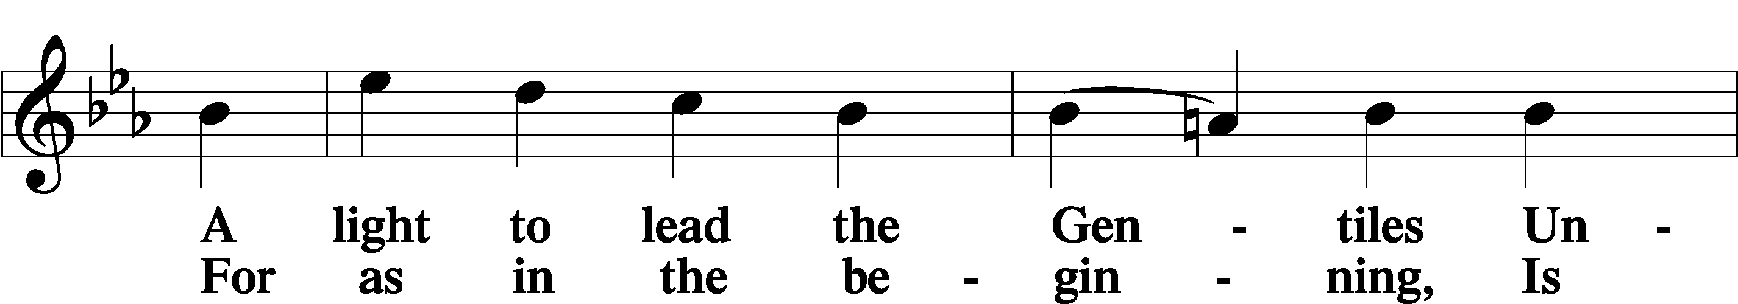
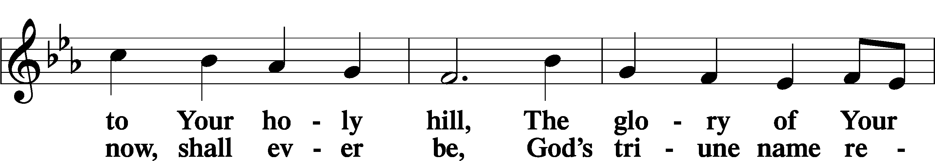
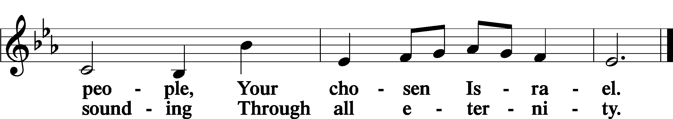

Post-Communion Collect
A Let us pray.
We give thanks to You, almighty God, that You have refreshed us through this salutary gift, and we implore You that of Your mercy You would strengthen us through the same in faith toward You and in fervent love toward one another; through Jesus Christ, Your Son, our Lord, who lives and reigns with You and the Holy Spirit, one God, now and forever.
C Amen.

Verse of the Day Luke 13:29

A Alleluia. People will come from east and west, and from north and south,
C and recline at table in the kingdom of God. Alleluia.

Benedicamus LSB 212
A Let us bless the Lord.
C Thanks be to God.

Benediction
P The Lord bless you and keep you.
The Lord make His face shine on you and be gracious to you.
The Lord look upon you with favor and T give you peace.
C Amen.

735 Have No Fear, Little Flock
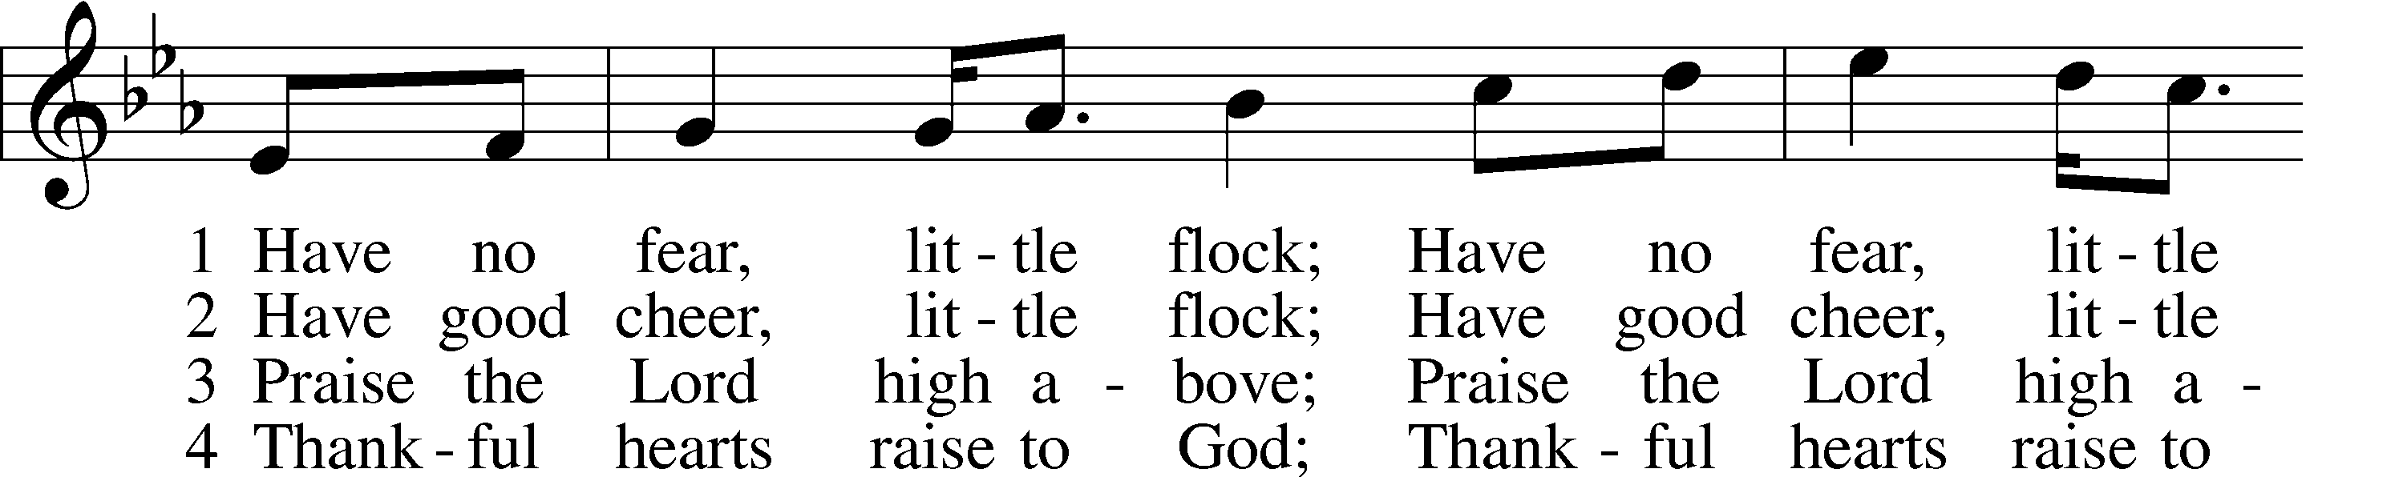
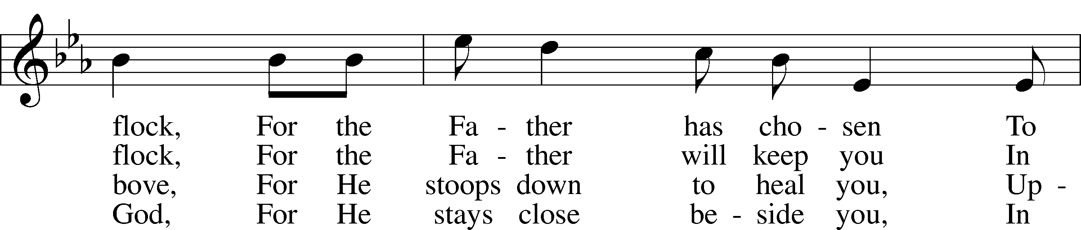
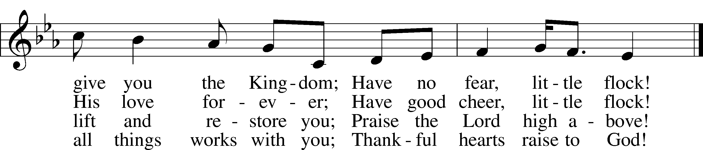
Text (sts. 2–4): Marjorie A. Jillson, 1931–2010 Text (st. 1) and tune: Heinz Werner Zimmermann, 1930–2022
Text and tune: © 1973 Concordia Publishing House. Used by permission: LSB Hymn License no. 110003995

Acknowledgments
Divine Service, Setting Four from Lutheran Service Book Unless otherwise indicated, Scripture quotations are from
the ESV® Bible (The Holy Bible, English Standard Version®), copyright © 2001 by Crossway, a publishing ministry
of Good News Publishers. Used by permission. All rights reserved. Created by Lutheran Service Builder © 2025 Concordia Publishing House.
Prayers of the Church
This week, we lift up:

Angela H (surgery on 13th), Sheila, Elaine, Bob, Angie Z, Angela C,
Ross, & Kathy H.

Family of the week: Jim C

*If you have any prayer request let us know.

Last week: Attendance 17 Offering $540

Serving Next Week (8/31/25)  Service Leader: Vicar Previn Hudetz  Communion Celebrant  Worship Assistant: Charlie M  Reader: Sheila S  Refreshments: Sheila  Altar Guild: Angie Z & Sheila S  Greeter: Juanita | Readings Next Week  Twelfth Sunday after Pentecost  Proverbs 25:2-10  Psalm 131  Hebrews 13:1-17  Luke 14:1-14  *Please sign up to help during service.*
Announcements  Birthdays:  This Week at OSLC:  Bible Study: After Service  Bible Study: Thursday 10am | Coming Up:  Congregational Meeting to confirm & elect Council Members.  September 28, 2025  Following service

Seasons of the Church Year

The non-celebratory half of the Church year is called the “Time of The Church”, or traditionally the “Time of Trinity” (Trinitytide). These weeks are marked by counting the Sundays after Pentecost. This is the longest season of the church year. The color of the season is green, to represent growth and the power of the Lord working in mission.



Note from National Director of Right to Life

On Tuesday, August 26, the Right to Life Committee of New Mexico is hosting a gala at the Marriott Pyramid North, 5151 San Francisco Rd NE. The guest speaker will be Monica Kelsey, founder of the Safe Haven Baby Box project.

Some donors have provided free tickets so I was wondering if you, or some members of your congregation, would like to come. The event is billed as a fundraiser but checkbooks are optional. :)

Doors open at 5:45 PM, dinner is at 6:15 PM, and we should be out by 8:30. I'd love to have you, or members of PoP join us. If you'd like, you can give them my email and phone number, and have them contact me. I'll happy to register them.

Let me know if you have any questions!
Carol
505-321-6729
Carol Tobias <dctobias1998@yahoo.com

New Pastors for Central New Mexico –
God be praised for two new pastors in central New Mexico, covering four pulpits. Rev. Rakotonirina, a recent seminary graduate, originally from Madagascar, was installed at Immanuel, Las Vegas, in July.

Rev. Ben Davis was installed at Snagre de Cristo, Taos in August.
Rev. Davis, a local ranch manager who completed his pastor’s training through the Concordia remote program, will cover three pulpits in Taos, Angel Fire, and Springer.

Please keep these congregations and these new pastors in your prayers as they work to share God’s Word and Sacraments to His people in these rural areas.

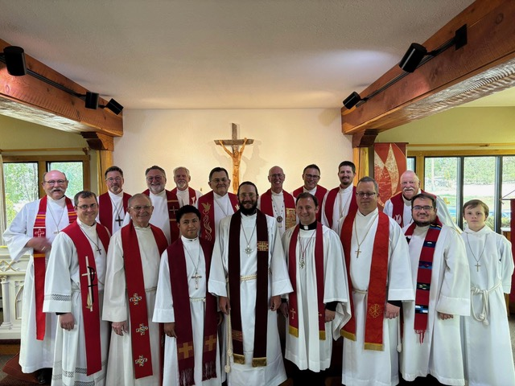

July 26th, 2025 - Immanuel, Las Vegas NM - Rev. Solomona Rakotonirina

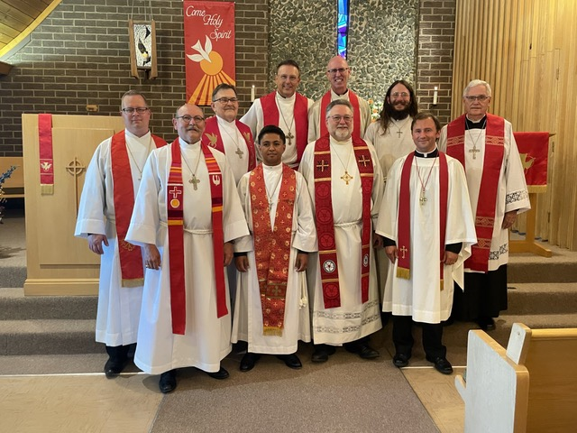

August 9th, 2025 - Sangre de Cristo, Taos - Rev. Ben Davis

