

If you had faith like a grain of mustard seed, you could say to this mulberry tree, ‘Be uprooted and planted in the sea,’ and it would obey.

Luke 17:6

Our Savior Lutheran Church (LCMS)
4301 Atrisco Drive NW
Albuquerque, New Mexico
Website: OSLCNM.COM
Phone: 505.836.7007
Email: oslcabq@gmail.com

Seventeenth Sunday after Pentecost
October 5th,2025

The Time of the Church (Trinitytide)
Seventeenth Sunday after Pentecost
October 5th, 2025

Welcome to Our Savior Lutheran Church (LCMS).  We are glad you are here as we worship, praise, and give thanks to our loving Lord, Jesus Christ. Please join us immediately after service for fellowship and snacks. Adult Bible Study starts at 10:30. If you have any questions about our service or need other assistance, please contact one of our worship assistants. | Hymns  Opening # 576 & 850  Sermon # 685  Distribution # He Lives  Closing # 857

Today’s Message

Faith does not preclude Christians from adversity and persecution. Faith arms believers with Christlike tenacity, equipping us to persevere in prayer and joy, continually confessing Jesus as the source of life and immortality. Temptations will come; believing saints will sin; yet repentant sinners will be forgiven. Satan will surely seek to undermine our faith, yet Christ Jesus in unrelenting mercy and forgiveness will guard us until the day of salvation.

+++
Serving Today
Service Leader: Vicar Previn Hudetz
Communion Celebrant: Rev John Heffelfinger
Communion Assistant: Jim C
Worship Assistant: Charlie Mike
Reader: Jim C
Refreshments: Pot Luck
Altar Guild: Angie Z & Sheila S
Greeter: Juanita

Welcome
Divine Service IV

576 My Hope Is Built on Nothing Less
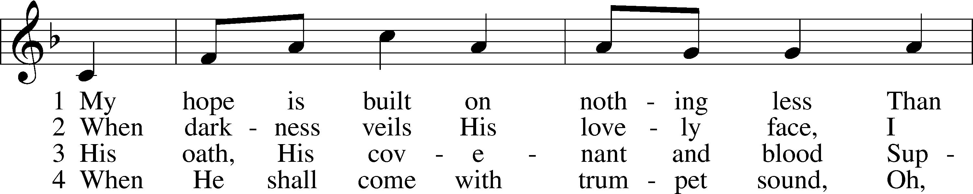
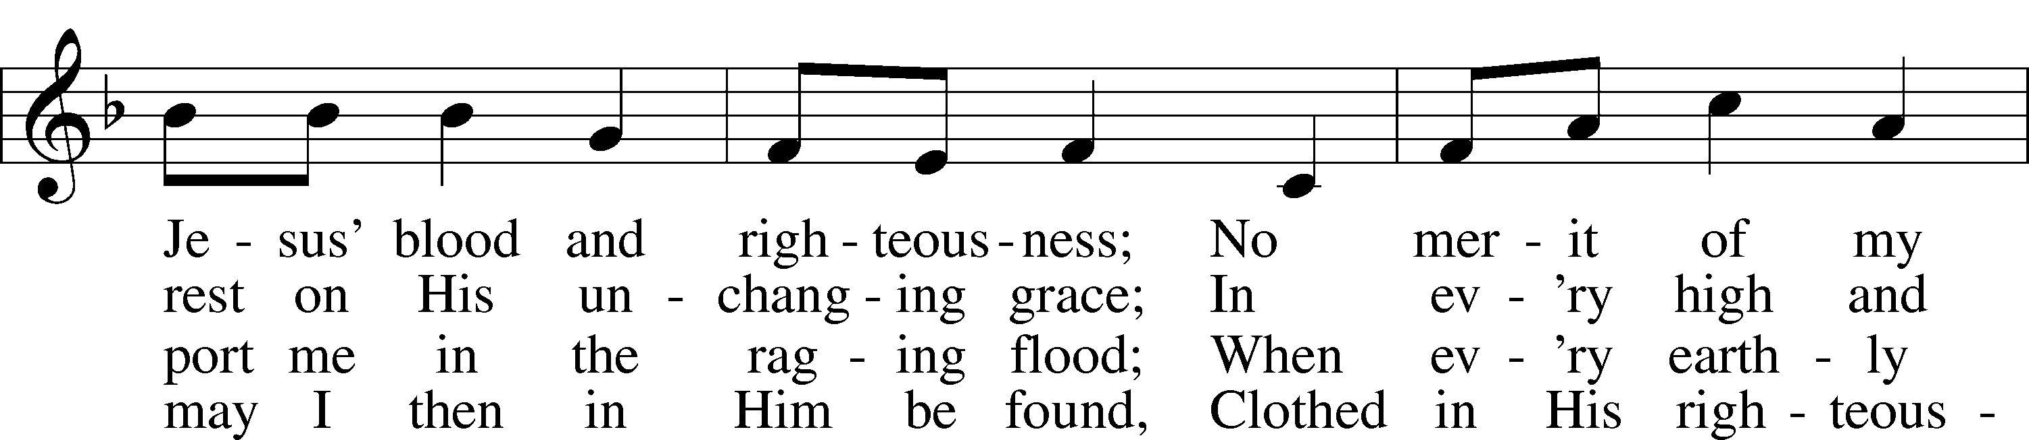
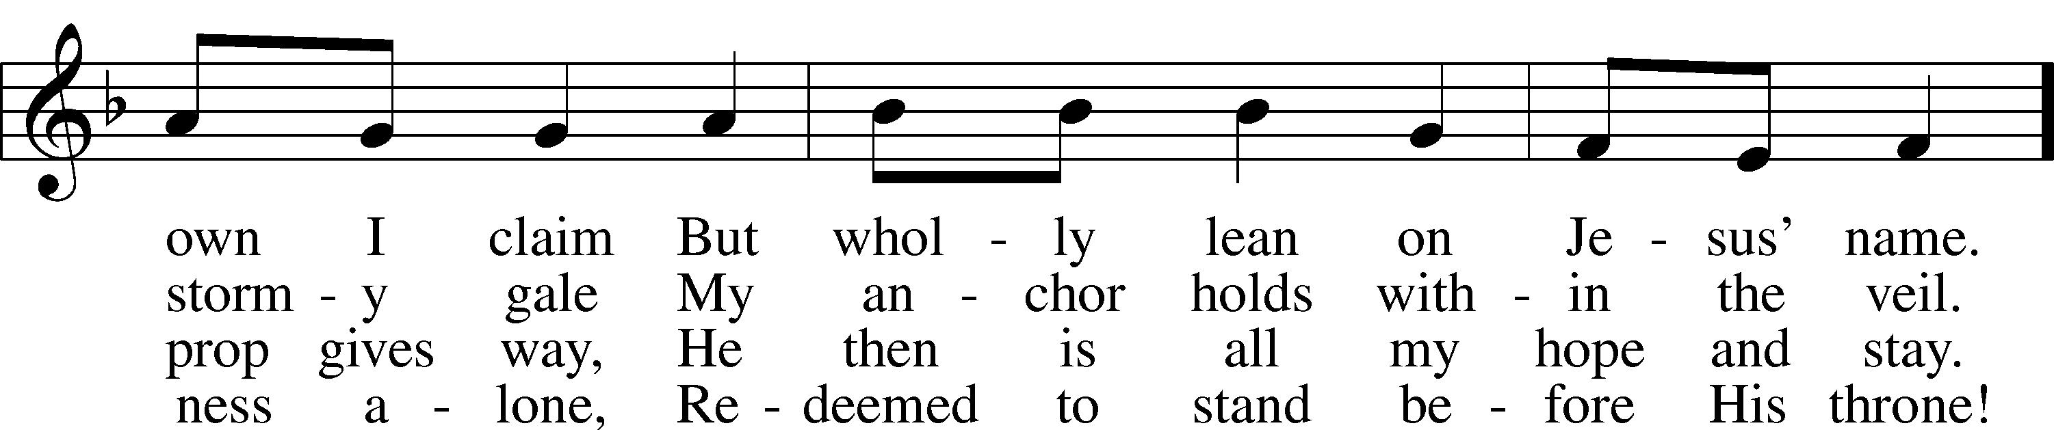
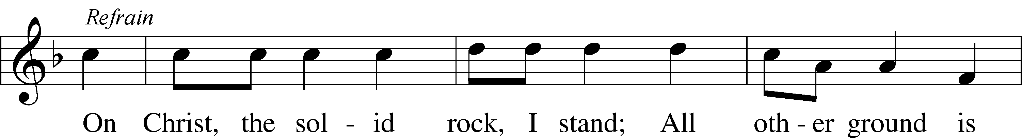
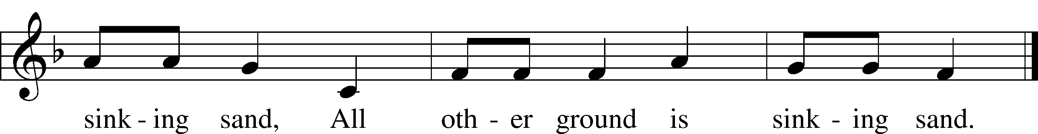
Text: Edward Mote, 1797–1874, alt.
Tune: William B. Bradbury, 1816–68
Text and tune: Public domain


850 God of Grace and God of Glory
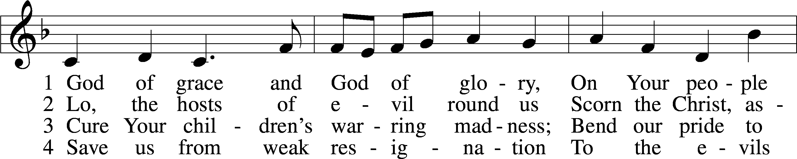
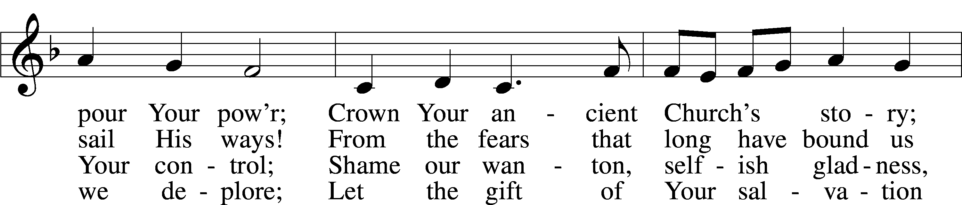
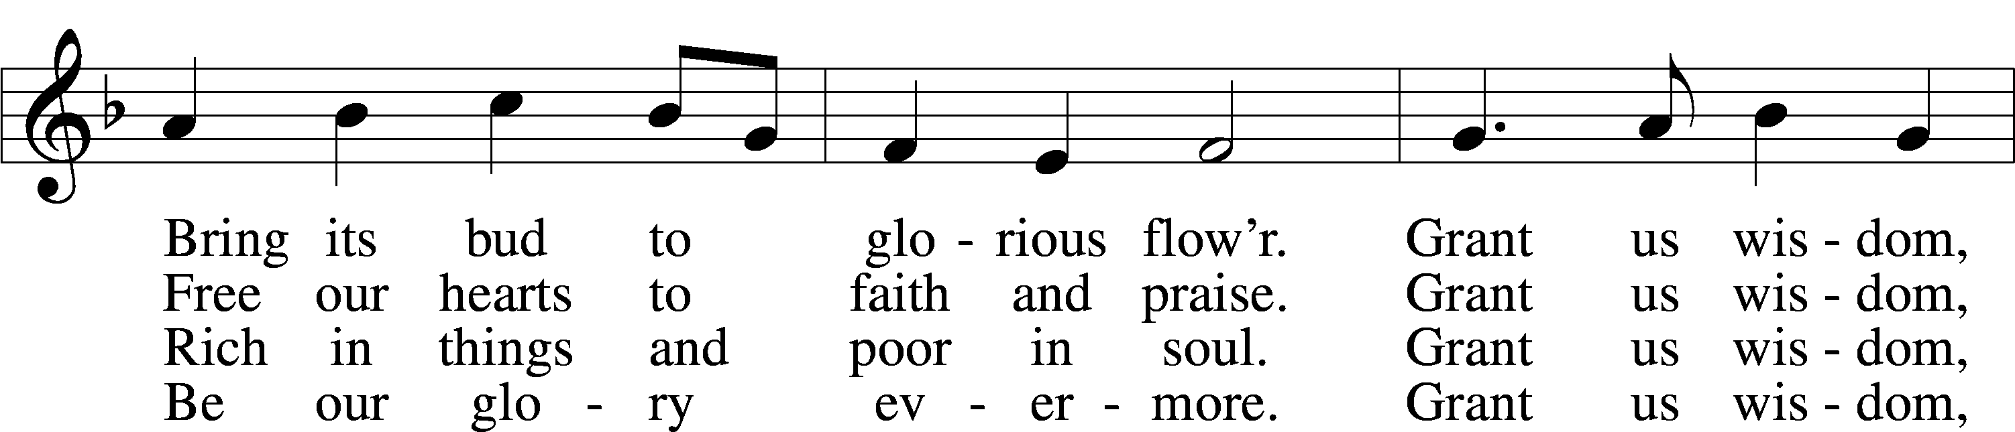
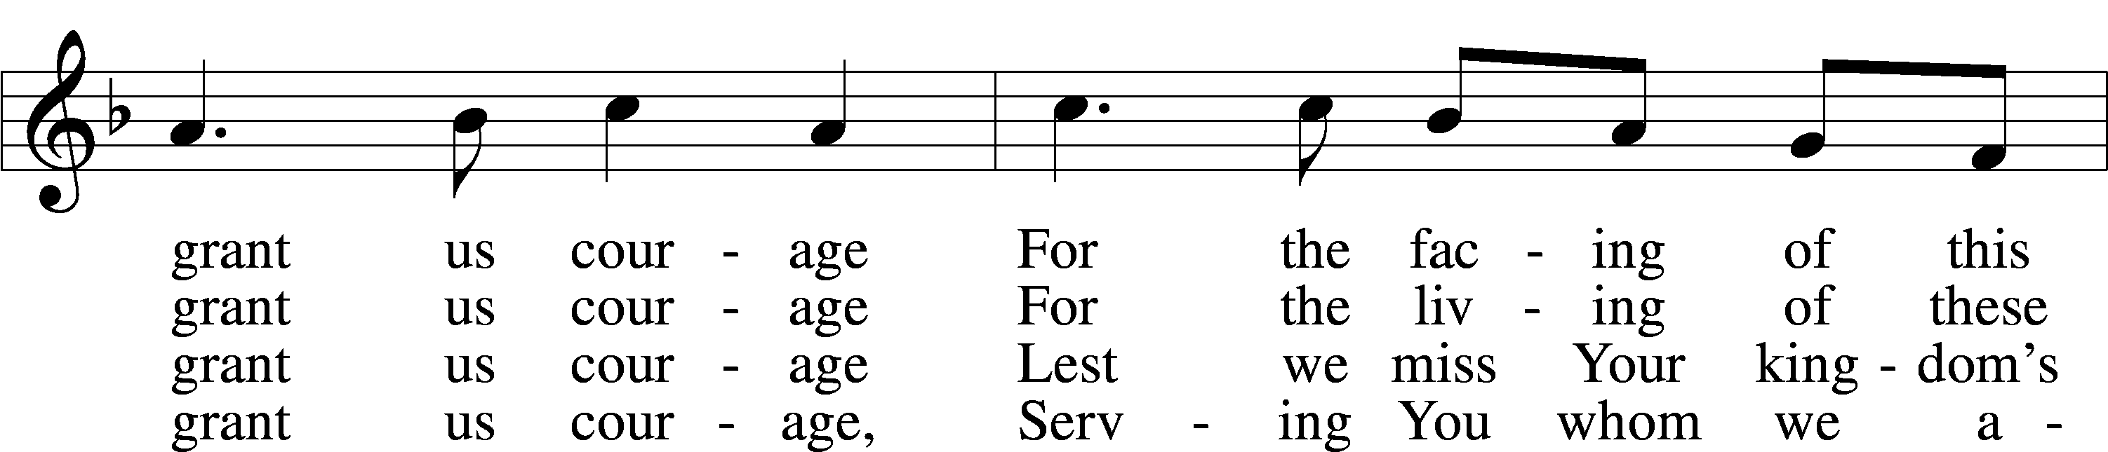
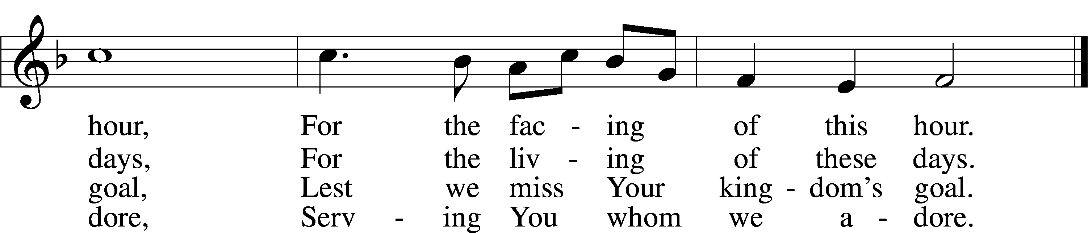
Text: Harry Emerson Fosdick, 1878–1969
Tune: John Hughes, 1873–1932
Text and tune: Public domain



Confession and Absolution
Stand
The sign of the cross may be made by all in remembrance of their Baptism.

L In the name of the Father and of the T Son and of the Holy Spirit.
C Amen.

L Our help is in the name of the Lord,
C who made heaven and earth.

L If You, O Lord, kept a record of sins, O Lord, who could stand?
C But with You there is forgiveness; therefore You are feared.

L Since we are gathered to hear God’s Word, call upon Him in prayer and praise, and receive the body and blood of our Lord Jesus Christ in the fellowship of this altar, let us first consider our unworthiness and confess before God and one another that we have sinned in thought, word, and deed, and that we cannot free ourselves from our sinful condition. Together as His people let us take refuge in the infinite mercy of God, our heavenly Father, seeking His grace for the sake of Christ, and saying: God, be merciful to me, a sinner.

Pause for Reflection

C Almighty God, have mercy upon us, forgive us our sins, and lead us to everlasting life. Amen.

L Almighty God, in His mercy has given His Son to die for you and for His sake forgive you all you sins. As a called servant of Christ, and by His authority, I therefore forgive you all your sins in the name of the Father and of the T Son and of the Holy Spirit.
C Amen.

Stand
Service of the Word

Invitatory for Trinitytide
L The Lord has enlightened us in the true faith
O come, let us worship Him.
C In the day of my trouble I call upon You,
for Your answer me. Psalm 86:7

Introit Psalm 119:162, 164–165, 167; antiphon: v. 166
I hope for your salvation, | O Lord,*
and I do your com- | mandments.
I rejoice | at your word*
like one who | finds great spoil.
Seven times a day I | praise you*
for your just and righ- | teous decrees.
Great peace have those who | love your law;*
nothing can make them | stumble.
My soul keeps your testi- | monies;*
I love them ex- | ceedingly.
Glory be to the Father and | to the Son*
and to the Holy | Spirit;
as it was in the be- | ginning,*
is now, and will be forever. | Amen.
I hope for your salvation, | O Lord,*
and I do your com- | mandments.

Kyrie
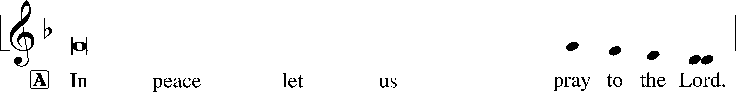
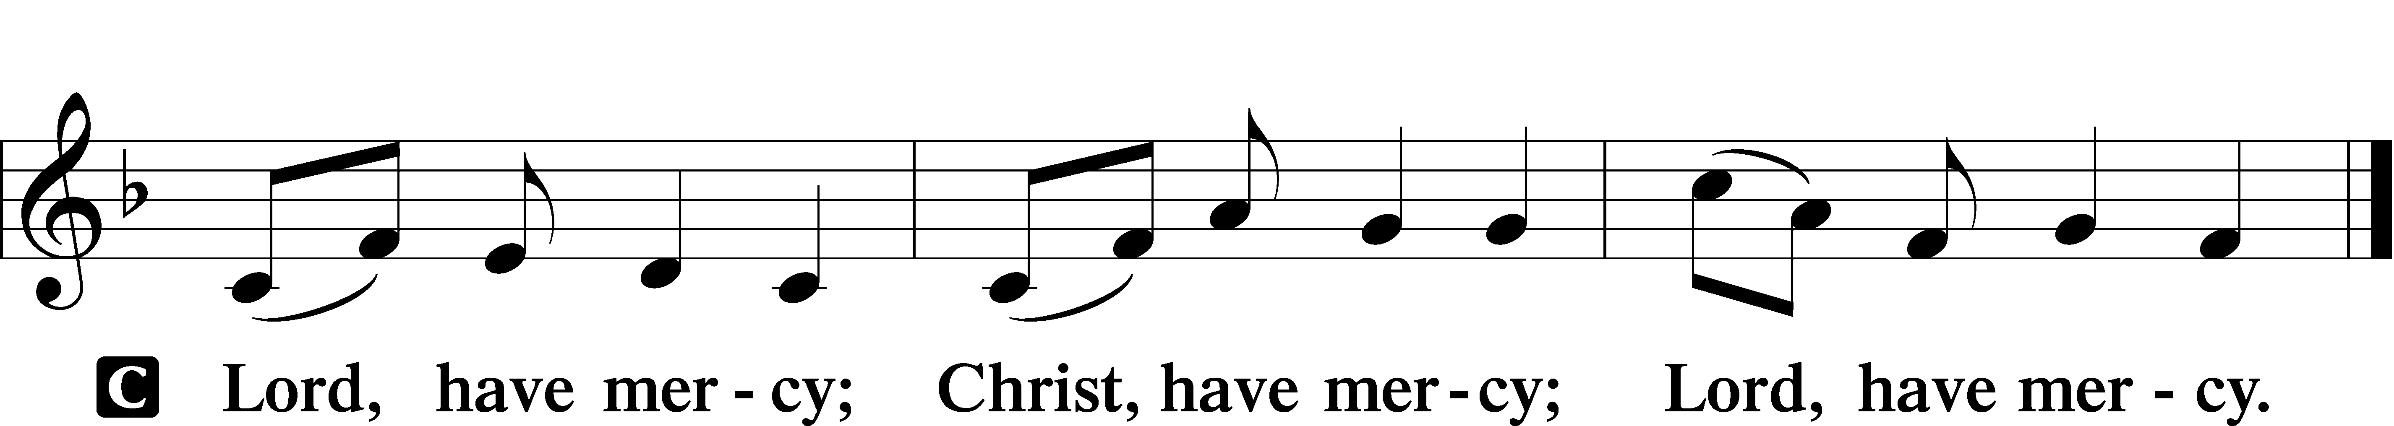

A For the peace from above and for our salvation let us pray to the Lord.

A For the peace of the whole world, for the well-being of the Church of God, and for the unity of all let us pray to the Lord.

A For this holy house and for all who offer here their worship and praise let us pray to the Lord.

This Is the Feast LSB 155
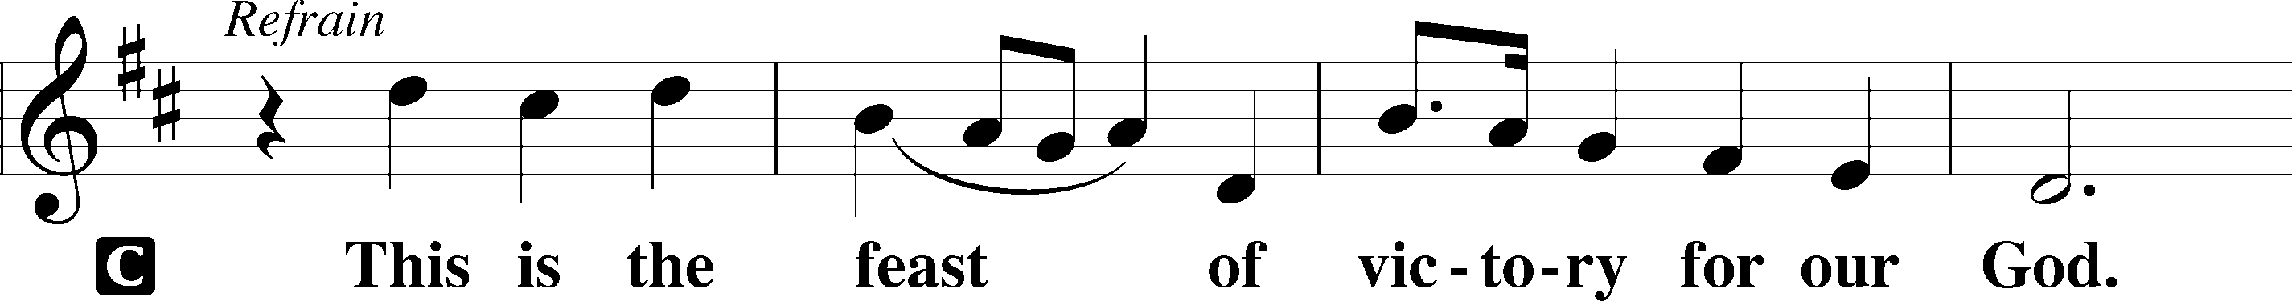
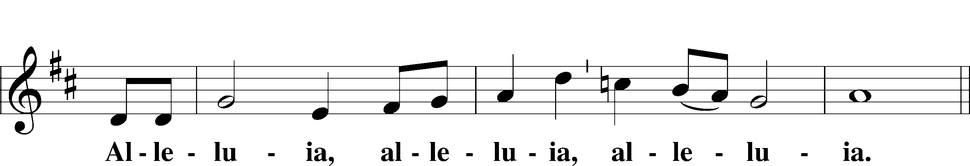
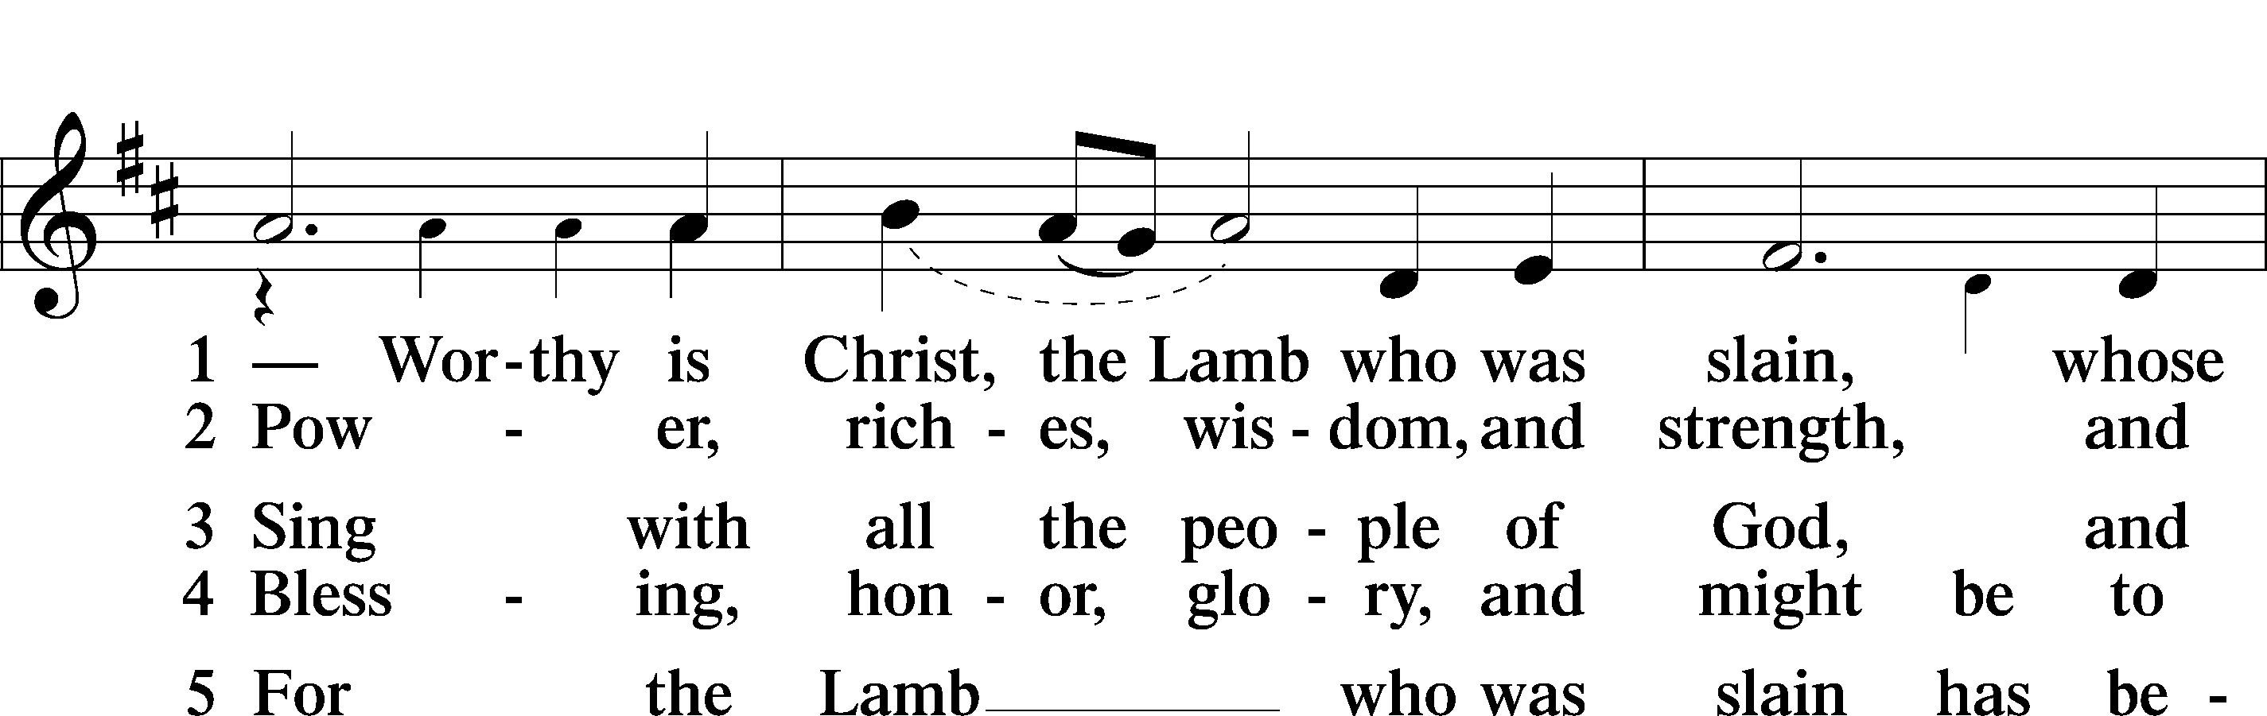
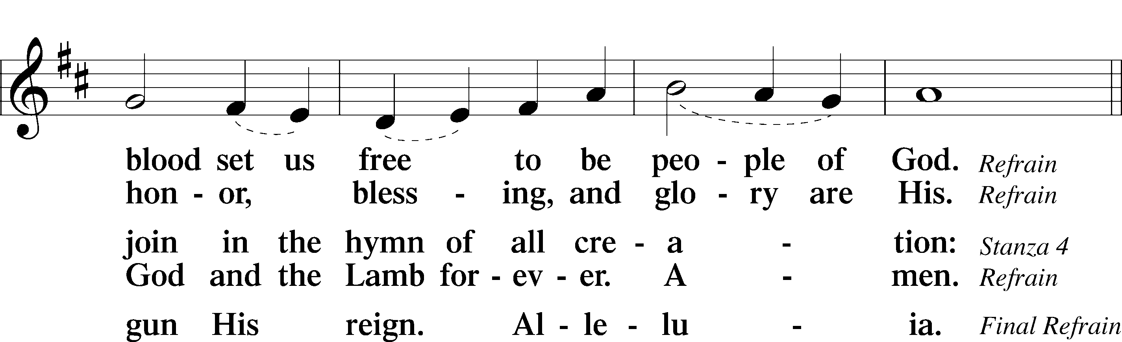
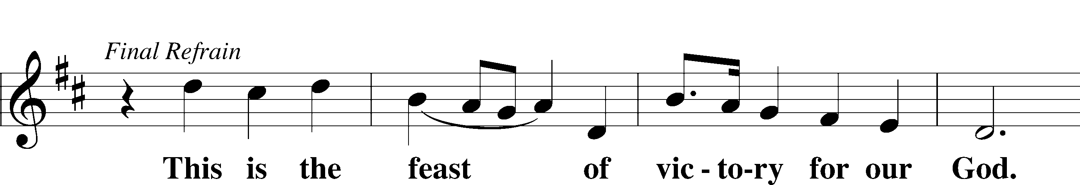
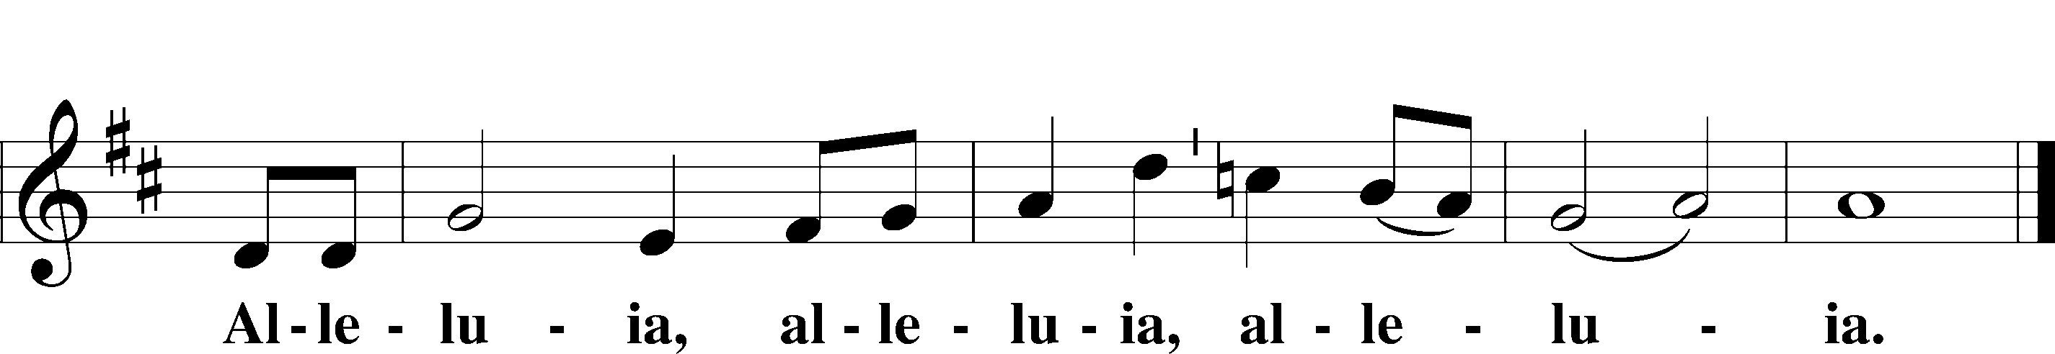

Salutation and Collect of the Day
L The Lord be with you.
C And also with you.

L Let us pray.
O God, our refuge and strength, the author of all godliness, by Your grace hear the prayers of Your Church. Grant that those things which we ask in faith we may receive through Your bountiful mercy; through Jesus Christ, Your Son, our Lord, who lives and reigns with You and the Holy Spirit, one God, now and forever.

C Amen.
Sit
Old Testament Reading Habakkuk 1:1–4; 2:1–4

A The Old Testament read from the 1st chapter of Habakkuk.

1The oracle that Habakkuk the prophet saw.
2O Lord, how long shall I cry for help,
and you will not hear?
Or cry to you “Violence!”
and you will not save?
3Why do you make me see iniquity,
and why do you idly look at wrong?
Destruction and violence are before me;
strife and contention arise.
4So the law is paralyzed,
and justice never goes forth.
For the wicked surround the righteous;
so justice goes forth perverted.
1I will take my stand at my watchpost
and station myself on the tower,
and look out to see what he will say to me,
and what I will answer concerning my complaint.
2And the Lord answered me:
“Write the vision;
make it plain on tablets,
so he may run who reads it.
3For still the vision awaits its appointed time;
it hastens to the end—it will not lie.
If it seems slow, wait for it;
it will surely come; it will not delay.
4“Behold, his soul is puffed up; it is not upright within him,
but the righteous shall live by his faith.”

A This is the Word of the Lord.
C Thanks be to God.

Psalm Psalm 62; antiphon: v. 1
1For God alone my soul waits in | silence;*
from him comes my sal- | vation.
2He only is my rock and my salvation,
my | fortress;*
I shall not be greatly | shaken.
3How long will all of you attack a man
to | batter him,*
like a leaning wall, a | tottering fence?
4They only plan to thrust him down from his high position.
They take pleasure in | falsehood.*
They bless with their mouths,
but inwardly | they curse.
5For God alone, O my soul, wait in | silence,*
for my hope is | from him.
6He only is my rock and my salvation,
my | fortress;*
I shall not be | shaken.
7On God rests my salvation and my | glory;*
my mighty rock, my refuge | is God.
8Trust in him at all times, O people;
pour out your heart be- | fore him;*
God is a refuge | for us.
9Those of low estate are but a breath;
those of high estate are a de- | lusion;*
in the balances they go up;
they are together lighter | than a breath.
10Put no trust in extortion;
set no vain hopes on | robbery;*
if riches increase, set not your | heart on them.
11Once God has spoken;
twice have I | heard this:*
that power belongs to God,
12and that to you, O Lord, belongs | steadfast love.
For you will render | to a man*
according | to his work.

Epistle 2 Timothy 1:1–14
A The Epistle is from 2nd Timothy chapter 1.

1Paul, an apostle of Christ Jesus by the will of God according to the promise of the life that is in Christ Jesus,
2To Timothy, my beloved child:
Grace, mercy, and peace from God the Father and Christ Jesus our Lord.
3I thank God whom I serve, as did my ancestors, with a clear conscience, as I remember you constantly in my prayers night and day. 4As I remember your tears, I long to see you, that I may be filled with joy. 5I am reminded of your sincere faith, a faith that dwelt first in your grandmother Lois and your mother Eunice and now, I am sure, dwells in you as well. 6For this reason I remind you to fan into flame the gift of God, which is in you through the laying on of my hands, 7for God gave us a spirit not of fear but of power and love and self-control.
8Therefore do not be ashamed of the testimony about our Lord, nor of me his prisoner, but share in suffering for the gospel by the power of God, 9who saved us and called us to a holy calling, not because of our works but because of his own purpose and grace, which he gave us in Christ Jesus before the ages began, 10and which now has been manifested through the appearing of our Savior Christ Jesus, who abolished death and brought life and immortality to light through the gospel, 11for which I was appointed a preacher and apostle and teacher, 12which is why I suffer as I do. But I am not ashamed, for I know whom I have believed, and I am convinced that he is able to guard until that Day what has been entrusted to me. 13Follow the pattern of the sound words that you have heard from me, in the faith and love that are in Christ Jesus. 14By the Holy Spirit who dwells within us, guard the good deposit entrusted to you.

A This is the Word of the Lord.
C Thanks be to God.

Stand
Alleluia and Verse

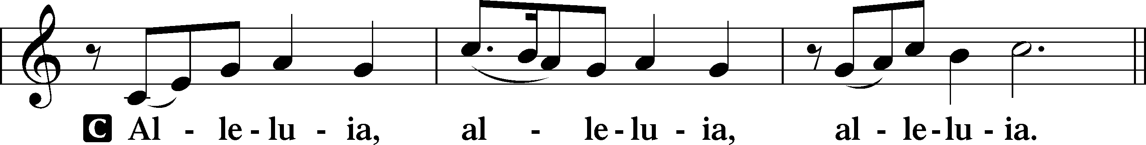

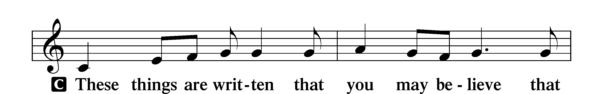
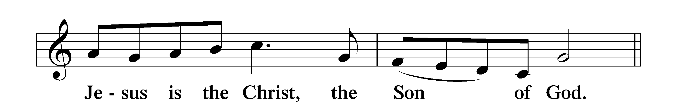

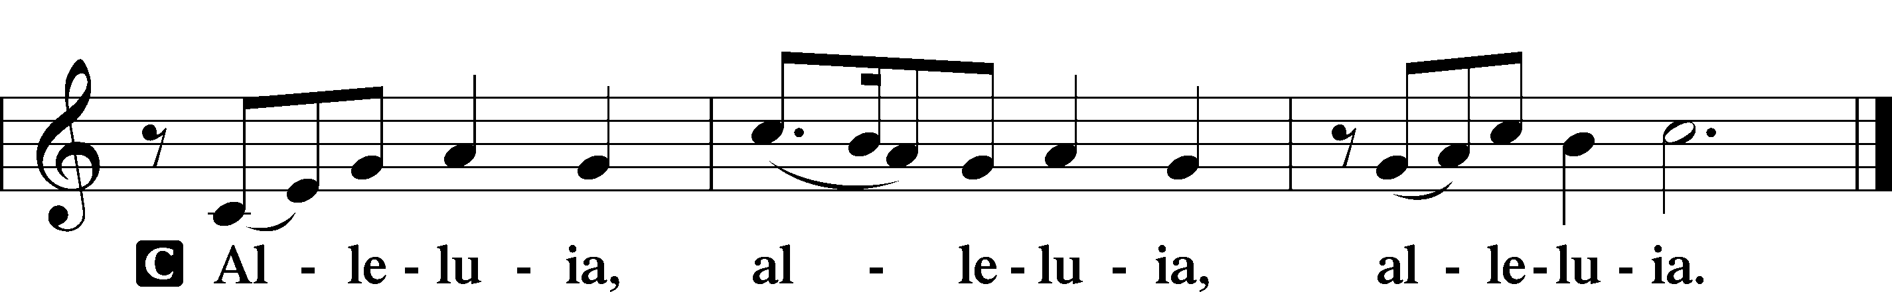

Holy Gospel Luke 17:1–10
P The Holy Gospel according to St. Luke, the seventeenth chapter.
C Glory to You, O Lord.

1[Jesus] said to his disciples, “Temptations to sin are sure to come, but woe to the one through whom they come! 2It would be better for him if a millstone were hung around his neck and he were cast into the sea than that he should cause one of these little ones to sin. 3Pay attention to yourselves! If your brother sins, rebuke him, and if he repents, forgive him, 4and if he sins against you seven times in the day, and turns to you seven times, saying, ‘I repent,’ you must forgive him.”
5The apostles said to the Lord, “Increase our faith!” 6And the Lord said, “If you had faith like a grain of mustard seed, you could say to this mulberry tree, ‘Be uprooted and planted in the sea,’ and it would obey you.
7“Will any one of you who has a servant plowing or keeping sheep say to him when he has come in from the field, ‘Come at once and recline at table’? 8Will he not rather say to him, ‘Prepare supper for me, and dress properly, and serve me while I eat and drink, and afterward you will eat and drink’? 9Does he thank the servant because he did what was commanded? 10So you also, when you have done all that you were commanded, say, ‘We are unworthy servants; we have only done what was our duty.’”

P This is the Gospel of the Lord.
C Praise to You, O Christ.

Sit

685 Let Us Ever Walk with Jesus
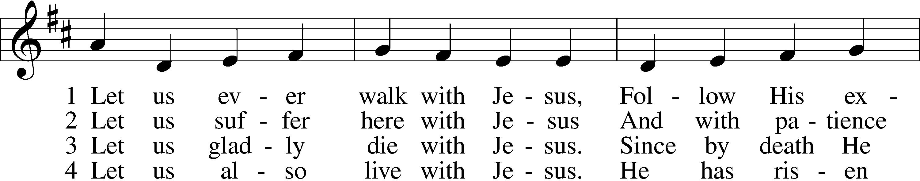
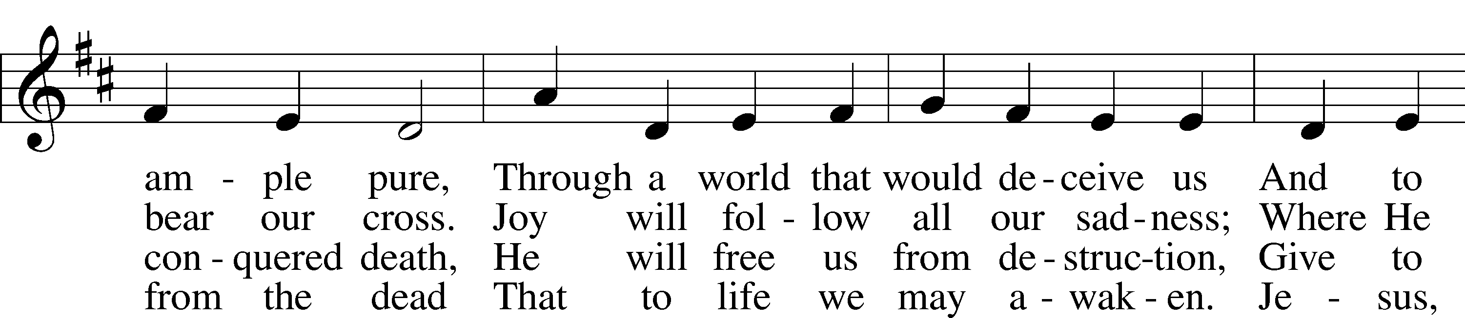
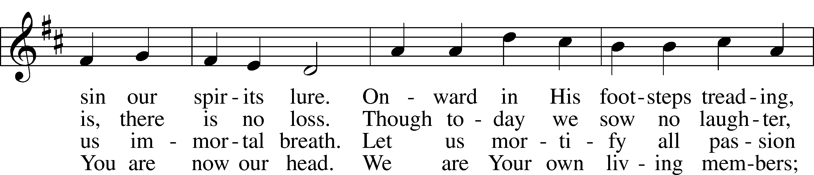
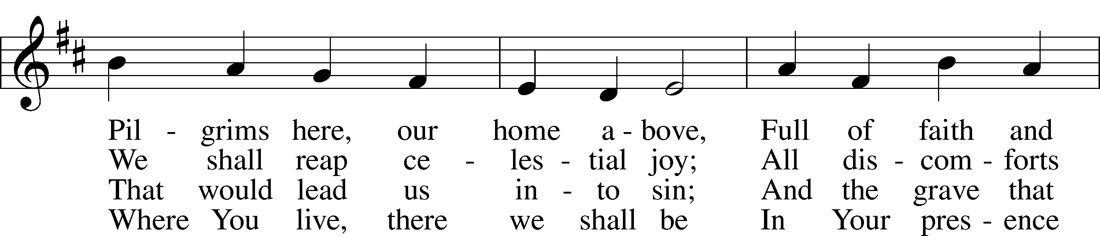
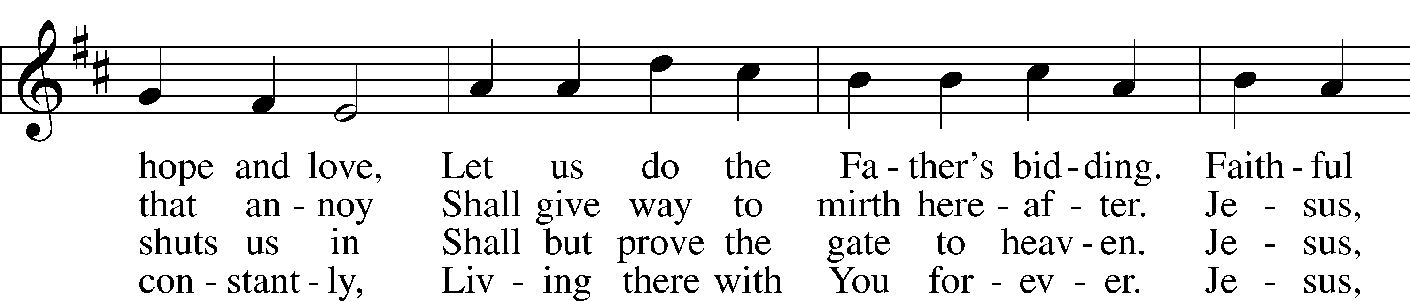
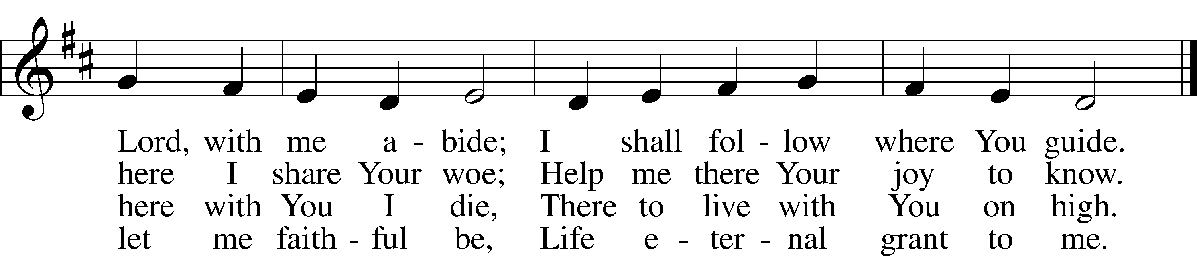
Text: Sigismund von Birken, 1626–81; tr. Lutheran Book of Worship, 1978, alt.
Tune: Georg G. Boltze, 18th cent.
Text: © 1978 Lutheran Book of Worship. Used by permission: LSB Hymn License no. 110003995
Tune: Public domain

Sermon

Apostles’ Creed
C I believe in God, the Father Almighty,
maker of heaven and earth.

And in Jesus Christ, His only Son, our Lord,
who was conceived by the Holy Spirit,
born of the virgin Mary,
suffered under Pontius Pilate,
was crucified, died and was buried.
He descended into hell.
The third day He rose again from the dead.
He ascended into heaven
and sits at the right hand of God the Father Almighty.
From thence He will come to judge the living and the dead.

I believe in the Holy Spirit,
the holy Christian Church,
the communion of saints,
the forgiveness of sins,
the resurrection of the body,
and the life T everlasting. Amen.
Stand

Prayer of the Church & Sharing of the Peace

Following the prayers, the people may greet one another in the name of the Lord, saying,
“Peace be with you,” as a sign of reconciliation and of the unity of the Spirit in the bond of peace
(Matt. 5:22–24; Eph. 4:1–3).

Sit

Offering & Offertory

LSB 192
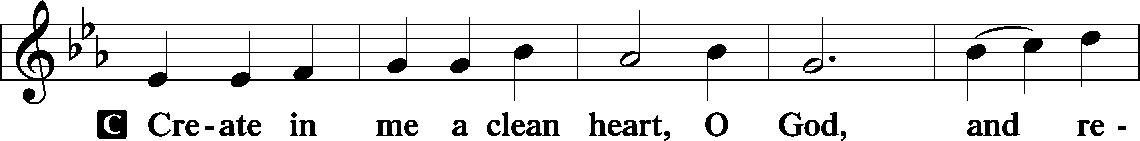
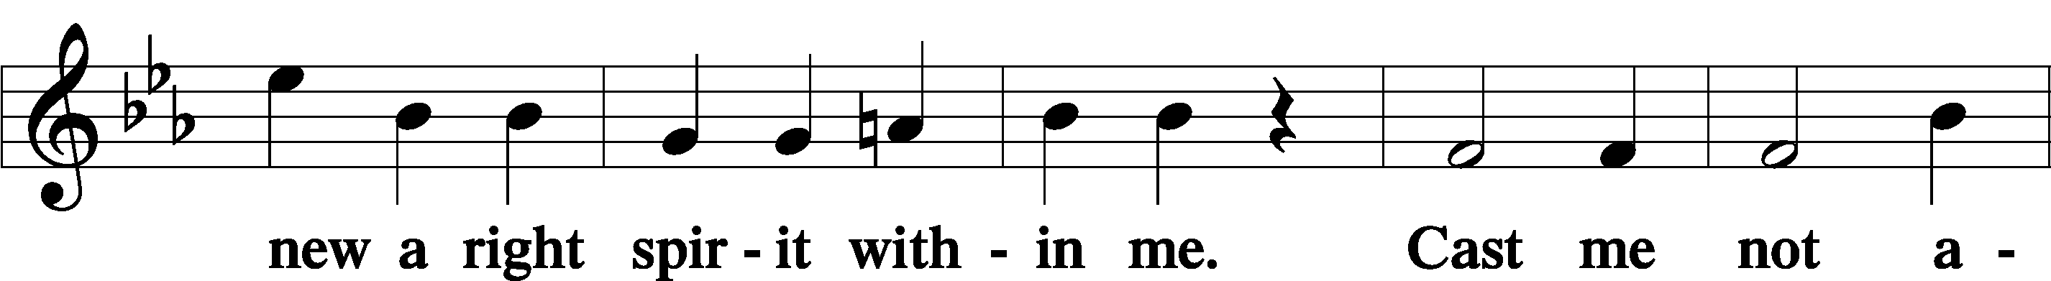
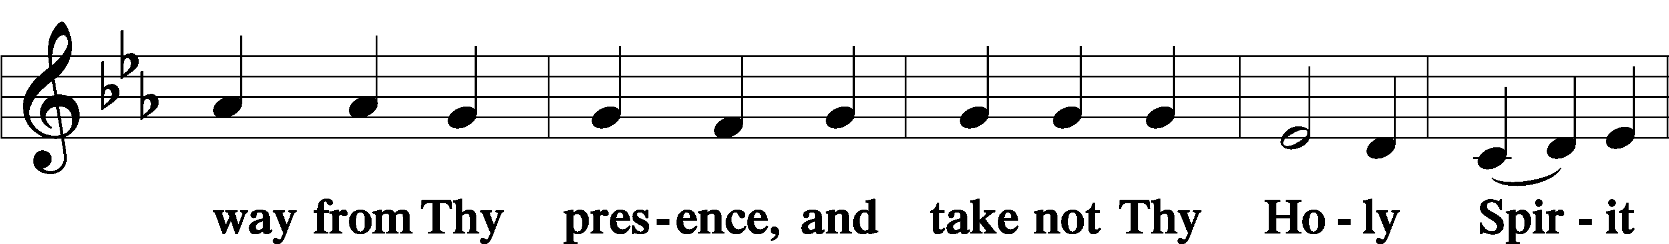
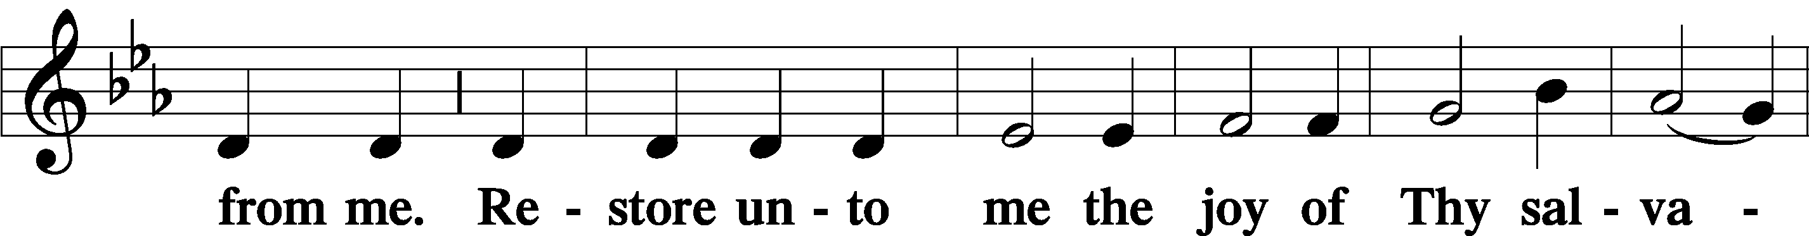
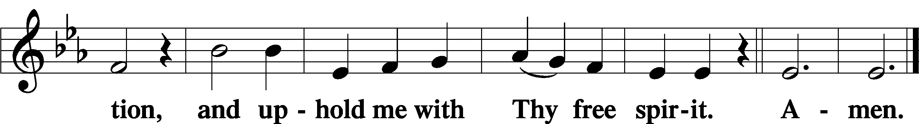

Service of Holy Communion
Communion Statement

The Lord’s Supper is celebrated at this congregation in the confession and glad confidence that, as He says, our Lord gives into our mouths not only bread and wine but His very body and blood to eat and to drink for the forgiveness of sins and to strengthen our union with Him and with one another. Our Lord invites to His table those who trust His words, repent of all sin, and set aside any refusal to forgive and love as He forgives and loves us, that they may show forth His death until He comes.

Because those who eat and drink our Lord’s body and blood unworthily do so to their great harm and because Holy Communion is a confession of the faith which is confessed at this altar, any who are not yet instructed, in doubt, or who hold a confession differing from that of this congregation and the Lutheran Church Missouri Synod, and yet desire to receive this sacrament, are asked to speak with the Pastor.
* See more about the Lutheran teaching on communion in the Hymnal p 329.

Stand

Preface LSB 208
P The Lord be with you.
C And also with you.

P Lift up your hearts.
C We lift them to the Lord.

P Let us give thanks to the Lord our God.
C It is right to give Him thanks and praise.

P It is truly good, right, and salutary that we should at all times and in all places give thanks to You, O Lord, holy Father, almighty and everlasting God, for the countless blessings You so freely bestow on us and all creation. Above all, we give thanks for Your boundless love shown to us when You sent Your only-begotten Son, Jesus Christ, into our flesh and laid on Him our sin, giving Him into death that we might not die eternally. Because He is now risen from the dead and lives and reigns to all eternity, all who believe in Him will overcome sin and death and will rise again to new life. Therefore with angels and archangels and with all the company of heaven we laud and magnify Your glorious name, evermore praising You and saying:

Sanctus LSB 208
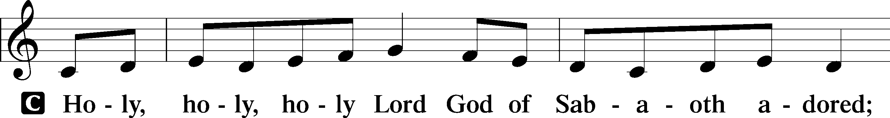
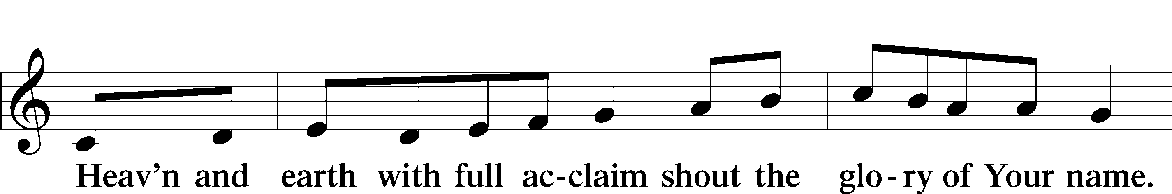
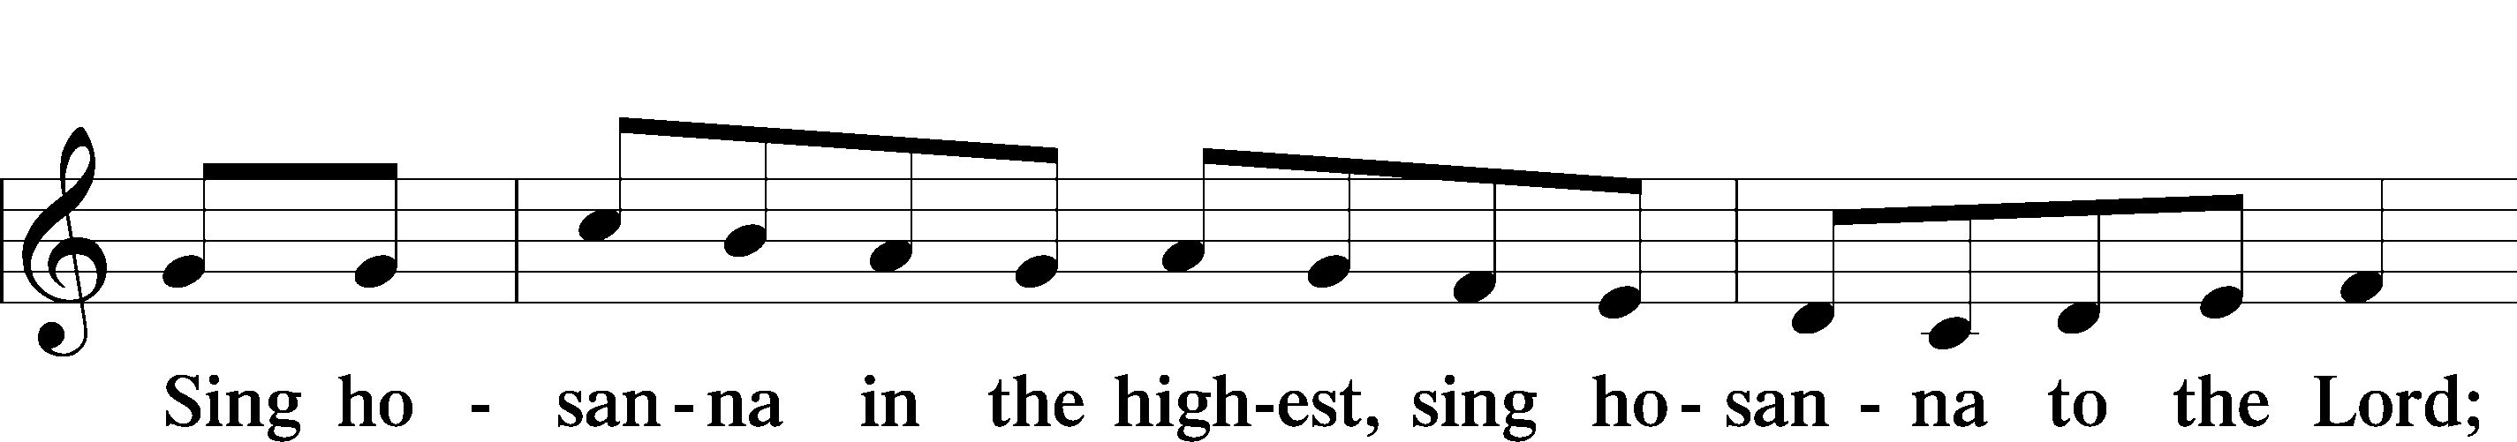
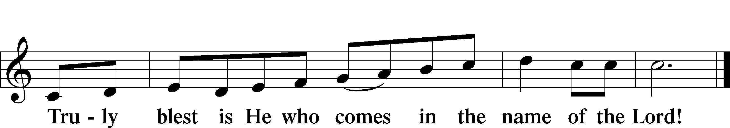
Text: Stephen P. Starke

Prayer of Thanksgiving
P Blessed are You, O Lord our God, king of all creation, for You have had mercy on us and given Your only-begotten Son that whoever believes in Him should not perish but have eternal life.

In these last days, you have poured out Your Holy Spirit on Your Church that Your sons and daughters might proclaim the wonders of Your salvation in Christ Jesus our Lord. Pour out Your Holy Spirit upon Your gathered people that, faithfully eating and drinking the body and blood of Your Son, we may go forth to proclaim His salvation to the ends of the earth.

Hear us as we pray in His name and as He has taught us:

Lord’s Prayer
C Our Father who art in heaven, hallowed be Thy name,
Thy kingdom come, Thy will be done on earth
as it is in heaven; give us this day our daily bread;
and forgive us our trespasses as we forgive those
who trespass against us;
and lead us not into temptation, but deliver us from evil.
For Thine is the kingdom and the power and the glory
forever and ever. Amen.

The Words of Our Lord
P Our Lord Jesus Christ, on the night when He was betrayed, took bread, and when He had given thanks, He broke it and gave it to the disciples and said: “Take, eat; this is My T body, which is given for you. This do in remembrance of Me.”

In the same way also He took the cup after supper, and when He had given thanks, He gave it to them, saying: “Drink of it, all of you; this cup is the new testament in My T blood, which is shed for you for the forgiveness of sins. This do, as often as you drink it, in remembrance of Me.”

Pax Domini
P The peace of the Lord be with you always.
C Amen.



Agnus Dei LSB 210
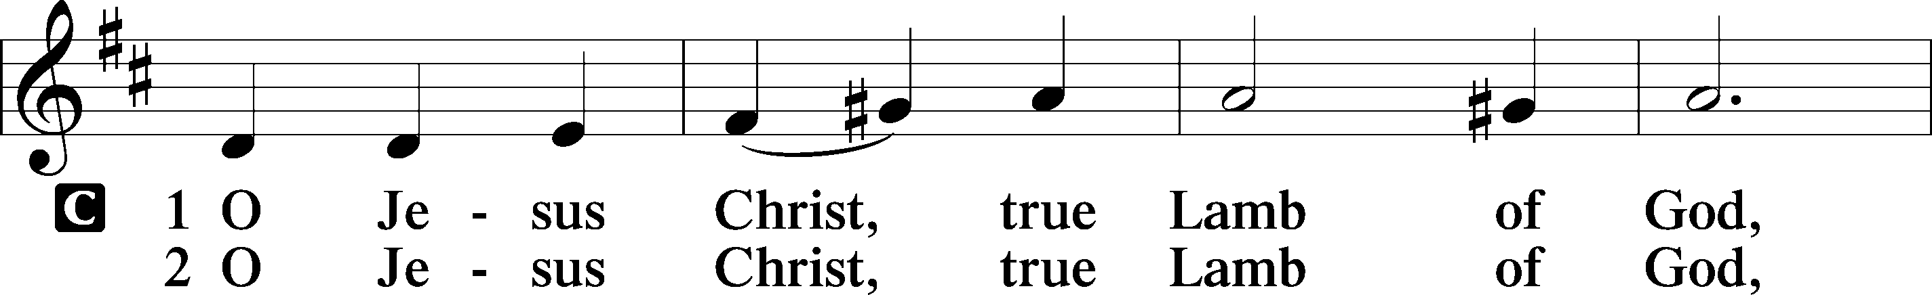
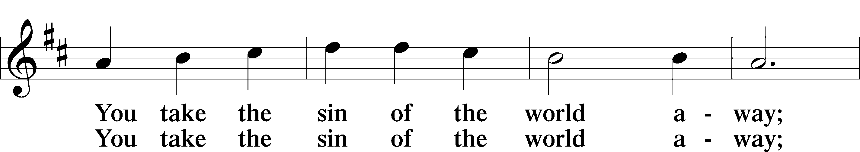
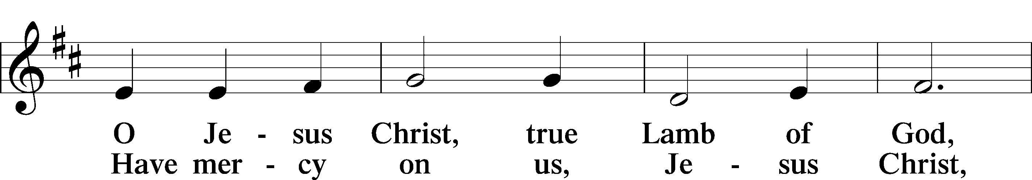
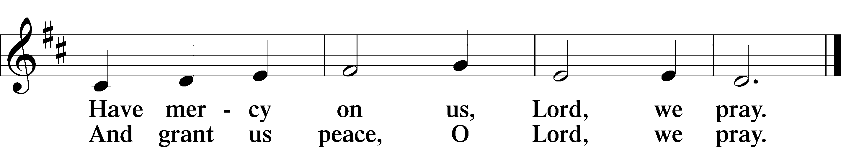
Text: Stephen P. Starke

Sit

Distribution
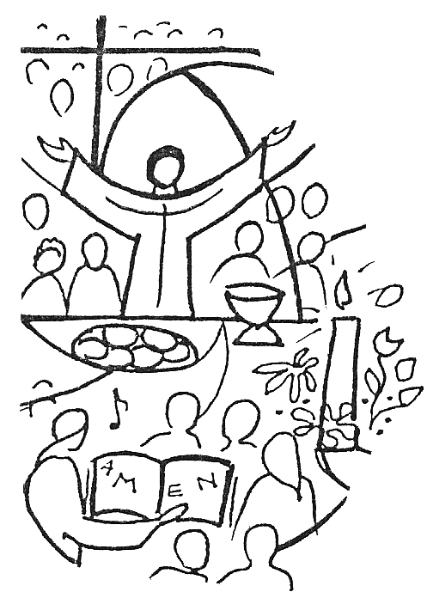
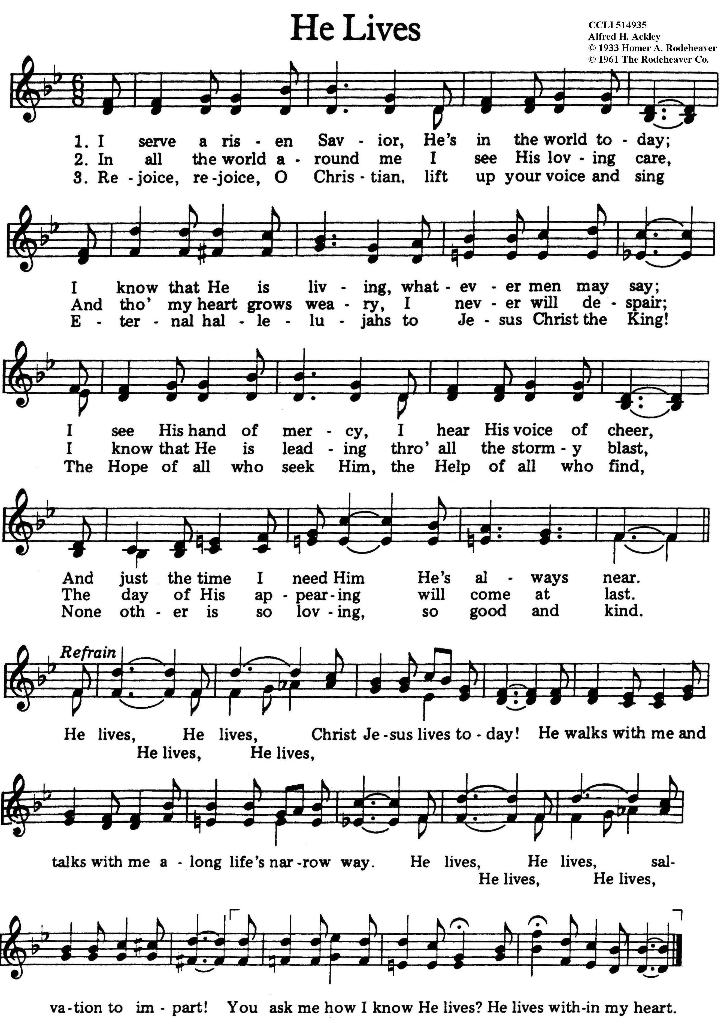
Stand

Nunc Dimittis LSB 211
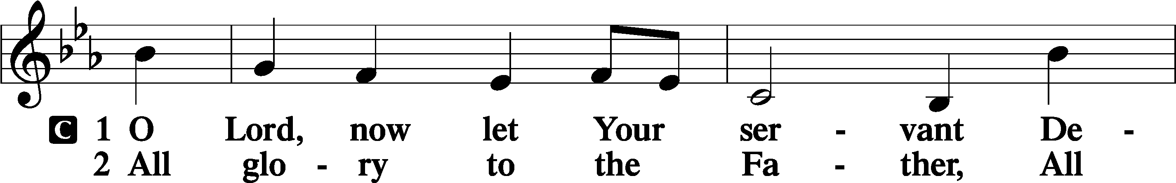
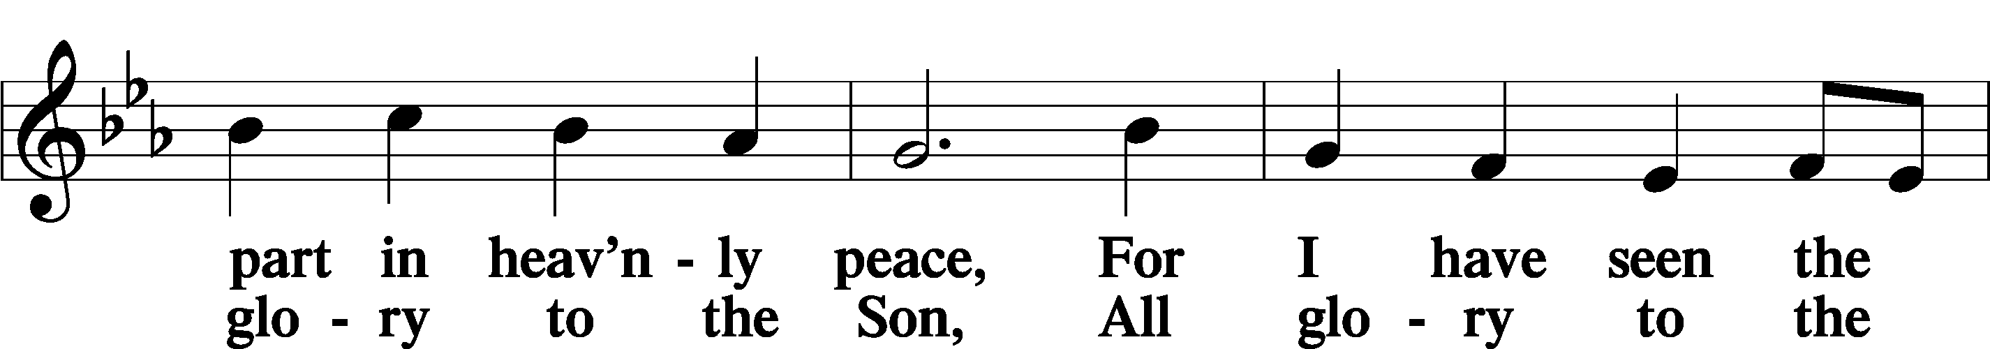
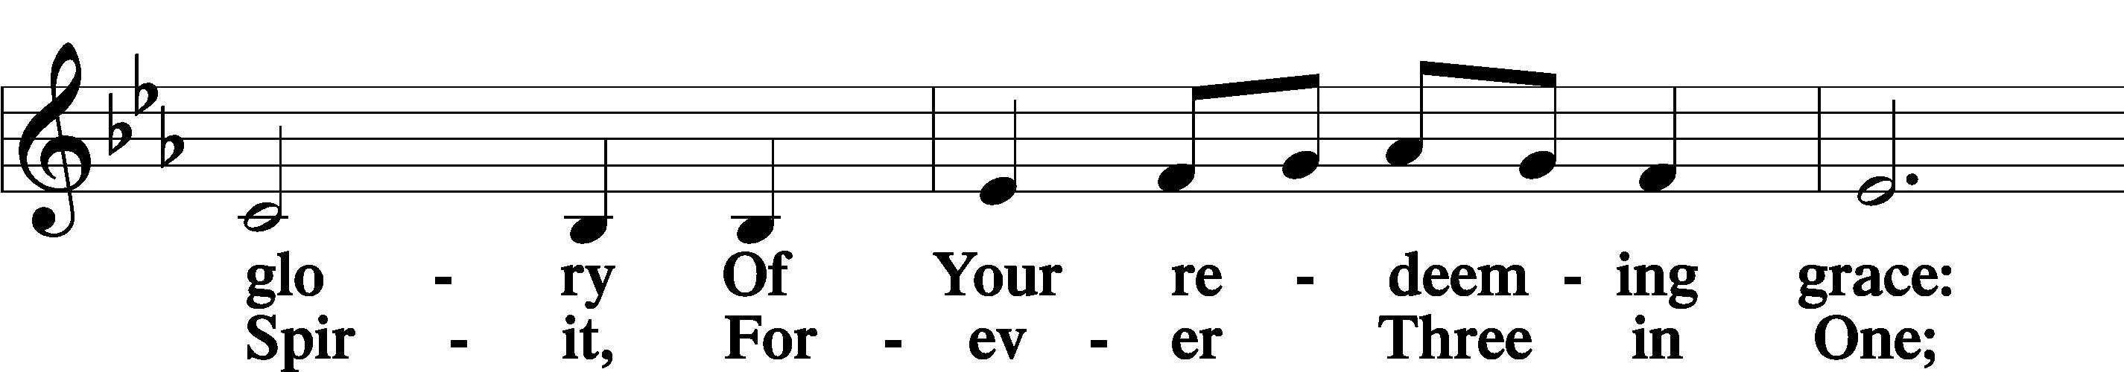
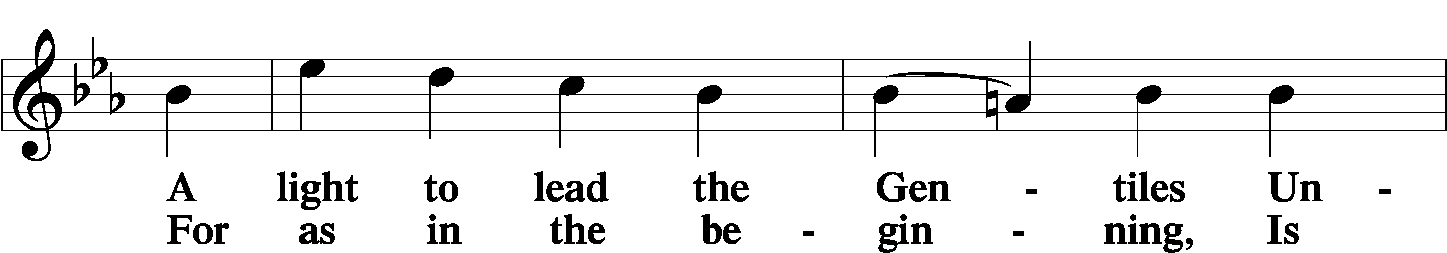
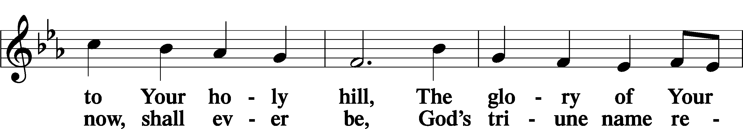
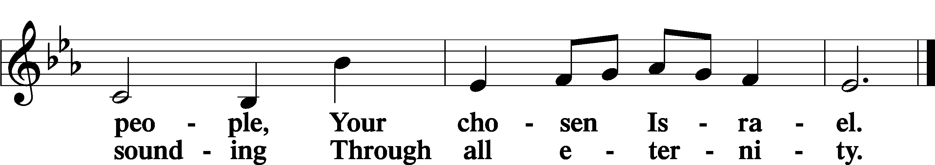

Post-Communion Collect
A Let us pray.
We give thanks to You, almighty God, that You have refreshed us through this salutary gift, and we implore You that of Your mercy You would strengthen us through the same in faith toward You and in fervent love toward one another; through Jesus Christ, Your Son, our Lord, who lives and reigns with You and the Holy Spirit, one God, now and forever.
C Amen.
Verse of the Day Luke 17:3b
P Alleluia! If your brother sins, rebuke him,
C and if he repents, forgive him. Alleluia!

Benedicamus LSB 212
A Let us bless the Lord.
C Thanks be to God.

Benediction
P The Lord bless you and keep you.
The Lord make His face shine on you and be gracious to you.
The Lord look upon you with favor and T give you peace.
C Amen.

857 Lord, Help Us Walk Your Servant Way
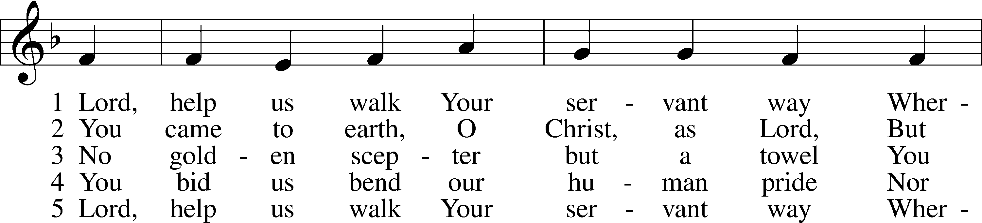
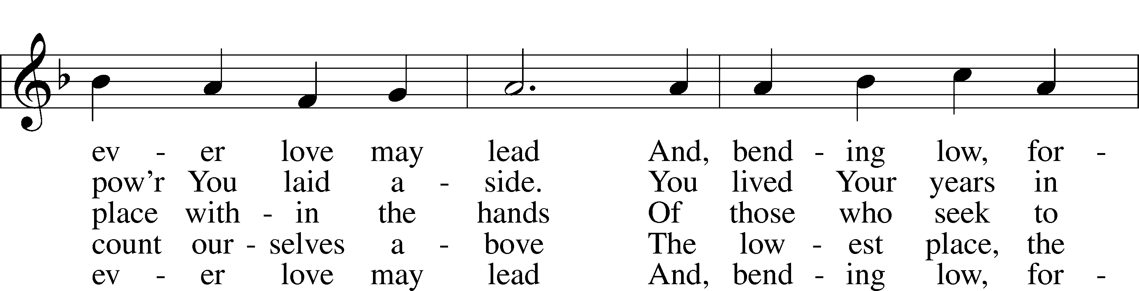
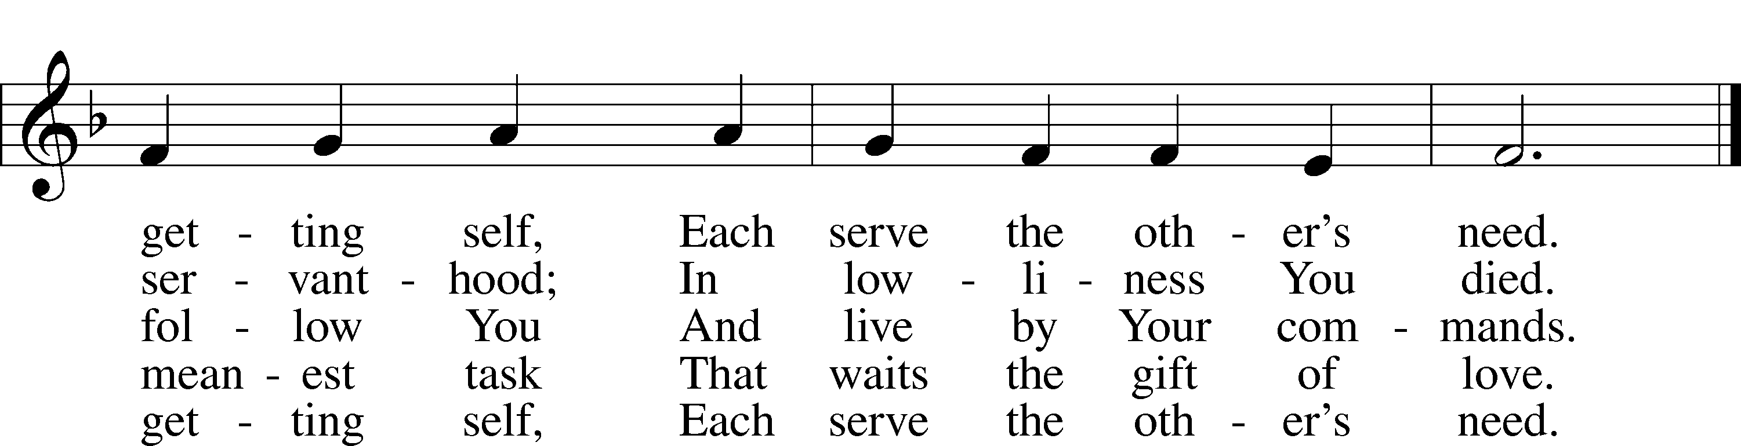
Text: Herman G. Stuempfle, Jr., 1923–2007 Tune: The Whole Booke of Psalmes, 1562, London
Text: © 1997 GIA Publications, Inc. Used by permission: LSB Hymn License no. 110003995 Tune: Public domain
Acknowledgments
Divine Service, Setting Four from Lutheran Service Book Unless otherwise indicated, Scripture quotations are from the ESV® Bible (The Holy Bible, English Standard Version®), copyright © 2001 by Crossway, a publishing ministry of Good News Publishers. Used by permission. All rights reserved.
Created by Lutheran Service Builder © 2025 Concordia Publishing House.

Prayers of the Church
This week, we lift up:

Bob C, Mike Y, Angela H, Sheila, Elaine, Angie Z, Angela C, Ross, & Kathy H.

Family of the week: Samantha & Paul Tennant and Family

*If you have any prayer request let us know.

Last week: Attendance 30 Offering $1,075

Serving Next Week (10/12/25)  Guest Pastor: Rev Doyle Boykin  Music Minister: Vicar Previn Hudetz  Communion Assistant: Jim C  Worship Assistant: TBD  Reader: Sheila S  Refreshments: Tania  Altar Guild: Angie Z & Sheila S  Greeter: TBD | Readings Next Week  Seventeenth Sunday after Pentecost  - Ruth 1:1-19a  - Psalm 111  - 2 Timothy 2:1-13  - Luke 17:11-19  *Please sign up to help during service.*
Announcements  Birthdays: Angela H – 6th  This Week at OSLC:  Bible Study: After Service  Bible Study: Thursday 10am | Coming Up:


Seasons of the Church Year

Color: Green • Symbol: Hourglass or Watchful Eye
As we move into the last weeks of Trinitytide, the focus of the Church’s worship turns toward the end of all things. The lectionary readings call us to watchfulness, repentance, and readiness for Christ’s return. Though the paraments remain green, these final Sundays remind us that God is bringing His kingdom to completion and that His people live in hope, awaiting the day when all things are made new.

Stewardship Thoughts…

Ephesians 3:20-21 “Now to him who is able to do far more abundantly than all that we ask or think, according to the power at work within us, to him be glory in the church and in Christ Jesus throughout all generations, forever and ever. Amen.”

God delights in exceeding expectations and in pouring out mercies in abundance. This truth stands in contrast to our fears about lacking what we need for “this body and life.” We have an abundantly-blessing God who has proven His love for us on the cross. How could we not trust Him? How could we not respond to His love with generosity toward His mission in the church? How could we not have a desire to imitate Him in blessing others?
Lcms.org/stewardship

