

And the angel of the Lord appeared to [Moses] in a flame of fire out of the midst of a bush. He looked, and behold, the bush was burning, yet it was not consumed.

Exodus 3:2

Our Savior Lutheran Church (LCMS)
4301 Atrisco Drive NW
Albuquerque, New Mexico
Website: OSLCNM.COM
Phone: 505.836.7007
Email: oslcabq@gmail.com

Twenty-Second Sunday after Pentecost
November 9th,2025
The Time of the Church (Trinitytide)
Twenty Second Sunday after Pentecost
November 9th, 2025

Welcome to Our Savior Lutheran Church (LCMS).  We are glad you are here as we worship, praise, and give thanks to our loving Lord, Jesus Christ. Please join us immediately after service for fellowship and snacks. Adult Bible Study starts at 10:30. If you have any questions about our service or need other assistance, please contact one of our worship assistants. | Hymns  Opening # 660 & 585  Sermon # 771  Distribution: Have Thine  Own Way Lord  Closing # 461

Today’s Message

“God of the Living” – From Old Testament times to the days of Jesus, the message of the Holy Spirit is clear: our God is the God of the living—those who live in Him for all eternity. The great “I AM” is the God of our fathers, our God today, and the God of those yet to come. When we or our loved ones face death, we can be assured that our God is the God of the living. In Christ, we live even though we die.
+++
Serving Today
Guest Pastor: Rev Doyle Boykin
Music Ministry: Vicar Previn Hudetz
Communion Assistant: Jim C
Worship Assistant: TBD
Reader: Sheila S
Refreshments: Rebecca Vigil
Altar Guild: Angie Z & Sheila S
Greeter: TBD

Welcome - Divine Service 1
660 Stand Up, Stand Up for Jesus
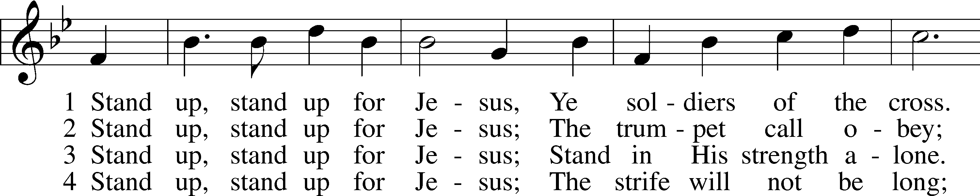
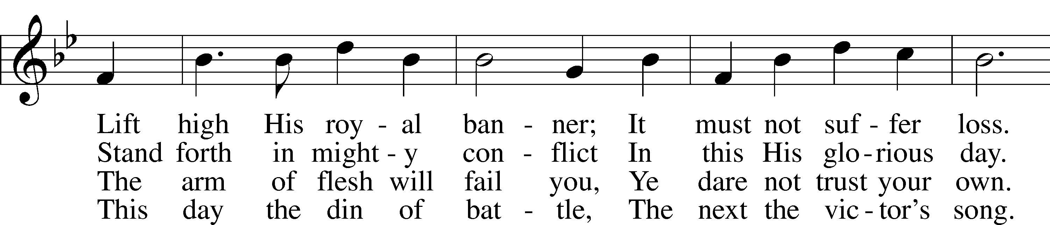
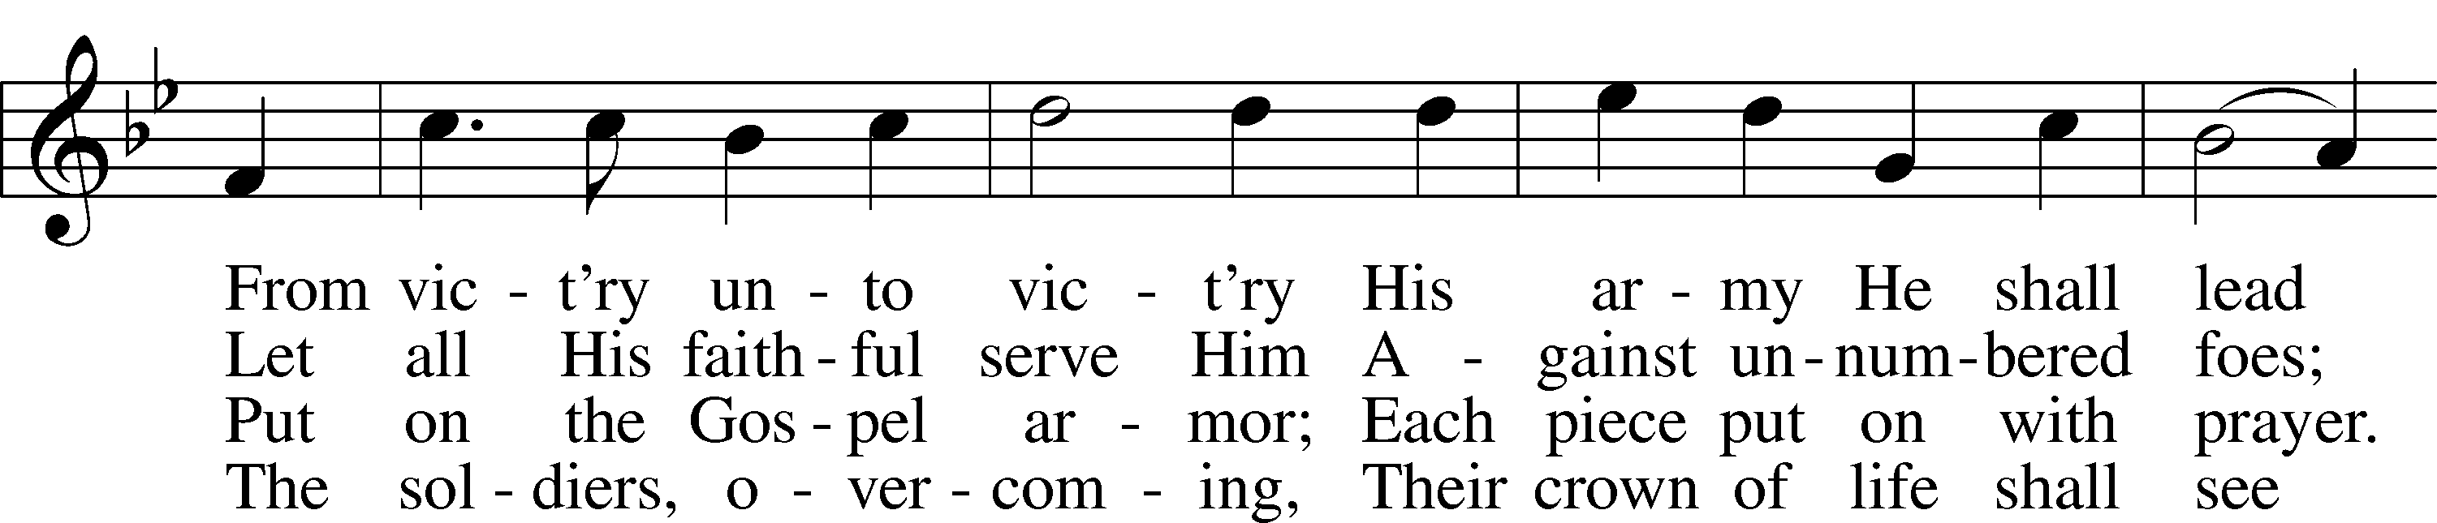
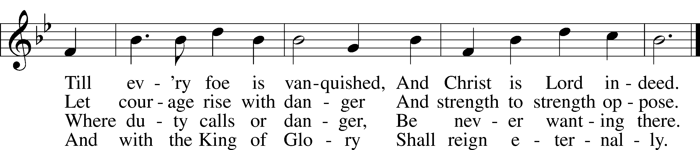
Text: George Duffield, Jr., 1818–88, alt.Tune: George J. Webb, 1803–87 Text and tune: Public domain

585 Lord Jesus Christ, with Us Abide sts. 1–2, 4–6
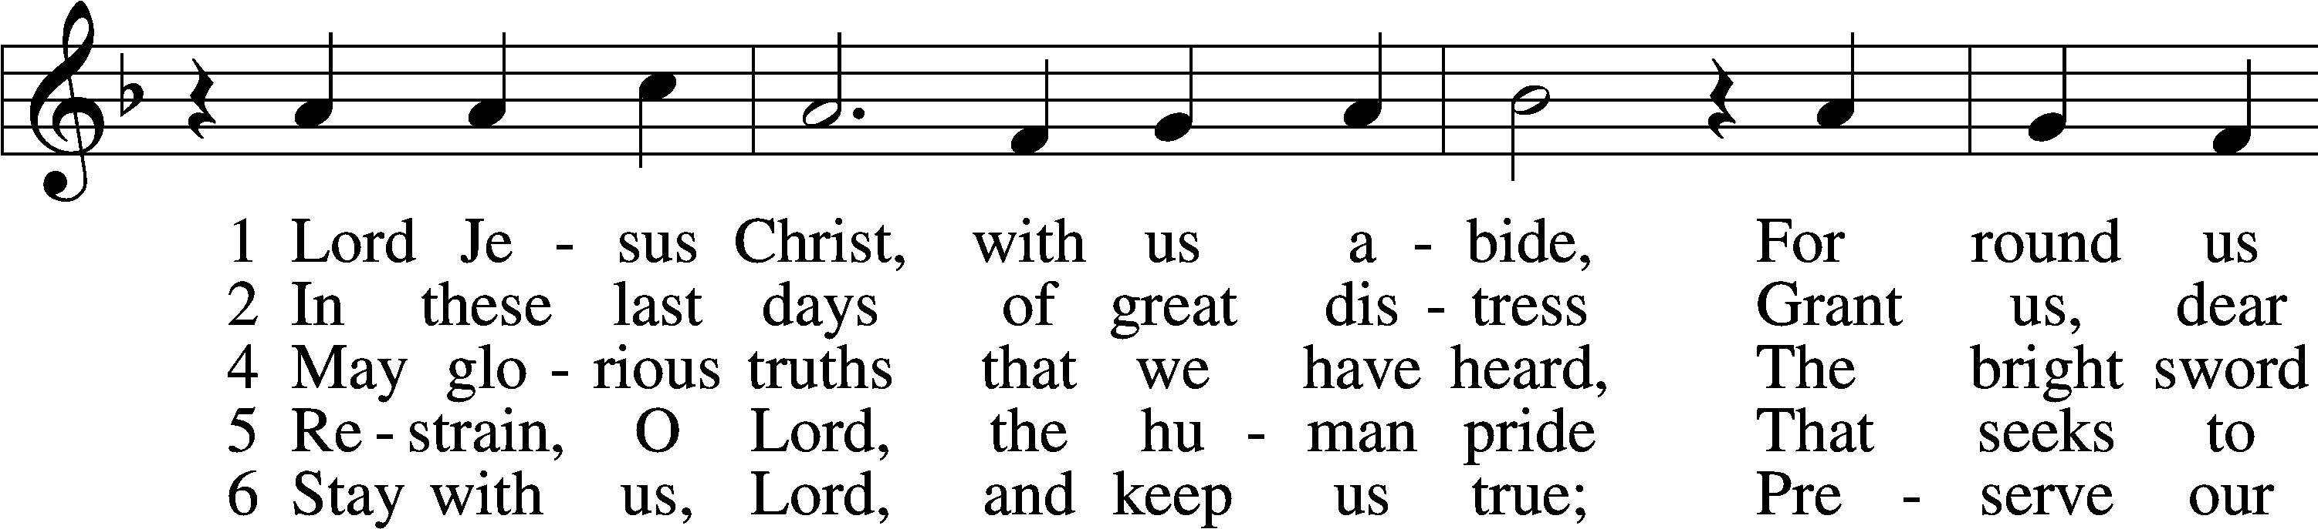
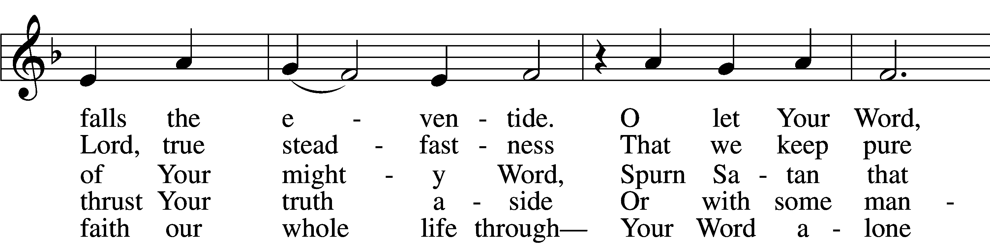
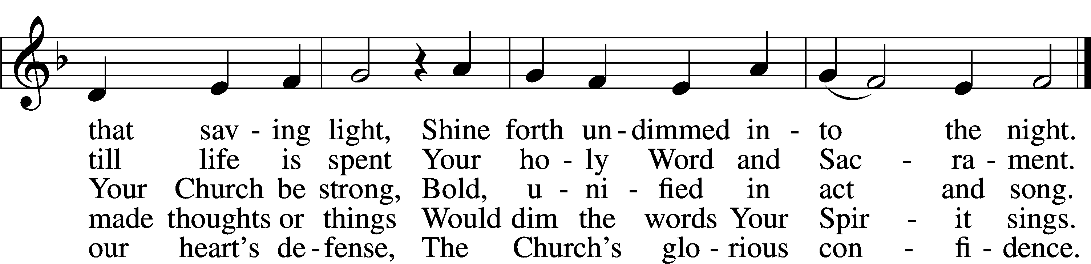
Text: tr. F. Samuel Janzow, 1913–2001, alt.; (st. 1): Philipp Melanchthon, 1497–1560; (st. 1): German version Geistliche Psalmen, 1611, Nuremberg; (sts. 2, 4–6): Nicolaus Selnecker, 1532–92 Tune: Geistliche Lieder D. Martini Lutheri, 1589, Leipzig Text: © 1982 Concordia Publishing House. Used by permission: LSB Hymn License no. 110003995 Tune: Public domain
Confession and Absolution
Stand
The sign of the cross may be made by all in remembrance of their Baptism.

P In the name of the Father and of the T Son and of the Holy Spirit.
C Amen.

P If we say we have no sin, we deceive ourselves, and the truth is not in us.
C But if we confess our sins, God, who is faithful and just, will forgive our sins and cleanse us from all unrighteousness.

Silence for reflection on God’s Word and for self-examination.

P Let us then confess our sins to God our Father.
C Most merciful God, we confess that we are by nature sinful and unclean. We have sinned against You in thought, word, and deed, by what we have done and by what we have left undone. We have not loved You with our whole heart; we have not loved our neighbors as ourselves. We justly deserve Your present and eternal punishment. For the sake of Your Son, Jesus Christ, have mercy on us. Forgive us, renew us, and lead us, so that we may delight in Your will and walk in Your ways to the glory of Your holy name. Amen.
P Almighty God in His mercy has given His Son to die for you and for His sake forgives you all your sins. As a called and ordained servant of Christ, and by His authority, I therefore forgive you all your sins in the name of the Father and of the T Son and of the Holy Spirit.
C Amen.
Service of the Word
Invitatory for Trinitytide

P Blessed be God, the Father, the Son and the Holy Spirit.
O come, let us worship Him.
C Oh give thanks to the Lord, for He is good.
His steadfast love endures forever! Psalm 107:1
Introit Psalm 115:2–4, 8, 17–18; antiphon: v. 11
You who fear the Lord, trust | in the Lord!*
He is their help | and their shield.
Why should the | nations say,*
“Where | is their God?”
Our God is in the | heavens;*
he does all that he | pleases.
Their idols are sil- | ver and gold,*
the work of | human hands.
Those who make them be- | come like them;*
so do all who | trust in them.
The dead do not | praise the Lord,*
nor do any who go down into | silence.
But we will | bless the Lord*
from this time forth and forevermore. | Praise the Lord!
Glory be to the Father and | to the Son*
and to the Holy | Spirit;
as it was in the be- | ginning,*
is now, and will be forever. | Amen.
You who fear the Lord, trust | in the Lord!*
He is their help | and their shield.
Kyrie LSB 152


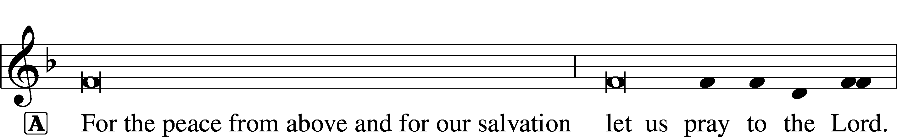

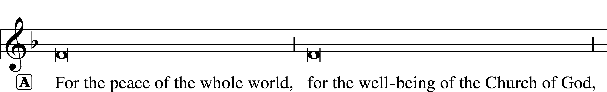


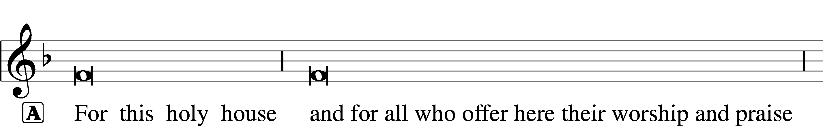





Gloria in Excelsis LSB 154
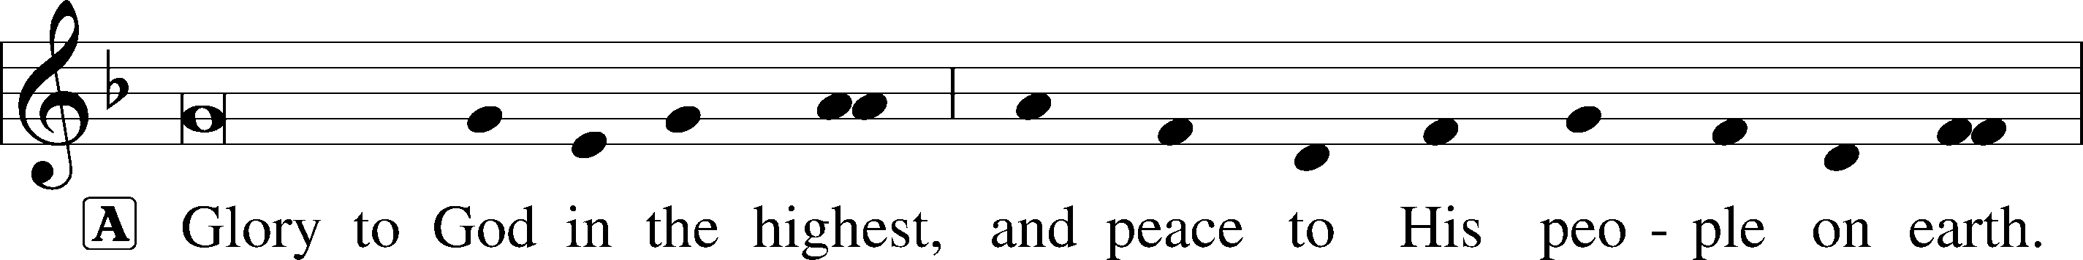
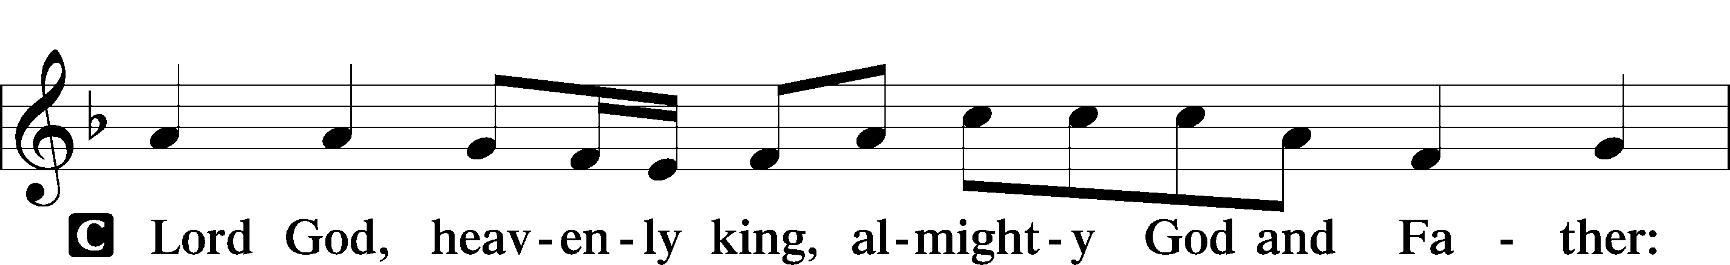
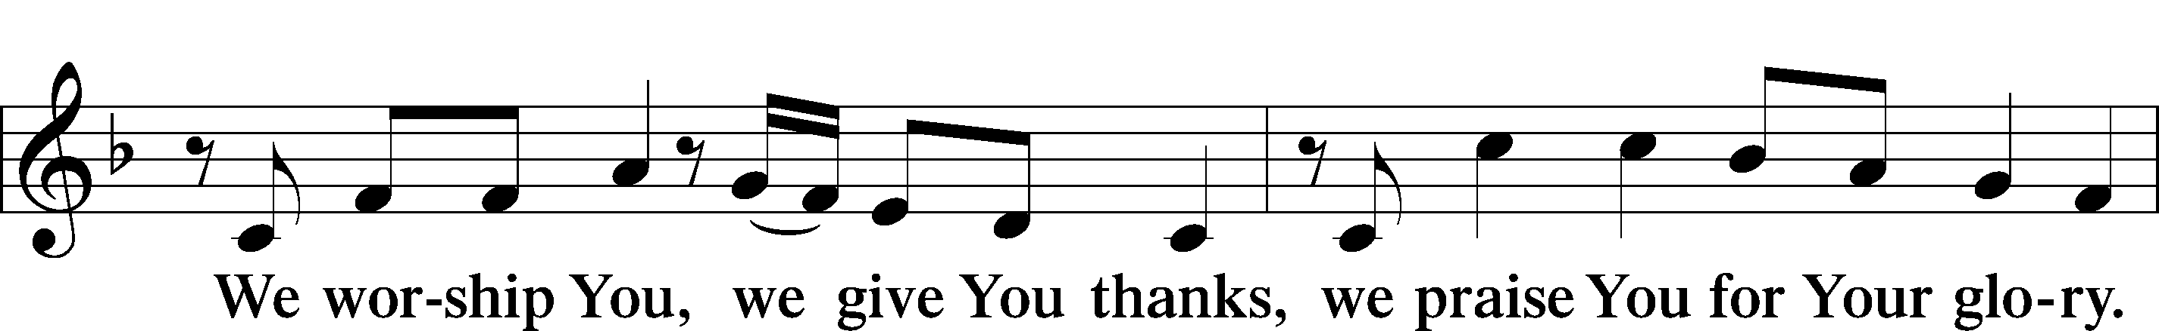
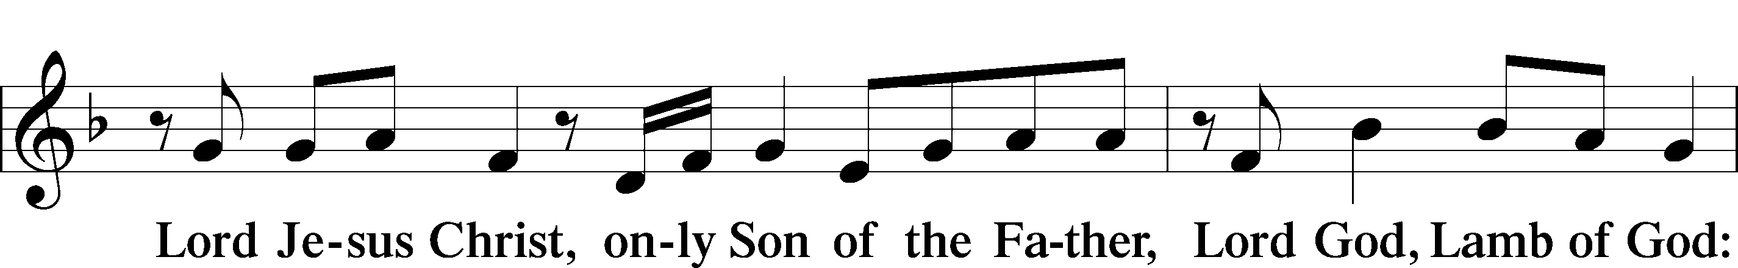
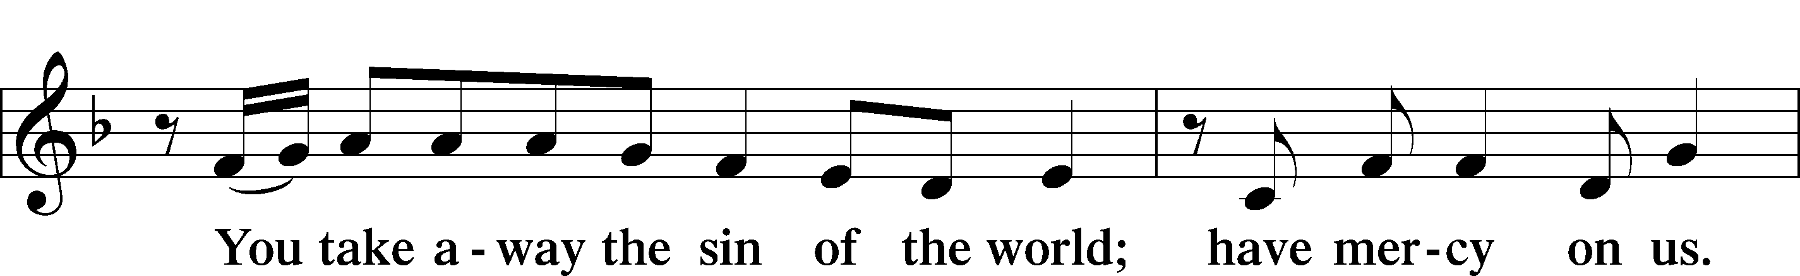
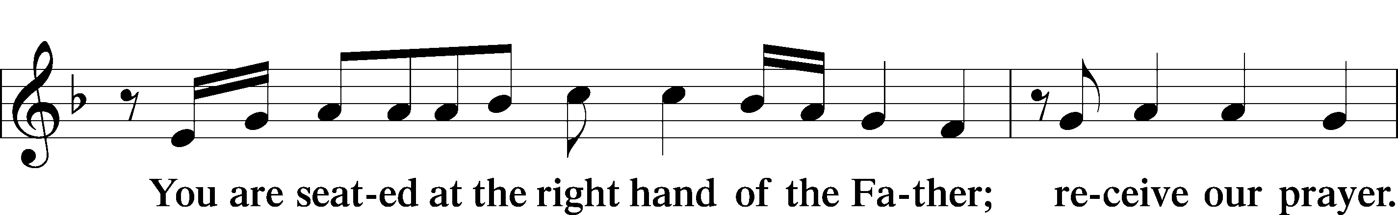
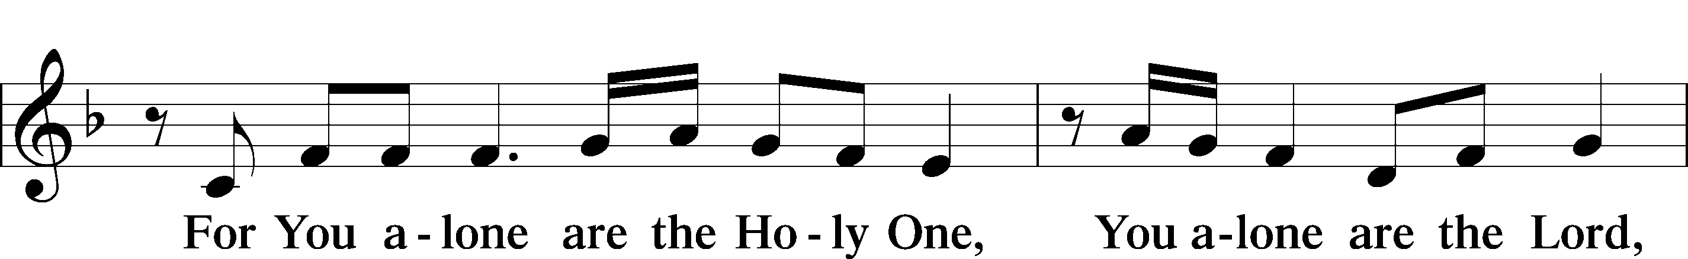
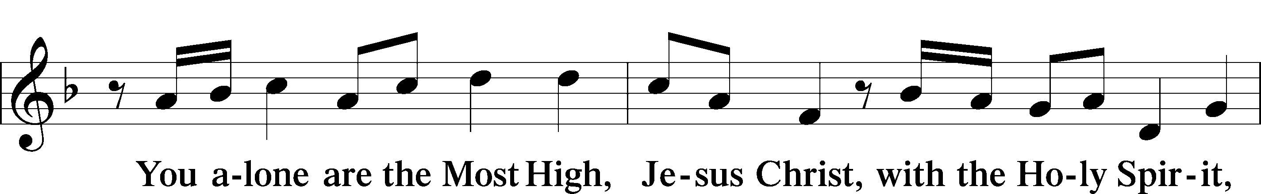
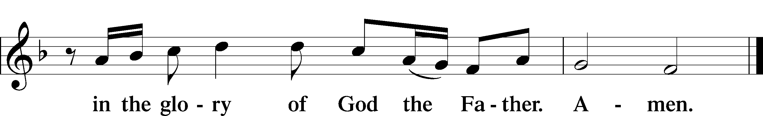

Salutation and Collect of the Day
P The Lord be with you.
C And also with you.

P Let us pray.
Living God, Your almighty power is made known chiefly in showing mercy and pity. Grant us the fullness of Your grace to lay hold of Your promises and live forever in Your presence; through Jesus Christ, Your Son, our Lord, who lives and reigns with You and the Holy Spirit, one God, now and forever.

C Amen.
Sit

Old Testament Reading Exodus 3:1–15

God promises Moses He will be with him.

1Now Moses was keeping the flock of his father-in-law, Jethro, the priest of Midian, and he led his flock to the west side of the wilderness and came to Horeb, the mountain of God. 2And the angel of the Lord appeared to him in a flame of fire out of the midst of a bush. He looked, and behold, the bush was burning, yet it was not consumed. 3And Moses said, “I will turn aside to see this great sight, why the bush is not burned.” 4When the Lord saw that he turned aside to see, God called to him out of the bush, “Moses, Moses!” And he said, “Here I am.” 5Then he said, “Do not come near; take your sandals off your feet, for the place on which you are standing is holy ground.” 6And he said, “I am the God of your father, the God of Abraham, the God of Isaac, and the God of Jacob.” And Moses hid his face, for he was afraid to look at God.
7Then the Lord said, “I have surely seen the affliction of my people who are in Egypt and have heard their cry because of their taskmasters. I know their sufferings, 8and I have come down to deliver them out of the hand of the Egyptians and to bring them up out of that land to a good and broad land, a land flowing with milk and honey, to the place of the Canaanites, the Hittites, the Amorites, the Perizzites, the Hivites, and the Jebusites. 9And now, behold, the cry of the people of Israel has come to me, and I have also seen the oppression with which the Egyptians oppress them. 10Come, I will send you to Pharaoh that you may bring my people, the children of Israel, out of Egypt.” 11But Moses said to God, “Who am I that I should go to Pharaoh and bring the children of Israel out of Egypt?” 12He said, “But I will be with you, and this shall be the sign for you, that I have sent you: when you have brought the people out of Egypt, you shall serve God on this mountain.”
13Then Moses said to God, “If I come to the people of Israel and say to them, ‘The God of your fathers has sent me to you,’ and they ask me, ‘What is his name?’ what shall I say to them?” 14God said to Moses, “I am who I am.” And he said, “Say this to the people of Israel, ‘I am has sent me to you.’” 15God also said to Moses, “Say this to the people of Israel, ‘The Lord, the God of your fathers, the God of Abraham, the God of Isaac, and the God of Jacob, has sent me to you.’ This is my name forever, and thus I am to be remembered throughout all generations.”

A This is the Word of the Lord.
C Thanks be to God.

Psalm Psalm 148; antiphon: v. 13
“His majesty is above earth and heaven”
1Praise the Lord!
Praise the Lord from the | heavens;*
praise him | in the heights!
2Praise him, all his | angels;*
praise him, | all his hosts!
3Praise him, | sun and moon,*
praise him, all you | shining stars!
4Praise him, you highest | heavens,*
and you waters above the | heavens!
5Let them praise the name | of the Lord!*
For he commanded and they were cre- | ated.
6And he established them forever and | ever;*
he gave a decree, and it shall not | pass away.
7Praise the Lord | from the earth,*
you great sea creatures and | all deeps,
8fire and hail, | snow and mist,*
stormy wind fulfill- | ing his word!
9Mountains and | all hills,*
fruit trees and all | cedars!
10Beasts and all | livestock,*
creeping things and | flying birds!
11Kings of the earth and all | peoples,*
princes and all rulers | of the earth!
12Young men and maidens to- | gether,*
old men and | children!
13Let them praise the name of the Lord,
for his name alone is ex- | alted;*
his majesty is above earth and | heaven.
14He has raised up a horn for his people,
praise for | all his saints,*
for the people of Israel who are near to him. | Praise the Lord!
Epistle 2 Thessalonians 2:1–8, 13–17

Stand firm and hold to the traditions that you were taught by us

1Now concerning the coming of our Lord Jesus Christ and our being gathered together to him, we ask you, brothers, 2not to be quickly shaken in mind or alarmed, either by a spirit or a spoken word, or a letter seeming to be from us, to the effect that the day of the Lord has come. 3Let no one deceive you in any way. For that day will not come, unless the rebellion comes first, and the man of lawlessness is revealed, the son of destruction, 4who opposes and exalts himself against every so-called god or object of worship, so that he takes his seat in the temple of God, proclaiming himself to be God. 5Do you not remember that when I was still with you I told you these things? 6And you know what is restraining him now so that he may be revealed in his time. 7For the mystery of lawlessness is already at work. Only he who now restrains it will do so until he is out of the way. 8And then the lawless one will be revealed, whom the Lord Jesus will kill with the breath of his mouth and bring to nothing by the appearance of his coming. . . .
13But we ought always to give thanks to God for you, brothers beloved by the Lord, because God chose you as the firstfruits to be saved, through sanctification by the Spirit and belief in the truth. 14To this he called you through our gospel, so that you may obtain the glory of our Lord Jesus Christ. 15So then, brothers, stand firm and hold to the traditions that you were taught by us, either by our spoken word or by our letter.
16Now may our Lord Jesus Christ himself, and God our Father, who loved us and gave us eternal comfort and good hope through grace, 17comfort your hearts and establish them in every good work and word.

A This is the Word of the Lord.
C Thanks be to God.

Stand

Alleluia and Verse LSB 156
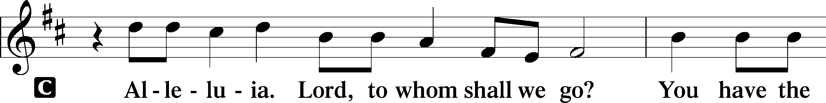
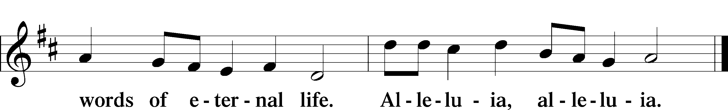

Holy Gospel Luke 20:27–40
P The Holy Gospel according to St. Luke, the twentieth chapter.
C Glory to You, O Lord.

He is the God of the living.

27There came to [Jesus] some Sadducees, those who deny that there is a resurrection, 28and they asked him a question, saying, “Teacher, Moses wrote for us that if a man’s brother dies, having a wife but no children, the man must take the widow and raise up offspring for his brother. 29Now there were seven brothers. The first took a wife, and died without children. 30And the second 31and the third took her, and likewise all seven left no children and died. 32Afterward the woman also died. 33In the resurrection, therefore, whose wife will the woman be? For the seven had her as wife.”
34And Jesus said to them, “The sons of this age marry and are given in marriage, 35but those who are considered worthy to attain to that age and to the resurrection from the dead neither marry nor are given in marriage, 36for they cannot die anymore, because they are equal to angels and are sons of God, being sons of the resurrection. 37But that the dead are raised, even Moses showed, in the passage about the bush, where he calls the Lord the God of Abraham and the God of Isaac and the God of Jacob. 38Now he is not God of the dead, but of the living, for all live to him.” 39Then some of the scribes answered, “Teacher, you have spoken well.” 40For they no longer dared to ask him any question.

P This is the Gospel of the Lord.
C Praise to You, O Christ.
Sit

771 Be Still, My Soul, before the Lord
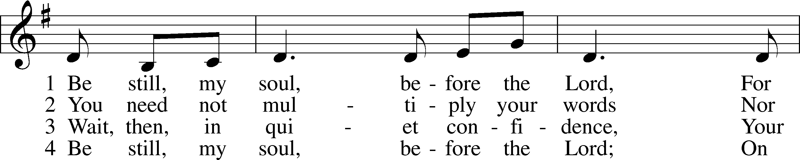
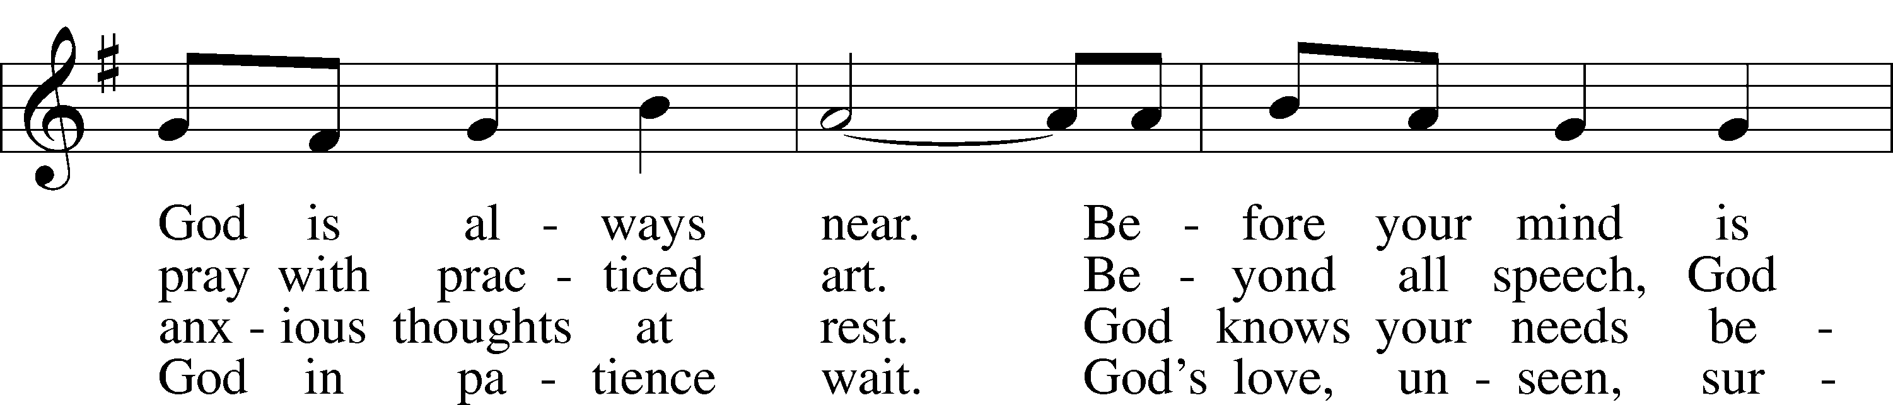
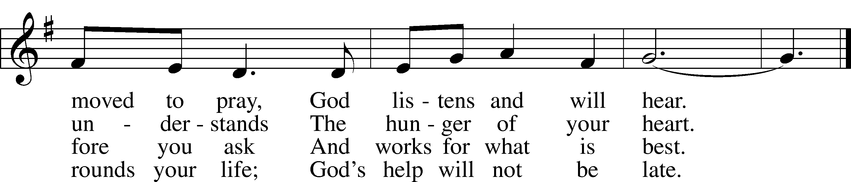
Text: Herman G. Stuempfle, Jr., 1923–2007 Tune: Marty Haugen, 1950 Text: © 2000 GIA Publications, Inc. Used by permission: LSB Hymn License no. 110003995 Tune: © 1984, 2006 GIA Publications, Inc. Used by permission: LSB Hymn License no. 110003995
Sermon
Stand

Nicene Creed
C I believe in one God, the Father Almighty,
maker of heaven and earth and of all things visible and invisible.

And in one Lord Jesus Christ, the only-begotten Son of God,
begotten of His Father before all worlds, God of God,
Light of Light, very God of very God, begotten, not made,
being of one substance with the Father,
by whom all things were made;
who for us men and for our salvation came down from heaven
and was incarnate by the Holy Spirit of the virgin Mary
and was made man;
and was crucified also for us under Pontius Pilate.
He suffered and was buried.
And the third day He rose again according to the Scriptures
and ascended into heaven and sits at the right hand of the Father.
And He will come again with glory to judge both the living and
the dead, whose kingdom will have no end.

And I believe in the Holy Spirit, the Lord and giver of life,
who proceeds from the Father and the Son,
who with the Father and the Son together is worshiped
and glorified, who spoke by the prophets.
And I believe in one holy Christian and apostolic Church,
I acknowledge one Baptism for the remission of sins,
and I look for the resurrection of the dead
and the life T of the world to come. Amen.

Prayer of the Church & Sharing of the Peace

Following the prayers, the people may greet one another in the name of the Lord, saying,
“Peace be with you,” as a sign of reconciliation and of the unity of the Spirit in the bond of peace
(Matt. 5:22–24; Eph. 4:1–3).
Offering & Offertory

Stand
781 We Give Thee But Thine Own sts. 1–2
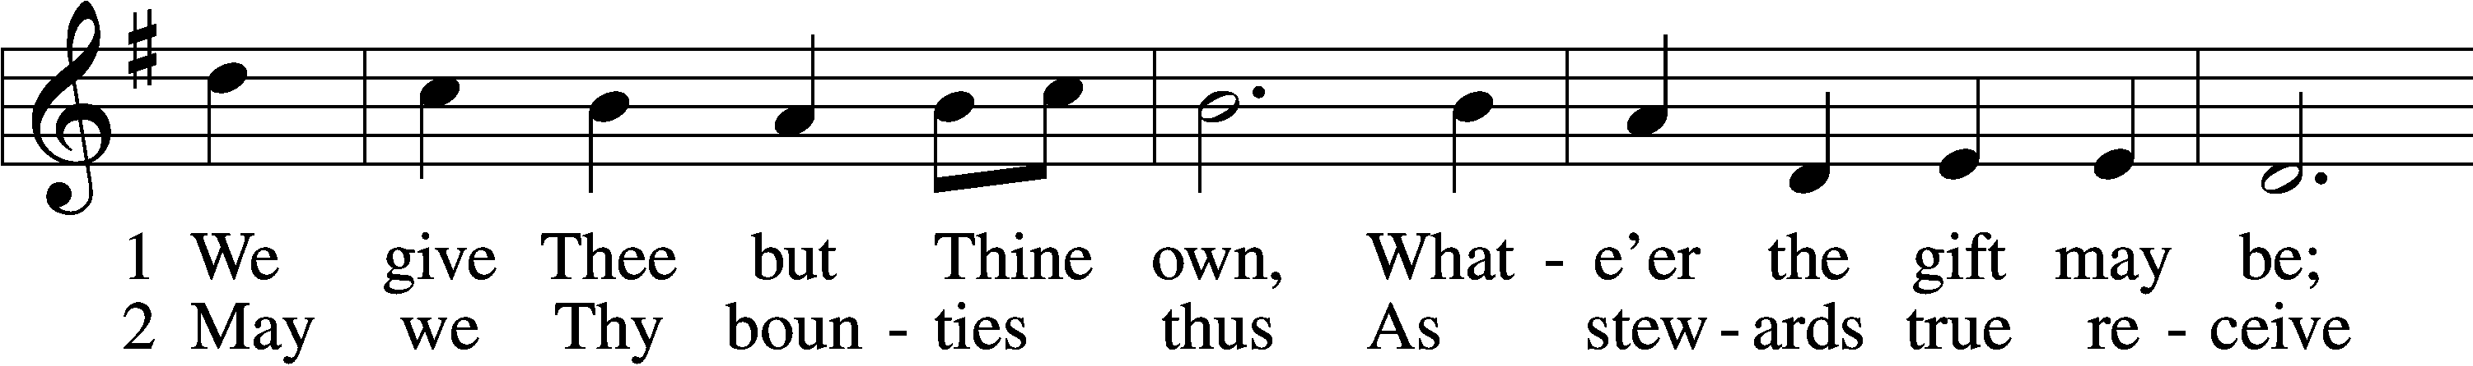
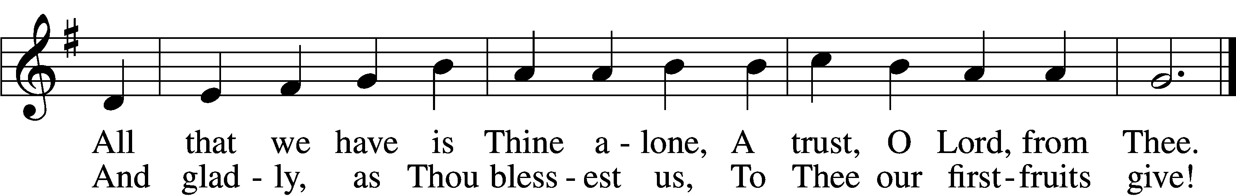
Text: William W. How, 1823–97 Tune: William H. Monk, 1823–89 Text and tune: Public domain
Service of Holy Communion
Communion Statement

The Lord’s Supper is celebrated at this congregation in the confession and glad confidence that, as He says, our Lord gives into our mouths not only bread and wine but His very body and blood to eat and to drink for the forgiveness of sins and to strengthen our union with Him and with one another. Our Lord invites to His table those who trust His words, repent of all sin, and set aside any refusal to forgive and love as He forgives and loves us, that they may show forth His death until He comes.

Because those who eat and drink our Lord’s body and blood unworthily do so to their great harm and because Holy Communion is a confession of the faith which is confessed at this altar, any who are not yet instructed, in doubt, or who hold a confession differing from that of this congregation and the Lutheran Church Missouri Synod, and yet desire to receive this sacrament, are asked to speak with the Pastor.
* See more about the Lutheran teaching on communion in the Hymnal p 329.

Preface LSB 160





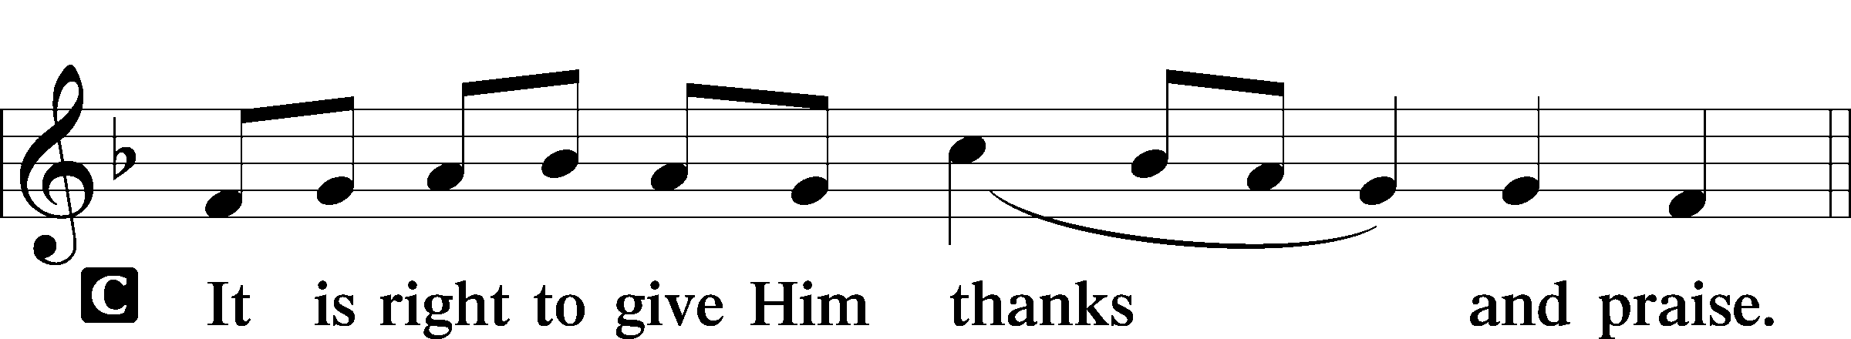

P It is truly good, right, and salutary that we should at all times and in all places give thanks to You, holy Lord, almighty Father, everlasting God, through Jesus Christ, our Lord, who, out of love for His fallen creation, humbled Himself by taking on the form of a servant, becoming obedient unto death, even death upon a cross. Risen from the dead, He has freed us from eternal death and given us life everlasting. Therefore with angels and archangels and with all the company of heaven we laud and magnify Your glorious name, evermore praising You and saying:
Sanctus LSB 161
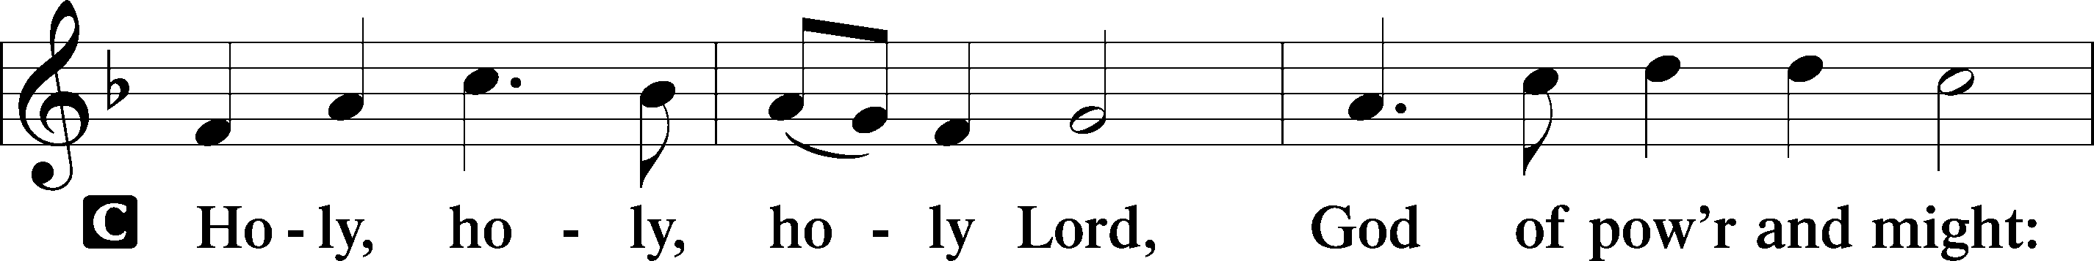
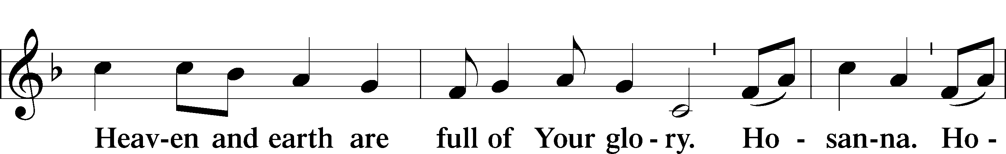
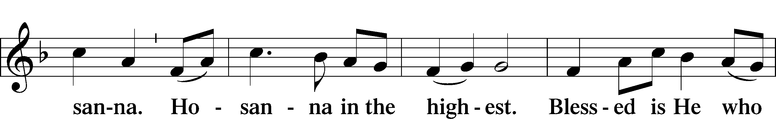
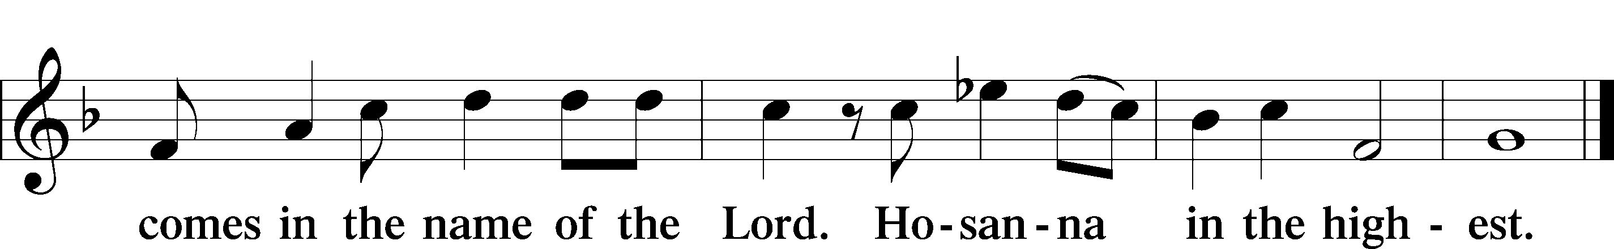
Prayer of Thanksgiving LSB 161
P Blessed are You, Lord of heaven and earth, for You have had mercy on those whom You created and sent Your only-begotten Son into our flesh to bear our sin and be our Savior. With repentant joy we receive the salvation accomplished for us by the all-availing sacrifice of His body and His blood on the cross.

Gathered in the name and the remembrance of Jesus, we beg You, O Lord, to forgive, renew, and strengthen us with Your Word and Spirit. Grant us faithfully to eat His body and drink His blood as He bids us do in His own testament. Gather us together, we pray, from the ends of the earth to celebrate with all the faithful the marriage feast of the Lamb in His kingdom, which has no end. Graciously receive our prayers; deliver and preserve us. To You alone, O Father, be all glory, honor, and worship, with the Son and the Holy Spirit, one God, now and forever.
C Amen.

The Words of Our Lord
P Our Lord Jesus Christ, on the night when He was betrayed, took bread, and when He had given thanks, He broke it and gave it to the disciples and said: “Take, eat; this is My T body, which is given for you. This do in remembrance of Me.”
In the same way also He took the cup after supper, and when He had given thanks, He gave it to them, saying: “Drink of it, all of you; this cup is the new testament in My T blood, which is shed for you for the forgiveness of sins. This do, as often as you drink it, in remembrance of Me.”

P As often as we eat this bread and drink this cup, we proclaim the Lord’s death until He comes.
C Amen. Come, Lord Jesus.

P O Lord Jesus Christ, only Son of the Father, in giving us Your body and blood to eat and to drink, You lead us to remember and confess Your holy cross and passion, Your blessed death, Your rest in the tomb, Your resurrection from the dead, Your ascension into heaven, and Your coming for the final judgment. So remember us in Your kingdom and teach us to pray:
Lord’s Prayer
C Our Father who art in heaven, hallowed be Thy name,
Thy kingdom come, Thy will be done on earth
as it is in heaven; give us this day our daily bread;
and forgive us our trespasses as we forgive those
who trespass against us;
and lead us not into temptation, but deliver us from evil.
For Thine is the kingdom and the power and the glory
forever and ever. Amen.

Pax Domini LSB 163
P The peace of the Lord be with you always.
C Amen.

Agnus Dei (Spoken)

The pastor elevates the chalice and host and says:

P Behold, the Lamb of God that takes away the sins of the world.
C Lord, have mercy upon us.

Agnus Dei LSB 163
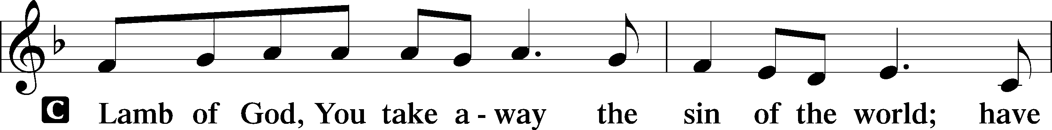
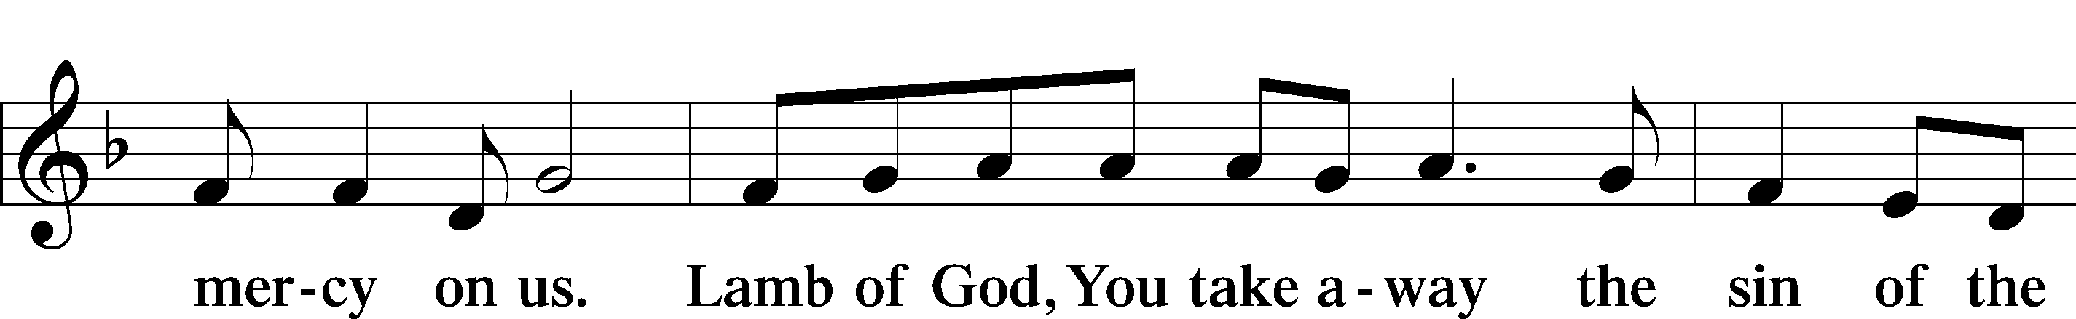
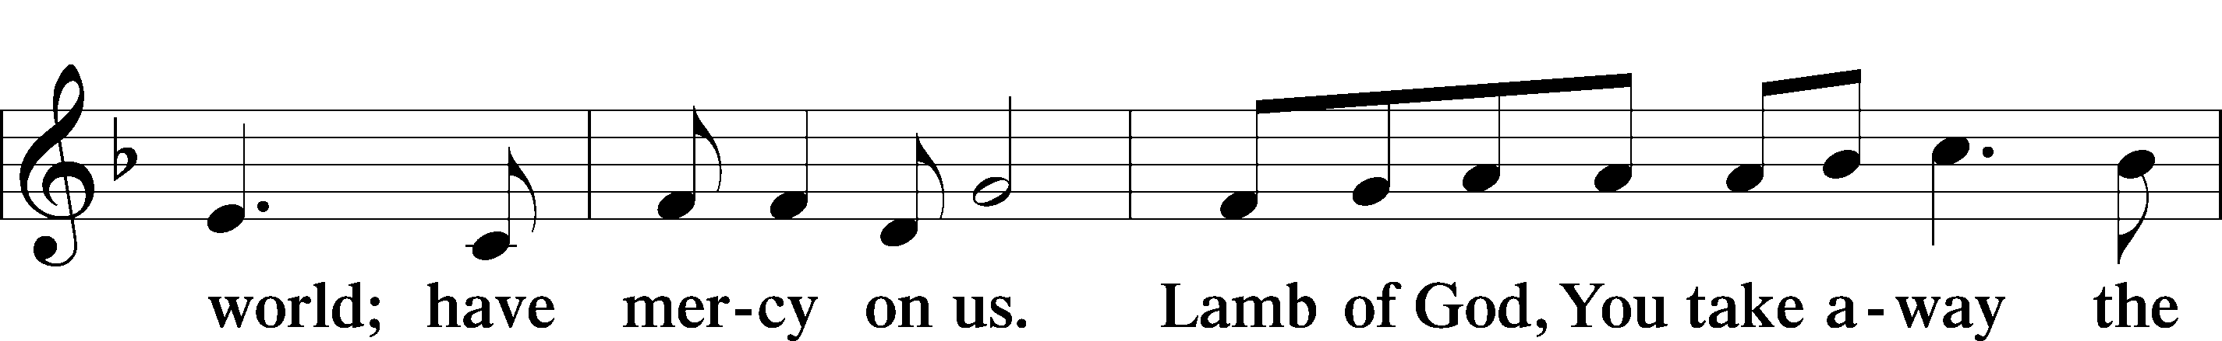
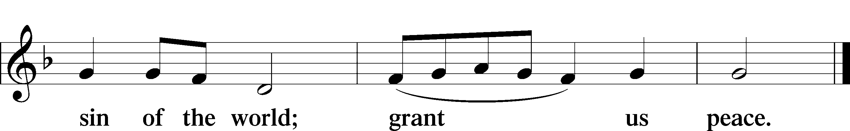

Distribution

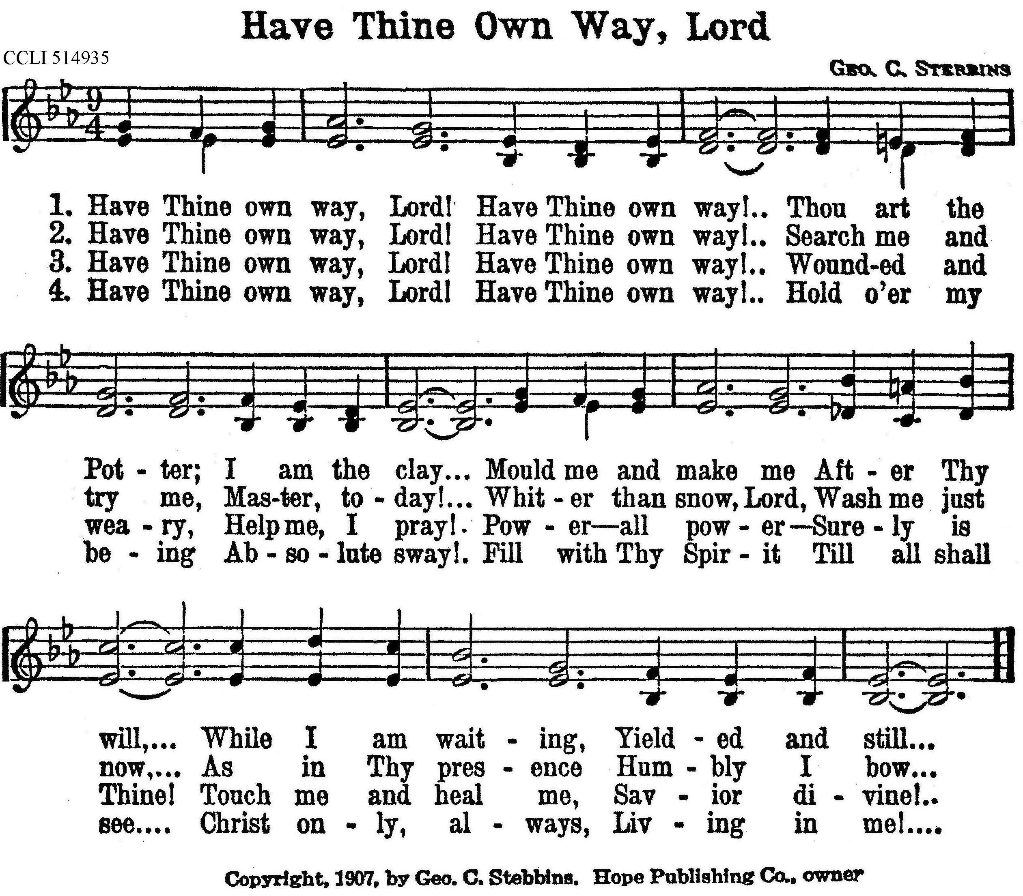
Stand

Thank the Lord LSB 164
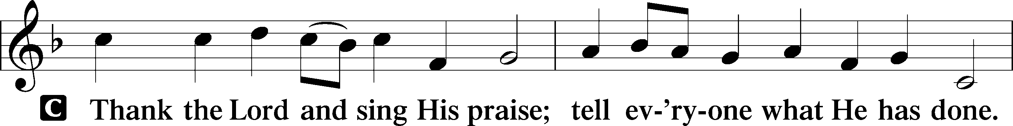
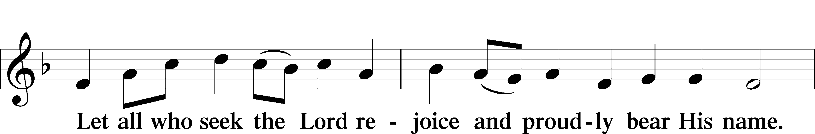
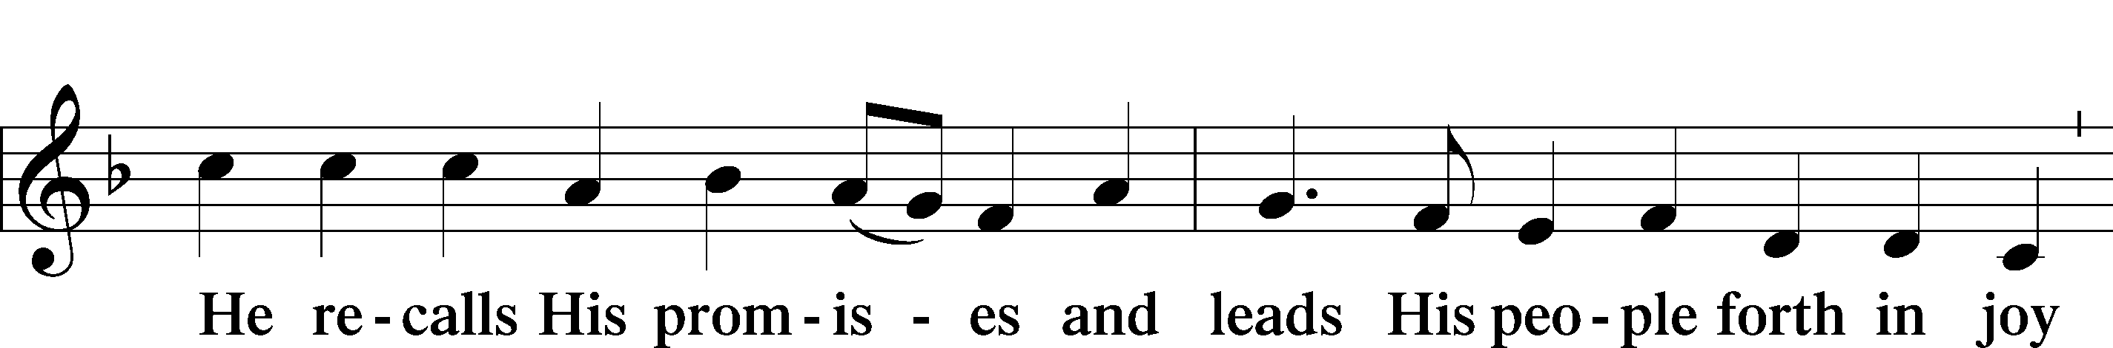
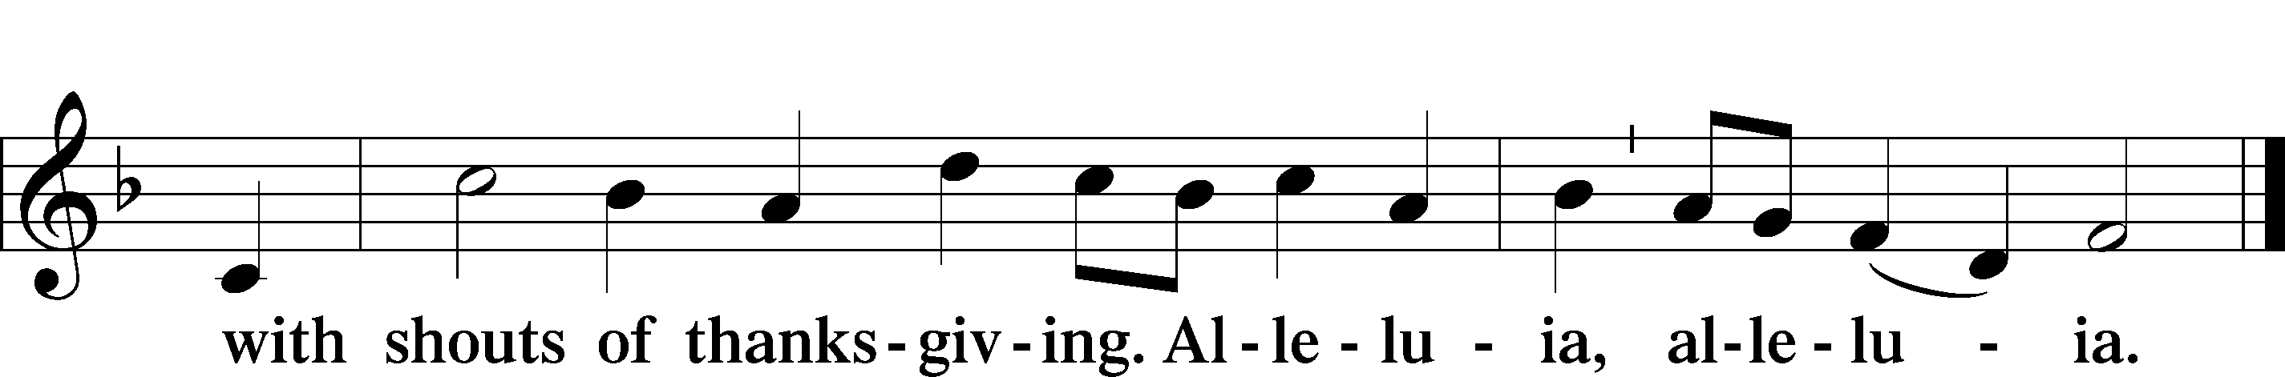

Post-Communion Collect
A Let us pray.
We give thanks to You, almighty God, that You have refreshed us through this salutary gift, and we implore You that of Your mercy You would strengthen us through the same in faith toward You and in fervent love toward one another; through Jesus Christ, Your Son, our Lord, who lives and reigns with You and the Holy Spirit, one God, now and forever.
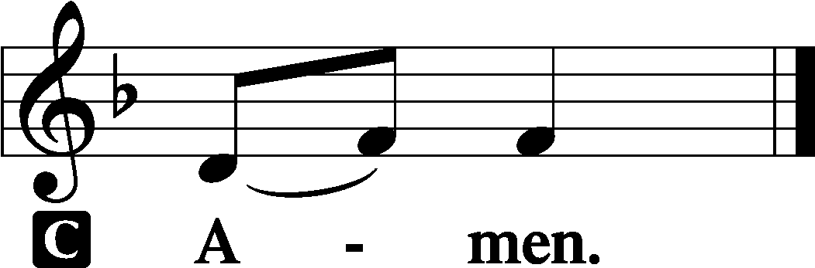

Verse of the Day Luke 20:38

P Alleluia! He is not God of the dead,
C but of the living, for all live to him. Alleluia!

Benediction LSB 166
P The Lord bless you and keep you.
The Lord make His face shine on you and be gracious to you.
The Lord look upon you with favor and T give you peace.

461 I Know That My Redeemer Lives sts. 1, 3, 5, 7–8
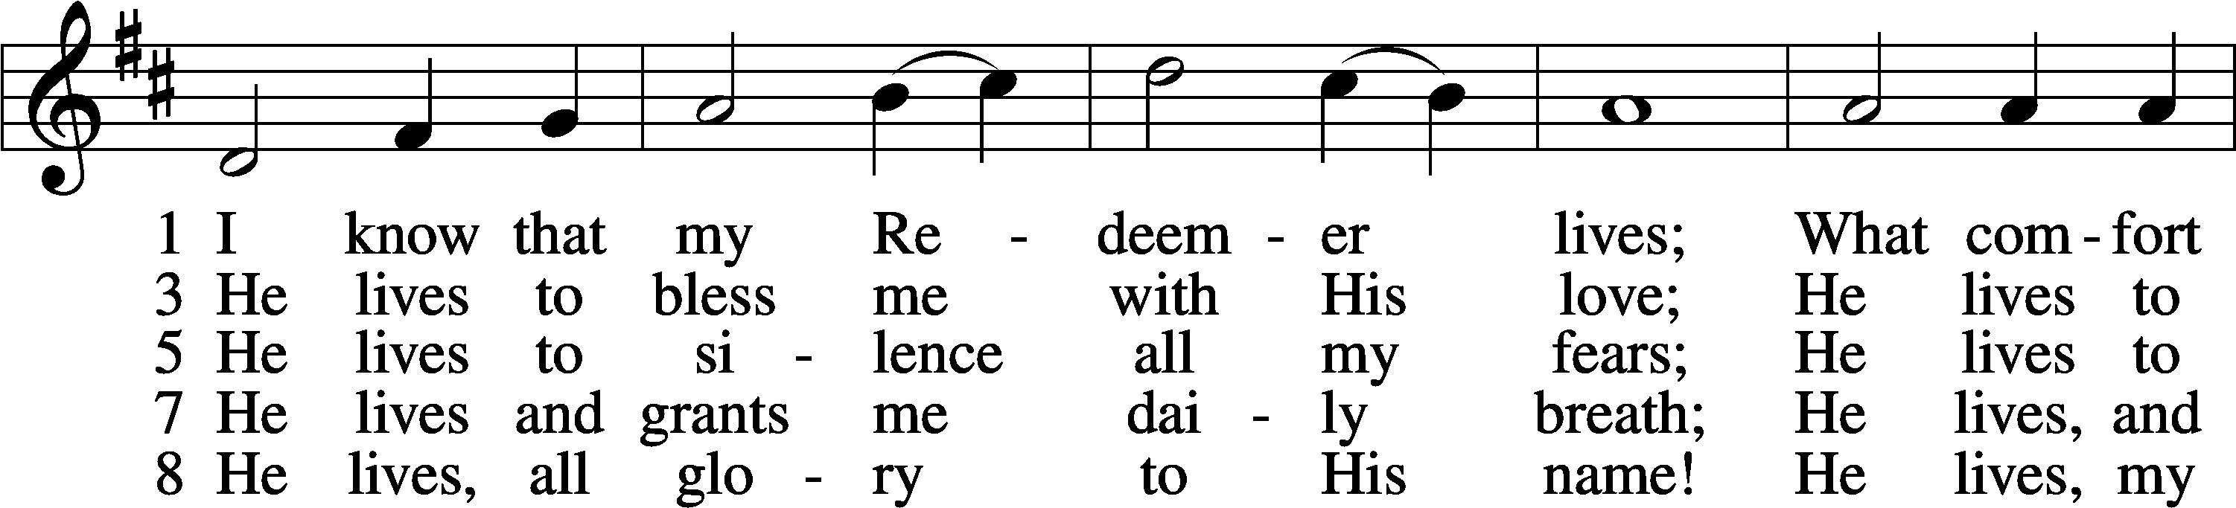
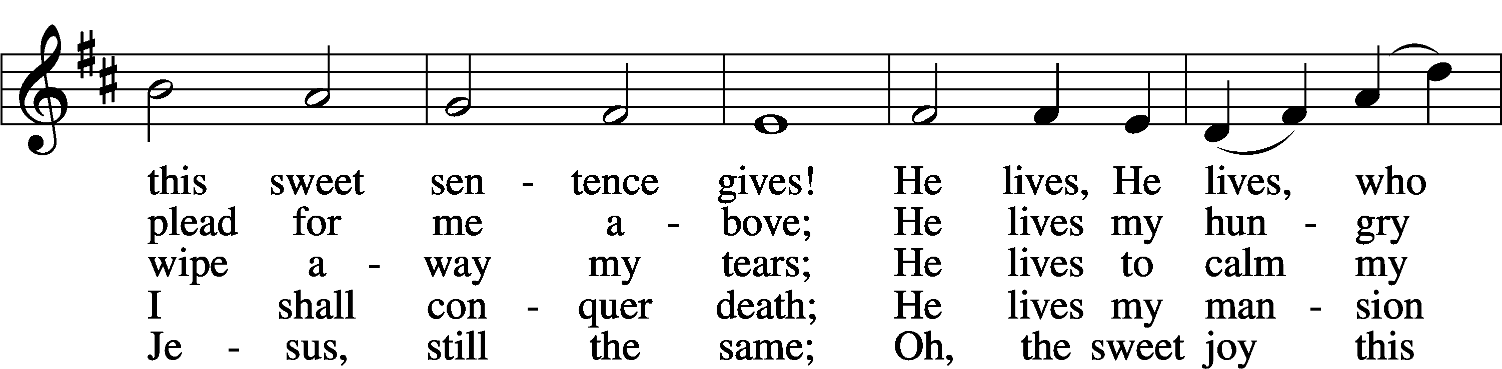
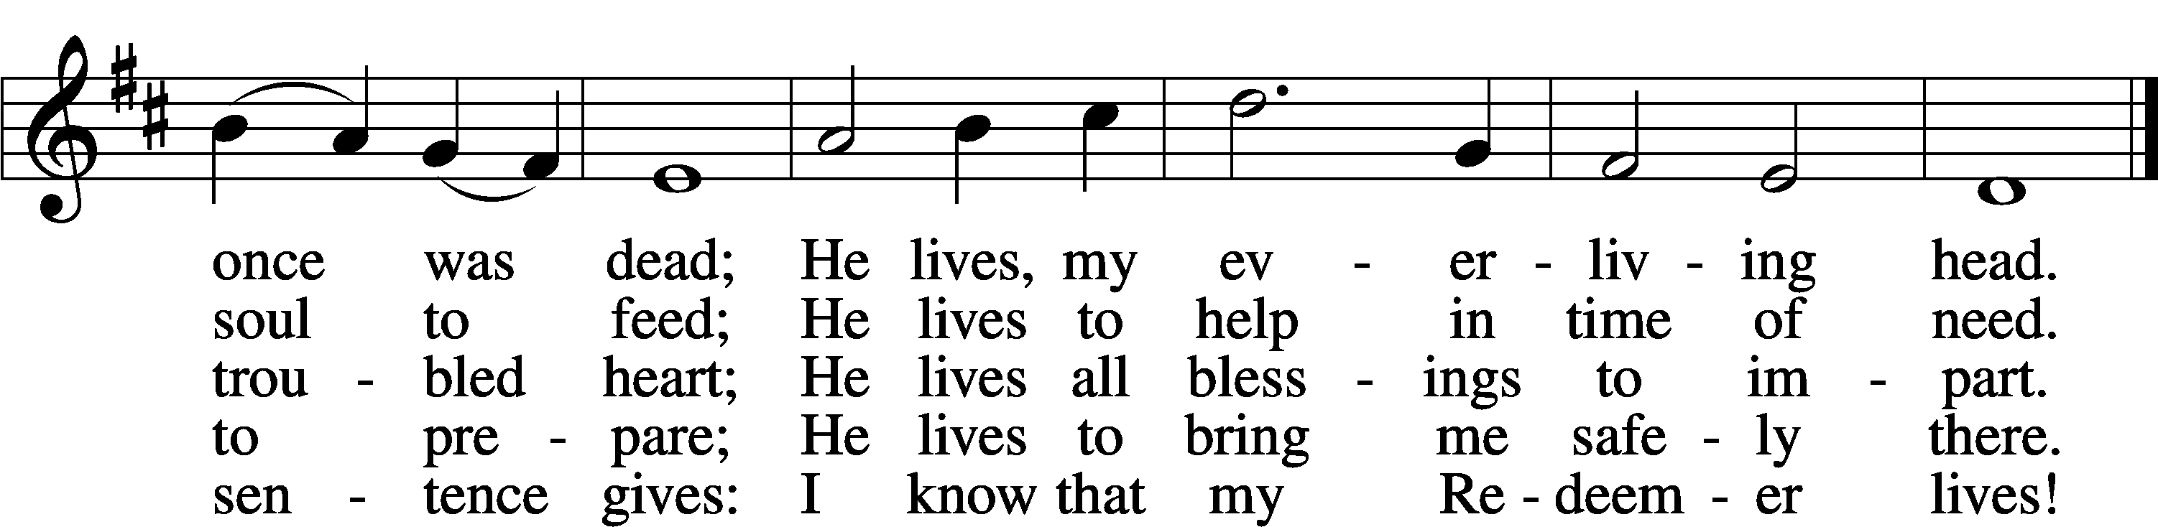
Text: Samuel Medley, 1738–99, abr. Tune: attr. John C. Hatton, d. 1793 Text and tune: Public domain
Acknowledgments
Divine Service, Setting One from Lutheran Service Book Unless otherwise indicated, Scripture quotations are from the ESV® Bible (The Holy Bible, English Standard Version®), copyright © 2001 by Crossway, a publishing ministry of Good News Publishers. Used by permission. All rights reserved.
Created by Lutheran Service Builder © 2025 Concordia Publishing House.

Prayers of the Church
This week, we lift up:

Angela H, Bob C, Mike Y, Sheila, Elaine, Angie Z, Angela C, Ross, & Kathy H.

Family of the week: Vicar Previn, Ananda and Cyrus Hudetz.

*If you have any prayer request let us know.

Last week: Attendance 31 Offering $1087

October 2025 Income: $8,815 Expenses: $13,671

Serving Next Week (11/16/25)  Service leader: Vicar Previn Hudetz  Communion Celebrant: Rev John Heffelfinger  Communion Assistant: Jim C  Worship Assistant: TBD  Reader: Samantha T  Refreshments: Rebecca Vigil  Altar Guild: Angie Z & Sheila S  Greeter: Michael Y | Readings Next Week  Twenty-third Sunday after Pentecost  - Malachi 4  - Psalm 98  - 2 Thessalonians 3:1-13  - Luke 21:5-28  *Please sign up to help during service.*
Announcements  Birthdays:  This Week at OSLC:  Bible Study: After Service  Bible Study: Thursday 10am  This Month at OSLC  11/26 6pm Thanksgiving Eve Service  11/27 1pm Thanksgiving Meal  (Please sign up to attend.) | Coming Up:  Christmas Decorating Sat 11/29/25  ADVENT  December 3,10, & 17  4:30pm Soup - Fellowship - Games  6:00pm Advent Services


Stewardship Thoughts… November 9th, 2025

Mark 12:44 –

“For they all contributed out of their abundance, but she out of her poverty has put in everything she had, all she had to live on.” From Old Testament times right through to today the Lord has urged us to give to His work in the Church in proportion to how He has blessed us. He has also called us to sacrificial giving, that is, giving that actually costs us something. That’s the shape of true Christian generosity.

Lcms.org/stewardship

Seasons of the Church Year
Trinitytide
Color: Green • Symbol: Hourglass or Watchful Eye

As we move into the last weeks of Trinitytide, the focus of the Church’s worship turns toward the end of all things. The lectionary readings call us to watchfulness, repentance, and readiness for Christ’s return. Though the paraments remain green, these final Sundays remind us that God is bringing His kingdom to completion and that His people live in hope awaiting the day when all things are made new.

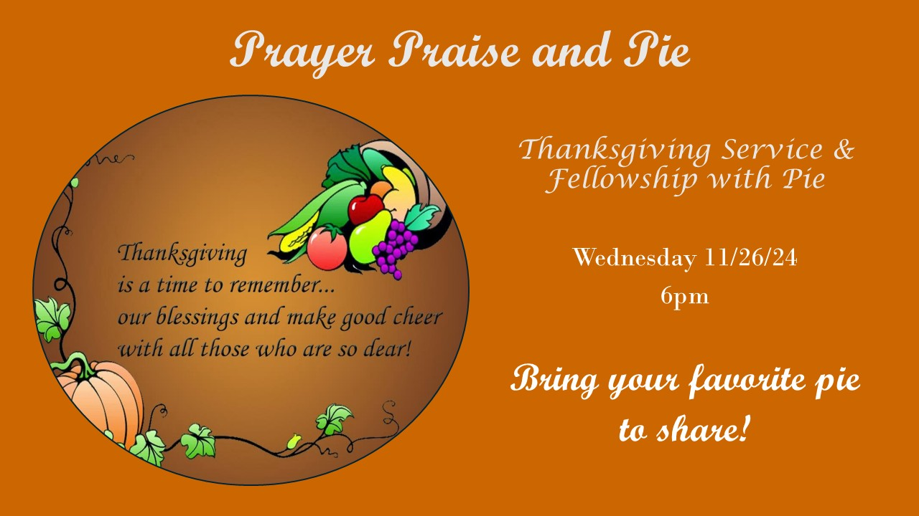



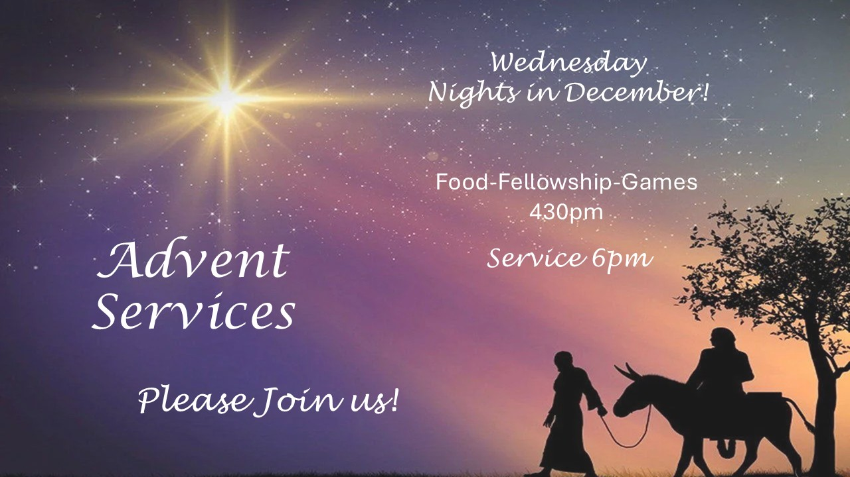

Lectionary Summaries
Overview of Today’s Assigned Reading (9 November 2025)
Exodus 3:1–15 / 2 Thessalonians 2:1–8, 13–17 / Luke 20:27–40

The Triune God Curbs Evil and Overcomes Death with Resurrection

Christians live as “sons of God, being sons of the resurrection” (Luke 20:36), for the Lord our God “is not God of the dead, but of the living” (Luke 20:38). “Those who deny that there is a resurrection” (Luke 20:27) neither know the Scriptures nor the power of God, but the baptized faithful know “that the dead are raised” (Luke 20:37).

For the Lord, who was and is and is to come, knows Israel’s sufferings and has “come down to deliver them” (Ex. 3:8). Moses reveals the name of Yahweh to God’s chosen people, by which He is “remembered throughout all generations” (Ex. 3:15).

In contrast to that sacred remembrance of His name, St. Paul warns against the antichrist, who “takes his seat in the temple of God” (2 Thess. 2:4). That lawless man preaches and practices the activity of Satan. Christians, however, are comforted by the coming of the Lord Jesus, who slays the antichrist and refutes his false doctrine “with the breath of his mouth” (2 Thess. 2:8). By His preaching, “stand firm and hold to the traditions that you were taught” (2 Thess. 2:15). Hear, receive and believe God’s promise of love, comfort and good hope.

