

‘Rejoice with me, for I have found my sheep that was lost.’
Luke 15:6

Our Savior Lutheran Church (LCMS)
4301 Atrisco Drive NW
Albuquerque, New Mexico
Website: OSLCNM.COM
Phone: 505.836.7007
Email: oslcabq@gmail.com

Fourteenth Sunday after Pentecost
September 14th,2025
The Time of the Church (Trinitytide)
Fourteenth Sunday after Pentecost
September 14th, 2025

Welcome to Our Savior Lutheran Church (LCMS).  We are glad you are here as we worship, praise, and give thanks to our loving Lord, Jesus Christ. Please join us immediately after service for fellowship and snacks. Adult Bible Study starts at 10:30. If you have any questions about our service or need other assistance, please contact one of our worship assistants. | Hymns  Opening # 740  Sermon # 681  Distribution # 437  Closing # 744
Today’s Message

“The Power of One” — What is the value of ‘one’? To Jesus, ‘one’ is infinitely precious. He tells us in Luke, “There is joy before the angels of God over one sinner who repents.” That one could be you—or someone you love. Christ came for every ‘one,’ so that each might share His eternal Kingdom. The value of one? In the eyes of Jesus—'priceless’.
+++

Serving Today
Guest Pastor: Rev Doyle Boykin
Music Minister: Vicar Previn Hudetz
Worship Assistant: TBD
Reader: Sheila S
Refreshments: Mike Y
Altar Guild: Angie Z & Sheila S
Greeter: Juanita

Welcome
Divine Service IV

740 I Am Jesus’ Little Lamb
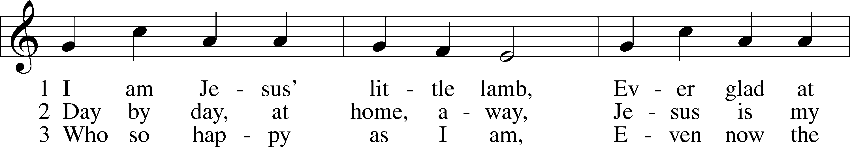
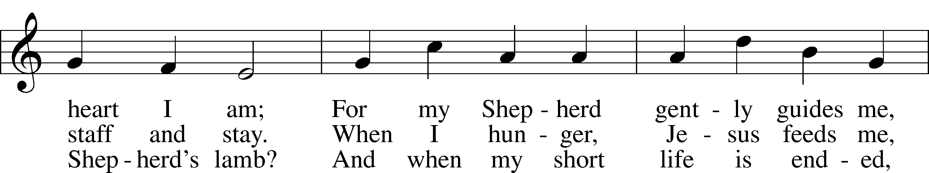
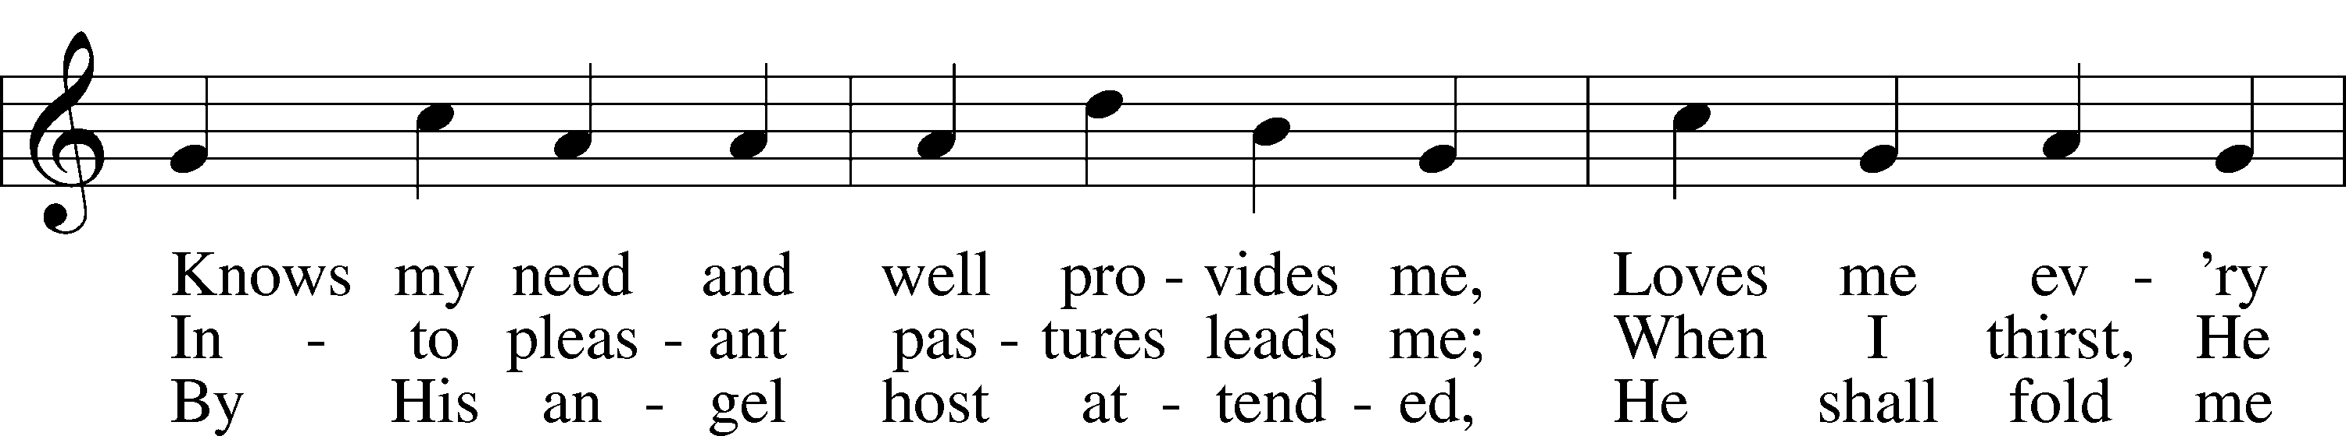
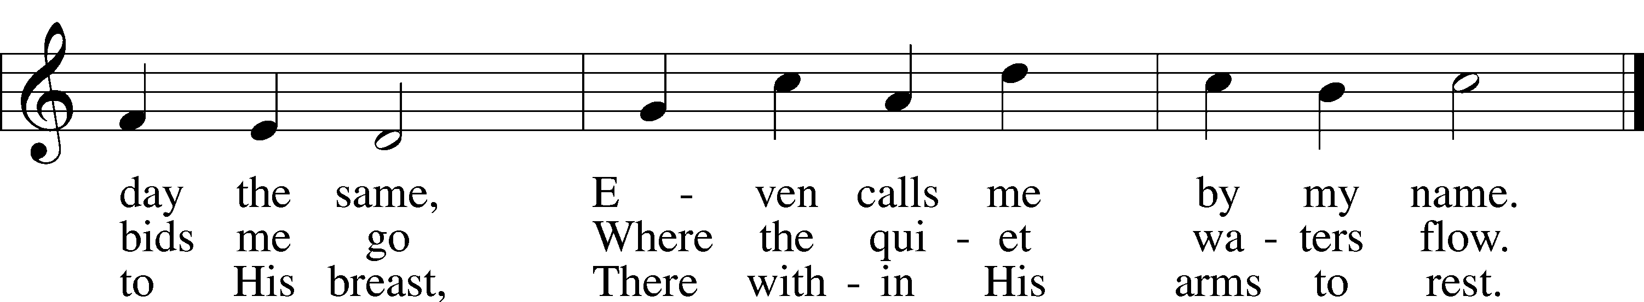
Text: Henrietta L. von Hayn, 1724–82; tr. The Lutheran Hymnal, 1941
Tune: Choral-Buch . . . Brüder-Gemeinen, 1784, Leipzig
Text and tune: Public domain

Stand
Confession and Absolution
The sign of the cross may be made by all in remembrance of their Baptism.

P In the name of the Father and of the T Son and of the Holy Spirit.
C Amen.

P Our help is in the name of the Lord,
C who made heaven and earth.

P If You, O Lord, kept a record of sins, O Lord, who could stand?
C But with You there is forgiveness; therefore You are feared.

P Since we are gathered to hear God’s Word, call upon Him in prayer and praise, and receive the body and blood of our Lord Jesus Christ in the fellowship of this altar, let us first consider our unworthiness and confess before God and one another that we have sinned in thought, word, and deed, and that we cannot free ourselves from our sinful condition. Together as His people let us take refuge in the infinite mercy of God, our heavenly Father, seeking His grace for the sake of Christ, and saying: God, be merciful to me, a sinner.

Pause for reflection

C Almighty God, have mercy upon us, forgive us our sins, and lead us to everlasting life. Amen.

P Almighty God, in His mercy has given His Son to die for you and for His sake forgive you all you sins. As a called and ordained servant of Christ, and by His authority, I therefore forgive you all your sins in the name of the Father and of the T Son and of the Holy Spirit.
Grant this, Lord, unto us all.
C Amen.

Stand
Service of the Word

Invitatory for Trinitytide
The Lord has sanctified us in the true faith *
O come, let us worship Him. *
Lord, teach me to do Your will.
Let Your good Spirit lead me on level ground. Psalm 143:10
Introit
You have turned for me my mourning into | dancing;*
O Lord my God, I will give thanks to you for- | ever!
O Lord my God, I cried to | you for help,*
and you have | healed me.
O Lord, you have brought up my soul | from Sheol;*
you restored me to life from among those who go down | to the pit.
Sing praises to the Lord, O | you his saints,*
and give thanks to his | holy name.
For his anger is but for a moment, and his favor is for a | lifetime.*
Weeping may tarry for the night, but joy comes with the | morning.
Glory be to the Father and | to the Son*
and to the Holy | Spirit;
as it was in the be- | ginning,*
is now, and will be forever. | Amen.
You have turned for me my mourning into | dancing;*
O Lord my God, I will give thanks to you for- | ever!
Kyrie 204

P In Peace, let us pray to the Lord
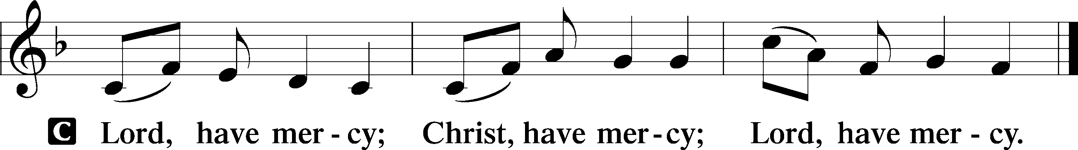

P For the peace of the whole world, for the wellbeing of the Church of God and for the unity of all; let us pray to the Lord.

P For this holy House, and all who offer here their worship and praise; let us pray to the Lord.
Gloria in Excelsis LSB 204
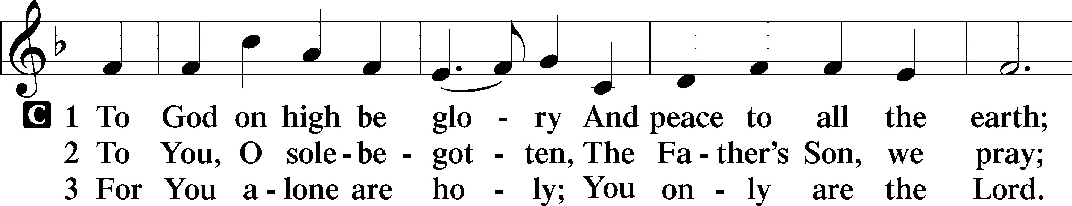
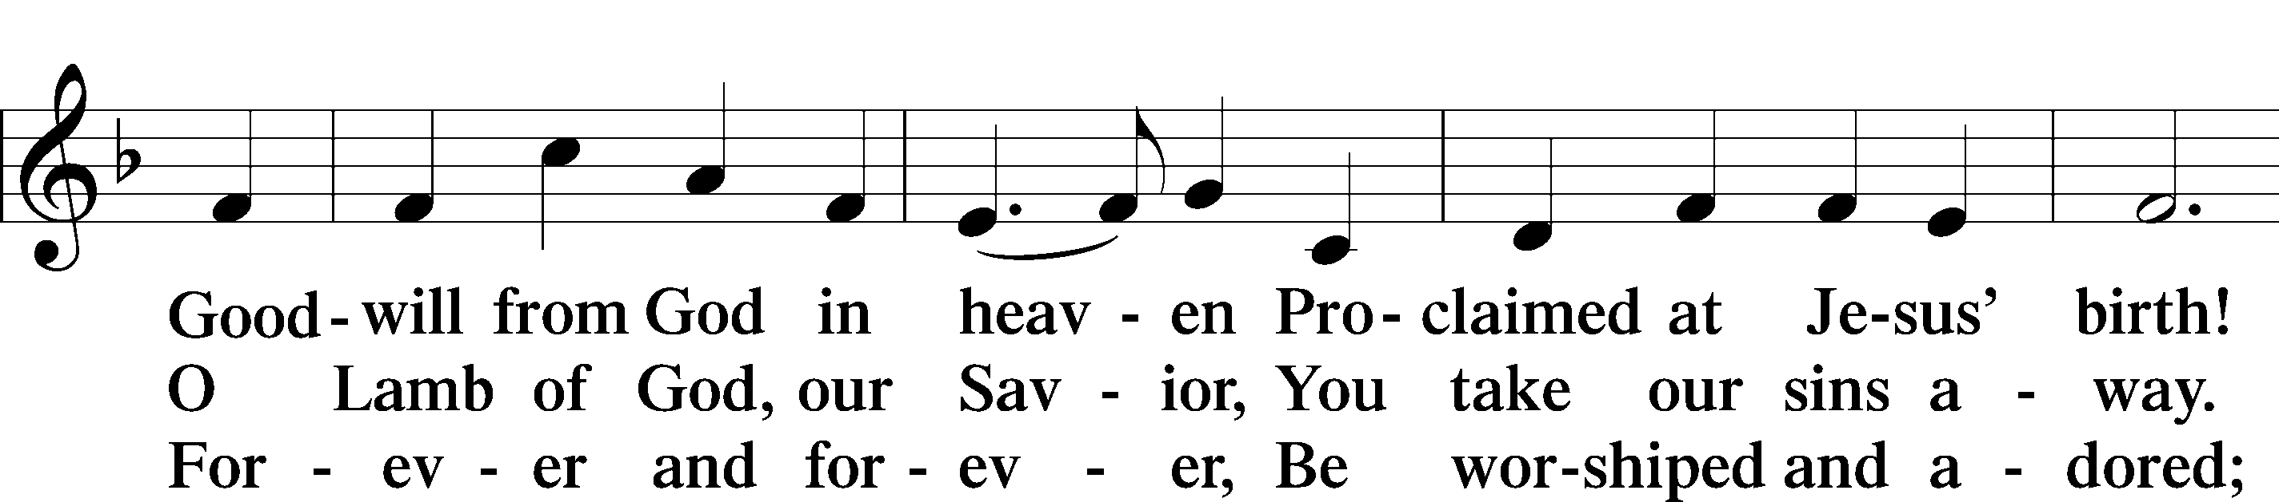
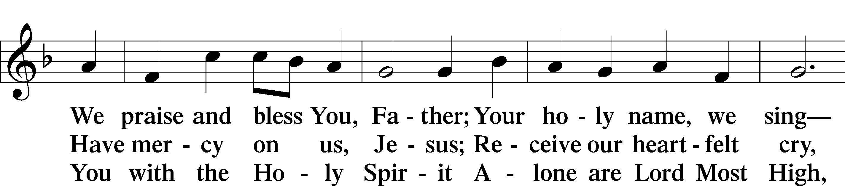
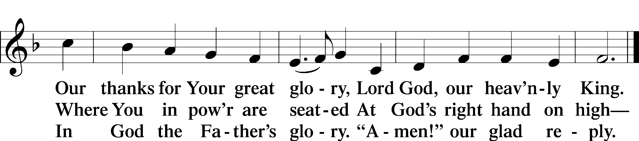
Text: Stephen P. Starke

Salutation and Collect of the Day
P The Lord be with you.
C And also with you.
P Let us pray.
Lord Jesus, You are the Good Shepherd, without whom nothing is secure. Rescue and preserve us that we may not be lost forever but follow You, rejoicing in the way that leads to eternal life; for You live and reign with the Father and the Holy Spirit, one God, now and forever.

C Amen.
Sit
Old Testament Reading Ezekiel 34:11–24

A The Old Testament read from the 34th chapter of Ezekiel.

11“For thus says the Lord God: Behold, I, I myself will search for my sheep and will seek them out. 12As a shepherd seeks out his flock when he is among his sheep that have been scattered, so will I seek out my sheep, and I will rescue them from all places where they have been scattered on a day of clouds and thick darkness. 13And I will bring them out from the peoples and gather them from the countries, and will bring them into their own land. And I will feed them on the mountains of Israel, by the ravines, and in all the inhabited places of the country. 14I will feed them with good pasture, and on the mountain heights of Israel shall be their grazing land. There they shall lie down in good grazing land, and on rich pasture they shall feed on the mountains of Israel. 15I myself will be the shepherd of my sheep, and I myself will make them lie down, declares the Lord God. 16I will seek the lost, and I will bring back the strayed, and I will bind up the injured, and I will strengthen the weak, and the fat and the strong I will destroy. I will feed them in justice.
17“As for you, my flock, thus says the Lord God: Behold, I judge between sheep and sheep, between rams and male goats. 18Is it not enough for you to feed on the good pasture, that you must tread down with your feet the rest of your pasture; and to drink of clear water, that you must muddy the rest of the water with your feet? 19And must my sheep eat what you have trodden with your feet, and drink what you have muddied with your feet?
20“Therefore, thus says the Lord God to them: Behold, I, I myself will judge between the fat sheep and the lean sheep. 21Because you push with side and shoulder, and thrust at all the weak with your horns, till you have scattered them abroad, 22I will rescue my flock; they shall no longer be a prey. And I will judge between sheep and sheep. 23And I will set up over them one shepherd, my servant David, and he shall feed them: he shall feed them and be their shepherd. 24And I, the Lord, will be their God, and my servant David shall be prince among them. I am the Lord; I have spoken.”

A This is the Word of the Lord.
C Thanks be to God.

Psalm Psalm 119:169–176; antiphon: v. 176
Taw
169Let my cry come before you, | O Lord;*
give me understanding according | to your word!
170Let my plea come be- | fore you;*
deliver me according | to your word.
171My lips will | pour forth praise,*
for you teach me your | statutes.
172My tongue will sing | of your word,*
for all your command- | ments are right.
173Let your hand be ready to | help me,*
for I have chosen your | precepts.
174I long for your salvation, | O Lord,*
and your law is | my delight.
175Let my soul live and | praise you,*
and let your just decrees | help me.
176I have gone astray like a lost sheep; seek your | servant,*
for I do not forget your com- | mandments.
Epistle 1 Timothy 1:5–17

A The Epistle is read from 1st Timothy chapter 1.

5The aim of our charge is love that issues from a pure heart and a good conscience and a sincere faith. 6Certain persons, by swerving from these, have wandered away into vain discussion, 7desiring to be teachers of the law, without understanding either what they are saying or the things about which they make confident assertions.
8Now we know that the law is good, if one uses it lawfully, 9understanding this, that the law is not laid down for the just but for the lawless and disobedient, for the ungodly and sinners, for the unholy and profane, for those who strike their fathers and mothers, for murderers, 10the sexually immoral, men who practice homosexuality, enslavers, liars, perjurers, and whatever else is contrary to sound doctrine, 11in accordance with the glorious gospel of the blessed God with which I have been entrusted.
12I thank him who has given me strength, Christ Jesus our Lord, because he judged me faithful, appointing me to his service, 13though formerly I was a blasphemer, persecutor, and insolent opponent. But I received mercy because I had acted ignorantly in unbelief, 14and the grace of our Lord overflowed for me with the faith and love that are in Christ Jesus. 15The saying is trustworthy and deserving of full acceptance, that Christ Jesus came into the world to save sinners, of whom I am the foremost. 16But I received mercy for this reason, that in me, as the foremost, Jesus Christ might display his perfect patience as an example to those who were to believe in him for eternal life. 17To the King of ages, immortal, invisible, the only God, be honor and glory forever and ever. Amen.

A This is the Word of the Lord.
C Thanks be to God.
Stand
Alleluia and Verse

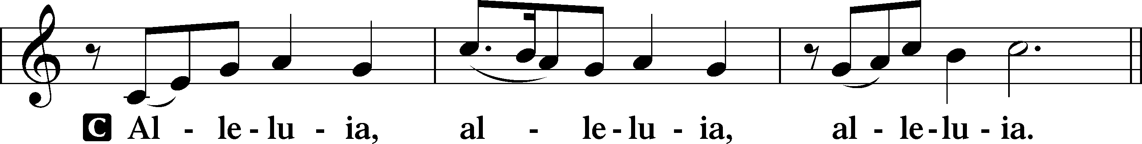

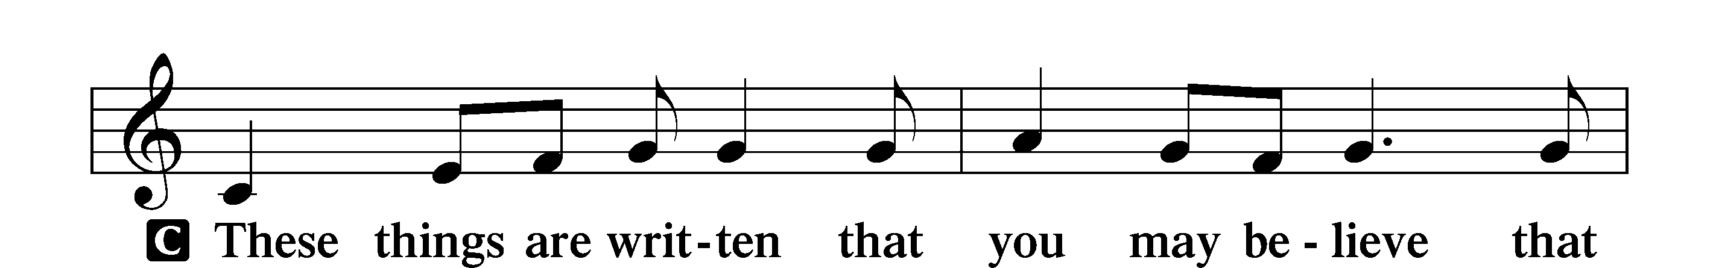
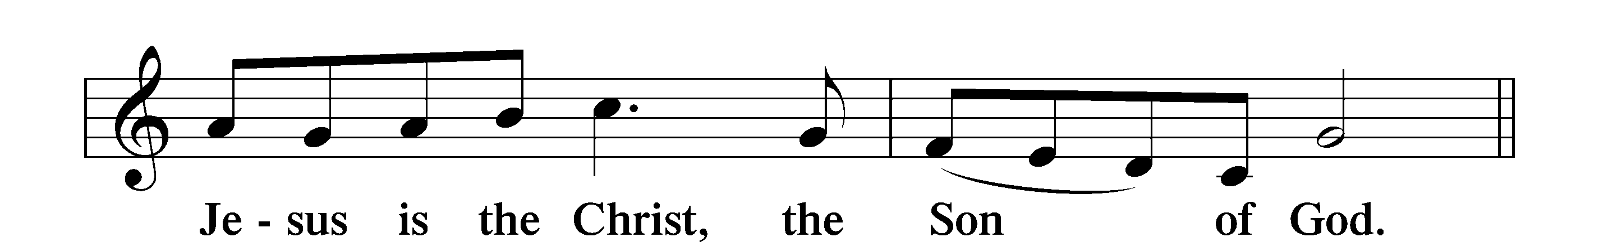

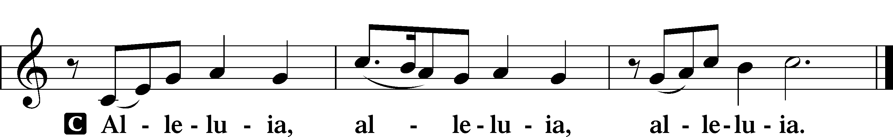

Holy Gospel Luke 15:1–10
P The Holy Gospel according to St. Luke, the fifteenth chapter.
C Glory to You, O Lord.

1Now the tax collectors and sinners were all drawing near to hear [Jesus]. 2And the Pharisees and the scribes grumbled, saying, “This man receives sinners and eats with them.”
3So he told them this parable: 4“What man of you, having a hundred sheep, if he has lost one of them, does not leave the ninety-nine in the open country, and go after the one that is lost, until he finds it? 5And when he has found it, he lays it on his shoulders, rejoicing. 6And when he comes home, he calls together his friends and his neighbors, saying to them, ‘Rejoice with me, for I have found my sheep that was lost.’ 7Just so, I tell you, there will be more joy in heaven over one sinner who repents than over ninety-nine righteous persons who need no repentance.
8“Or what woman, having ten silver coins, if she loses one coin, does not light a lamp and sweep the house and seek diligently until she finds it? 9And when she has found it, she calls together her friends and neighbors, saying, ‘Rejoice with me, for I have found the coin that I had lost.’ 10Just so, I tell you, there is joy before the angels of God over one sinner who repents.”

P This is the Gospel of the Lord.
C Praise to You, O Christ.

Nicene Creed
C I believe in one God, the Father Almighty,
maker of heaven and earth and of all things visible and invisible.
And in one Lord Jesus Christ, the only-begotten Son of God,
begotten of His Father before all worlds, God of God,
Light of Light, very God of very God, begotten, not made,
being of one substance with the Father,
by whom all things were made;
who for us men and for our salvation came down from heaven
and was incarnate by the Holy Spirit of the virgin Mary
and was made man; and was crucified also for us
under Pontius Pilate. He suffered and was buried.
And the third day He rose again according to the Scriptures
and ascended into heaven and sits at the right hand of the Father.
And He will come again with glory to judge both the living and
the dead, whose kingdom will have no end.

And I believe in the Holy Spirit, the Lord and giver of life,
who proceeds from the Father and the Son, who with the
Father and the Son together is worshiped and glorified,
who spoke by the prophets.
And I believe in one holy Christian and apostolic Church,
I acknowledge one Baptism for the remission of sins,
and I look for the resurrection of the dead
and the life T of the world to come. Amen.
Sit

681 Send, O Lord, Your Holy Spirit
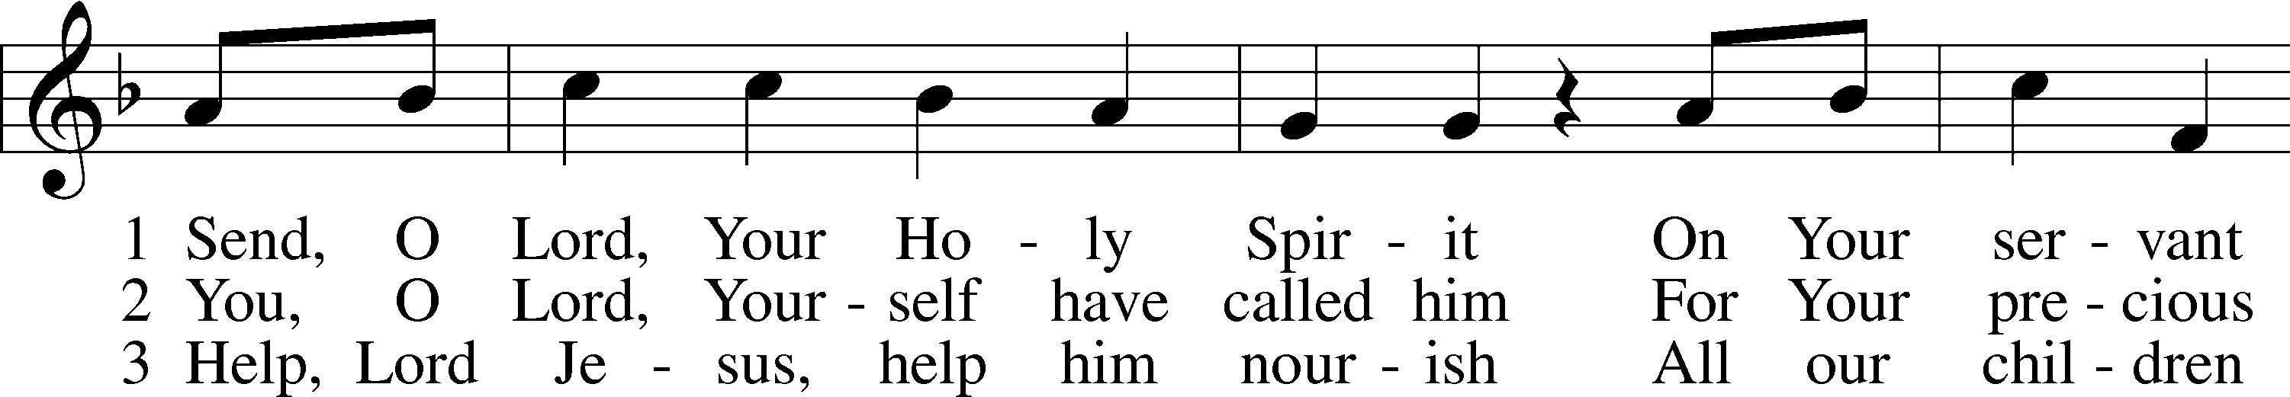
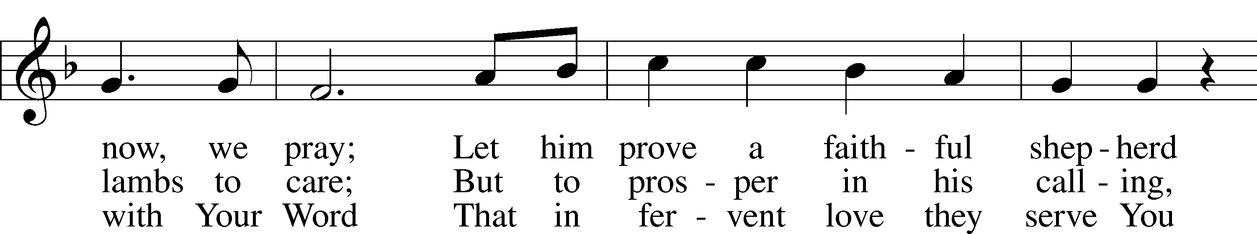
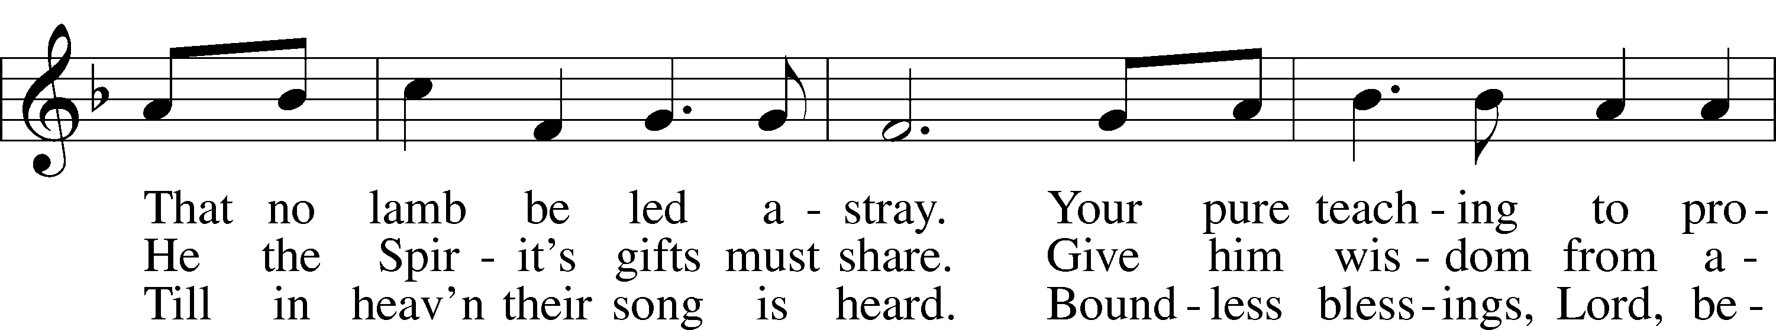
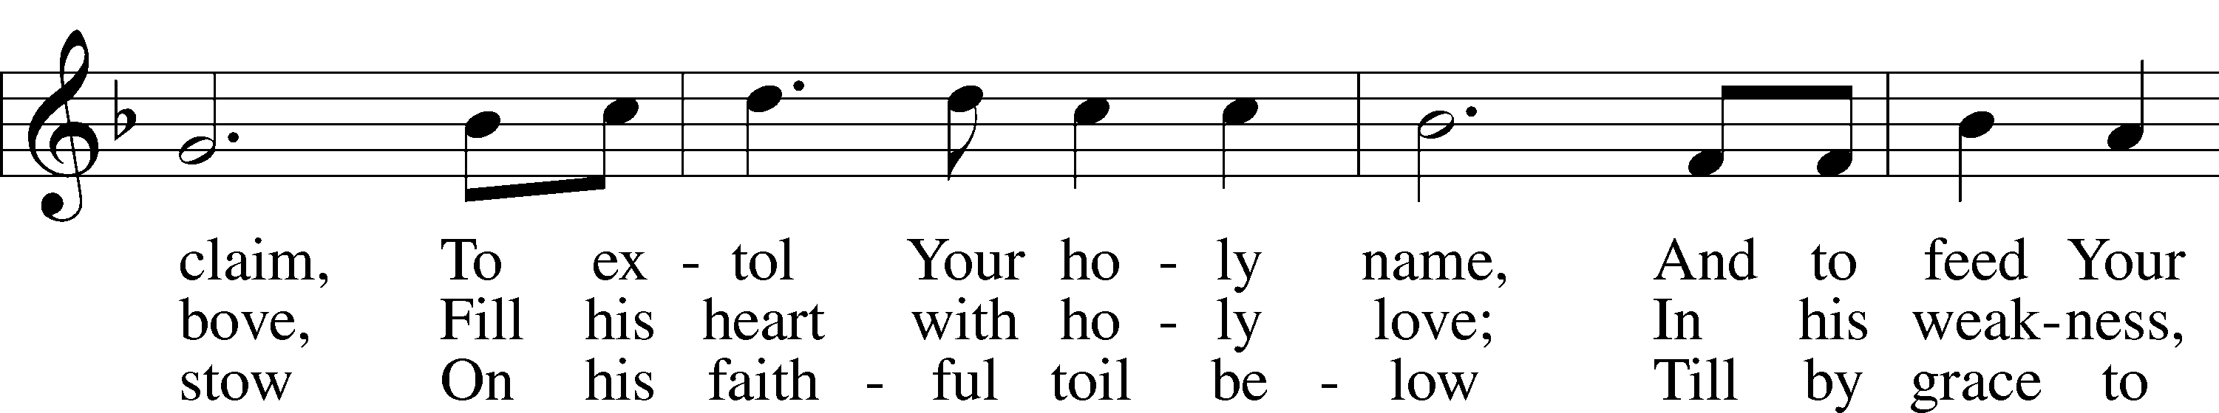
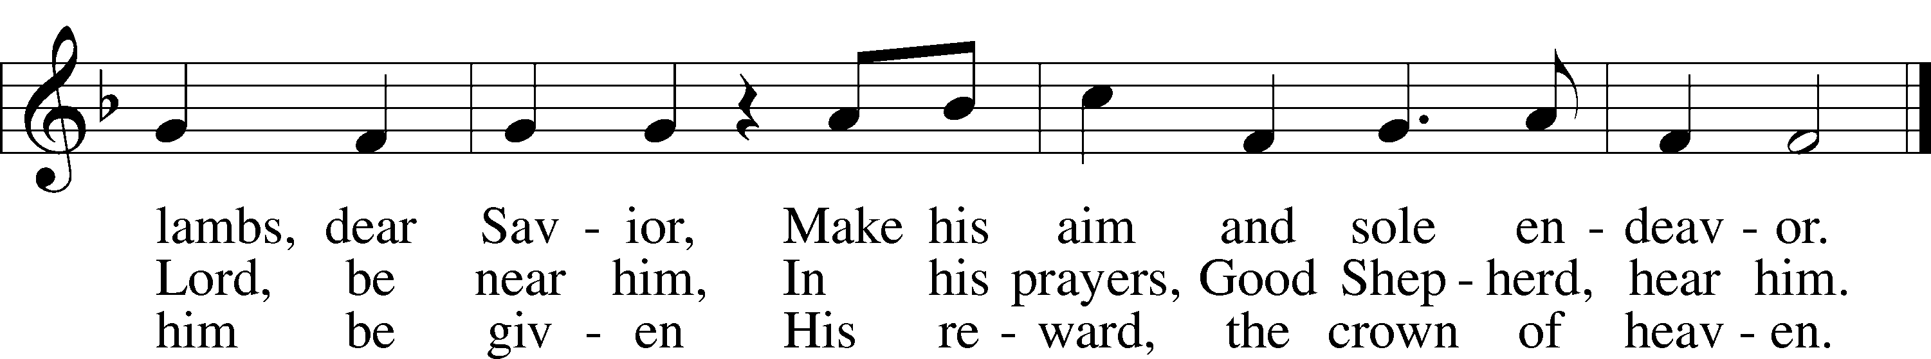
Text: Lieder-Perlen, 1905, St. Louis; tr. Frederick W. Herzberger, 1859–1930, alt.
Tune: Johann Schop, c. 1590–1667
Text and tune: Public domain

Sermon

Stand

Prayer of the Church

Following the prayers, the people may greet one another in the name of the Lord,
saying, “Peace be with you,” as a sign of reconciliation and of the unity of
the Spirit in the bond of peace (Matt. 5:22–24; Eph. 4:1–3).

Sit
Offering & Sharing of the Peace

Offertory LSB 159
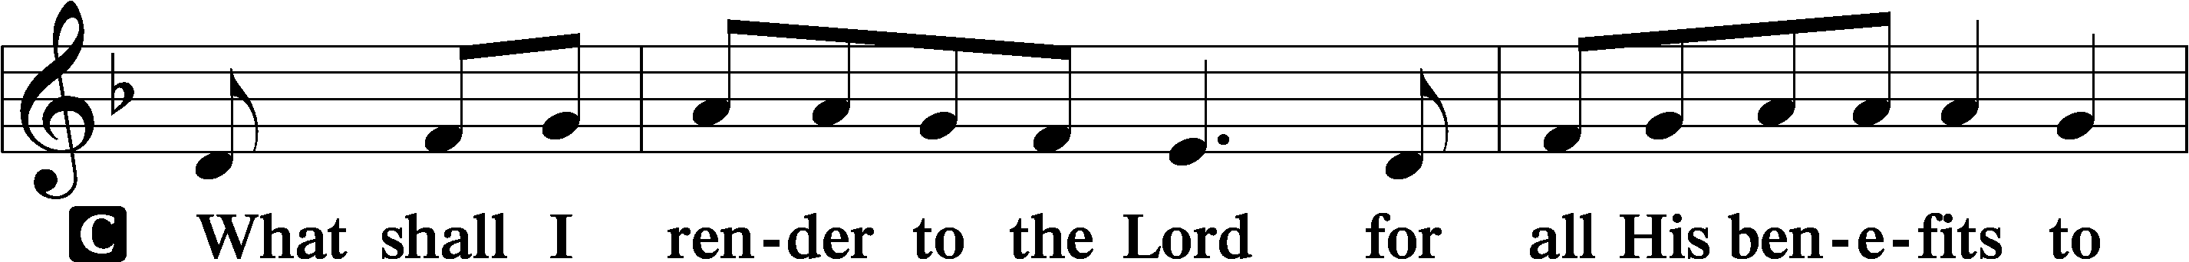
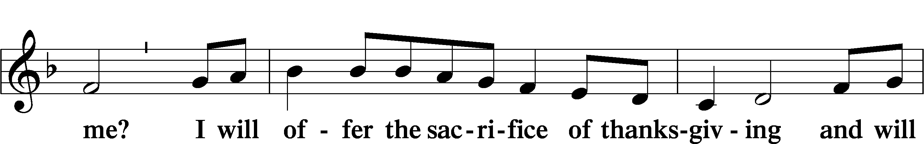
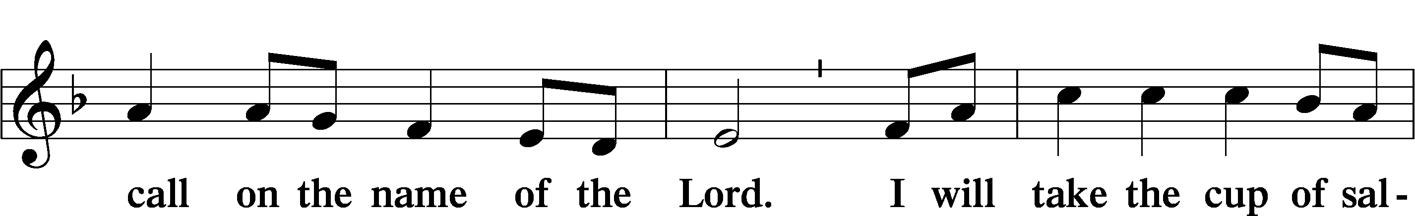
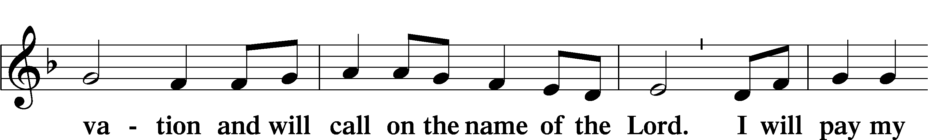
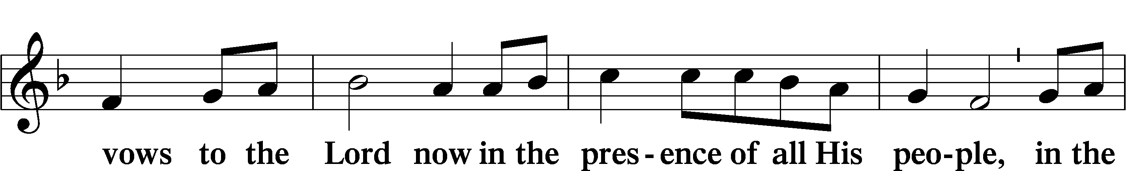
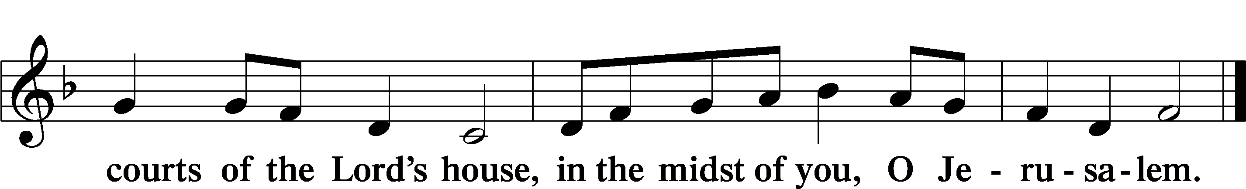

Service of Holy Communion
Communion Statement

The Lord’s Supper is celebrated at this congregation in the confession and glad confidence that, as He says, our Lord gives into our mouths not only bread and wine but His very body and blood to eat and to drink for the forgiveness of sins and to strengthen our union with Him and with one another. Our Lord invites to His table those who trust His words, repent of all sin, and set aside any refusal to forgive and love as He forgives and loves us, that they may show forth His death until He comes.

Because those who eat and drink our Lord’s body and blood unworthily do so to their great harm and because Holy Communion is a confession of the faith which is confessed at this altar, any who are not yet instructed, in doubt, or who hold a confession differing from that of this congregation and the Lutheran Church Missouri Synod, and yet desire to receive this sacrament, are asked to speak with the Pastor.
* See more about the Lutheran teaching on communion in the Hymnal p 329.

Stand

Preface LSB 208
P The Lord be with you.
C And also with you.

P Lift up your hearts.
C We lift them to the Lord.

P Let us give thanks to the Lord our God.
C It is right to give Him thanks and praise.

P It is truly good, right, and salutary that we should at all times and in all places give thanks to You, O Lord, holy Father, almighty and everlasting God, for the countless blessings You so freely bestow on us and all creation. Above all, we give thanks for Your boundless love shown to us when You sent Your only-begotten Son, Jesus Christ, into our flesh and laid on Him our sin, giving Him into death that we might not die eternally. Because He is now risen from the dead and lives and reigns to all eternity, all who believe in Him will overcome sin and death and will rise again to new life. Therefore with angels and archangels and with all the company of heaven we laud and magnify Your glorious name, evermore praising You and saying:
Sanctus LSB 208
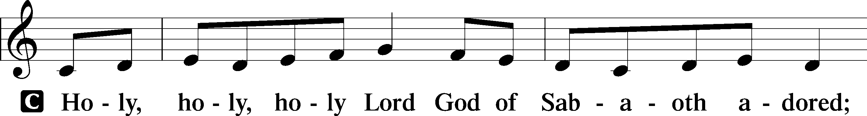
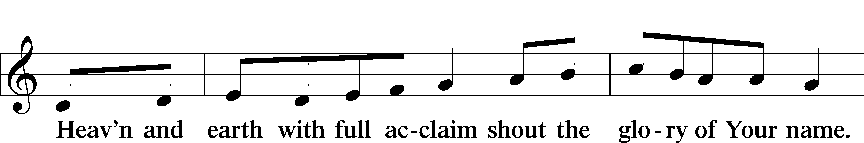
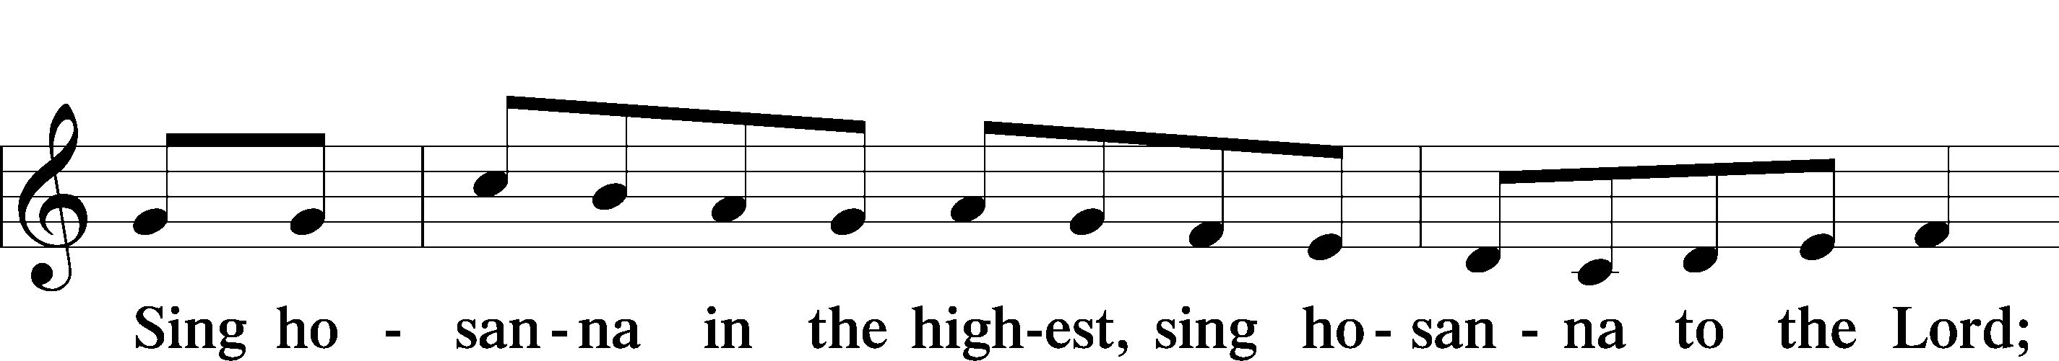
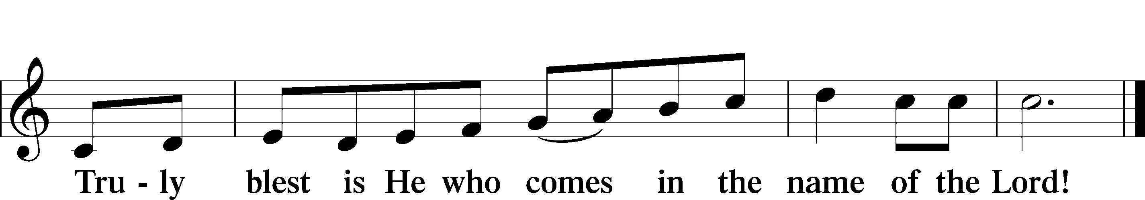
Text: Stephen P. Starke

Prayer of Thanksgiving
P Blessed are You, O Lord our God, king of all creation, for You have had mercy on us and given Your only-begotten Son that whoever believes in Him should not perish but have eternal life.

In Your righteous judgment You condemned the sin of Adam and Eve, who ate the forbidden fruit, and You justly barred them and all their children from the tree of life. Yet, in Your great mercy, You promised salvation by a second Adam, Your Son, Jesus Christ, our Lord, and made His cross a life-giving tree for all who trust in Him.

We give You thanks for the redemption You have prepared for us through Jesus Christ. Grant us Your Holy Spirit that we may faithfully eat and drink of the fruits of His cross and receive the blessings of forgiveness, life, and salvation that come to us in His body and blood.

Hear us as we pray in His name and as He has taught us:

Lord’s Prayer
C Our Father who art in heaven, hallowed be Thy name,
Thy kingdom come, Thy will be done on earth
as it is in heaven; give us this day our daily bread;
and forgive us our trespasses as we forgive those
who trespass against us;
and lead us not into temptation, but deliver us from evil.
For Thine is the kingdom and the power and the glory
forever and ever. Amen.

The Words of Our Lord
P Our Lord Jesus Christ, on the night when He was betrayed, took bread, and when He had given thanks, He broke it and gave it to the disciples and said: “Take, eat; this is My T body, which is given for you. This do in remembrance of Me.”

In the same way also He took the cup after supper, and when He had given thanks, He gave it to them, saying: “Drink of it, all of you; this cup is the new testament in My T blood, which is shed for you for the forgiveness of sins. This do, as often as you drink it, in remembrance of Me.”

Pax Domini
P The peace of the Lord be with you always.
C Amen.

Agnus Dei LSB 210
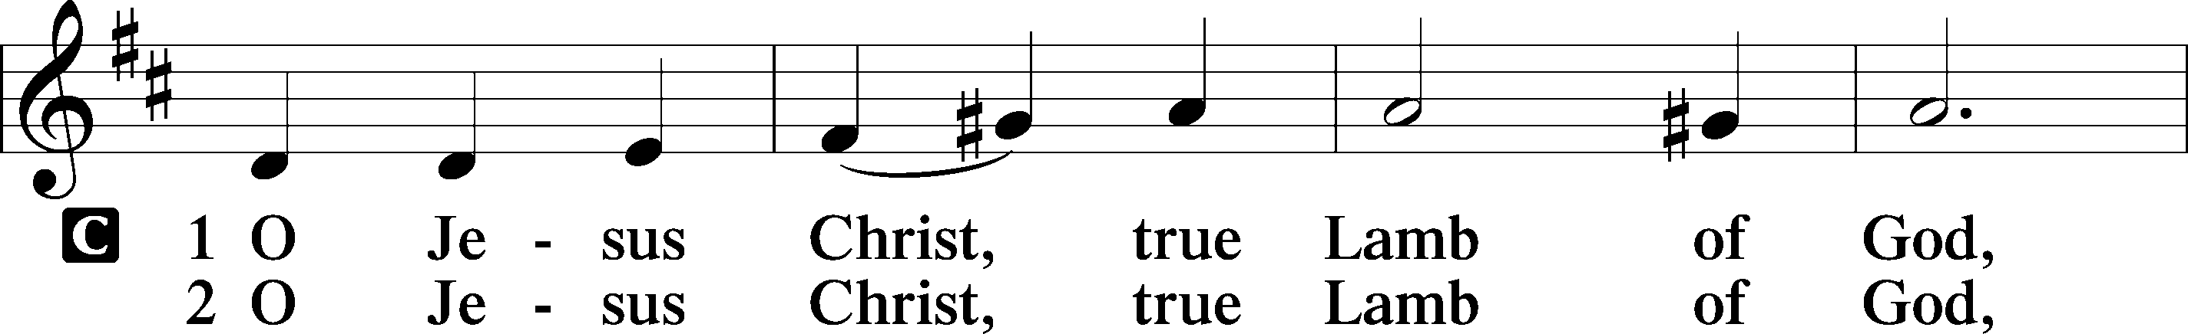
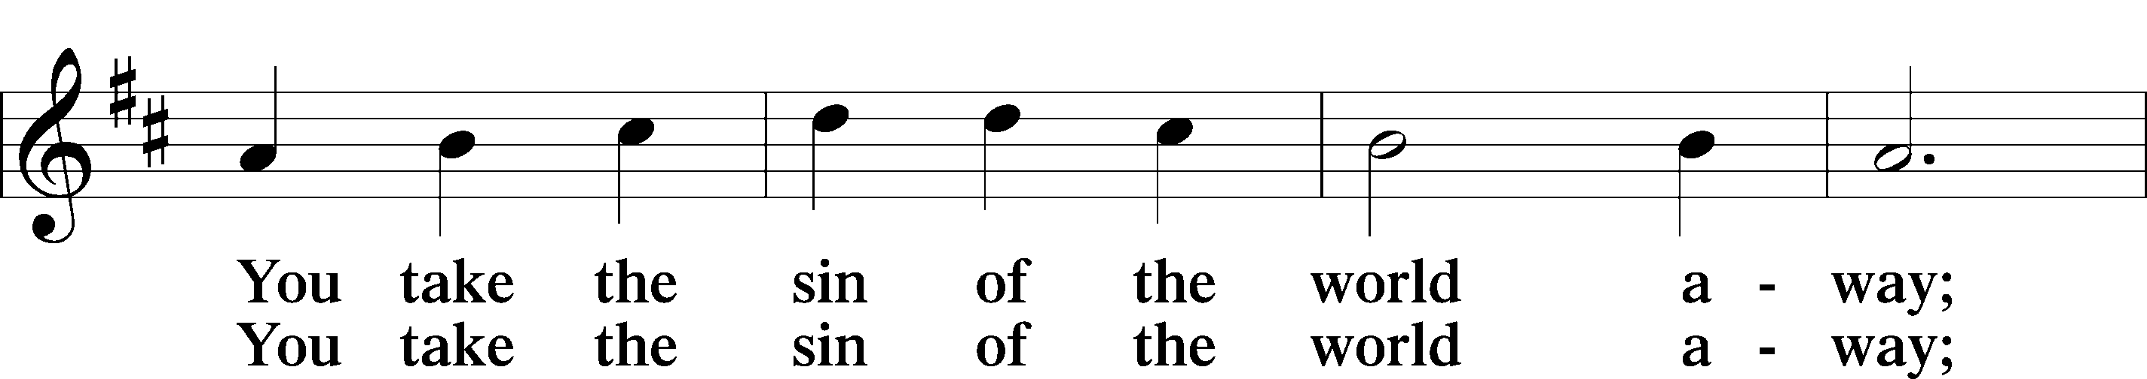
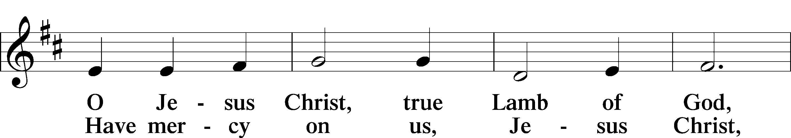
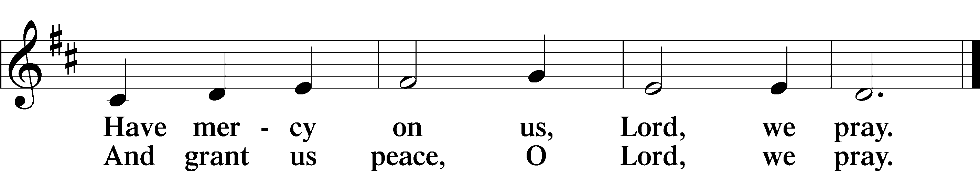
Text: Stephen P. Starke

Sit

Distribution

437 Alas! And Did My Savior Bleed
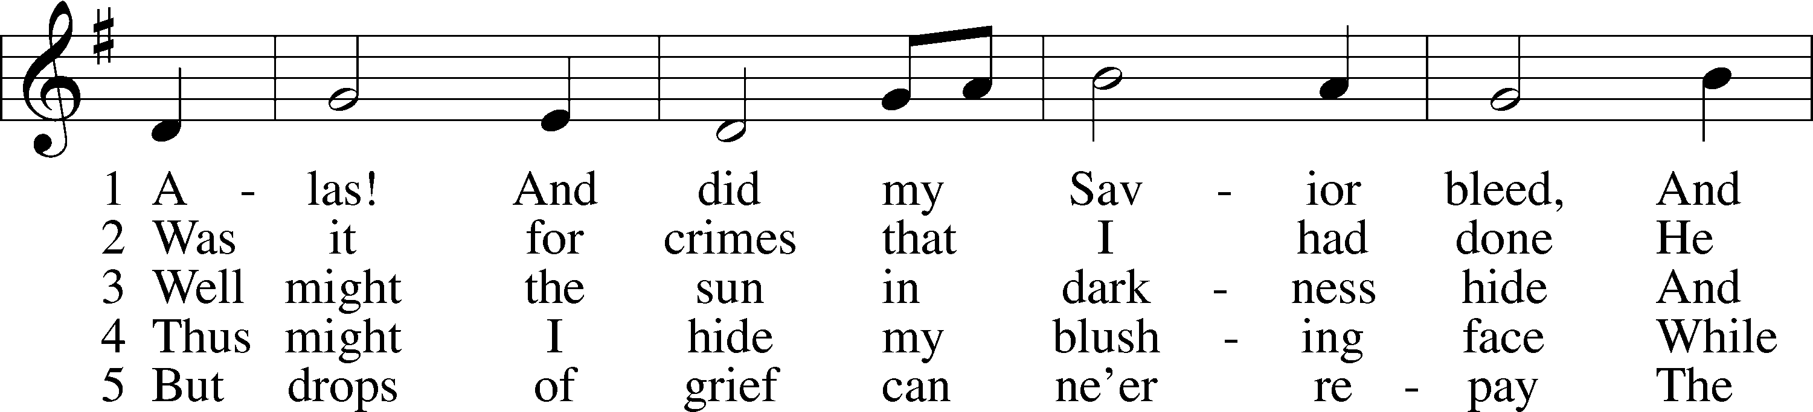
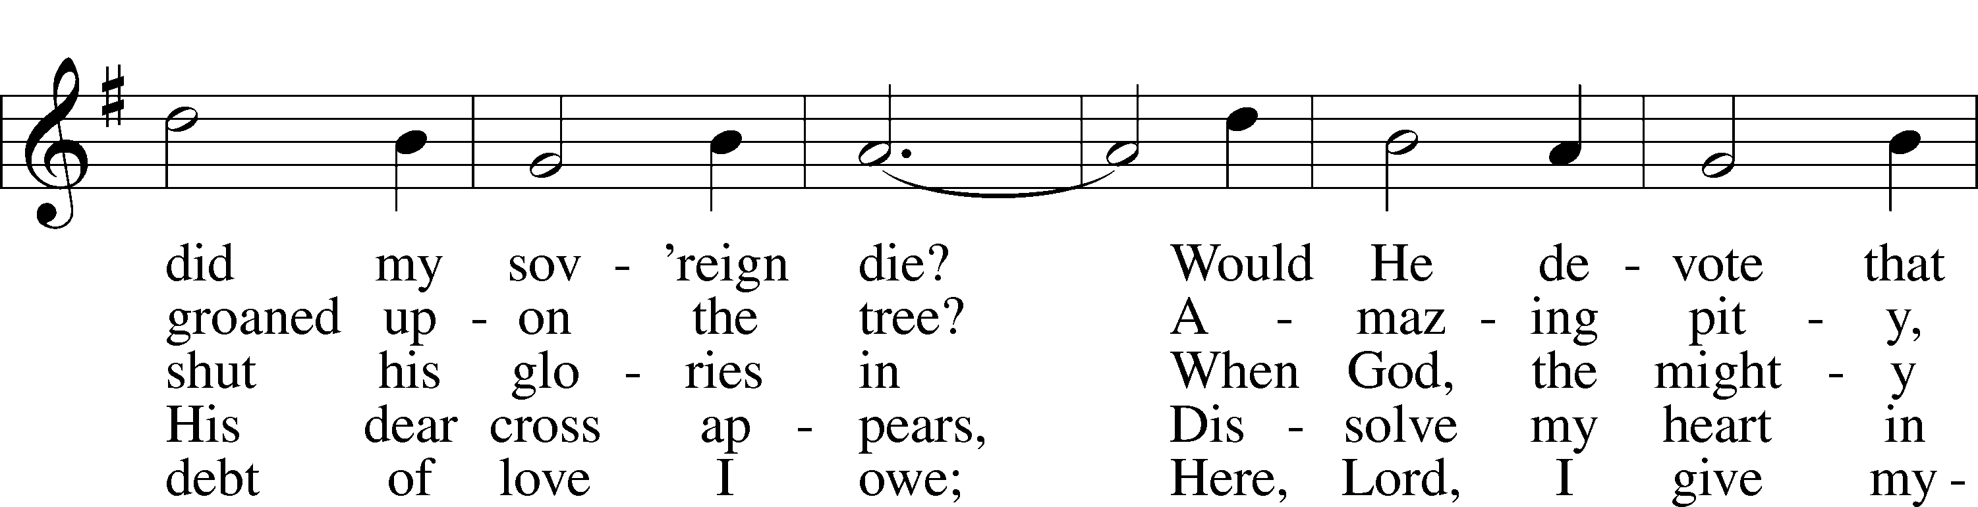
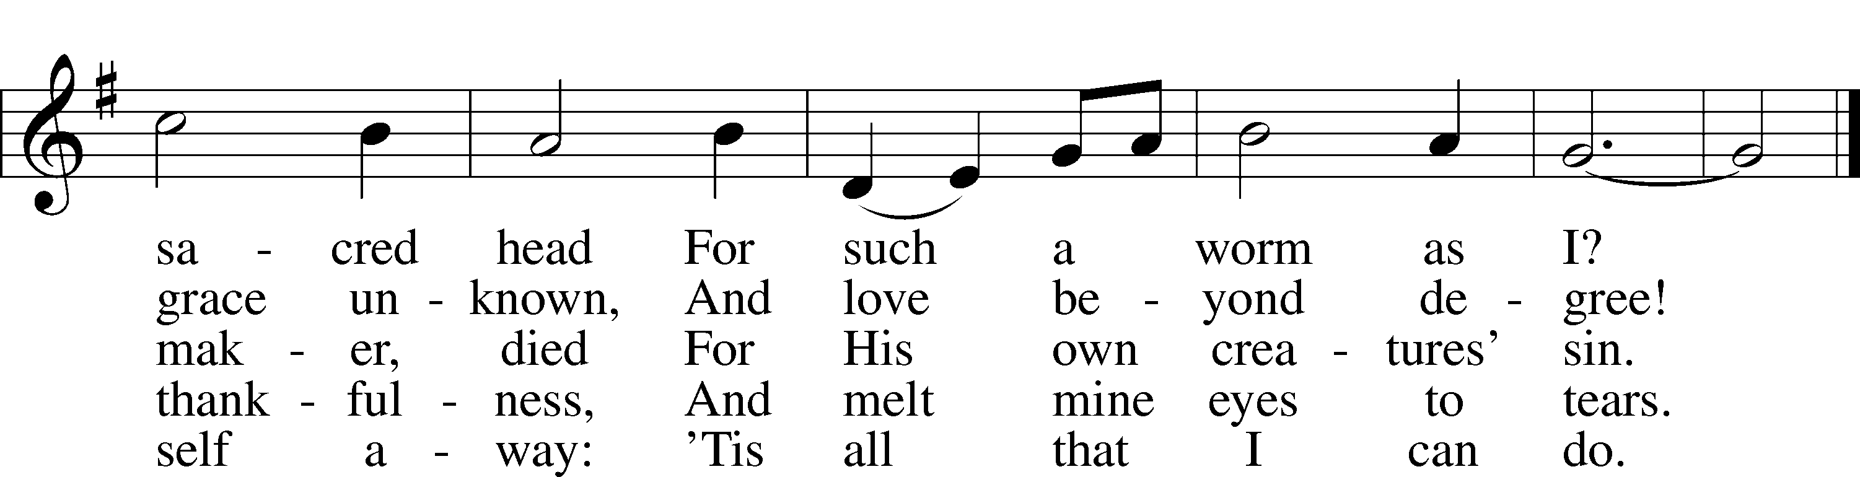
Text: Isaac Watts, 1674–1748, alt.
Tune: Hugh Wilson, 1764–1824
Text and tune: Public domain

Stand

Nunc Dimittis LSB 211
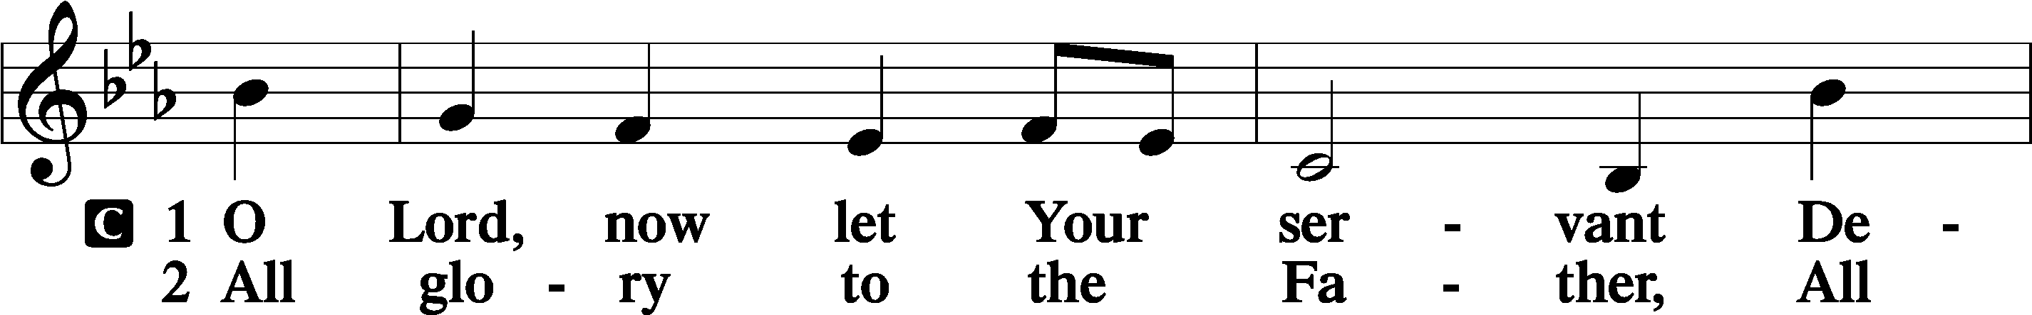
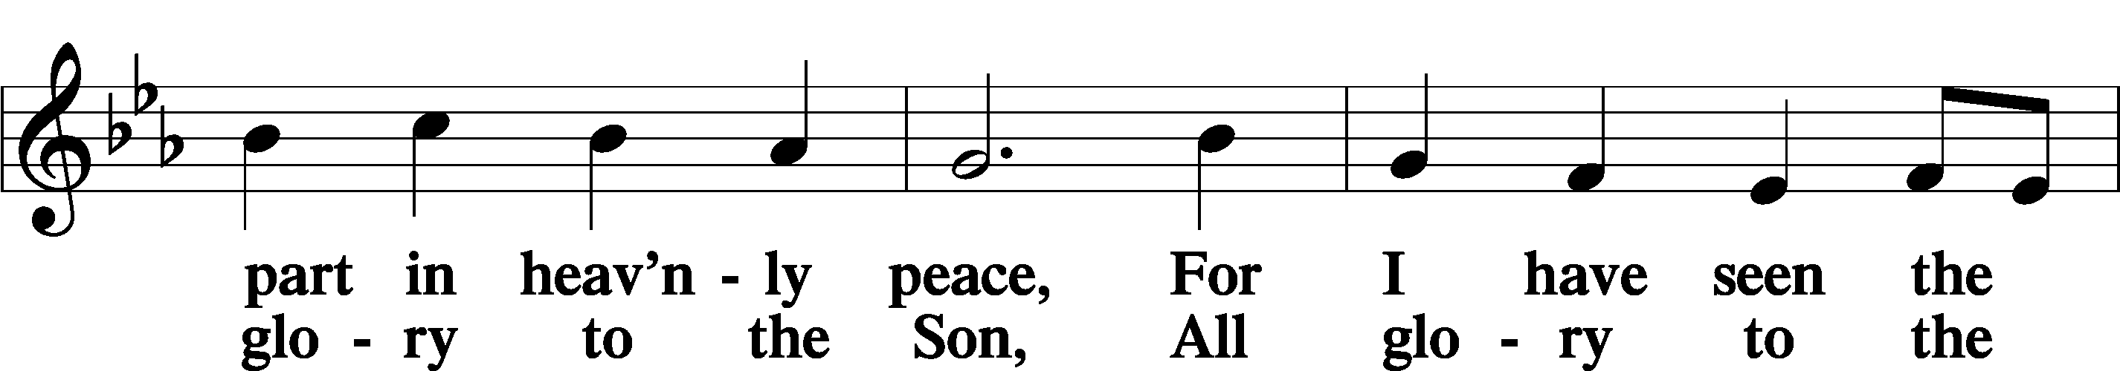
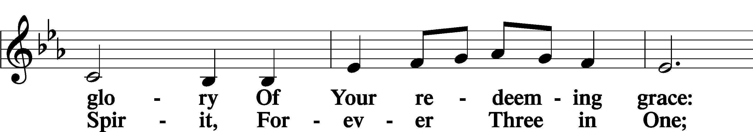
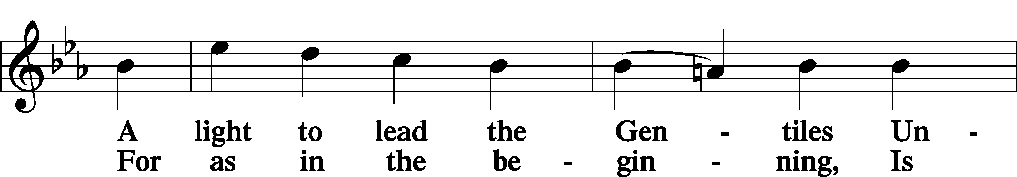
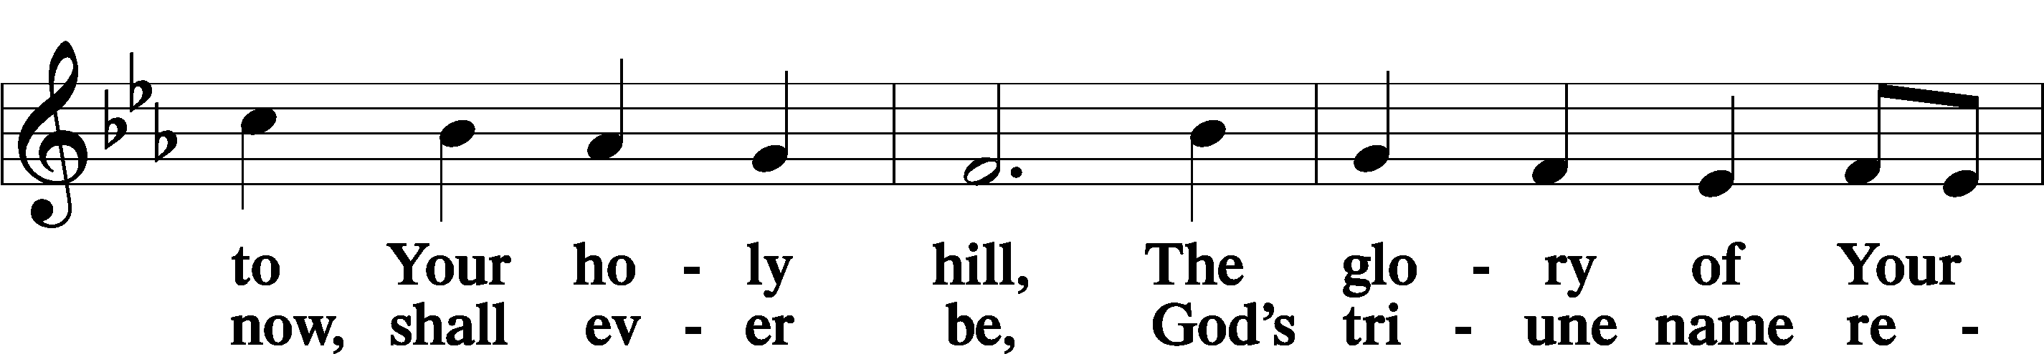
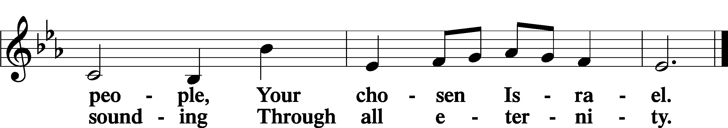

Post-Communion Collect
A Let us pray.
We give thanks to You, almighty God, that You have refreshed us through this salutary gift, and we implore You that of Your mercy You would strengthen us through the same in faith toward You and in fervent love toward one another; through Jesus Christ, Your Son, our Lord, who lives and reigns with You and the Holy Spirit, one God, now and forever.
C Amen.

Verse of the Day Luke 15:10
Alleluia. I tell you,
there is joy before the angels of God over one sinner who repents. Alleluia.

Benedicamus LSB 212
A Let us bless the Lord.
C Thanks be to God.

Benediction
P The Lord bless you and keep you.
The Lord make His face shine on you and be gracious to you.
The Lord look upon you with favor and T give you peace.
C Amen.

744 Amazing Grace sts. 1–5
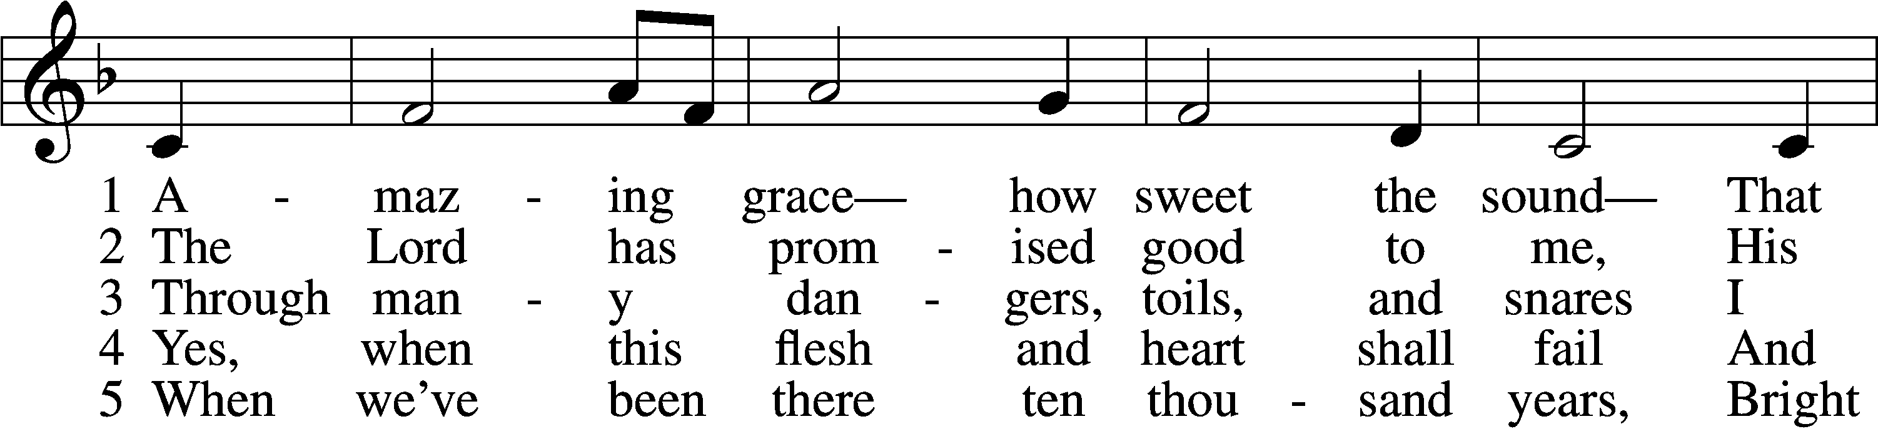
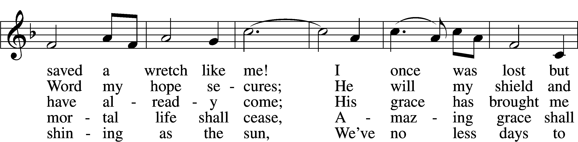
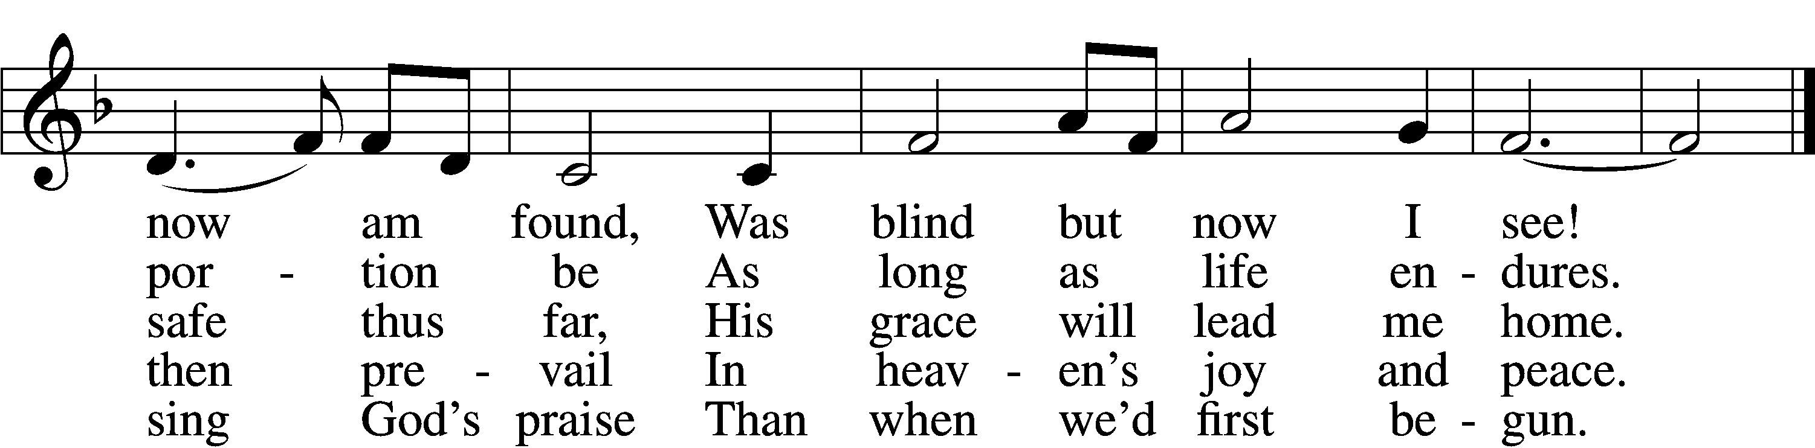
Text (sts. 1–4): John Newton, 1725–1807, alt.; (st. 5): A Collection of Sacred Ballads, 1790, Richmond Tune: Columbian Harmony, 1829, Cincinnati
Text and tune: Public domain
Acknowledgments
Divine Service, Setting Four from Lutheran Service Book
Unless otherwise indicated, Scripture quotations are from the ESV® Bible (The Holy Bible, English Standard Version®), copyright © 2001 by Crossway, a publishing ministry of Good News Publishers. Used by permission. All rights reserved. Created by Lutheran Service Builder © 2025 Concordia Publishing House.
Prayers of the Church
This week, we lift up:

Angela H, Sheila, Elaine, Bob, Angie Z, Angela C, Ross, & Kathy H.

Family of the week: Rebecca & Tania Vigil

*If you have any prayer request let us know.

Last week: Attendance 27 Offering $750

Serving Next Week (9/21/25)  Service Leader: Vicar Previn Hudetz  Communion Celebrant: Rev John Heffelfinger  Worship Assistant: TBD  Reader: Angie Z  Refreshments: Angie Z  Altar Guild: Angie Z & Sheila S  Greeter: Mike Y | Readings Next Week  Fifteenth Sunday after Pentecost  - Amos 8:4-7  - Psalm 113  - 1 Timothy 2  - Luke 16:1-15  *Please sign up to help during service.*
Announcements  Birthdays  Last Week: Sheila S (6th)  Next Week: Jim Carrie (13th), Steve H (14th)  This Week at OSLC:  Bible Study: After Service  Bible Study: Thursday 10am | Coming Up:  Congregational Meeting to confirm & elect Council Members.  September 28, 2025  Following service

Please consider signing up to help

During Service-
Readers
Altar Set up (Communion)
Worship Assistant (Candles, Usher)
Greeter (Welcome and hand out bulletins)
Refreshments
Coffee Set up (Barista)

General
Finish Shed’s
Trash around property
Weeding
Backing on Banners
Preparing Baptismal Banners



