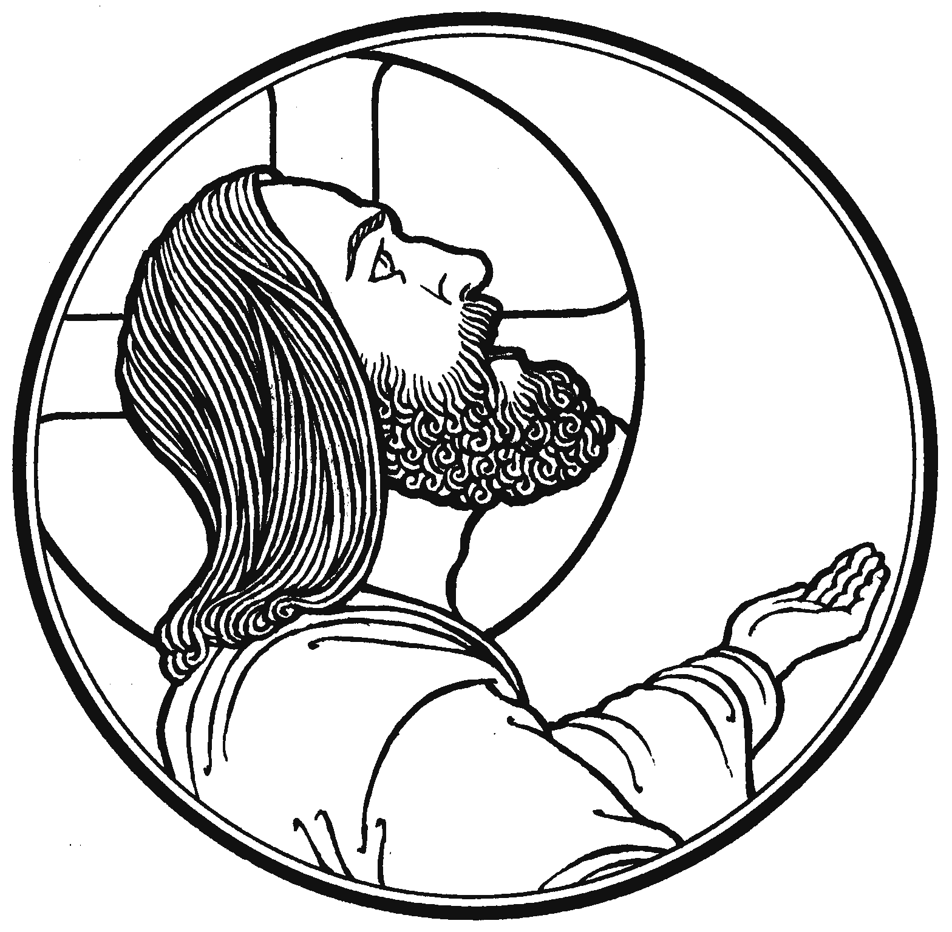

*“…take heart; I have overcome the world.”*

*John 16:33*

**Our Savior Lutheran Church (LCMS)**

4301 Atrisco Drive NW

Albuquerque, New Mexico

Website: OSLCNM.COM

Phone: 505.836.7007

Email: oslcabq@gmail.com

*The Sixth Sunday of Easter*

*May 25th, 2025*

|  |
| --- |
|  |

# **The Time of Easter**

# *The Sixth Sunday of Easter*

# *May 25th, 2025*

|  |  |
| --- | --- |
| *Welcome to Our Savior Lutheran Church (LCMS).*  *We are glad you are here as we worship, praise, and give thanks to our loving Lord, Jesus Christ. Please join us immediately after service for fellowship and snacks. Adult Bible Study starts at 10:30. If you have any questions about our service or need other assistance, please contact one of our worship assistants.* | **Hymns**  Opening # 469  Sermon # 716 (vs 1-3)  Distribution # Bless the Lord  Closing # 716 (v 4-6) |

**Today’s Message**

**Thorns, Thistles & Such...** - In the Book of Genesis (3.17-18), the Lord God tells Adam and Eve “...cursed is the ground because of you; in pain you shall eat of it all the days of your life; thorns and thistles it shall bring forth for you...” - Ever since, life on this planet has not been easy, not only does nature lash out at us, so do our fellow men. For those who follow Jesus, there is no reprieve; our lives can be worse than those around us; happiness may be elusive. Jesus has “overcome” the world's troubles and temptations; He has risen above sin, death, and evil. He calls for us to live in joy, knowing that our future is secure in Him, as true joy lifts us up beyond our current struggle.

+++

**Serving Today**

Guest Pastor: Rev Doyle Boykin

Music Minister: Vicar Previn Hudetz

Worship Assistant: Charlie M

Reader: Jim C

Refreshments: Sheila S

Altar Guild: Angie Z

Greeter: Ross

# Divine Service 1

# Welcome

469 Christ the Lord Is Risen Today sts. 1–4

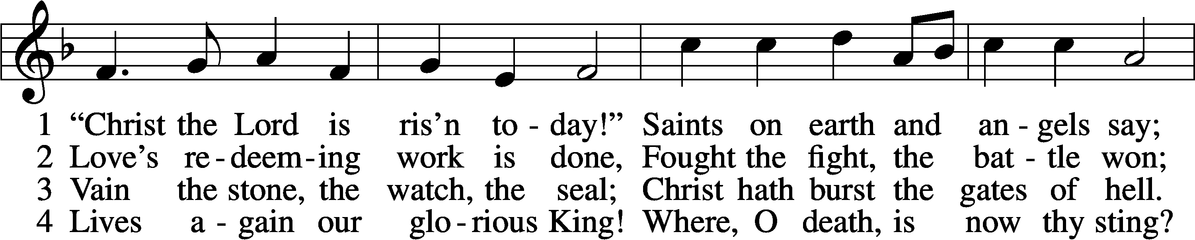

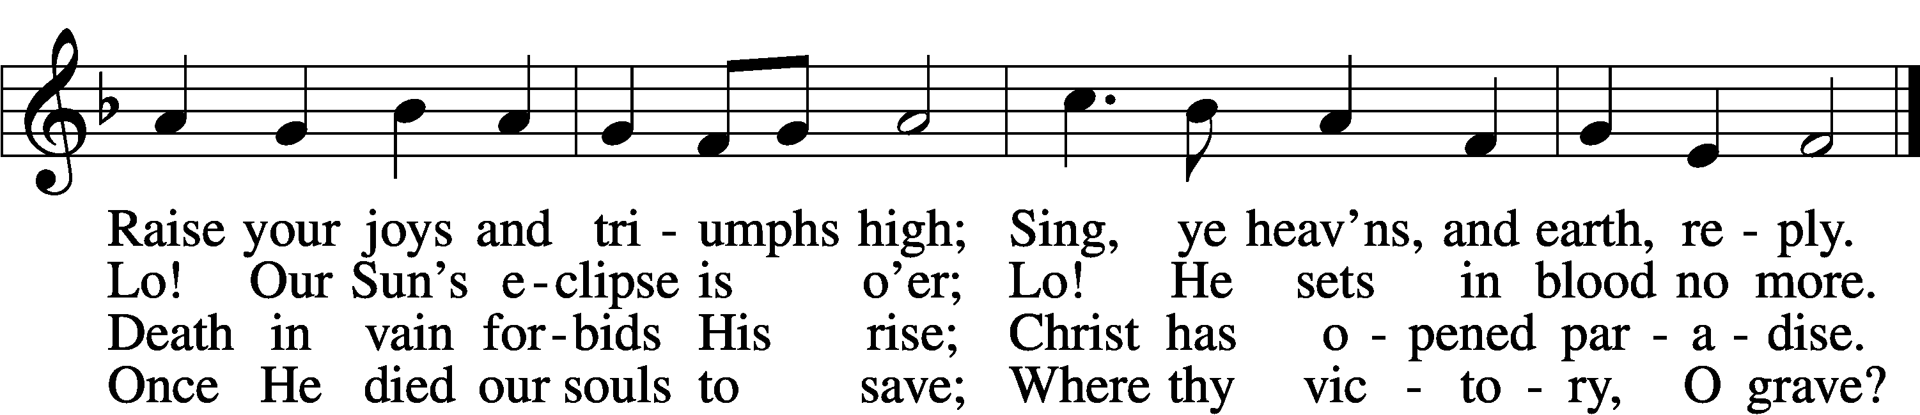

Text: Charles Wesley, 1707–88, alt.  
Tune: French, 13th cent.  
Text and tune: Public domain

Stand

# Confession and Absolution

The sign of the cross may be made by all in remembrance of their Baptism.

P In the name of the Father and of the T Son and of the Holy Spirit.

C **Amen.**

P If we say we have no sin, we deceive ourselves, and the truth is not in us.

C **But if we confess our sins, God, who is faithful and just, will forgive our sins and cleanse us from all unrighteousness.**

Silence for reflection on God’s Word and for self-examination.

P Let us then confess our sins to God our Father.

C **Most merciful God, we confess that we are by nature sinful and unclean. We have sinned against You in thought, word, and deed, by what we have done and by what we have left undone. We have not loved You with our whole heart; we have not loved our neighbors as ourselves. We justly deserve Your present and eternal punishment. For the sake of Your Son, Jesus Christ, have mercy on us. Forgive us, renew us, and lead us, so that we may delight in Your will and walk in Your ways to the glory of Your holy name. Amen.**

P Almighty God in His mercy has given His Son to die for you and for His sake forgives you all your sins. As a called and ordained servant of Christ, and by His authority, I therefore forgive you all your sins in the name of the Father and of the T Son and of the Holy Spirit.

C **Amen.**

# Service of the Word

Invitatory Psalm 29:1-2

The Lord has risen O come, let us worship Him. *  
**Give to the Lord the glory and strength, give Him the honor due His name. Alleluia.**

Introit Psalm 55:4, 16–18; antiphon: v. 22

Cast your burden on the Lord, and he will sus- | tain you;*  
 **he will never permit the righteous to**  | **be moved.**  
My heart is in anguish with- | in me;*  
 **the terrors of death have fallen up-** | **on me.**  
But I | call to God,*  
 **and the Lord will**  | **save me.**  
Evening and morning and at noon I utter my com- | plaint and moan,*  
 **and he**  | **hears my voice.**  
He redeems my soul in safety from the battle | that I wage,*  
 **for many are arrayed a-** | **gainst me.**  
**Glory be to the Father and**  | **to the Son**\*  
 **and to the Holy**  | **Spirit;**  
**as it was in the be-** | **ginning,**\*  
 **is now, and will be forever.**  | **Amen.**  
Cast your burden on the Lord, and he will sus- | tain you;*  
 **he will never permit the righteous to**  | **be moved.**

Kyrie LSB 152

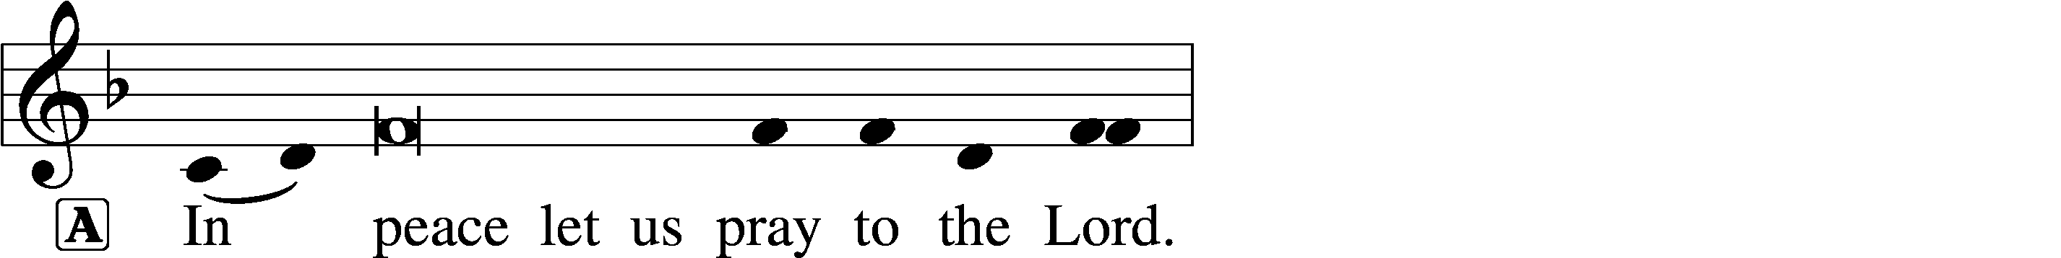

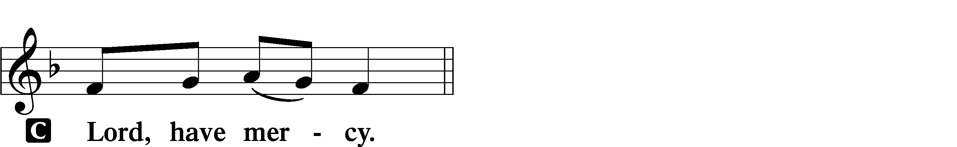

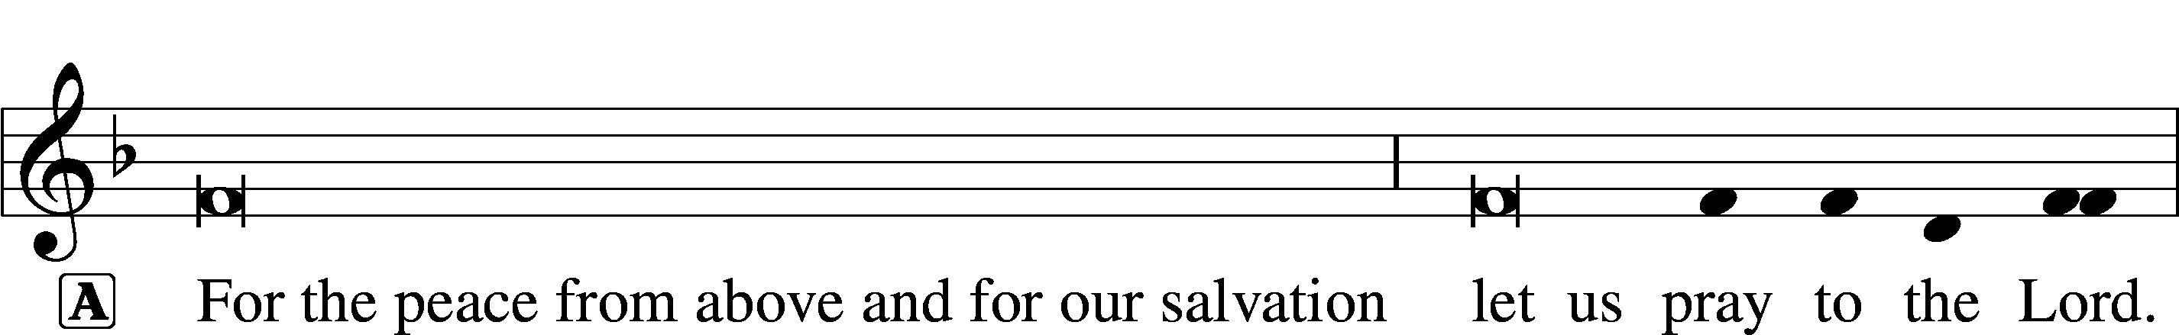

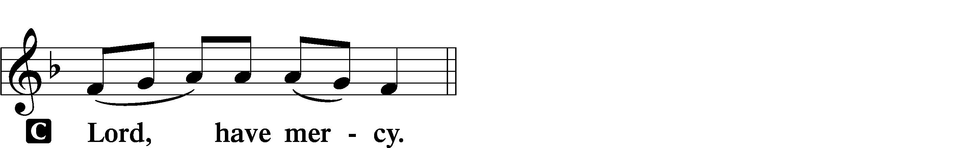

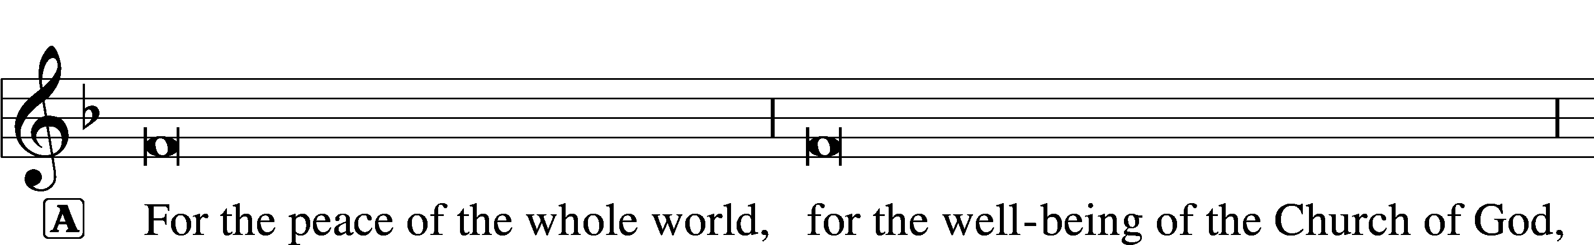

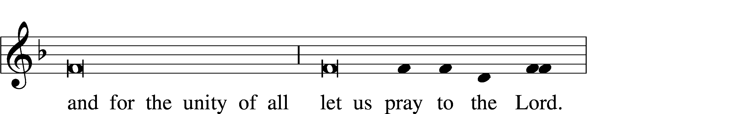

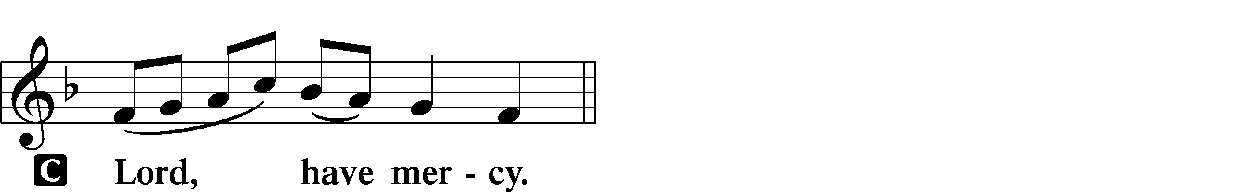

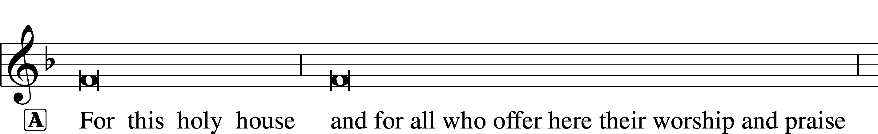

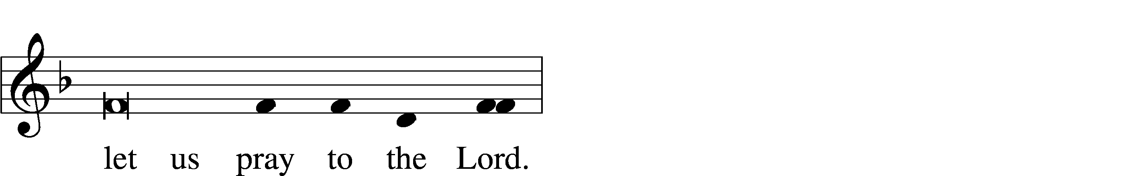

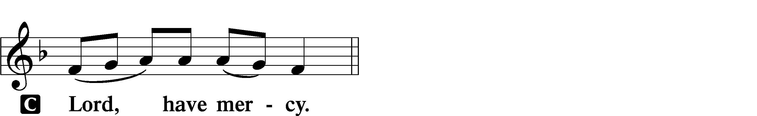

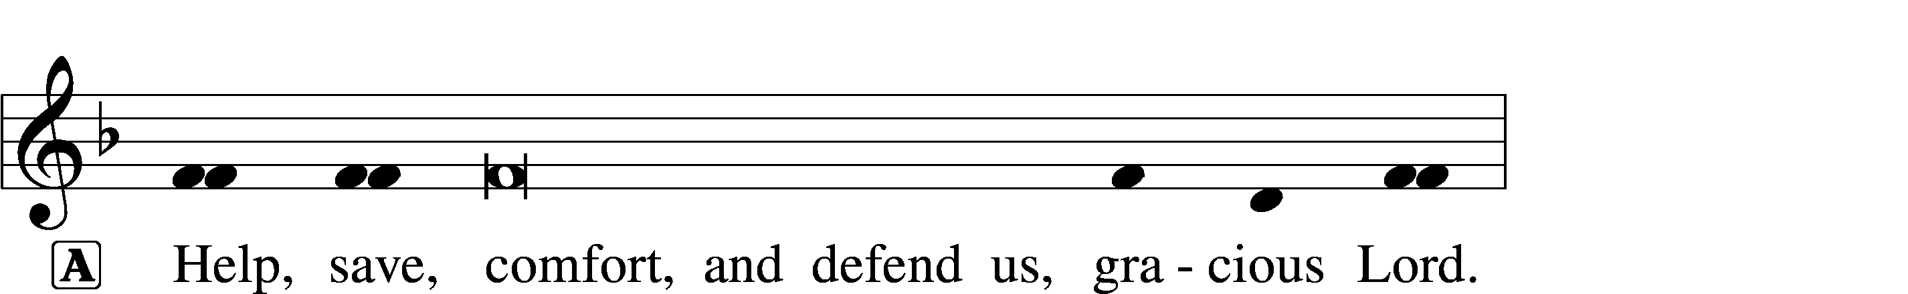



This Is the Feast

LSB 155

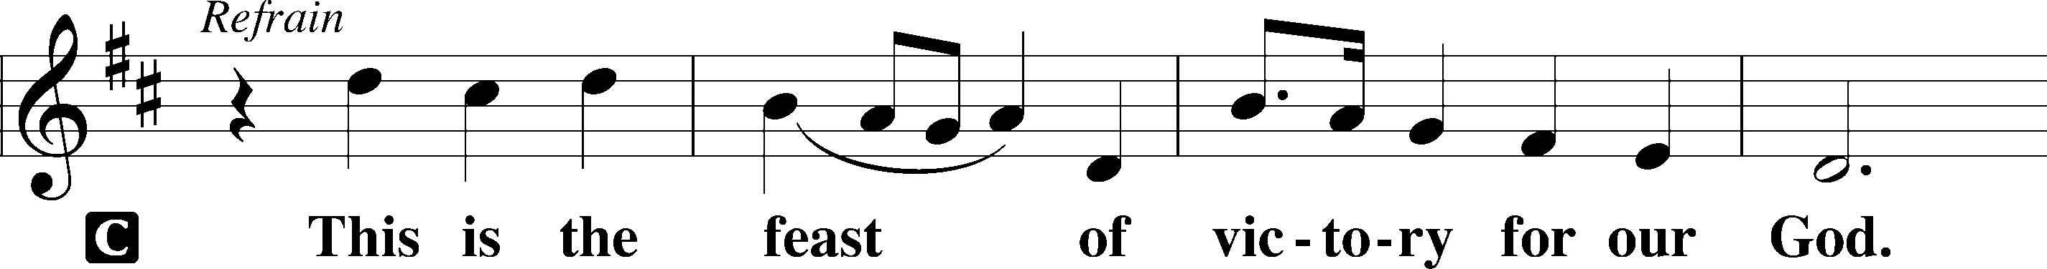

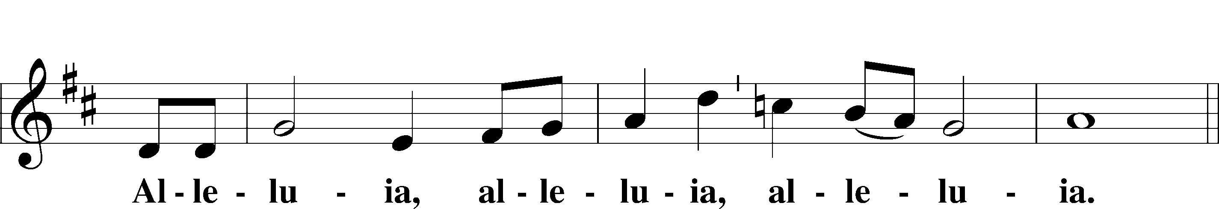

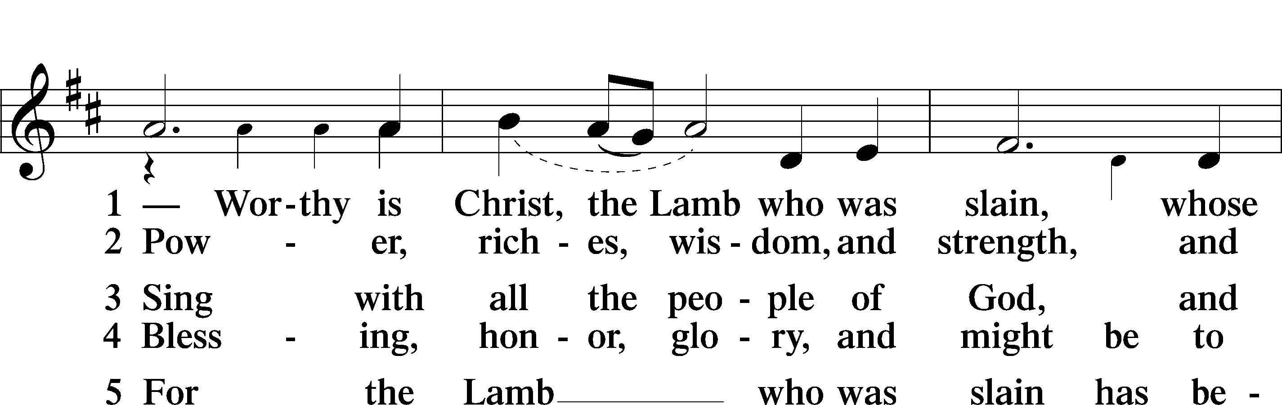

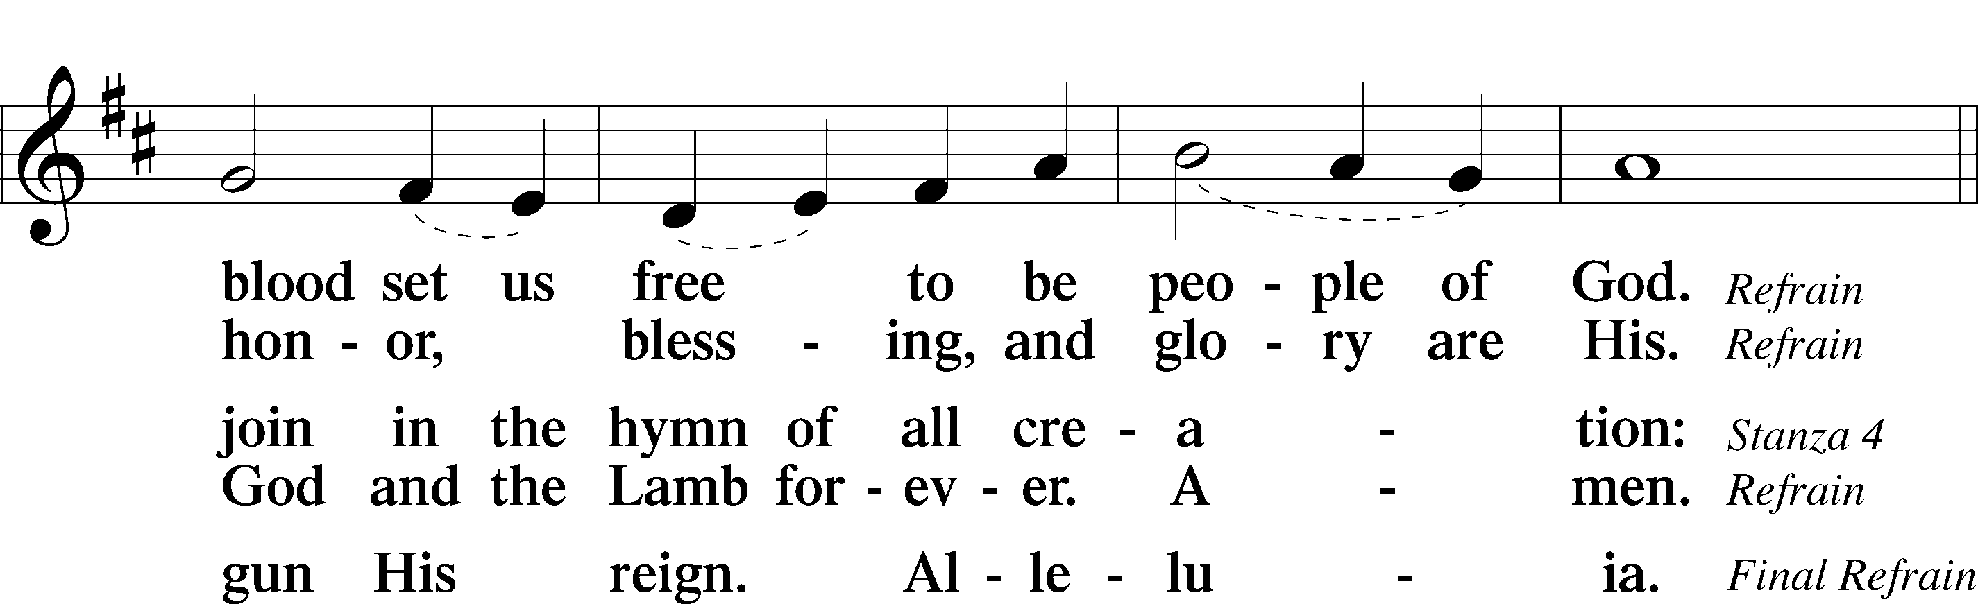

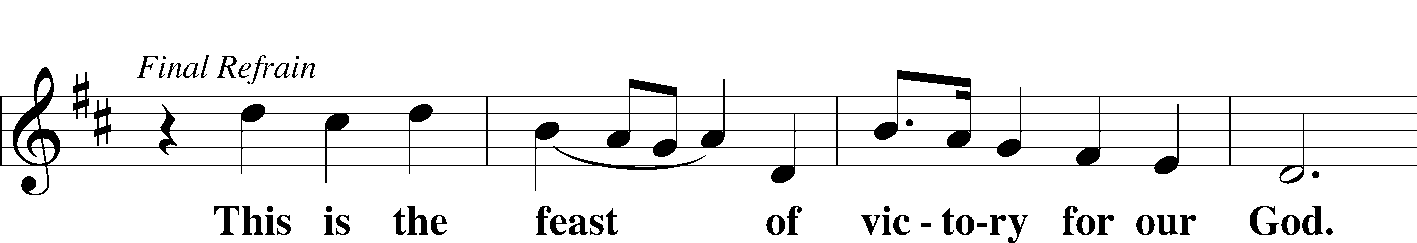

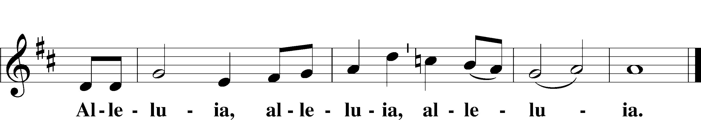

Salutation and Collect of the Day

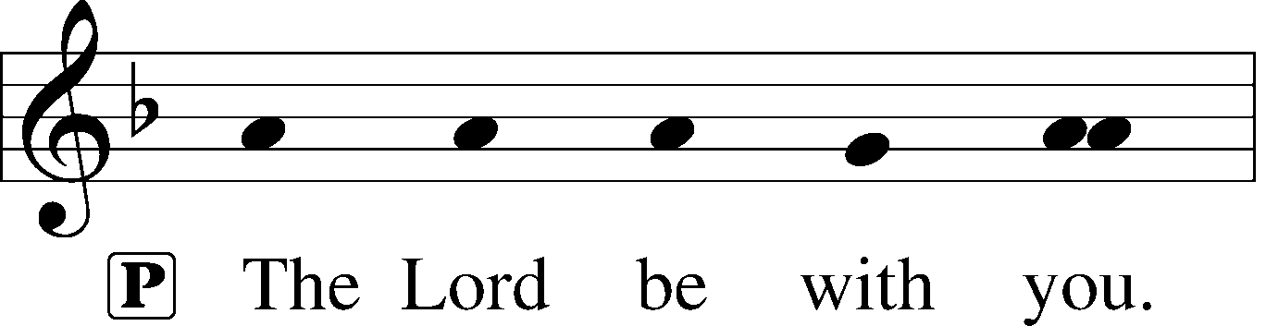

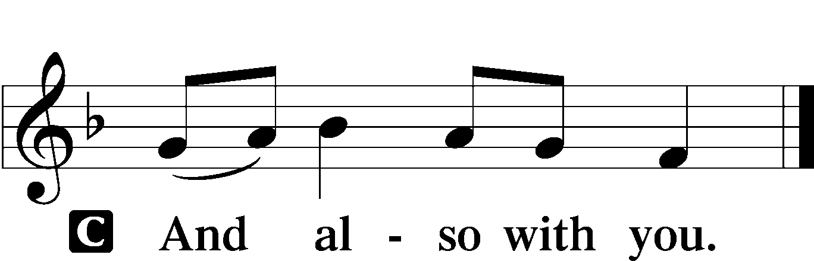

P Let us pray.

O God, the giver of all that is good, by Your holy inspiration grant that we may think those things that are right and by Your merciful guiding accomplish them; through Jesus Christ, Your Son, our Lord, who lives and reigns with You and the Holy Spirit, one God, now and forever.

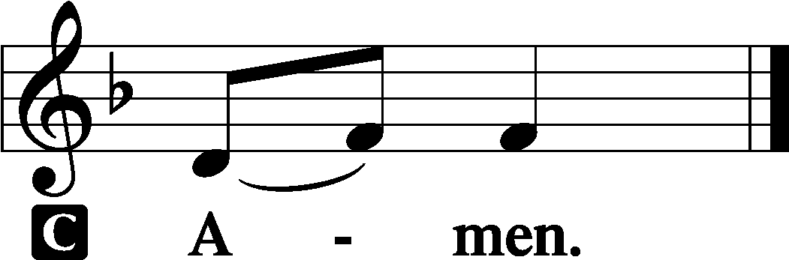

Sit

First Reading

Acts 16:9–15

A The first reading comes from Acts chapter 16.

9A vision appeared to Paul in the night: a man of Macedonia was standing there, urging him and saying, “Come over to Macedonia and help us.” 10And when Paul had seen the vision, immediately we sought to go on into Macedonia, concluding that God had called us to preach the gospel to them.

11So, setting sail from Troas, we made a direct voyage to Samothrace, and the following day to Neapolis, 12and from there to Philippi, which is a leading city of the district of Macedonia and a Roman colony. We remained in this city some days. 13And on the Sabbath day we went outside the gate to the riverside, where we supposed there was a place of prayer, and we sat down and spoke to the women who had come together. 14One who heard us was a woman named Lydia, from the city of Thyatira, a seller of purple goods, who was a worshiper of God. The Lord opened her heart to pay attention to what was said by Paul. 15And after she was baptized, and her household as well, she urged us, saying, “If you have judged me to be faithful to the Lord, come to my house and stay.” And she prevailed upon us.

A This is the Word of the Lord.

C **Thanks be to God.**

Gradual adapt. from Matthew 28:7; Hebrews 2:7; Psalm 8:6

Christ has risen | from the dead.*  
 **[God the Father] has crowned him with glory and**  | **honor.**  
He has given him dominion over the works | of his hands;*  
 **he has put all things un-** | **der his feet.**

Epistle Revelation 21:9–14, 21–27

A The Epistle is read from Revelation the 21st chapter.

9Then came one of the seven angels who had the seven bowls full of the seven last plagues and spoke to me, saying, “Come, I will show you the Bride, the wife of the Lamb.” 10And he carried me away in the Spirit to a great, high mountain, and showed me the holy city Jerusalem coming down out of heaven from God, 11having the glory of God, its radiance like a most rare jewel, like a jasper, clear as crystal. 12It had a great, high wall, with twelve gates, and at the gates twelve angels, and on the gates the names of the twelve tribes of the sons of Israel were inscribed— 13on the east three gates, on the north three gates, on the south three gates, and on the west three gates. 14And the wall of the city had twelve foundations, and on them were the twelve names of the twelve apostles of the Lamb. . . .

21And the twelve gates were twelve pearls, each of the gates made of a single pearl, and the street of the city was pure gold, transparent as glass.

22And I saw no temple in the city, for its temple is the Lord God the Almighty and the Lamb. 23And the city has no need of sun or moon to shine on it, for the glory of God gives it light, and its lamp is the Lamb. 24By its light will the nations walk, and the kings of the earth will bring their glory into it, 25and its gates will never be shut by day—and there will be no night there. 26They will bring into it the glory and the honor of the nations. 27But nothing unclean will ever enter it, nor anyone who does what is detestable or false, but only those who are written in the Lamb’s book of life.

A This is the Word of the Lord.

C **Thanks be to God.**

Stand

Alleluia and Verse LSB 156

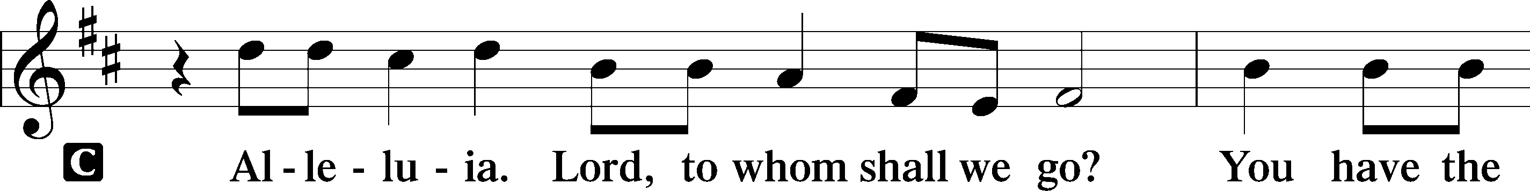

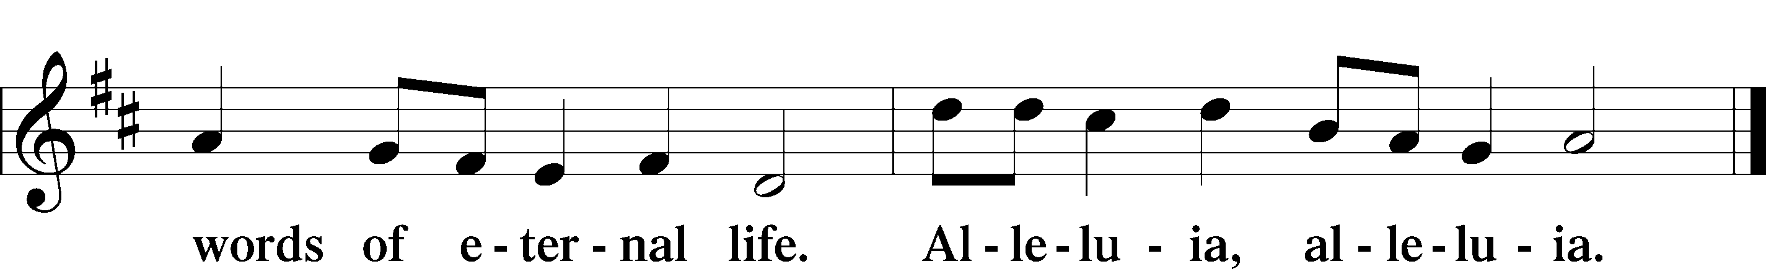

Holy Gospel John 16:23–33

P The Holy Gospel according to St. John, the sixteenth chapter.

C **Glory to You, O Lord.**

23[Jesus said:] “In that day you will ask nothing of me. Truly, truly, I say to you, whatever you ask of the Father in my name, he will give it to you. 24Until now you have asked nothing in my name. Ask, and you will receive, that your joy may be full.

25“I have said these things to you in figures of speech. The hour is coming when I will no longer speak to you in figures of speech but will tell you plainly about the Father. 26In that day you will ask in my name, and I do not say to you that I will ask the Father on your behalf; 27for the Father himself loves you, because you have loved me and have believed that I came from God. 28I came from the Father and have come into the world, and now I am leaving the world and going to the Father.”

29His disciples said, “Ah, now you are speaking plainly and not using figurative speech! 30Now we know that you know all things and do not need anyone to question you; this is why we believe that you came from God.” 31Jesus answered them, “Do you now believe? 32Behold, the hour is coming, indeed it has come, when you will be scattered, each to his own home, and will leave me alone. Yet I am not alone, for the Father is with me. 33I have said these things to you, that in me you may have peace. In the world you will have tribulation. But take heart; I have overcome the world.”

P This is the Gospel of the Lord.

C **Praise to You, O Christ.**

Sit

716 I Walk in Danger All the Way sts. 1–3

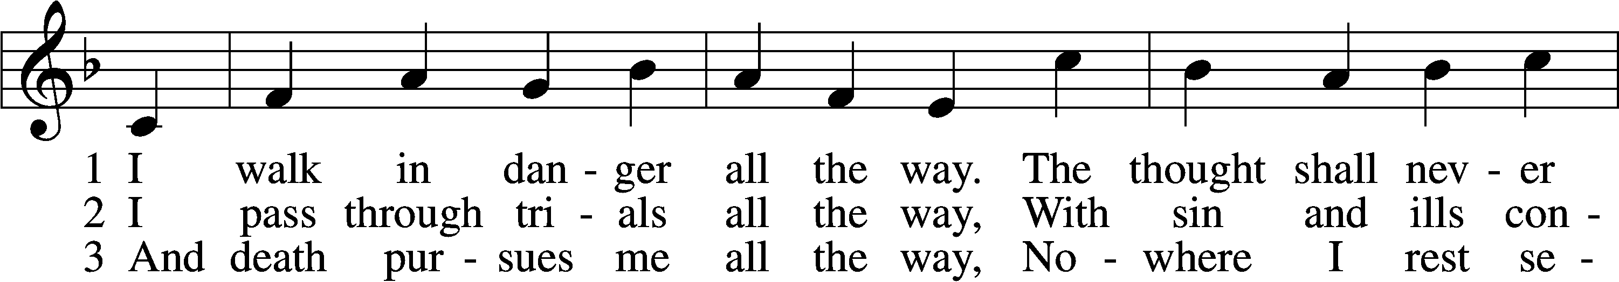

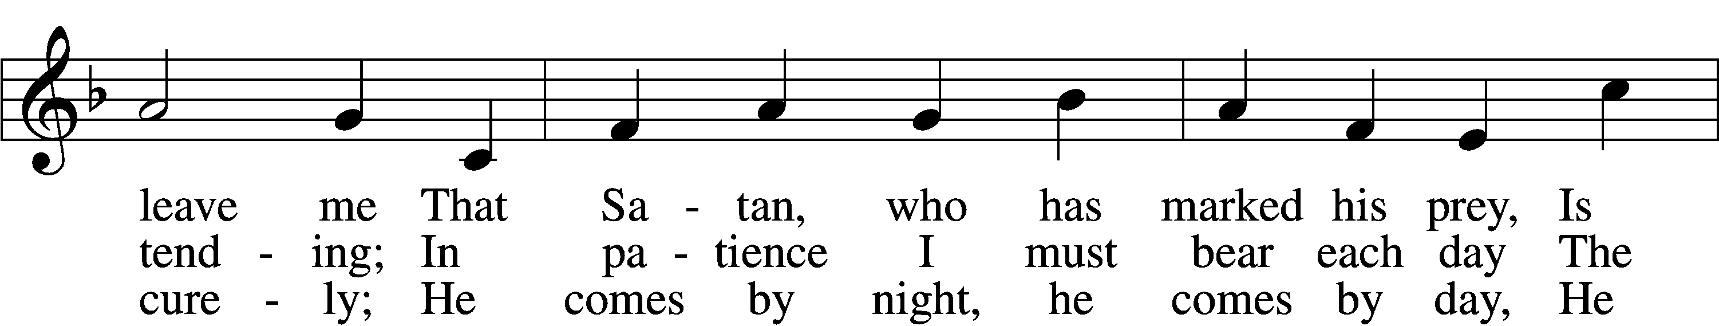

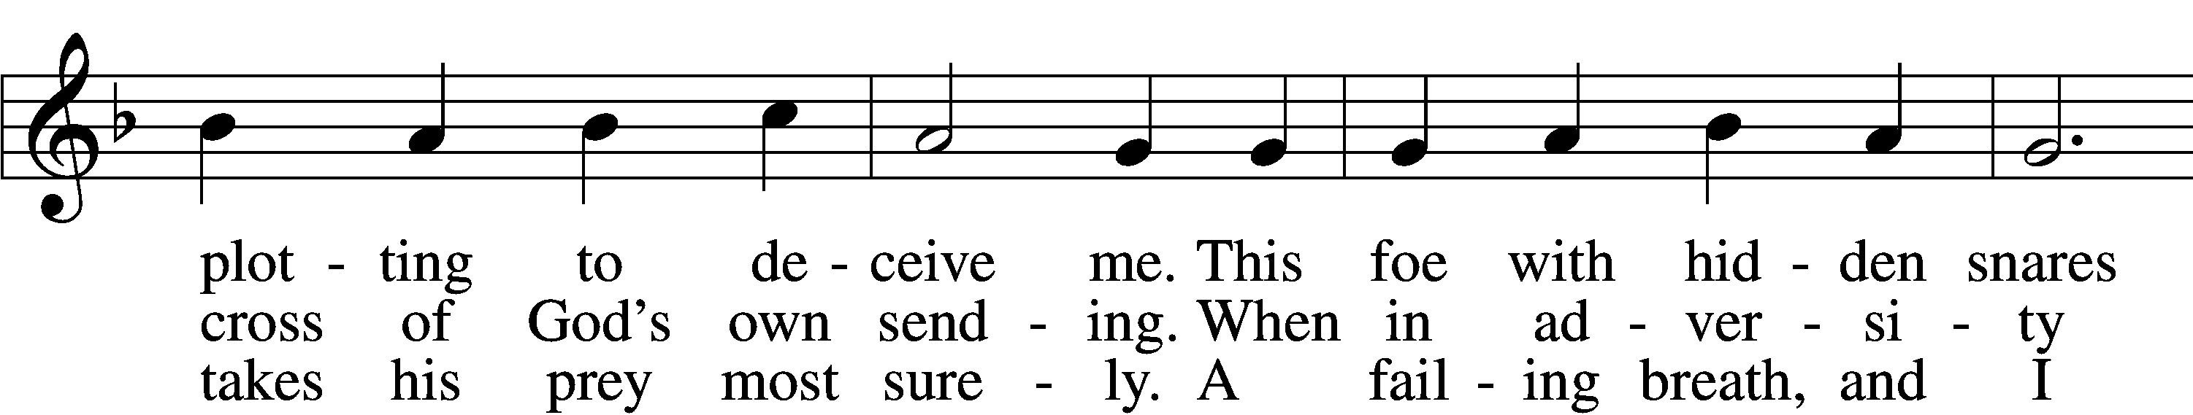

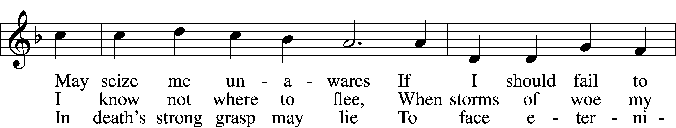

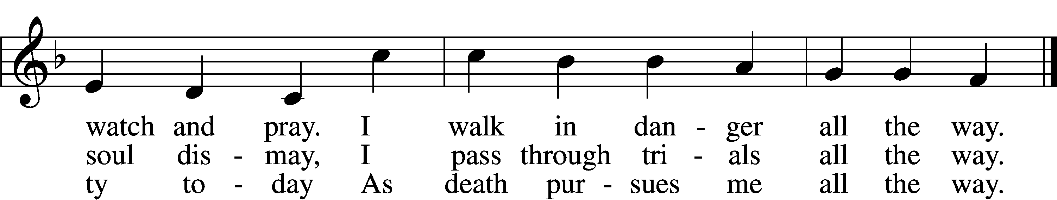

Text: Hans Adolf Brorson, 1694–1764; tr. Ditlef G. Ristad, 1863–1938, alt.  
Tune: Geist-reiches Gesang-Buch, 1708, 4th ed., Halle, ed. Johann A. Freylinghausen  
Text and tune: Public domain

Sermon- Thorns, Thistles & Such

Stand

Nicene Creed

C **I believe in one God, the Father Almighty,**

**maker of heaven and earth and of all things visible and invisible.**

**And in one Lord Jesus Christ, the only-begotten Son of God,**

**begotten of His Father before all worlds,**

**God of God, Light of Light, very God of very God,**

**begotten, not made, being of one substance with the Father,**

**by whom all things were made;**

**who for us men and for our salvation came down from heaven**

**and was incarnate by the Holy Spirit of the virgin Mary**

**and was made man;**

**and was crucified also for us under Pontius Pilate.**

**He suffered and was buried.**

**And the third day He rose again according to the Scriptures**

**and ascended into heaven**

**and sits at the right hand of the Father.**

**And He will come again with glory to judge both the living**

**and the dead, whose kingdom will have no end.**

**And I believe in the Holy Spirit,**

**the Lord and giver of life,**

**who proceeds from the Father and the Son,**

**who with the Father and the Son together is worshiped**

**and glorified, who spoke by the prophets.**

**And I believe in one holy Christian and apostolic Church,**

**I acknowledge one Baptism for the remission of sins,**

**and I look for the resurrection of the dead**

**and the life** T **of the world to come. Amen.**

Prayer of the Church

Following the prayers, the people may greet one another in the name of the Lord, saying, “Peace be with you,” as a sign of reconciliation and of the unity of the Spirit in the bond of peace (Matt. 5:22–24; Eph. 4:1–3).

Offering Sharing of the Peace

Offertory LSB 159

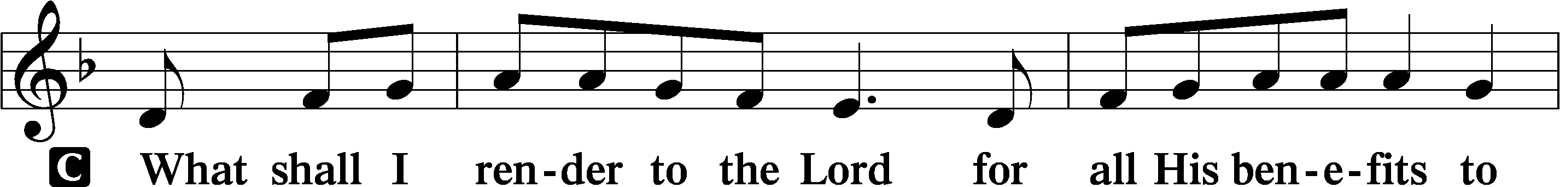

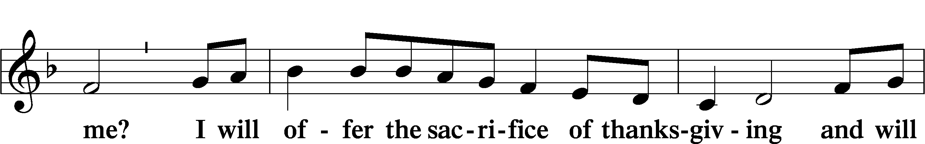

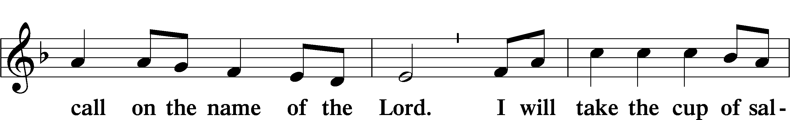

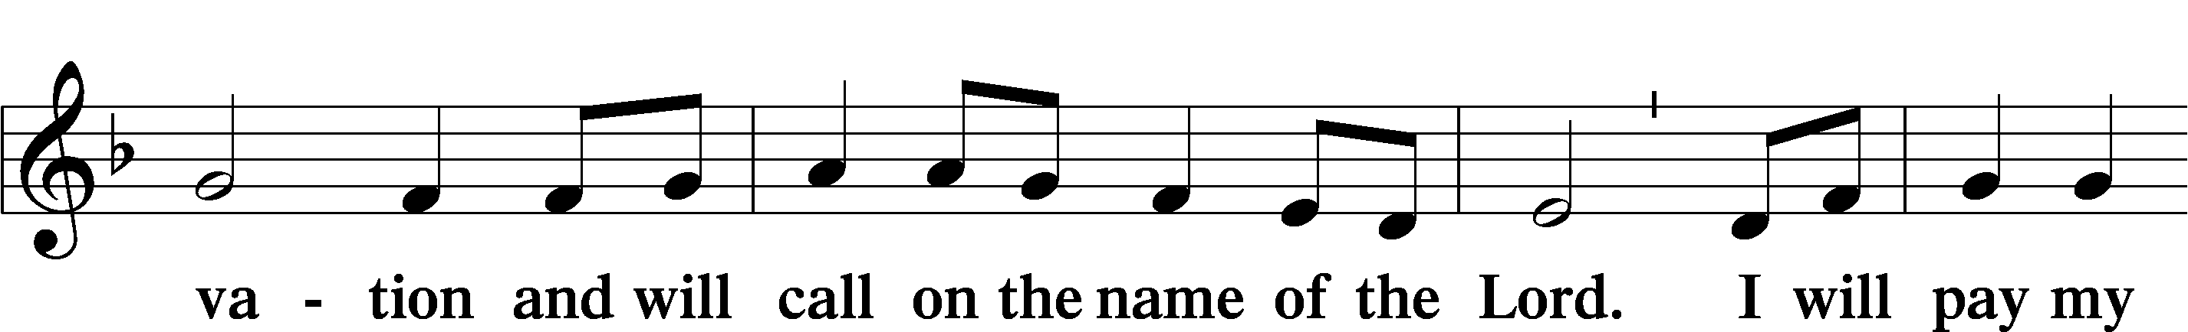

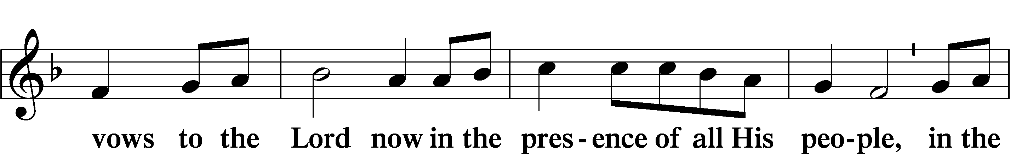

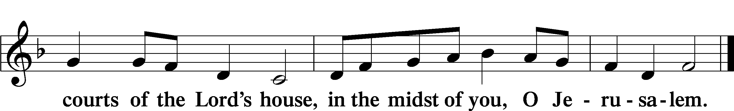

# Service of Holy Communion

**Communion Statement**

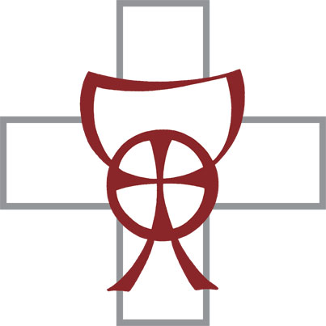

*The Lord’s Supper is celebrated at this congregation in the confession and glad confidence that, as He says, our Lord gives into our mouths not only bread and wine but His very body and blood to eat and to drink for the forgiveness of sins and to strengthen our union with Him and with one another. Our Lord invites to His table those who trust His words, repent of all sin, and set aside any refusal to forgive and love as He forgives and loves us, that they may show forth His death until He comes.*

*Because those who eat and drink our Lord’s body and blood unworthily do so to their great harm and because Holy Communion is a confession of the faith which is confessed at this altar, any who are not yet instructed, in doubt, or who hold a confession differing from that of this congregation and the Lutheran Church Missouri Synod, and yet desire to receive this sacrament, are asked to speak with the Pastor.*

*\* See more about the Lutheran teaching on communion in the Hymnal p 329.*

Preface LSB 160

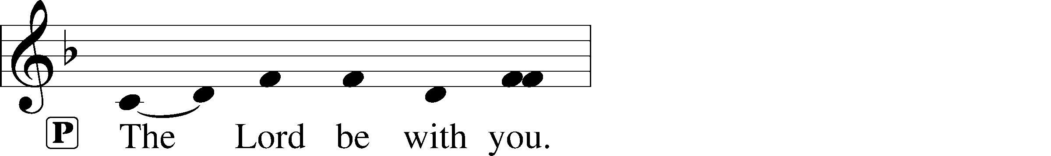

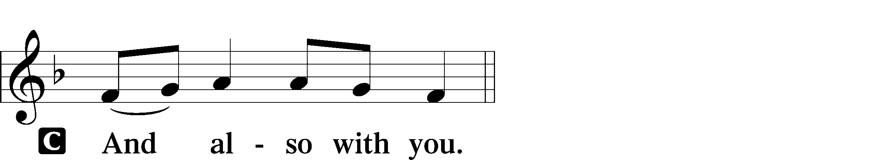

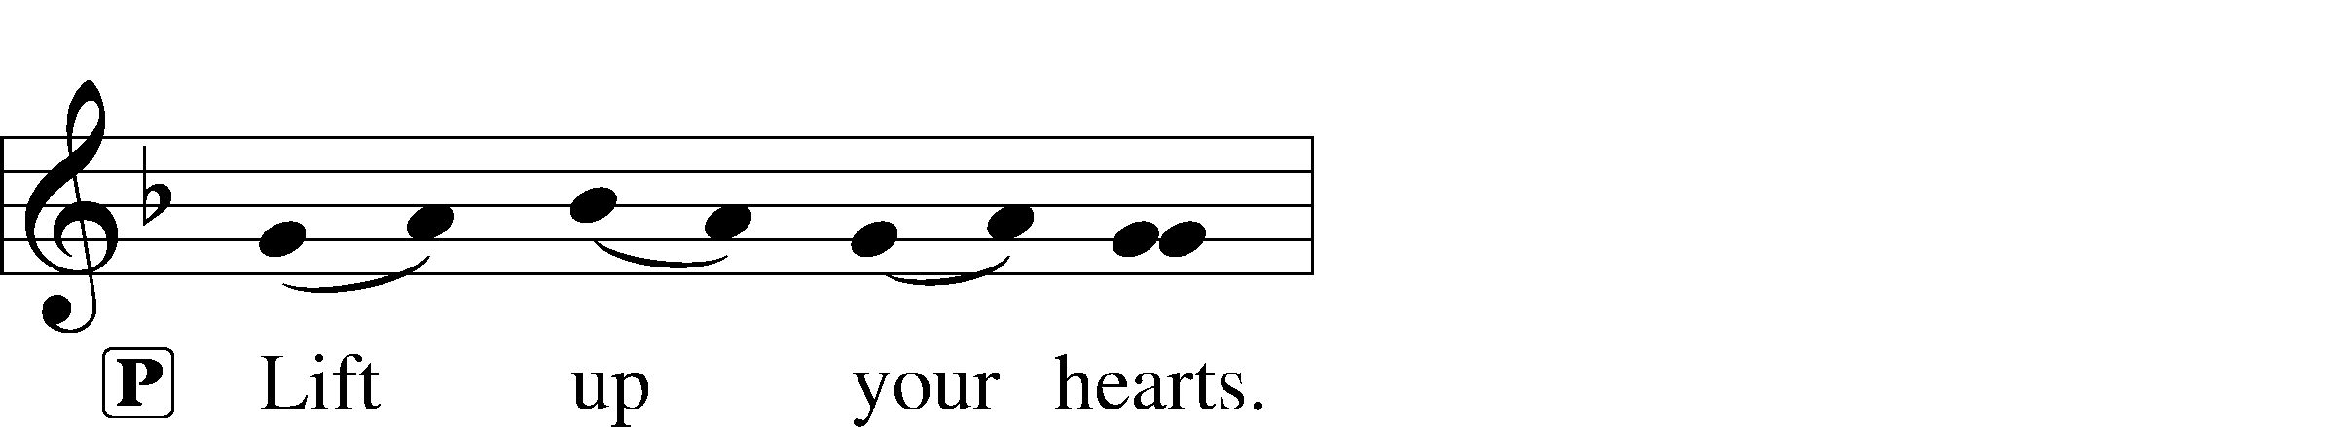



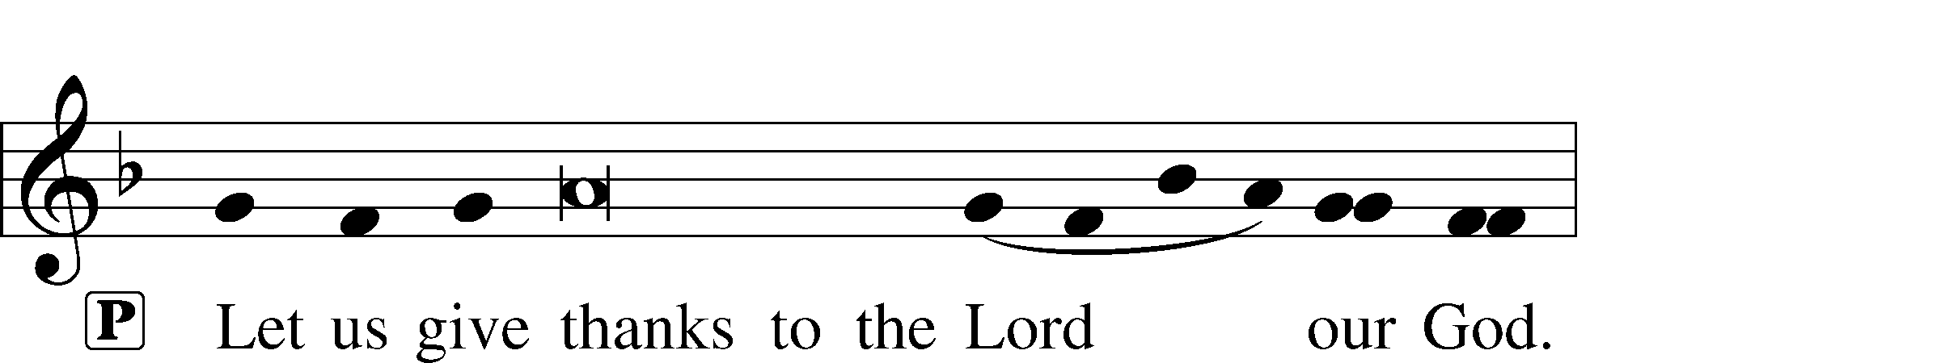

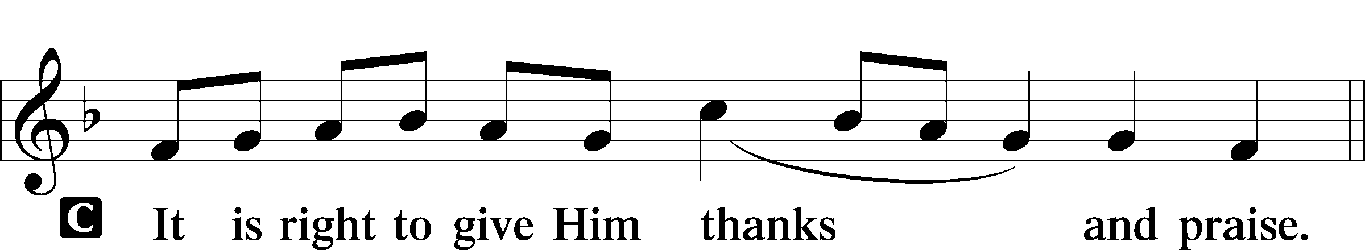

P It is truly good, right, and salutary that we should at all times and in all places give thanks to You, holy Lord, almighty Father, everlasting God. And most especially are we bound to praise You on this day for the glorious resurrection of Your Son, Jesus Christ, the very Paschal Lamb, who was sacrificed for us and bore the sins of the world. By His dying He has destroyed death, and by His rising again He has restored to us everlasting life. Therefore with Mary Magdalene, Peter and John, and with all the witnesses of the resurrection, with angels and archangels, and with all the company of heaven we laud and magnify Your glorious name, evermore praising You and saying:

Sanctus LSB 161

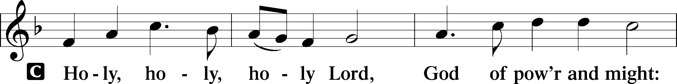

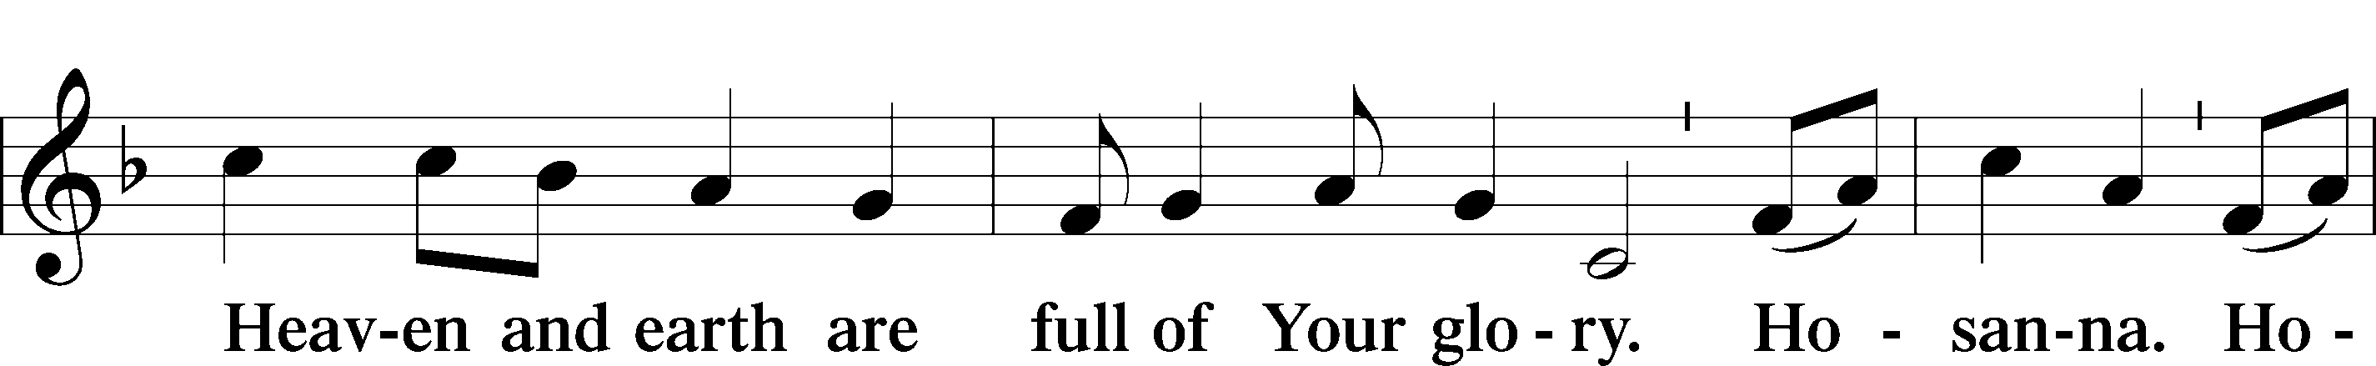

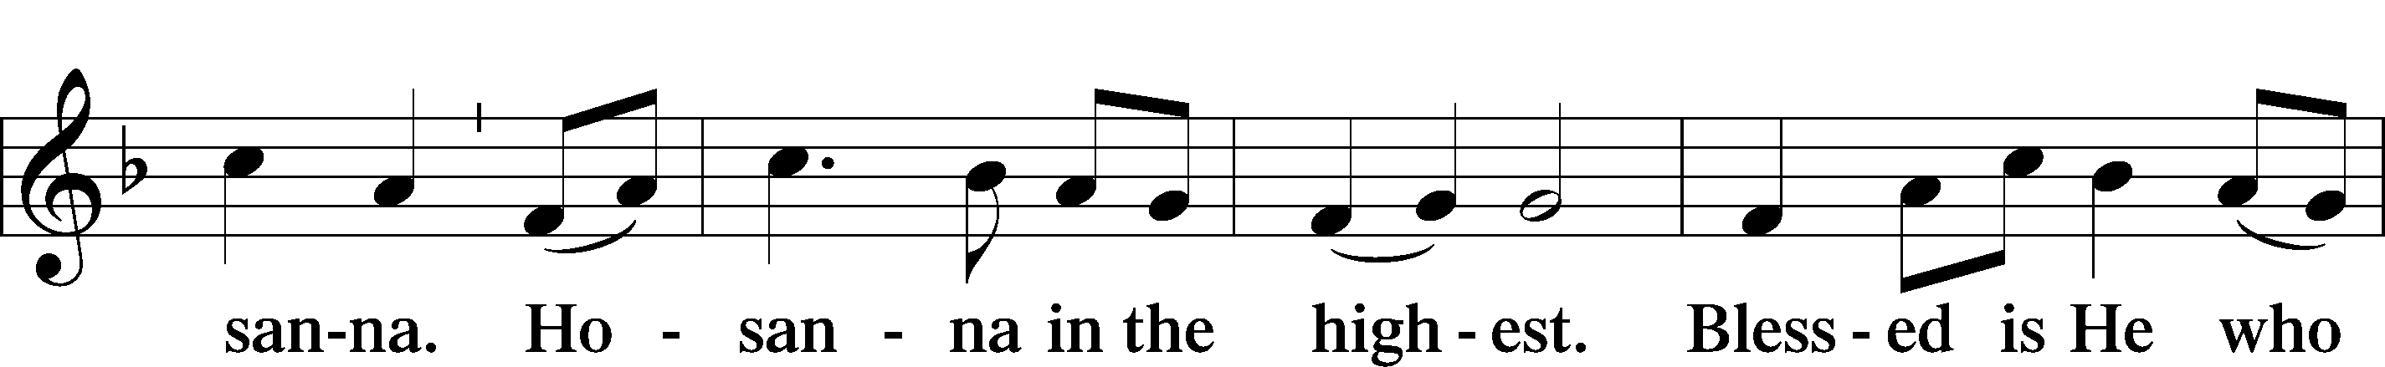

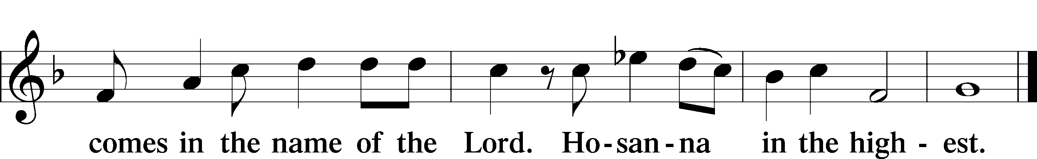

Prayer of Thanksgiving

LSB 161

P Blessed are You, Lord of heaven and earth, for You have had mercy on those whom You created and sent Your only-begotten Son into our flesh to bear our sin and be our Savior. With repentant joy we receive the salvation accomplished for us by the all-availing sacrifice of His body and His blood on the cross.

Gathered in the name and the remembrance of Jesus, we beg You, O Lord, to forgive, renew, and strengthen us with Your Word and Spirit. Grant us faithfully to eat His body and drink His blood as He bids us do in His own testament. Gather us together, we pray, from the ends of the earth to celebrate with all the faithful the marriage feast of the Lamb in His kingdom, which has no end. Graciously receive our prayers; deliver and preserve us. To You alone, O Father, be all glory, honor, and worship, with the Son and the Holy Spirit, one God, now and forever.

C **Amen.**

The Words of Our Lord

P Our Lord Jesus Christ, on the night when He was betrayed, took bread, and when He had given thanks, He broke it and gave it to the disciples and said: “Take, eat; this is My T body, which is given for you. This do in remembrance of Me.”

In the same way also He took the cup after supper, and when He had given thanks, He gave it to them, saying: “Drink of it, all of you; this cup is the new testament in My T blood, which is shed for you for the forgiveness of sins. This do, as often as you drink it, in remembrance of Me.”

P As often as we eat this bread and drink this cup, we proclaim the Lord’s death until He comes.

C **Amen. Come, Lord Jesus.**

P O Lord Jesus Christ, only Son of the Father, in giving us Your body and blood to eat and to drink, You lead us to remember and confess Your holy cross and passion, Your blessed death, Your rest in the tomb, Your resurrection from the dead, Your ascension into heaven, and Your coming for the final judgment. So remember us in Your kingdom and teach us to pray:

Lord’s Prayer

C **Our Father who art in heaven,**

**hallowed be Thy name,**

**Thy kingdom come,**

**Thy will be done on earth**

**as it is in heaven;**

**give us this day our daily bread;**

**and forgive us our trespasses**

**as we forgive those**

**who trespass against us;**

**and lead us not into temptation,**

**but deliver us from evil.**

**For Thine is the kingdom**

**and the power and the glory**

**forever and ever. Amen.**

Pax Domini LSB 163

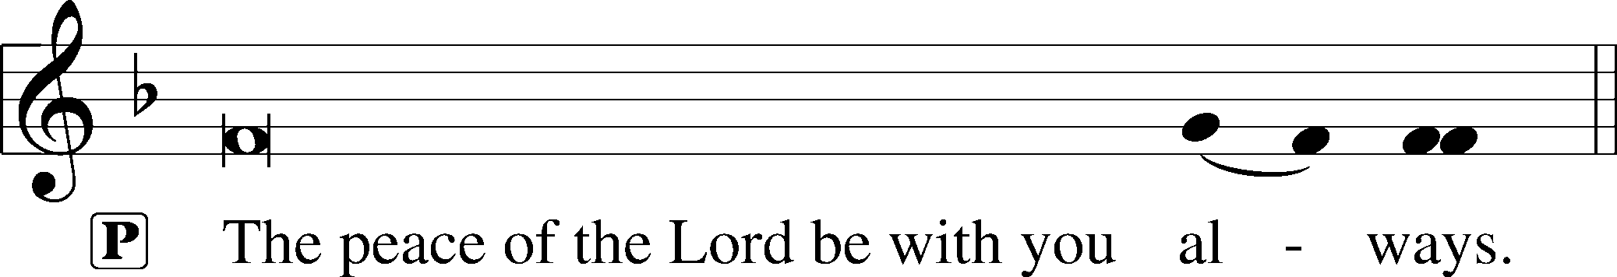



Agnus Dei LSB 163

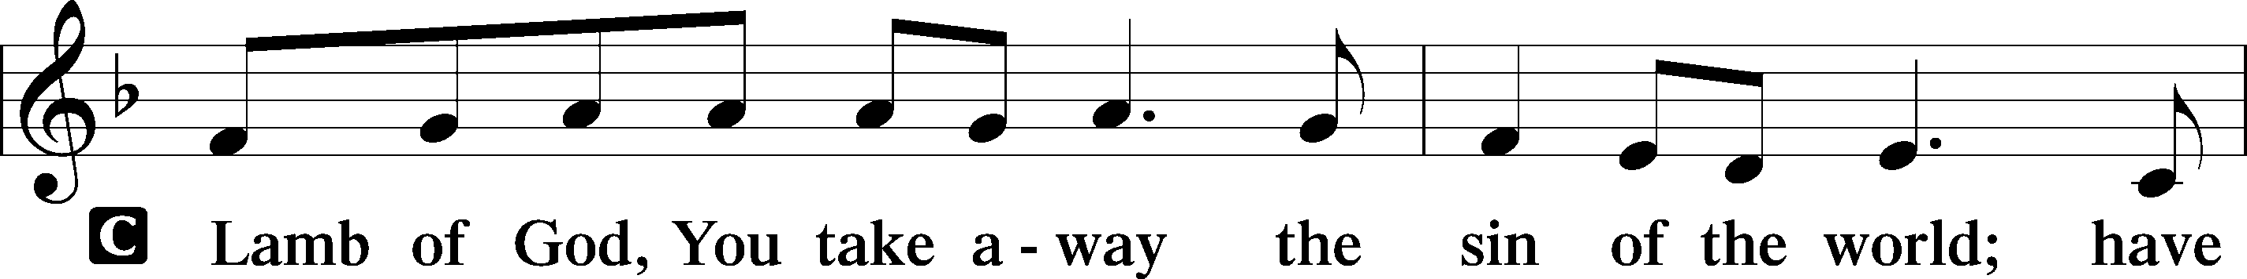

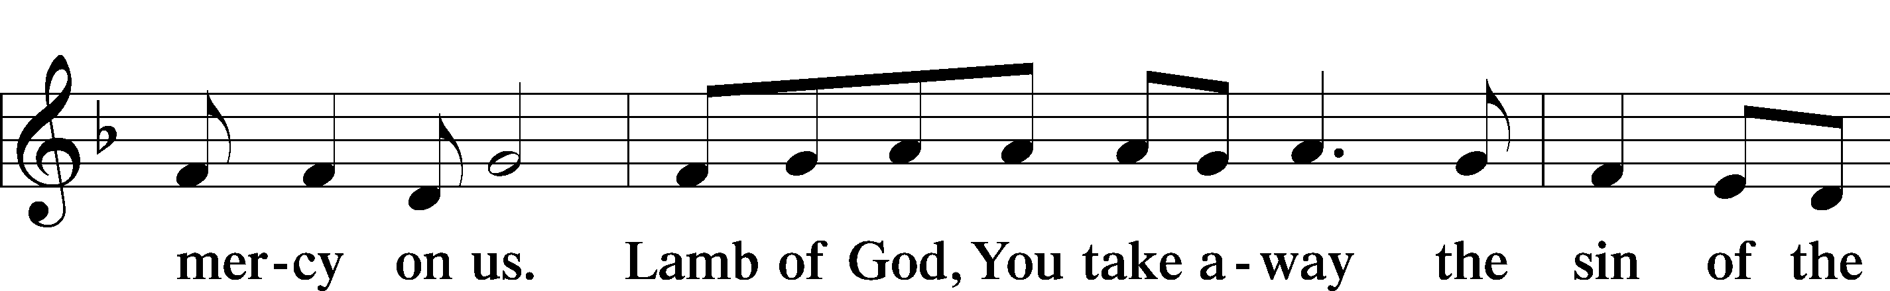

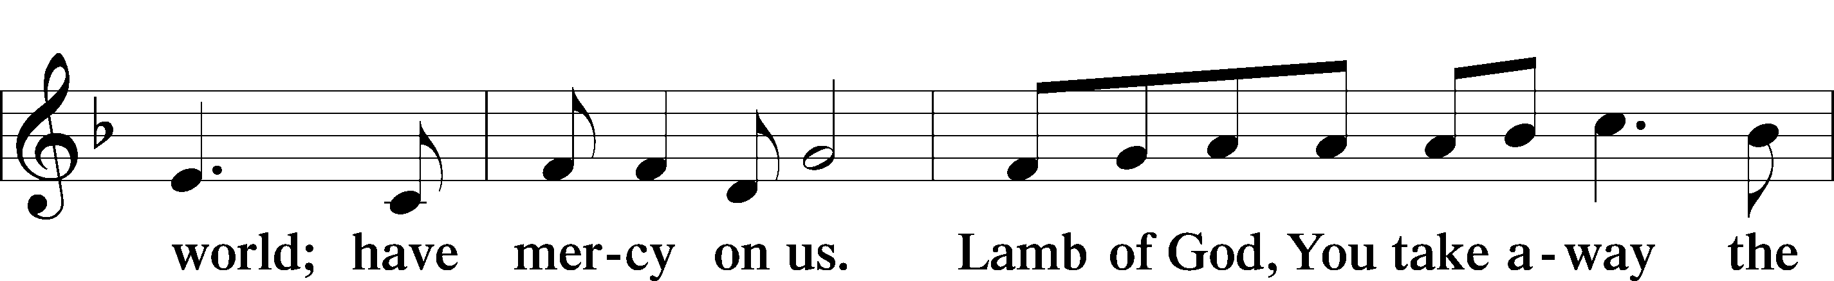

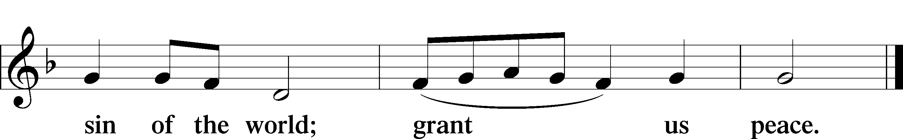

Sit

Distribution

Stand

Thank the Lord LSB 164

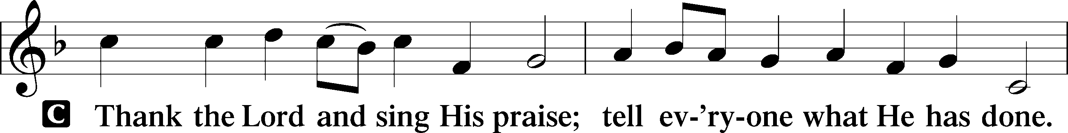

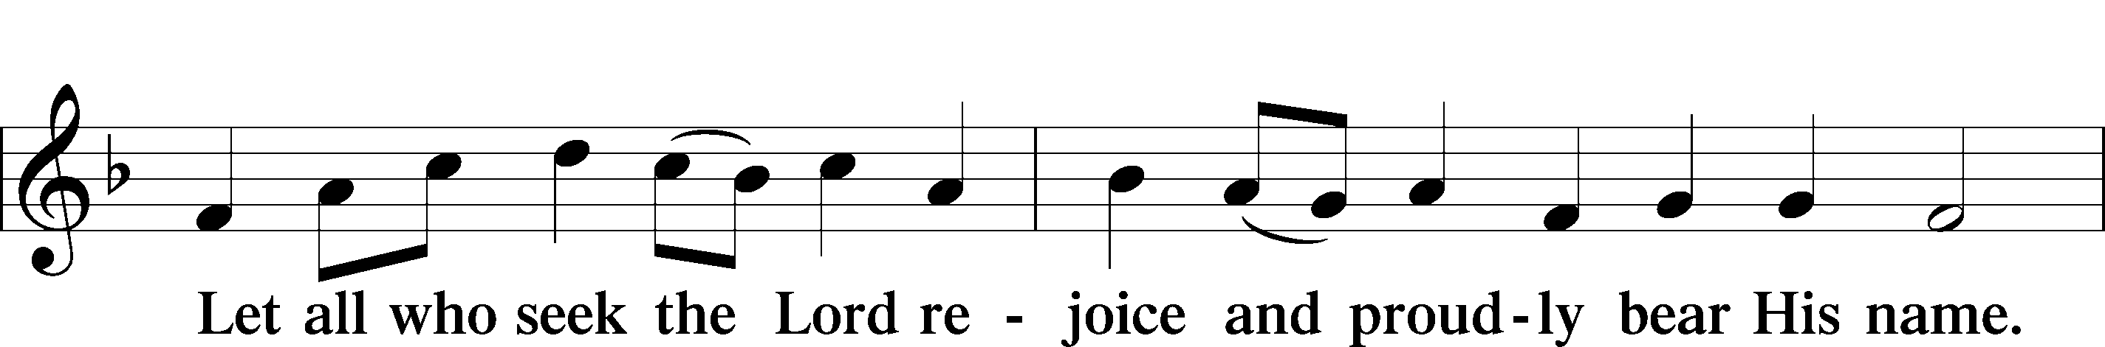

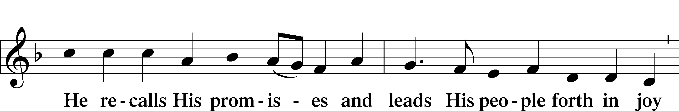

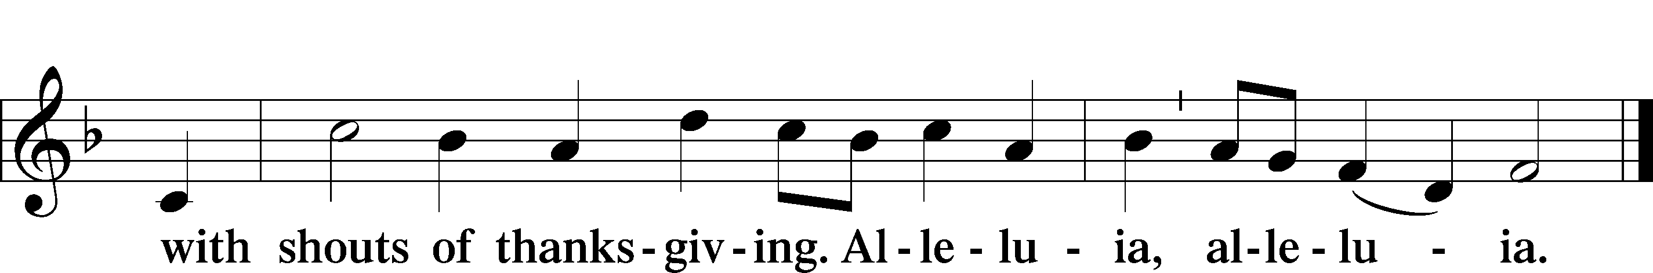

Post-Communion Collect

A Let us pray.

We give thanks to You, almighty God, that You have refreshed us through this salutary gift, and we implore You that of Your mercy You would strengthen us through the same in faith toward You and in fervent love toward one another; through Jesus Christ, Your Son, our Lord, who lives and reigns with You and the Holy Spirit, one God, now and forever.

C **Amen.**

Verse Romans 6:9; John 16:33b

Alleluia. We know that Christ being raised from the dead will never die again; death no longer has dominion over him.

**In the world you will have tribulation. But take heart; I have overcome the world. Alleluia.**

Benediction LSB 166

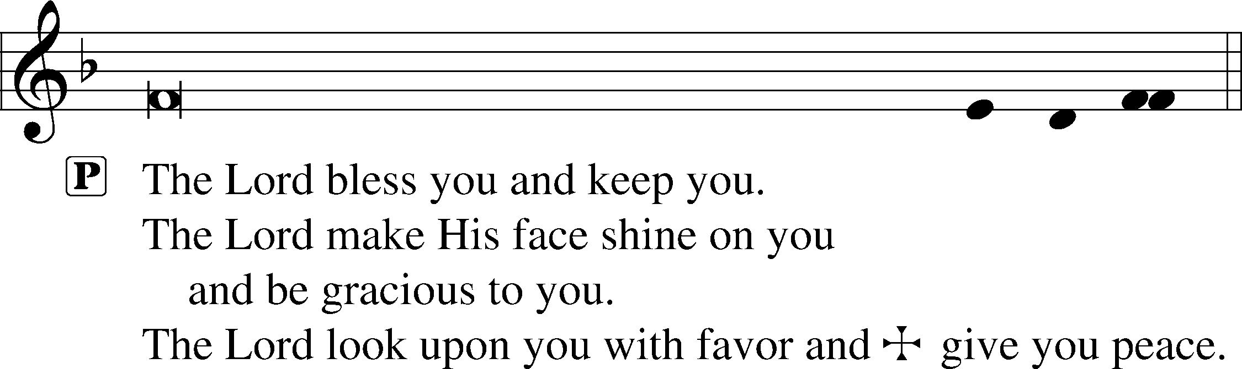



716 I Walk in Danger All the Way sts. 4–6

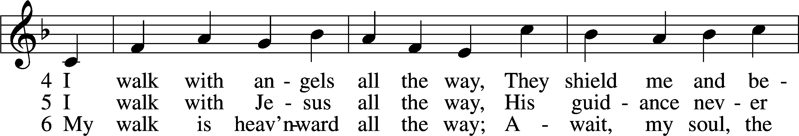

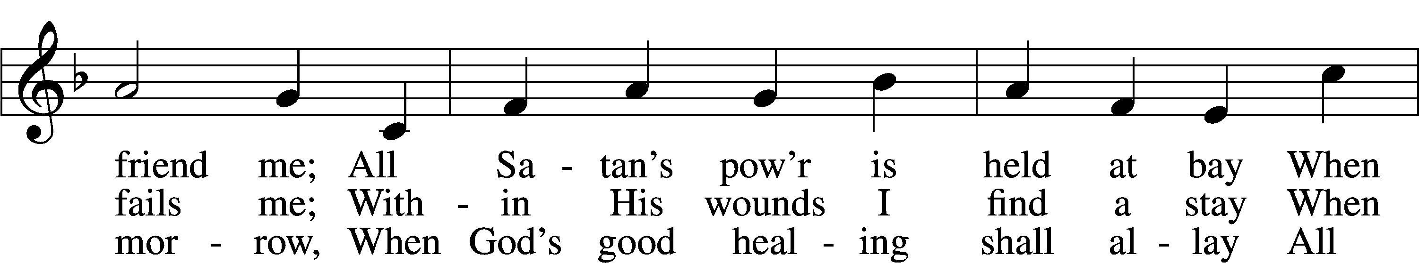

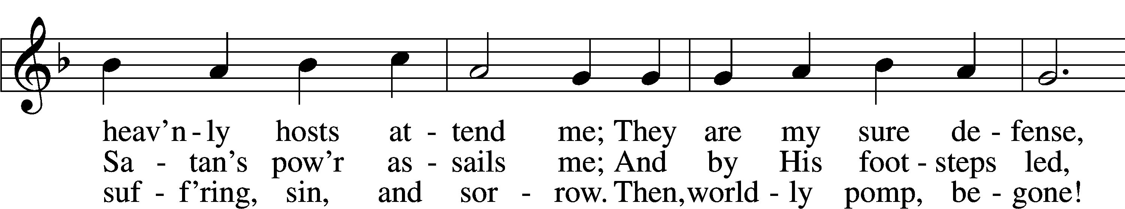

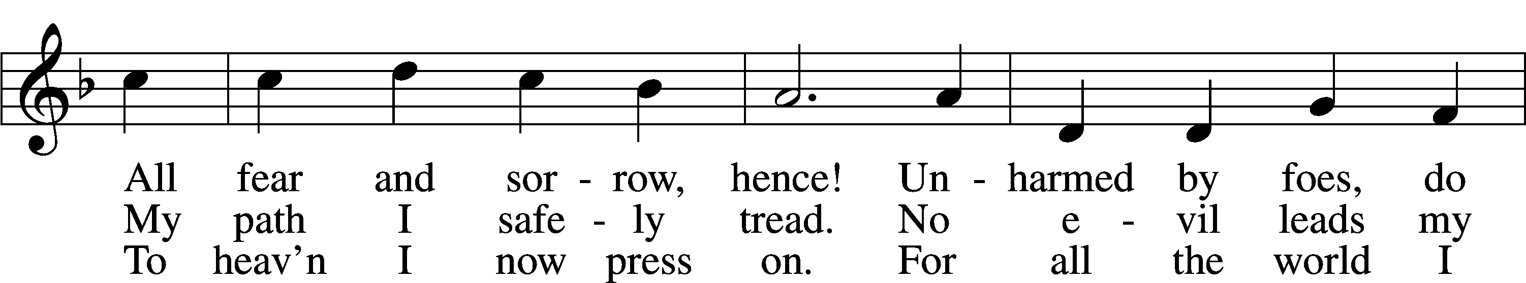

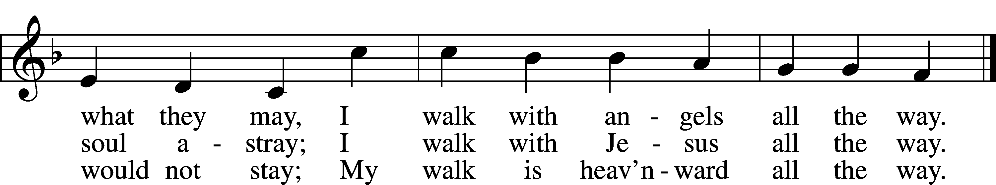

Text: Hans Adolf Brorson, 1694–1764; tr. Ditlef G. Ristad, 1863–1938, alt.  
Tune: Geist-reiches Gesang-Buch, 1708, 4th ed., Halle, ed. Johann A. Freylinghausen  
Text and tune: Public domain

Acknowledgments

Divine Service, Setting One from Lutheran Service Book

Unless otherwise indicated, Scripture quotations are from the ESV® Bible (The Holy Bible, English Standard Version®), copyright © 2001 by Crossway, a publishing ministry of Good News Publishers. Used by permission. All rights reserved.

Created by Lutheran Service Builder © 2025 Concordia Publishing House.

**Prayers of the Church**

*This week, we lift up:*

Jim, Angela H., Elaine & Bob, Angelina, Sheila, Angela Carrie, Kathy H.,

Family of the week: Rebecca (Beckey) Haulenbeek

*If you have any prayer request let us know.

Last week: Attendance - 26 Offering - $541

|  |  |
| --- | --- |
| **Serving Next Week** 6/1/25)  Service Leader: Vicar Previn Hudetz  Communion Celebrant: Rev John Heffelfinger  Worship Assistant: Charlie M.  Reader: Jim  Refreshments: PotLuck  Altar Guild: Angie Zak  Greeter: Bob | **Readings Next Week**  *7th Sunday of Easter*  Acts 1:12-26  Psalm 133  Revelation 22:1-20  John 17:20-26  ***Please sign up to help Read, Greet, Set up Communion, be a Worship Assistant or bring Refreshments.*** |
| **Announcements**  Birthdays:  This Week at OSLC:  Bible Study: After Service  Bible Study: Thursday 10am | **This Month**:  Wear RED on Pentecost which is June 8th!  Father’s Day is June 15th! |

**Seasons of the Church Year**

Easter is a 50-day season from the Day of the Resurrection of our Lord to the Day of Pentecost.

It is the richest and most lavishly celebrated festival at the church year. The resurrection is the crux of everything we believe, all our faith hinges on Jesus return from the dead; for if there is no resurrection, there is no life eternal for believers.

