

…for all have sinned and fall short of the glory of God, and are justified by his grace as a gift, through the redemption that is in Christ Jesus…

Romans 3:23-24

Our Savior Lutheran Church (LCMS)
4301 Atrisco Drive NW
Albuquerque, New Mexico
Website: OSLCNM.COM
Phone: 505.836.7007
Email: oslcabq@gmail.com

Reformation Sunday
October 26th,2025
Reformation Sunday
October 26th, 2025

Welcome to Our Savior Lutheran Church (LCMS).  We are glad you are here as we worship, praise, and give thanks to our loving Lord, Jesus Christ. Please join us immediately after service for fellowship and snacks. Adult Bible Study starts at 10:30. If you have any questions about our service or need other assistance, please contact one of our worship assistants. | Hymns  Opening # 657 & 803  Sermon # 570  Distribution # Sola Gratia  Closing # 702
Today’s Message

“Anfechtung” describes the overwhelming fear that one’s salvation is not secure—the sense that God, the righteous Judge, seeks to keep sinners out rather than welcome them into His eternal kingdom. Martin Luther wrestled deeply with these fears until the Holy Spirit revealed through Scripture that our Creator God both wants us and loves us. The sacrifice of Jesus on the cross was no accident but part of God’s eternal plan of redemption—proof of His presence, power, and mercy. Through His Son alone, we are led to the path of life eternal.

+++
Serving Today
Guest Pastor: Reverand Doyle Boyken
Music Minister: Vicar Previn Hudetz
Communion Assistant: Jim C
Worship Assistant: Charlie Mike
Reader: Tania V
Refreshments: Tania V
Altar Guild: Angie Z & Sheila S
Greeter: Juanita S
Welcome
Divine Service I

657 A Mighty Fortress Is Our God sts. 1–4
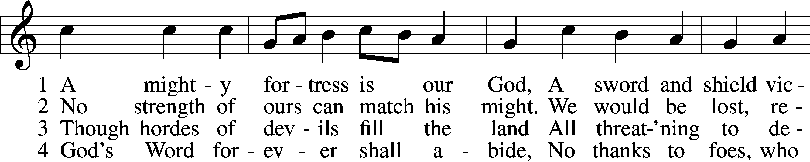
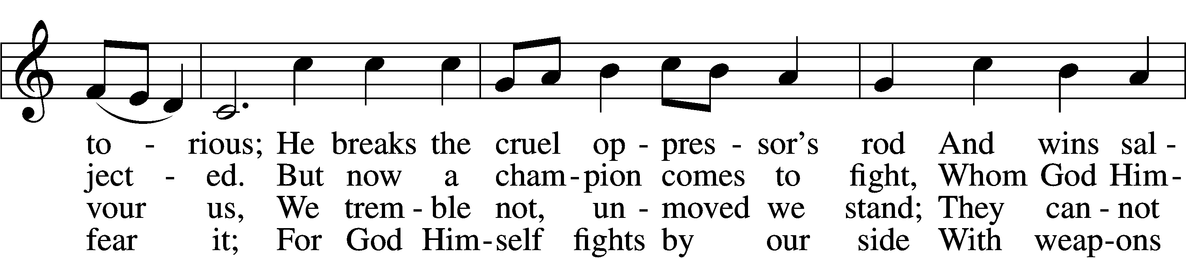
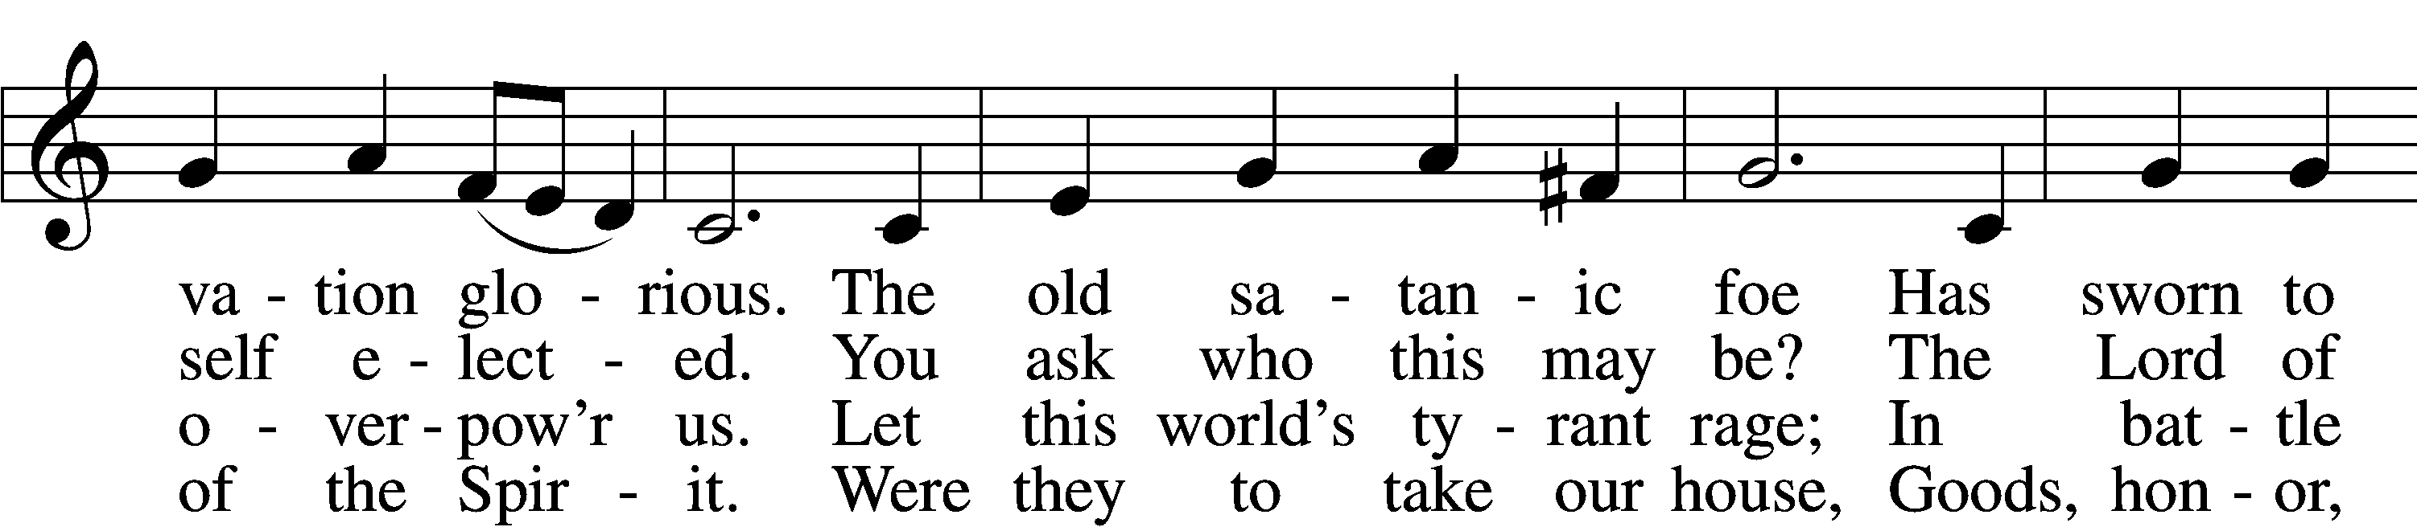
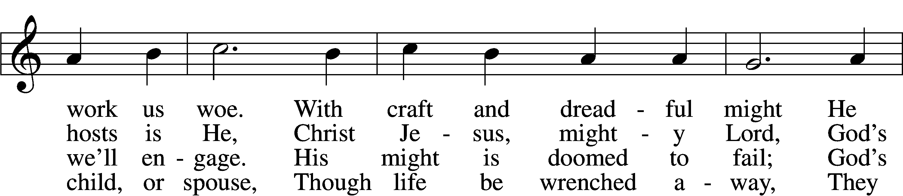
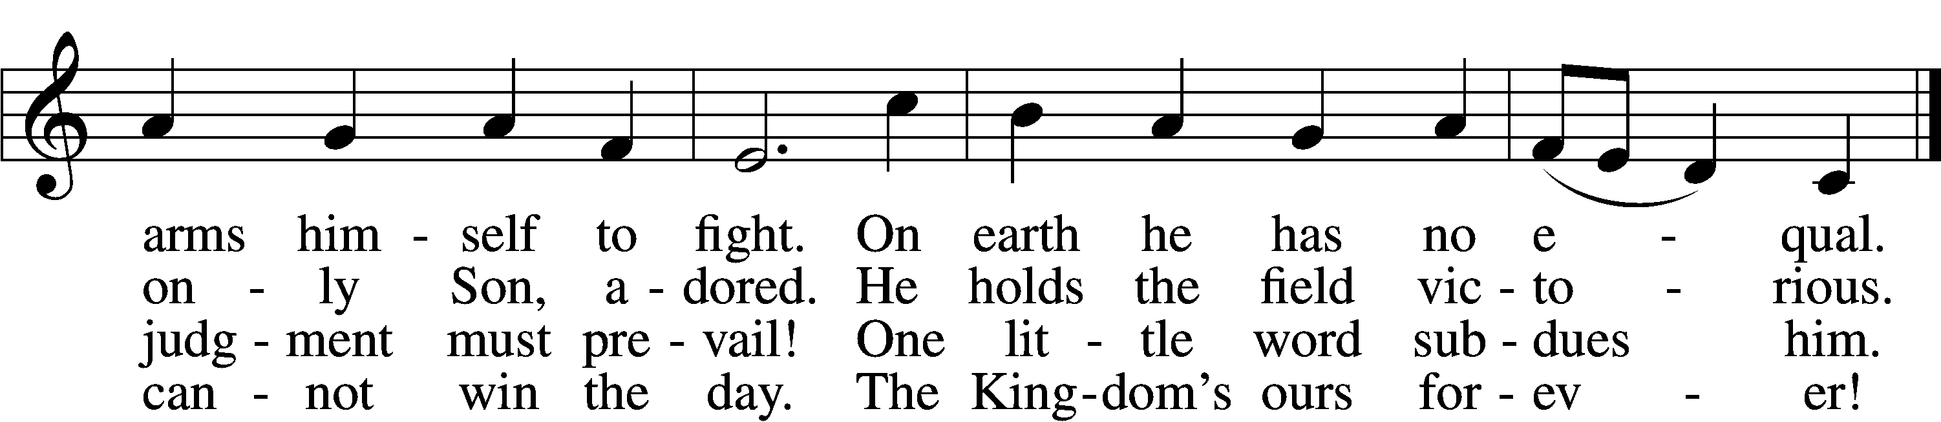

Text: tr. Lutheran Book of Worship, 1978 Text and tune: Martin Luther, 1483–1546
Text: © 1978 Lutheran Book of Worship. Used by permission: LSB Hymn License no. 110003995
Tune: Public domain

803 Joyful, Joyful We Adore Thee
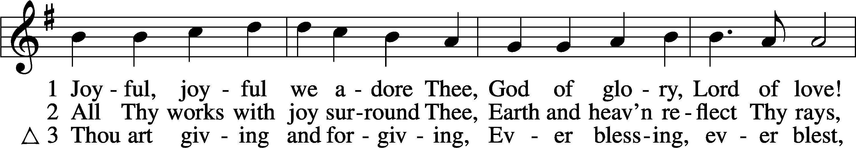
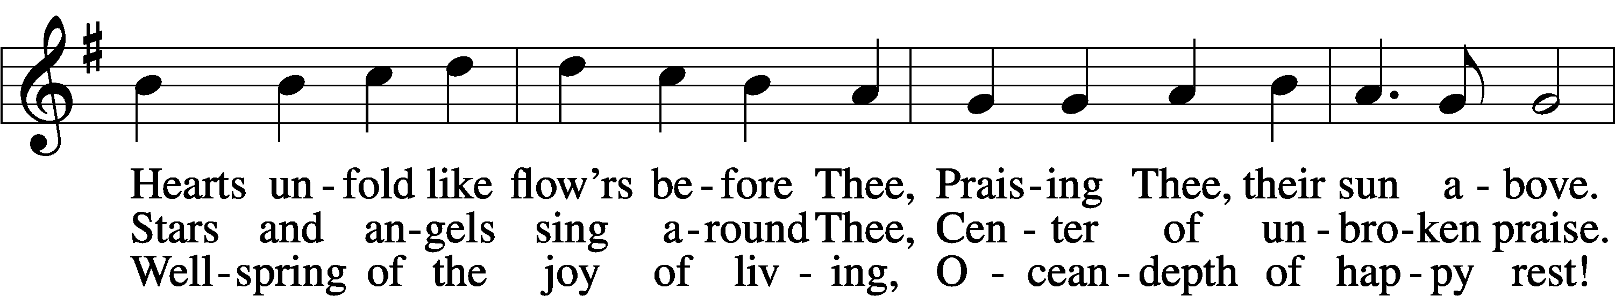
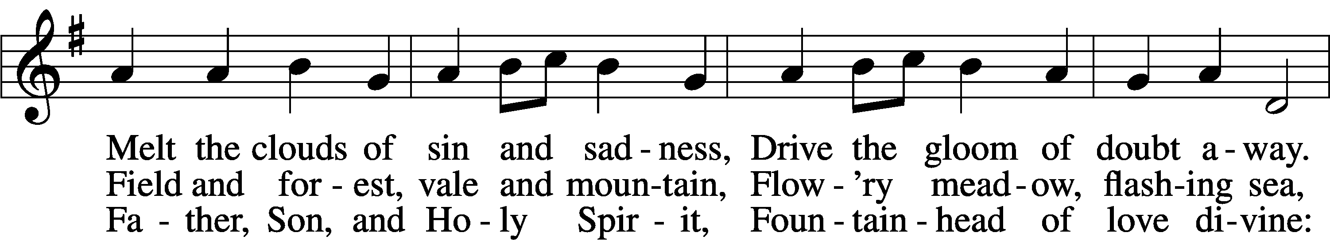
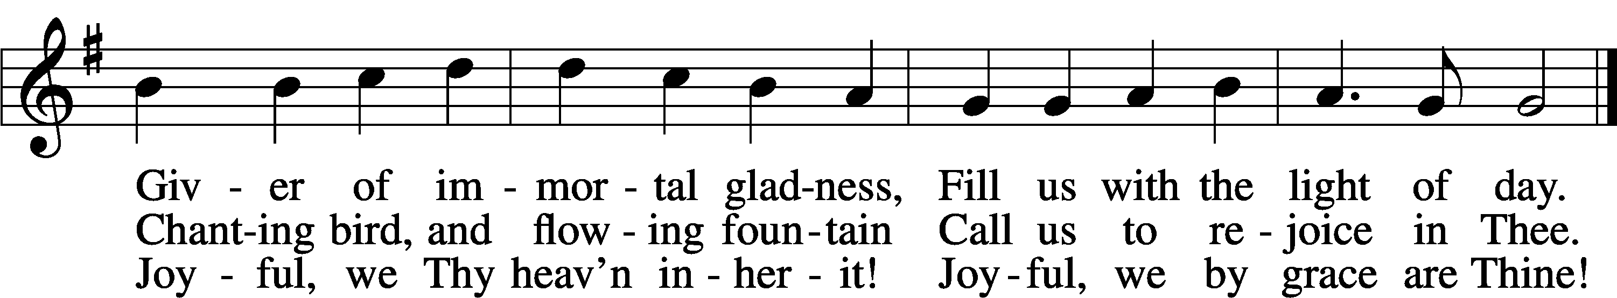
Text: Henry Van Dyke, 1852–1933, alt.
Tune: Ludwig van Beethoven, 1770–1827; adapt. Edward Hodges, 1796–1867
Text and tune: Public domain

Confession and Absolution
Stand

The sign of the cross may be made by all in remembrance of their Baptism.

L In the name of the Father and of the T Son and of the Holy Spirit.
C Amen.

L If we say we have no sin, we deceive ourselves, and the truth is not in us.
C But if we confess our sins, God, who is faithful and just, will forgive our sins and cleanse us from all unrighteousness.

Silence for reflection on God’s Word and for self-examination.

L Let us then confess our sins to God our Father.
C Most merciful God, we confess that we are by nature sinful and unclean. We have sinned against You in thought, word, and deed, by what we have done and by what we have left undone. We have not loved You with our whole heart; we have not loved our neighbors as ourselves. We justly deserve Your present and eternal punishment. For the sake of Your Son, Jesus Christ, have mercy on us. Forgive us, renew us, and lead us, so that we may delight in Your will and walk in Your ways to the glory of Your holy name. Amen.

L Almighty God in His mercy has given His Son to die for you and for His sake forgives you all your sins. As a called servant of Christ, and by His authority, I therefore forgive you all your sins in the name of the Father and of the T Son and of the Holy Spirit.
C Amen.

Stand

Service of the Word

Invitatory for Reformation Sunday
L Blessed be God, the Father, the Son and the Holy Spirit.
O come, let us worship him
C I will speak of your testimonies before kings
And shall not be put to shame. Psalm 119.46

Introit Psalm 34:1–2, 11, 22; antiphon: Psalm 119:46
I will speak of your testimonies before kings, | [O Lord,]*
and shall not be | put to shame.
I will bless the Lord at | all times;*
his praise shall continually be | in my mouth.
My soul makes its boast | in the Lord;*
let the humble hear | and be glad.
Come, O children, lis- | ten to me;*
I will teach you the fear | of the Lord.
The Lord redeems the life of his | servants;*
none of those who take refuge in him will | be condemned.
Glory be to the Father and | to the Son*
and to the Holy | Spirit;
as it was in the be- | ginning,*
is now, and will be forever. | Amen.
I will speak of your testimonies before kings, | [O Lord,]*
and shall not be | put to shame.

Kyrie LSB 152

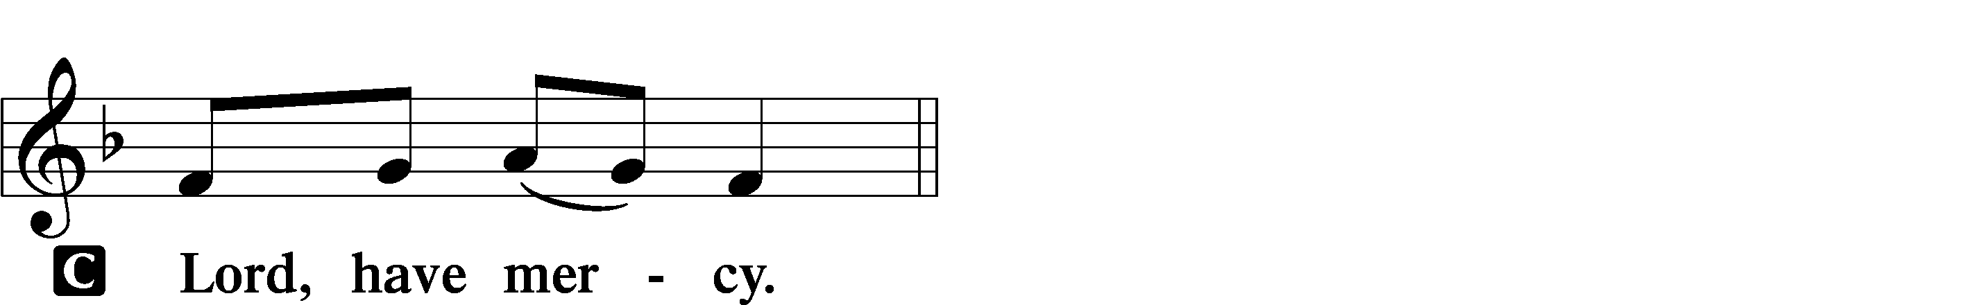
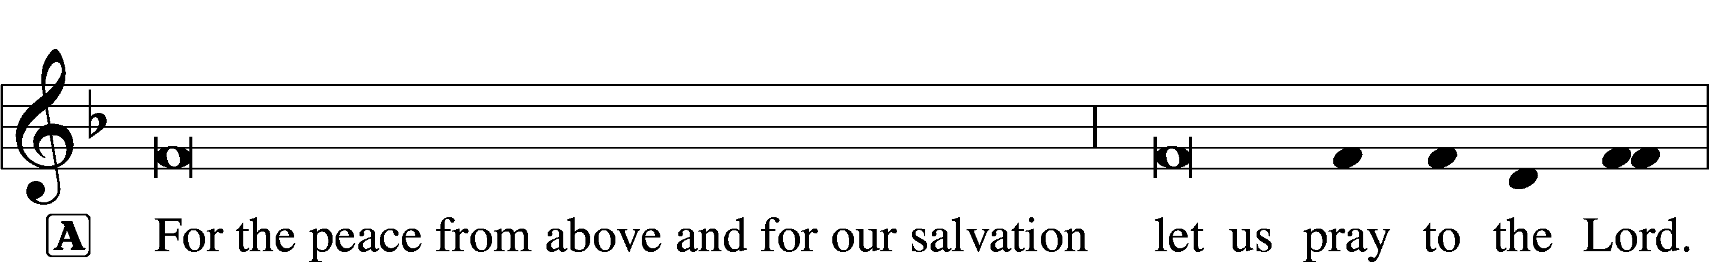
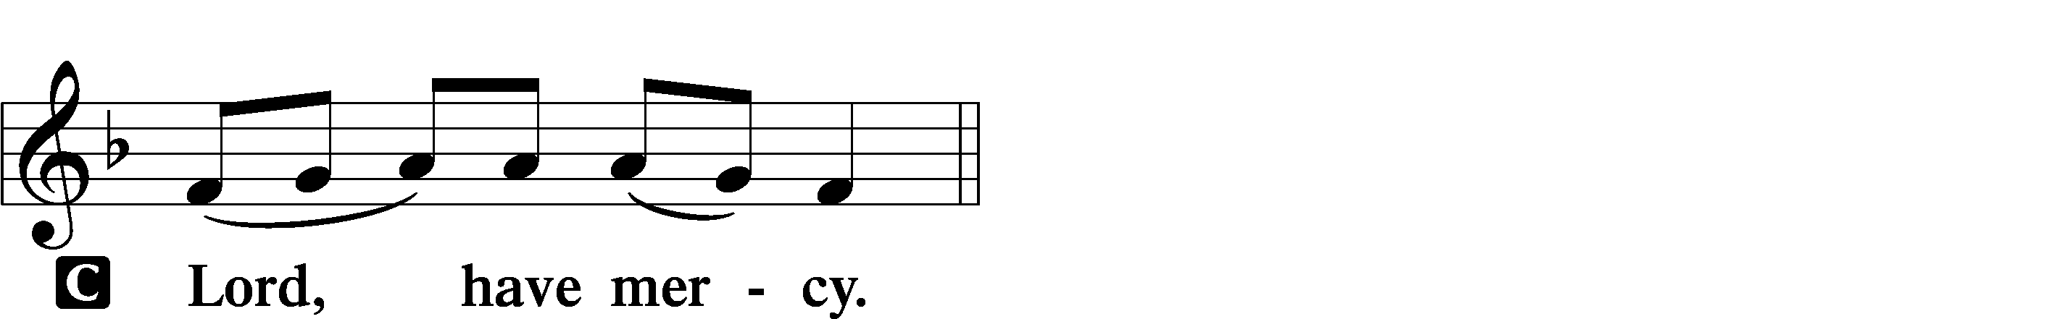
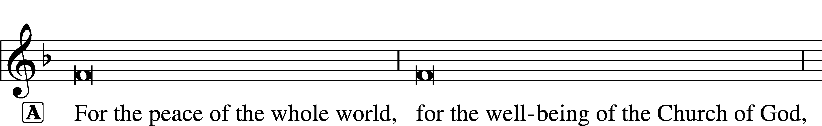

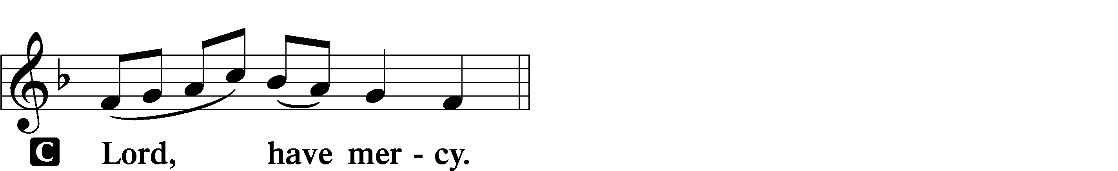
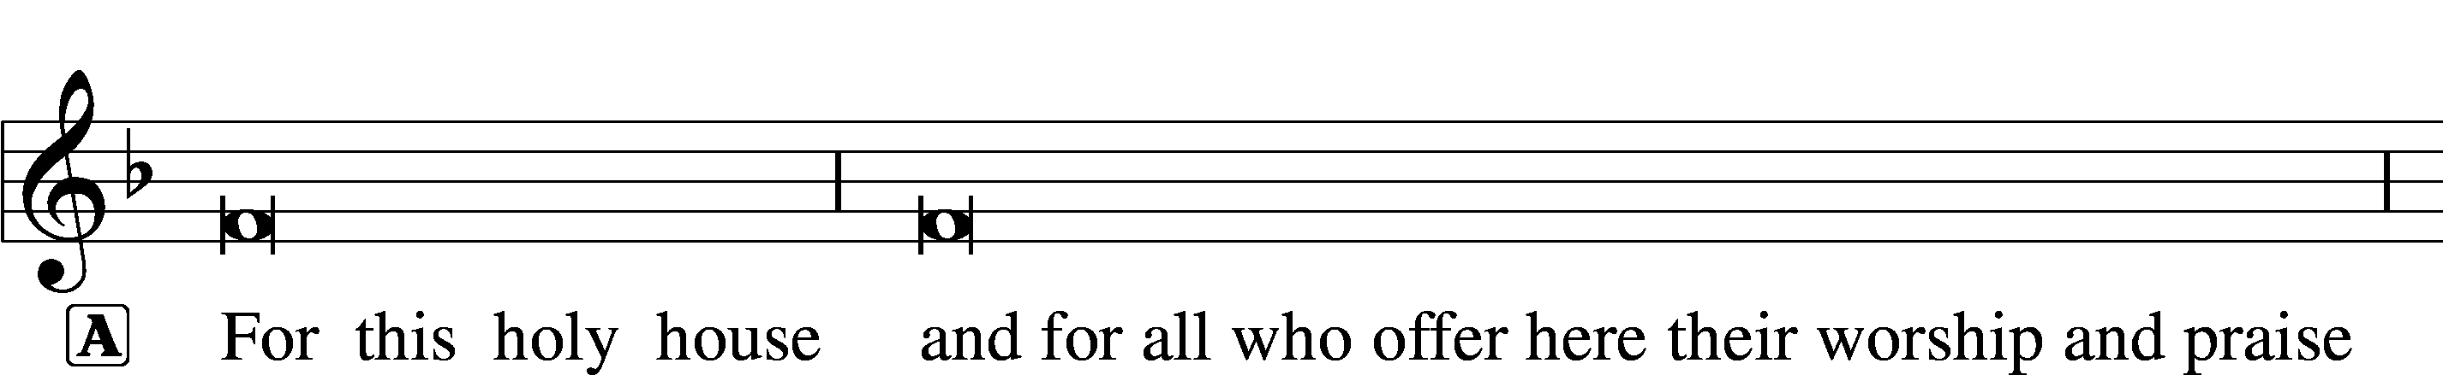

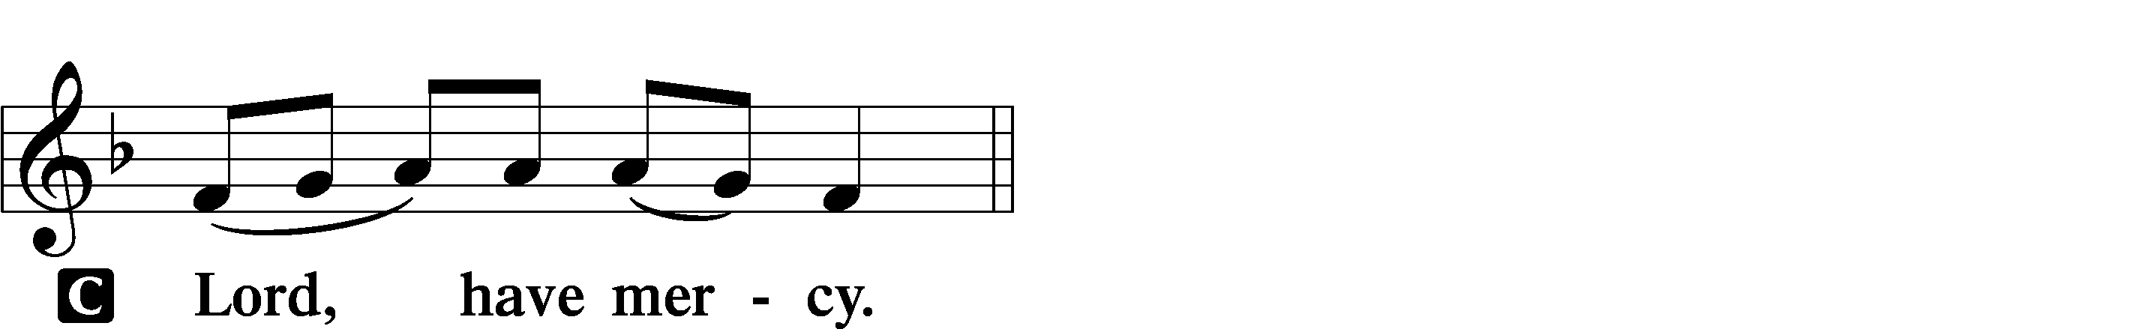



Gloria in Excelsis LSB 154
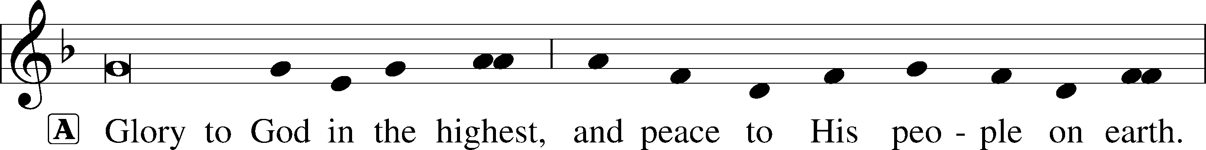
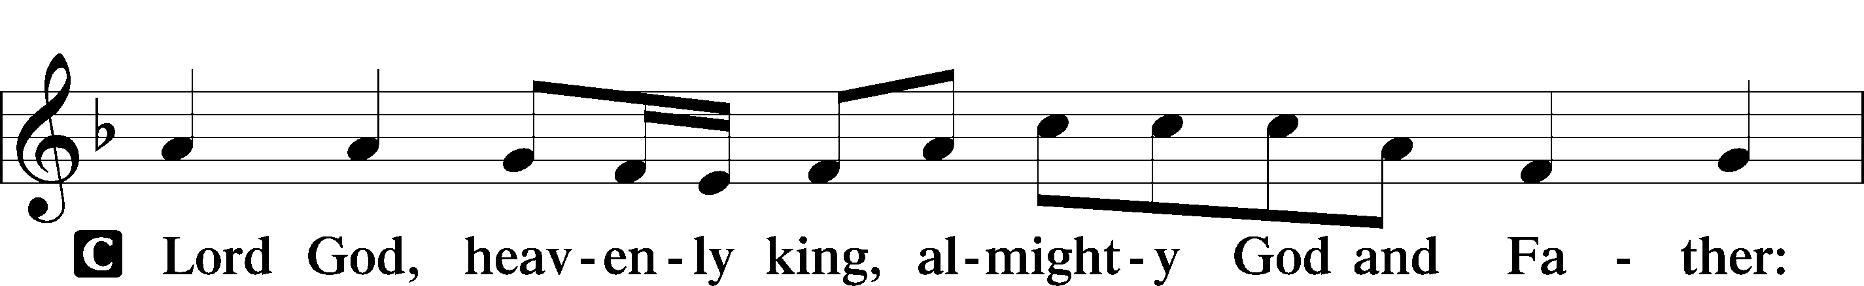
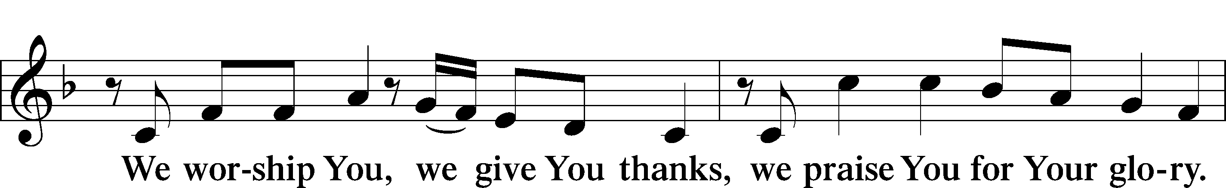
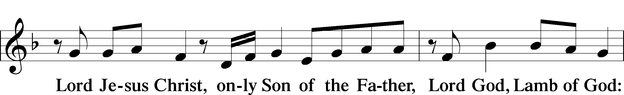
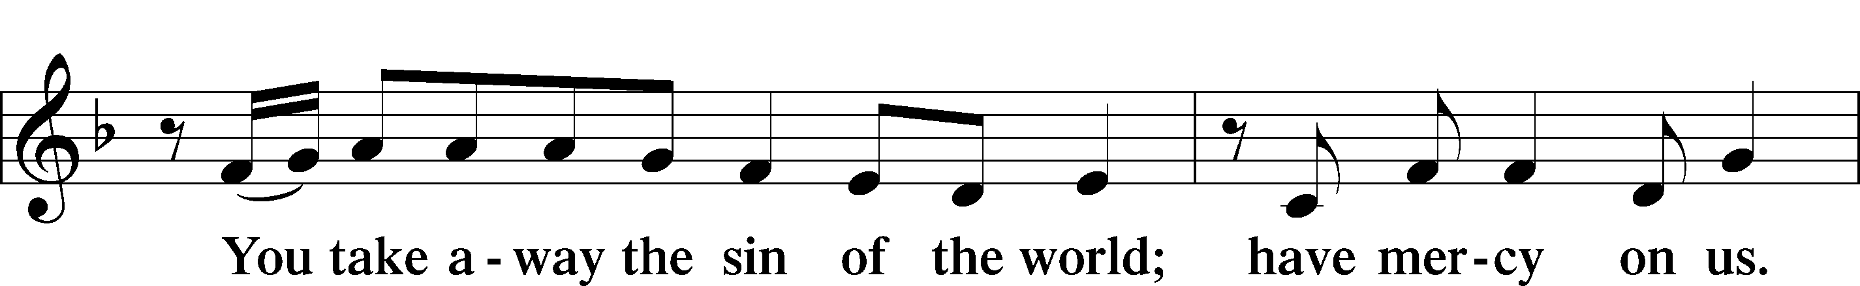
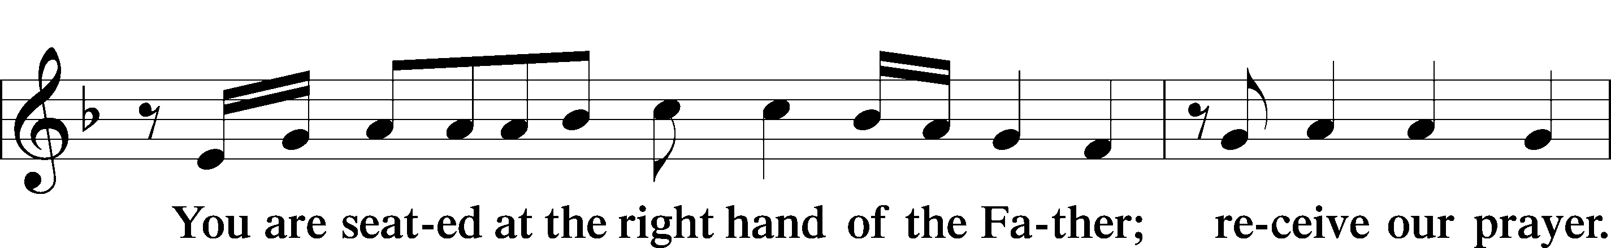
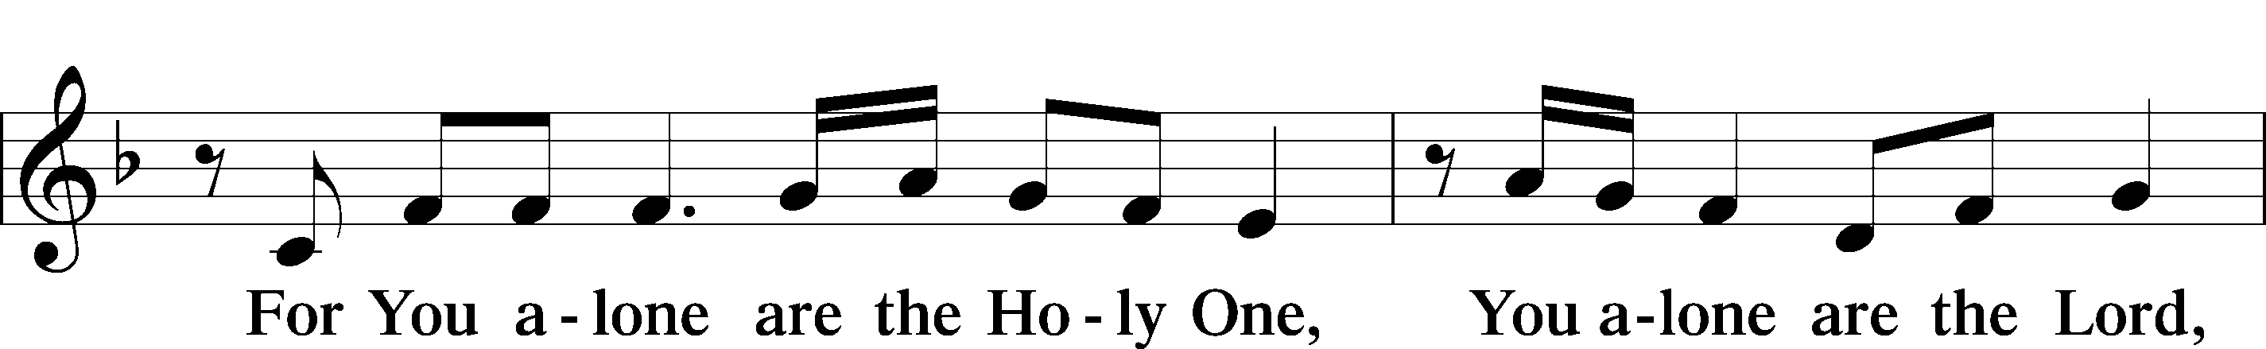
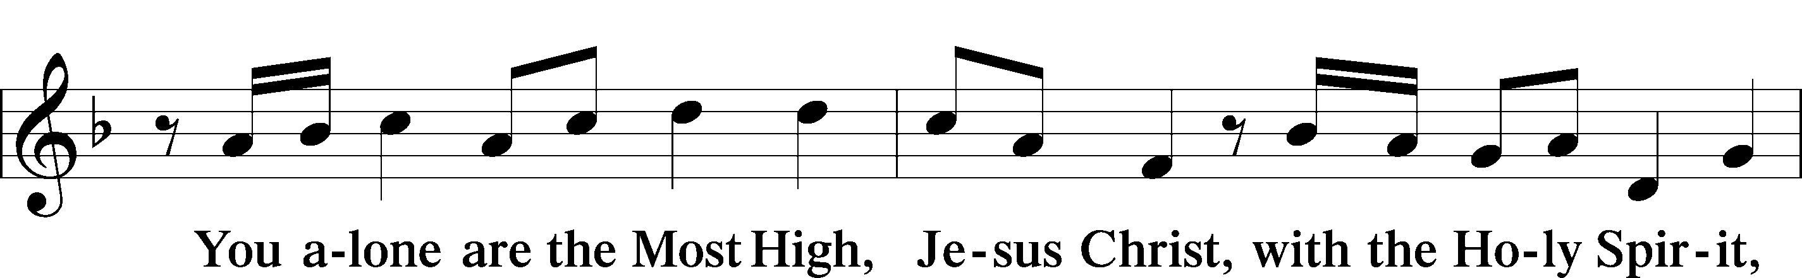
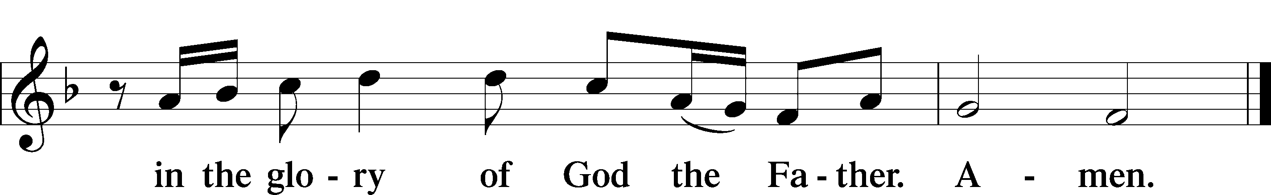

Salutation and Collect of the Day
P The Lord be with you.
C And also with you.

P Let us pray.
Almighty and gracious Lord, pour out Your Holy Spirit on Your faithful people. Keep us steadfast in Your grace and truth, protect and deliver us in times of temptation, defend us against all enemies, and grant to Your Church Your saving peace; through Jesus Christ, Your Son, our Lord, who lives and reigns with You and the Holy Spirit, one God, now and forever.

C Amen.

Sit

First Reading - “Fear God and give Him glory.” Revelation 14:6–7

A The first reading is from the 14th book of Revelation.

6Then I saw another angel flying directly overhead, with an eternal gospel to proclaim to those who dwell on earth, to every nation and tribe and language and people. 7And he said with a loud voice, “Fear God and give him glory, because the hour of his judgment has come, and worship him who made heaven and earth, the sea and the springs of water.”

A This is the Word of the Lord.
C Thanks be to God.

Psalm - God is our refuge and strength Psalm 46; antiphon: v. 7
1God is our ref- | uge and strength,*
a very present help in | trouble.
2Therefore we will not fear though the | earth gives way,*
though the mountains be moved into the heart | of the sea,
3though its waters | roar and foam,*
though the mountains tremble at its | swelling.
4There is a river whose streams make glad the cit- | y of God,*
the holy habitation of the | Most High.
5God is in the midst of her; she shall | not be moved;*
God will help her when | morning dawns.
6The nations rage, the kingdoms | totter;*
he utters his voice, the | earth melts.
7The Lord of hosts is | with us;*
the God of Jacob is our | fortress.
8Come, behold the works | of the Lord,*
how he has brought desolations | on the earth.
9He makes wars cease to the end | of the earth;*
he breaks the bow and shatters the spear;
he burns the chariots | with fire.
10“Be still, and know that | I am God.*
I will be exalted among the nations,
I will be exalted | in the earth!”
11The Lord of hosts is | with us;*
the God of Jacob is our | fortress.
Epistle - A man is justified by faith. Romans 3:19–28

A This Epistle is from Romans chapter 3.

19Now we know that whatever the law says it speaks to those who are under the law, so that every mouth may be stopped, and the whole world may be held accountable to God. 20For by works of the law no human being will be justified in his sight, since through the law comes knowledge of sin.
21But now the righteousness of God has been manifested apart from the law, although the Law and the Prophets bear witness to it— 22the righteousness of God through faith in Jesus Christ for all who believe. For there is no distinction: 23for all have sinned and fall short of the glory of God, 24and are justified by his grace as a gift, through the redemption that is in Christ Jesus, 25whom God put forward as a propitiation by his blood, to be received by faith. This was to show God’s righteousness, because in his divine forbearance he had passed over former sins. 26It was to show his righteousness at the present time, so that he might be just and the justifier of the one who has faith in Jesus.
27Then what becomes of our boasting? It is excluded. By what kind of law? By a law of works? No, but by the law of faith. 28For we hold that one is justified by faith apart from works of the law.

A This is the Word of the Lord.
C Thanks be to God.

Stand

Alleluia and Verse LSB 156
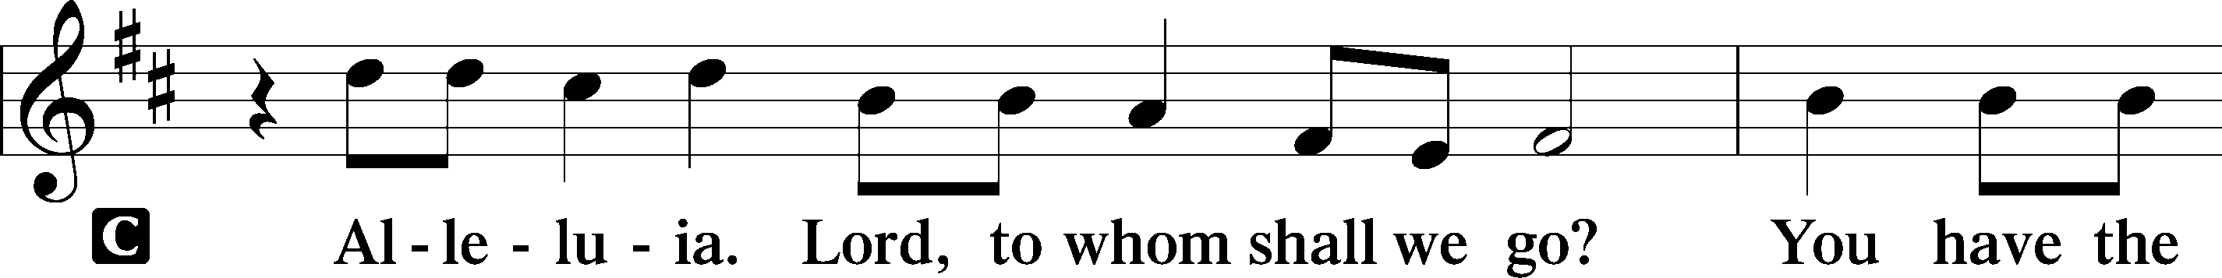
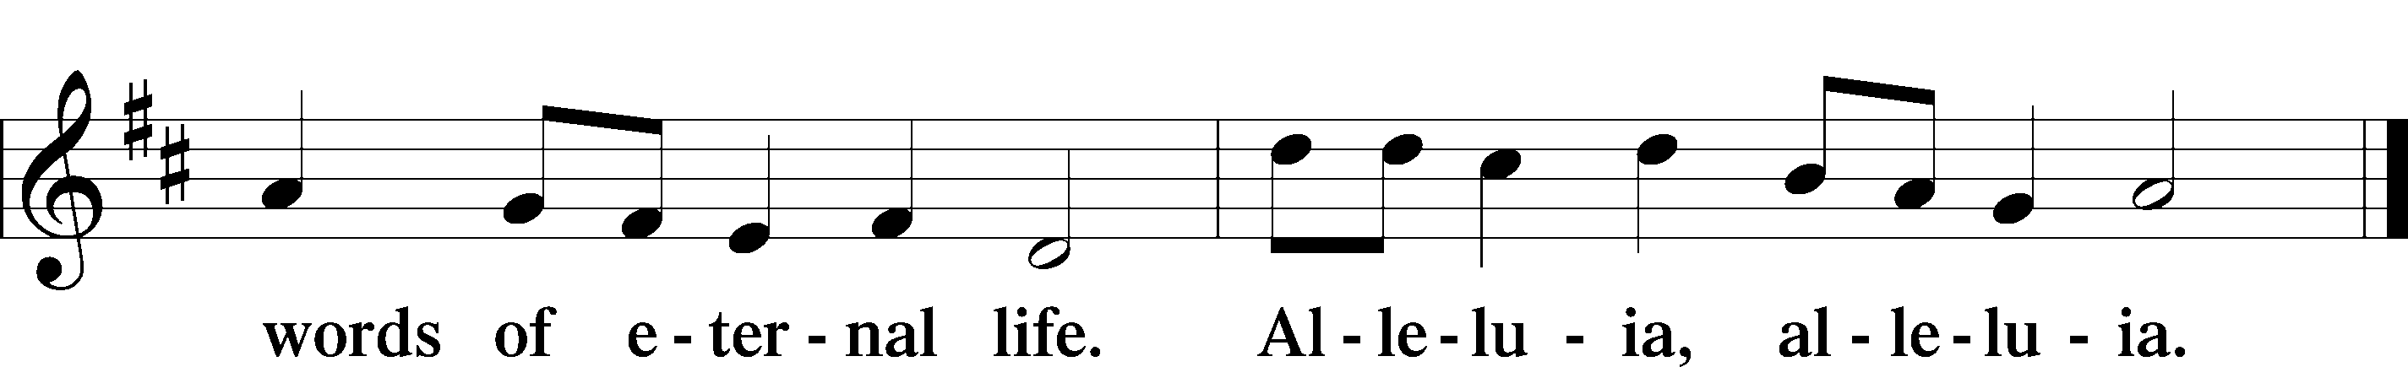

Holy Gospel John 8:31–36
“The truth will set you free.”
P The Holy Gospel according to St. John, the eighth chapter.
C Glory to You, O Lord.

31So Jesus said to the Jews who had believed in him, “If you abide in my word, you are truly my disciples, 32and you will know the truth, and the truth will set you free.” 33They answered him, “We are offspring of Abraham and have never been enslaved to anyone. How is it that you say, ‘You will become free’?”
34Jesus answered them, “Truly, truly, I say to you, everyone who commits sin is a slave to sin. 35The slave does not remain in the house forever; the son remains forever. 36So if the Son sets you free, you will be free indeed.”

P This is the Gospel of the Lord.
C Praise to You, O Christ.

Sit
570 Just as I Am, without One Plea
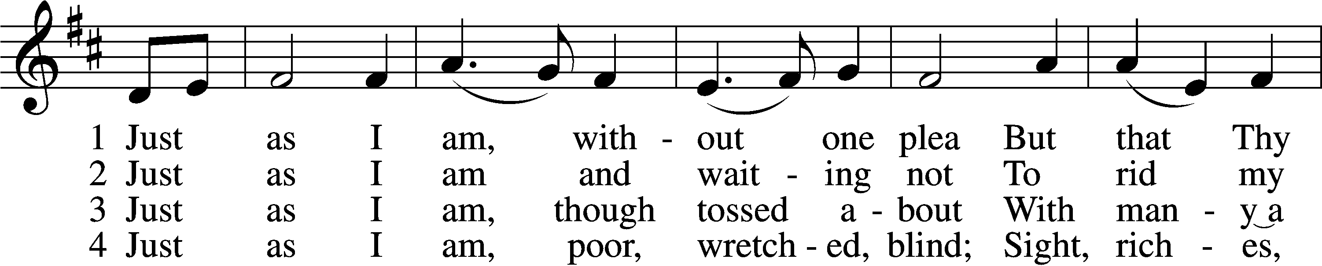
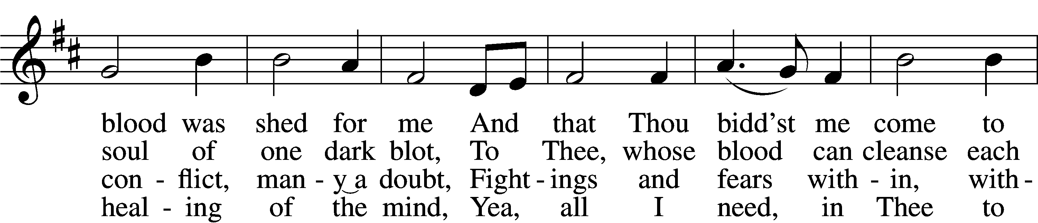
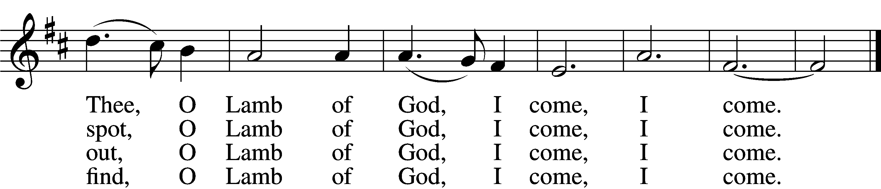
Text: Charlotte Elliott, 1789–1871 Tune: William B. Bradbury, 1816–68 Text and tune: Public domain

Sermon

Stand
Nicene Creed
C I believe in one God, the Father Almighty,
maker of heaven and earth and of all things visible and invisible.

And in one Lord Jesus Christ, the only-begotten Son of God,
begotten of His Father before all worlds,
God of God, Light of Light, very God of very God,
begotten, not made, being of one substance with the Father,
by whom all things were made;
who for us men and for our salvation came down from heaven
and was incarnate by the Holy Spirit of the virgin Mary
and was made man;
and was crucified also for us under Pontius Pilate.
He suffered and was buried. And the third day He rose
again according to the Scriptures and ascended into heaven
and sits at the right hand of the Father.
And He will come again with glory to judge both the living and
the dead, whose kingdom will have no end.

And I believe in the Holy Spirit, the Lord and giver of life,
who proceeds from the Father and the Son,
who with the Father and the Son together is worshiped
and glorified, who spoke by the prophets.
And I believe in one holy Christian and apostolic Church,
I acknowledge one Baptism for the remission of sins,
and I look for the resurrection of the dead
and the life T of the world to come. Amen.

Prayer of the Church & Sharing of the Peace

Following the prayers, the people may greet one another in the name of the Lord, saying,
“Peace be with you,” as a sign of reconciliation and of the unity of the Spirit in the bond of peace
(Matt. 5:22–24; Eph. 4:1–3).

Offering & Offertory

Stand
LSB 159
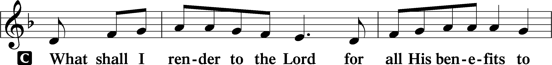
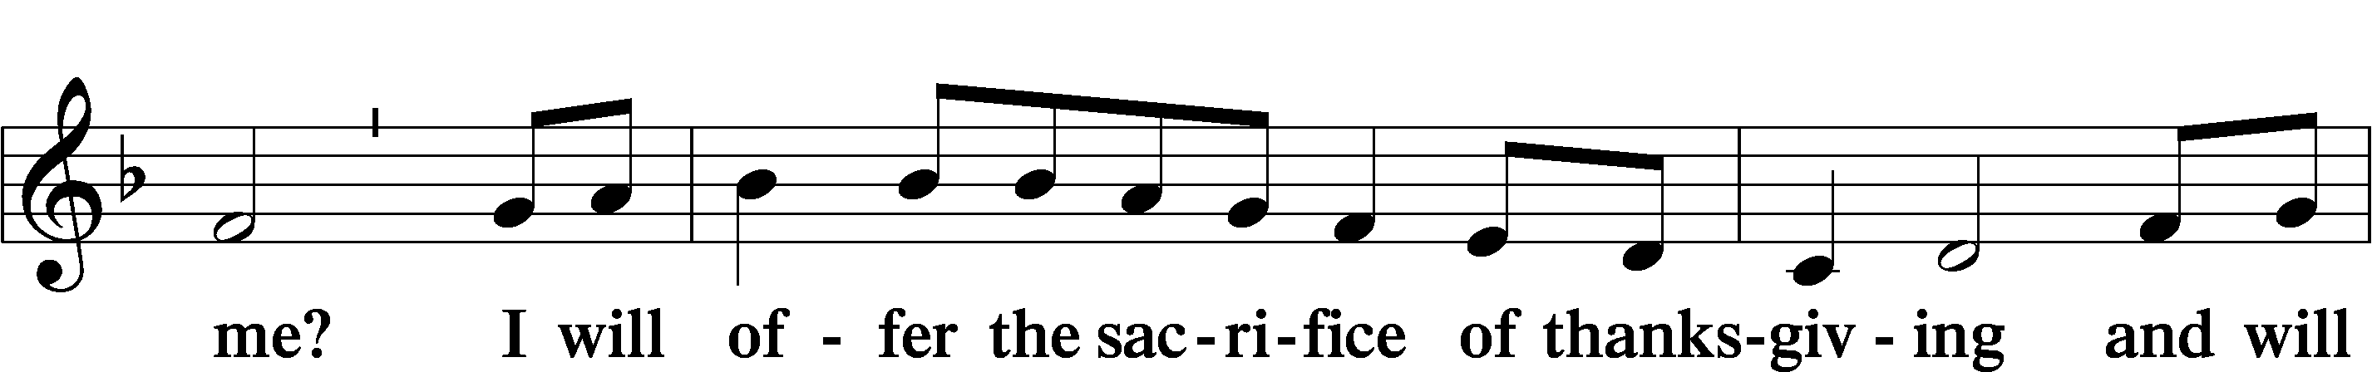
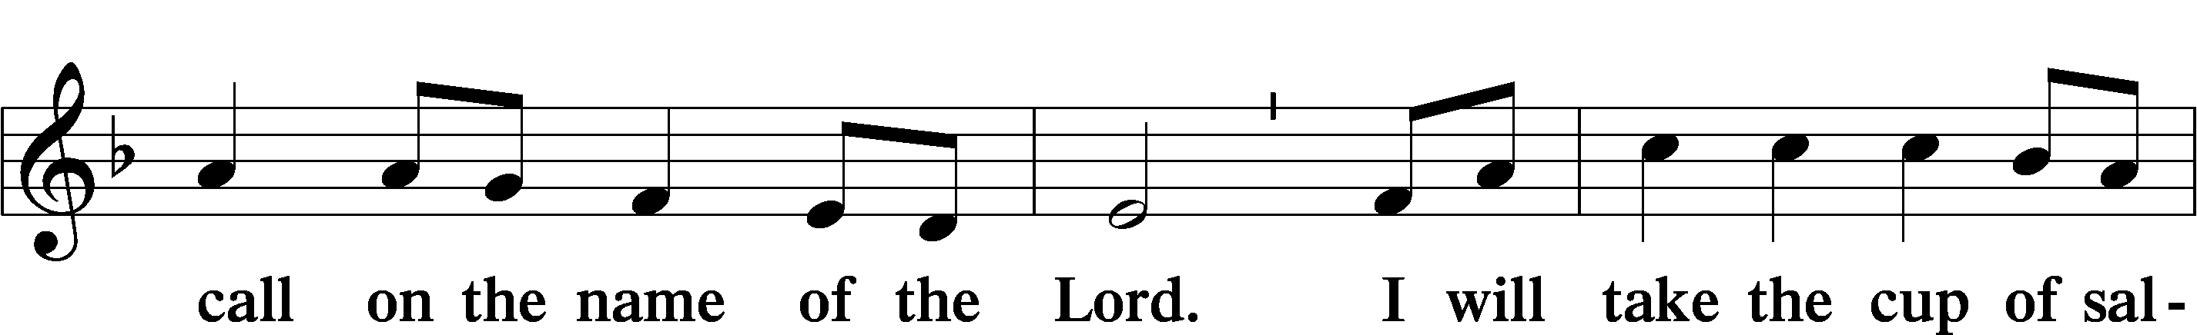
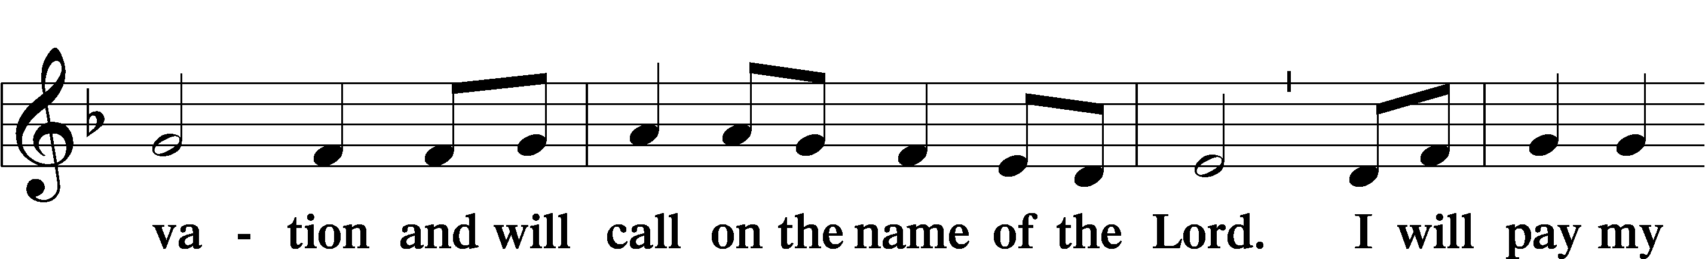
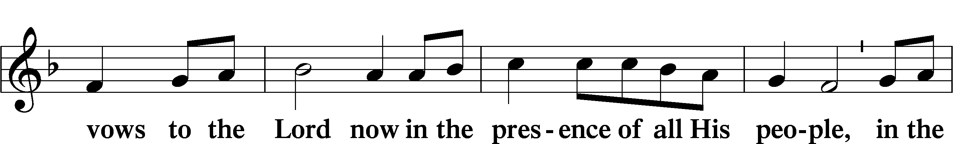
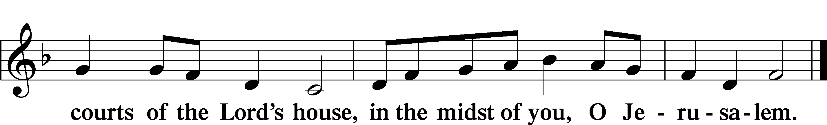

Service of Holy Communion
Communion Statement

The Lord’s Supper is celebrated at this congregation in the confession and glad confidence that, as He says, our Lord gives into our mouths not only bread and wine but His very body and blood to eat and to drink for the forgiveness of sins and to strengthen our union with Him and with one another. Our Lord invites to His table those who trust His words, repent of all sin, and set aside any refusal to forgive and love as He forgives and loves us, that they may show forth His death until He comes.

Because those who eat and drink our Lord’s body and blood unworthily do so to their great harm and because Holy Communion is a confession of the faith which is confessed at this altar, any who are not yet instructed, in doubt, or who hold a confession differing from that of this congregation and the Lutheran Church Missouri Synod, and yet desire to receive this sacrament, are asked to speak with the Pastor.
* See more about the Lutheran teaching on communion in the Hymnal p 329.

Preface LSB 160





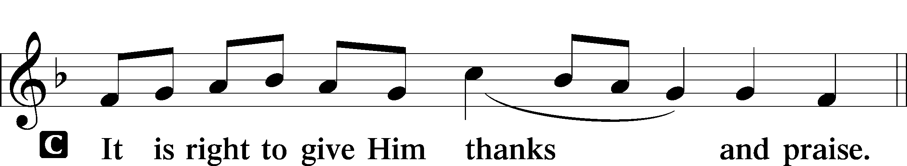
P It is truly good, right, and salutary that we should at all times and in all places give thanks to You, holy Lord, almighty Father, everlasting God, through Jesus Christ, our Lord, who, having created all things, took on human flesh and was born of the virgin Mary. For our sake He died on the cross and rose from the dead to put an end to death, thus fulfilling Your will and gaining for You a holy people. Therefore with angels and archangels and with all the company of heaven we laud and magnify Your glorious name, evermore praising You and saying:

Sanctus LSB 161
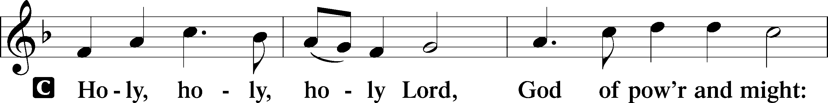
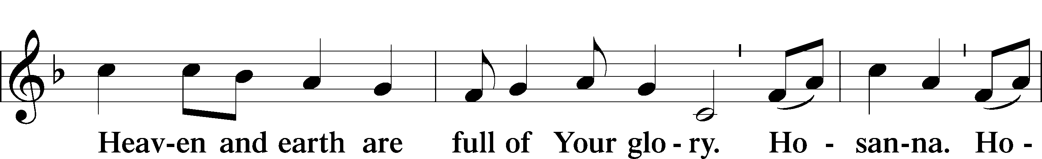
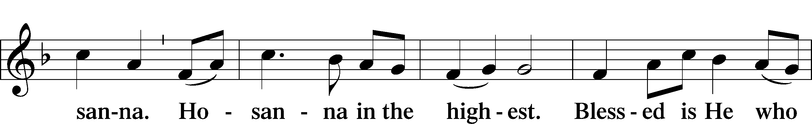
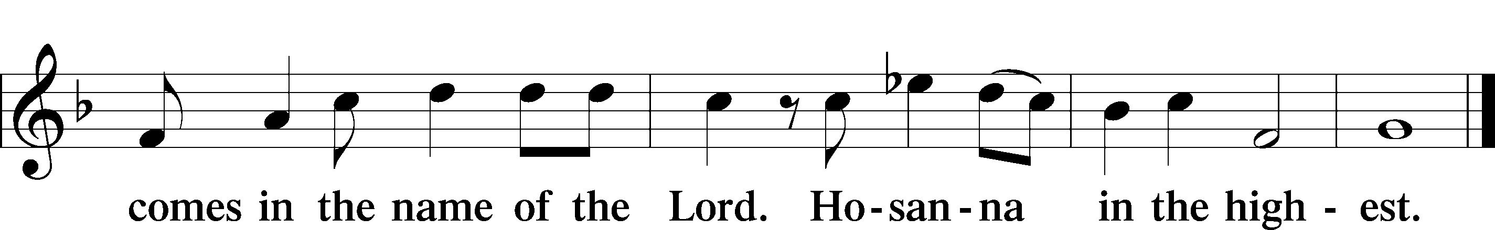

Prayer of Thanksgiving LSB 161
P Blessed are You, Lord of heaven and earth, for You have had mercy on those whom You created and sent Your only-begotten Son into our flesh to bear our sin and be our Savior. With repentant joy we receive the salvation accomplished for us by the all-availing sacrifice of His body and His blood on the cross.

Gathered in the name and the remembrance of Jesus, we beg You, O Lord, to forgive, renew, and strengthen us with Your Word and Spirit. Grant us faithfully to eat His body and drink His blood as He bids us do in His own testament. Gather us together, we pray, from the ends of the earth to celebrate with all the faithful the marriage feast of the Lamb in His kingdom, which has no end. Graciously receive our prayers; deliver and preserve us. To You alone, O Father, be all glory, honor, and worship, with the Son and the Holy Spirit, one God, now and forever.
C Amen.

The Words of Our Lord
P Our Lord Jesus Christ, on the night when He was betrayed, took bread, and when He had given thanks, He broke it and gave it to the disciples and said: “Take, eat; this is My T body, which is given for you. This do in remembrance of Me.”

In the same way also He took the cup after supper, and when He had given thanks, He gave it to them, saying: “Drink of it, all of you; this cup is the new testament in My T blood, which is shed for you for the forgiveness of sins. This do, as often as you drink it, in remembrance of Me.”
P As often as we eat this bread and drink this cup, we proclaim the Lord’s death until He comes.
C Amen. Come, Lord Jesus.
P O Lord Jesus Christ, only Son of the Father, in giving us Your body and blood to eat and to drink, You lead us to remember and confess Your holy cross and passion, Your blessed death, Your rest in the tomb, Your resurrection from the dead, Your ascension into heaven, and Your coming for the final judgment. So remember us in Your kingdom and teach us to pray:

Lord’s Prayer
C Our Father who art in heaven, hallowed be Thy name,
Thy kingdom come, Thy will be done on earth as it is in heaven;
give us this day our daily bread;
and forgive us our trespasses as we forgive those
who trespass against us; and lead us not into temptation,
but deliver us from evil.
For Thine is the kingdom and the power and the glory
forever and ever. Amen.
Pax Domini LSB 163
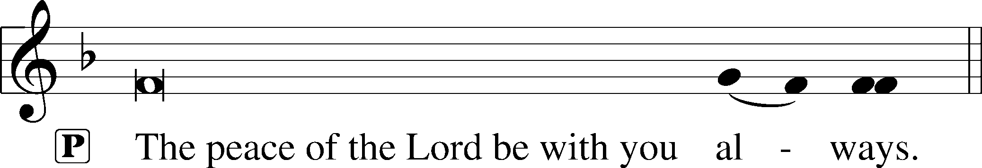


Agnus Dei (Spoken)

The pastor elevates the chalice and host and says:

P Behold, the Lamb of God that takes away the sins of the world.
C Lord, have mercy upon us.

Agnus Dei LSB 163
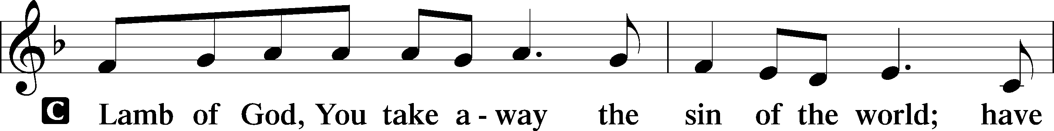
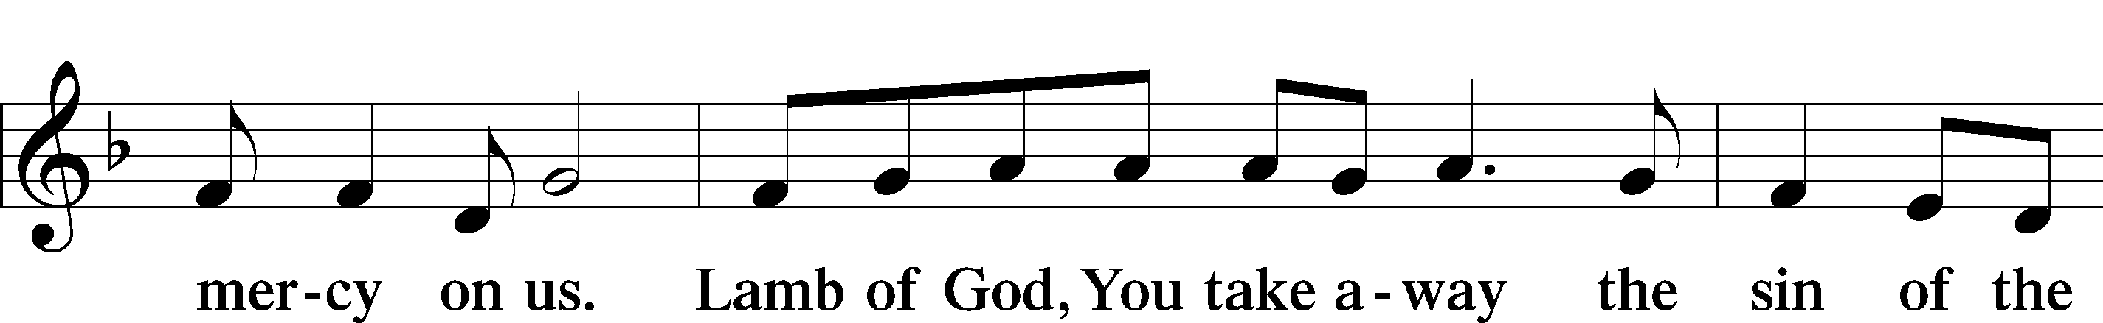
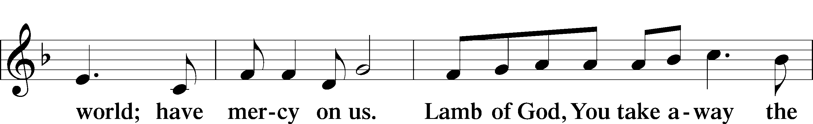
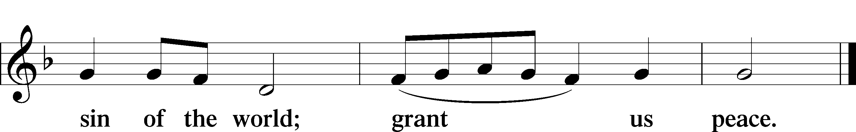

Sit

Distribution -
Alleluia/ Sola Gratia by Previn Hudetz

Alleluiah, Alleluiah,
Sola Gratia
For all our lives

Alleluiah, Alleluiah,
Sola Gratia
He sanctifies.

Sola Gratia, Sola Fide
Solus Christus,
This we own;
We are saved by God’s own Grace, alone.

Alleluiah, Alleluiah,
Sola Fide,
From the Spirit, sent,

Alleluiah, Alleluiah,
Sola Fide
By the sacraments

Sola Gratia, Sola Fide
Solus Christus,
This we own;
We are Justified by Faith, alone.

Alleluiah, Alleluiah,
Solus Christus
Jesus gave his life.

Alleluiah, Alleluiah,
Solus Christus
Now he reigns on high.

Sola Gratia, Sola Fide
Solus Christus,
This we own;
We are saved by Faith in Christ, alone.

Alleluiah, Alleluiah,
Sola Scriptura,
In His Word we Trust.

Alleluiah, Alleluiah,
Sola Scriptura
God’s own Word to us.

Sola Gratia, Sola Fide
Solus Christus,
This we own;
We are guided by God’s Word, alone.

Stand
Thank the Lord LSB 164
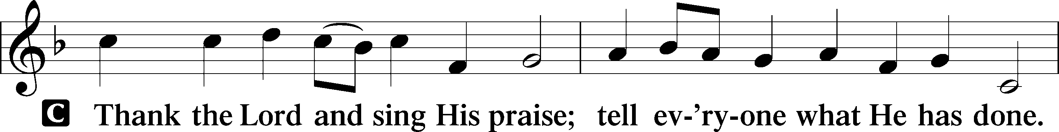
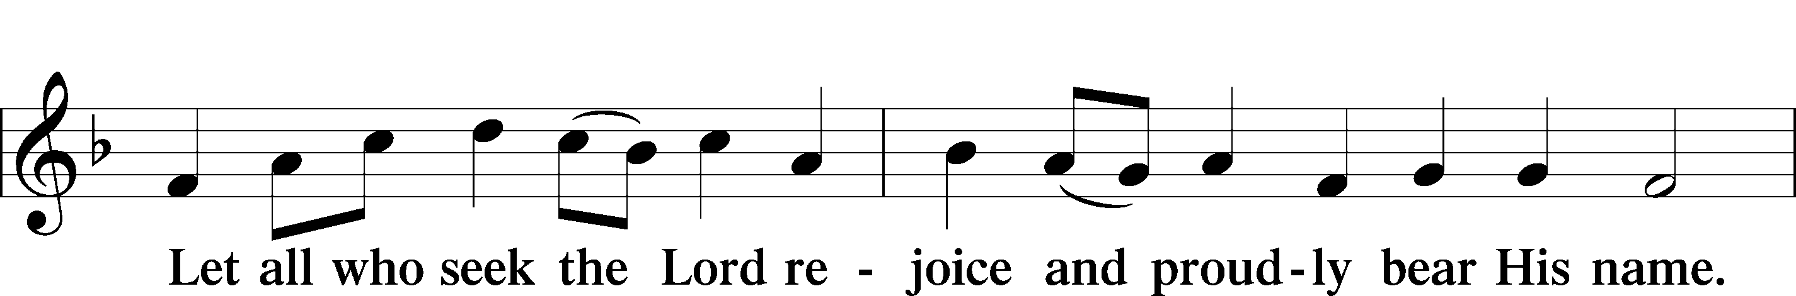
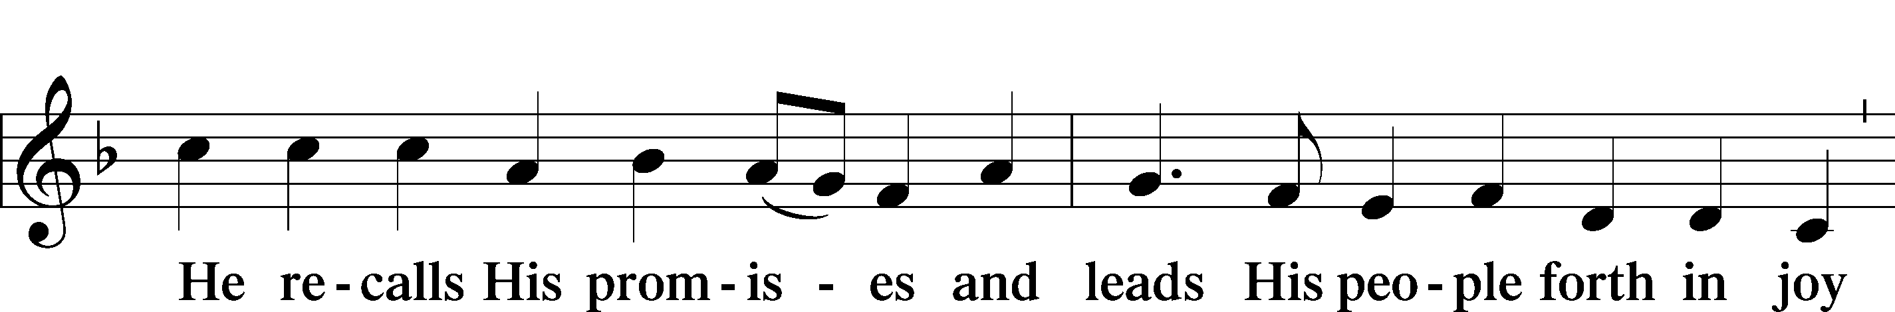
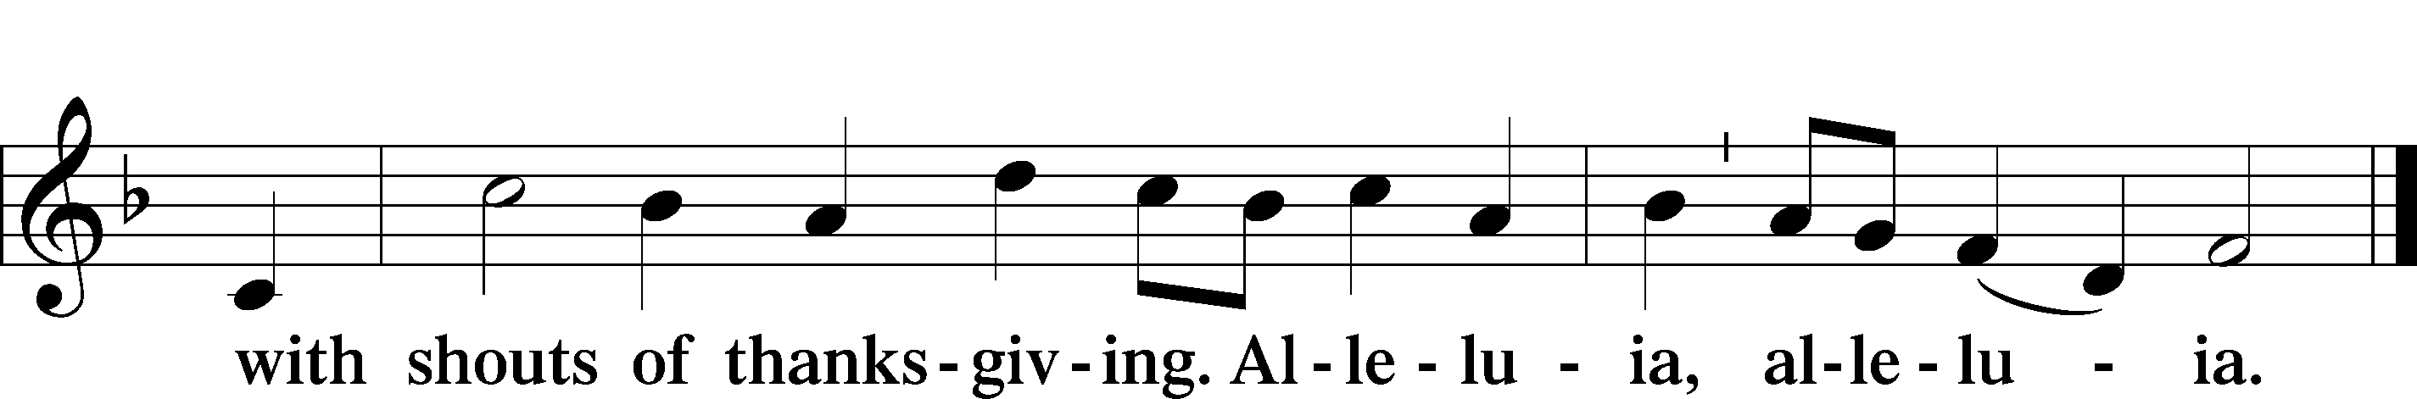

Post-Communion Collect
A Let us pray.
We give thanks to You, almighty God, that You have refreshed us through this salutary gift, and we implore You that of Your mercy You would strengthen us through the same in faith toward You and in fervent love toward one another; through Jesus Christ, Your Son, our Lord, who lives and reigns with You and the Holy Spirit, one God, now and forever.
C Amen.

Verse of the Day Luke 12:32
A Alleluia! Fear not, little flock, for it is your Father’s good pleasure
C to give you the kingdom. Alleluia.

Benediction LSB 166
P The Lord bless you and keep you.
The Lord make His face shine on you and be gracious to you.
The Lord look upon you with favor and T give you peace.

702 My Faith Looks Up to Thee
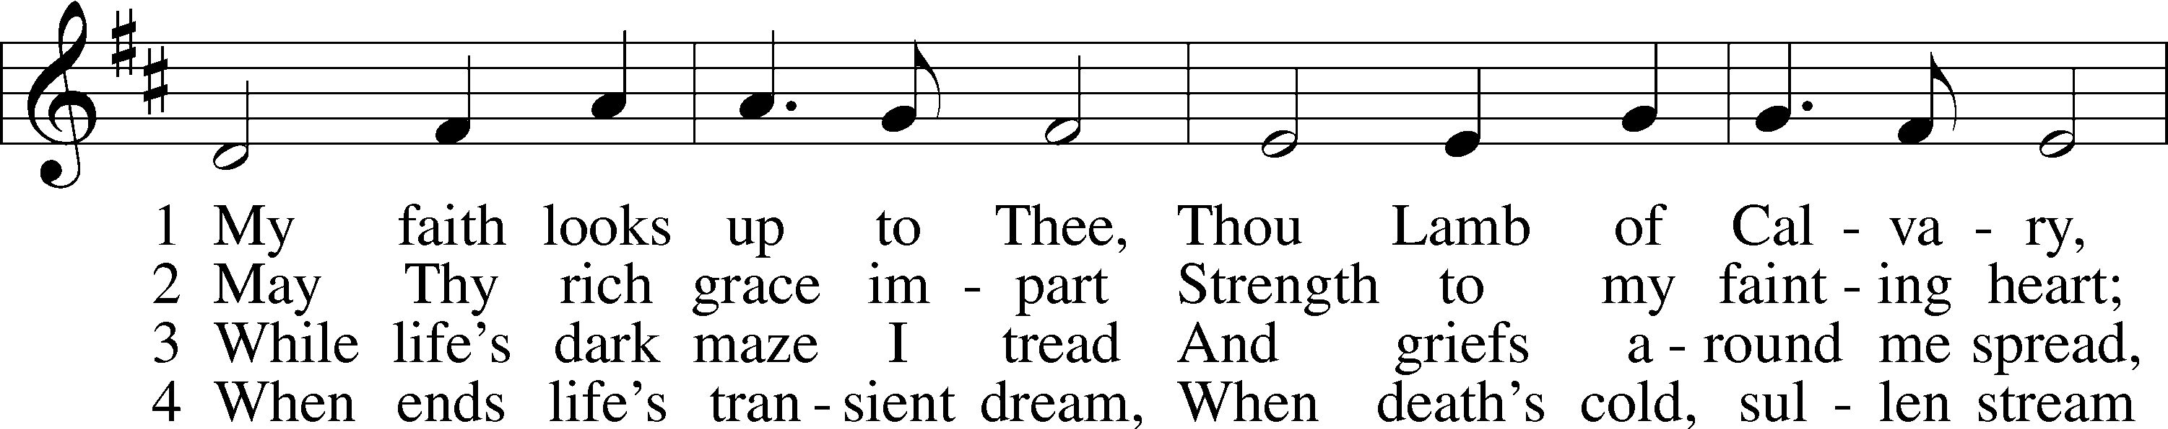
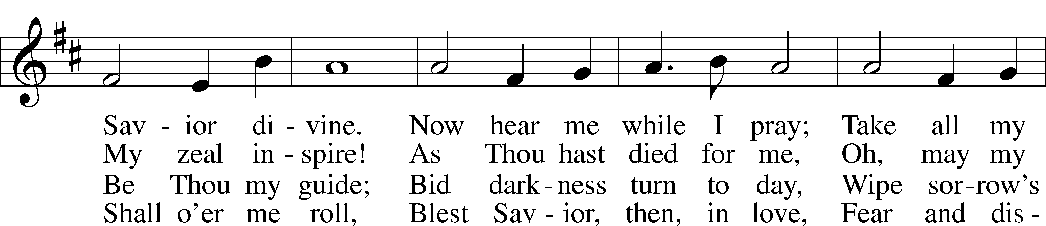
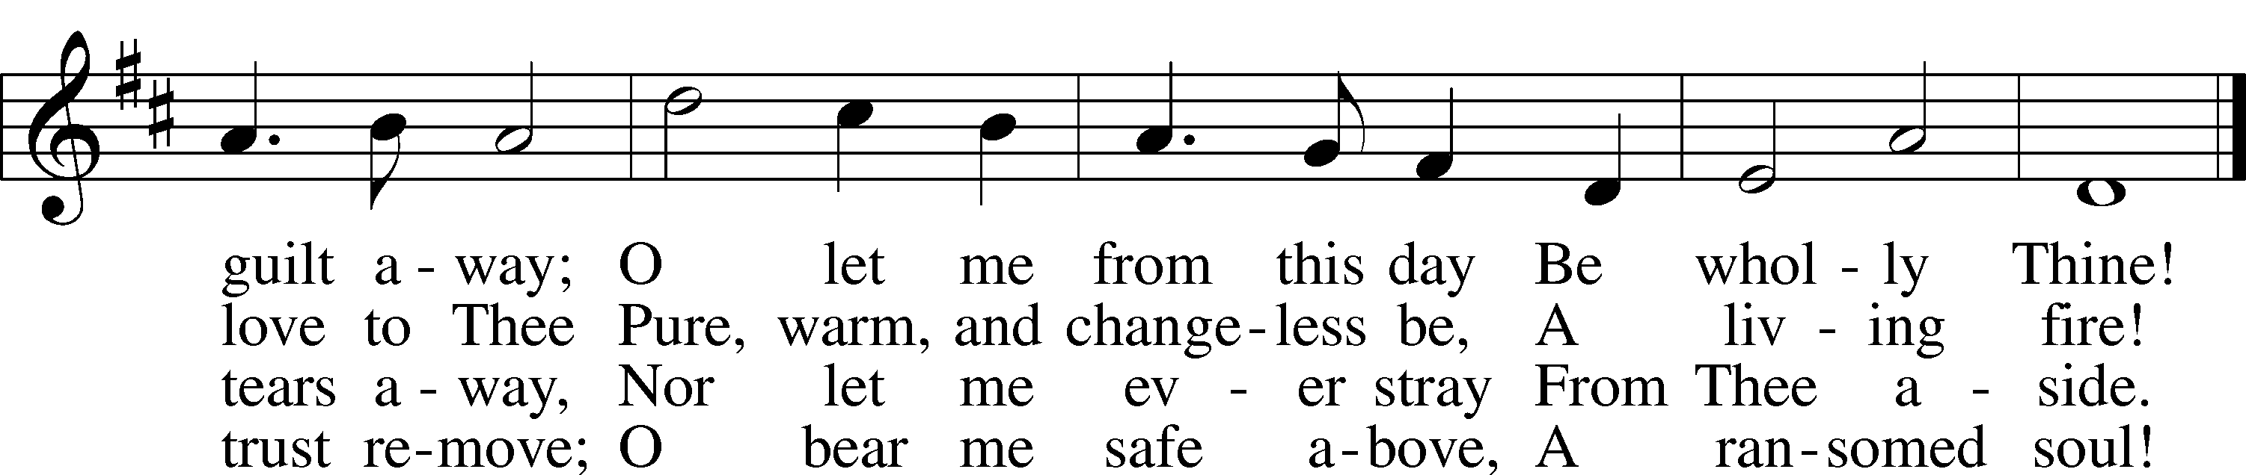
Text: Ray Palmer, 1808–87
Tune: Lowell Mason, 1792–1872
Text and tune: Public domain

Acknowledgments
Divine Service, Setting One from Lutheran Service Book
Unless otherwise indicated, Scripture quotations are from the ESV® Bible (The Holy Bible, English Standard Version®), copyright © 2001 by Crossway, a publishing ministry of Good News Publishers. Used by permission. All rights reserved. Created by Lutheran Service Builder © 2025 Concordia Publishing House.

Prayers of the Church
This week, we lift up:

Angela H, Bob C, Mike Y, Sheila, Elaine, Angie Z, Angela C, Ross, & Kathy H.

Family of the week: Horeb, Isabel, and Elijah Miranda

*If you have any prayer request let us know.
Last week: Attendance 28 Offering $755

Serving Next Week (11/2/25)  Service Leader: Vicar Previn Hudetz  Communion Celebrant: Rev John Heffelfinger  Communion Assistant: Jim C  Worship Assistant: Charlie M  Reader: Jim C  Refreshments: Pot Luck  Altar Guild: Angie Z & Sheila S  Greeter: Juanita | Readings Next Week  All Saints Day  - Revelation 7:2-17  - Psalm 149  - 1 John 3:1-3  - Matthew 5:1-12  *Please sign up to help during service.*
Announcements  Birthdays: Bob Cook 11/1  This Week at OSLC:  Bible Study: After Service  Bible Study: Thursday 10am | Coming Up:  - All Saints Sunday 11/2/2025
All Saints Sunday (11/2)

For generations, November 1st, has been known as “All Saints' Day”, it commemorates all the believers of the church, both living and departed, what we Lutheran’s call the “Communion of Saints”. Unless the day falls on a Sunday, the celebration is usually held the next Sunday. Liturgy of Names - During the Prayers of the Church on All Saints Day, it is tradition that the names of congregants and family members who have passed into glory over the last few years are read aloud. If you would like to honor a loved one this way, please give their name to the office staff to be included.

Do you not know that all of us who have been baptized into
Christ Jesus were baptized into his death?
We were buried therefore with him by baptism into death,
in order that, just as Christ was raised from the dead by the glory of the Father, we too might walk in newness of life.
Romans 6.3-4

Stewardship Thoughts… for Reformation Day

Revelation 14:6 - “Then I saw another angel flying directly overhead, with an eternal gospel to proclaim to those who dwell on earth, to every nation and tribe and language and people.”

During the reformation, this text was used to refer to Luther’s ministry and the Lutheran message. We have an eternal Godpel to proclaim. Christ has freed us from our sins without ny works on our part. We are saved by grace alone! And ironically enough, Luther said this should make him the ‘apostle of works.” Once we are freed by grace, we are truly free to serve God in works that flow from thankfulness and praise.

Lcms.org/stewardship


Seasons of the Church Year

Color: Red • Symbol: Luther Rose or Open Bible
Reformation Sunday celebrates the renewal of the Church through the Gospel, as rediscovered in the time of Martin Luther. We rejoice that we are saved by grace alone, through faith alone, in Christ alone. The red paraments remind us of the Spirit’s power to reform and renew the Church in every age.

Lectionary Summaries-

Overview of Today’s Assigned Reading (26 October 2025)

Genesis 4:1–15 / 2 Timothy 4:6–8, 16–18 / Luke 18:9–17

In Humble Repentance, Faith Lives by Grace and Mercy and Is Exalted by God in Christ

Jesus tells a parable “to some who trusted in themselves that they were righteous” (Luke 18:9). In this parable, the Pharisee unjustly boasted before God on the basis of his own merits, whereas the tax collector intently prayed, “God, be merciful to me, a sinner!” (Luke 18:13). That poor, miserable sinner trusted Christ, and he went “down to his house justified, rather than the other” (Luke 18:14). So do little children, “even infants,” come to Jesus with their need, and they “receive the kingdom of God” through faith (Luke 18:15–17). For “the one who humbles himself will be exalted,” but “everyone who exalts himself will be humbled” (Luke 18:14).

That is why “the Lord had regard for Abel and his offering, but for Cain and his offering he had no regard” (Gen. 4:4–5).

St. Paul’s life, “poured out as a drink offering,” was another sacrifice like Abel’s (2 Tim. 4:6). The Lord stood by Paul and strengthened him, that “the message might be fully proclaimed” (2 Tim. 4:17). It is by that Gospel message of Christ that we “have loved his appearing” and as repentant sinners pray to “the Lord, the righteous judge” by faith (2 Tim. 6:8).

