# *“it is the Lord!” So Peter, threw himself into the sea*

*and swam to shore.*

*John 21:7*

**Our Savior Lutheran Church (LCMS)**

4301 Atrisco Drive NW

Albuquerque, New Mexico

Website: OSLCNM.COM

Phone: 505.836.7007

Email: oslcabq@gmail.com

*The Third Sunday of Easter*

*May 4th, 2025*

|  |
| --- |
|  |

# **The Time of Easter**

# *The Third Sunday of Easter*

# *May 4th, 2025*

|  |  |
| --- | --- |
| *Welcome to Our Savior Lutheran Church (LCMS).*  *We are glad you are here as we worship, praise, and give thanks to our loving Lord, Jesus Christ. Please join us immediately after service for fellowship and snacks. Adult Bible Study starts at 10:30. If you have any questions about our service or need other assistance, please contact one of our worship assistants.* | **Hymns**  Opening # 478  Sermon # 688  Distribution # In the Garden  Closing # 525 |

**Today’s Message**

Jesus summons followers, leaders, rebels, and all creatures to confess the name of the Lord. Paul’s murderous persecution of Christians becomes passionate Gospel preaching. Living creatures of heaven and earth heap praise upon the Lamb of God. Disciples witness Jesus’ miraculous intervention in Word and deed. So it is with the church. We are forgiven; we are fed; we witness Jesus’ miracles; and we are called to believe the preaching of His most precious Gospel

+++

**Serving Today**

Service Leader: Vicar Previn Hudetz

Communion Celebrant: Rev John Heffelfinger

Worship Assistant: Charlie M

Reader: Jim C

Refreshments: PotLuck

Altar Guild: Angie Z

Greeter: Juanita S

# Divine Service I

# Welcome

Stand

478 The Day of Resurrection

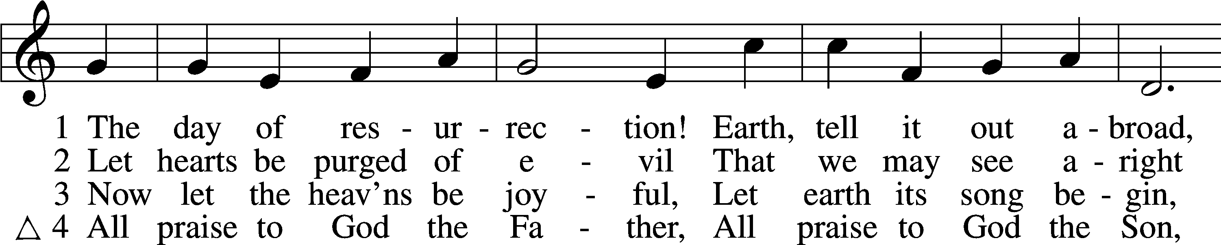

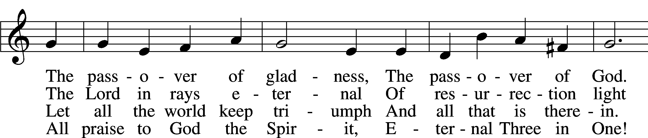

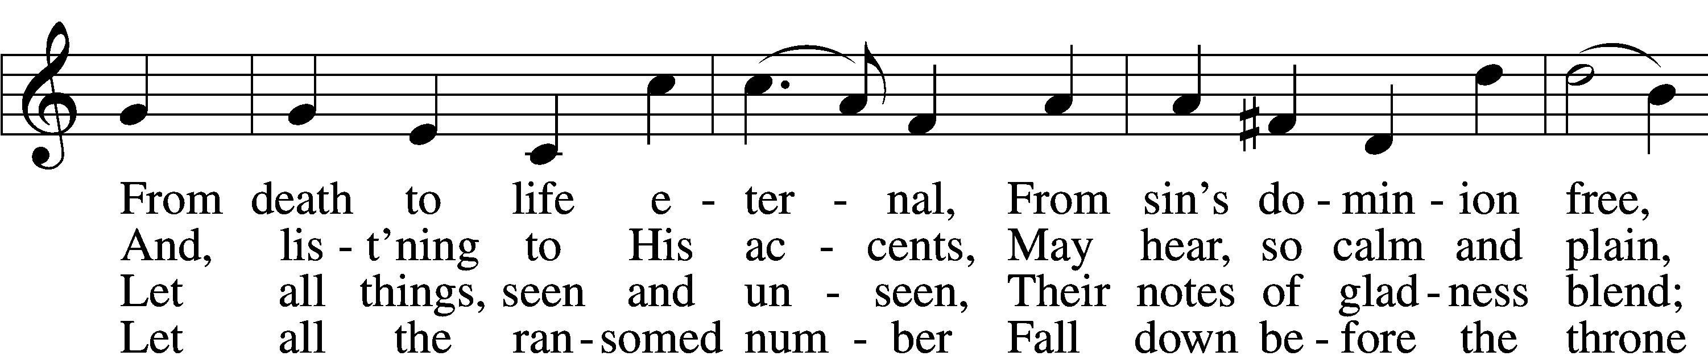

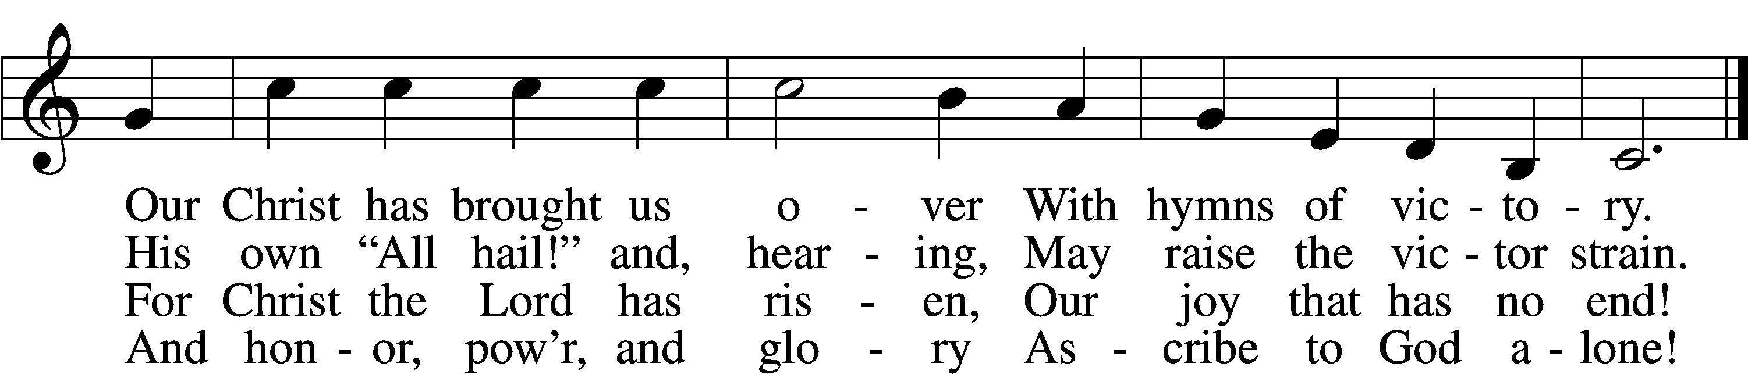

Text: John of Damascus, c. 696–c. 754; tr. John Mason Neale, 1818–66, alt.  
Tune: Henry T. Smart, 1813–79  
Text and tune: Public domain

# Confession and Absolution

The sign of the cross may be made by all in remembrance of their Baptism.

L In the name of the Father and of the T Son and of the Holy Spirit.

C **Amen.**

L If we say we have no sin, we deceive ourselves, and the truth is not in us.

C **But if we confess our sins, God, who is faithful and just, will forgive our sins and cleanse us from all unrighteousness.**

Silence for reflection on God’s Word and for self-examination.

L Let us then confess our sins to God our Father.

C **Most merciful God, we confess that we are by nature sinful and unclean. We have sinned against You in thought, word, and deed, by what we have done and by what we have left undone. We have not loved You with our whole heart; we have not loved our neighbors as ourselves. We justly deserve Your present and eternal punishment. For the sake of Your Son, Jesus Christ, have mercy on us. Forgive us, renew us, and lead us, so that we may delight in Your will and walk in Your ways to the glory of Your holy name. Amen.**

L Almighty God in His mercy has given His Son to die for you and for His sake forgives you all your sins. As a called servant of Christ, and by His authority, I therefore forgive you all your sins in the name of the Father and of the T Son and of the Holy Spirit.

C **Amen.**

# Service of the Word

Invitatory

L The Lord has risen.

O come let us worship him.*

C **Sing to the Lord and bless His name.**

**proclaim His salvation from day to day.**

Psalm 96:2

Introit Psalm 145:4–7, 9; antiphon: v. 10

All your works shall give thanks to you, | O Lord,*  
 **and all your saints shall**  | **bless you!**  
One generation shall commend your works to an- | other,*  
 a**nd shall declare your**  | **mighty acts.**  
On the glorious splendor of your | majesty,*  
 **and on your wondrous works, I will**  | **meditate.**  
They shall speak of the might of your | awesome deeds,*  
 **and I will declare your**  | **greatness.**  
They shall pour forth the fame of your abundant | goodness*  
 **and shall sing aloud of your**  | **righteousness.**  
The Lord is | good to all,*  
 **and his mercy is over all that**  | **he has made.**  
Glory be to the Father and | to the Son*  
 **and to the Holy**  | **Spirit;**  
as it was in the be- | ginning,*  
 **is now, and will be forever.**  | **Amen.**  
All your works shall give thanks to you, | O Lord,*  
 **and all your saints shall**  | **bless you!**

Kyrie LSB 152



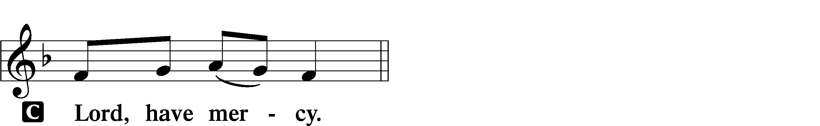

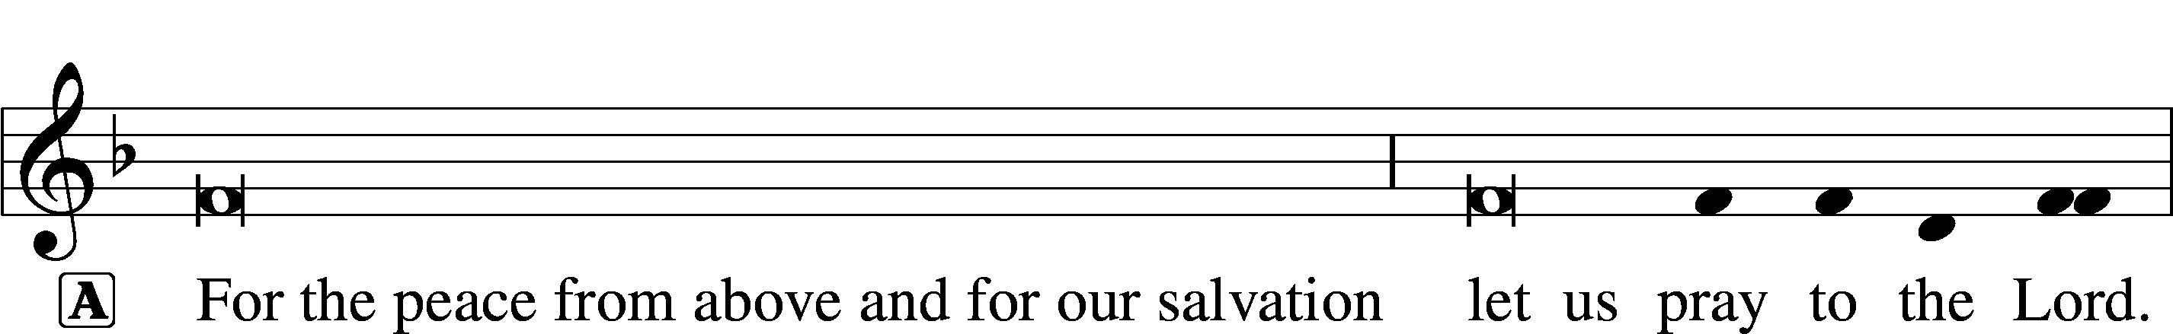



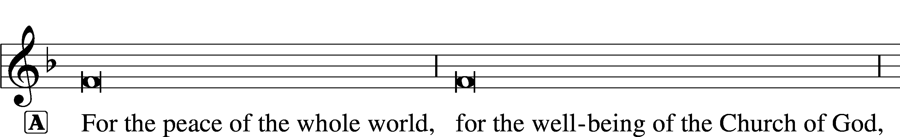





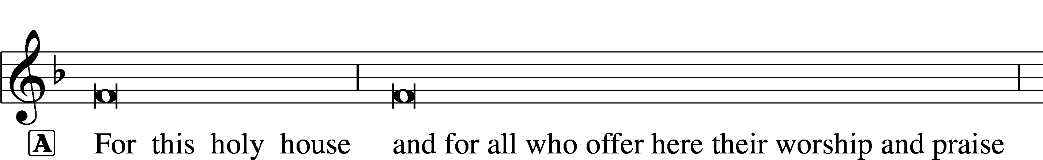



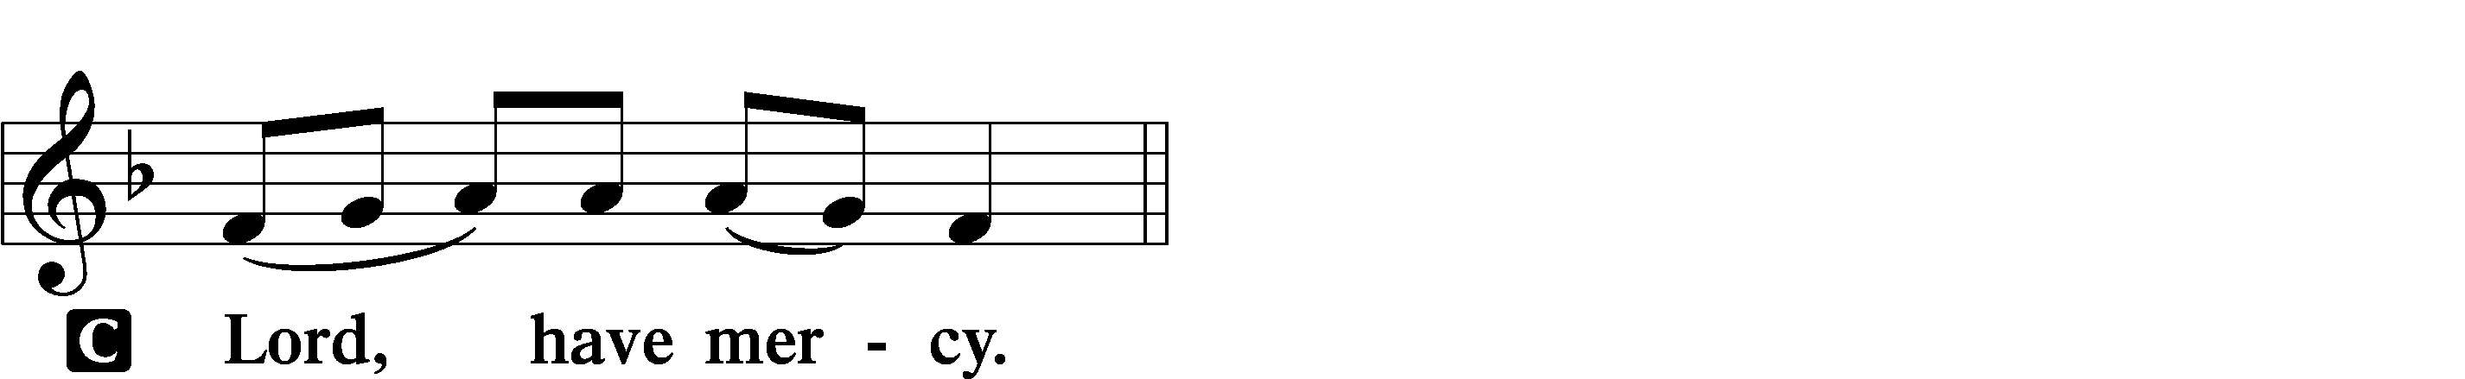





Gloria in Excelsis LSB 154

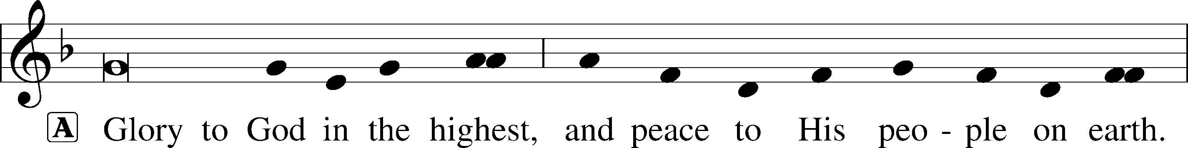

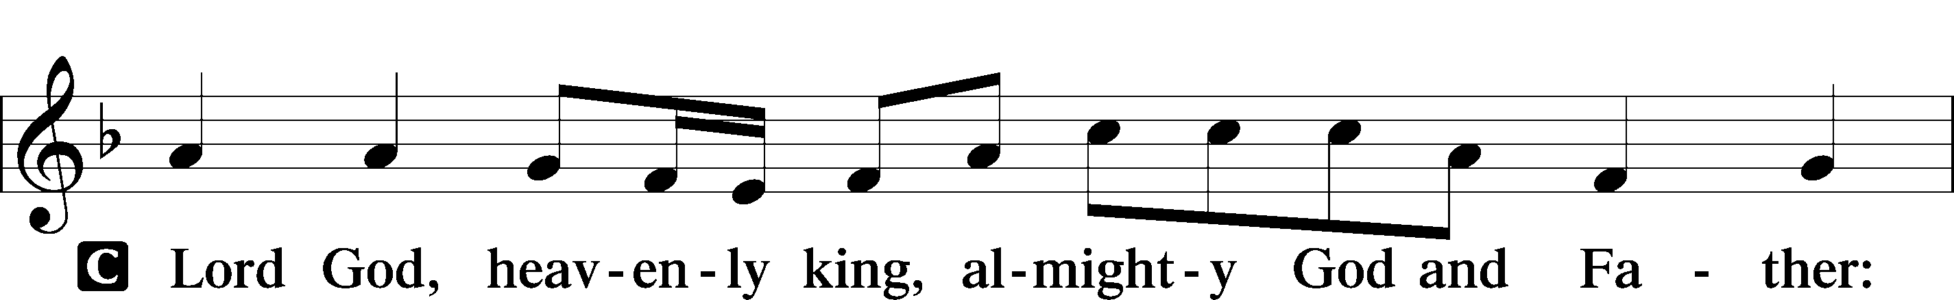

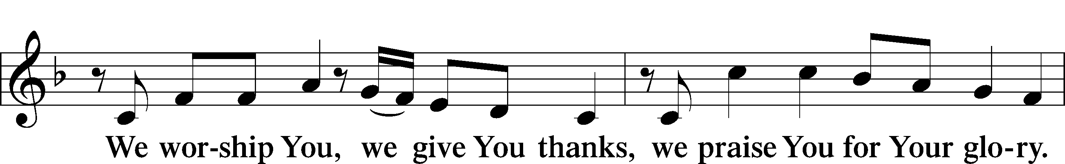

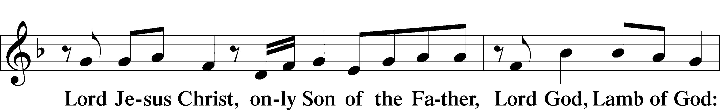

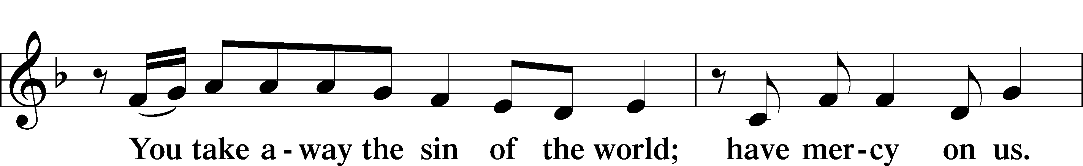

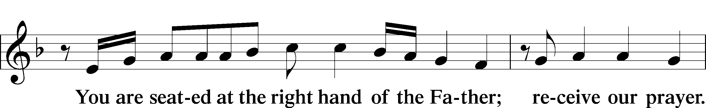

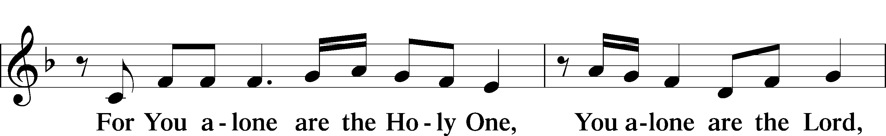

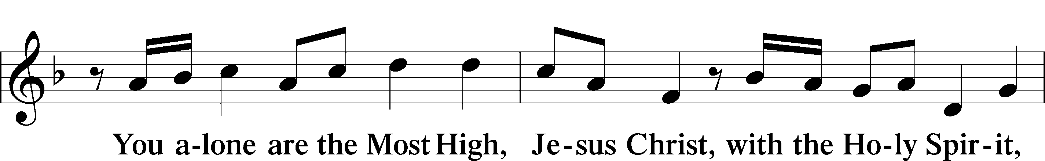

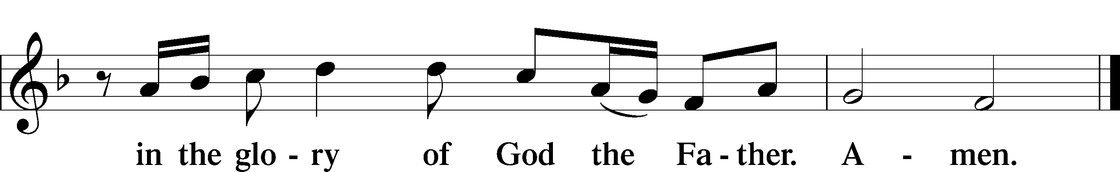

Salutation and Collect of the Day

L The Lord be with you.

C **And also with you.**

L Let us pray.

O God, through the humiliation of Your Son You raised up the fallen world. Grant to Your faithful people, rescued from the peril of everlasting death, perpetual gladness and eternal joys; through Jesus Christ, our Lord, who lives and reigns with You and the Holy Spirit, one God, now and forever.

C **Amen.**

Sit

First Reading Acts 9:1–22

A The First reading is from the 9th chapter of Acts

1But Saul, still breathing threats and murder against the disciples of the Lord, went to the high priest 2and asked him for letters to the synagogues at Damascus, so that if he found any belonging to the Way, men or women, he might bring them bound to Jerusalem. 3Now as he went on his way, he approached Damascus, and suddenly a light from heaven flashed around him. 4And falling to the ground he heard a voice saying to him, “Saul, Saul, why are you persecuting me?” 5And he said, “Who are you, Lord?” And he said, “I am Jesus, whom you are persecuting. 6But rise and enter the city, and you will be told what you are to do.” 7The men who were traveling with him stood speechless, hearing the voice but seeing no one. 8Saul rose from the ground, and although his eyes were opened, he saw nothing. So they led him by the hand and brought him into Damascus. 9And for three days he was without sight, and neither ate nor drank.

10Now there was a disciple at Damascus named Ananias. The Lord said to him in a vision, “Ananias.” And he said, “Here I am, Lord.” 11And the Lord said to him, “Rise and go to the street called Straight, and at the house of Judas look for a man of Tarsus named Saul, for behold, he is praying, 12and he has seen in a vision a man named Ananias come in and lay his hands on him so that he might regain his sight.” 13But Ananias answered, “Lord, I have heard from many about this man, how much evil he has done to your saints at Jerusalem. 14And here he has authority from the chief priests to bind all who call on your name.” 15But the Lord said to him, “Go, for he is a chosen instrument of mine to carry my name before the Gentiles and kings and the children of Israel. 16For I will show him how much he must suffer for the sake of my name.” 17So Ananias departed and entered the house. And laying his hands on him he said, “Brother Saul, the Lord Jesus who appeared to you on the road by which you came has sent me so that you may regain your sight and be filled with the Holy Spirit.” 18And immediately something like scales fell from his eyes, and he regained his sight. Then he rose and was baptized; 19and taking food, he was strengthened.

For some days he was with the disciples at Damascus. 20And immediately he proclaimed Jesus in the synagogues, saying, “He is the Son of God.” 21And all who heard him were amazed and said, “Is not this the man who made havoc in Jerusalem of those who called upon this name? And has he not come here for this purpose, to bring them bound before the chief priests?” 22But Saul increased all the more in strength, and confounded the Jews who lived in Damascus by proving that Jesus was the Christ.

A This is the Word of the Lord.

C **Thanks be to God.**

Gradual adapt. from Matthew 28:7; Hebrews 2:7; Psalm 8:6

Christ has risen | from the dead.*  
 **[God the Father] has crowned him with glory and**  | **honor.**  
He has given him dominion over the works | of his hands;*  
 **he has put all things un-** | **der his feet.**

Epistle Revelation 5:1–14

A The Epistle is from the 5th chapter of Revelations.

1Then I saw in the right hand of him who was seated on the throne a scroll written within and on the back, sealed with seven seals. 2And I saw a strong angel proclaiming with a loud voice, “Who is worthy to open the scroll and break its seals?” 3And no one in heaven or on earth or under the earth was able to open the scroll or to look into it, 4and I began to weep loudly because no one was found worthy to open the scroll or to look into it. 5And one of the elders said to me, “Weep no more; behold, the Lion of the tribe of Judah, the Root of David, has conquered, so that he can open the scroll and its seven seals.”

6And between the throne and the four living creatures and among the elders I saw a Lamb standing, as though it had been slain, with seven horns and with seven eyes, which are the seven spirits of God sent out into all the earth. 7And he went and took the scroll from the right hand of him who was seated on the throne. 8And when he had taken the scroll, the four living creatures and the twenty-four elders fell down before the Lamb, each holding a harp, and golden bowls full of incense, which are the prayers of the saints. 9And they sang a new song, saying,

“Worthy are you to take the scroll  
 and to open its seals,  
for you were slain, and by your blood you ransomed people for God  
 from every tribe and language and people and nation,  
10and you have made them a kingdom and priests to our God,  
 and they shall reign on the earth.”

11Then I looked, and I heard around the throne and the living creatures and the elders the voice of many angels, numbering myriads of myriads and thousands of thousands, 12saying with a loud voice, “Worthy is the Lamb who was slain, to receive power and wealth and wisdom and might and honor and glory and blessing!” 13And I heard every creature in heaven and on earth and under the earth and in the sea, and all that is in them, saying, “To him who sits on the throne and to the Lamb be blessing and honor and glory and might forever and ever!” 14And the four living creatures said, “Amen!” and the elders fell down and worshiped.

A This is the Word of the Lord.

C **Thanks be to God.**

Stand

Alleluia and Verse LSB 156

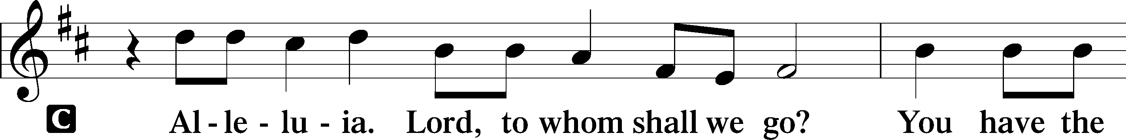

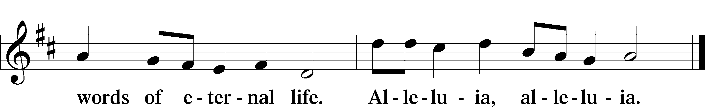

Holy Gospel John 21:1–19

L The Holy Gospel according to St. John, the twenty-first chapter.

C **Glory to You, O Lord.**

1After this Jesus revealed himself again to the disciples by the Sea of Tiberias, and he revealed himself in this way. 2Simon Peter, Thomas (called the Twin), Nathanael of Cana in Galilee, the sons of Zebedee, and two others of his disciples were together. 3Simon Peter said to them, “I am going fishing.” They said to him, “We will go with you.” They went out and got into the boat, but that night they caught nothing.

4Just as day was breaking, Jesus stood on the shore; yet the disciples did not know that it was Jesus. 5Jesus said to them, “Children, do you have any fish?” They answered him, “No.” 6He said to them, “Cast the net on the right side of the boat, and you will find some.” So they cast it, and now they were not able to haul it in, because of the quantity of fish. 7That disciple whom Jesus loved therefore said to Peter, “It is the Lord!” When Simon Peter heard that it was the Lord, he put on his outer garment, for he was stripped for work, and threw himself into the sea. 8The other disciples came in the boat, dragging the net full of fish, for they were not far from the land, but about a hundred yards off.

9When they got out on land, they saw a charcoal fire in place, with fish laid out on it, and bread. 10Jesus said to them, “Bring some of the fish that you have just caught.” 11So Simon Peter went aboard and hauled the net ashore, full of large fish, 153 of them. And although there were so many, the net was not torn. 12Jesus said to them, “Come and have breakfast.” Now none of the disciples dared ask him, “Who are you?” They knew it was the Lord. 13Jesus came and took the bread and gave it to them, and so with the fish. 14This was now the third time that Jesus was revealed to the disciples after he was raised from the dead.

15When they had finished breakfast, Jesus said to Simon Peter, “Simon, son of John, do you love me more than these?” He said to him, “Yes, Lord; you know that I love you.” He said to him, “Feed my lambs.” 16He said to him a second time, “Simon, son of John, do you love me?” He said to him, “Yes, Lord; you know that I love you.” He said to him, “Tend my sheep.” 17He said to him the third time, “Simon, son of John, do you love me?” Peter was grieved because he said to him the third time, “Do you love me?” and he said to him, “Lord, you know everything; you know that I love you.” Jesus said to him, “Feed my sheep. 18Truly, truly, I say to you, when you were young, you used to dress yourself and walk wherever you wanted, but when you are old, you will stretch out your hands, and another will dress you and carry you where you do not want to go.” 19(This he said to show by what kind of death he was to glorify God.) And after saying this he said to him, “Follow me.”

L This is the Gospel of the Lord.

C **Praise to You, O Christ.**

Sit

688 “Come, Follow Me,” the Savior Spake

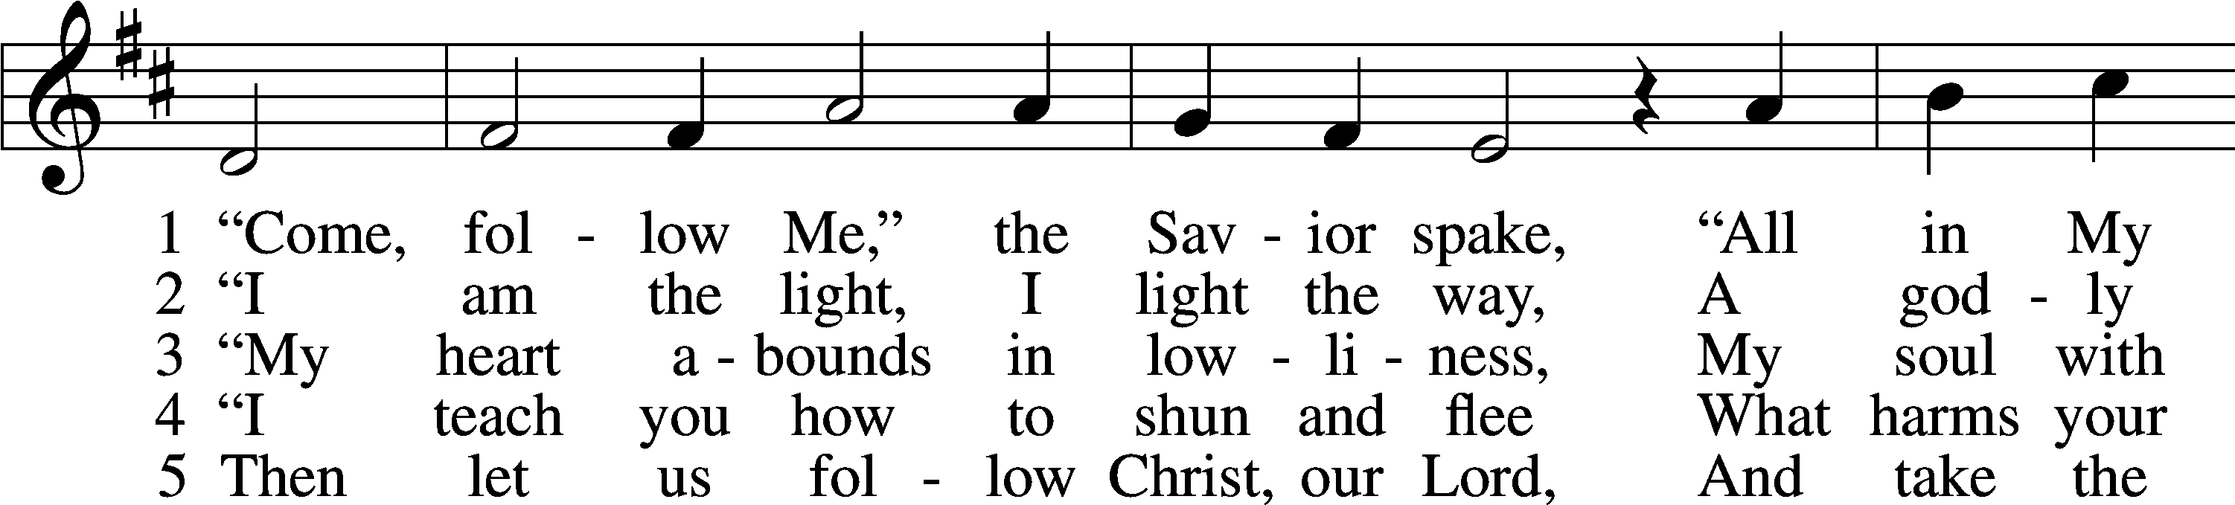

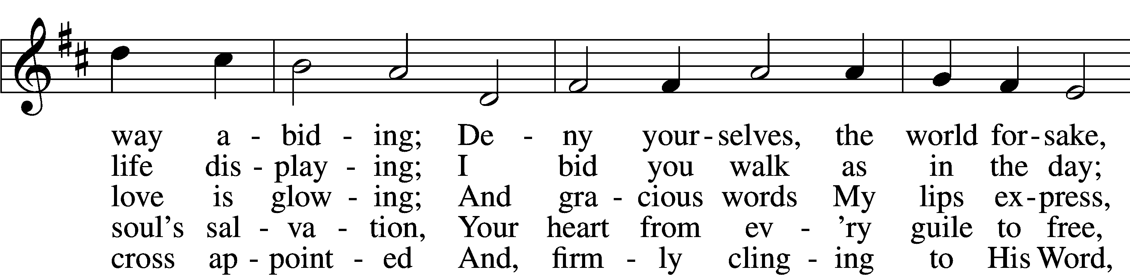

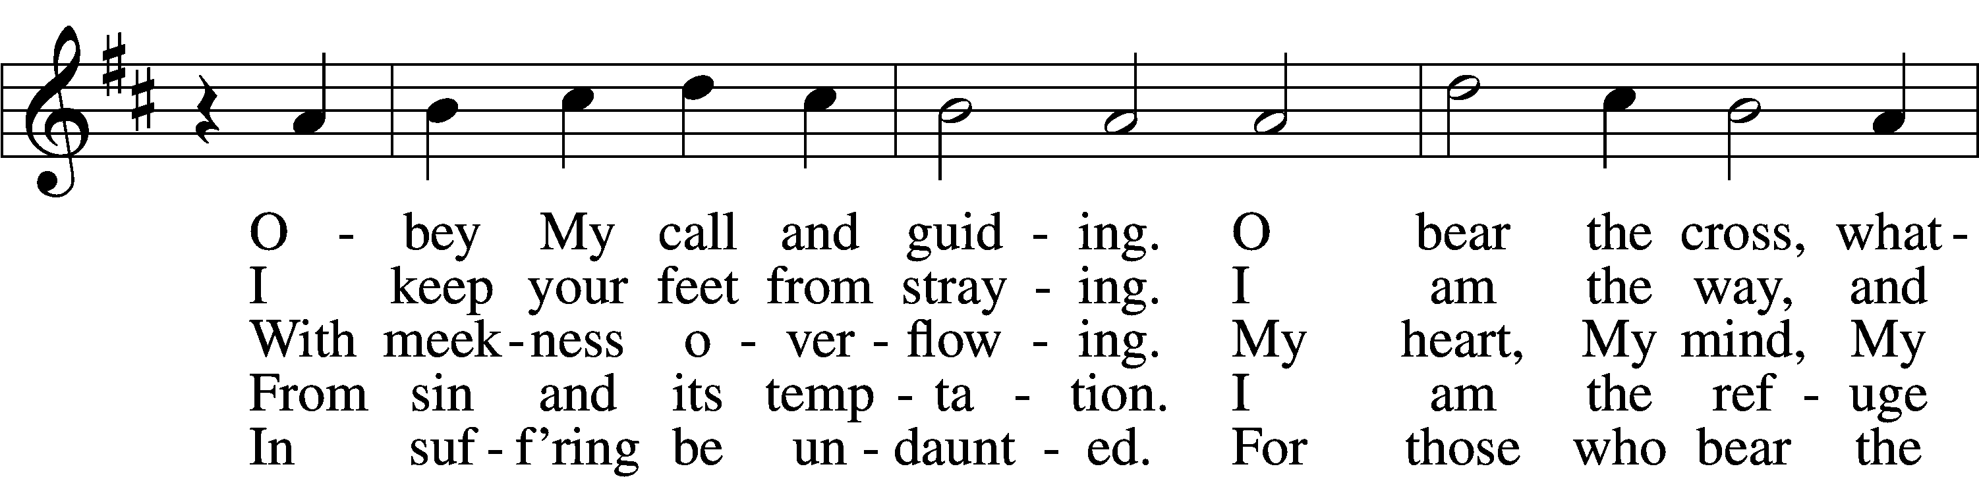

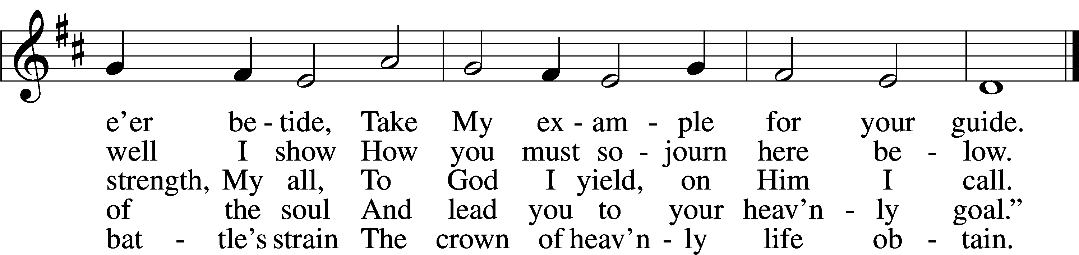

Text: tr. Charles W. Schaeffer, 1813–96; (sts. 1–3, 5): Johann Scheffler, 1624–77; (st. 4): Geistliche Lieder und Lobgesänge, 1695  
Tune: Bartholomäus Gesius, c. 1555–1613, adapt.  
Text and tune: Public domain

Sermon- "I am Jesus" changes everything

Stand

Apostles’ Creed

C **I believe in God, the Father Almighty,**

**maker of heaven and earth.**

**And in Jesus Christ, His only Son, our Lord,**

**who was conceived by the Holy Spirit,**

**born of the virgin Mary,**

**suffered under Pontius Pilate,**

**was crucified, died and was buried.**

**He descended into hell.**

**The third day He rose again from the dead.**

**He ascended into heaven**

**and sits at the right hand of God the Father Almighty.**

**From thence He will come to judge the living and the dead.**

**I believe in the Holy Spirit,**

**the holy Christian Church,**

**the communion of saints,**

**the forgiveness of sins,**

**the resurrection of the body,**

**and the life** T **everlasting. Amen.**

Prayer of the Church

Offering & Sharing of Peace

Stand

Offertory LSB 159

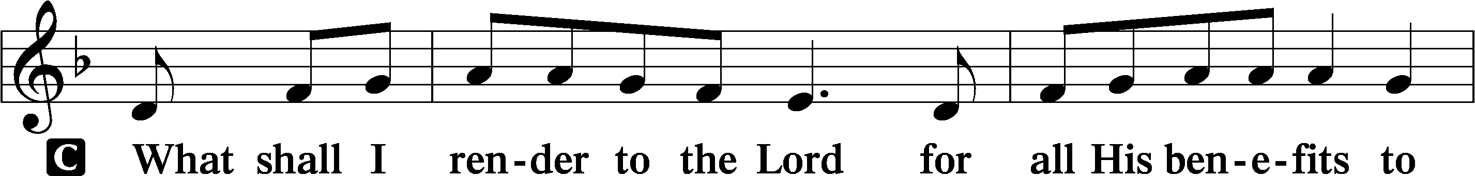

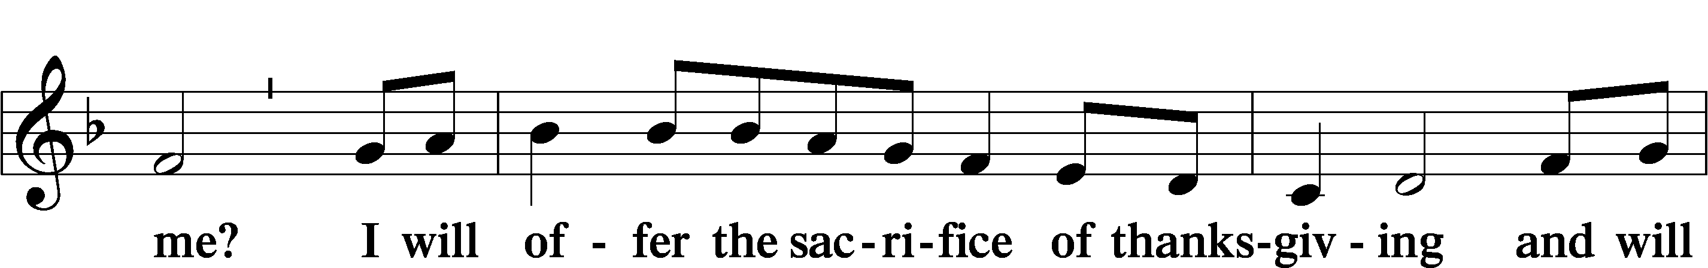

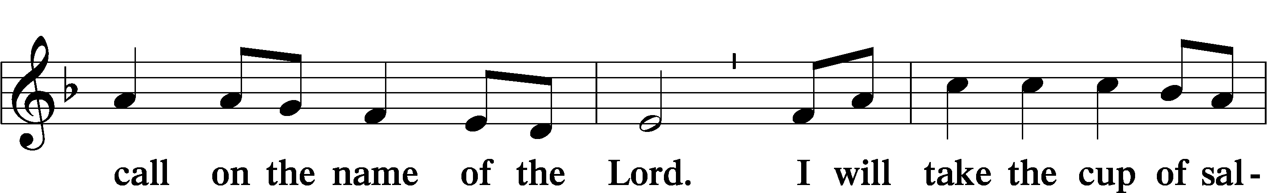

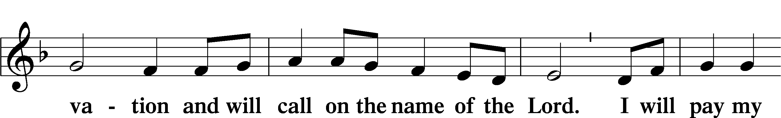

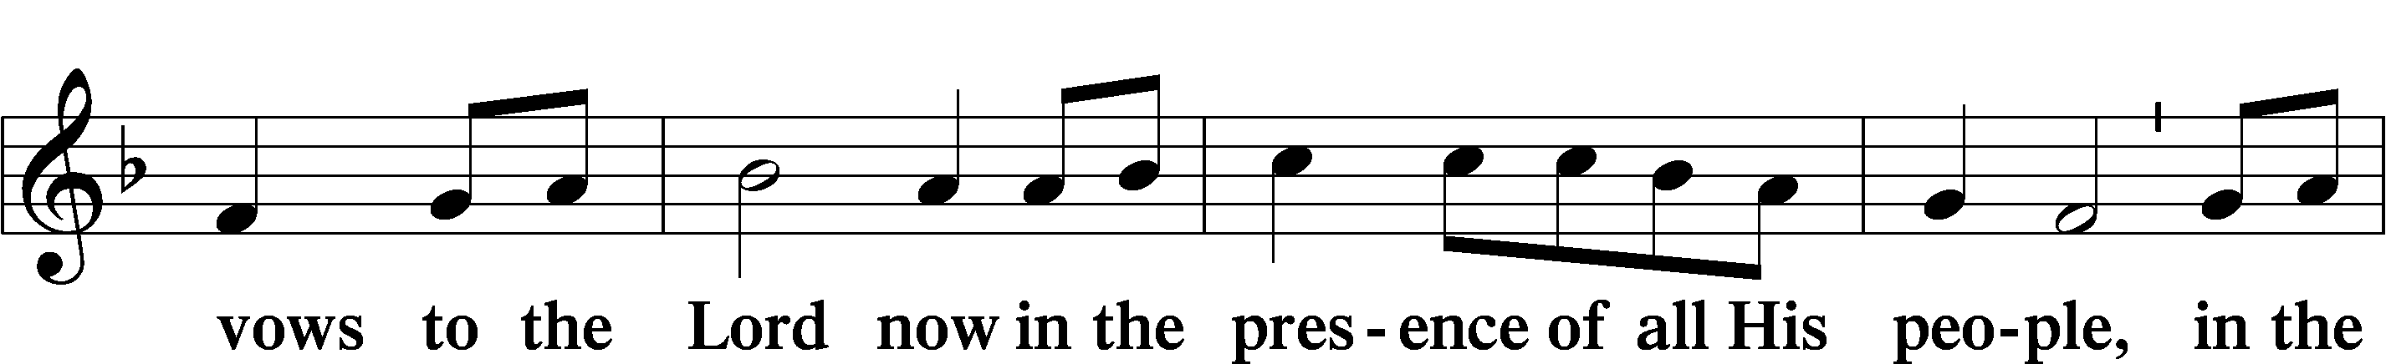

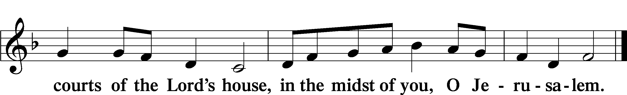

# Service of the Sacrament

Preface LSB 160











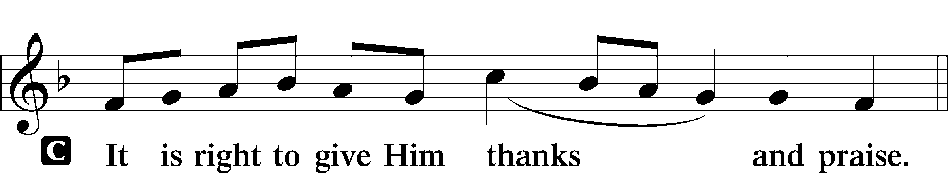

P It is truly good, right, and salutary that we should at all times and in all places give thanks to You, holy Lord, almighty Father, everlasting God. And most especially are we bound to praise You on this day for the glorious resurrection of Your Son, Jesus Christ, the very Paschal Lamb, who was sacrificed for us and bore the sins of the world. By His dying He has destroyed death, and by His rising again He has restored to us everlasting life. Therefore with Mary Magdalene, Peter and John, and with all the witnesses of the resurrection, with angels and archangels, and with all the company of heaven we laud and magnify Your glorious name, evermore praising You and saying:

Sanctus LSB 161

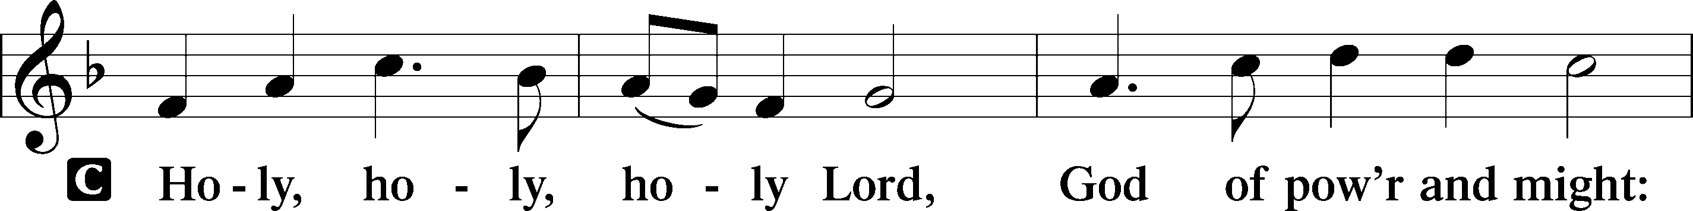

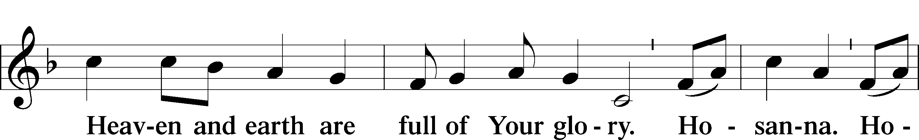

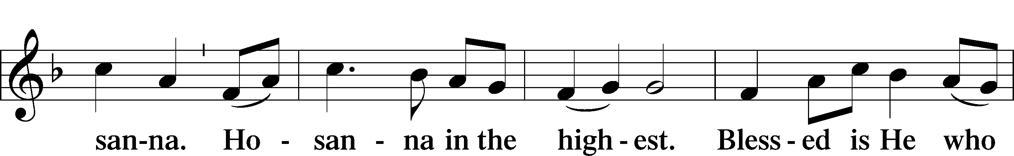

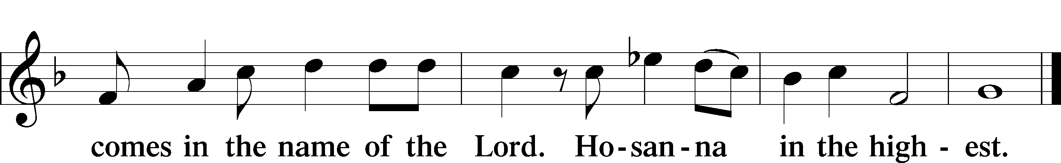

Prayer of Thanksgiving LSB 161

P Blessed are You, Lord of heaven and earth, for You have had mercy on those whom You created and sent Your only-begotten Son into our flesh to bear our sin and be our Savior. With repentant joy we receive the salvation accomplished for us by the all-availing sacrifice of His body and His blood on the cross.

Gathered in the name and the remembrance of Jesus, we beg You, O Lord, to forgive, renew, and strengthen us with Your Word and Spirit. Grant us faithfully to eat His body and drink His blood as He bids us do in His own testament. Gather us together, we pray, from the ends of the earth to celebrate with all the faithful the marriage feast of the Lamb in His kingdom, which has no end. Graciously receive our prayers; deliver and preserve us. To You alone, O Father, be all glory, honor, and worship, with the Son and the Holy Spirit, one God, now and forever.

C **Amen.**

The Words of Our Lord

P Our Lord Jesus Christ, on the night when He was betrayed, took bread, and when He had given thanks, He broke it and gave it to the disciples and said: “Take, eat; this is My T body, which is given for you. This do in remembrance of Me.”

In the same way also He took the cup after supper, and when He had given thanks, He gave it to them, saying: “Drink of it, all of you; this cup is the new testament in My T blood, which is shed for you for the forgiveness of sins. This do, as often as you drink it, in remembrance of Me.”

P As often as we eat this bread and drink this cup, we proclaim the Lord’s death until He comes.

C **Amen. Come, Lord Jesus.**

P O Lord Jesus Christ, only Son of the Father, in giving us Your body and blood to eat and to drink, You lead us to remember and confess Your holy cross and passion, Your blessed death, Your rest in the tomb, Your resurrection from the dead, Your ascension into heaven, and Your coming for the final judgment. So remember us in Your kingdom and teach us to pray:

Lord’s Prayer

C **Our Father who art in heaven,**

**hallowed be Thy name,**

**Thy kingdom come,**

**Thy will be done on earth**

**as it is in heaven;**

**give us this day our daily bread;**

**and forgive us our trespasses**

**as we forgive those**

**who trespass against us;**

**and lead us not into temptation,**

**but deliver us from evil.**

**For Thine is the kingdom**

**and the power and the glory**

**forever and ever. Amen.**

Pax Domini LSB 163

P The peace of the Lord be with you always.

C **Amen.**

Agnus Dei LSB 163

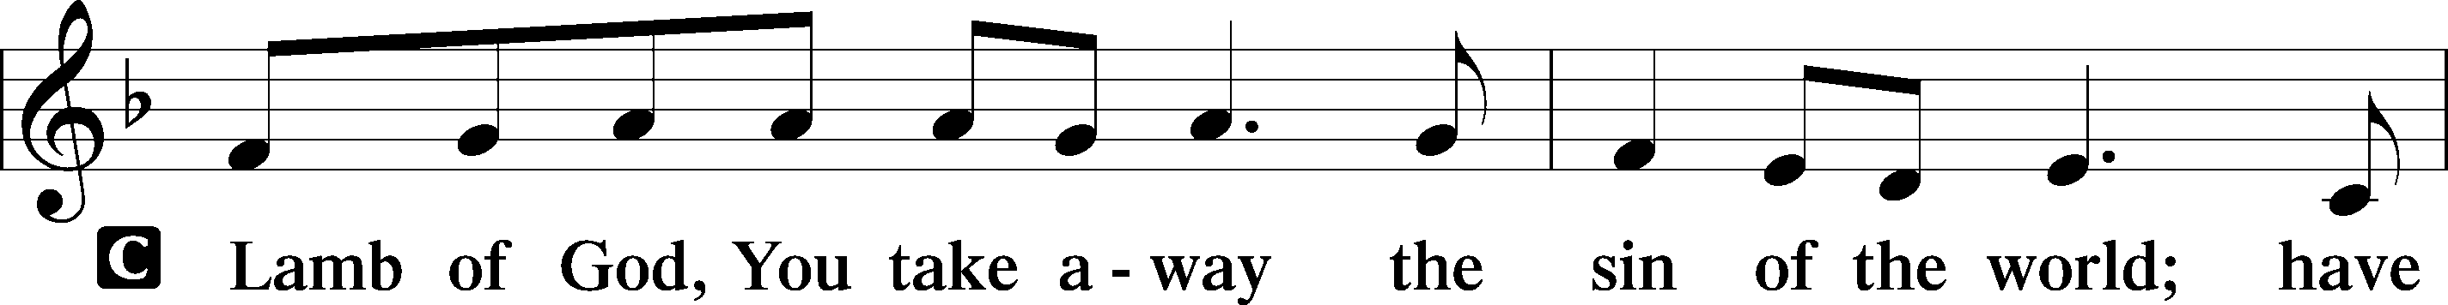

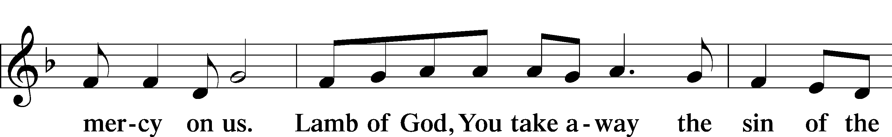

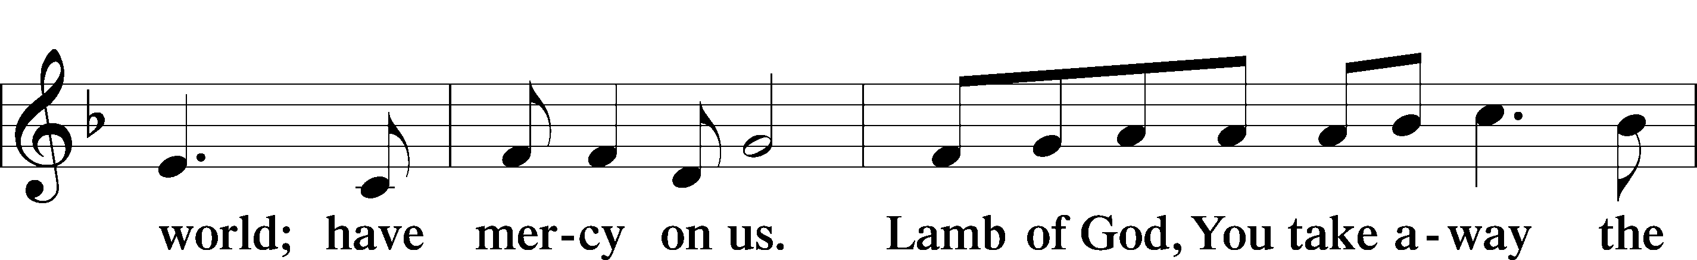

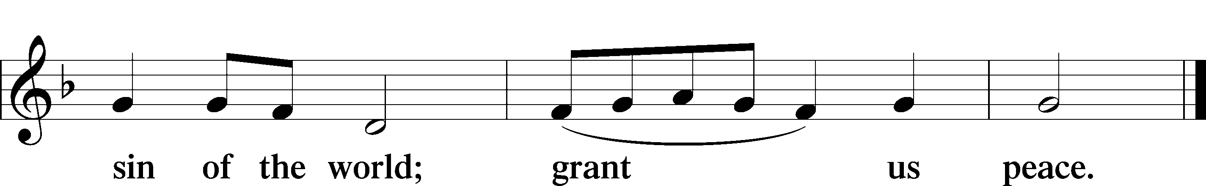

Sit

Distribution

Hymn

Thank the Lord LSB 164

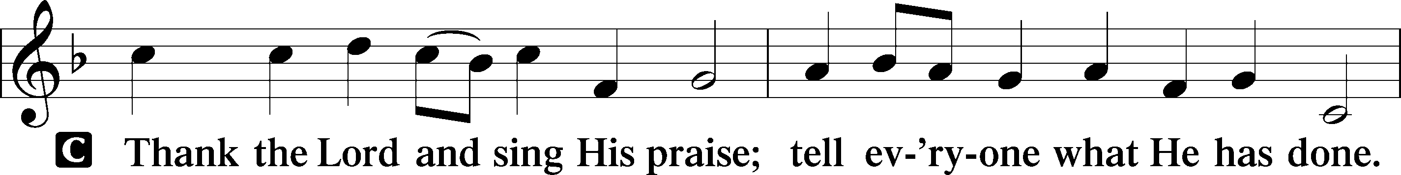

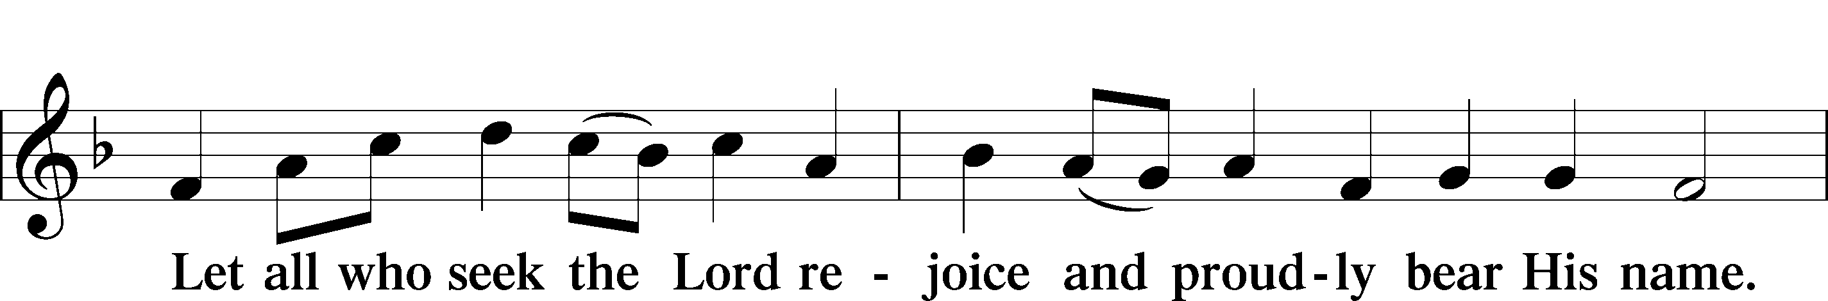

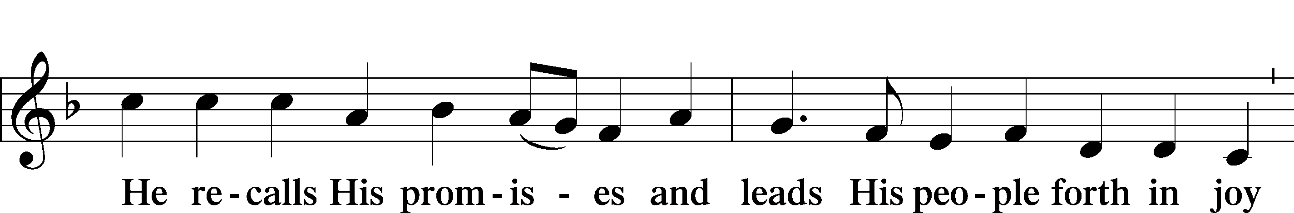

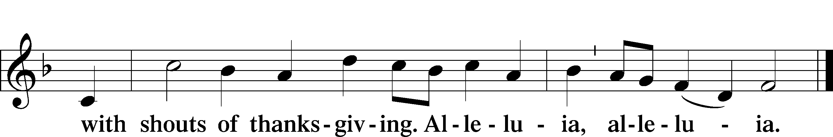

Post-Communion Collect

P Let us pray.

We give thanks to You, almighty God, that You have refreshed us through this salutary gift, and we implore You that of Your mercy You would strengthen us through the same in faith toward You and in fervent love toward one another; through Jesus Christ, Your Son, our Lord, who lives and reigns with You and the Holy Spirit, one God, now and forever.

C **Amen.**

Verse Romans 6:9; Luke 24:32

P Alleluia. We know that Christ being raised from the dead will never die again; death no longer has dominion over him. *

C **Did not our hearts burn within us while he talked to us on the road, while he opened to us the Scriptures? Alleluia.**

Benediction LSB 166

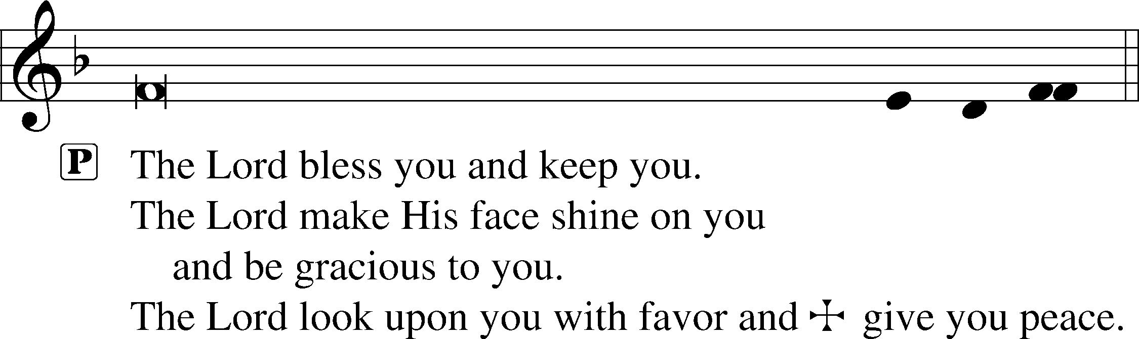



525 Crown Him with Many Crowns

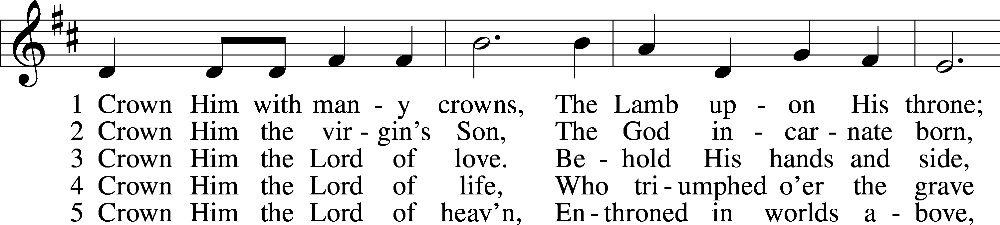

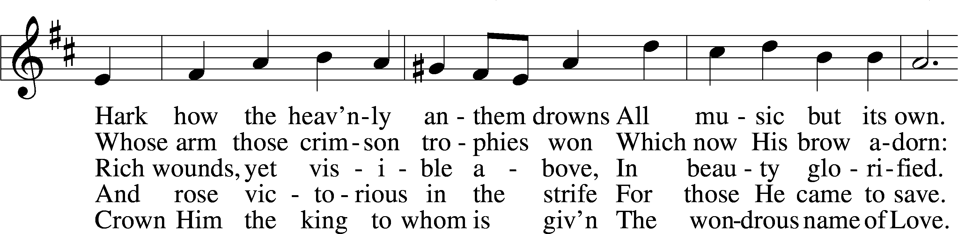

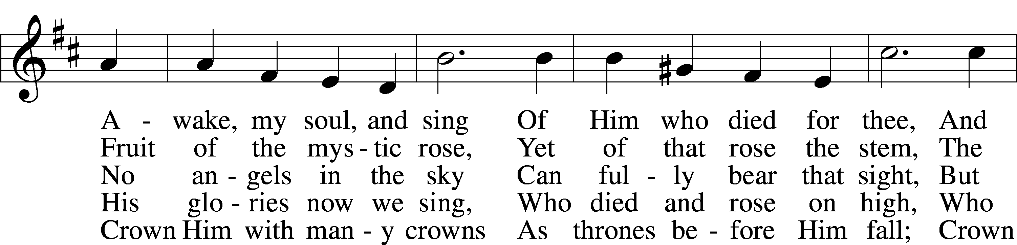

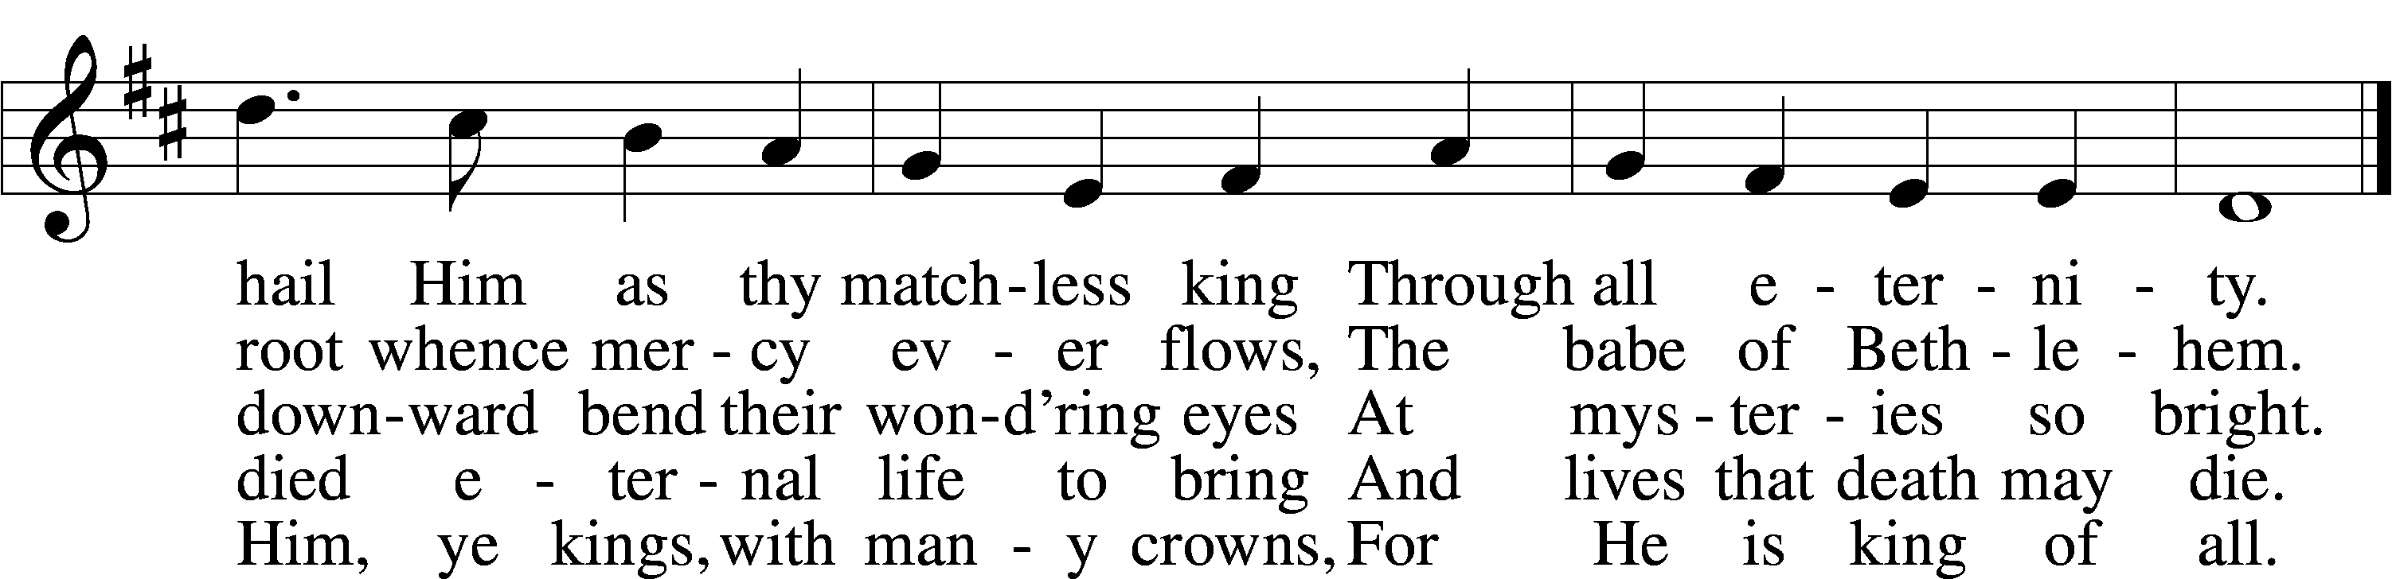

**Prayers of the Church**

*This week, we lift up:*

Continued prayers of healing for Jim & Sue, Angelina, Sheila, Bob & Elaine, Angela Carrie, Kathy Heffelfinger, JoAn Anders, Noel Vigil, Angela H and Mike B.

Family of the week: Tina Moore & family

*If you have any prayer request let us know.

Last week: Attendance - 28 Offering - $980

|  |  |
| --- | --- |
| **Serving Next Week** (5/11/25)  Guest Pastor: Rev Doyle Boykin  Music Minister: Vicar Previn Hudetz  Worship Assistant: Mike B  Reader: Sheila S  Refreshments: ----  Altar Guild: Angie Zak  Greeter: Angela H | **Readings Next Week**  *4th Sunday of Easter & Mothers’ Day*  Acts 20:17-35  Psalm 23  Revelation 7:9-17  John 10:22-30  ***Please sign up to help Read, Greet, Set up Communion, be a Worship Assistant or bring Refreshments.*** |
| **Announcements**  Birthdays:  This Week at OSLC:  Bible Study: After Service  Bible Study: Thursday 10am | **This Month**:  MOTHERS DAY WOMENS FELLOWSHIP  Next Saturday 5/10 1p-3p  Saturday Clean up! 9a-11p  May 17rd |

+++

**Seasons of the Church Year**

Easter is a 50-day season from the Day of the Resurrection of our Lord to the Day of Pentecost. This extended season, 1/7 of the entire year, is a victory celebration, a time for all Christians to proclaim boldly, their faith in a risen and victorious Savior.

Easter is the richest and most lavishly celebrated festival at the church year. The resurrection is the crux of everything we believe, all our faith hinges on Jesus return from the dead; for if there is no resurrection, there is no life eternal for believers. The colors of Easter are white and gold.

