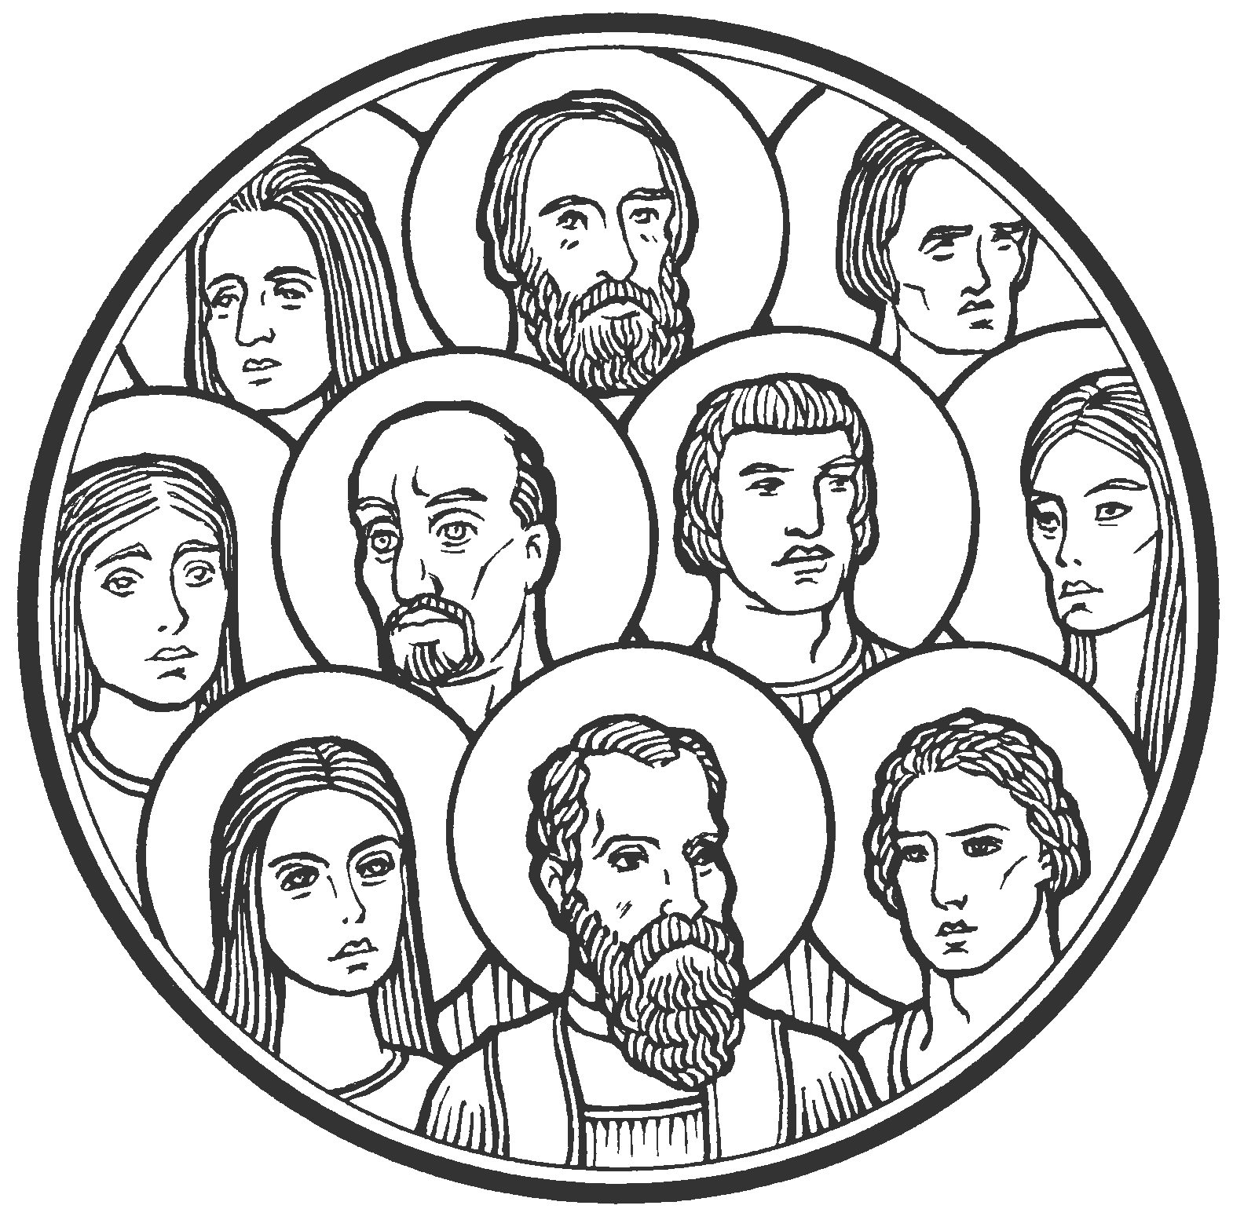

…to every nation and tribe and language and people –
He said with a loud voice, “Fear God and give him glory,
because the hour of his judgment has come…

Revelation 14:6-7

Our Savior Lutheran Church (LCMS)
4301 Atrisco Drive NW
Albuquerque, New Mexico
Website: OSLCNM.COM
Phone: 505.836.7007
Email: oslcabq@gmail.com

All Saints Day
November 2nd,2025
The Time of the Church (Trinitytide)
All Saints Day
November 2nd, 2025

Welcome to Our Savior Lutheran Church (LCMS).  We are glad you are here as we worship, praise, and give thanks to our loving Lord, Jesus Christ. Please join us immediately after service for fellowship and snacks. Adult Bible Study starts at 10:30. If you have any questions about our service or need other assistance, please contact one of our worship assistants. | Hymns  Opening # 677 & 733  Sermon # 507  Distribution # 817  Closing # 680

Today’s Message

The confession resounds in every time and place by all believing peoples, tribes, and churches: “Salvation belongs to our God who sits on the throne, and to the Lamb!” These words emanate from faith-filled saints who belong to Jesus. In His eternal presence, the beloved saints are utterly content in endless service and worship. Saints are the ones forever blessed, comforted, satisfied, and rewarded, because their inheritance is the very kingdom of God.

+++
Serving Today
Service Leader: Vicar Previn Hudetz
Communion Celebrant: Pastor John Heffelfinger
Communion Assistant: Jim C
Worship Assistant: Charlie Mike
Reader: Jim C
Refreshments: POTLUCK
Altar Guild: Angie Z & Sheila S
Greeter: TBD
Welcome - Divine Service I
677 For All the Saints sts. 1–2, 6–8
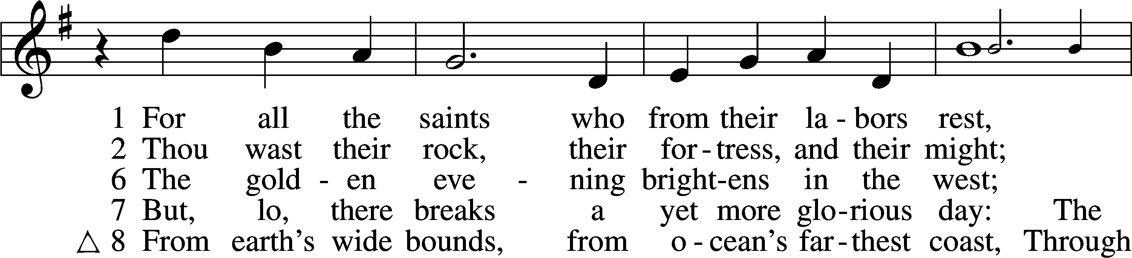
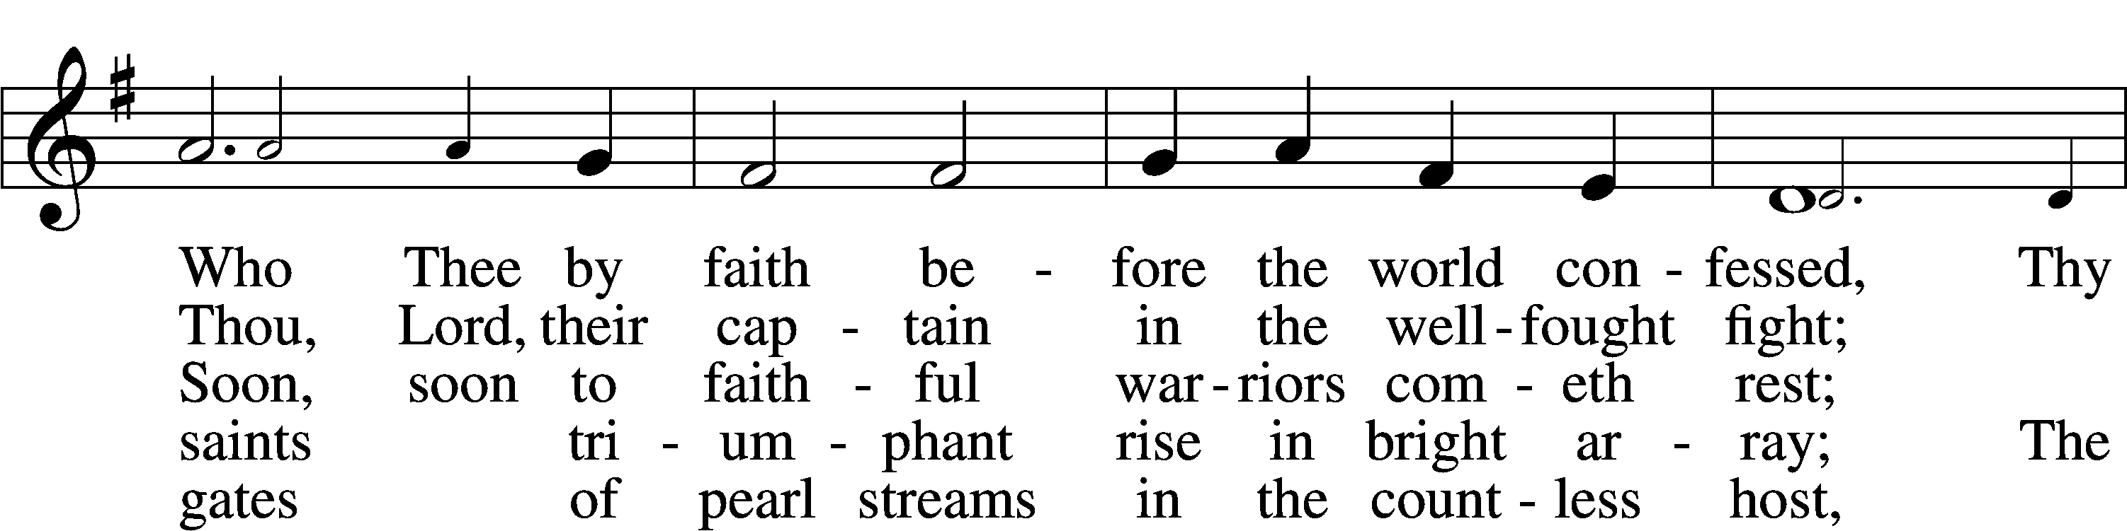
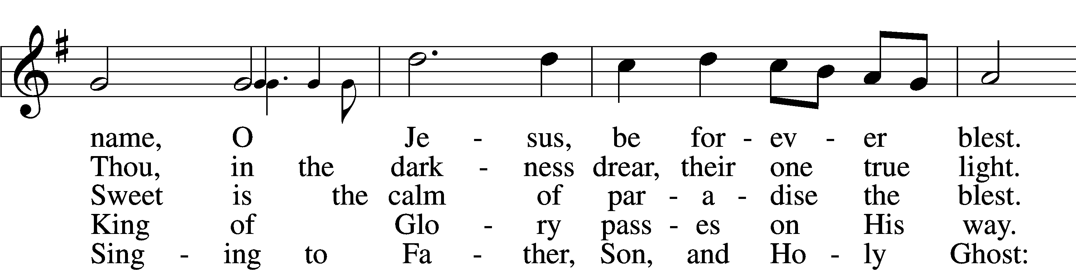
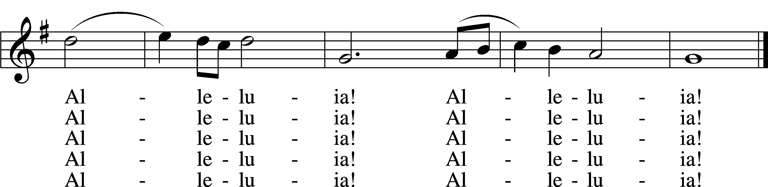
Text: William W. How, 1823–97, alt. Tune: Ralph Vaughan Williams, 1872–1958 Text and tune: Public domain

733 O God, Our Help in Ages Past sts. 1–4, 8
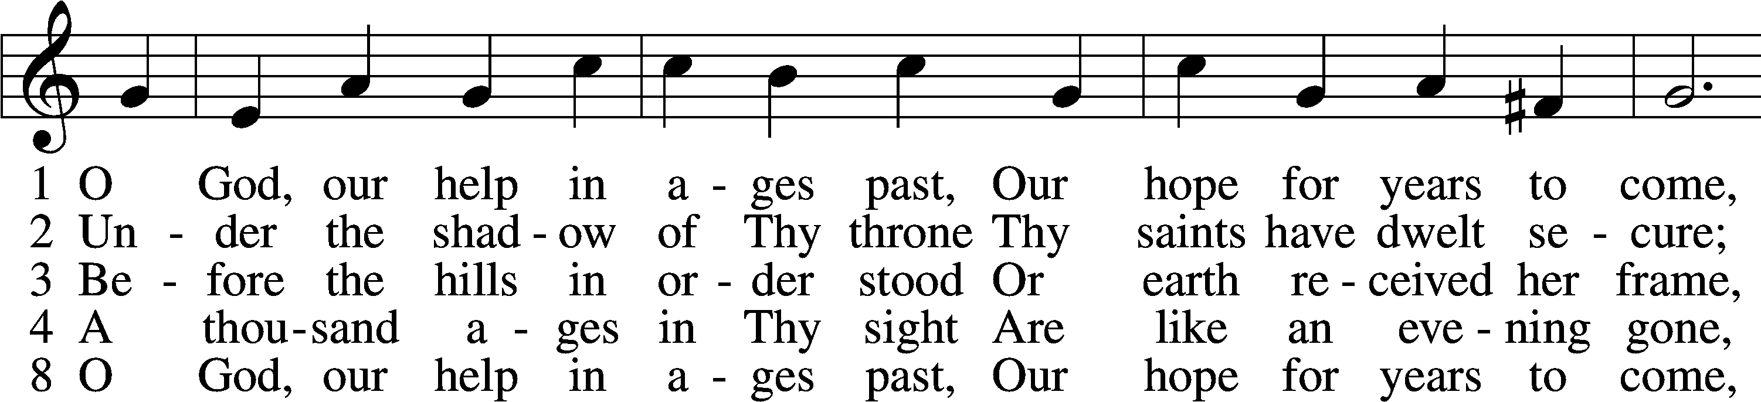
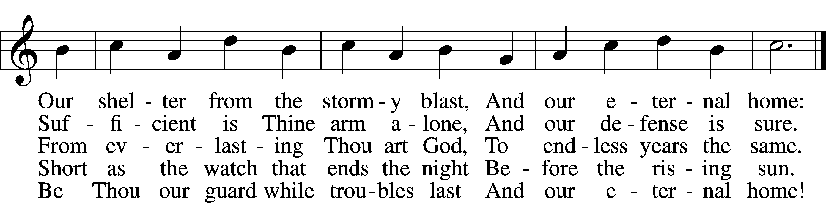
Text: Isaac Watts, 1674–1748, alt. Tune: William Croft, 1678–1727 Text and tune: Public domain
Confession and Absolution
Stand
The sign of the cross may be made by all in remembrance of their Baptism.

P In the name of the Father and of the T Son and of the Holy Spirit.
C Amen.

P If we say we have no sin, we deceive ourselves, and the truth is not in us.
C But if we confess our sins, God, who is faithful and just, will forgive our sins and cleanse us from all unrighteousness.

Silence for reflection on God’s Word and for self-examination.

P Let us then confess our sins to God our Father.
C Most merciful God, we confess that we are by nature sinful and unclean. We have sinned against You in thought, word, and deed, by what we have done and by what we have left undone. We have not loved You with our whole heart; we have not loved our neighbors as ourselves. We justly deserve Your present and eternal punishment. For the sake of Your Son, Jesus Christ, have mercy on us. Forgive us, renew us, and lead us, so that we may delight in Your will and walk in Your ways to the glory of Your holy name. Amen.
P Almighty God in His mercy has given His Son to die for you and for His sake forgives you all your sins. As a called servant of Christ, and by His authority, I therefore forgive you all your sins in the name of the Father and of the T Son and of the Holy Spirit.
C Amen.

Service of the Word
Invitatory for All Saints’ Day

P Blessed be God, the Father, the Son and the Holy Spirit.
O come, let us worship Him.
C These are the ones coming out of the great tribulation.
They have washed their robes and made them white in the
blood of the Lamb. Revelation 7:14

Introit Psalm 31:1, 3, 5; antiphon: Revelation 7:14b
These are the ones coming out of the great tribu- | lation.*
They have washed their robes and made them white in the blood | of the Lamb.
In you, O Lord, do I take refuge; let me never be | put to shame;*
in your righteousness de- | liver me.
For you are my rock and my | fortress;*
and for your name’s sake you lead me and | guide me.
Into your hand I commit my | spirit;*
you have redeemed me, O Lord, | faithful God.
Glory be to the Father and | to the Son*
and to the Holy | Spirit;
as it was in the be- | ginning,*
is now, and will be forever. | Amen.
These are the ones coming out of the great tribu- | lation.*
They have washed their robes and made them white in the blood | of the Lamb.
Kyrie LSB 152

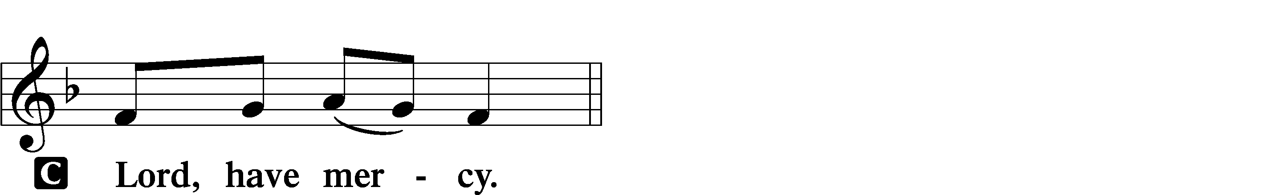
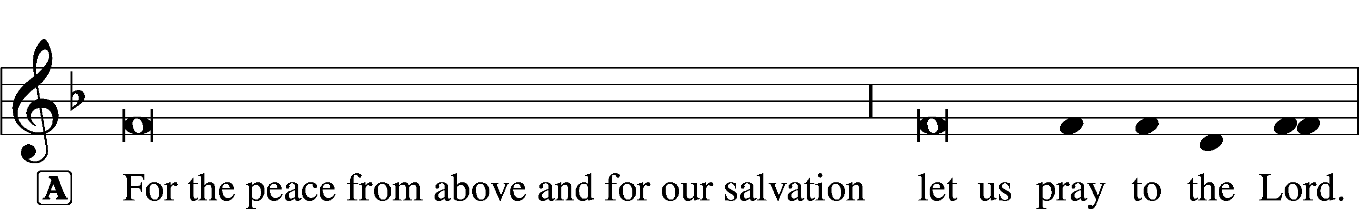

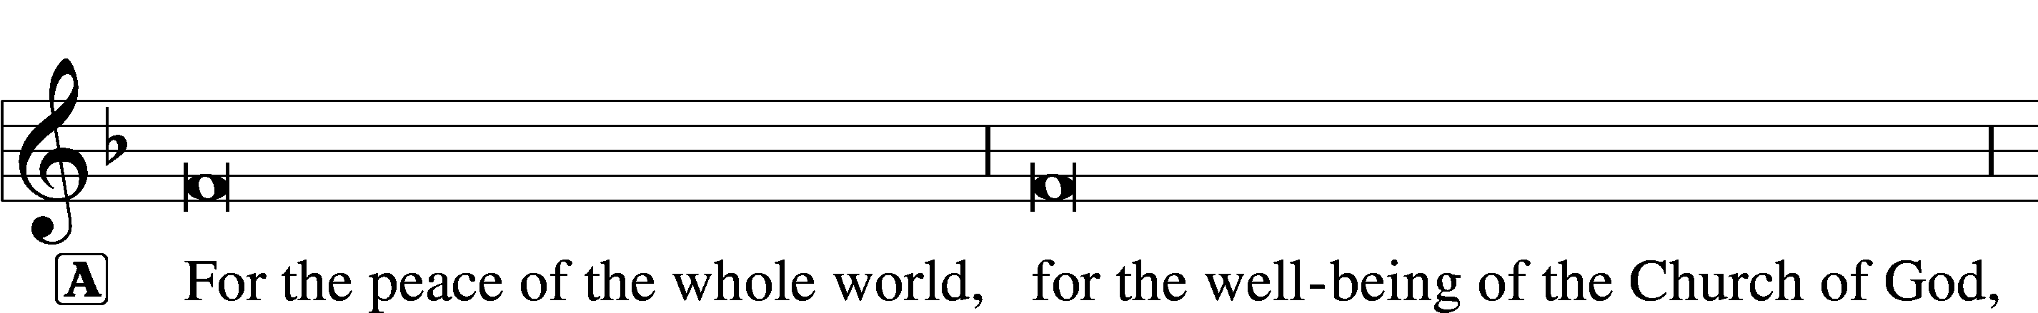


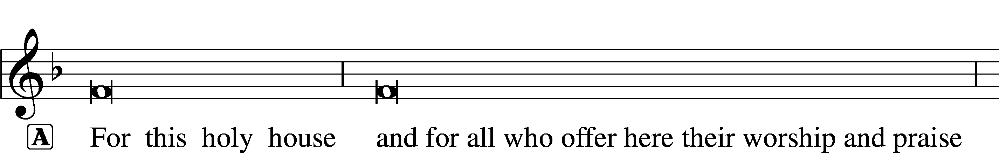





This Is the Feast LSB 155
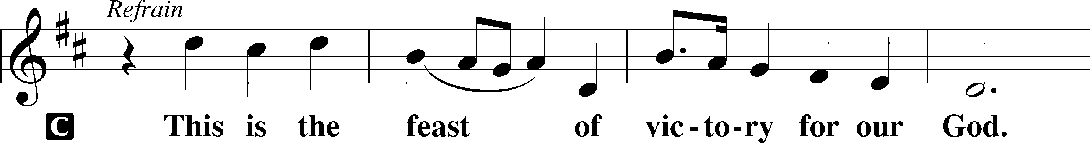
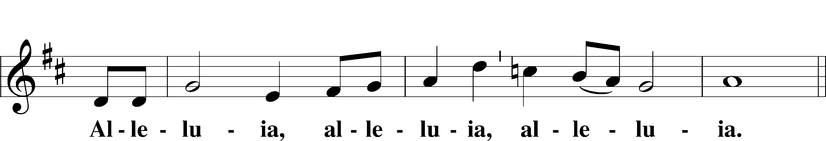
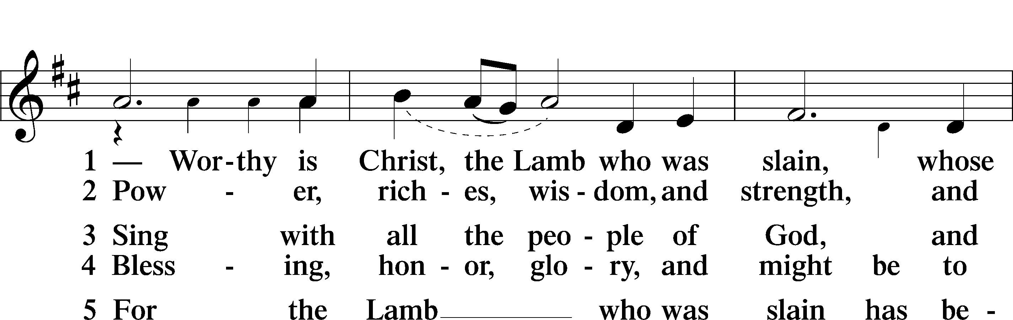
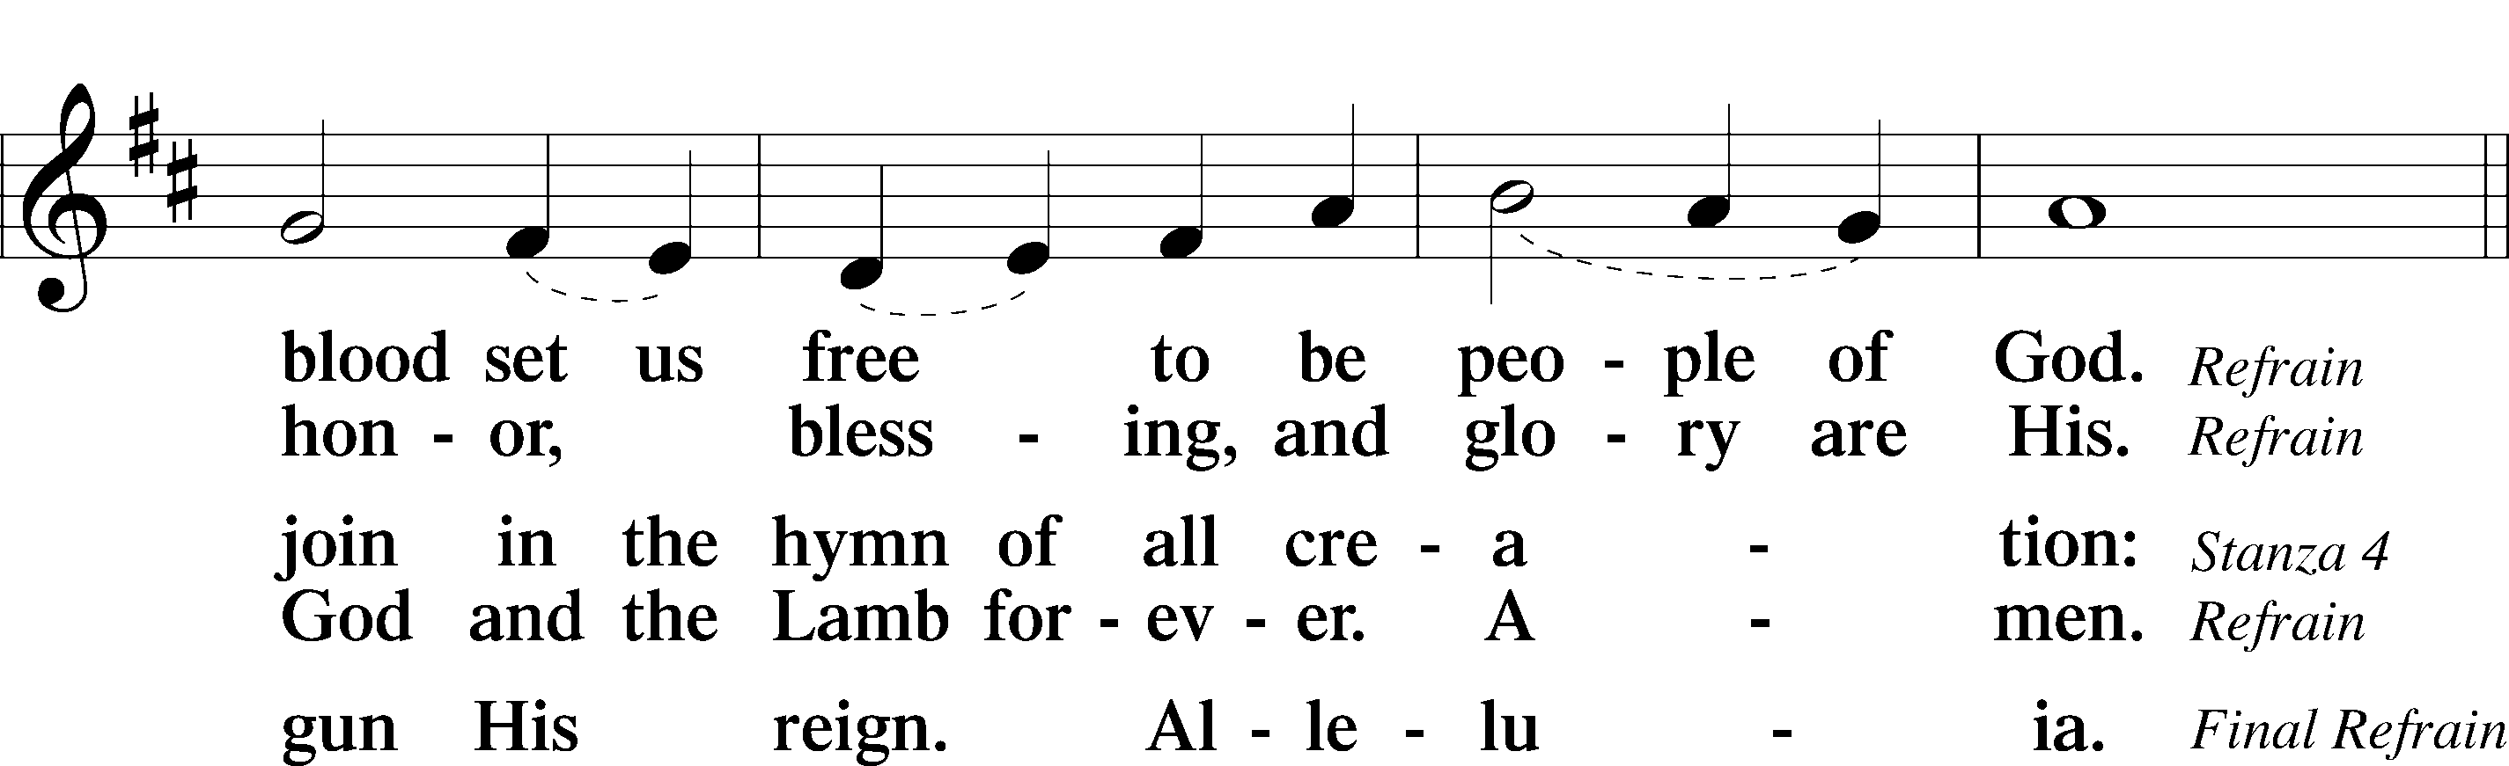
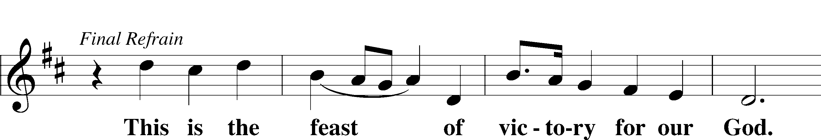
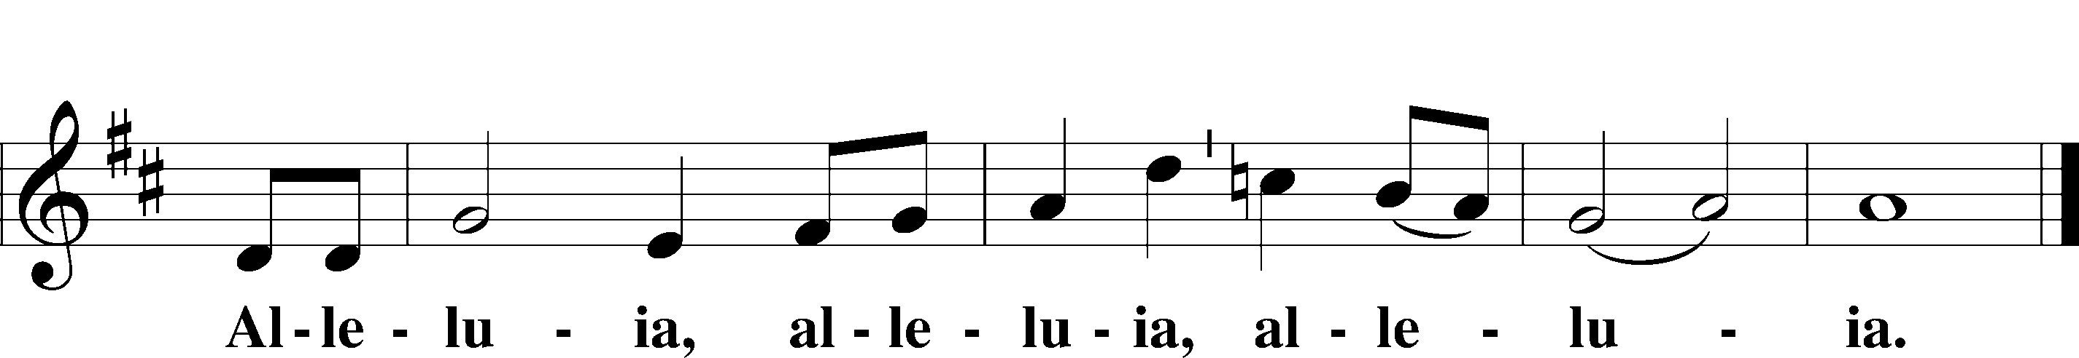

Salutation and Collect of the Day
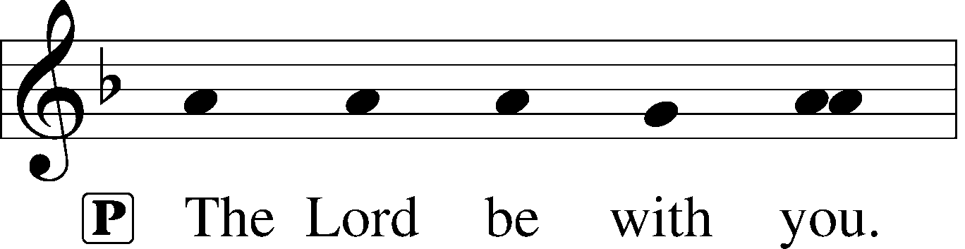
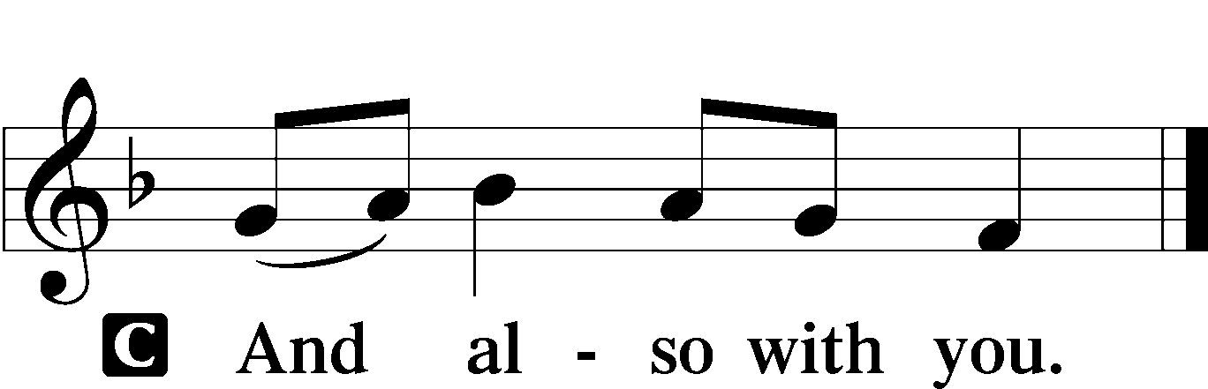

P Let us pray.
Almighty and everlasting God, You knit together Your faithful people of all times and places into one holy communion, the mystical body of Your Son, Jesus Christ. Grant us so to follow Your blessed saints in all virtuous and godly living that, together with them, we may come to the unspeakable joys You have prepared for those who love You; through Jesus Christ, our Lord, who lives and reigns with You and the Holy Spirit, one God, now and forever.

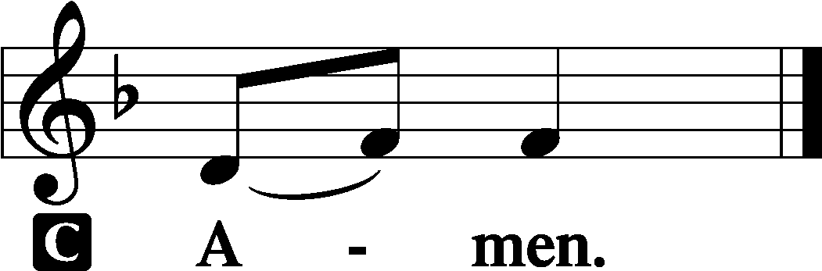
Sit

First Reading - The great multitude in white robes Revelation 7:9–17

9After this I looked, and behold, a great multitude that no one could number, from every nation, from all tribes and peoples and languages, standing before the throne and before the Lamb, clothed in white robes, with palm branches in their hands, 10and crying out with a loud voice, “Salvation belongs to our God who sits on the throne, and to the Lamb!” 11And all the angels were standing around the throne and around the elders and the four living creatures, and they fell on their faces before the throne and worshiped God, 12saying, “Amen! Blessing and glory and wisdom and thanksgiving and honor and power and might be to our God forever and ever! Amen.”
13Then one of the elders addressed me, saying, “Who are these, clothed in white robes, and from where have they come?” 14I said to him, “Sir, you know.” And he said to me, “These are the ones coming out of the great tribulation. They have washed their robes and made them white in the blood of the Lamb.
15“Therefore they are before the throne of God,
and serve him day and night in his temple;
and he who sits on the throne will shelter them with his presence.
16They shall hunger no more, neither thirst anymore;
the sun shall not strike them,
nor any scorching heat.
17For the Lamb in the midst of the throne will be their shepherd,
and he will guide them to springs of living water,
and God will wipe away every tear from their eyes.”

A This is the Word of the Lord.
C Thanks be to God.

Psalm “The Lord takes pleasure in His people.” Psalm 149; antiphon: v. 4
1Praise the Lord!
Sing to the Lord a | new song,*
his praise in the assembly of the | godly!
2Let Israel be glad in his | Maker;*
let the children of Zion rejoice | in their King!
3Let them praise his name with | dancing,*
making melody to him with tambou- | rine and lyre!
4For the Lord takes pleasure in his | people;*
he adorns the humble with sal- | vation.
5Let the godly exult in | glory;*
let them sing for joy | on their beds.
6Let the high praises of God be | in their throats*
and two-edged swords | in their hands,
7to execute vengeance on the | nations*
and punishments on the | peoples,
8to bind their | kings with chains*
and their nobles with fet- | ters of iron,
9to execute on them the judgment | written!*
This is honor for all his godly ones. | Praise the Lord!

Epistle “See what kind of love the Father has given to us.” 1 John 3:1–3

1See what kind of love the Father has given [lavished] to us, that we should be called children of God; and so we are. The reason why the world does not know us is that it did not know him. 2Beloved, we are God’s children now, and what we will be has not yet appeared; but we know that when he appears we shall be like him, because we shall see him as he is. 3And everyone who thus hopes in him purifies himself as he is pure.

A This is the Word of the Lord.
C Thanks be to God.

Stand

Alleluia and Verse LSB 156
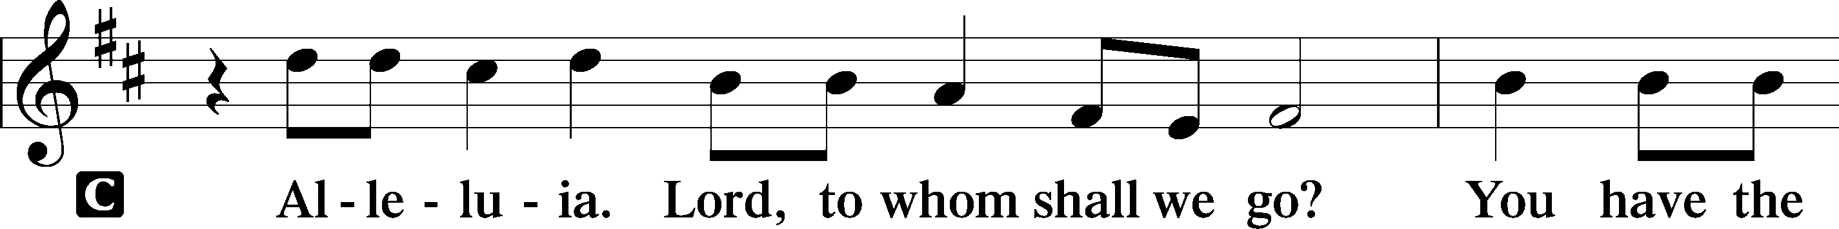
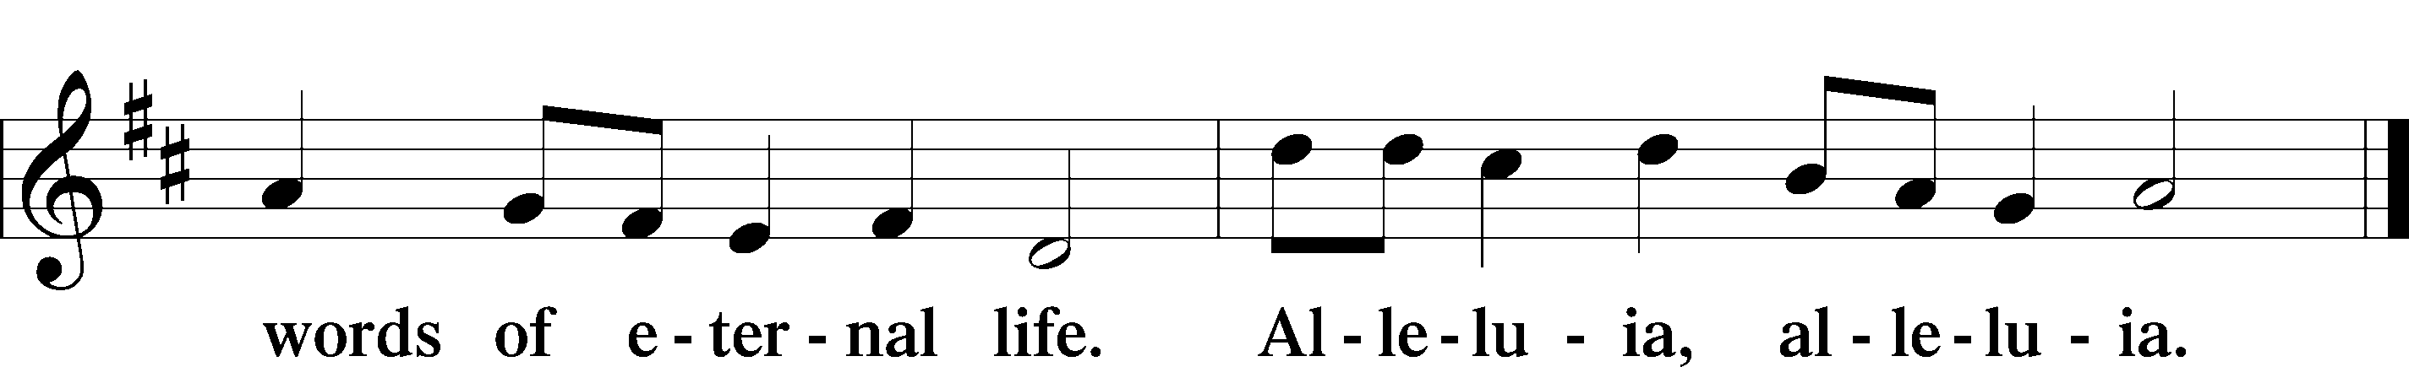

Holy Gospel The beatitudes Matthew 5:1–12
P The Holy Gospel according to St. Matthew, the fifth chapter.
C Glory to You, O Lord.

1Seeing the crowds, [Jesus] went up on the mountain, and when he sat down, his disciples came to him.
2And he opened his mouth and taught them, saying:
3“Blessed are the poor in spirit, for theirs is the kingdom of heaven.
4“Blessed are those who mourn, for they shall be comforted.
5“Blessed are the meek, for they shall inherit the earth.
6“Blessed are those who hunger and thirst for righteousness,
for they shall be satisfied.
7“Blessed are the merciful, for they shall receive mercy.
8“Blessed are the pure in heart, for they shall see God.
9“Blessed are the peacemakers, for they shall be called sons of God.
10“Blessed are those who are persecuted for righteousness’ sake,
for theirs is the kingdom of heaven.
11“Blessed are you when others revile you and persecute you and utter all kinds of evil against you falsely on my account. 12Rejoice and be glad, for your reward is great in heaven, for so they persecuted the prophets who were before you.”

P This is the Gospel of the Lord.
C Praise to You, O Christ.

Sit

507 Holy, Holy, Holy sts. 1–4
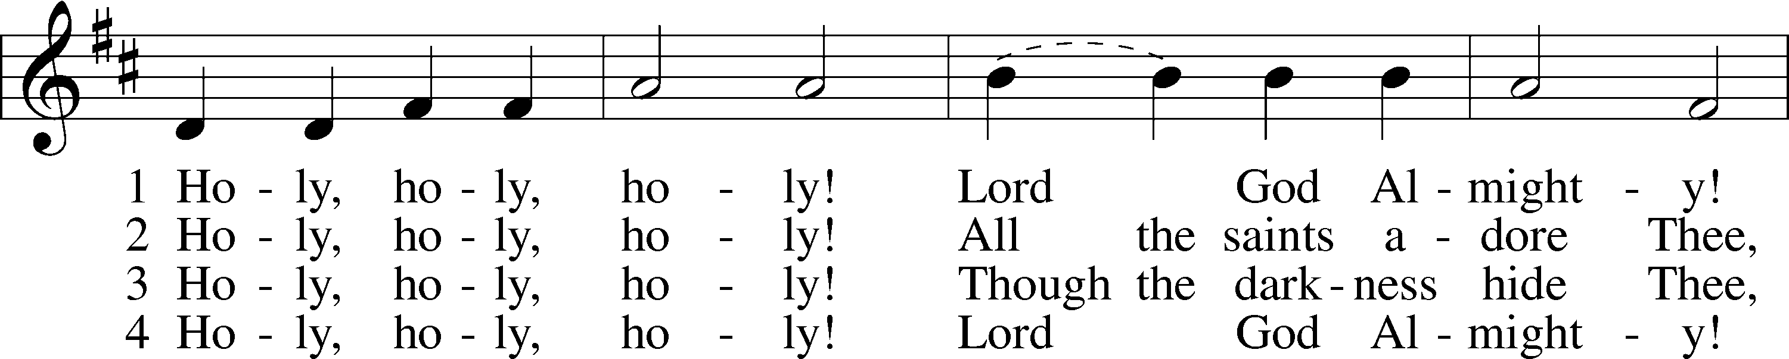
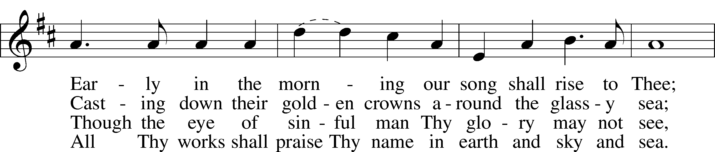
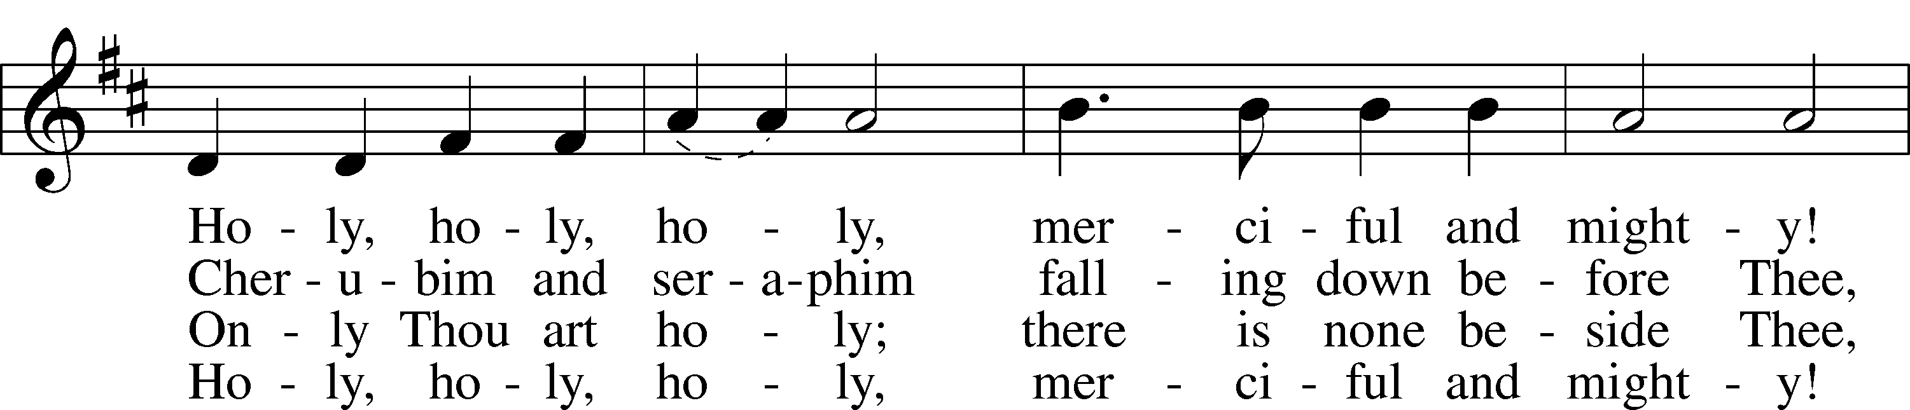
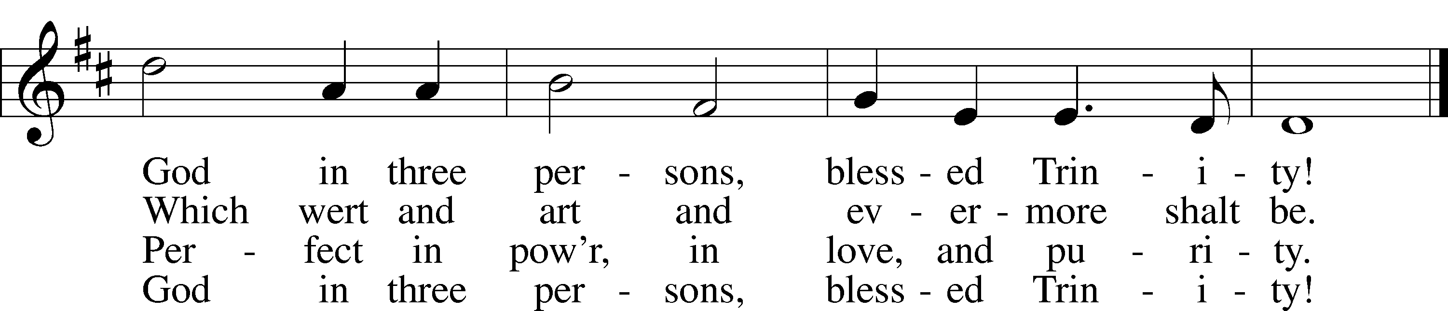
Text: Reginald Heber, 1783–1826 Tune: John B. Dykes, 1823–76 Text and tune: Public domain

Sermon

Stand

Apostles’ Creed
C I believe in God, the Father Almighty, maker of heaven and earth.

And in Jesus Christ, His only Son, our Lord,
who was conceived by the Holy Spirit, born of the virgin Mary,
suffered under Pontius Pilate, was crucified, died and was buried.
He descended into hell.
The third day He rose again from the dead.
He ascended into heaven
and sits at the right hand of God the Father Almighty.
From thence He will come to judge the living and the dead.

I believe in the Holy Spirit, the holy Christian Church,
the communion of saints, the forgiveness of sins,
the resurrection of the body, and the life T everlasting. Amen.

Commemoration of the Faithful Departed

P In joyful expectation of the resurrection to life eternal, we remember before the Lord our departed family and friends who have gone before us in faith and all those who are in our hearts and minds this day.

The faithful departed are remembered …

P Let us pray.
Almighty God, we remember with thanksgiving those who loved and served You in Your Church on earth and who now rest from their labors. Keep us in fellowship with all Your saints, and bring us at last to the joy of Your heavenly kingdom; through Jesus Christ, Your Son, our Lord, who lives and reigns with You and the Holy Spirit, one God, now and forever.
C Amen.

P Thanks be to God!
C Alleluia!

Prayer of the Church & Sharing of the Peace

Following the prayers, the people may greet one another in the name of the Lord, saying,
“Peace be with you,” as a sign of reconciliation and of the unity of the Spirit in the bond of peace
(Matt. 5:22–24; Eph. 4:1–3).
Offering & Offertory

Stand
LSB 159
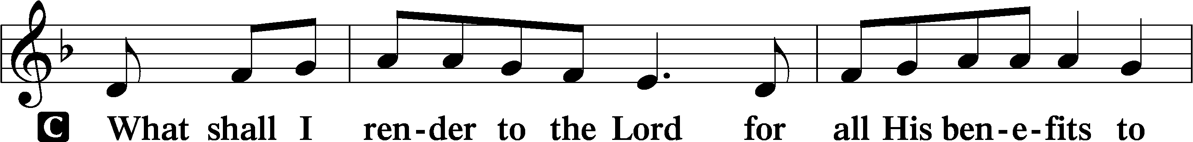
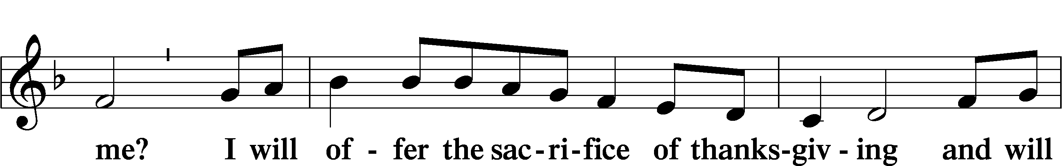
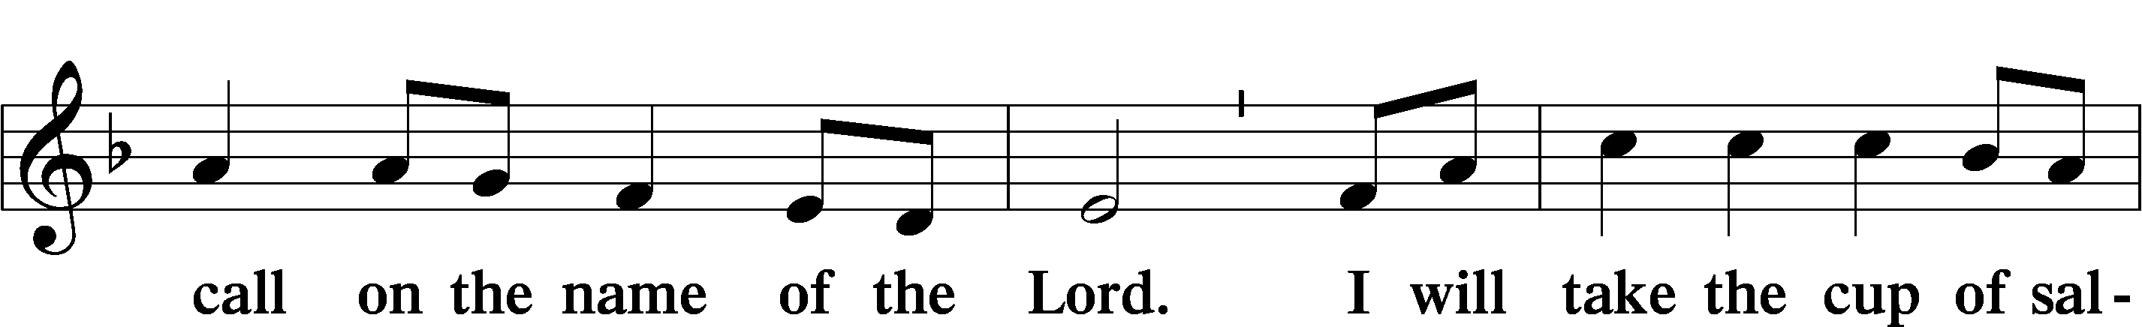
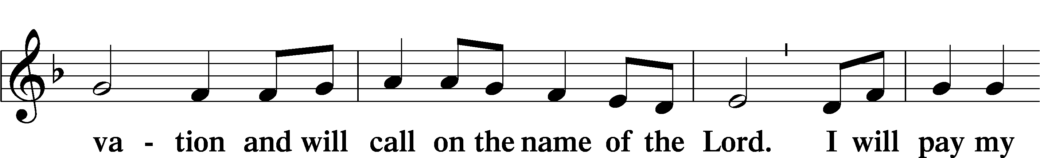
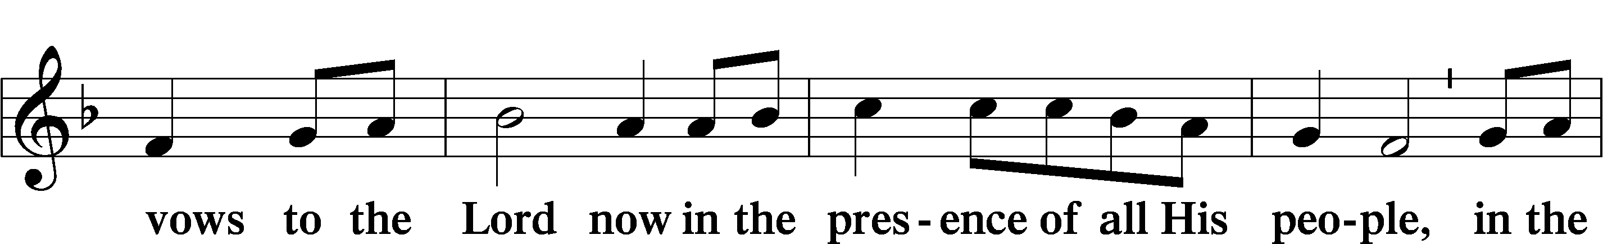
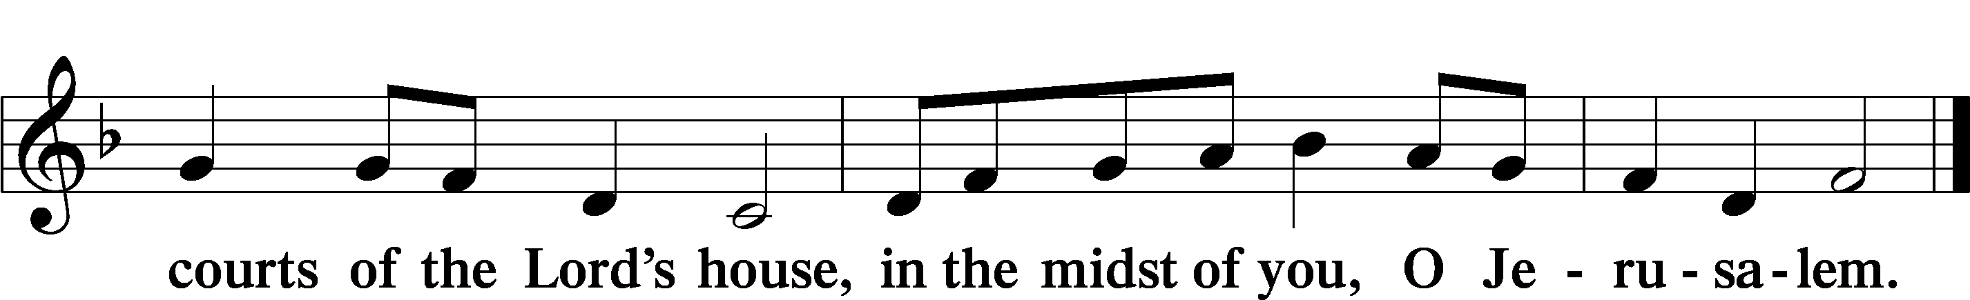

Service of Holy Communion
Communion Statement

The Lord’s Supper is celebrated at this congregation in the confession and glad confidence that, as He says, our Lord gives into our mouths not only bread and wine but His very body and blood to eat and to drink for the forgiveness of sins and to strengthen our union with Him and with one another. Our Lord invites to His table those who trust His words, repent of all sin, and set aside any refusal to forgive and love as He forgives and loves us, that they may show forth His death until He comes.

Because those who eat and drink our Lord’s body and blood unworthily do so to their great harm and because Holy Communion is a confession of the faith which is confessed at this altar, any who are not yet instructed, in doubt, or who hold a confession differing from that of this congregation and the Lutheran Church Missouri Synod, and yet desire to receive this sacrament, are asked to speak with the Pastor.
* See more about the Lutheran teaching on communion in the Hymnal p 329.

Preface LSB 160





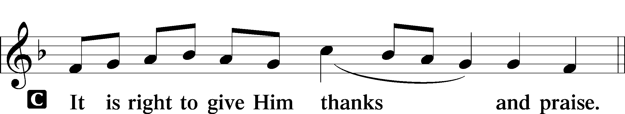

P It is truly good, right, and salutary that we should at all times and in all places give thanks to You, holy Lord, almighty Father, everlasting God. In the communion of all Your saints gathered into the one body of Your Son, You have surrounded us with so great a cloud of witnesses that we, encouraged by their faith and strengthened by their fellowship, may run with perseverance the race that is set before us and, together with them, receive the crown of glory that does not fade away. Therefore with angels and archangels and with all the company of heaven we laud and magnify Your glorious name, evermore praising You and saying:

Sanctus LSB 161
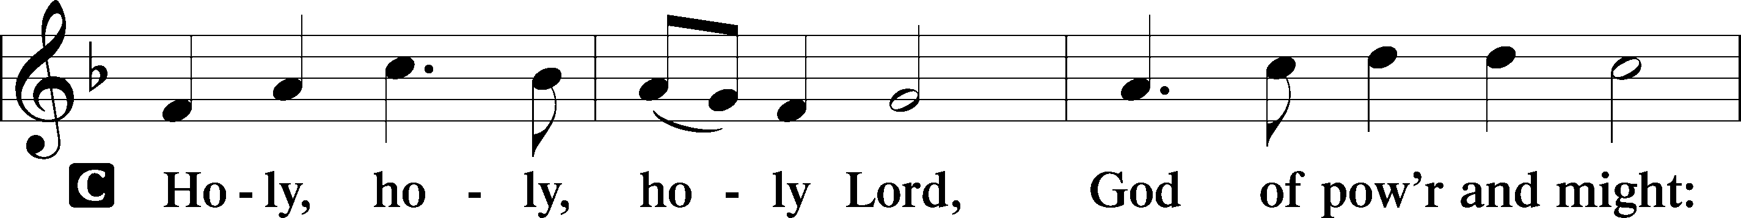
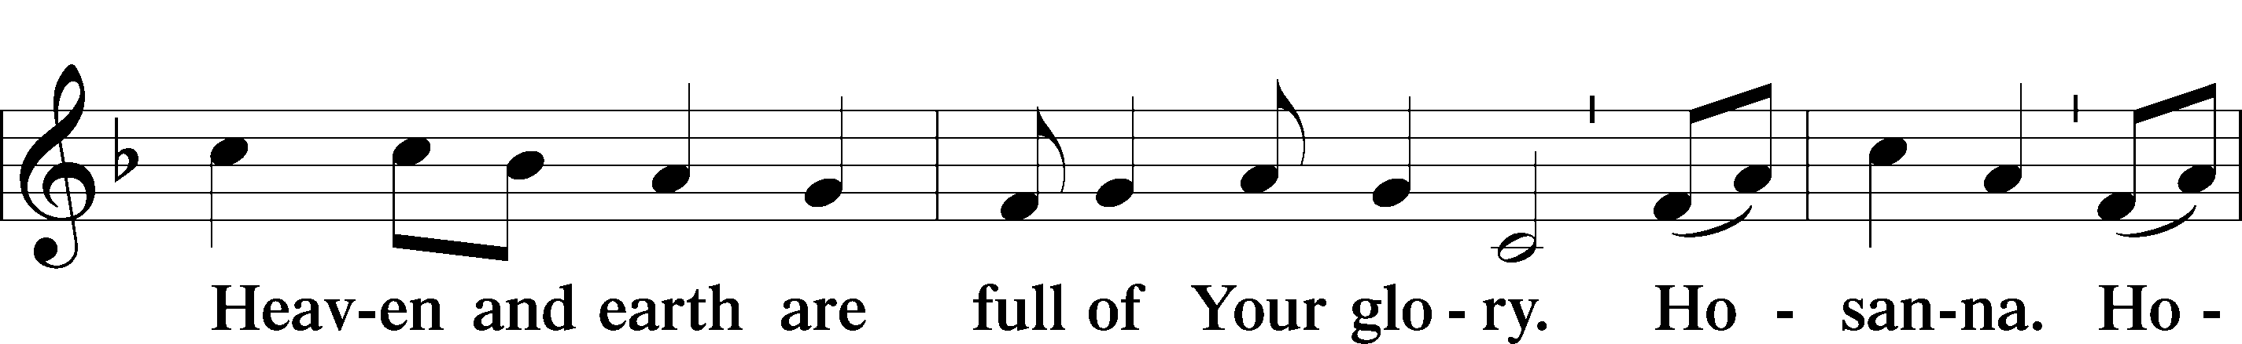
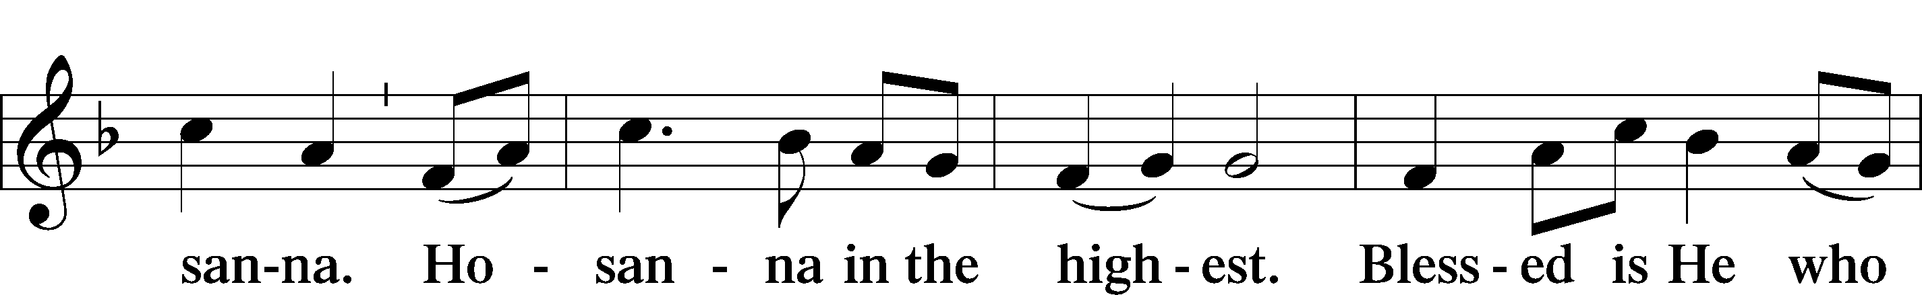
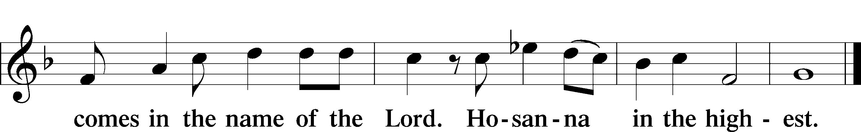

Prayer of Thanksgiving LSB 161
P Blessed are You, Lord of heaven and earth, for You have had mercy on those whom You created and sent Your only-begotten Son into our flesh to bear our sin and be our Savior. With repentant joy we receive the salvation accomplished for us by the all-availing sacrifice of His body and His blood on the cross.

Gathered in the name and the remembrance of Jesus, we beg You, O Lord, to forgive, renew, and strengthen us with Your Word and Spirit. Grant us faithfully to eat His body and drink His blood as He bids us do in His own testament. Gather us together, we pray, from the ends of the earth to celebrate with all the faithful the marriage feast of the Lamb in His kingdom, which has no end. Graciously receive our prayers; deliver and preserve us. To You alone, O Father, be all glory, honor, and worship, with the Son and the Holy Spirit, one God, now and forever.
C Amen.

The Words of Our Lord
P Our Lord Jesus Christ, on the night when He was betrayed, took bread, and when He had given thanks, He broke it and gave it to the disciples and said: “Take, eat; this is My T body, which is given for you. This do in remembrance of Me.”

In the same way also He took the cup after supper, and when He had given thanks, He gave it to them, saying: “Drink of it, all of you; this cup is the new testament in My T blood, which is shed for you for the forgiveness of sins. This do, as often as you drink it, in remembrance of Me.”

P As often as we eat this bread and drink this cup, we proclaim the Lord’s death until He comes.
C Amen. Come, Lord Jesus.

P O Lord Jesus Christ, only Son of the Father, in giving us Your body and blood to eat and to drink, You lead us to remember and confess Your holy cross and passion, Your blessed death, Your rest in the tomb, Your resurrection from the dead, Your ascension into heaven, and Your coming for the final judgment. So remember us in Your kingdom and teach us to pray:

Lord’s Prayer
C Our Father who art in heaven, hallowed be Thy name,
Thy kingdom come, Thy will be done on earth as it is in heaven;
give us this day our daily bread;
and forgive us our trespasses as we forgive those
who trespass against us; and lead us not into temptation,
but deliver us from evil.
For Thine is the kingdom and the power and the glory
forever and ever. Amen.

Pax Domini LSB 163
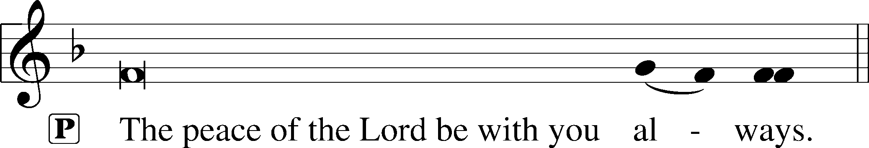


Agnus Dei (Spoken)

The pastor elevates the chalice and host and says:

P Behold, the Lamb of God that takes away the sins of the world.
C Lord, have mercy upon us.

Agnus Dei LSB 163
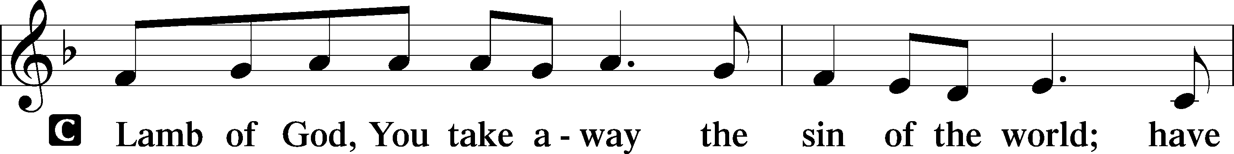
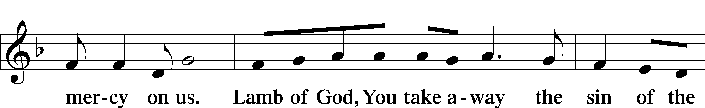
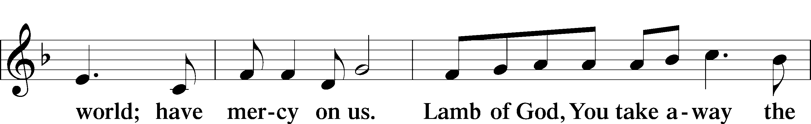
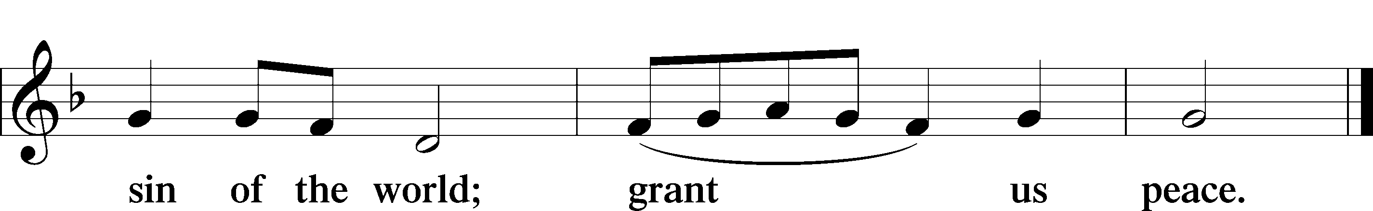

Sit
Distribution

817 Earth and All Stars
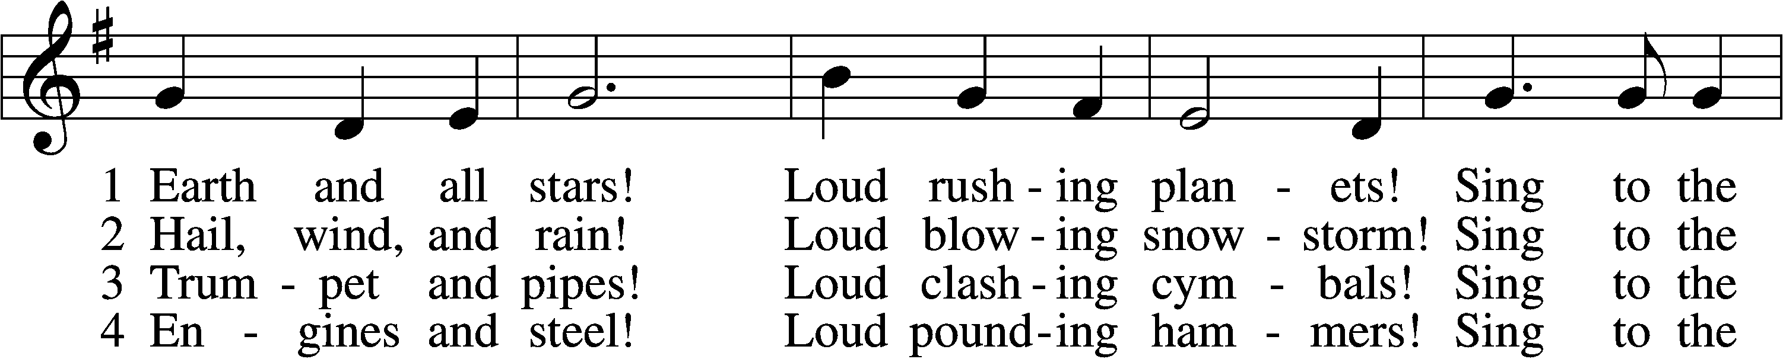
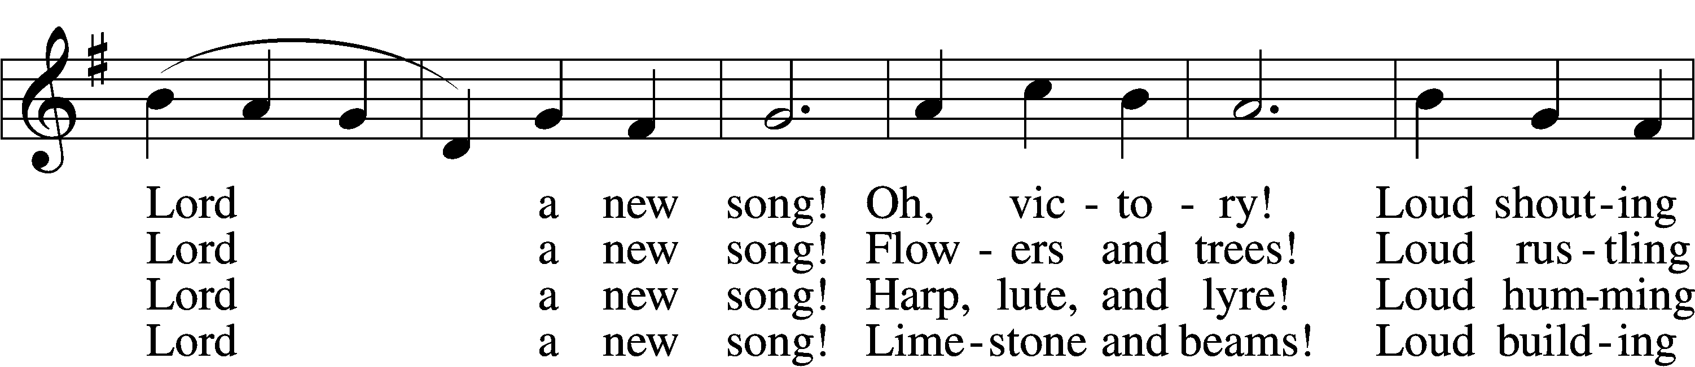
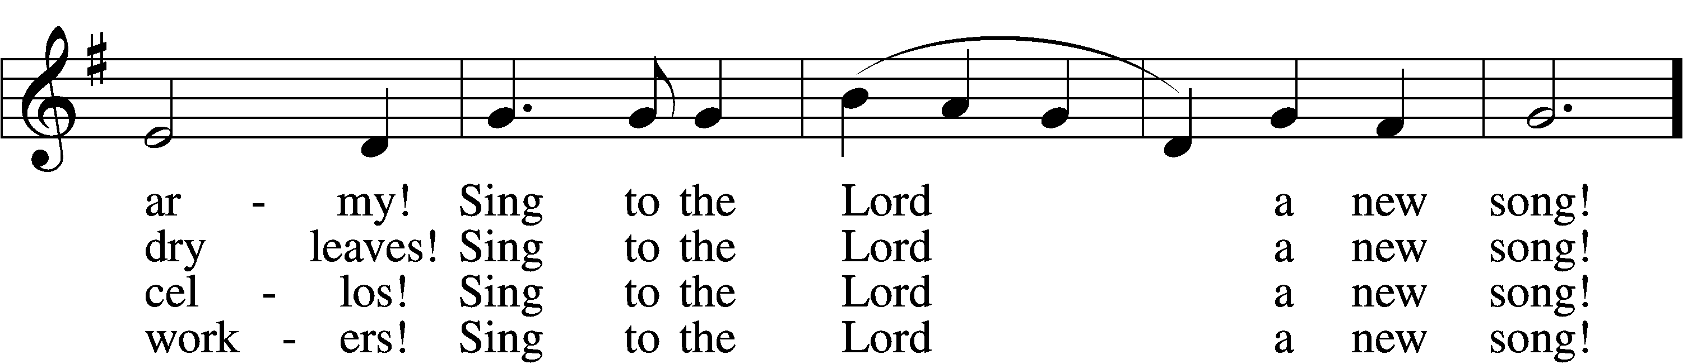
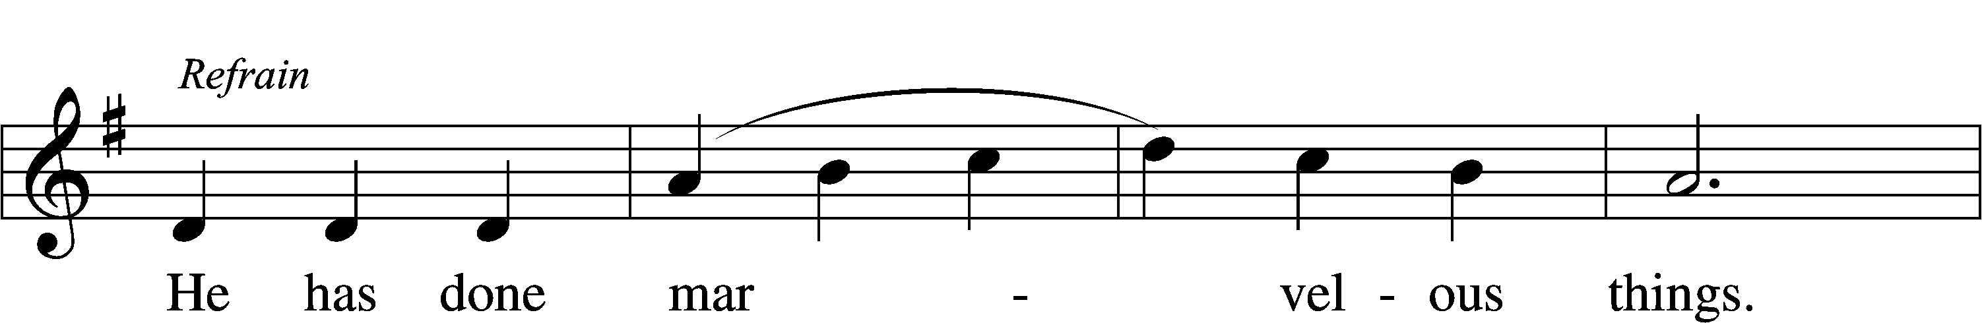
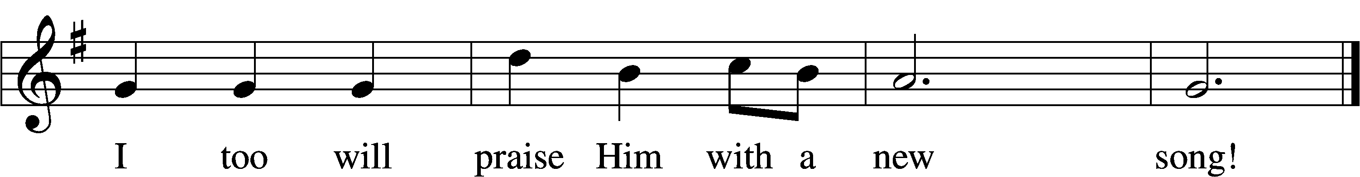

5 Classrooms and labs! Loud boiling test tubes!
Sing to the Lord a new song! Athlete and band!
Loud cheering people!
Sing to the Lord a new song! Refrain
6 Knowledge and truth! Loud sounding wisdom! Sing to the Lord a new song!
Daughter and son!
Loud praying members!
Sing to the Lord a new song! Refrain
7 Children of God,
Dying and rising, Sing to the Lord a new song!
Heaven and earth,
Hosts everlasting,
Sing to the Lord a new song! Refrain

Stand
Thank the Lord LSB 164
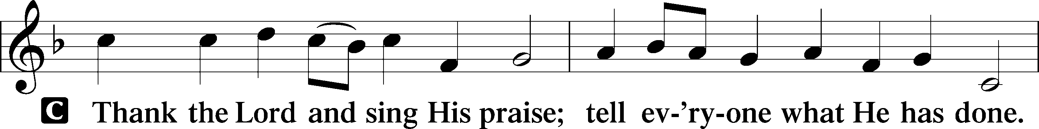
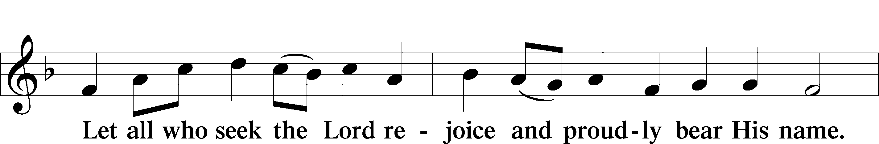
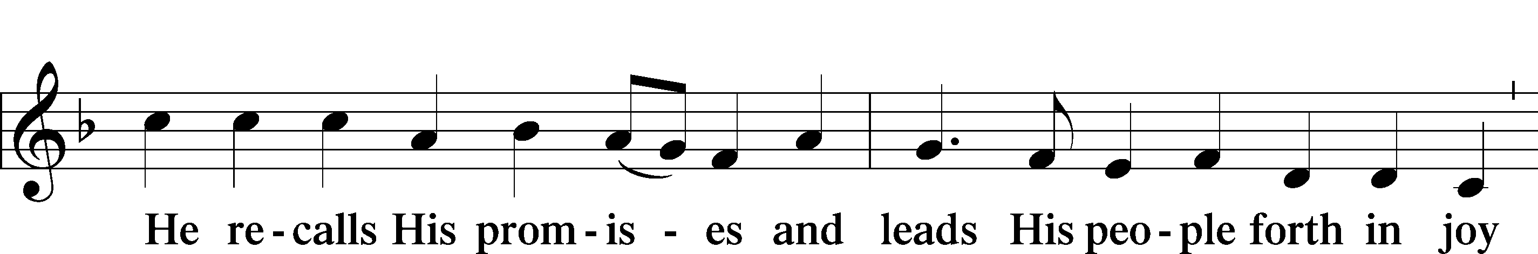
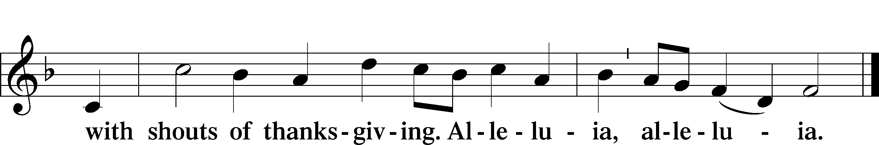

Post-Communion Collect
A Let us pray.
We give thanks to You, almighty God, that You have refreshed us through this salutary gift, and we implore You that of Your mercy You would strengthen us through the same in faith toward You and in fervent love toward one another; through Jesus Christ, Your Son, our Lord, who lives and reigns with You and the Holy Spirit, one God, now and forever.
C Amen.

Verse of the Day Luke 5:15
P Alleluia! Since we are surrounded by so great a cloud of witnesses,
C let us look to Jesus, the founder and perfecter of our faith. Alleluia!

Benediction LSB 166
P The Lord bless you and keep you.
The Lord make His face shine on you and be gracious to you.
The Lord look upon you with favor and T give you peace.
C Amen.

680 Thine the Amen, Thine the Praise
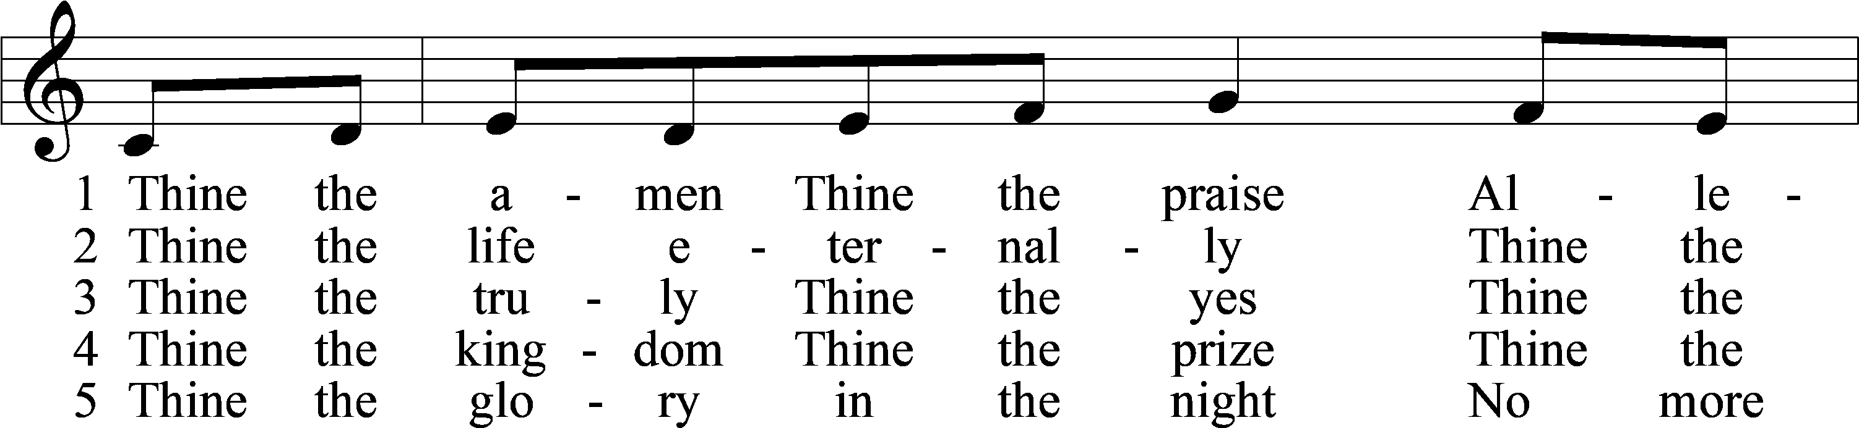
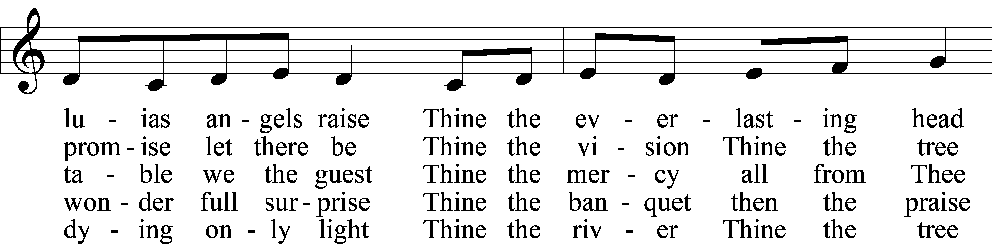
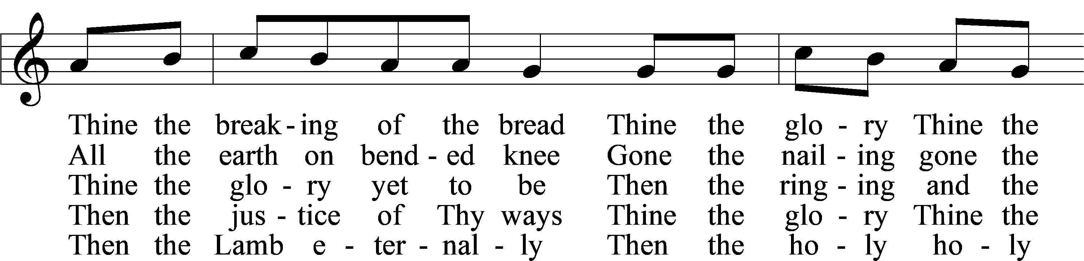
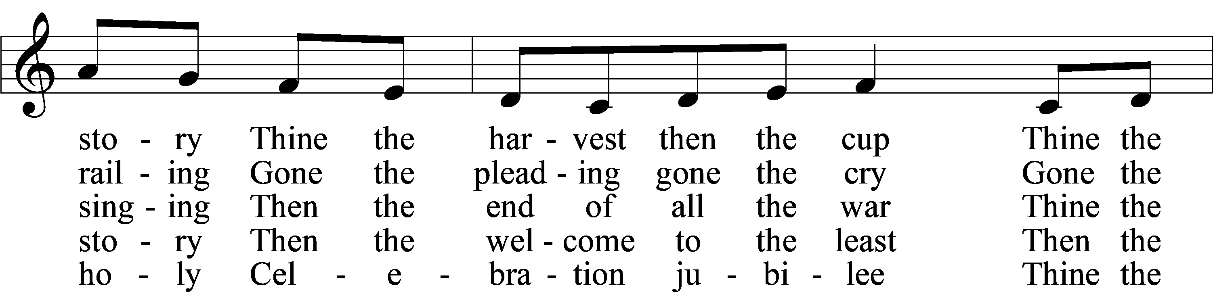
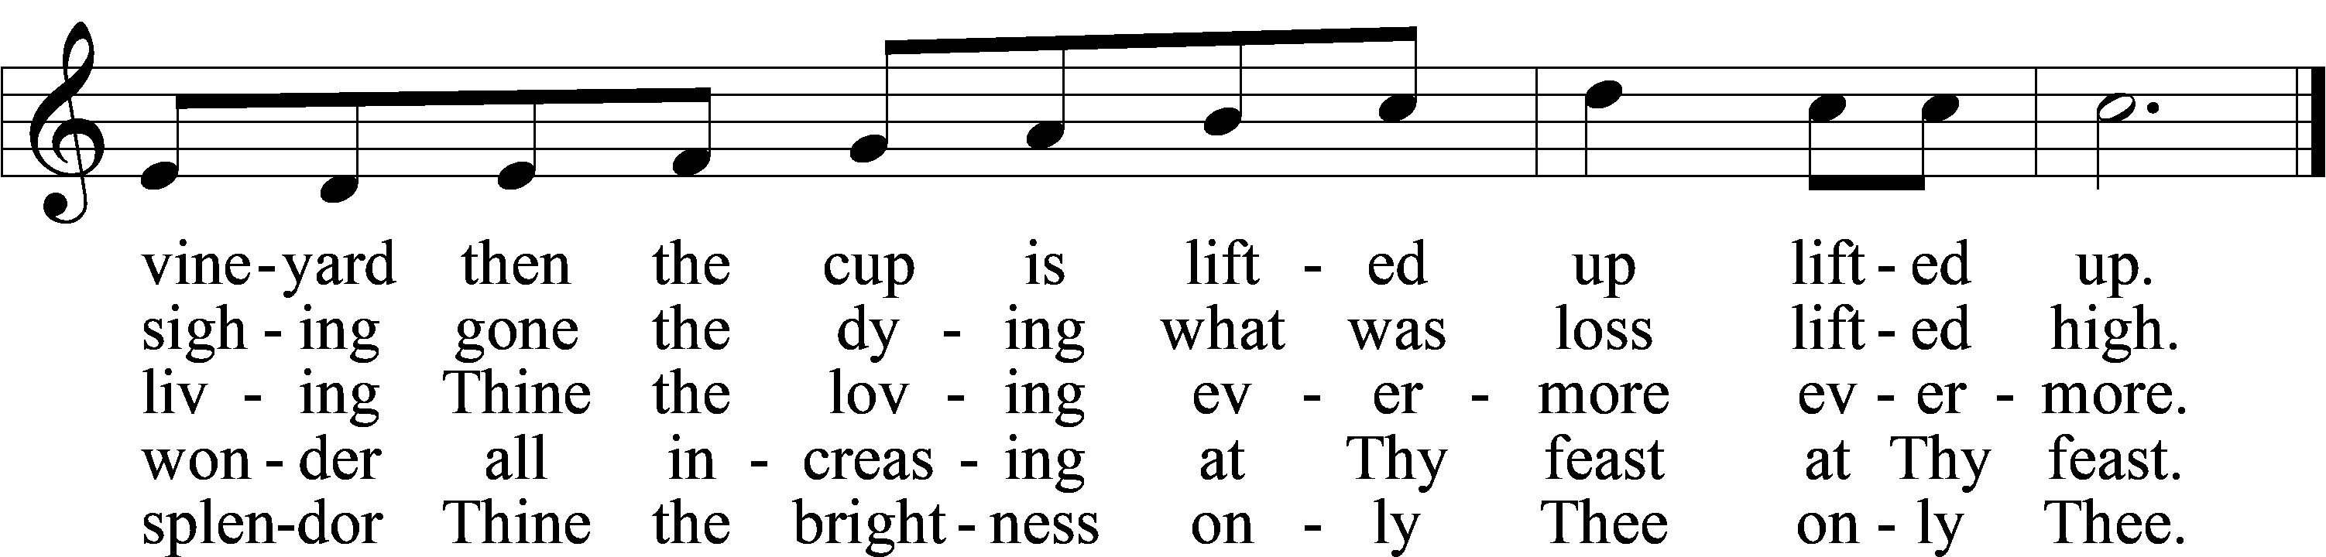
Text: Herbert F. Brokering, 1926–2009
Tune: Carl F. Schalk, 1929–2021
Text and tune: © 1983 Augsburg Publishing House. Used by permission: LSB Hymn License no. 110003995
Acknowledgments
Divine Service, Setting One from Lutheran Service Book Unless otherwise indicated, Scripture quotations are from the ESV® Bible (The Holy Bible, English Standard Version®), copyright © 2001 by Crossway, a publishing ministry of Good News Publishers. Used by permission. All rights reserved. Created by Lutheran Service Builder © 2025 Concordia Publishing House.

Prayers of the Church
This week, we lift up:

Juanita S, Bob C, Angela H, Sheila, Elaine, Angie Z, Angela C, Ross, Kathy H.

Family of the week: Rev John & Kathy Heffelfinger and Family

*If you have any prayer request let us know.

Last week: Attendance 28 Offering $1431.00

Serving Next Week (11/9/25)  Guest Pastor: Rev Doyle Boykin  Music Minister: Vicar Previn Hudetz  Communion Assistant: Jim C  Worship Assistant: TBD  Reader: Sheila S  Refreshments: Rebecca Vigil  Altar Guild: Angie Z & Sheila S  Greeter: Michael Y | Readings Next Week  Twenty-second Sunday after Pentecost  - Exodus 3:1-15  - Psalm 148  - 2 Thessalonians 2:1-8,13-17  - Luke 20:27-40  *Please sign up to help during service.*
Announcements  Birthdays:  This Week at OSLC:  Bible Study: After Service  Bible Study: Thursday 10am  This Month at OSLC  11/26 6pm Thanksgiving Eve Service  11/27 1pm Thanksgiving Meal  (Please sign up to attend.) | Coming Up:  Christmas Decorating Sat 11/29/25  ADVENT  December 3,10, & 17  4:30pm Soup - Fellowship - Games  6:00pm Advent Services

Stewardship Thoughts… for All Saint’s Day

“With angels, archangels, and with all the company of heaven ...”

When we gather around the altar of the Lord in His house, we pray and praise God “with all the company of heaven.” Those we have lost in the Lord are not truly lost to us — they have simply entered their rest with the Lord. As we gather to worship our Lord, we gather along with them. On the Last Day, everything that God has given into the care of our stewardship will fade away — everything except our brothers and sisters in Christ. Caring for one another in love and grace is our highest calling.

Lcms.org/stewardship


Seasons of the Church Year
All Saints’ Day
Color: White • Symbol: Cloud of Witnesses or Halo
On All Saints’ Day, the Church gives thanks for all believers who have gone before us in the faith and now rest from their labors. We rejoice that we are united with them in Christ, who is the Lord of the living and the dead.

Lectionary Summaries

Overview of Today’s Assigned Reading (2 November 2025)
Revelation 7:(2–8) 9–17 / 1 John 3:1–3 / Matthew 5:1–12

Saints Are Blessed in the Eternal Presence of Christ

“A great multitude … from all tribes and peoples and languages” cry out, “Salvation belongs to our God who sits on the throne” (Rev. 7:9–10).

Faith-filled saints from every place and time with unified voices eternally magnify the Lamb of God. As His beloved children, we, too, “shall see him as he is” (1 John 3:2). Joined with the throng of angels and countless saints, we shall “serve him day and night in his temple” (Rev. 7:15).

In our earthly tension vacillating between saint and sinner, faith and doubt, sacred and profane, we earnestly seek Jesus to calm our fears, comfort our spirits and forgive our sins. The Holy Spirit, through faith in Christ, propels us forward, fortifying us in Word and Sacrament, to our eternal home. In the midst of our constant struggle as believers, we need to be blessed. And so we are. The poor in spirit, the meek, the hungry, the thirsty, the merciful, the pure and the persecuted are all blessed, and we will most certainly inherit the kingdom of heaven (Matt. 5:1–12).

