

“Now when these things begin to take place, straighten up and raise your heads, because your redemption is drawing near.”

Luke 21:28

Our Savior Lutheran Church (LCMS)
4301 Atrisco Drive NW
Albuquerque, New Mexico
Website: OSLCNM.COM
Phone: 505.836.7007
Email: oslcabq@gmail.com

Twenty-Third Sunday after Pentecost
November 16th,2025

The Time of the Church (Trinitytide)
Twenty-Third Sunday after Pentecost
November 16th, 2025

Welcome to Our Savior Lutheran Church (LCMS).  We are glad you are here as we worship, praise, and give thanks to our loving Lord, Jesus Christ. Please join us immediately after service for fellowship and snacks. Adult Bible Study starts at 10:30. If you have any questions about our service or need other assistance, please contact one of our worship assistants. | Hymns  Opening # 783 & 968  Sermon # 733  Distribution solo by Sheila S.  Closing # 897

Today’s Message

These final days are mingled with destruction and redemption. Intense fire will reduce the evil and arrogant to ash. Christ’s righteousness will delight and heal those who fear God’s name. As we live out these final days, we dare not be idle, but rather labor diligently, imitating the very nature of Christ. Wars will rage; calamities will increase; disease will plague mankind. In the midst of all this, we proclaim truth: the day of redemption draws near.

+++
Serving Today
Service Leader: Vicar Previn Hudetz
Communion Celebrant: Pastor John Heffelfinger
Communion Assistant: Jim C
Worship Assistant: Arthur MacNeil
Reader: Samantha T.
Refreshments: Rebecca V
Altar Guild: Angie Z & Sheila S
Greeter: Michael Y
Welcome- Divine Service 1
783 Take My Life and Let It Be
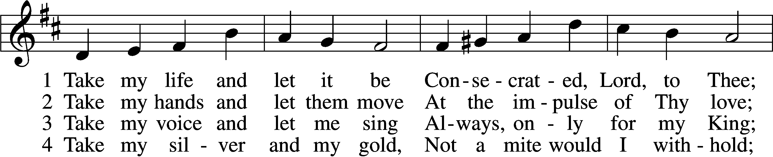
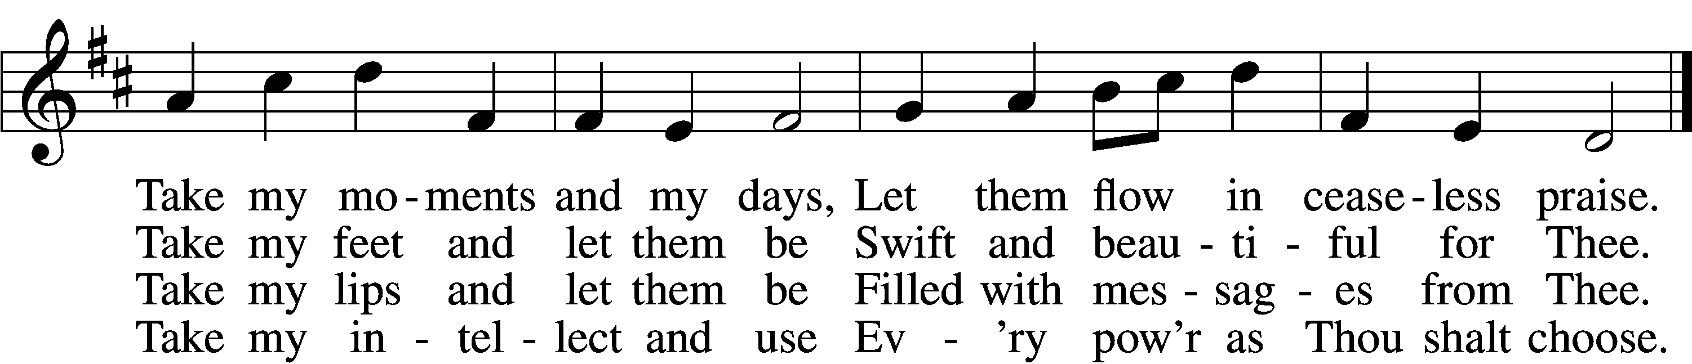

5 Take my will and make it Thine,
It shall be no longer mine;
Take my heart, it is Thine own,
It shall be Thy royal throne.
6 Take my love, my Lord, I pour
At Thy feet its treasure store;
Take myself, and I will be
Ever, only, all for Thee.

Text: Frances R. Havergal, 1836–79 Tune: William H. Havergal, 1793–1870 Text and tune: Public domain

968 My Lord, What a Morning
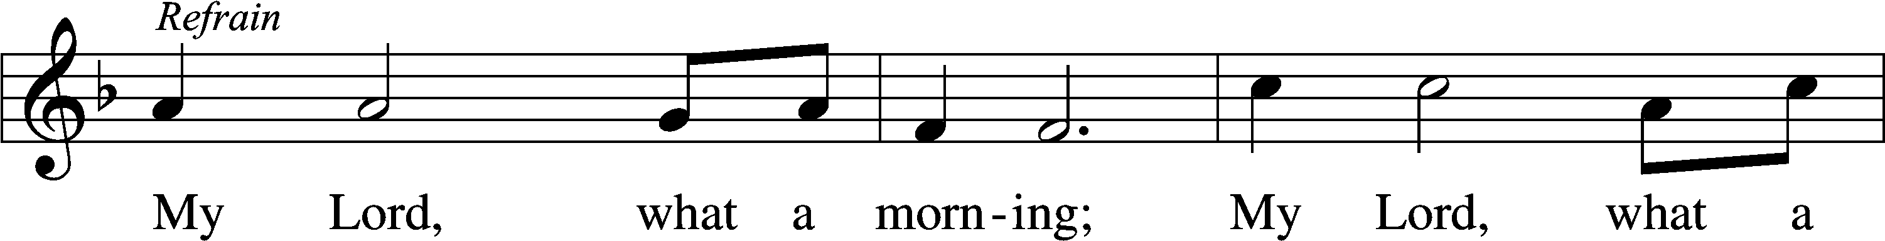
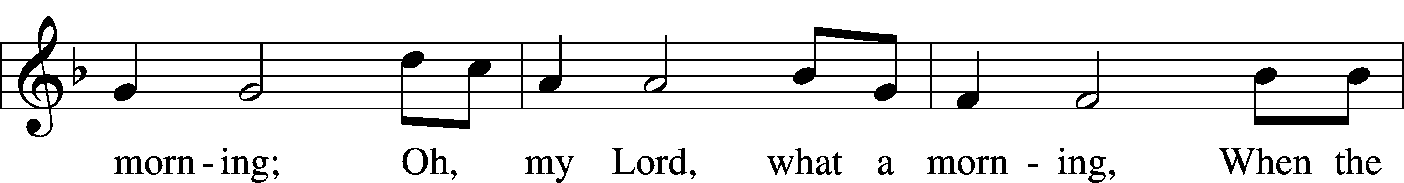
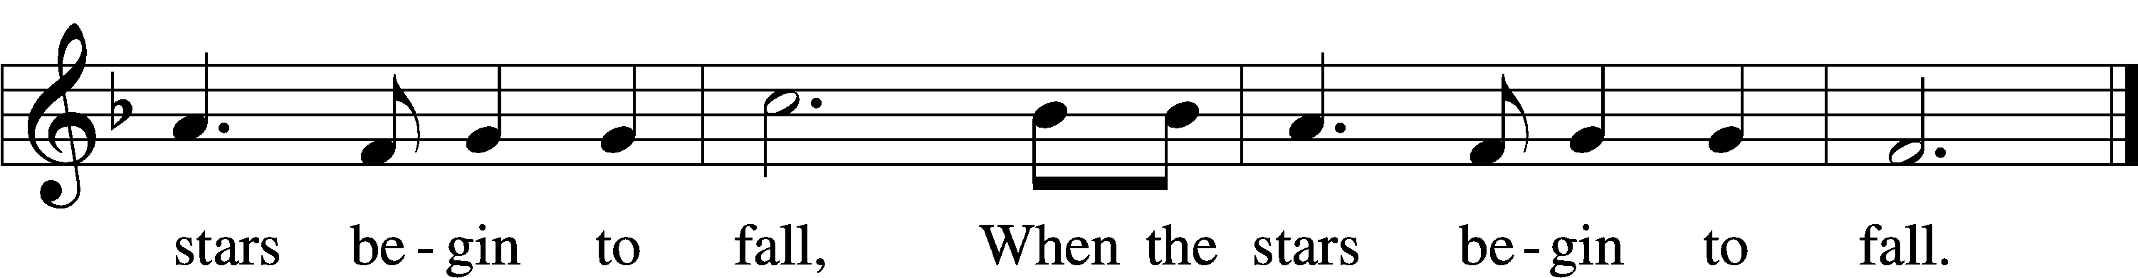
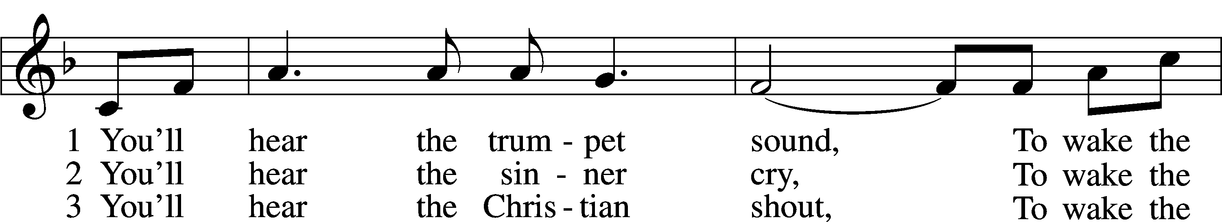
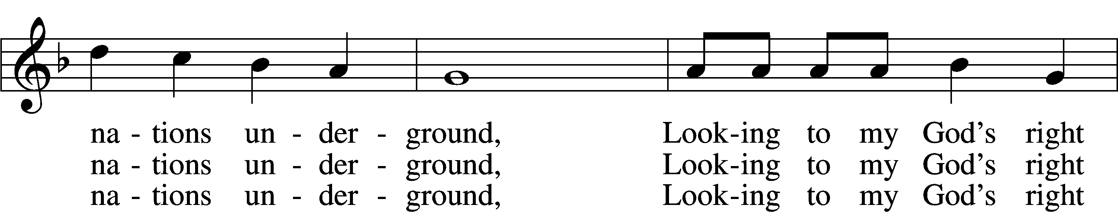
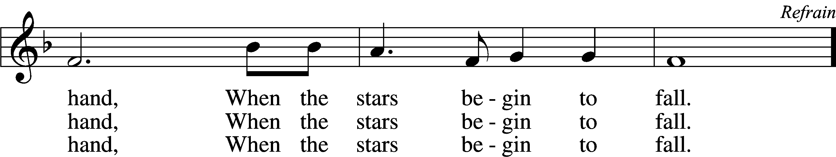
Text and tune: African American spiritual Text and tune: Public domain
Confession and Absolution
Stand
The sign of the cross may be made by all in remembrance of their Baptism.

P In the name of the Father and of the T Son and of the Holy Spirit.
C Amen.
P If we say we have no sin, we deceive ourselves, and the truth is not in us.
C But if we confess our sins, God, who is faithful and just, will forgive our sins and cleanse us from all unrighteousness.

Silence for reflection on God’s Word and for self-examination.

P Let us then confess our sins to God our Father.
C Most merciful God, we confess that we are by nature sinful and unclean. We have sinned against You in thought, word, and deed, by what we have done and by what we have left undone. We have not loved You with our whole heart; we have not loved our neighbors as ourselves. We justly deserve Your present and eternal punishment. For the sake of Your Son, Jesus Christ, have mercy on us. Forgive us, renew us, and lead us, so that we may delight in Your will and walk in Your ways to the glory of Your holy name. Amen.
P Almighty God in His mercy has given His Son to die for you and for His sake forgives you all your sins. As a called servant of Christ, and by His authority, I therefore forgive you all your sins in the name of the Father and of the T Son and of the Holy Spirit.
C Amen.

Stand
Service of the Word
Invitatory for Trinitytide

P The Lord has enlightened us in the true faith
O come, let us worship Him.
C He will command His angels concerning you
To guard you in all your ways. Psalm 91:11

Introit Psalm 121:1–2, 5, 7–8; antiphon: Luke 21:33
Heaven and earth will | pass away,*
but my words will not | pass away.
I lift up my eyes | to the hills.*
From where does my | help come?
My help comes | from the Lord,*
who made | heaven and earth.
The Lord is your | keeper;*
the Lord is your shade on your | right hand.
The Lord will keep you from all | evil;*
he will | keep your life.
The Lord will keep your going out and your | coming in*
from this time forth and for- | evermore.
Glory be to the Father and | to the Son*
and to the Holy | Spirit;
as it was in the be- | ginning,*
is now, and will be forever. | Amen.
Heaven and earth will | pass away,*
but my words will not | pass away.
Kyrie LSB 152


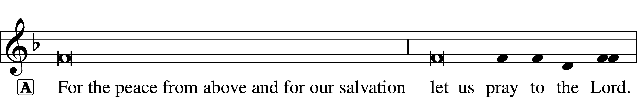

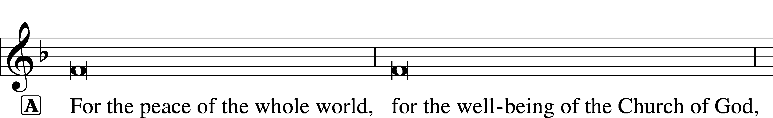


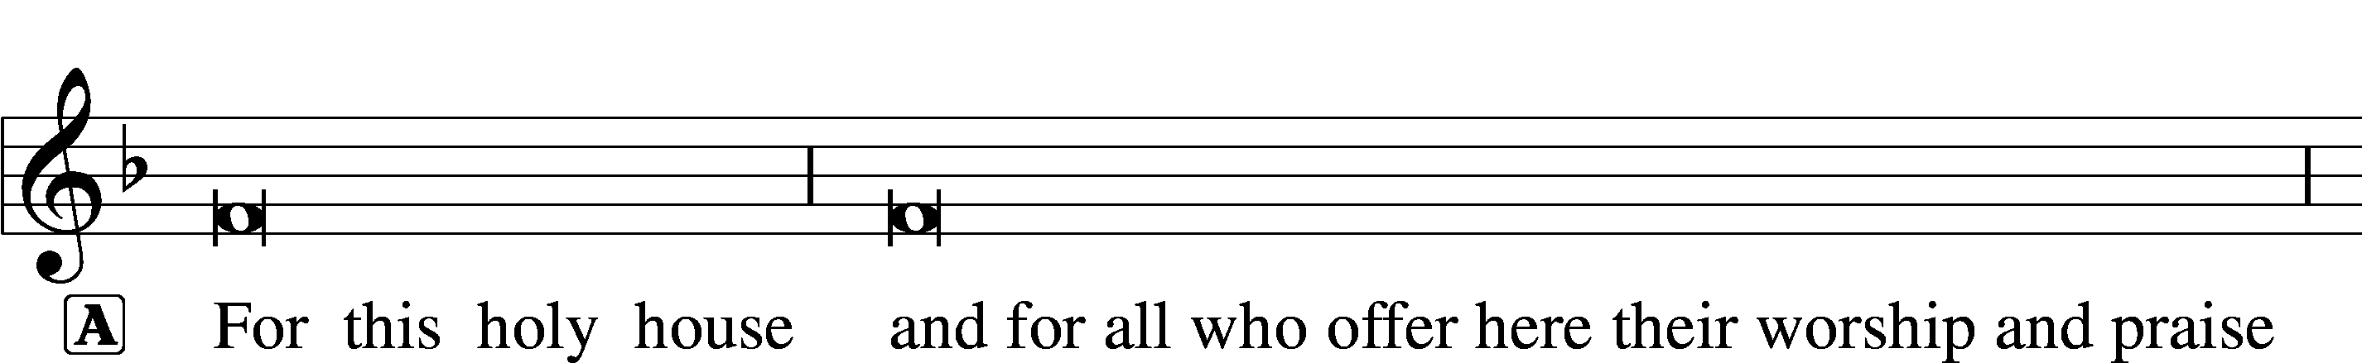





This Is the Feast LSB 155
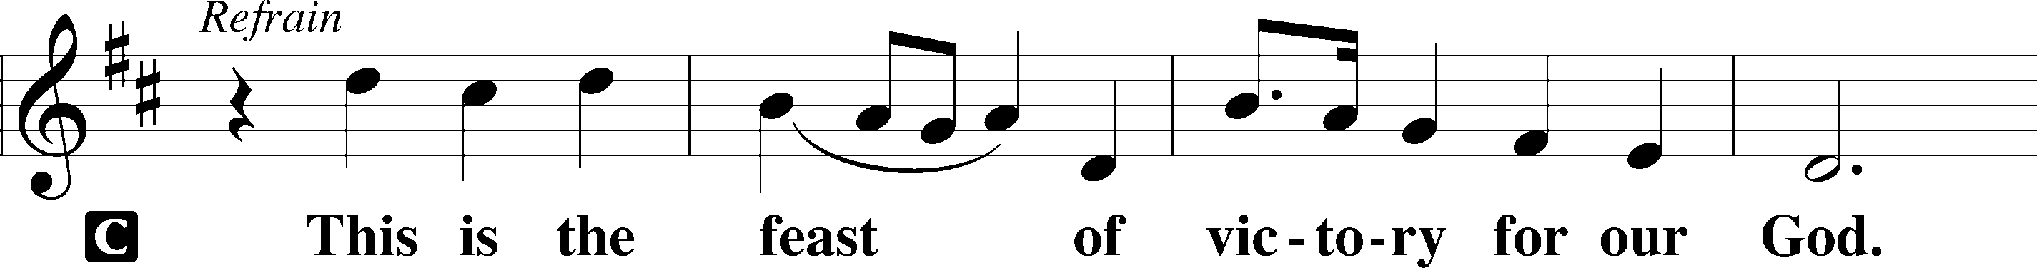
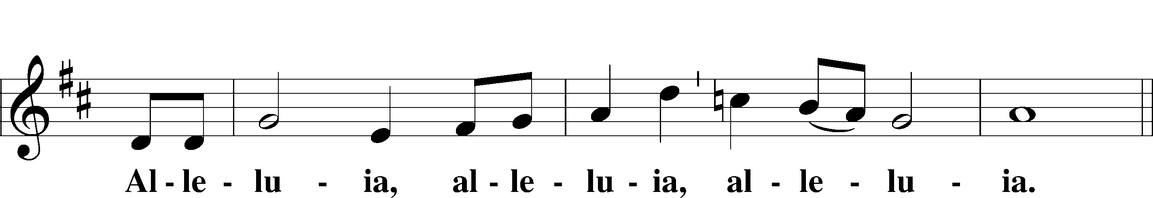
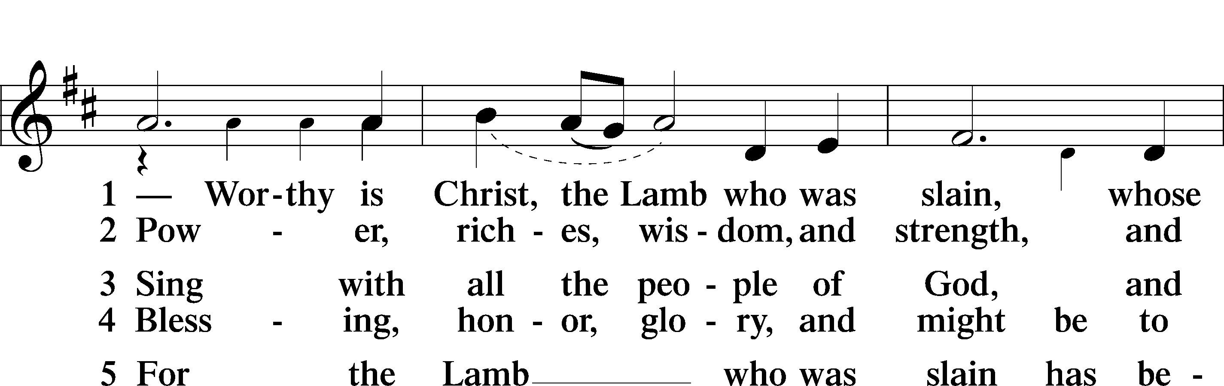
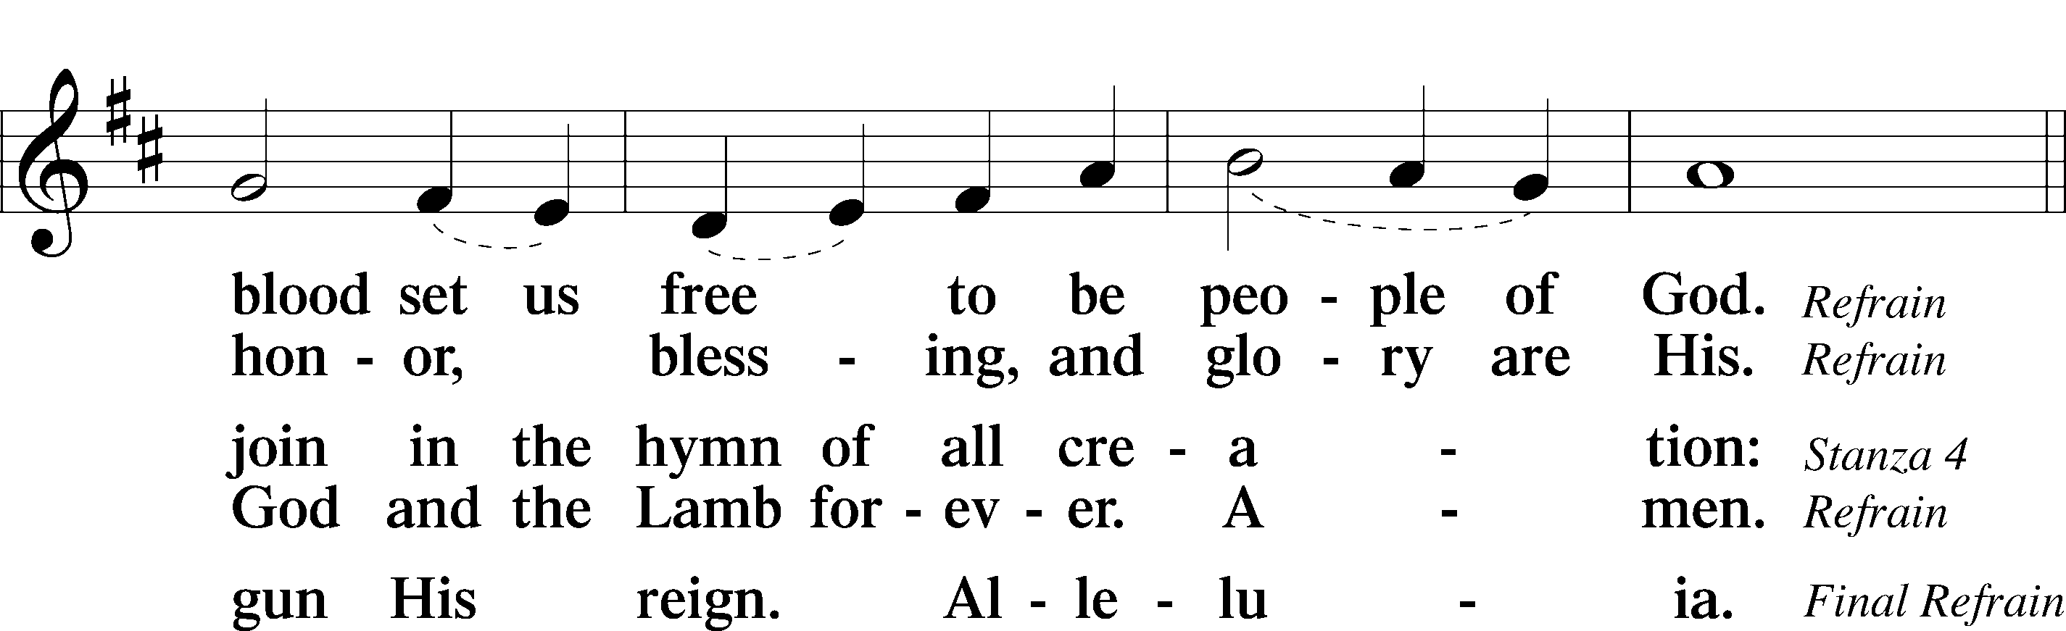
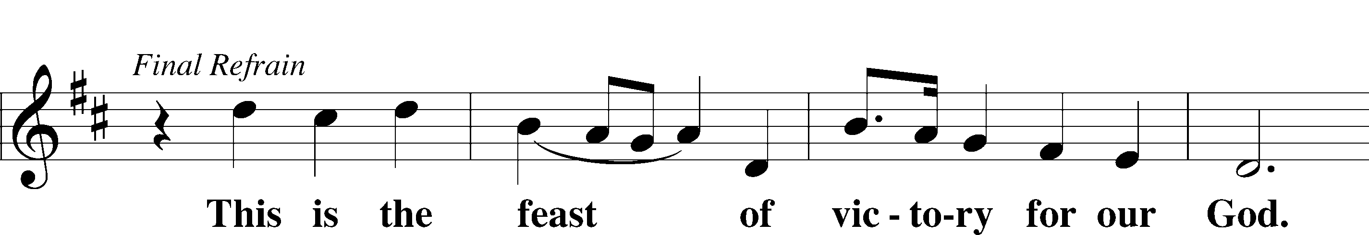
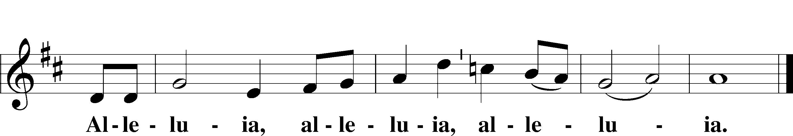

Salutation and Collect of the Day
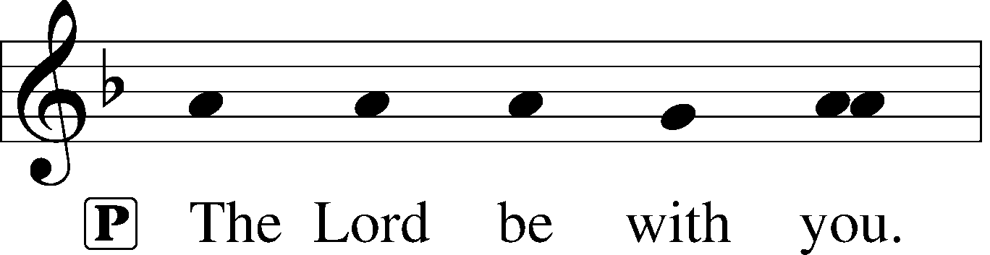
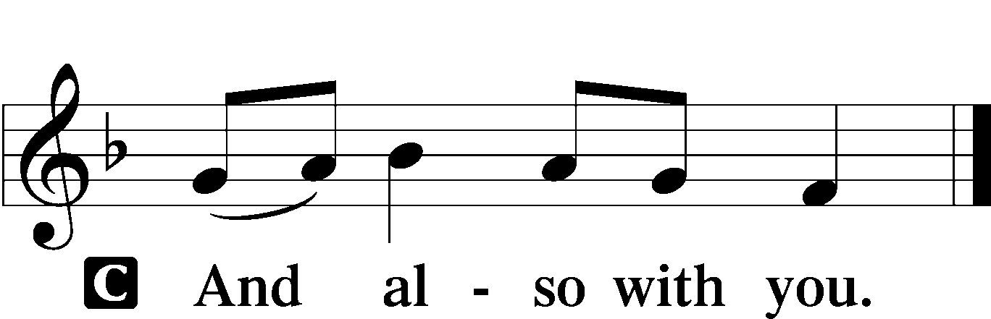

P Let us pray.
O Lord, almighty and ever-living God, You have given exceedingly great and precious promises to those who trust in You. Rule and govern our hearts and minds by Your Holy Spirit that we may live and abide forever in Your Son, who lives and reigns with You and the Holy Spirit, one God, now and forever.

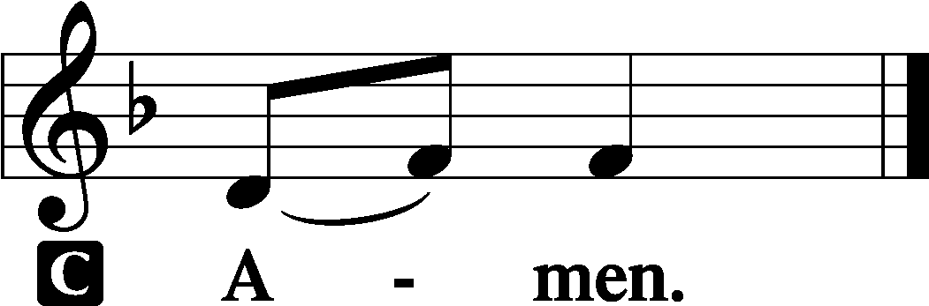

Sit

Old Testament Reading Malachi 4:1–6

“Behold, the day is coming… The sun of righteousness shall rise.”

1 “For behold, the day is coming, burning like an oven, when all the arrogant and all evildoers will be stubble. The day that is coming shall set them ablaze, says the Lord of hosts, so that it will leave them neither root nor branch. 2But for you who fear my name, the sun of righteousness shall rise with healing in its wings. You shall go out leaping like calves from the stall. 3And you shall tread down the wicked, for they will be ashes under the soles of your feet, on the day when I act, says the Lord of hosts.
4“Remember the law of my servant Moses, the statutes and just decrees that I commanded him at Horeb for all Israel.
5“Behold, I will send you Elijah the prophet before the great and awesome day of the Lord comes. 6And he will turn the hearts of fathers to their children and the hearts of children to their fathers, lest I come and strike the land with a decree of utter destruction.”
A This is the Word of the Lord.
C Thanks be to God.

Psalm Psalm 98; antiphon: v. 9b

“The Lord has made known His salvation; He has revealed His righteousness.”
1Oh sing to the Lord a new song,
for he has done | marvelous things!*
His right hand and his holy arm
have worked salva- | tion for him.
2The Lord has made known his sal- | vation;*
he has revealed his righteousness in the sight of the | nations.
3He has remembered his steadfast love and faithfulness
to the house of | Israel.*
All the ends of the earth have seen
the salvation | of our God.
4Make a joyful noise to the Lord, | all the earth;*
break forth into joyous song and sing | praises!
5Sing praises to the Lord | with the lyre,*
with the lyre and the sound of | melody!
6With trumpets and the sound | of the horn*
make a joyful noise before the | King, the Lord!
7Let the sea roar, and all that | fills it;*
the world and those who | dwell in it!
8Let the rivers clap their hands;
let the hills sing for joy together 9be- | fore the Lord,*
for he comes to | judge the earth.
He will judge the world with | righteousness,*
and the peoples with | equity.
Epistle 2 Thessalonians 3:1–13
“Do not grow weary in doing good.”

1Finally, brothers, pray for us, that the word of the Lord may speed ahead and be honored, as happened among you, 2and that we may be delivered from wicked and evil men. For not all have faith. 3But the Lord is faithful. He will establish you and guard you against the evil one. 4And we have confidence in the Lord about you, that you are doing and will do the things that we command. 5May the Lord direct your hearts to the love of God and to the steadfastness of Christ.
6Now we command you, brothers, in the name of our Lord Jesus Christ, that you keep away from any brother who is walking in idleness and not in accord with the tradition that you received from us. 7For you yourselves know how you ought to imitate us, because we were not idle when we were with you, 8nor did we eat anyone’s bread without paying for it, but with toil and labor we worked night and day, that we might not be a burden to any of you. 9It was not because we do not have that right, but to give you in ourselves an example to imitate. 10For even when we were with you, we would give you this command: If anyone is not willing to work, let him not eat. 11For we hear that some among you walk in idleness, not busy at work, but busybodies. 12Now such persons we command and encourage in the Lord Jesus Christ to do their work quietly and to earn their own living.
13As for you, brothers, do not grow weary in doing good.
A This is the Word of the Lord.
C Thanks be to God.

Stand

Alleluia and Verse LSB 156
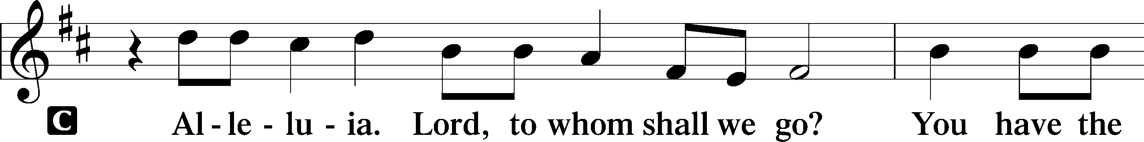
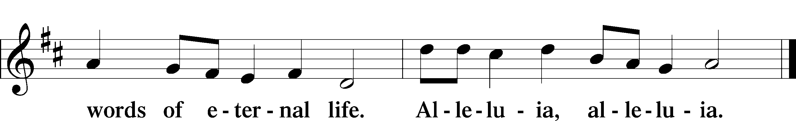

Holy Gospel Luke 21:5–28
P The Holy Gospel according to St. Luke, the twenty-first chapter.
C Glory to You, O Lord.

Signs of the end of the world

5While some were speaking of the temple, how it was adorned with noble stones and offerings, [Jesus] said, 6“As for these things that you see, the days will come when there will not be left here one stone upon another that will not be thrown down.” 7And they asked him, “Teacher, when will these things be, and what will be the sign when these things are about to take place?” 8And he said, “See that you are not led astray. For many will come in my name, saying, ‘I am he!’ and, ‘The time is at hand!’ Do not go after them. 9And when you hear of wars and tumults, do not be terrified, for these things must first take place, but the end will not be at once.”
10Then he said to them, “Nation will rise against nation, and kingdom against kingdom. 11There will be great earthquakes, and in various places famines and pestilences. And there will be terrors and great signs from heaven. 12But before all this they will lay their hands on you and persecute you, delivering you up to the synagogues and prisons, and you will be brought before kings and governors for my name’s sake. 13This will be your opportunity to bear witness. 14Settle it therefore in your minds not to meditate beforehand how to answer, 15for I will give you a mouth and wisdom, which none of your adversaries will be able to withstand or contradict. 16You will be delivered up even by parents and brothers and relatives and friends, and some of you they will put to death. 17You will be hated by all for my name’s sake. 18But not a hair of your head will perish. 19By your endurance you will gain your lives.
20“But when you see Jerusalem surrounded by armies, then know that its desolation has come near. 21Then let those who are in Judea flee to the mountains, and let those who are inside the city depart, and let not those who are out in the country enter it, 22for these are days of vengeance, to fulfill all that is written. 23Alas for women who are pregnant and for those who are nursing infants in those days! For there will be great distress upon the earth and wrath against this people. 24They will fall by the edge of the sword and be led captive among all nations, and Jerusalem will be trampled underfoot by the Gentiles, until the times of the Gentiles are fulfilled.
25“And there will be signs in sun and moon and stars, and on the earth distress of nations in perplexity because of the roaring of the sea and the waves, 26people fainting with fear and with foreboding of what is coming on the world. For the powers of the heavens will be shaken. 27And then they will see the Son of Man coming in a cloud with power and great glory. 28Now when these things begin to take place, straighten up and raise your heads, because your redemption is drawing near.”

P This is the Gospel of the Lord.
C Praise to You, O Christ.

Sit
733 O God, Our Help in Ages Past sts. 1–2, 4–6
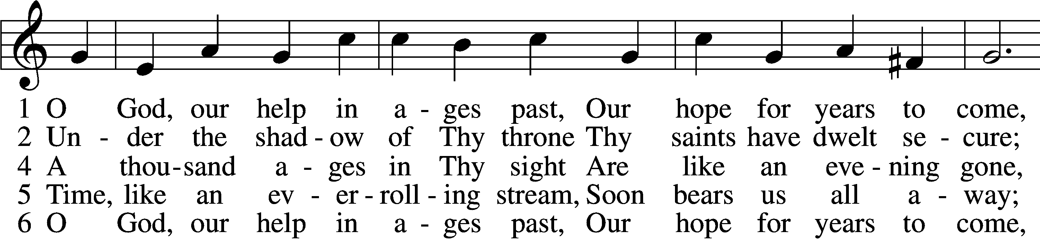
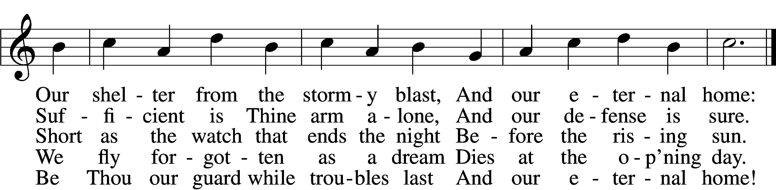
Text: Isaac Watts, 1674–1748, alt. Tune: William Croft, 1678–1727 Text and tune: Public domain
Sermon

Stand

Apostles’ Creed
C I believe in God, the Father Almighty,
maker of heaven and earth.

And in Jesus Christ, His only Son, our Lord, who was conceived by the Holy Spirit, born of the virgin Mary,
suffered under Pontius Pilate, was crucified, died and was buried.
He descended into hell. The third day He rose again from the dead.
He ascended into heaven and sits at the right hand of God the Father Almighty. From thence He will come to judge the living and the dead.

I believe in the Holy Spirit, the holy Christian Church,
the communion of saints, the forgiveness of sins,
the resurrection of the body, and the life T everlasting. Amen.

Prayer of the Church & Sharing of the Peace

Following the prayers, the people may greet one another in the name of the Lord, saying,
“Peace be with you,” as a sign of reconciliation and of the unity of the Spirit in the bond of peace
(Matt. 5:22–24; Eph. 4:1–3).

Offering & Offertory
Stand

781 We Give Thee But Thine Own sts. 1–2
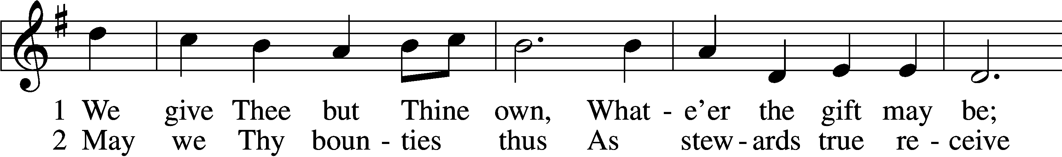
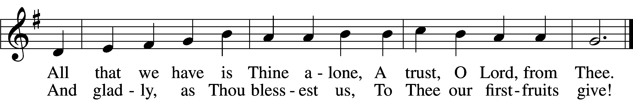
Text: William W. How, 1823–97 Tune: William H. Monk, 1823–89 Text and tune: Public domain

Service of Holy Communion
Communion Statement

The Lord’s Supper is celebrated at this congregation in the confession and glad confidence that, as He says, our Lord gives into our mouths not only bread and wine but His very body and blood to eat and to drink for the forgiveness of sins and to strengthen our union with Him and with one another. Our Lord invites to His table those who trust His words, repent of all sin, and set aside any refusal to forgive and love as He forgives and loves us, that they may show forth His death until He comes.

Because those who eat and drink our Lord’s body and blood unworthily do so to their great harm and because Holy Communion is a confession of the faith which is confessed at this altar, any who are not yet instructed, in doubt, or who hold a confession differing from that of this congregation and the Lutheran Church Missouri Synod, and yet desire to receive this sacrament, are asked to speak with the Pastor.
* See more about the Lutheran teaching on communion in the Hymnal p 329.

Preface LSB 160





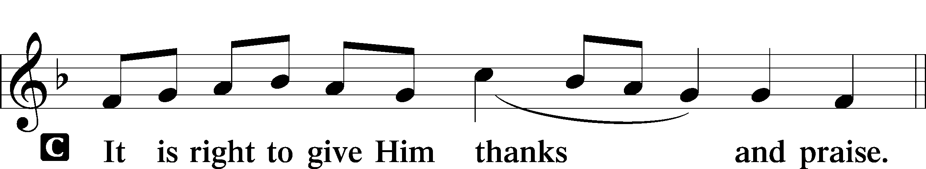

P It is truly good, right, and salutary that we should at all times and in all places give thanks to You, holy Lord, almighty Father, everlasting God, through Jesus Christ, our Lord, who, having created all things, took on human flesh and was born of the virgin Mary. For our sake He died on the cross and rose from the dead to put an end to death, thus fulfilling Your will and gaining for You a holy people. Therefore with angels and archangels and with all the company of heaven we laud and magnify Your glorious name, evermore praising You and saying:

Sanctus LSB 161
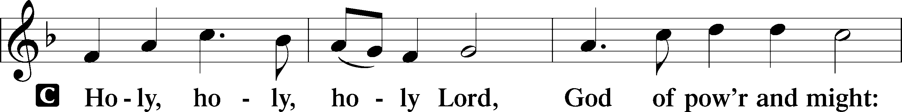
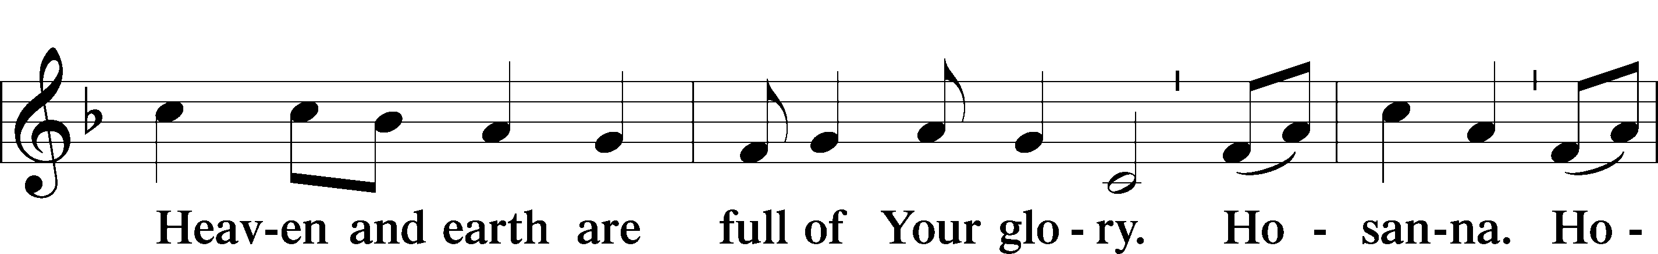
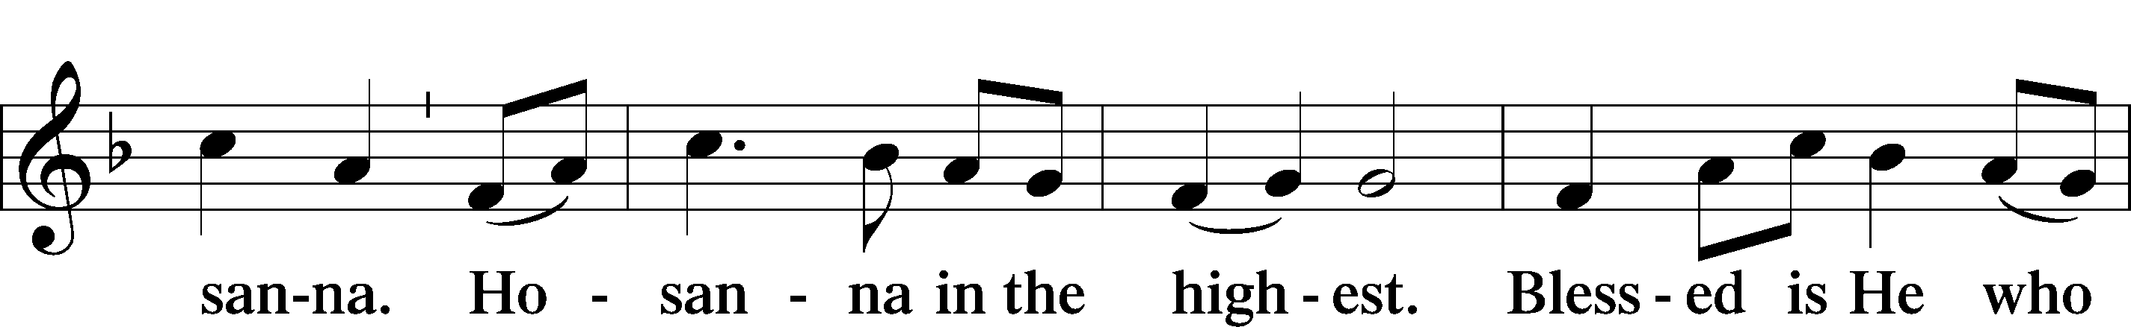
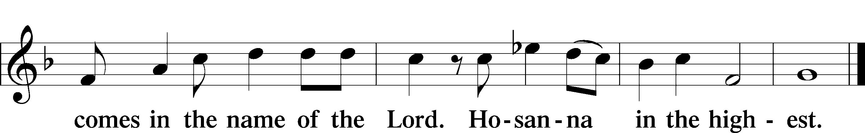

Prayer of Thanksgiving LSB 161
P Blessed are You, Lord of heaven and earth, for You have had mercy on those whom You created and sent Your only-begotten Son into our flesh to bear our sin and be our Savior. With repentant joy we receive the salvation accomplished for us by the all-availing sacrifice of His body and His blood on the cross.

Gathered in the name and the remembrance of Jesus, we beg You, O Lord, to forgive, renew, and strengthen us with Your Word and Spirit. Grant us faithfully to eat His body and drink His blood as He bids us do in His own testament. Gather us together, we pray, from the ends of the earth to celebrate with all the faithful the marriage feast of the Lamb in His kingdom, which has no end. Graciously receive our prayers; deliver and preserve us. To You alone, O Father, be all glory, honor, and worship, with the Son and the Holy Spirit, one God, now and forever.
C Amen.

The Words of Our Lord
P Our Lord Jesus Christ, on the night when He was betrayed, took bread, and when He had given thanks, He broke it and gave it to the disciples and said: “Take, eat; this is My T body, which is given for you. This do in remembrance of Me.”

In the same way also He took the cup after supper, and when He had given thanks, He gave it to them, saying: “Drink of it, all of you; this cup is the new testament in My T blood, which is shed for you for the forgiveness of sins. This do, as often as you drink it, in remembrance of Me.”
P As often as we eat this bread and drink this cup, we proclaim the Lord’s death until He comes.
C Amen. Come, Lord Jesus.

P O Lord Jesus Christ, only Son of the Father, in giving us Your body and blood to eat and to drink, You lead us to remember and confess Your holy cross and passion, Your blessed death, Your rest in the tomb, Your resurrection from the dead, Your ascension into heaven, and Your coming for the final judgment. So remember us in Your kingdom and teach us to pray:

Lord’s Prayer
C Our Father who art in heaven, hallowed be Thy name,
Thy kingdom come, Thy will be done on earth as it is in heaven;
give us this day our daily bread; and forgive us our trespasses
as we forgive those who trespass against us;
and lead us not into temptation, but deliver us from evil.
For Thine is the kingdom and the power and the glory
forever and ever. Amen.

Pax Domini LSB 163
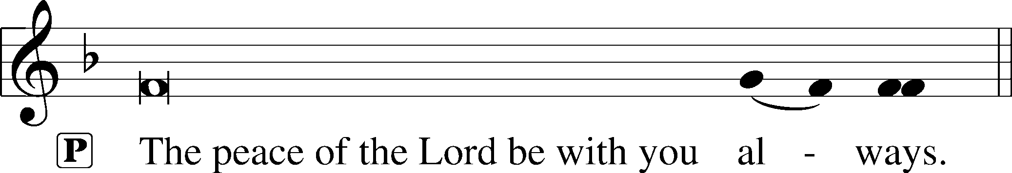


Agnus Dei (Spoken)

The pastor elevates the chalice and host and says:

P Behold, the Lamb of God that takes away the sins of the world.
C Lord, have mercy upon us.
Agnus Dei LSB 163
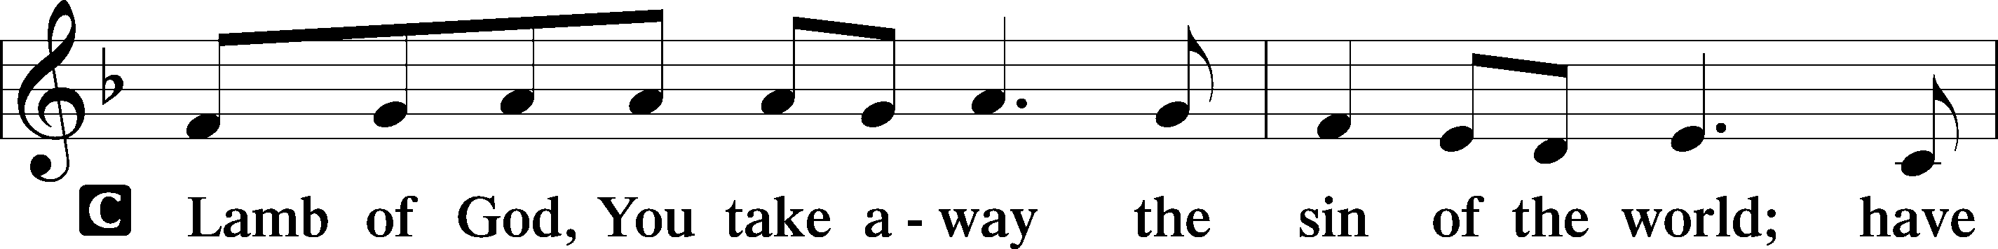
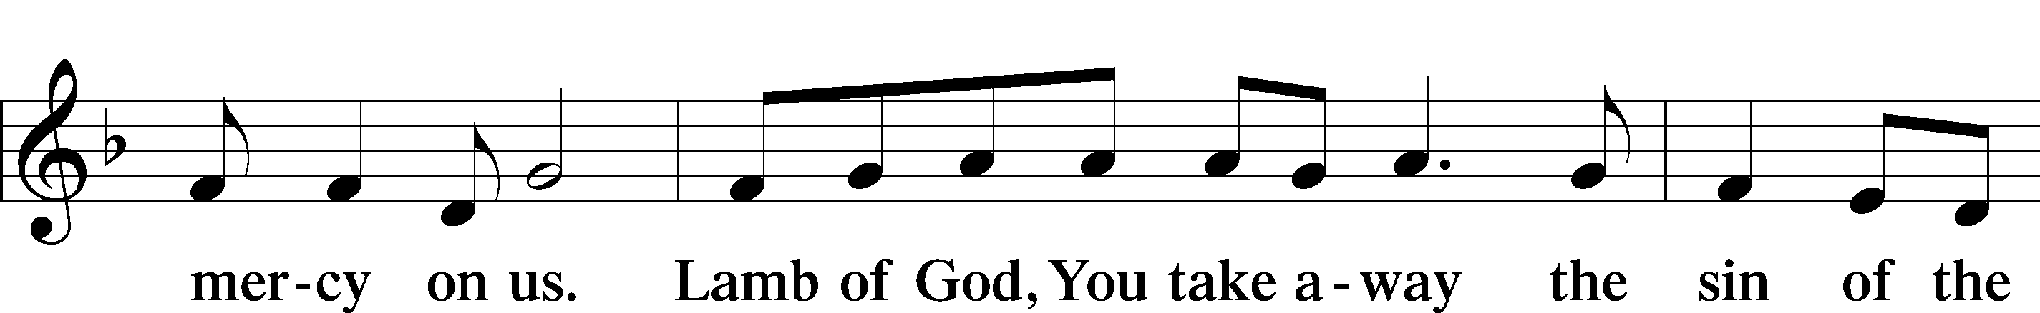
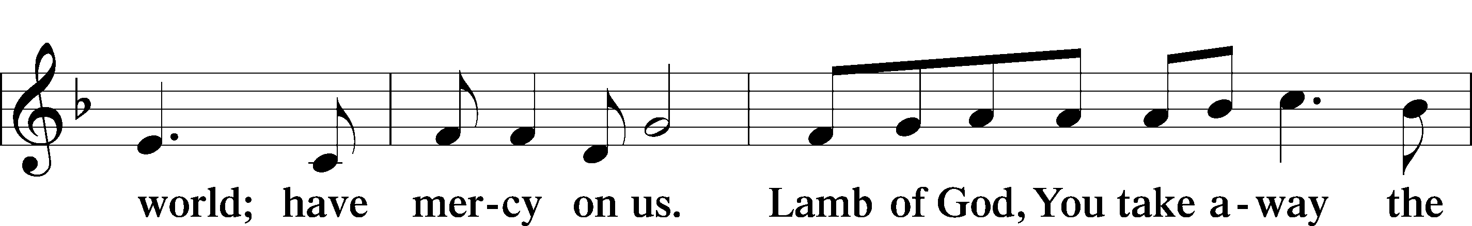
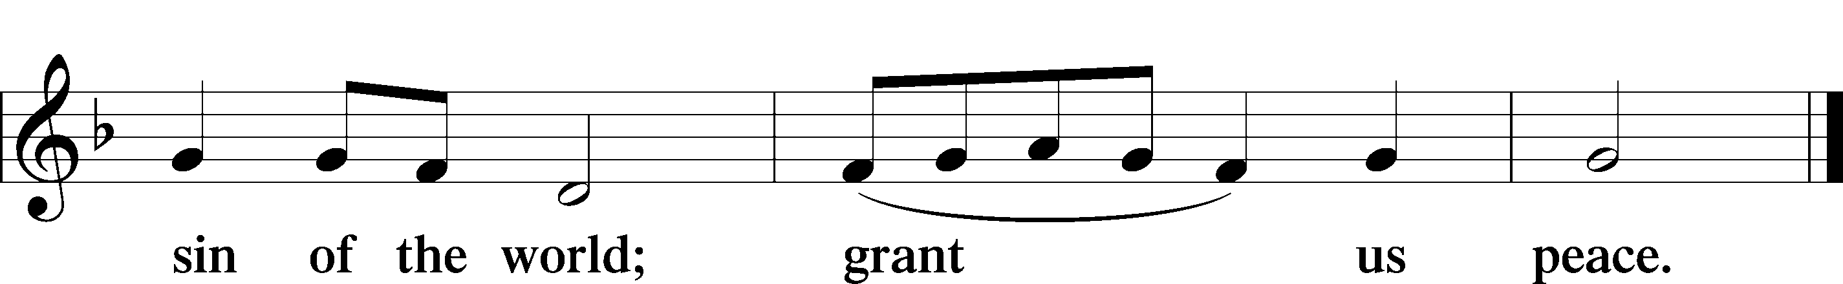

Sit

Distribution

The Blood Will Never Lose Its Power
solo by Sheila Small

Stand

Thank the Lord LSB 164
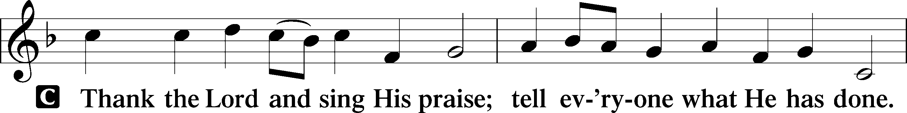
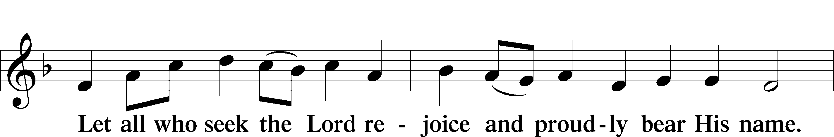
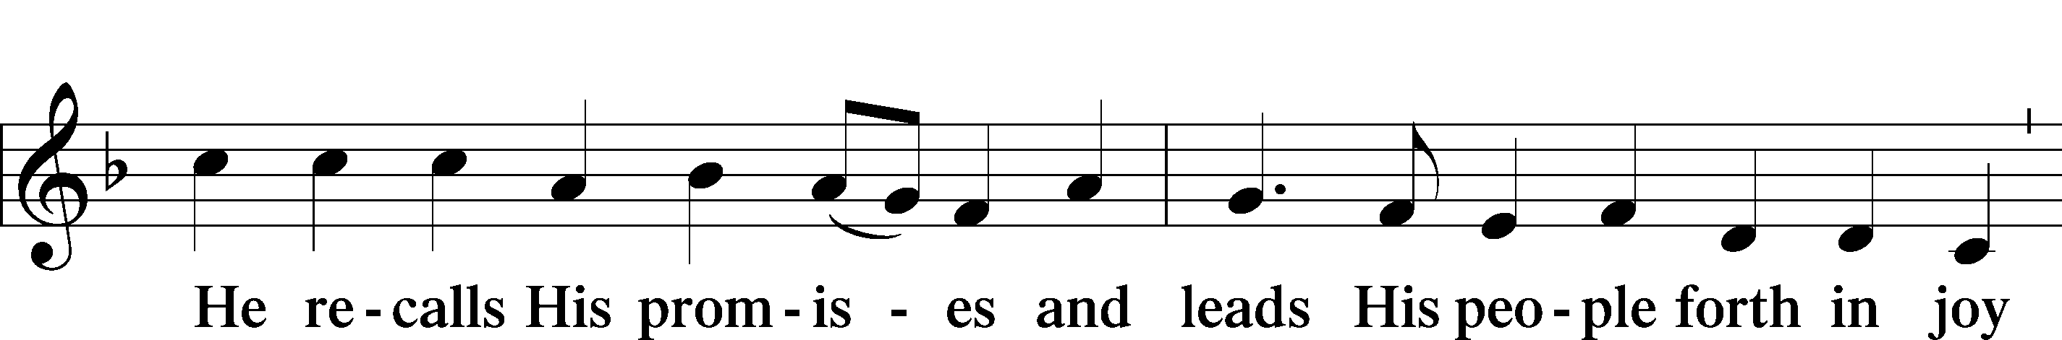
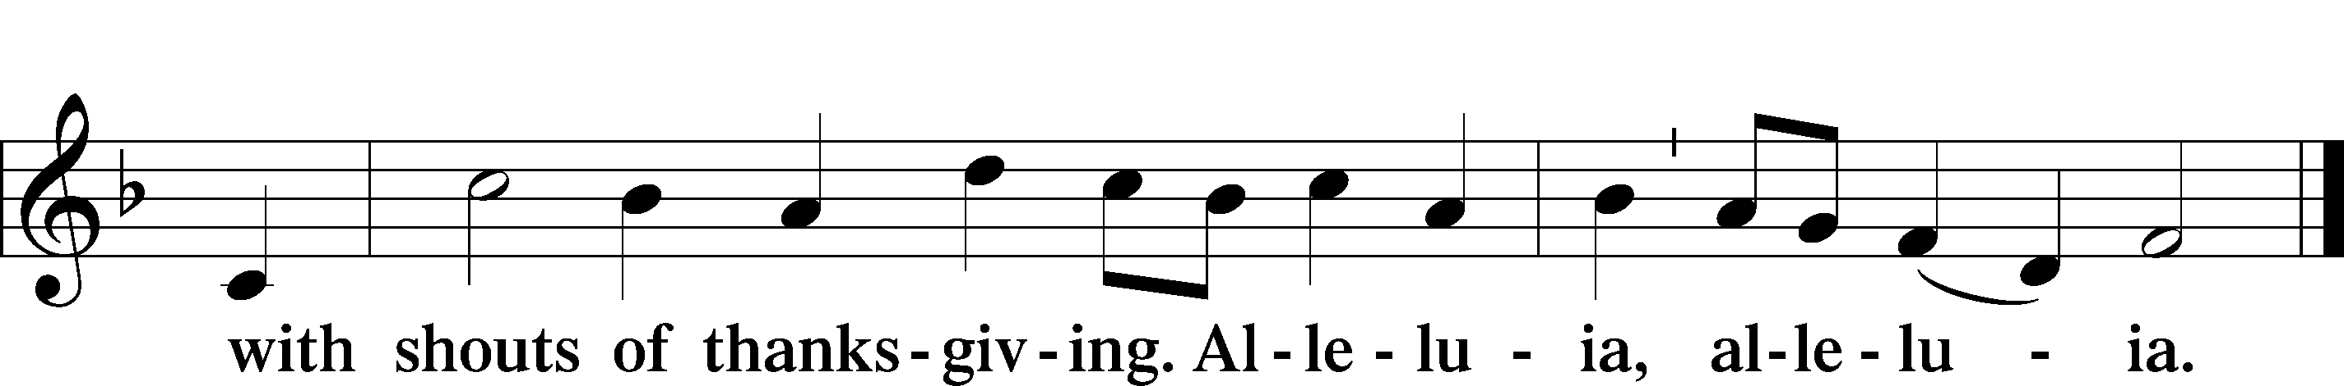

Post-Communion Collect
A Let us pray.
We give thanks to You, almighty God, that You have refreshed us through this salutary gift, and we implore You that of Your mercy You would strengthen us through the same in faith toward You and in fervent love toward one another; through Jesus Christ, Your Son, our Lord, who lives and reigns with You and the Holy Spirit, one God, now and forever.

Verse of the Day Luke 21:28b
P Alleluia! Straighten up and raise your heads,
C because your redemption is drawing near. Alleluia!

Benediction LSB 166
P The Lord bless you and keep you.
The Lord make His face shine on you and be gracious to you.
The Lord look upon you with favor and T give you peace.

897 O Rejoice, Ye Christians, Loudly
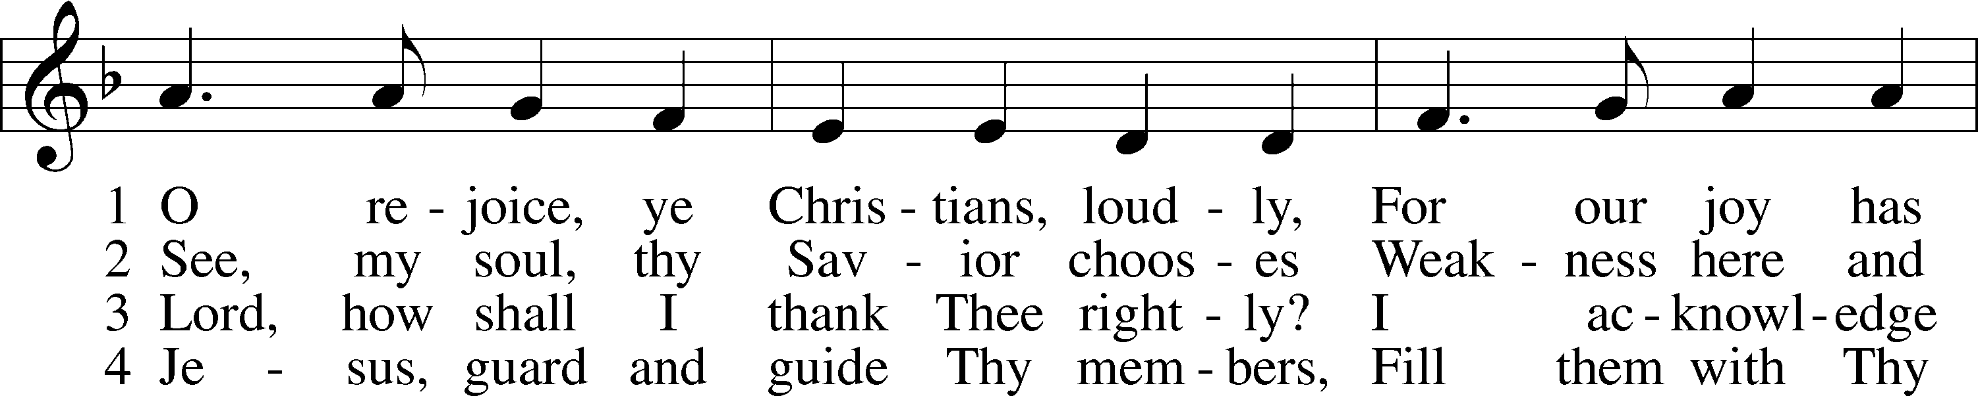
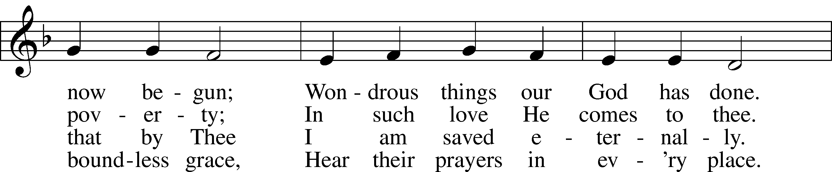
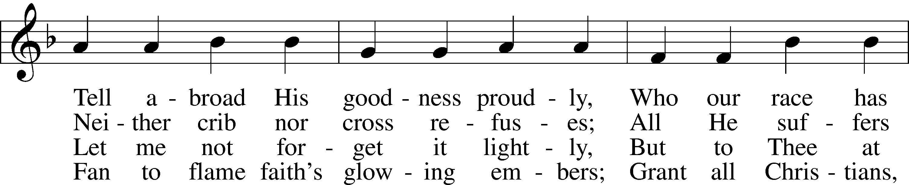
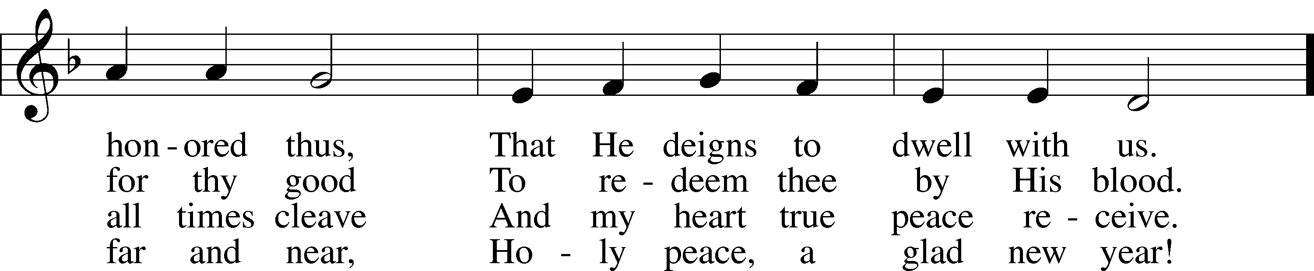
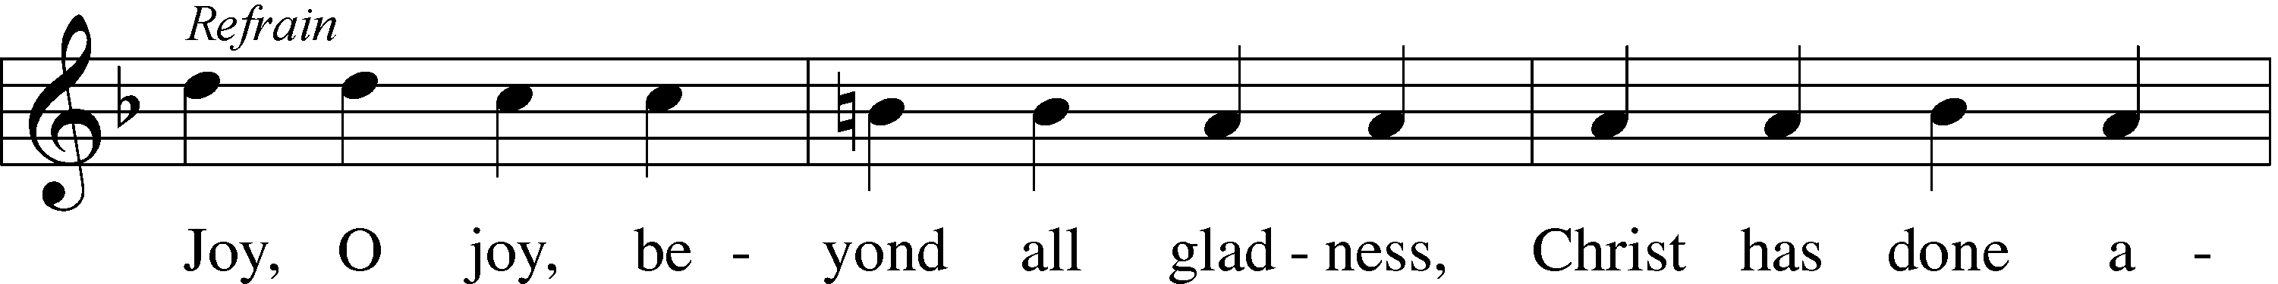
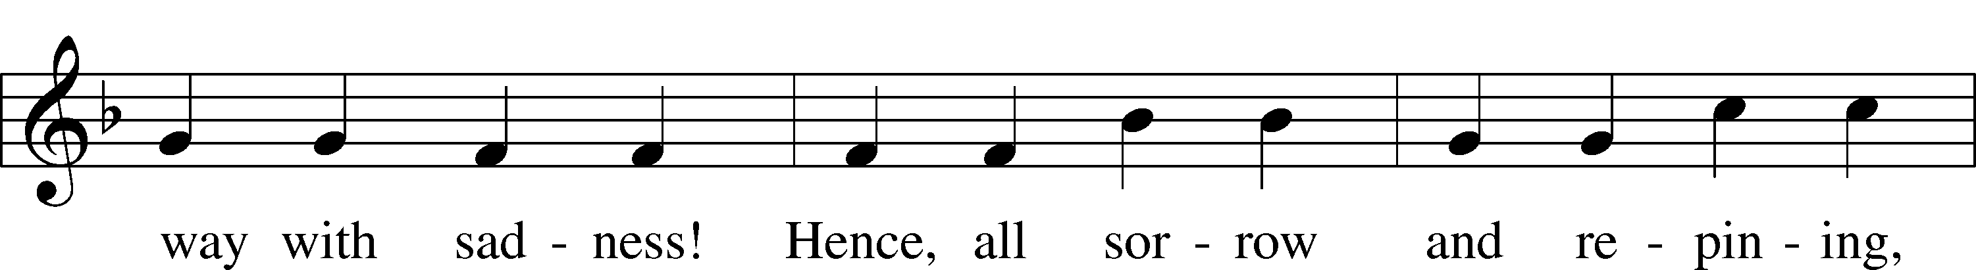
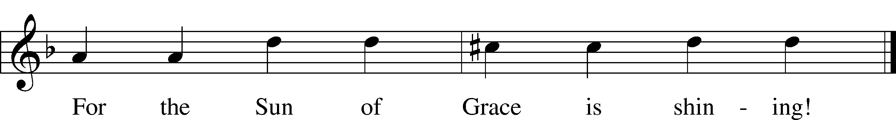
Text: Christian Keimann, 1607–62; tr. Catherine Winkworth, 1827–78, alt. Tune: Andreas Hammerschmidt, c. 1611–1675 Text and tune: Public domain

Acknowledgments Divine Service, Setting One from Lutheran Service Book Unless otherwise indicated, Scripture quotations are from the ESV® Bible (The Holy Bible, English Standard Version®), copyright © 2001 by Crossway, a publishing ministry of Good News Publishers. Used by permission. All rights reserved. Created by Lutheran Service Builder © 2025 Concordia Publishing House.

Prayers of the Church
This week, we lift up:

Angela H, Bob C, Mike Y, Sheila, Elaine, Angie Z, Angela C, Ross, & Kathy H.

Family of the week: Tina Moore and Family

*If you have any prayer request let us know.

Last week: Attendance 30 Offering $524
October 2025 Income $8,815 Expenses: $13,671

Serving Next Week (11/23/25)  Service Leader: Vicar Previn Hudetz  Communion Celebrant: Rev John Heffelfinger  Communion Assistant: Jim C  Worship Assistant: Arthur M.  Reader: Paul T  Refreshments: Angie Z  Altar Guild: Angie Z & Sheila S  Greeter: Juanita S | Readings Next Week  Last Sunday of the Church Year  - Malachi 3:13-18  - Psalm 46  - Colossians 1:13-20  - Luke 23:27-43  *Please sign up to help during service.*
Announcements  Birthdays: Barbara D 22nd Rebecca H. 23rd  This Week at OSLC:  Bible Study: After Service  Bible Study: Thursday 10am  This Month at OSLC  11/26 6pm Thanksgiving Eve Service  11/27 1pm Thanksgiving Meal  (Please sign up to attend.) | Coming Up:  Christmas Decorating Sat 11/29/25  ADVENT  December 3,10, & 17  4:30pm Soup - Fellowship - Games  6:00pm Advent Services

Stewardship Thoughts… November 16 – Proper 28

Luke 21:6 –

“As for these things that you see, the days will come when there will not be left here one stone upon another that will not be thrown down.” Everything in this world is headed for the graveyard, but some things are also destined to rise from the grave. On that Day of Resurrection — as we look back on our earthly life — what will we see? What will have really mattered? This is a good question to ask ourselves in this season of the church year that focuses on The Last Things.

Lcms.org/stewardship
Seasons of the Church Year
Twenty-Third Sunday after Pentecosr
Color: Green • Symbol: Hourglass or Watchful eye

As we move into the last weeks of Trinitytide, the focus of the Church’s worship turns toward the end of all things. The lectionary readings call us to watchfulness, repentance, and readiness for Christ’s return. Though the paraments remain green, these final Sundays remind us that God is bringing His kingdom to completion and that His people live in hope, awaiting the day when all things are made new.





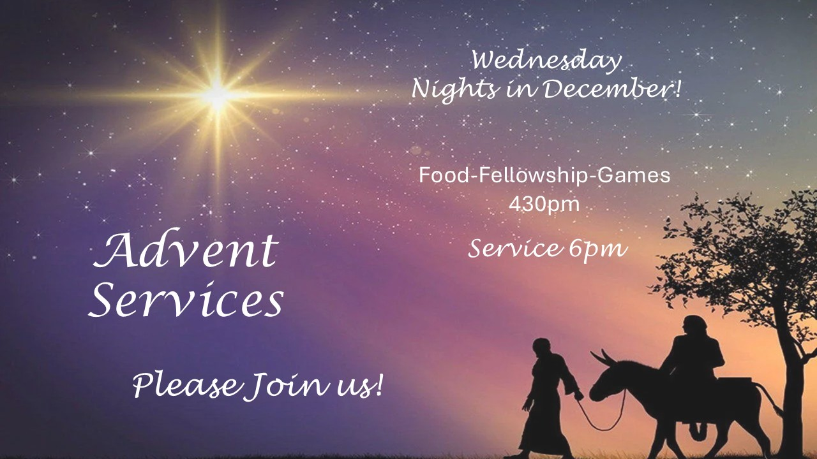

Lectionary Summaries
Overview of Today’s Assigned Reading (16 November 2025)
Malachi 4:1–6 / 2 Thessalonians 3:(1–5) 6–13 / Luke 21:5–28 (29–36)

God’s Plan of Redemption Trumps Earthly Destruction and Violence

There are signs of the Lord’s coming all around: the cross that marks His Church, the violence and death of the sinful world, and the shaking of the natural order. “There will be great distress upon the earth” (Luke 21:23), but the faithful know that “the kingdom of God is near” (Luke 21:31). Therefore, “straighten up and raise your heads, because your redemption is drawing near” (Luke 21:28). Be awake and alert, and heed the words of Christ, which “will not pass away” (Luke 21:33).

For you, “the sun of righteousness shall rise with healing in its wings” (Mal. 4:2). He sends His preachers of repentance in the spirit and power of Elijah “before the great and awesome day of the LORD comes” (Mal. 4:5), in order to “direct your hearts to the love of God and to the steadfastness of Christ” (2 Thess. 3:5).

Although you are often faithless, “the Lord is faithful,” and by the preaching of His Word “he will establish you and guard you against the evil one” (2 Thess. 3:3). Therefore, “do not grow weary in doing good” (2 Thess. 3:13). In the midst of calamity, believe upon the Lord, Jesus Christ.



