

“Fool! This night your soul is required of you, and the things you have prepared, whose will they be?”
Luke 12.20

Our Savior Lutheran Church (LCMS)
4301 Atrisco Drive NW
Albuquerque, New Mexico
Website: OSLCNM.COM
Phone: 505.836.7007
Email: oslcabq@gmail.com

Eighth Sunday after Pentecost
August 3rd,2025
The Time of the Church (Trinitytide)
Eighth Sunday after Pentecost
August 3rd, 2025

Welcome to Our Savior Lutheran Church (LCMS).  We are glad you are here as we worship, praise, and give thanks to our loving Lord, Jesus Christ. Please join us immediately after service for fellowship and snacks. Adult Bible Study starts at 10:30. If you have any questions about our service or need other assistance, please contact one of our worship assistants. | Hymns  Opening # 761  Sermon # 570  Distribution In the Garden  Closing # 770

Today’s Message

True wisdom proceeds from God and embraces the riches of knowing and confessing Christ. Our minds need not be fixated on earthly wealth or possessions; our behaviors should oppose earthly immorality, selfishness, and desire. Constant fixation on our labors, accomplishments, and assets is no more than vanity, leading to despair. Our image, knowledge, and actions ought to be shaped by Christ Jesus, for He alone is everything for those who believe in His name.

+++
Serving Today
Service Leader: Vicar Previn Hudetz
Communion Celebrant: Rev John Heffelfinger
Worship Assistant: Charlie M
Reader: Sheila S
Refreshments: Pot Luck
Altar Guild: Angie Z & Sheila S
Greeter: Tania V
Welcome

761 Rock of Ages, Cleft for Me
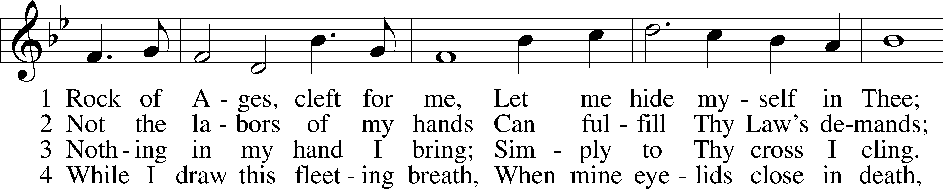
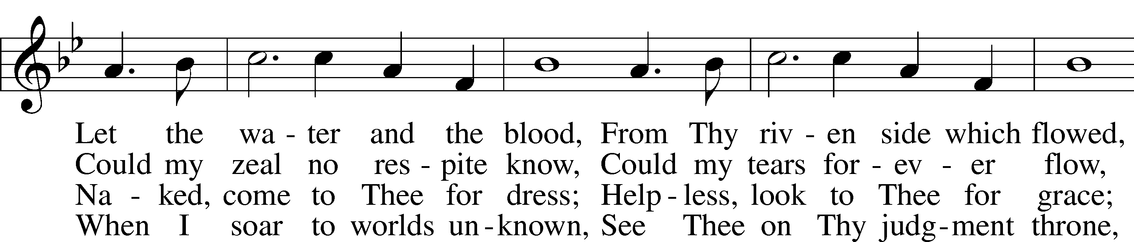
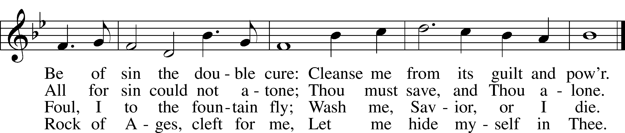
Text: Augustus M. Toplady, 1740–78
Tune: Thomas Hastings, 1784–1872
Text and tune: Public domain

Confession and Absolution

Stand

The sign of the cross may be made by all in remembrance of their Baptism.

P In the name of the Father and of the T Son and of the Holy Spirit.
C Amen.

P Our help is in the name of the Lord,
C who made heaven and earth.

P If You, O Lord, kept a record of sins, O Lord, who could stand?
C But with You there is forgiveness; therefore You are feared.

P Since we are gathered to hear God’s Word, call upon Him in prayer and praise, and receive the body and blood of our Lord Jesus Christ in the fellowship of this altar, let us first consider our unworthiness and confess before God and one another that we have sinned in thought, word, and deed, and that we cannot free ourselves from our sinful condition. Together as His people let us take refuge in the infinite mercy of God, our heavenly Father, seeking His grace for the sake of Christ, and saying: God, be merciful to me, a sinner.

Pause for Reflection…

C Almighty God, have mercy upon us, forgive us our sins, and lead us to everlasting life. Amen.

P Almighty God, merciful Father, in Holy Baptism You declared us to be Your children and gathered us into Your one, holy Church, in which You daily and richly forgive us our sins and grant us new life through Your Spirit. Be in our midst, enliven our faith, and graciously receive our prayer and praise; through Your Son, Jesus Christ, our Lord.
C Amen.

Stand

Service of the Word

Invitatory for Trinitytide
The Lord has enlightened us in the true faith.
O come, let us worship Him
Commit your work to the Lord, and
in all seasons let your plans rest with Him.

Proverbs 16:3

Introit Psalm 49:7–8, 13–14a, 15; antiphon: vv. 1–2
Hear this, all | peoples!*
Give ear, all inhabitants | of the world,
both | low and high,*
rich and poor to- | gether!
Truly no man can ransom an- | other,*
or give to God the price | of his life,
for the ransom of their life is | costly*
and can nev- | er suffice.
This is the path of those who have foolish | confidence;*
yet after them people approve | of their boasts.
Like sheep they are appointed | for Sheol;*
death shall be their | shepherd.
But God will ransom my soul from the power | of Sheol,*
for he will re- | ceive me.
Glory be to the Father and | to the Son*
and to the Holy | Spirit;
as it was in the be- | ginning,*
is now, and will be forever. | Amen.
Hear this, all | peoples!*
Give ear, all inhabitants | of the world,
both | low and high,*
rich and poor to- | gether!

Kyrie 204

P In Peace, let us pray to the Lord
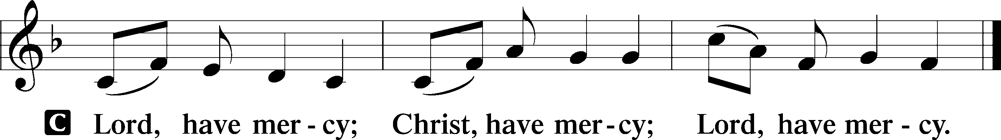

P For the peace of the whole world, for the well being of the Church of God and for the unity of all; let us pray to the Lord.

P For this holy House, and all who offer their worship and praise; let us pray to the Lord.

This Is the Feast LSB 155
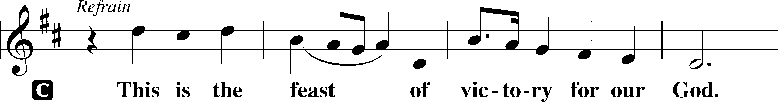
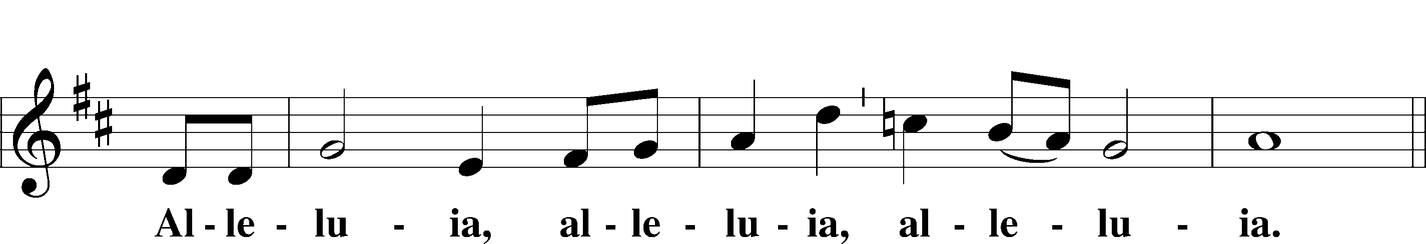
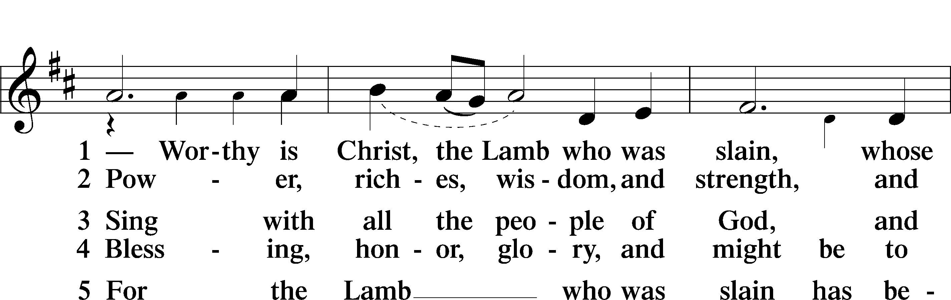
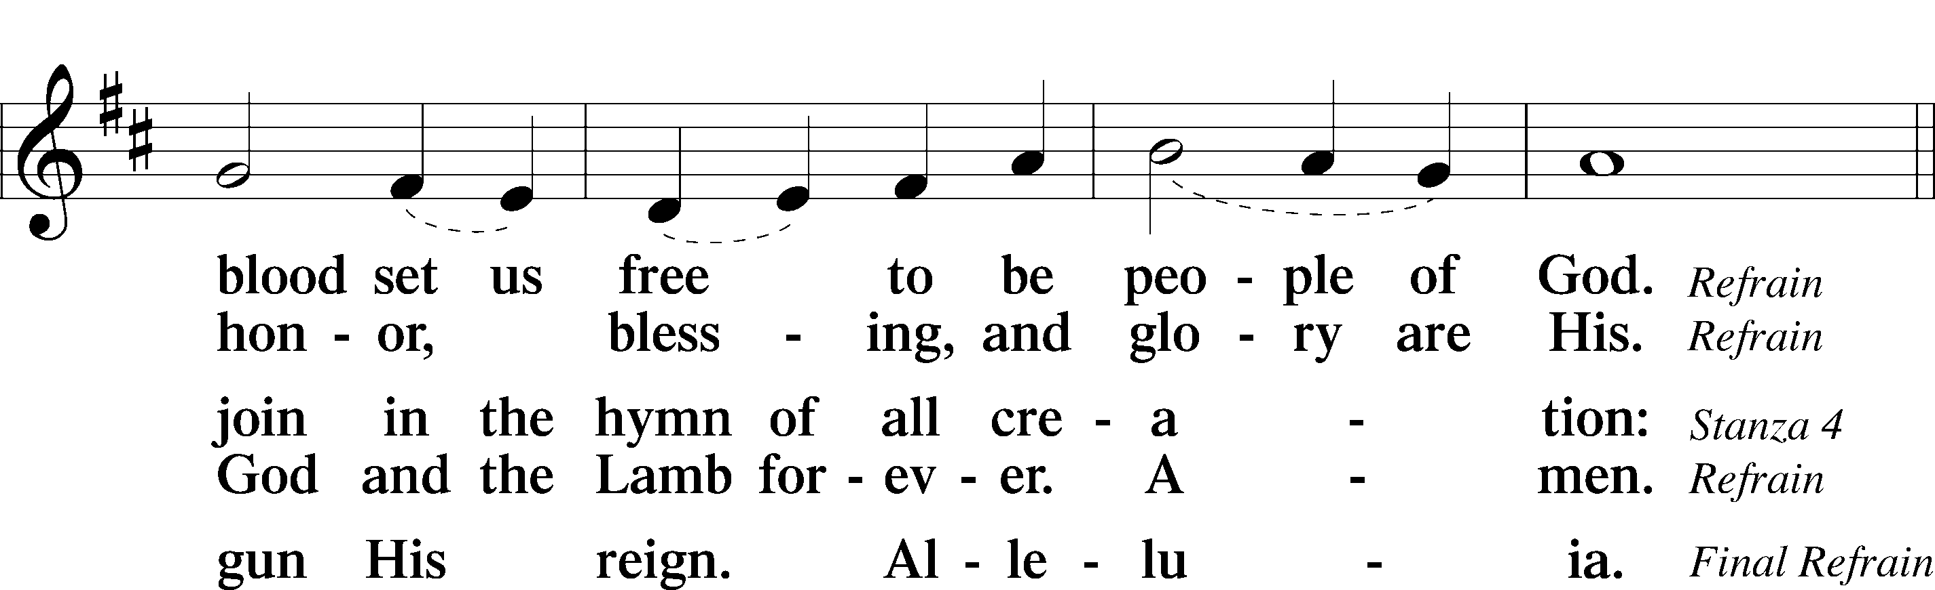
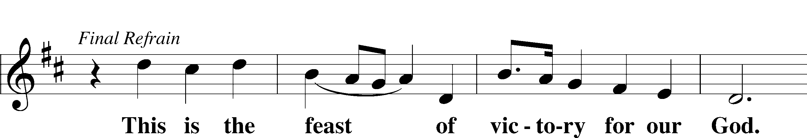
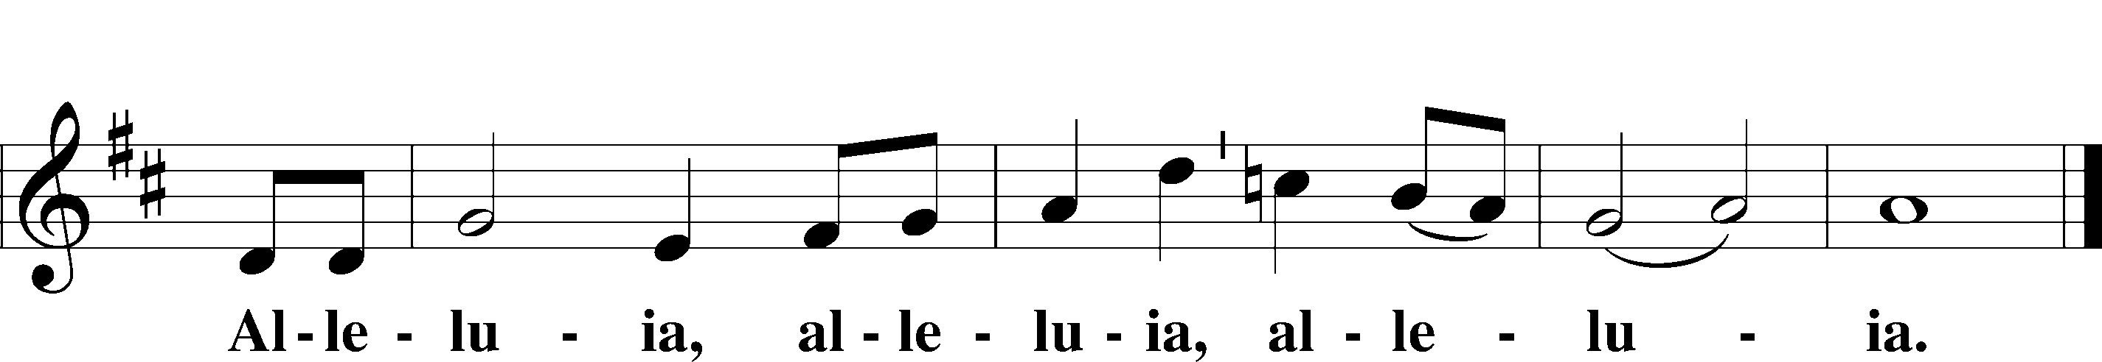

Salutation and Collect of the Day
P The Lord be with you.
C And also with you.

P Let us pray.
O Lord, grant us wisdom to recognize the treasures You have stored up for us in heaven, that we may never despair but always rejoice and be thankful for the riches of Your grace; through Jesus Christ, Your Son, our Lord, who lives and reigns with You and the Holy Spirit, one God, now and forever.

C Amen.

Sit

Old Testament Reading Ecclesiastes 1:2, 12–14; 2:18–26
A The Old Testament from the book of Ecclesiastes.

2Vanity of vanities, says the Preacher,
vanity of vanities! All is vanity. . . .
12I the Preacher have been king over Israel in Jerusalem. 13And I applied my heart to seek and to search out by wisdom all that is done under heaven. It is an unhappy business that God has given to the children of man to be busy with. 14I have seen everything that is done under the sun, and behold, all is vanity and a striving after wind. . . .
18I hated all my toil in which I toil under the sun, seeing that I must leave it to the man who will come after me, 19and who knows whether he will be wise or a fool? Yet he will be master of all for which I toiled and used my wisdom under the sun. This also is vanity. 20So I turned about and gave my heart up to despair over all the toil of my labors under the sun, 21because sometimes a person who has toiled with wisdom and knowledge and skill must leave everything to be enjoyed by someone who did not toil for it. This also is vanity and a great evil. 22What has a man from all the toil and striving of heart with which he toils beneath the sun? 23For all his days are full of sorrow, and his work is a vexation. Even in the night his heart does not rest. This also is vanity.
24There is nothing better for a person than that he should eat and drink and find enjoyment in his toil. This also, I saw, is from the hand of God, 25for apart from him who can eat or who can have enjoyment? 26For to the one who pleases him God has given wisdom and knowledge and joy, but to the sinner he has given the business of gathering and collecting, only to give to one who pleases God. This also is vanity and a striving after wind.

A This is the Word of the Lord.
C Thanks be to God.

Psalm Psalm 100; antiphon: v. 3
1Make a joyful noise to the Lord, | all the earth!*
2Serve the Lord with gladness!
Come into his presence with | singing!
3Know that the Lord, | he is God!*
It is he who made us, and we are his;
we are his people, and the sheep of his | pasture.
4Enter his gates with thanksgiving,
and his | courts with praise!*
Give thanks to him; | bless his name!
5For the Lord is good;
his steadfast love endures for- | ever,*
and his faithfulness to all gener- | ations.
Epistle Colossians 3:1–11
A The Epistle read from the 3rd chapter of Colossians.
1If then you have been raised with Christ, seek the things that are above, where Christ is, seated at the right hand of God. 2Set your minds on things that are above, not on things that are on earth. 3For you have died, and your life is hidden with Christ in God. 4When Christ who is your life appears, then you also will appear with him in glory.
5Put to death therefore what is earthly in you: sexual immorality, impurity, passion, evil desire, and covetousness, which is idolatry. 6On account of these the wrath of God is coming. 7In these you too once walked, when you were living in them. 8But now you must put them all away: anger, wrath, malice, slander, and obscene talk from your mouth. 9Do not lie to one another, seeing that you have put off the old self with its practices 10and have put on the new self, which is being renewed in knowledge after the image of its creator. 11Here there is not Greek and Jew, circumcised and uncircumcised, barbarian, Scythian, slave, free; but Christ is all, and in all.

A This is the Word of the Lord.
C Thanks be to God.

Stand

Alleluia and Verse

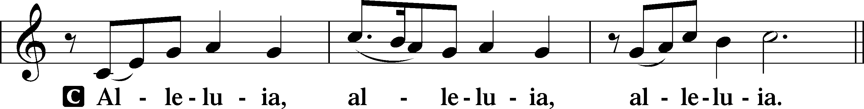

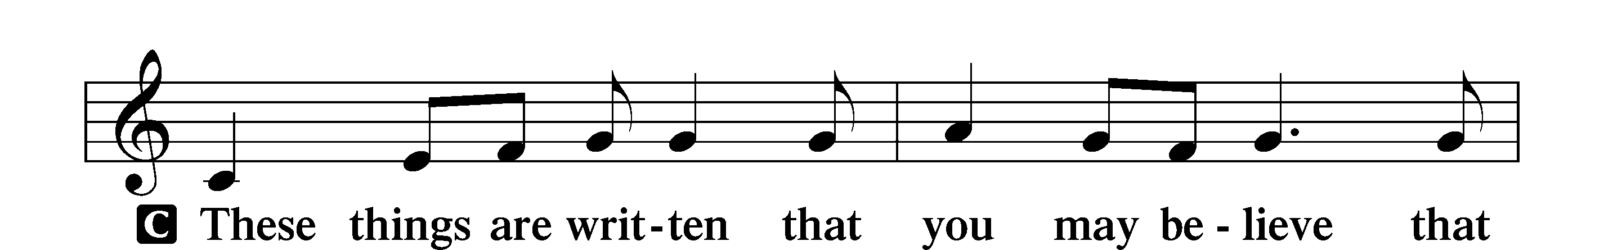
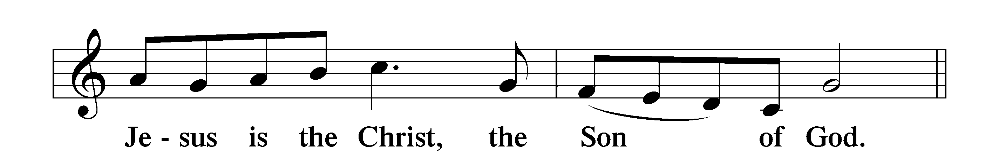

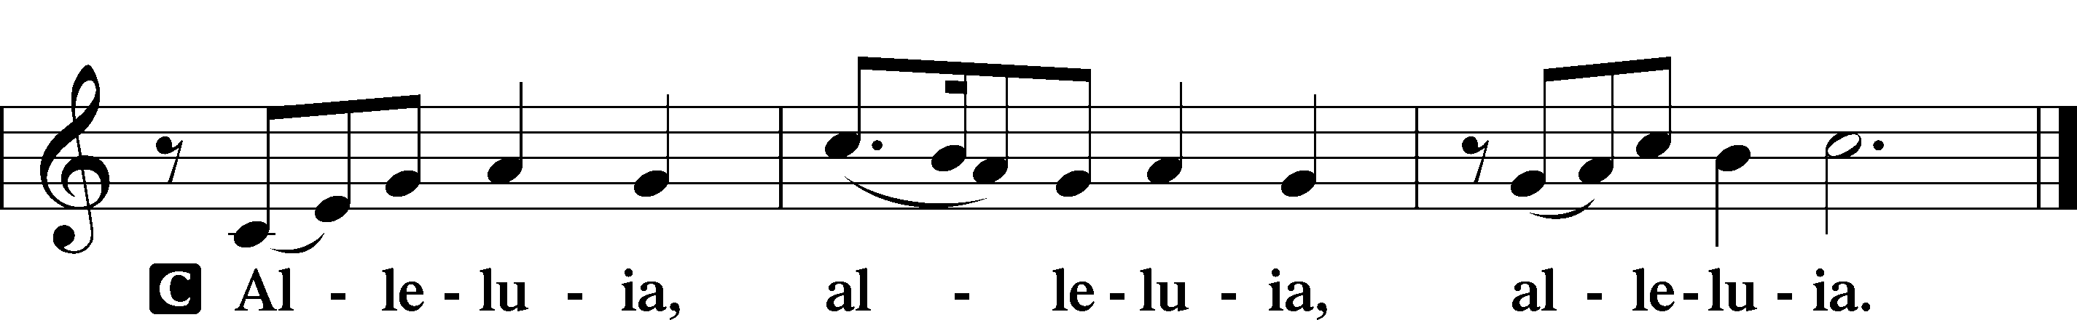

Holy Gospel Luke 12:13–21

P The Holy Gospel according to St. Luke, the twelfth chapter.
C Glory to You, O Lord.

13Someone in the crowd said to [Jesus], “Teacher, tell my brother to divide the inheritance with me.” 14But he said to him, “Man, who made me a judge or arbitrator over you?” 15And he said to them, “Take care, and be on your guard against all covetousness, for one’s life does not consist in the abundance of his possessions.” 16And he told them a parable, saying, “The land of a rich man produced plentifully, 17and he thought to himself, ‘What shall I do, for I have nowhere to store my crops?’ 18And he said, ‘I will do this: I will tear down my barns and build larger ones, and there I will store all my grain and my goods. 19And I will say to my soul, Soul, you have ample goods laid up for many years; relax, eat, drink, be merry.’ 20But God said to him, ‘Fool! This night your soul is required of you, and the things you have prepared, whose will they be?’ 21So is the one who lays up treasure for himself and is not rich toward God.”

P This is the Gospel of the Lord.
C Praise to You, O Christ.

Sit

721 Lead Me, Guide Me
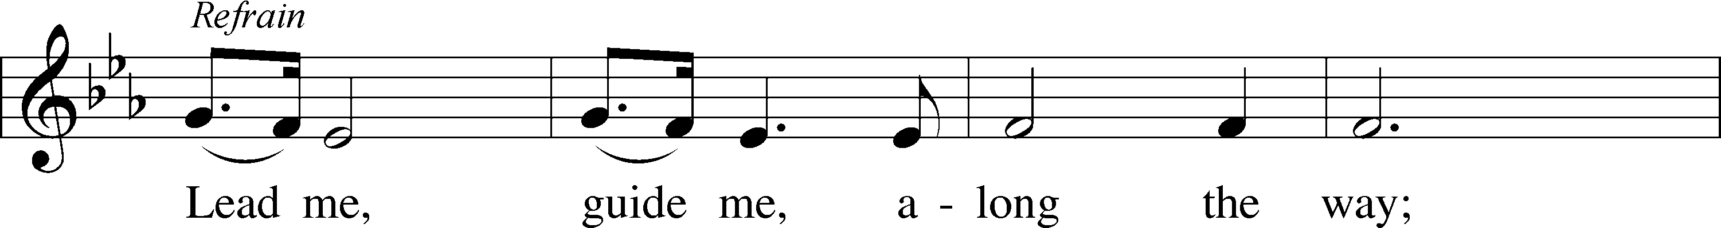
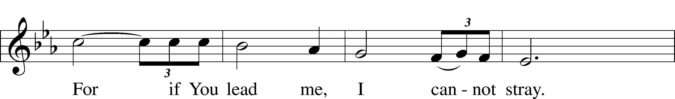
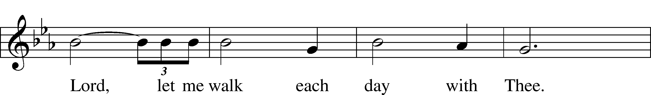
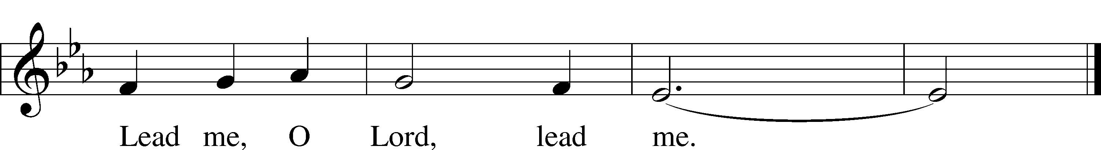
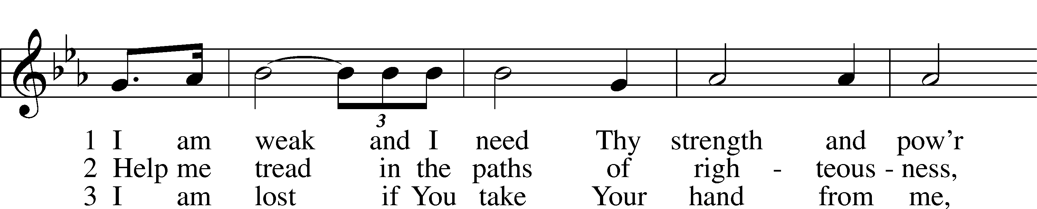
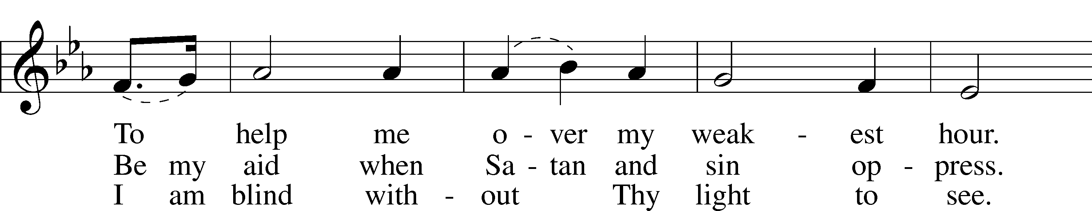
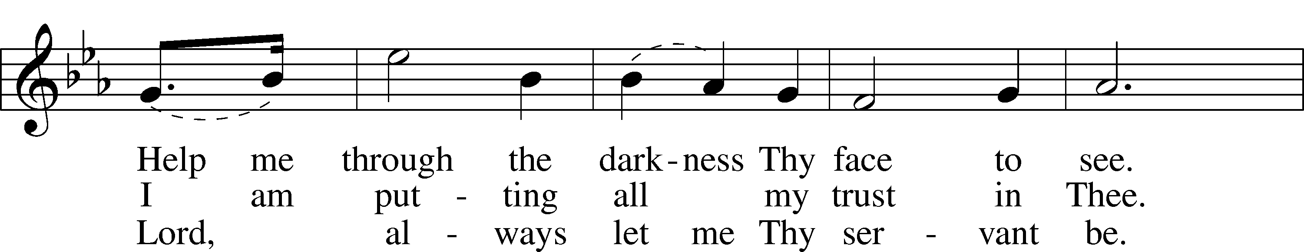
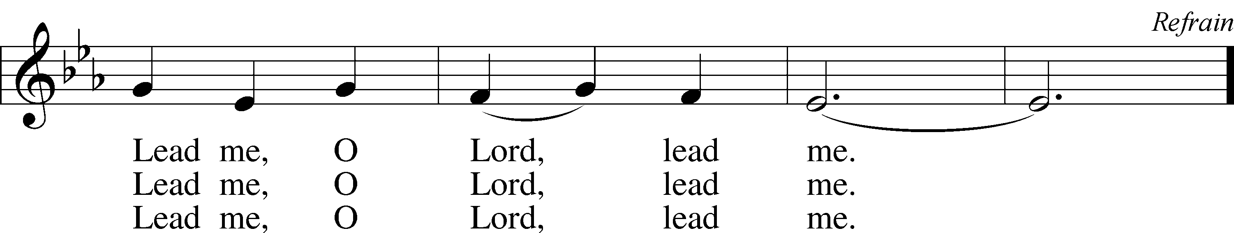
Text and tune: Doris M. Akers, 1922–95
Text and tune: © 1953 Doris M. Akers, admin. Chappell & Co. Used by permission: LSB Hymn License no. 110003995

Sermon

Reception of New Members

Apostles’ Creed
C I believe in God, the Father Almighty,
maker of heaven and earth.

And in Jesus Christ, His only Son, our Lord,
who was conceived by the Holy Spirit,
born of the virgin Mary,
suffered under Pontius Pilate,
was crucified, died and was buried.
He descended into hell.
The third day He rose again from the dead.
He ascended into heaven
and sits at the right hand of God the Father Almighty.
From thence He will come to judge the living and the dead.

I believe in the Holy Spirit,
the holy Christian Church,
the communion of saints,
the forgiveness of sins,
the resurrection of the body,
and the life T everlasting. Amen.

Stand

Prayer of the Church

Following the prayers, the people may greet one another in the name of the Lord, saying, “Peace be with you,” as a sign of reconciliation and of the unity of the Spirit in the bond of peace (Matt. 5:22–24; Eph. 4:1–3).

Sit

Offering & Sharing of the peace

Service of Holy Communion
Communion Statement


The Lord’s Supper is celebrated at this congregation in the confession and glad confidence that, as He says, our Lord gives into our mouths not only bread and wine but His very body and blood to eat and to drink for the forgiveness of sins and to strengthen our union with Him and with one another. Our Lord invites to His table those who trust His words, repent of all sin, and set aside any refusal to forgive and love as He forgives and loves us, that they may show forth His death until He comes.

Because those who eat and drink our Lord’s body and blood unworthily do so to their great harm and because Holy Communion is a confession of the faith which is confessed at this altar, any who are not yet instructed, in doubt, or who hold a confession differing from that of this congregation and the Lutheran Church Missouri Synod, and yet desire to receive this sacrament, are asked to speak with the Pastor.
* See more about the Lutheran teaching on communion in the Hymnal p 329.

Stand

Preface LSB 208
P The Lord be with you.
C And also with you.

P Lift up your hearts.
C We lift them to the Lord.

P Let us give thanks to the Lord our God.
C It is right to give Him thanks and praise.

P It is truly good, right, and salutary that we should at all times and in all places give thanks to You, O Lord, holy Father, almighty and everlasting God, for the countless blessings You so freely bestow on us and all creation. Above all, we give thanks for Your boundless love shown to us when You sent Your only-begotten Son, Jesus Christ, into our flesh and laid on Him our sin, giving Him into death that we might not die eternally. Because He is now risen from the dead and lives and reigns to all eternity, all who believe in Him will overcome sin and death and will rise again to new life. Therefore with angels and archangels and with all the company of heaven we laud and magnify Your glorious name, evermore praising You and saying:

Sanctus LSB 208
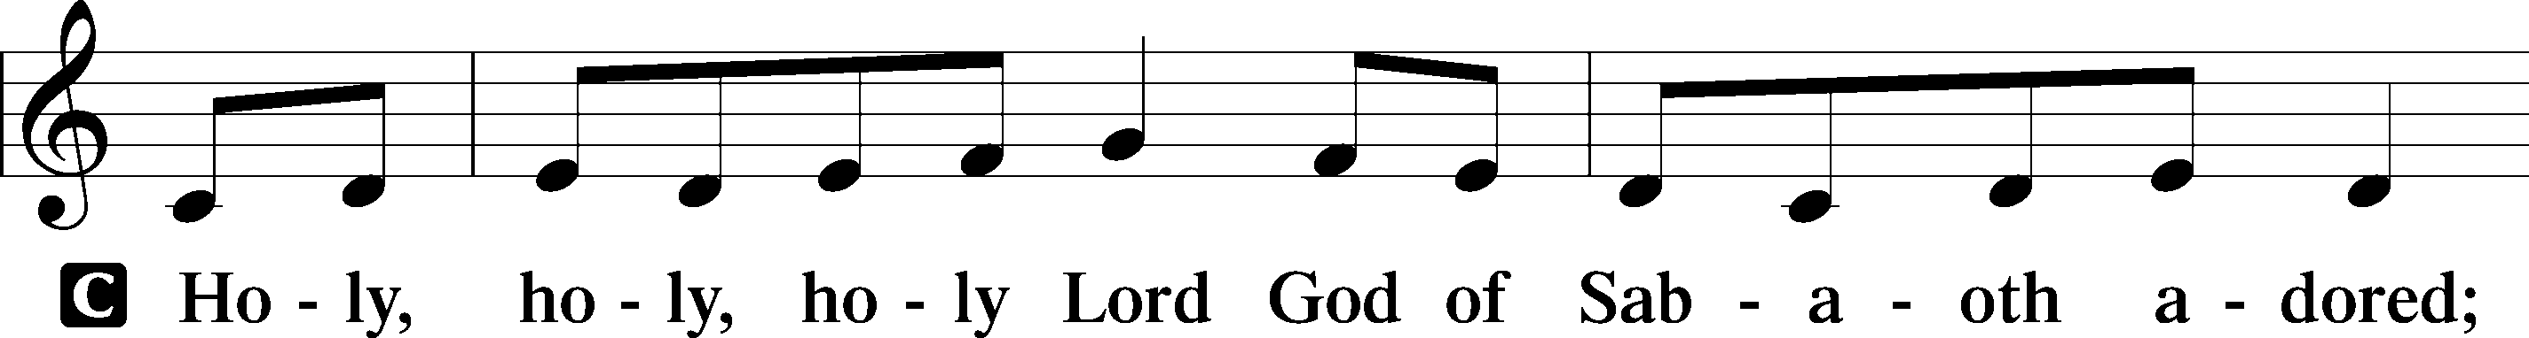
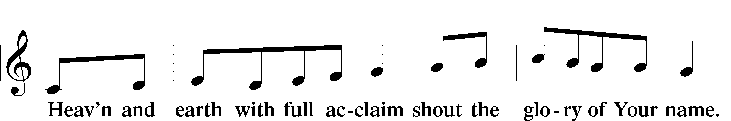
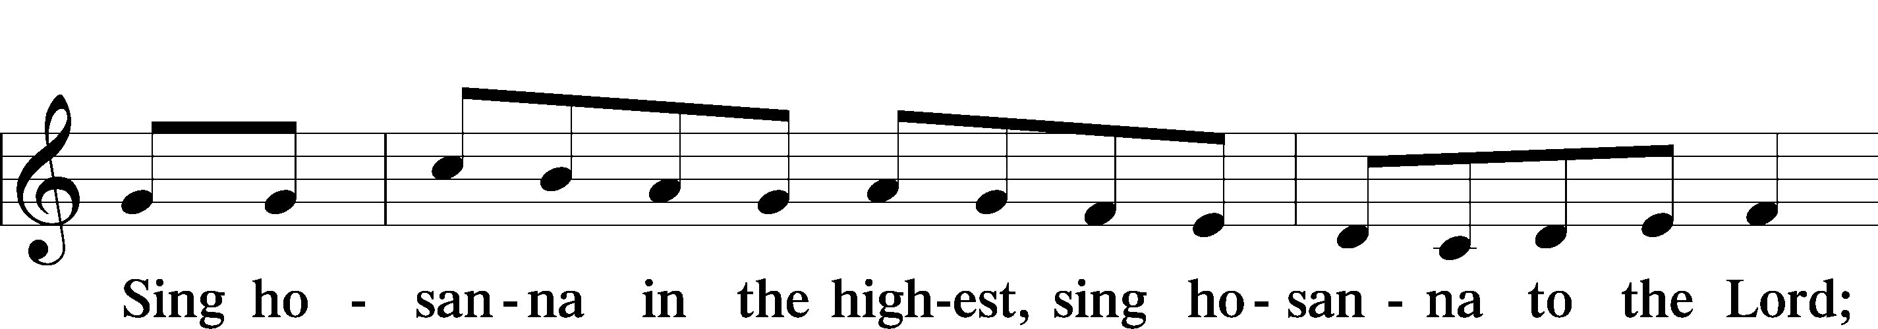
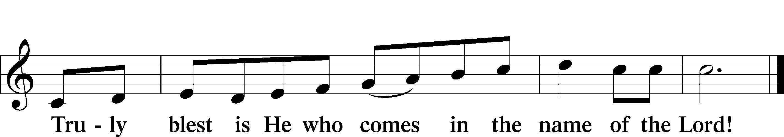
Text: Stephen P. Starke

Prayer of Thanksgiving
P Blessed are You, O Lord our God, king of all creation, for You have had mercy on us and given Your only-begotten Son that whoever believes in Him should not perish but have eternal life.

In these last days, You have poured out Your Holy Spirit on Your Church that Your sons and daughters might proclaim the wonders of Your salvation in Christ Jesus our Lord. Pour out Your Holy Spirit upon Your gathered people that, faithfully eating and drinking the body and blood of Your Son, we may go forth to proclaim His salvation to the ends of the earth.

Hear us as we pray in His name and as He has taught us:

Lord’s Prayer
C Our Father who art in heaven, hallowed be Thy name,
Thy kingdom come, Thy will be done on earth
as it is in heaven;
give us this day our daily bread; and forgive us our trespasses
as we forgive those who trespass against us;
and lead us not into temptation, but deliver us from evil.
For Thine is the kingdom
and the power and the glory
forever and ever. Amen.

The Words of Our Lord
P Our Lord Jesus Christ, on the night when He was betrayed, took bread, and when He had given thanks, He broke it and gave it to the disciples and said: “Take, eat; this is My T body, which is given for you. This do in remembrance of Me.”

In the same way also He took the cup after supper, and when He had given thanks, He gave it to them, saying: “Drink of it, all of you; this cup is the new testament in My T blood, which is shed for you for the forgiveness of sins. This do, as often as you drink it, in remembrance of Me.”

Pax Domini
P The peace of the Lord be with you always.
C Amen.

Agnus Dei LSB 210
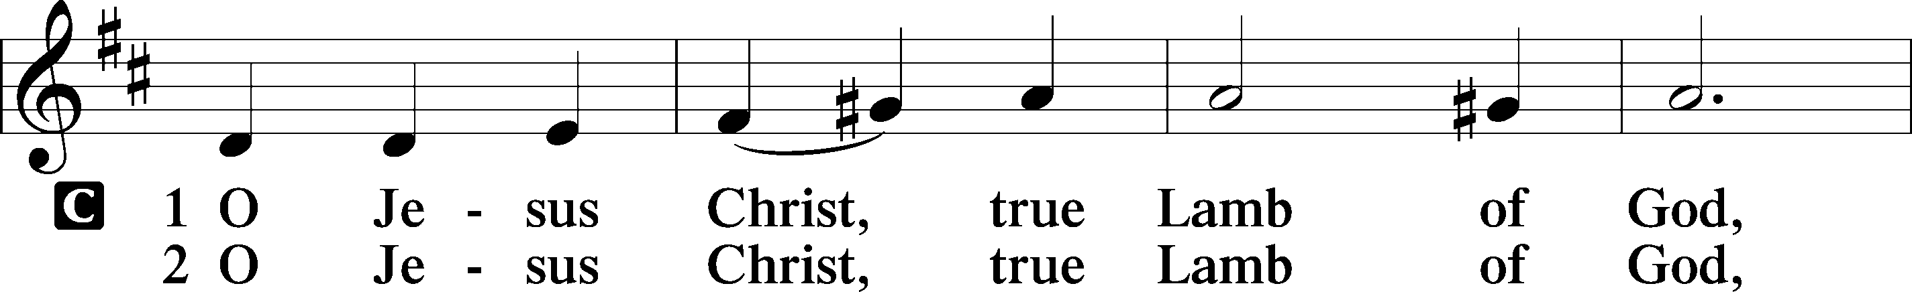
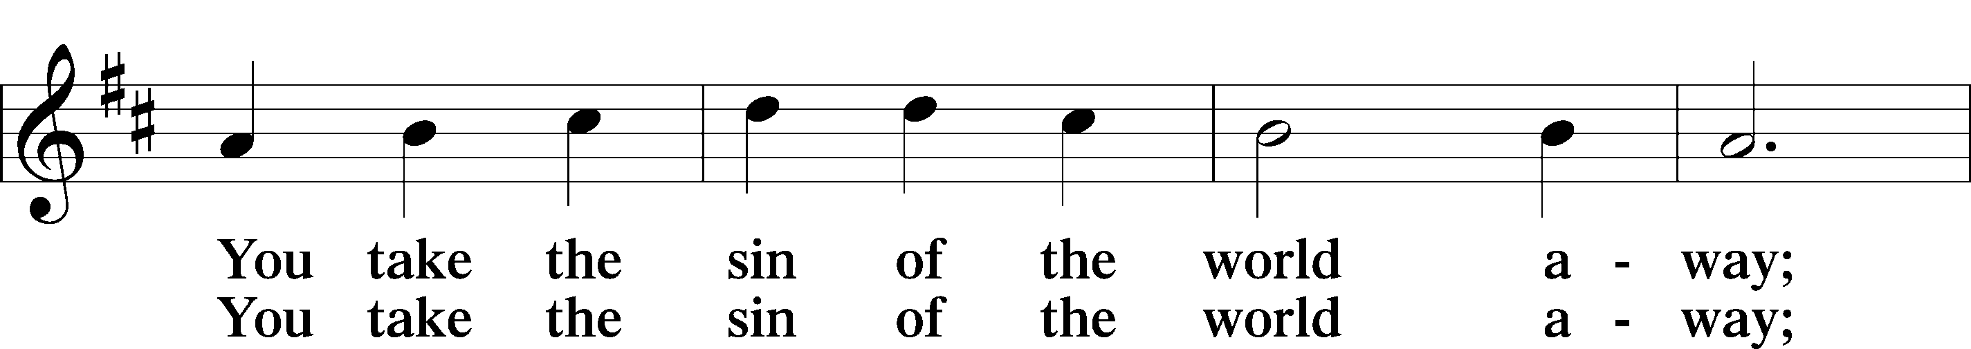
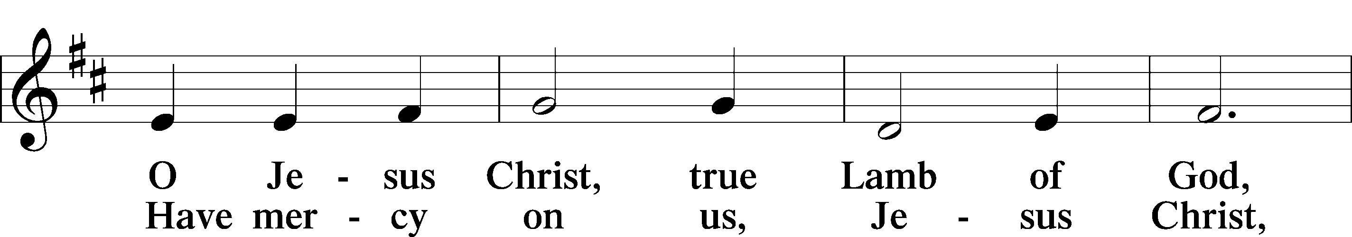
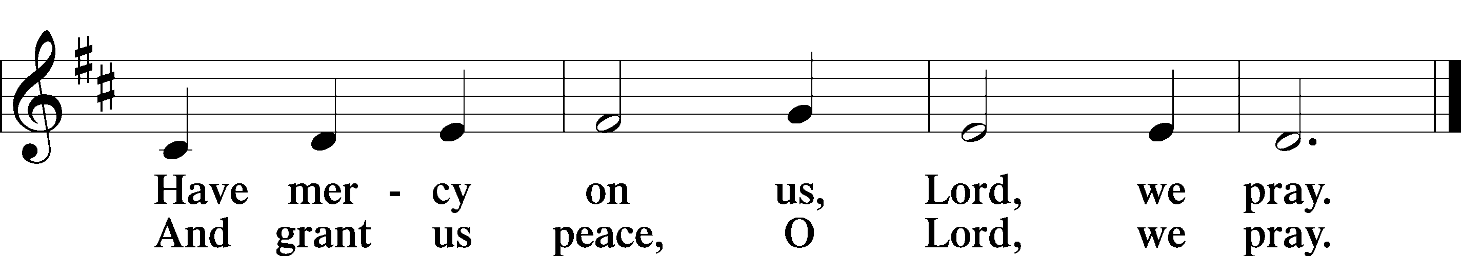
Text: Stephen P. Starke

Sit
Distribution
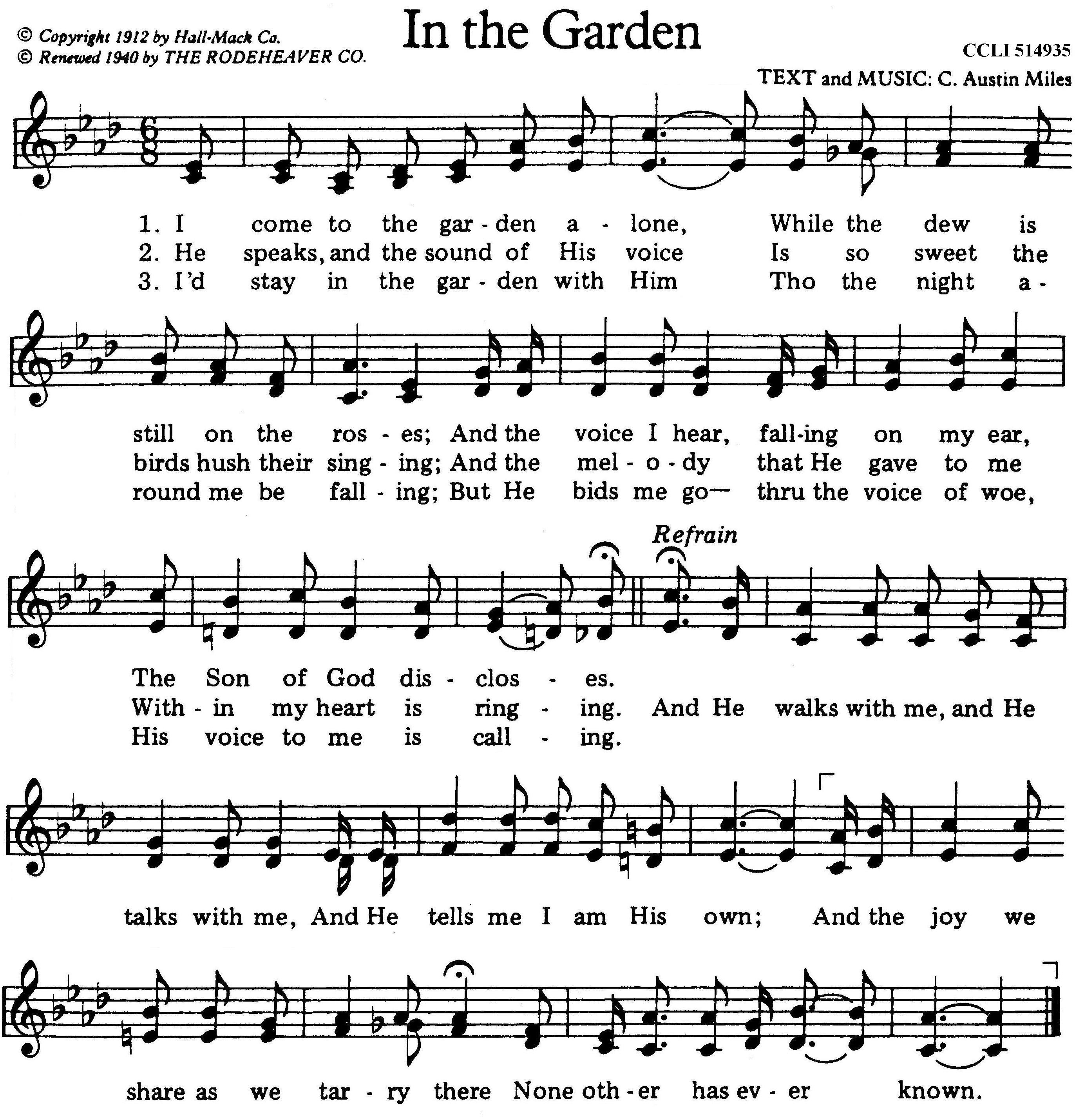

Stand

Nunc Dimittis LSB 211
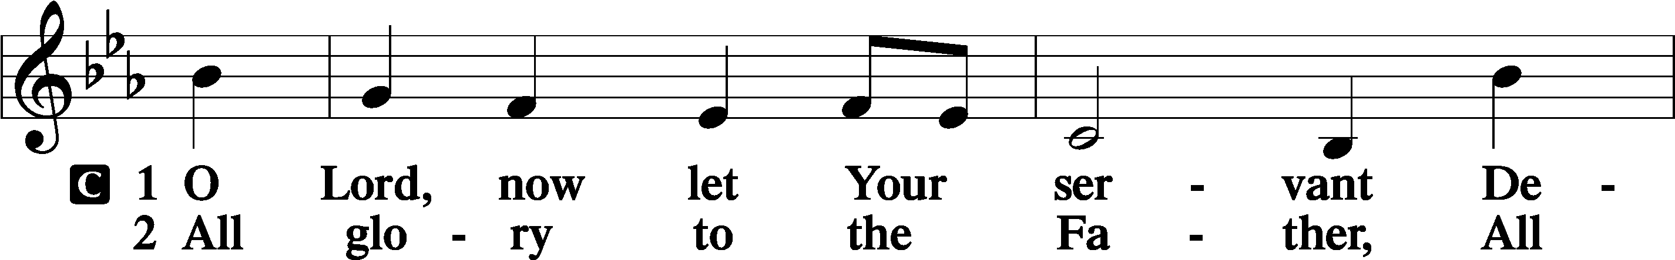
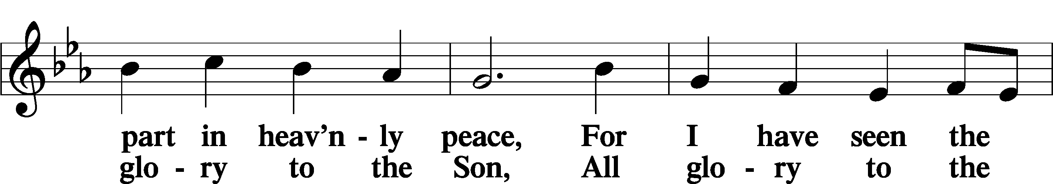
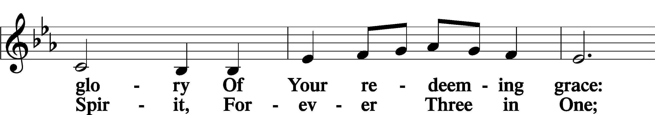
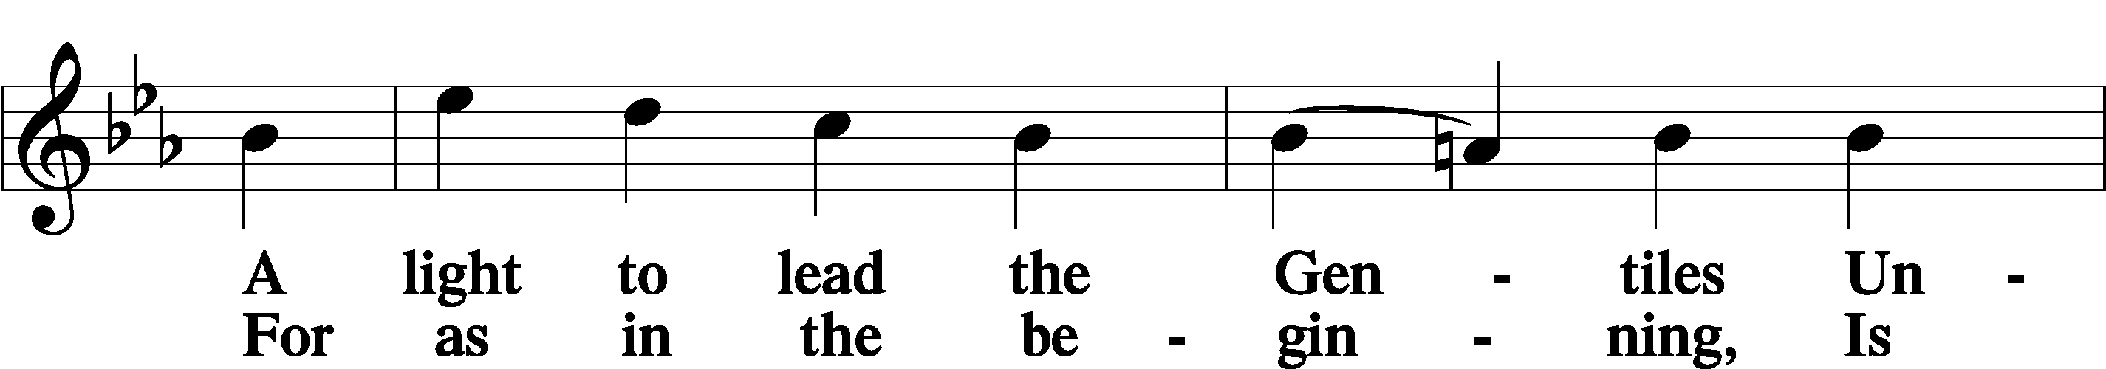
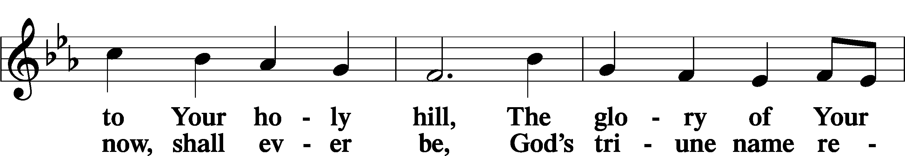
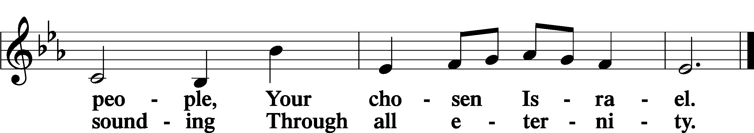

Post-Communion Collect
A Let us pray.
We give thanks to You, almighty God, that You have refreshed us through this salutary gift, and we implore You that of Your mercy You would strengthen us through the same in faith toward You and in fervent love toward one another; through Jesus Christ, Your Son, our Lord, who lives and reigns with You and the Holy Spirit, one God, now and forever.
C Amen.

Verse of The Day Colossians 3:23–24a
A Alleluia. Whatever you do, work heartily, as for the Lord and not for men,
C knowing that from the Lord you will receive the inheritance as your reward. Alleluia.

Benedicamus LSB 212
A Let us bless the Lord.
C Thanks be to God.

Benediction
P The Lord bless you and keep you.
The Lord make His face shine on you and be gracious to you.
The Lord look upon you with favor and T give you peace.
C Amen.

878 Abide with Me sts. 1–2, 4–6
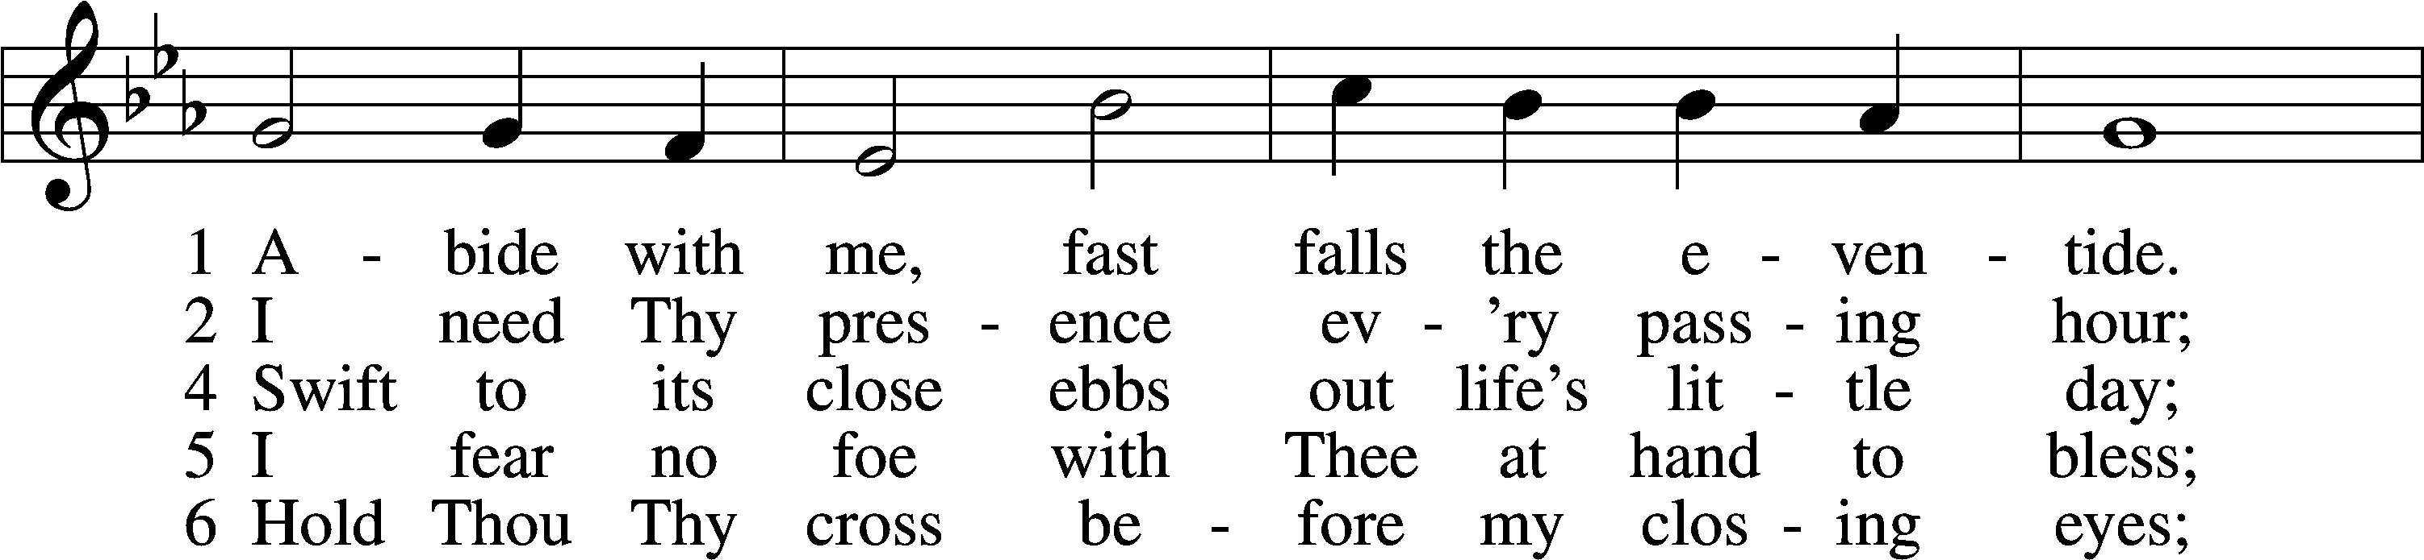
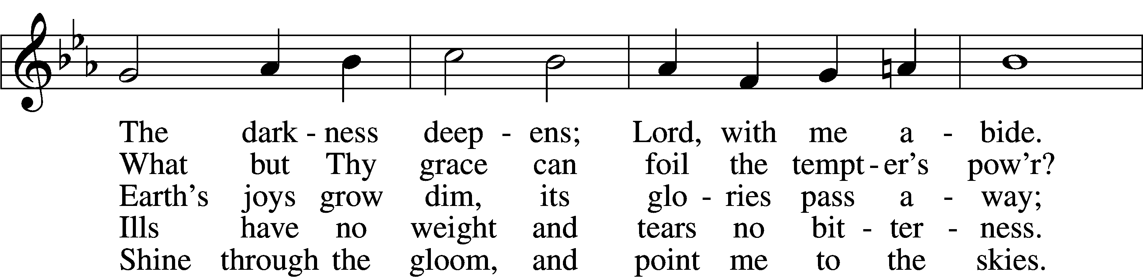
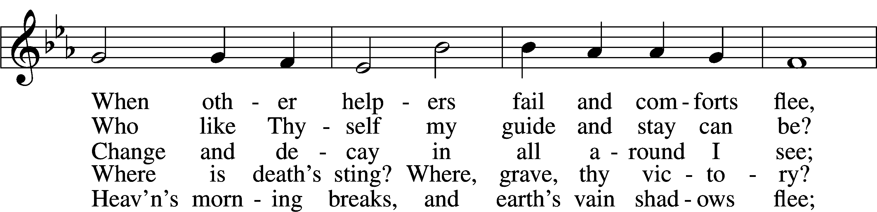
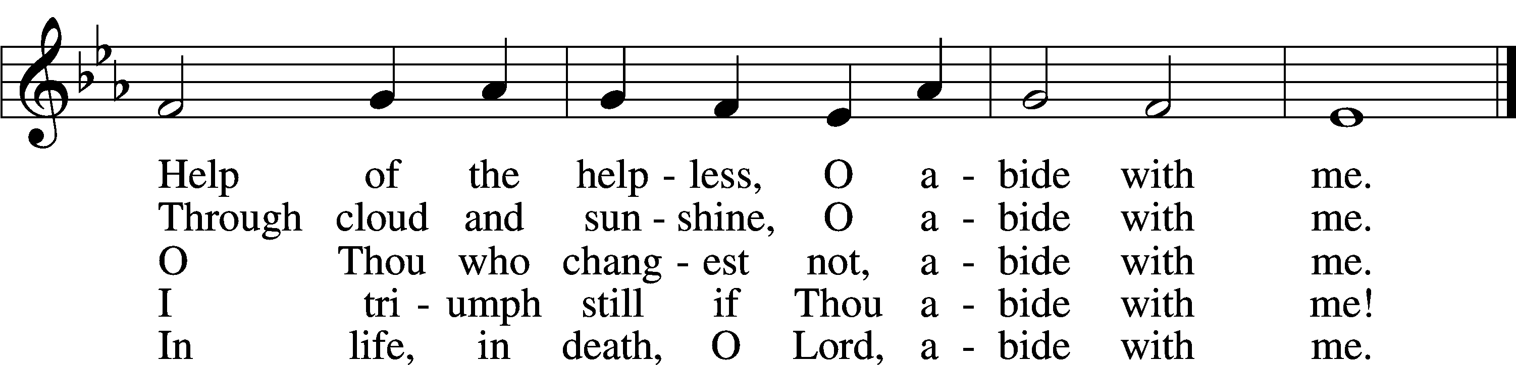
Text: Henry F. Lyte, 1793–1847, alt.
Tune: William H. Monk, 1823–89
Text and tune: Public domain

Acknowledgments
Divine Service, Setting Four from Lutheran Service Book
Unless otherwise indicated, Scripture quotations are from the ESV® Bible (The Holy Bible, English Standard Version®), copyright © 2001 by Crossway, a publishing ministry of Good News Publishers. Used by permission. All rights reserved.
Created by Lutheran Service Builder © 2025 Concordia Publishing House.

Prayers of the Church
This week, we lift up:

Jim, Angela H, Sheila, Elaine, Bob, Angie Z, Juanita, Angela C.and Ross

Family of the week: Rev John & Kathy Heffelfinger and Family

*If you have any prayer request let us know.

Last week: Attendance 32 Offering $1550
Serving Next Week (8/10/25)  Guest Pastor: Rev Doyle Boykin  Music Minister: Vicar Previn Hudetz  Worship Assistant: Charlie M  Reader: Jim  Refreshments: - TBD  Altar Guild: Angie Z & Sheila S  Greeter: TBD | Readings Next Week  Ninth Sunday after Pentecost  Genesis 15:1-6  Psalm 33:12-22  Hebrews 11:1-16  Luke 12:22-34  ***Please sign up to help Read, Greet, Set up Communion, be a Worship Assistant or bring Refreshments.***
Announcements  Birthdays:  This Week at OSLC:  Bible Study: After Service  Bible Study: Thursday 10am | This Month:  POT LUCK Today!
Seasons of the Church Year

The non-celebratory half of the Church year is called the “Time of The Church”, or traditionally the “Time of Trinity” (Trinitytide). These weeks are marked by counting the Sundays after Pentecost. This is the longest season of the church year. The color of the season is green, to represent growth and the power of the Lord working in mission.


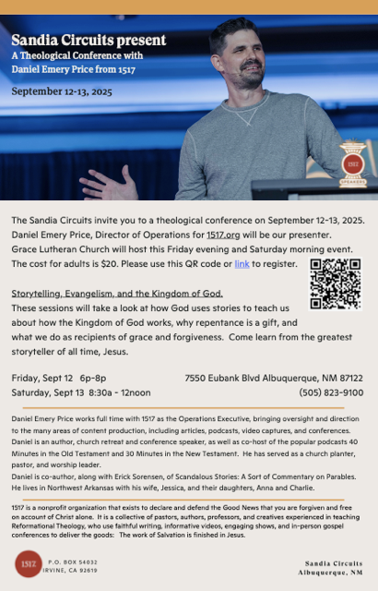





"Please join Grace Lutheran Church for our annual
Elder's BBQ on August 23rd.
Doors will open at 5:00pm
with dinner served between 5:30pm and 6:00pm

This will be a combination event to include
a Family Game Night following dinner.
Please come hungry and bring your favorite board game.
We hope to see you there!

For any questions regarding this event,
please contact Dan Wenz at 505-554-0620."

Grace Lutheran Church
7550 Eubank BLVD NE
Albuquerque, NM 87122

Welcome New Members!

Angela & Nathaniel Castenada
Rev John, Kathy & Andrew Heffelfinger
Steve Hollingsworth
Joanna Ryan
Juanita Sully
Paul and Samantha Tennant



Today after Service
Hope to see you there!

