

One who is faithful in a very little is also faithful in much, and one who is dishonest in a very little is also dishonest in much.
Luke 16:10

Our Savior Lutheran Church (LCMS)
4301 Atrisco Drive NW
Albuquerque, New Mexico
Website: OSLCNM.COM
Phone: 505.836.7007
Email: oslcabq@gmail.com

Fifteenth Sunday after Pentecost
September 21st,2025
The Time of the Church (Trinitytide)
Fifteenth Sunday after Pentecost
September 21st, 2025

Welcome to Our Savior Lutheran Church (LCMS).  We are glad you are here as we worship, praise, and give thanks to our loving Lord, Jesus Christ. Please join us immediately after service for fellowship and snacks. Adult Bible Study starts at 10:30. If you have any questions about our service or need other assistance, please contact one of our worship assistants. | Hymns  Opening # 797  Sermon # 708  Distribution # 619  Closing # 730
Today’s Message

Christ mediates the chasm between faith and faithlessness, mercy and judgment, life and death! Overseers and deacons are caretakers of this delicate balance between Law and Gospel. Their biblical qualifications for office require faithful service that is blameless, dignified, and godly. Preachers and teachers of God’s Word are to be above reproach, clinging to faith in Christ. In faith, we all fight the good fight and make the good confession as did Moses, the prophets, and the saints before us.

+++

Serving Today
Service Leader: Vicar Previn Hudetz
Communion Celebrant: Rev John Heffelfinger
Worship Assistant: TBD
Reader: Angie Z
Refreshments: Angie Z
Altar Guild: Angie Z & Sheila S
Greeter: Mike York
Welcome
Divine Service IV

797 Praise the Almighty
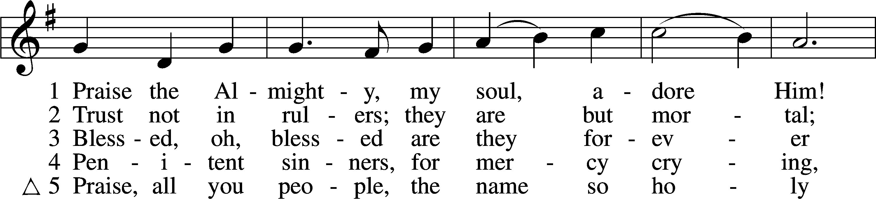
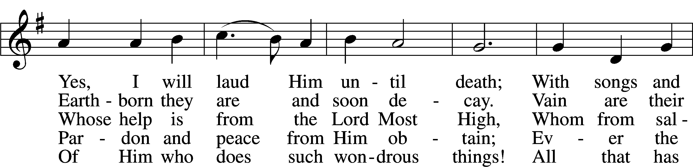
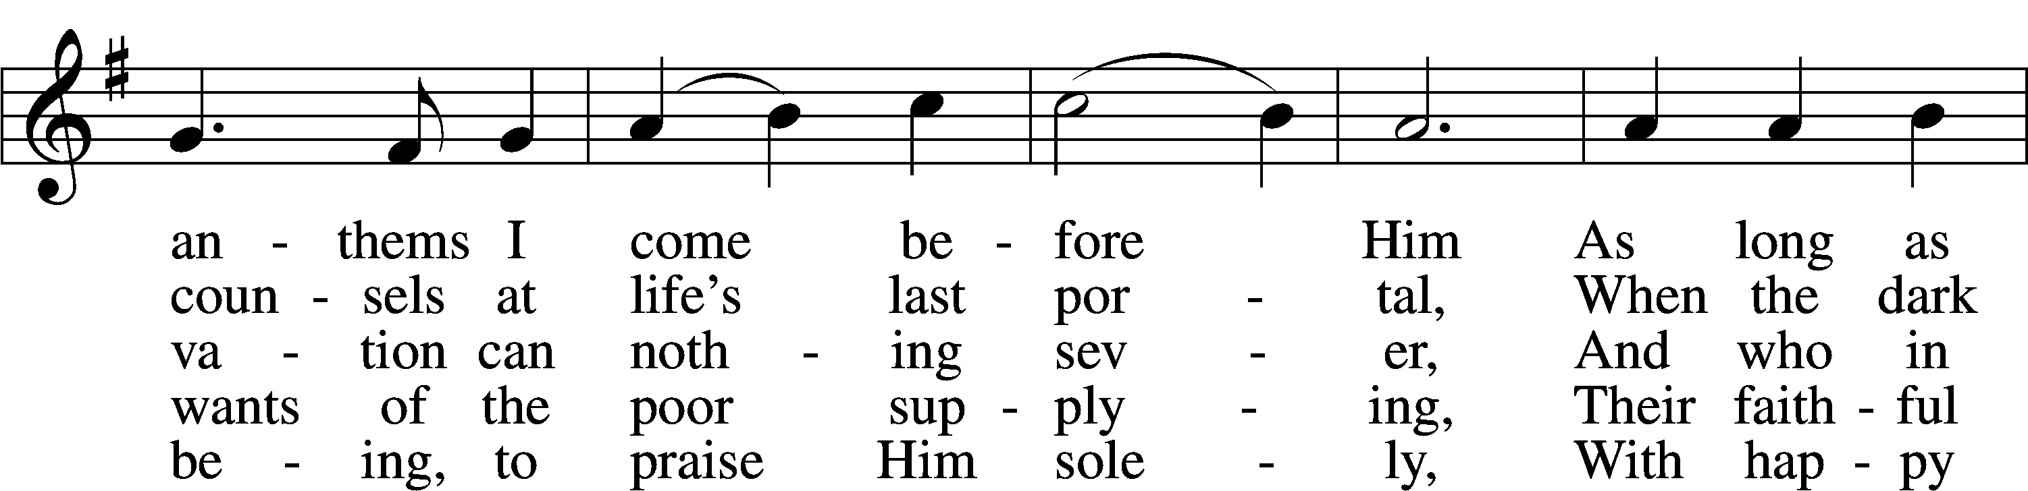
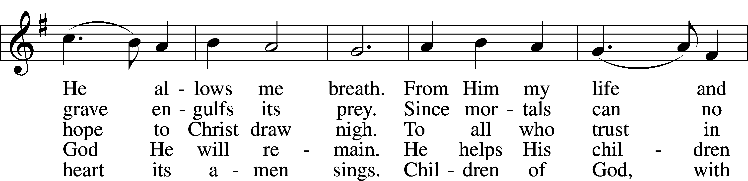
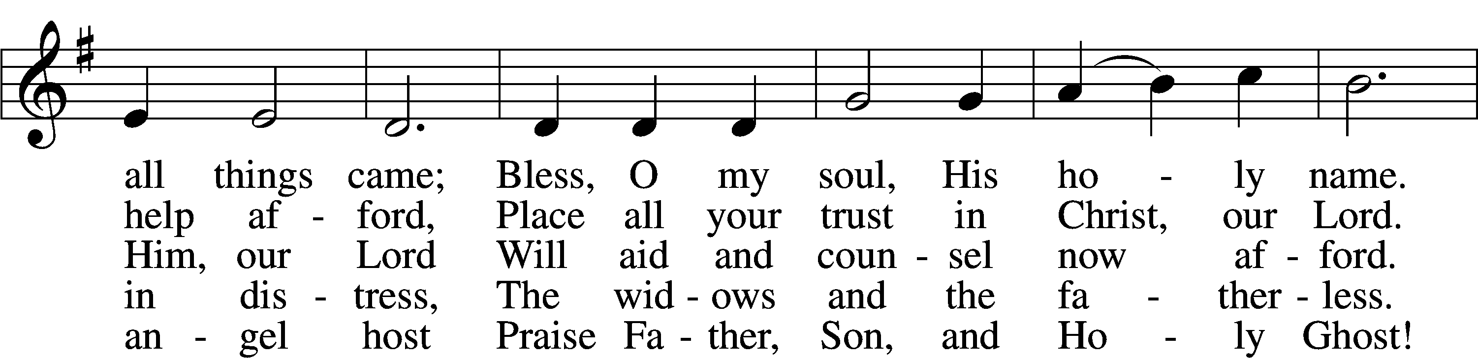
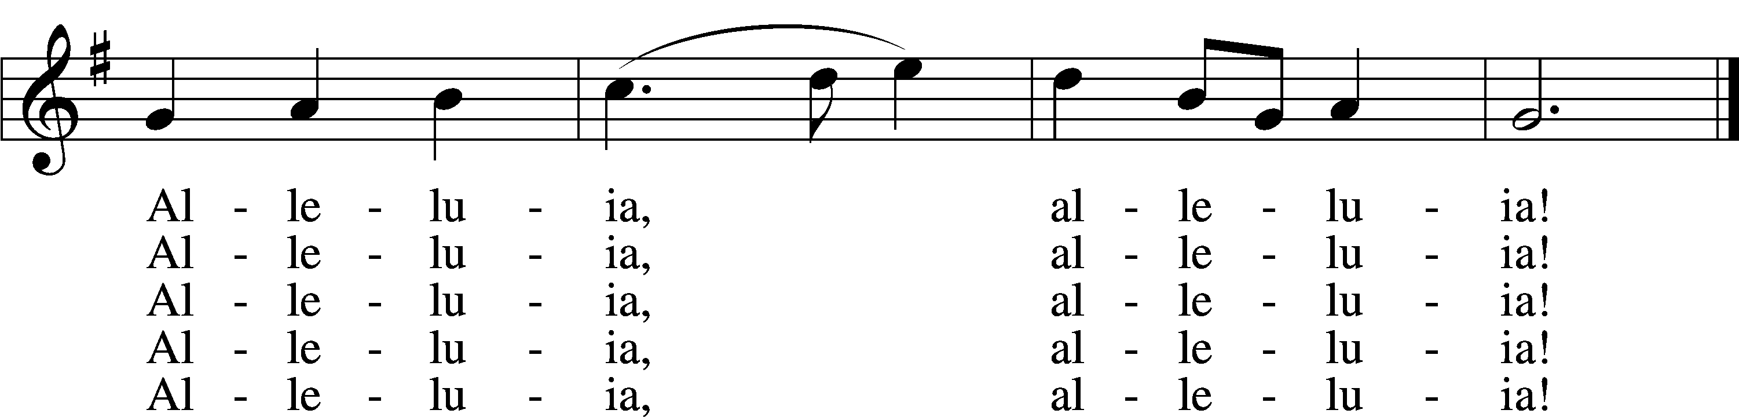
Text: Johann Daniel Herrnschmidt, 1675–1723; tr. Alfred E. R. Brauer, 1866–1949, alt. Tune: New-vermehrte Christliche Seelenharpf, 1665, Ansbach
Text and tune: Public domain
Confession and Absolution
Stand
The sign of the cross may be made by all in remembrance of their Baptism.

P In the name of the Father and of the T Son and of the Holy Spirit.
C Amen.
P Our help is in the name of the Lord,
C who made heaven and earth.
P If You, O Lord, kept a record of sins, O Lord, who could stand?
C But with You there is forgiveness; therefore You are feared.
P Since we are gathered to hear God’s Word, call upon Him in prayer and praise, and receive the body and blood of our Lord Jesus Christ in the fellowship of this altar, let us first consider our unworthiness and confess before God and one another that we have sinned in thought, word, and deed, and that we cannot free ourselves from our sinful condition. Together as His people let us take refuge in the infinite mercy of God, our heavenly Father, seeking His grace for the sake of Christ, and saying: God, be merciful to me, a sinner.

Pause for Reflection

C Almighty God, have mercy upon us, forgive us our sins, and lead us to everlasting life. Amen.
P Almighty God, in His mercy has given His Son to die for you and for His sake forgive you all you sins. As a called servant of Christ, and by His authority, I therefore forgive you all your sins in the name of the Father and of the T Son and of the Holy Spirit.
C Amen.

Service of the Word

Invitatory for Trinitytide
The Lord has sanctified us in the true faith *
O come, let us worship Him. *
Commit your work to the Lord, and
in all seasons let your plans rest with Him. Proverbs 19:3

Introit Psalm 119:137–140, 142; antiphon: v. 144
Your testimonies are righteous for- | ever;*
give me understanding that | I may live.
Righteous are you, | O Lord,*
and right are your | just decrees.
You have appointed your testimonies in | righteousness*
and in all | faithfulness.
My zeal con- | sumes me,*
because my foes for- | get your words.
Your promise is | well tried,*
and your servant | loves it.
Your righteousness is righteous for- | ever,*
and your | law is true.
Glory be to the Father and | to the Son*
and to the Holy | Spirit;
as it was in the be- | ginning,*
is now, and will be forever. | Amen.
Your testimonies are righteous for- | ever;*
give me understanding that | I may live.

Kyrie
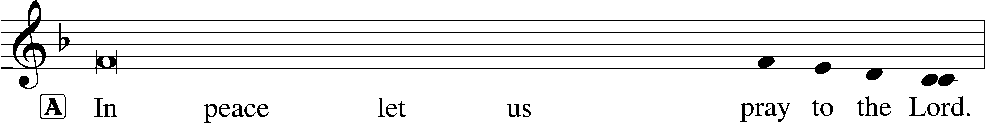
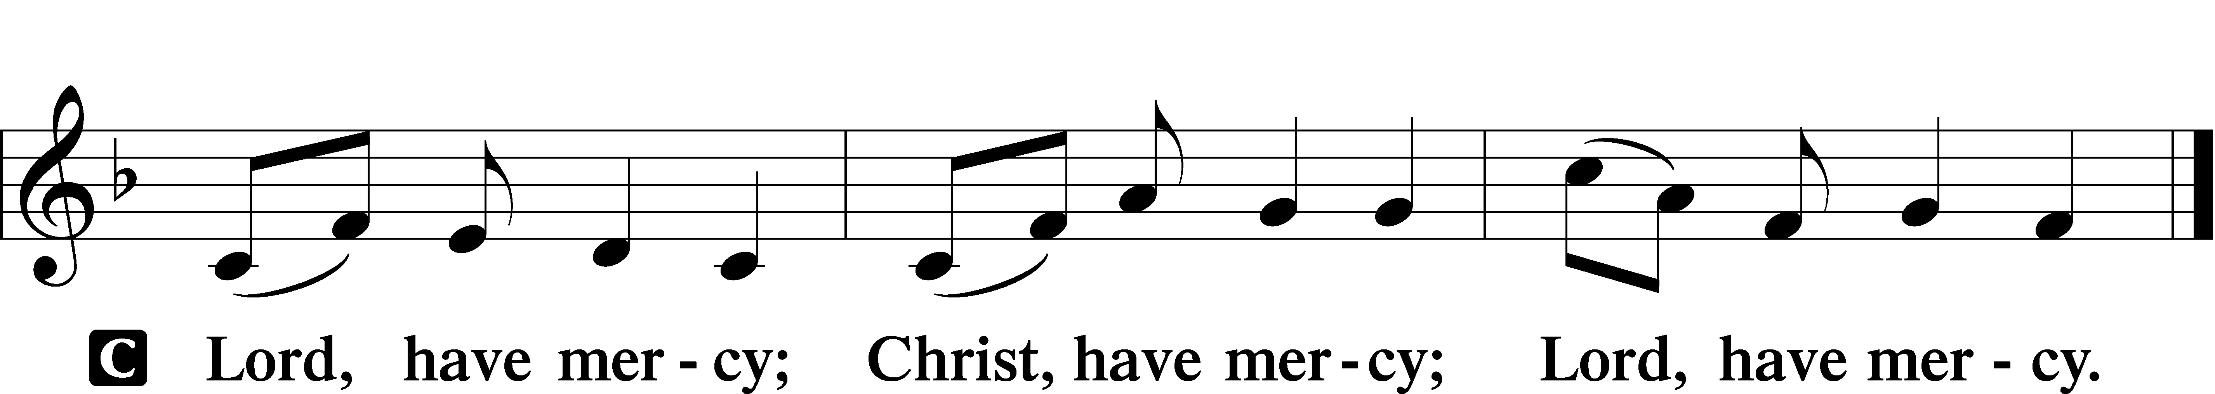

A For the peace from above and for our salvation let us pray to the Lord.

A For the peace of the whole world, for the well-being of the Church of God, and for the unity of all let us pray to the Lord.

A For this holy house and for all who offer here their worship and praise let us pray to the Lord.

A Help, save, comfort and defend us, gracious Lord.

This Is the Feast (Setting One) LSB 155
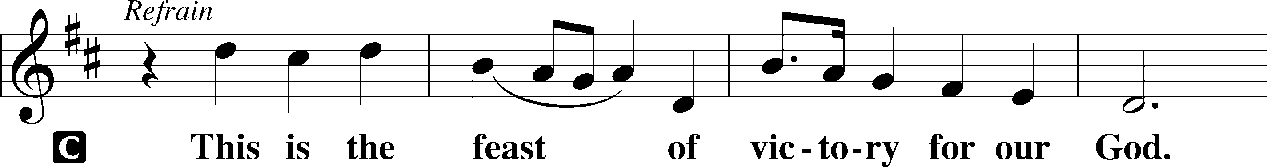
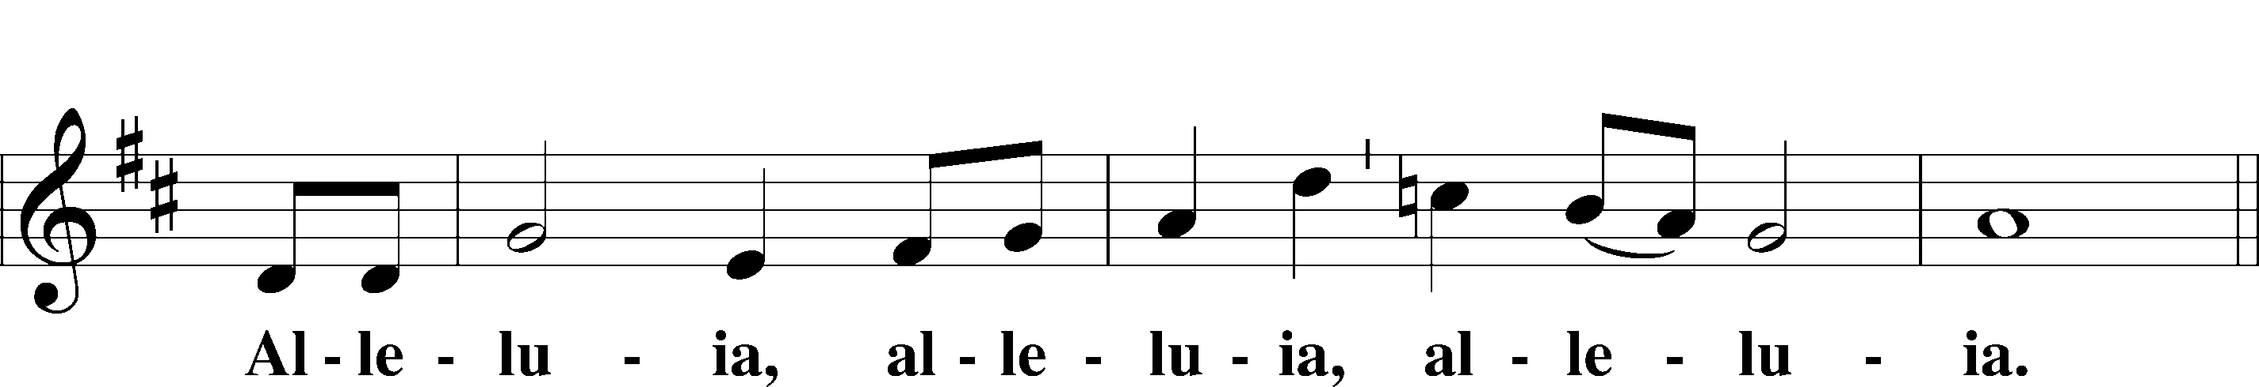
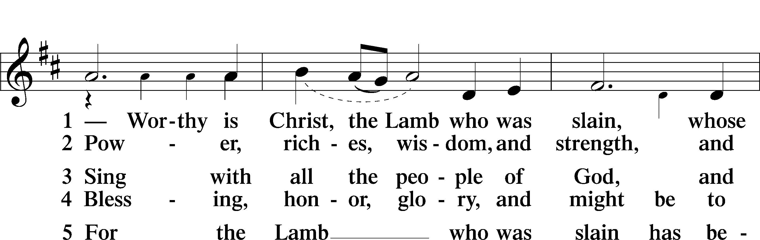
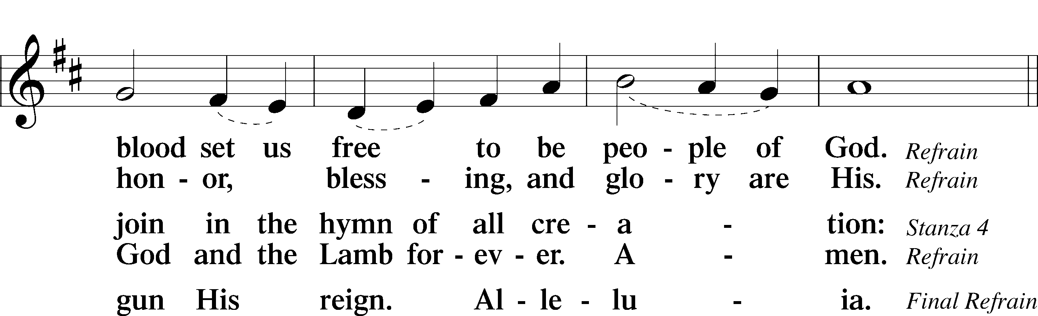
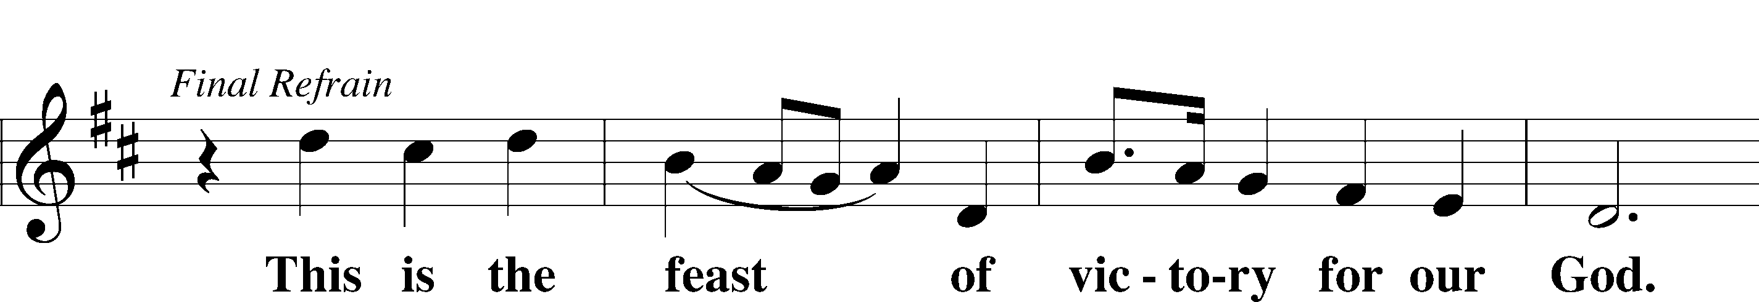
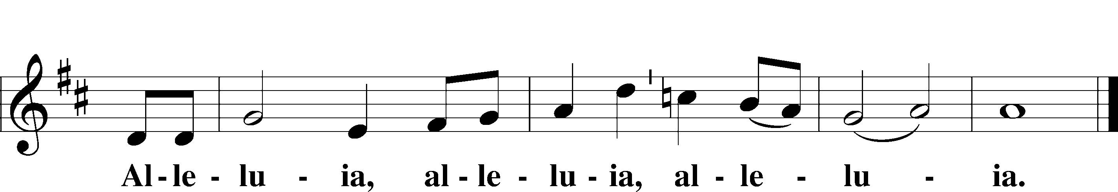

Salutation and Collect of the Day
P The Lord be with you.
C And also with you.
P Let us pray.
O Lord, keep Your Church in Your perpetual mercy; and because without You we cannot but fall, preserve us from all things hurtful, and lead us to all things profitable to our salvation; through Jesus Christ, Your Son, our Lord, who lives and reigns with You and the Holy Spirit, one God, now and forever.

C Amen.

Sit

Old Testament Reading Amos 8:4–7
4Hear this, you who trample on the needy
and bring the poor of the land to an end,
5saying, “When will the new moon be over,
that we may sell grain?
And the Sabbath,
that we may offer wheat for sale,
that we may make the ephah small and the shekel great
and deal deceitfully with false balances,
6that we may buy the poor for silver
and the needy for a pair of sandals
and sell the chaff of the wheat?”
7The Lord has sworn by the pride of Jacob:
“Surely I will never forget any of their deeds.”

A This is the Word of the Lord.
C Thanks be to God.

Psalm Psalm 113; antiphon: v. 3
1Praise the Lord!
Praise, O servants | of the Lord,*
praise the name | of the Lord!
2Blessèd be the name | of the Lord*
from this time forth and for- | evermore!
3From the rising of the sun to its | setting,*
the name of the Lord is | to be praised!
4The Lord is high above all | nations,*
and his glory above the | heavens!
5Who is like the | Lord our God,*
who is seated | on high,
6who looks | far down*
on the heavens | and the earth?
7He raises the poor | from the dust*
and lifts the needy from the | ash heap,
8to make them sit with | princes,*
with the princes of his | people.
9He gives the barren wom- | an a home,*
making her the joyous mother
of children. | Praise the Lord!

Epistle 1 Timothy 2:1–15
1First of all, then, I urge that supplications, prayers, intercessions, and thanksgivings be made for all people, 2for kings and all who are in high positions, that we may lead a peaceful and quiet life, godly and dignified in every way. 3This is good, and it is pleasing in the sight of God our Savior, 4who desires all people to be saved and to come to the knowledge of the truth. 5For there is one God, and there is one mediator between God and men, the man Christ Jesus, 6who gave himself as a ransom for all, which is the testimony given at the proper time. 7For this I was appointed a preacher and an apostle (I am telling the truth, I am not lying), a teacher of the Gentiles in faith and truth.
8I desire then that in every place the men should pray, lifting holy hands without anger or quarreling; 9likewise also that women should adorn themselves in respectable apparel, with modesty and self-control, not with braided hair and gold or pearls or costly attire, 10but with what is proper for women who profess godliness—with good works. 11Let a woman learn quietly with all submissiveness. 12I do not permit a woman to teach or to exercise authority over a man; rather, she is to remain quiet. 13For Adam was formed first, then Eve; 14and Adam was not deceived, but the woman was deceived and became a transgressor. 15Yet she will be saved through childbearing—if they continue in faith and love and holiness, with self-control.

A This is the Word of the Lord.
C Thanks be to God.

Stand

Alleluia and Verse

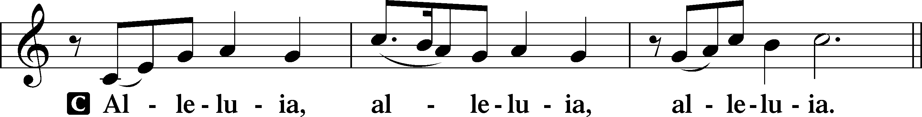

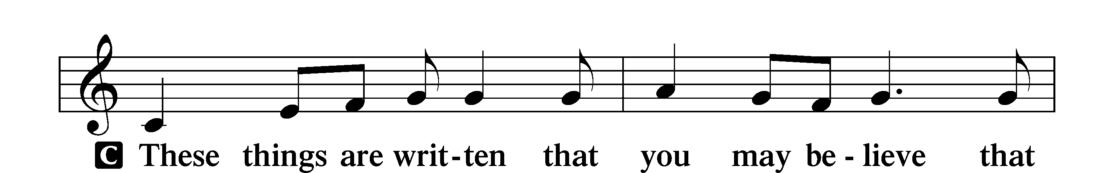
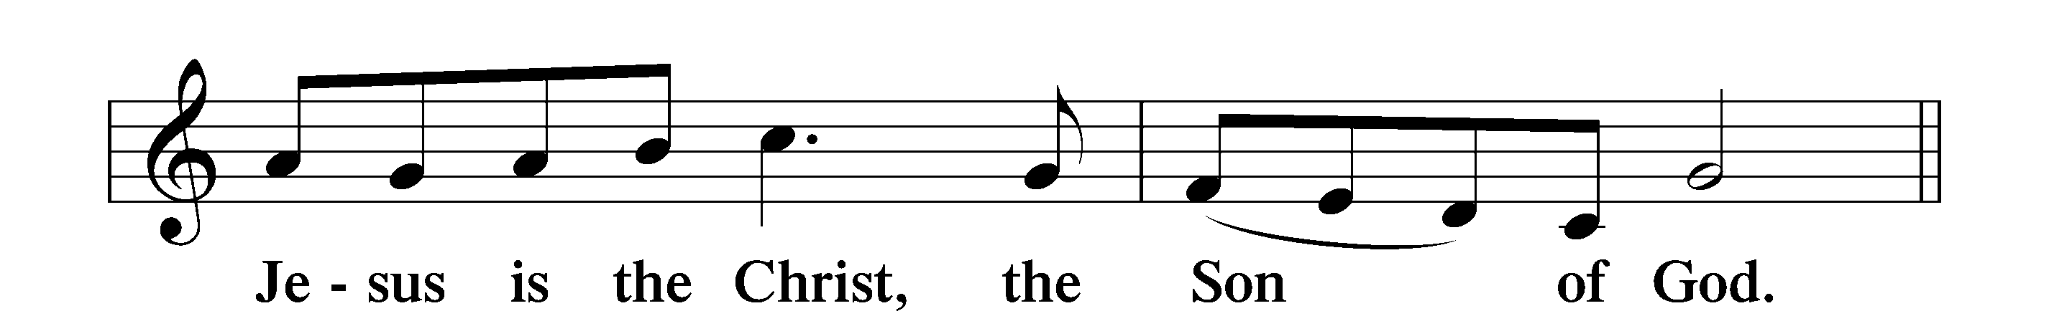

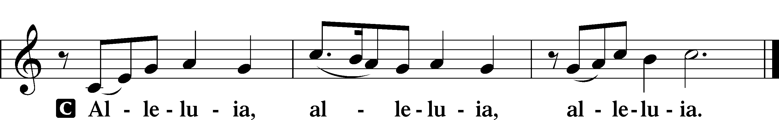

Holy Gospel Luke 16:1–15
P The Holy Gospel according to St. Luke, the sixteenth chapter.
C Glory to You, O Lord.

1[Jesus] also said to the disciples, “There was a rich man who had a manager, and charges were brought to him that this man was wasting his possessions. 2And he called him and said to him, ‘What is this that I hear about you? Turn in the account of your management, for you can no longer be manager.’ 3And the manager said to himself, ‘What shall I do, since my master is taking the management away from me? I am not strong enough to dig, and I am ashamed to beg. 4I have decided what to do, so that when I am removed from management, people may receive me into their houses.’ 5So, summoning his master’s debtors one by one, he said to the first, ‘How much do you owe my master?’ 6He said, ‘A hundred measures of oil.’ He said to him, ‘Take your bill, and sit down quickly and write fifty.’ 7Then he said to another, ‘And how much do you owe?’ He said, ‘A hundred measures of wheat.’ He said to him, ‘Take your bill, and write eighty.’ 8The master commended the dishonest manager for his shrewdness. For the sons of this world are more shrewd in dealing with their own generation than the sons of light. 9And I tell you, make friends for yourselves by means of unrighteous wealth, so that when it fails they may receive you into the eternal dwellings.
10“One who is faithful in a very little is also faithful in much, and one who is dishonest in a very little is also dishonest in much. 11If then you have not been faithful in the unrighteous wealth, who will entrust to you the true riches? 12And if you have not been faithful in that which is another’s, who will give you that which is your own? 13No servant can serve two masters, for either he will hate the one and love the other, or he will be devoted to the one and despise the other. You cannot serve God and money.”
14The Pharisees, who were lovers of money, heard all these things, and they ridiculed him. 15And he said to them, “You are those who justify yourselves before men, but God knows your hearts. For what is exalted among men is an abomination in the sight of God.”

P This is the Gospel of the Lord.
C Praise to You, O Christ.

Sit
708 Lord, Thee I Love with All My Heart
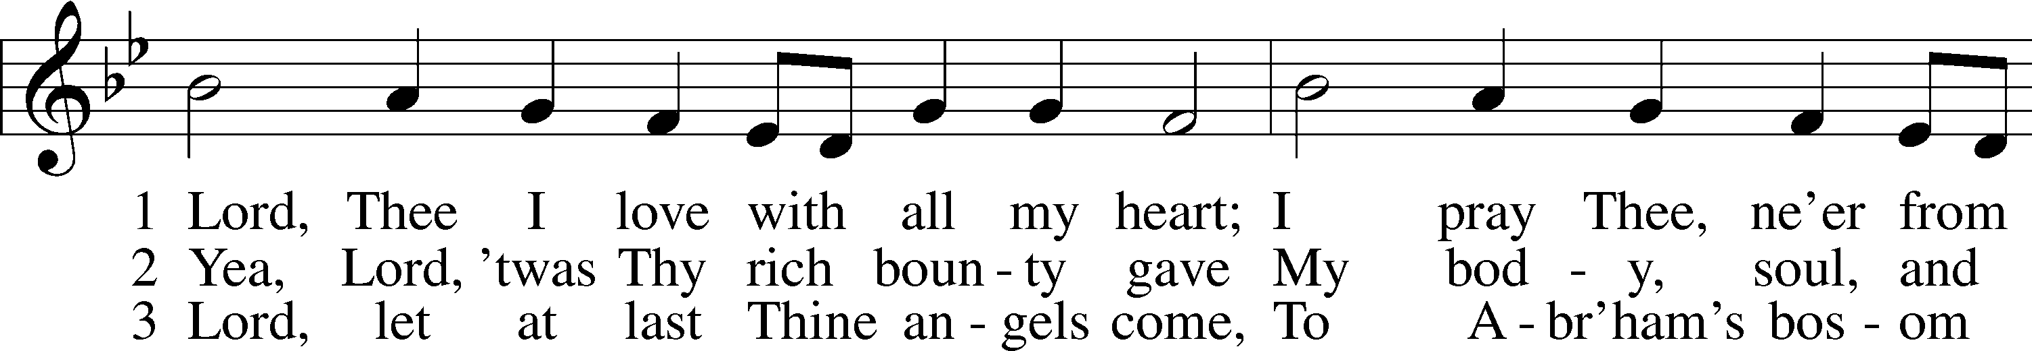
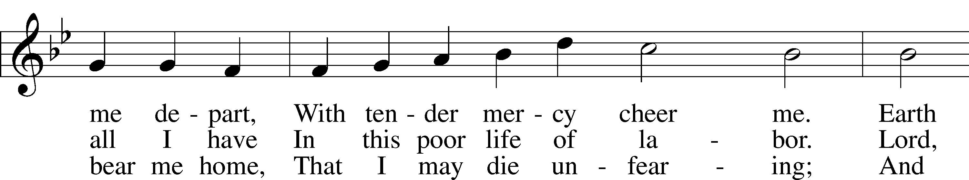
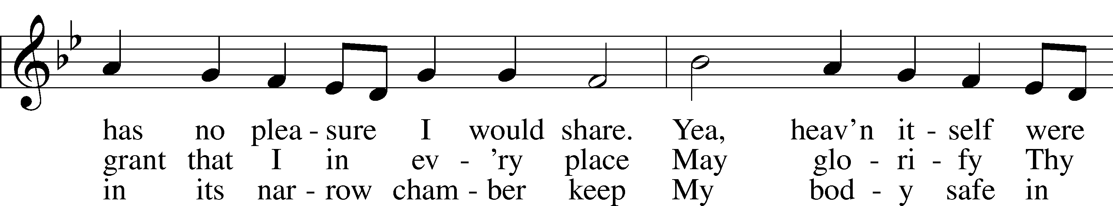
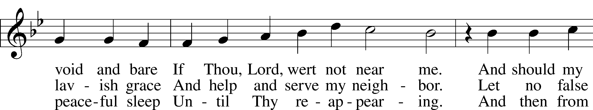
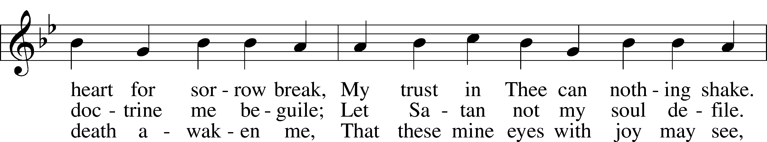
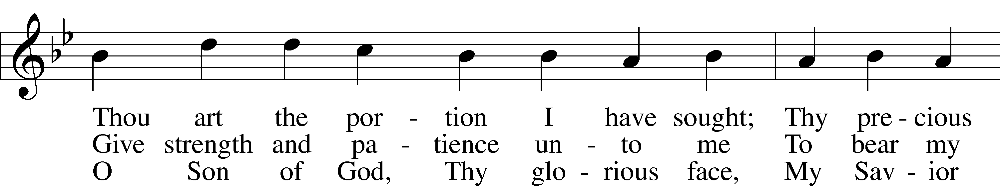
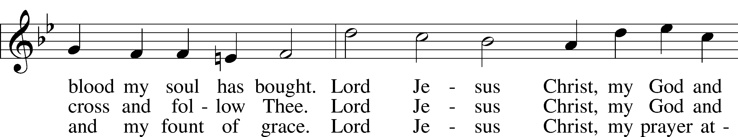
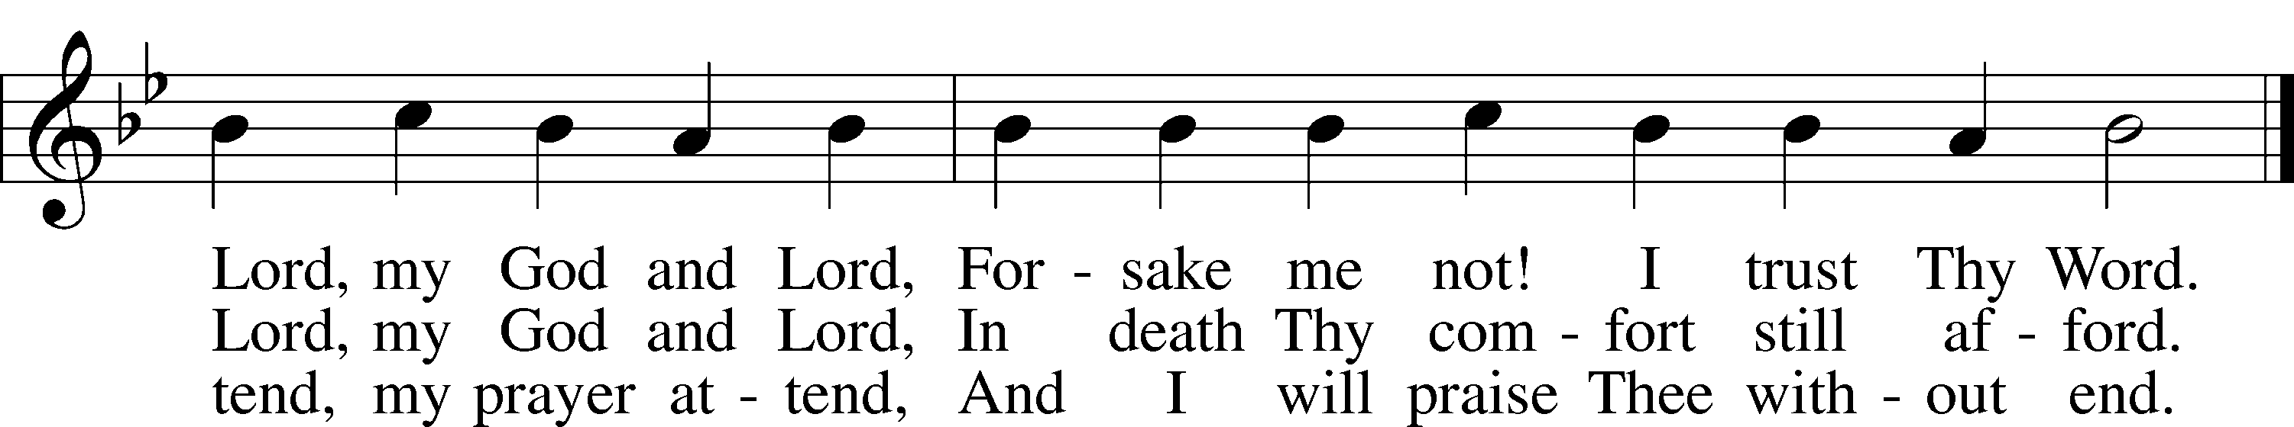
Text: Martin Schalling, 1532–1608; tr. Catherine Winkworth, 1827–78, alt.
Tune: Zwey Bücher . . . Tabulatur, 1577, Strassburg
Text and tune: Public domain

Sermon

Stand

Apostles’ Creed
C I believe in God, the Father Almighty, maker of heaven and earth.

And in Jesus Christ, His only Son, our Lord,
who was conceived by the Holy Spirit, born of the virgin Mary,
suffered under Pontius Pilate, was crucified, died and was buried.
He descended into hell.
The third day He rose again from the dead.
He ascended into heaven
and sits at the right hand of God the Father Almighty.
From thence He will come to judge the living and the dead.

I believe in the Holy Spirit, the holy Christian Church,
the communion of saints, the forgiveness of sins,
the resurrection of the body, and the life T everlasting. Amen.

Prayer of the Church & Sharing of the Peace

Following the prayers, the people may greet one another in the name of the Lord, saying,
“Peace be with you,” as a sign of reconciliation and of the unity of the Spirit in the bond of peace
(Matt. 5:22–24; Eph. 4:1–3).

Sit

Offering

Offertory LSB 159
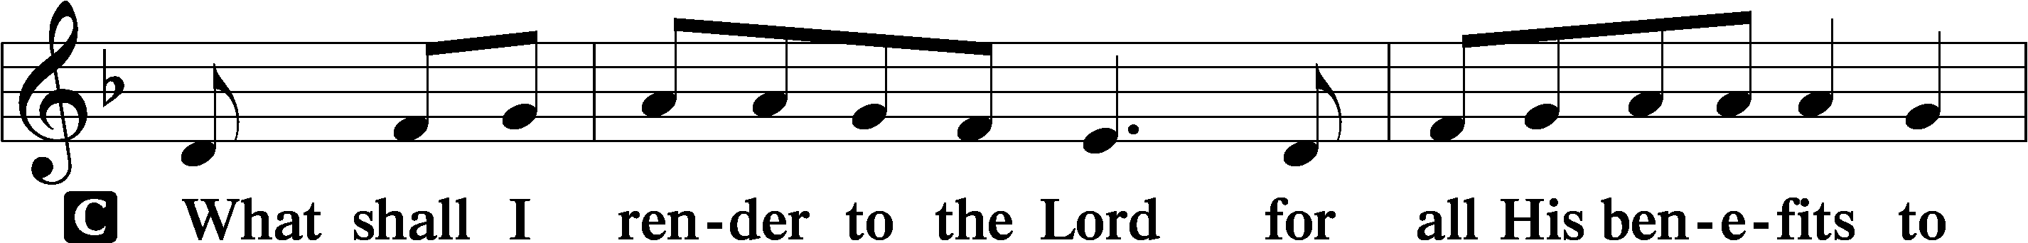
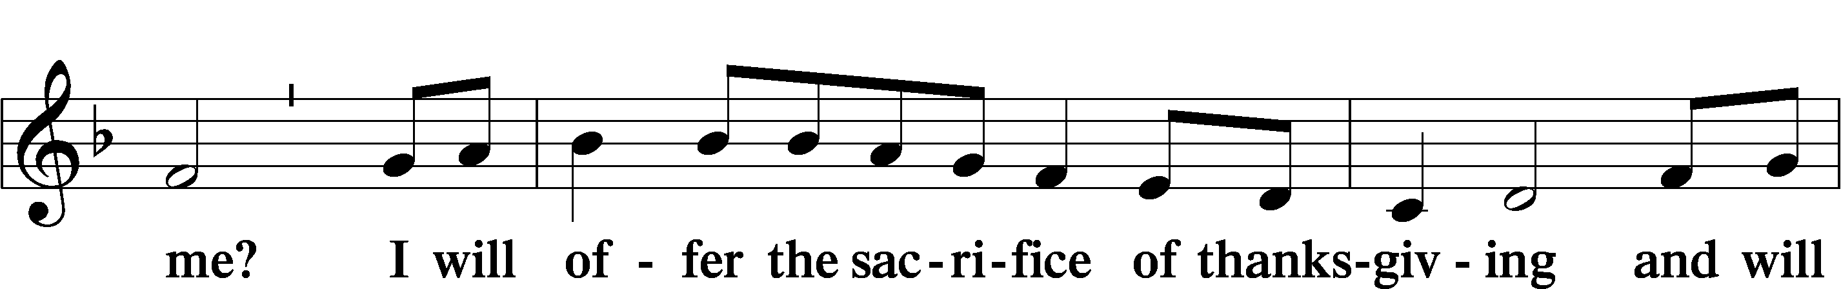
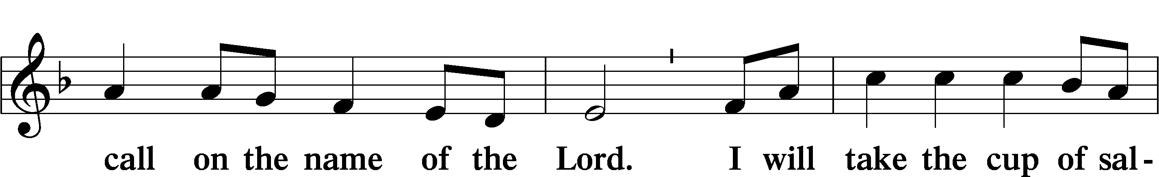
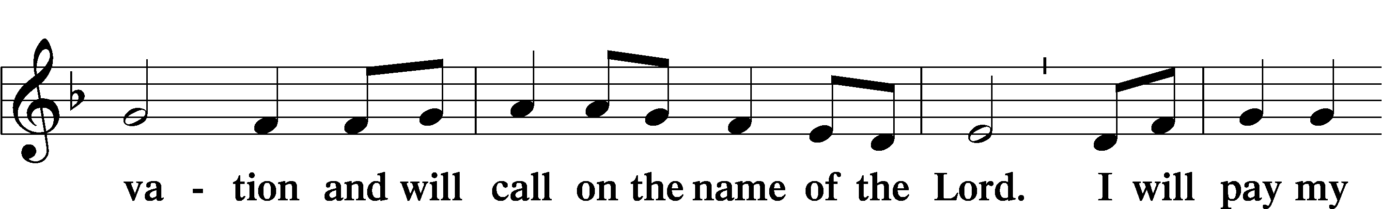
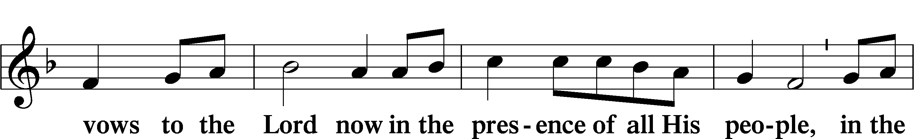
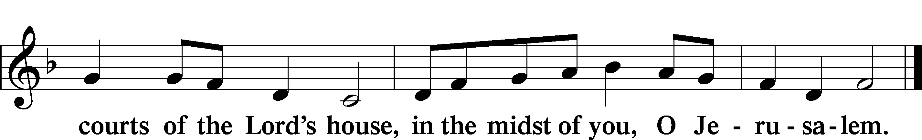



Service of Holy Communion
Communion Statement

The Lord’s Supper is celebrated at this congregation in the confession and glad confidence that, as He says, our Lord gives into our mouths not only bread and wine but His very body and blood to eat and to drink for the forgiveness of sins and to strengthen our union with Him and with one another. Our Lord invites to His table those who trust His words, repent of all sin, and set aside any refusal to forgive and love as He forgives and loves us, that they may show forth His death until He comes.

Because those who eat and drink our Lord’s body and blood unworthily do so to their great harm and because Holy Communion is a confession of the faith which is confessed at this altar, any who are not yet instructed, in doubt, or who hold a confession differing from that of this congregation and the Lutheran Church Missouri Synod, and yet desire to receive this sacrament, are asked to speak with the Pastor.
* See more about the Lutheran teaching on communion in the Hymnal p 329.

Stand
Preface LSB 208

P The Lord be with you.
C And also with you.
P Lift up your hearts.
C We lift them to the Lord.
P Let us give thanks to the Lord our God.
C It is right to give Him thanks and praise.
P It is truly good, right, and salutary that we should at all times and in all places give thanks to You, O Lord, holy Father, almighty and everlasting God, for the countless blessings You so freely bestow on us and all creation. Above all, we give thanks for Your boundless love shown to us when You sent Your only-begotten Son, Jesus Christ, into our flesh and laid on Him our sin, giving Him into death that we might not die eternally. Because He is now risen from the dead and lives and reigns to all eternity, all who believe in Him will overcome sin and death and will rise again to new life. Therefore with angels and archangels and with all the company of heaven we laud and magnify Your glorious name, evermore praising You and saying:

Sanctus LSB 208
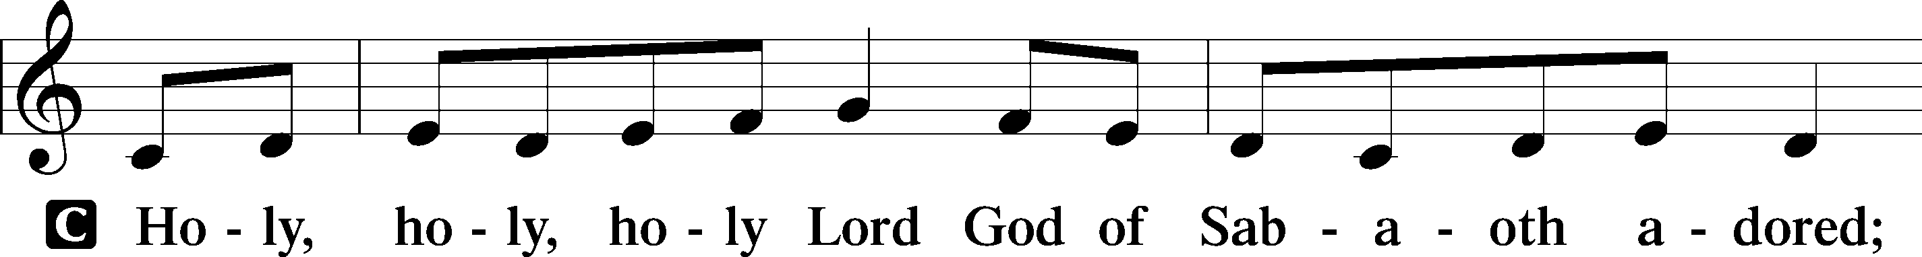
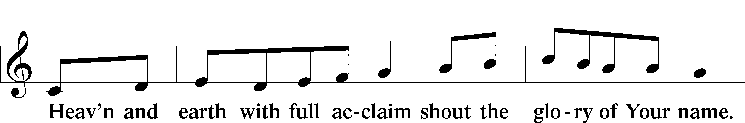
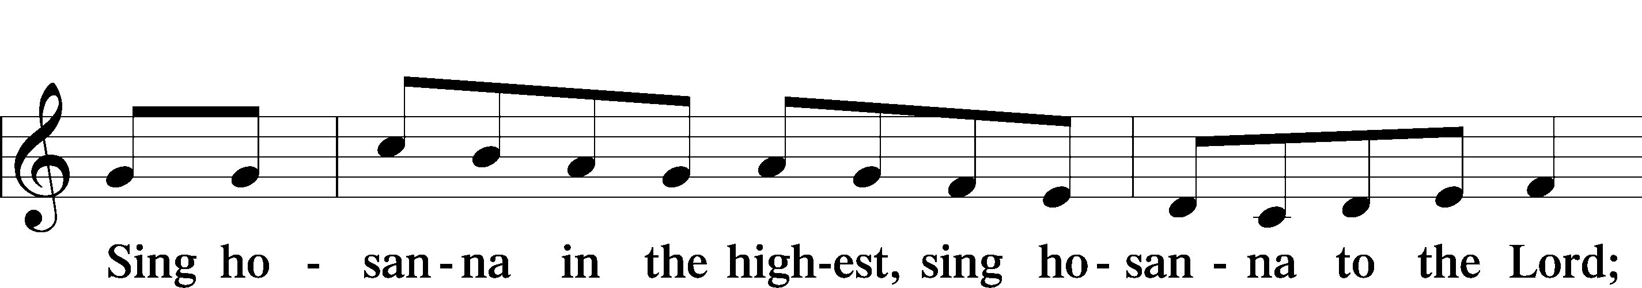
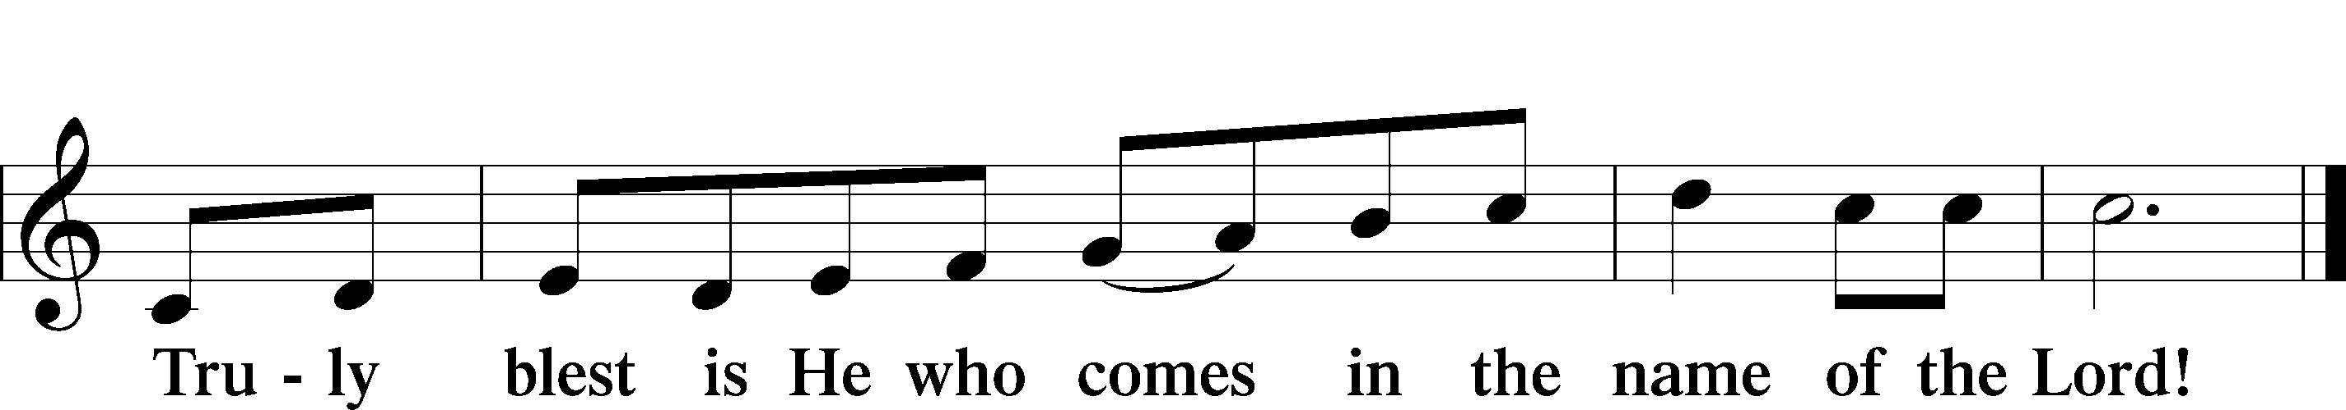
Text: Stephen P. Starke

Prayer of Thanksgiving
P Blessed are You, O Lord our God, king of all creation, for You have had mercy on us and given Your only-begotten Son that whoever believes in Him should not perish but have eternal life.

In Your righteous judgment You condemned the sin of Adam and Eve, who ate the forbidden fruit, and You justly barred them and all their children from the tree of life. Yet, in Your great mercy, You promised salvation by a second Adam, Your Son, Jesus Christ, our Lord, and made His cross a life-giving tree for all who trust in Him.

We give You thanks for the redemption You have prepared for us through Jesus Christ. Grant us Your Holy Spirit that we may faithfully eat and drink of the fruits of His cross and receive the blessings of forgiveness, life, and salvation that come to us in His body and blood.

Hear us as we pray in His name and as He has taught us:

Lord’s Prayer
C Our Father who art in heaven, hallowed be Thy name,
Thy kingdom come, Thy will be done on earth as it is in heaven;
give us this day our daily bread; and forgive us our trespasses
as we forgive those who trespass against us;
and lead us not into temptation, but deliver us from evil.
For Thine is the kingdom and the power and the glory
forever and ever. Amen.

The Words of Our Lord
P Our Lord Jesus Christ, on the night when He was betrayed, took bread, and when He had given thanks, He broke it and gave it to the disciples and said: “Take, eat; this is My T body, which is given for you. This do in remembrance of Me.”

In the same way also He took the cup after supper, and when He had given thanks, He gave it to them, saying: “Drink of it, all of you; this cup is the new testament in My T blood, which is shed for you for the forgiveness of sins. This do, as often as you drink it, in remembrance of Me.”

Pax Domini
P The peace of the Lord be with you always.
C Amen.

Agnus Dei LSB 210
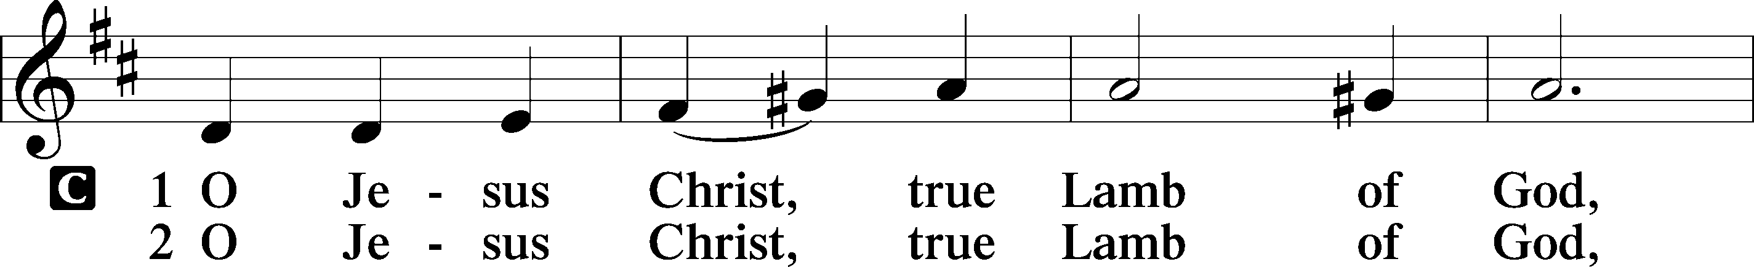
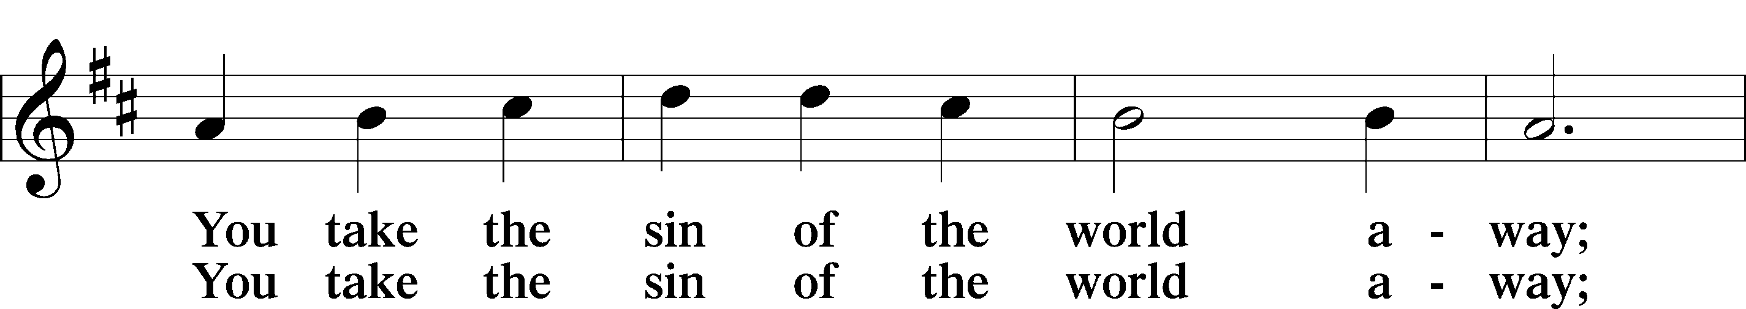
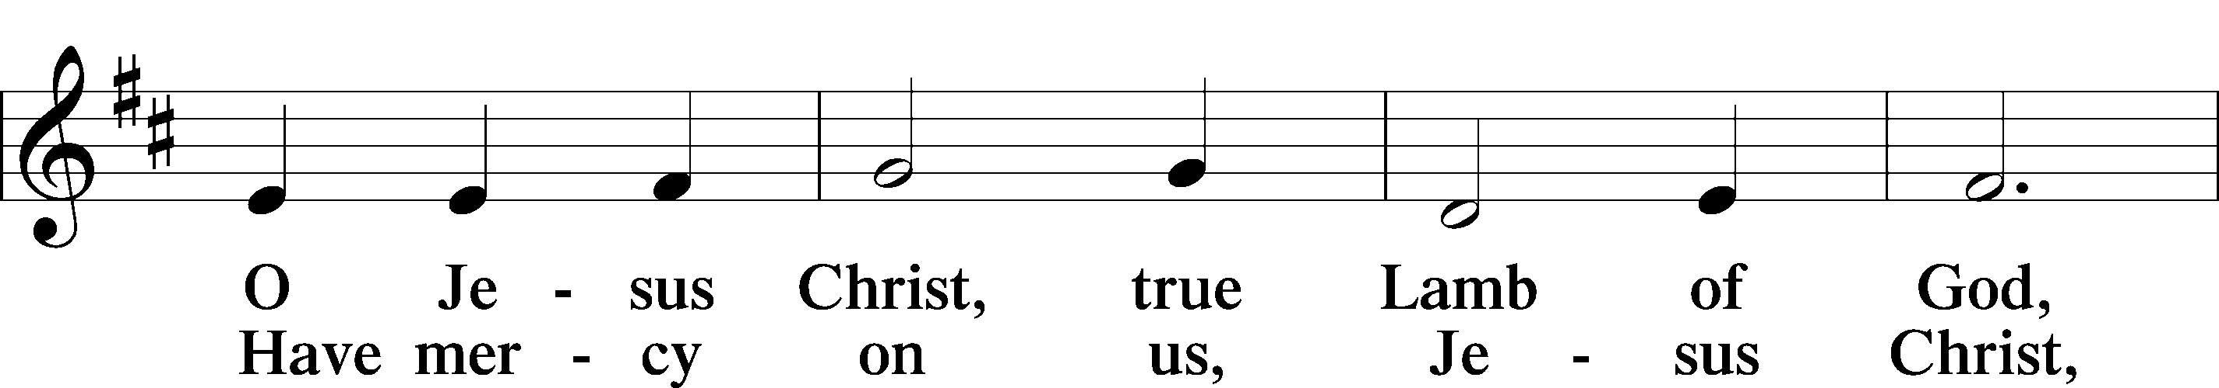
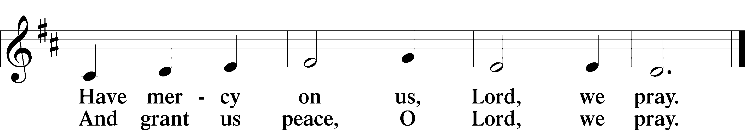
Text: Stephen P. Starke

Sit



Distribution Hymn
619 Thy Body, Given for Me, O Savior
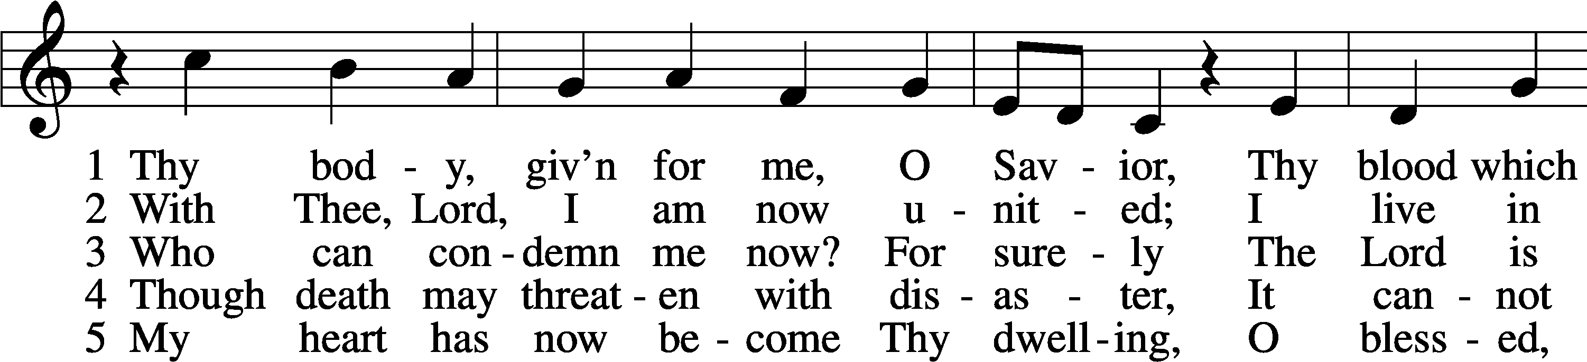
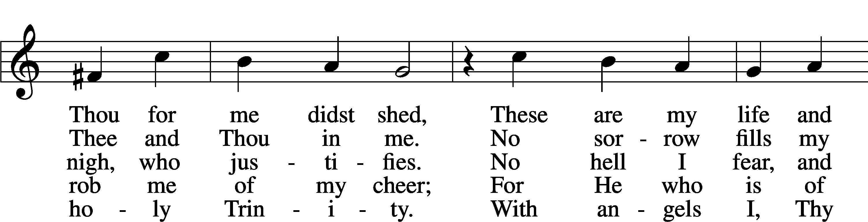
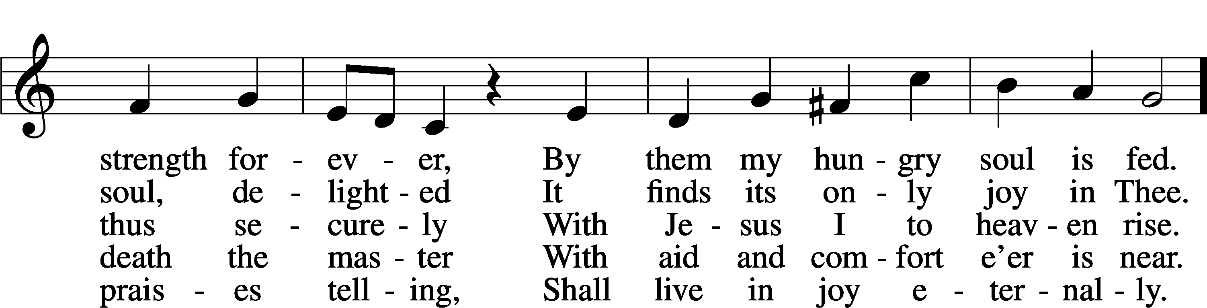
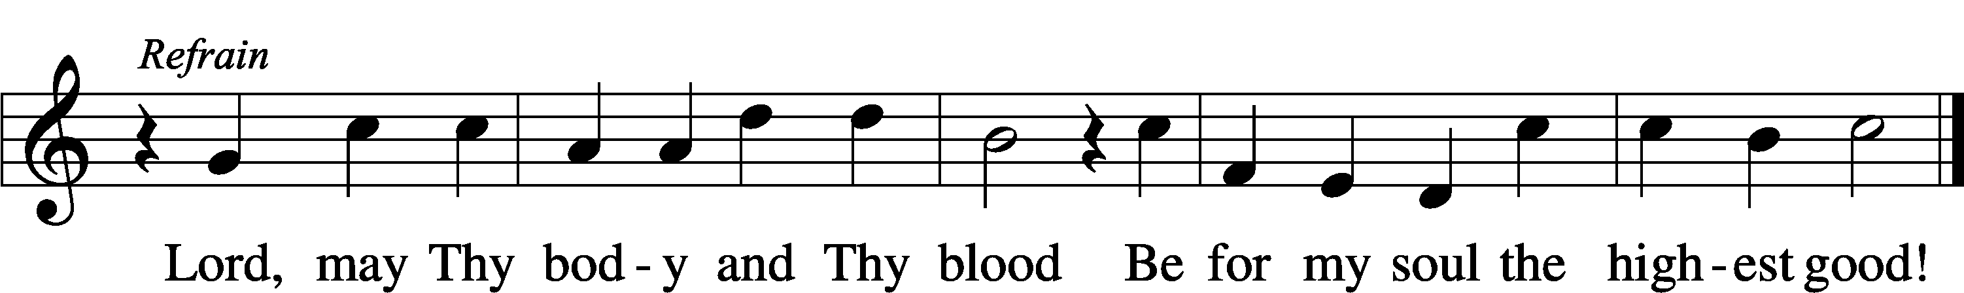
Text: Friedrich Christian Heyder, 1677–1754; tr. The Lutheran Hymnal, 1941, abr.
Tune: Emskirchner Choral-Buch, 1756, Leipzig
Text: © 1941 Concordia Publishing House. Used by permission: LSB Hymn License no. 110003995
Tune: Public domain

Stand
Nunc Dimittis LSB 211
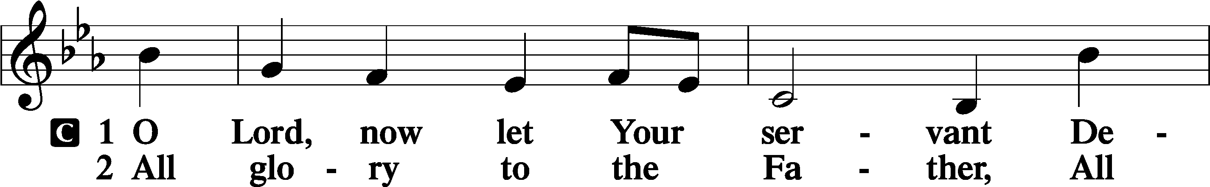
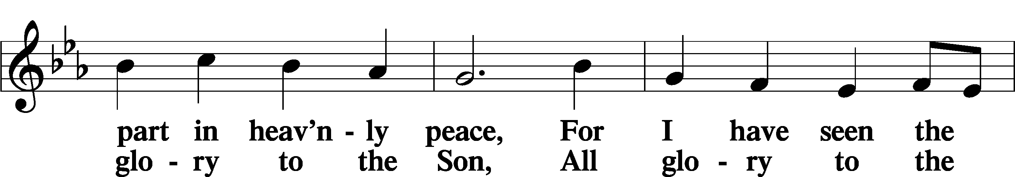
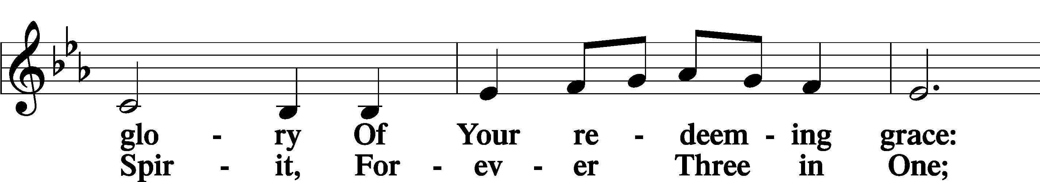
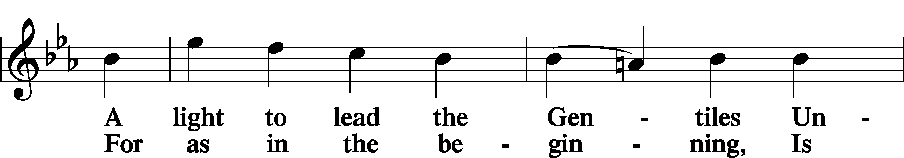
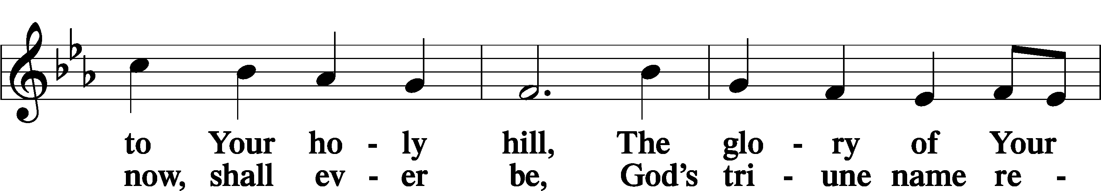
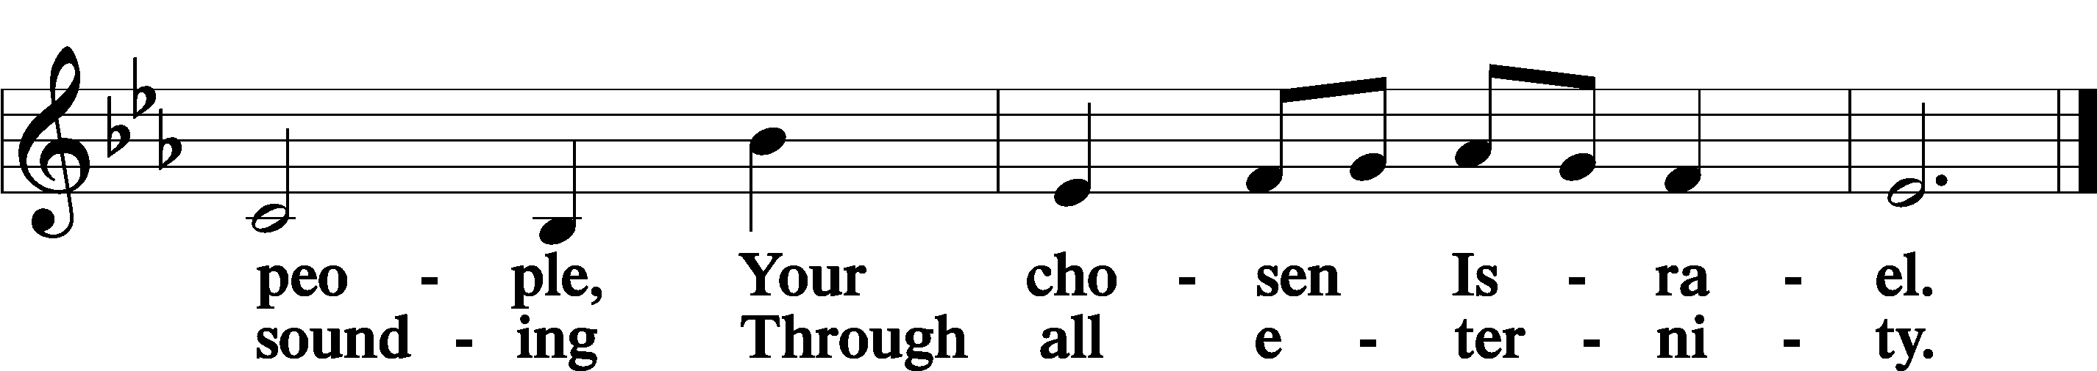

Post-Communion Collect
A Let us pray.
We give thanks to You, almighty God, that You have refreshed us through this salutary gift, and we implore You that of Your mercy You would strengthen us through the same in faith toward You and in fervent love toward one another; through Jesus Christ, Your Son, our Lord, who lives and reigns with You and the Holy Spirit, one God, now and forever.
C Amen.

Verse of the Day 1 Timothy 2:5–6a
A Alleluia! For there is one God, and there is one mediator between God and men,
C the man Christ Jesus, who gave himself as a ransom for all. Alleluia!

Benedicamus LSB 212
A Let us bless the Lord.
C Thanks be to God.

Benediction
P The Lord bless you and keep you.
The Lord make His face shine on you and be gracious to you.
The Lord look upon you with favor and T give you peace.
C Amen.

730 What Is the World to Me
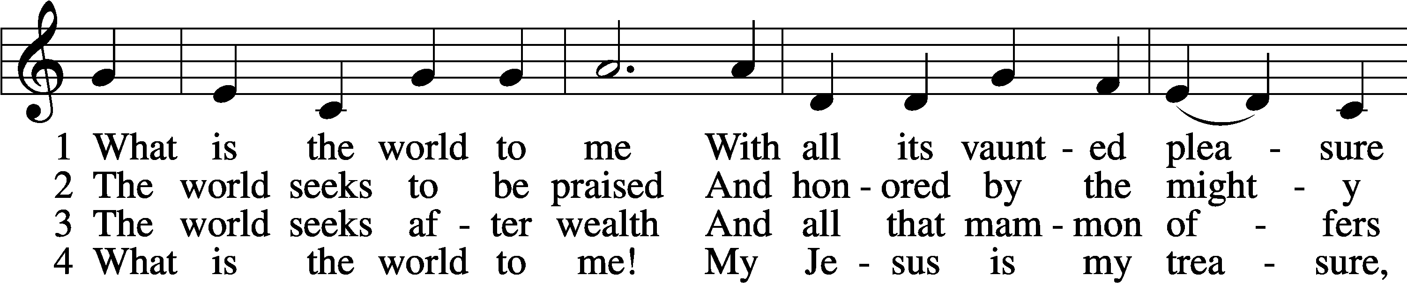
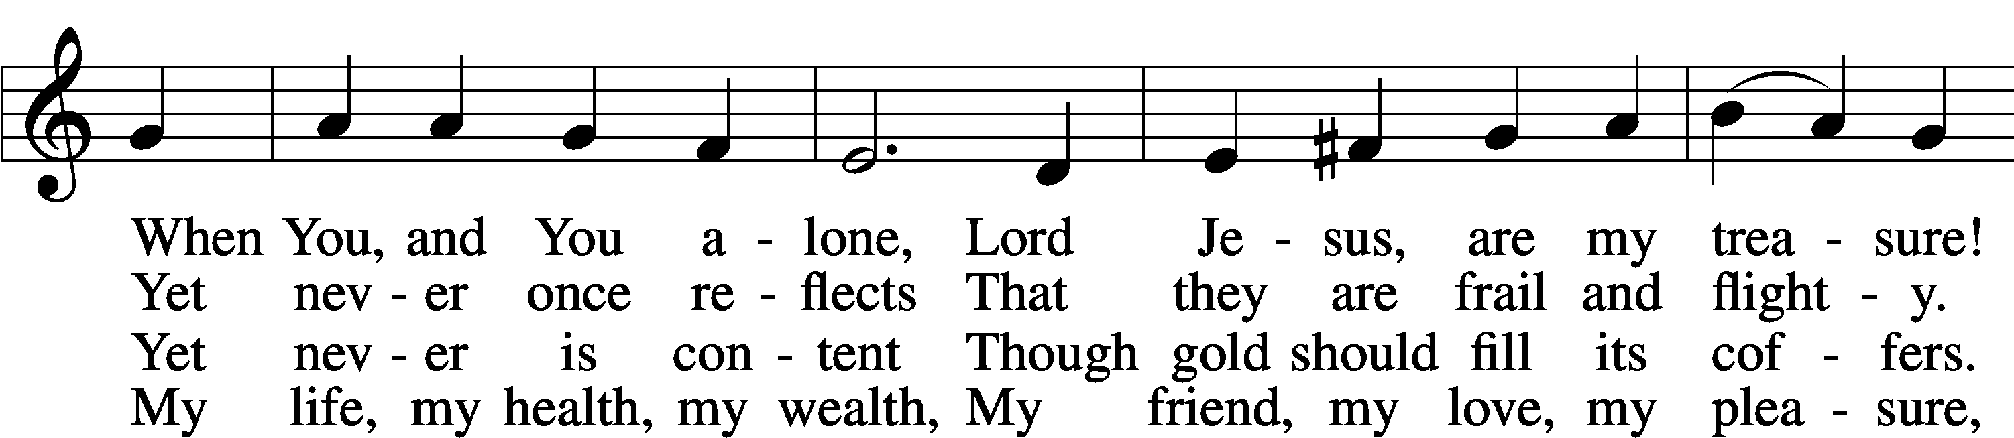
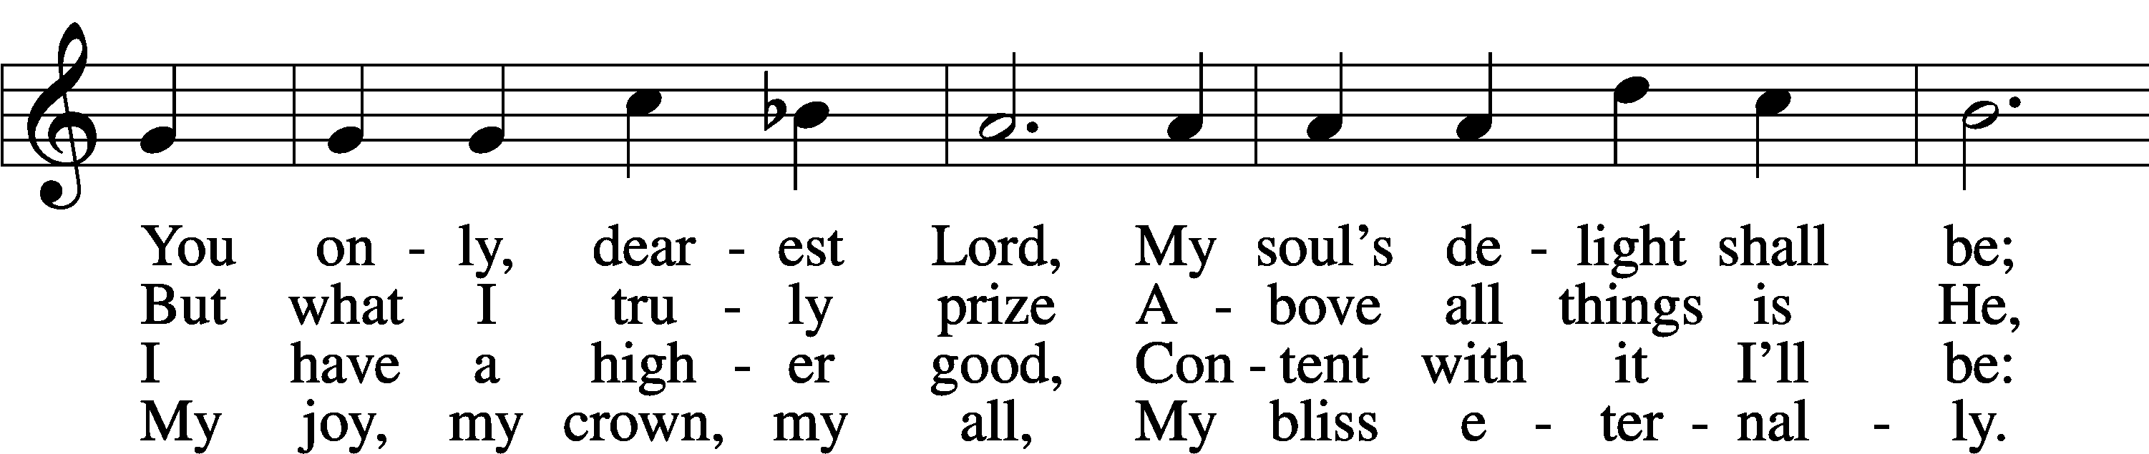
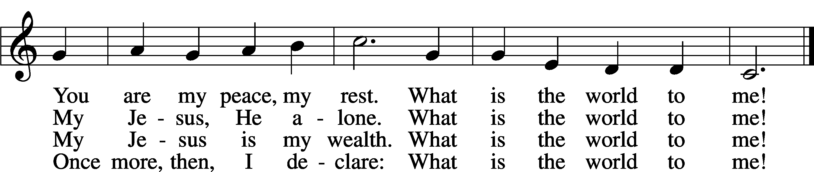
Text: Georg Michael Pfefferkorn, 1645–1732; tr. August Crull, 1845–1923, alt.
Tune: Ahasverus Fritsch, 1629–1701
Text and tune: Public domain

Acknowledgments Divine Service, Setting Four from Lutheran Service Book Unless otherwise indicated, Scripture quotations are from the ESV® Bible (The Holy Bible, English Standard Version®), copyright © 2001 by Crossway, a publishing ministry of Good News Publishers. Used by permission. All rights reserved. Created by Lutheran Service Builder © 2025 Concordia Publishing House.

Prayers of the Church
This week, we lift up:

Angela H, Sheila, Elaine, Bob, Angie Z, Angela C, Ross, & Kathy H.

Family of the week: Joanna Ryan

*If you have any prayer request let us know.

Last week: Attendance 35 Offering $1620

Serving Next Week (9/28/25)  Service Leader: Vicar Previn Hudetz  Communion Celebrant: Rev John Heffelfinger  Worship Assistant: TBD  Reader: Sheila S  Refreshments: Angie Z  Altar Guild: Angie Z & Sheila S  Greeter: Mike Y | Readings Next Week  Sixteenth Sunday after Pentecost  - Amos 6:1-7  - Psalm 146 antiphon v.2  - 1 Timothy 3:1-13  - Luke 16:19-31  *Please sign up to help during service.*
Announcements  Birthdays: Ross D – 22nd & Paul T – 26th  This Week at OSLC:  Bible Study: After Service  Bible Study: Thursday 10am | Coming Up:  Congregational Meeting to confirm & elect Council Members.  September 28, 2025  Following service

Council Positions for 9/28/25 vote

New
President: Jim Chmelicek
Spiritual Life & Worship: Pastor John Heffelfinger

Reinstall
Treasurer: Rebecca Haulenbeek
Secretary & Christian Education: Sheila Small
Finance & Stewardship: Tania Vigil

Open
Outreach
Property & Maintenance


Accepting donations of non perishable food. Please leave in boxes by front door.
All gifts are appreciated.

Please consider signing up to help

During Service-
Readers
Altar Set up (Communion)
Worship Assistant (Candles, Usher)
Greeter (Welcome and hand out bulletins)
Refreshments
Coffee Set up (Barista)

General
Finish Shed’s
Trash around property
Weeding
Backing on Banners
Preparing Baptismal Banners



