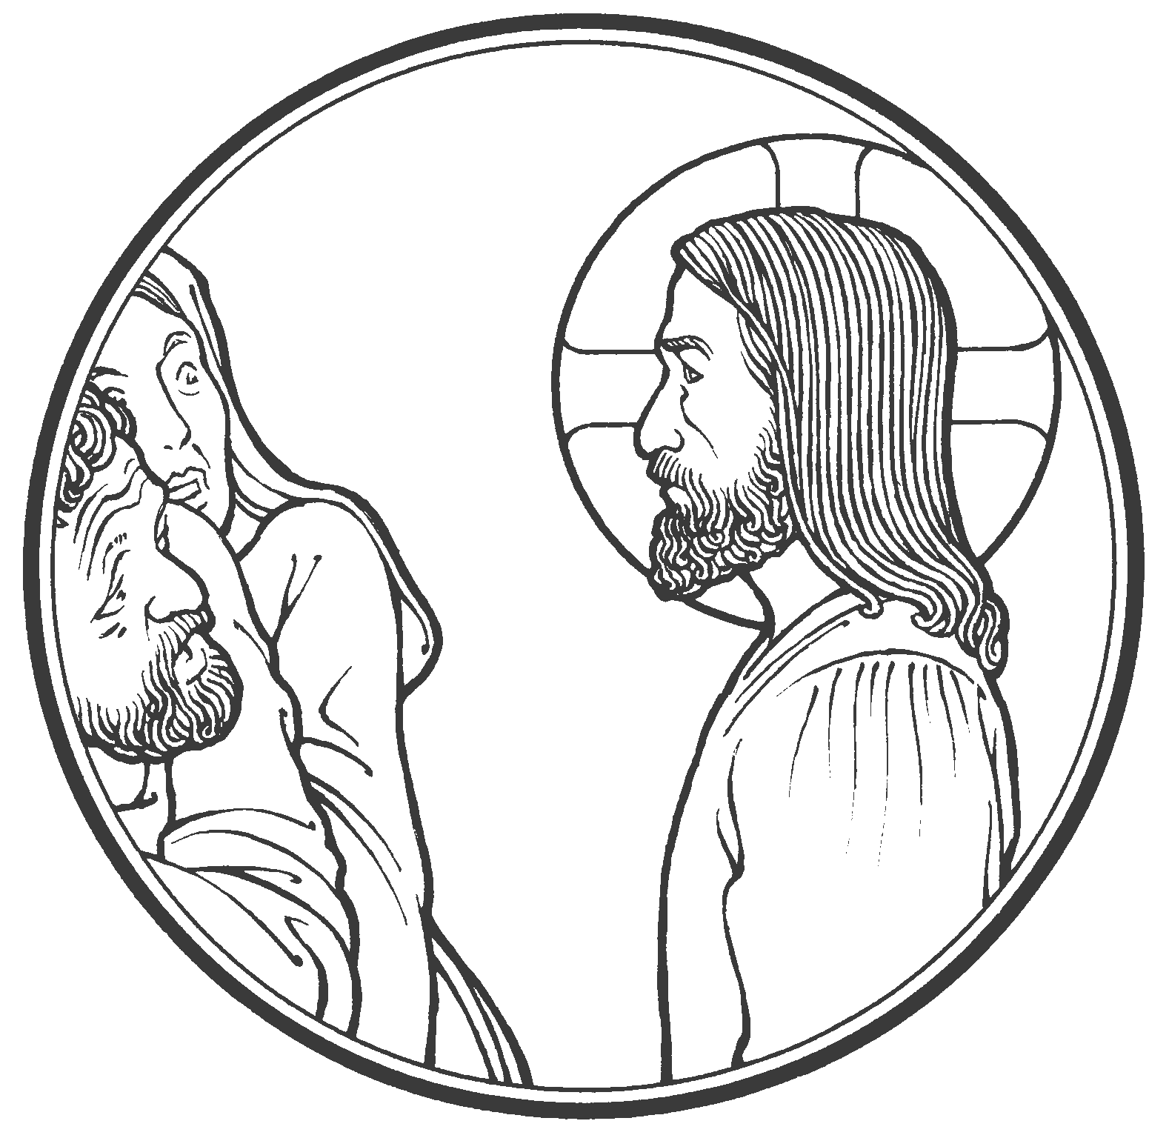

Do You think that I have come to give peace on earth?
No, I tell you, but rather division.
Luke 12:51

Our Savior Lutheran Church (LCMS)
4301 Atrisco Drive NW
Albuquerque, New Mexico
Website: OSLCNM.COM
Phone: 505.836.7007
Email: oslcabq@gmail.com

Tenth Sunday after Pentecost
August 17th,2025
The Time of the Church (Trinitytide)
Tenth Sunday after Pentecost
August17th, 2025

Welcome to Our Savior Lutheran Church (LCMS).  We are glad you are here as we worship, praise, and give thanks to our loving Lord, Jesus Christ. Please join us immediately after service for fellowship and snacks. Adult Bible Study starts at 10:30. If you have any questions about our service or need other assistance, please contact one of our worship assistants. | Hymns  Opening # 905  Sermon # 702  Distribution # Because He Lives  Closing # 804

Today’s Message

Deceptive prophecies are wicked. God will execute judgment on those whose counsels mitigate God’s Word! The refrain for the covenant people of God is faith! They whole heartedly believe exactly what the Lord says and count on His deliverance generation after generation. Jesus desires to reveal not only judgment but also grace through His cross. Faith alone comprehends the impact of Law and Gospel. Faith clings to Christ and repels all wickedness and deceit.

+++
Serving Today
Service Leader: Vicar Previn Hudetz
Communion Celebrant: Rev John Heffelfinger
Worship Assistant: Mike Y
Reader: Angie Z & Sheila S
Refreshments: Juanita
Altar Guild: Angie Z & Sheila S
Greeter: Bob

Welcome
Divine Service IV
905 Come, Thou Almighty King
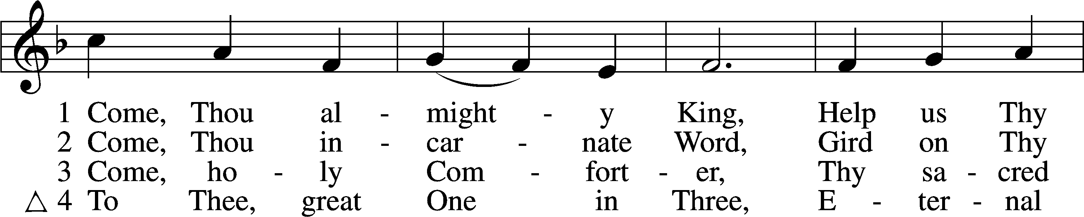
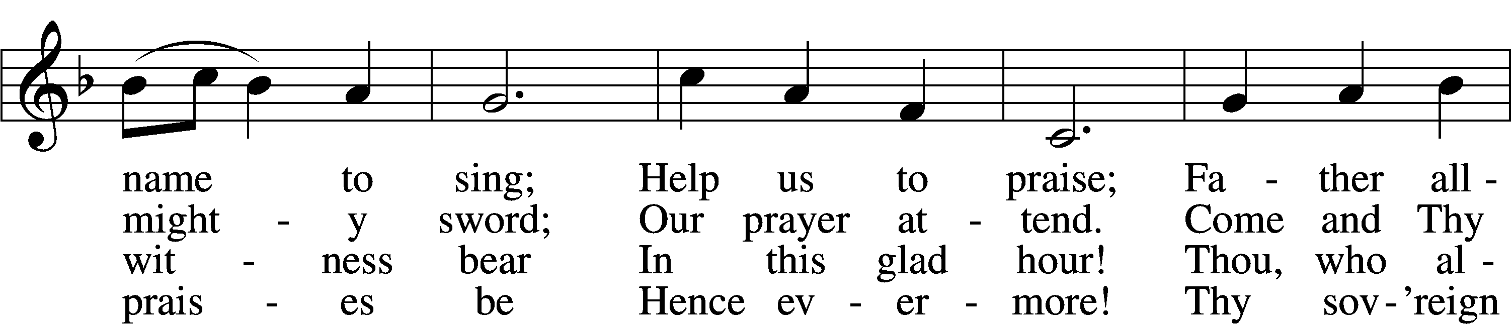
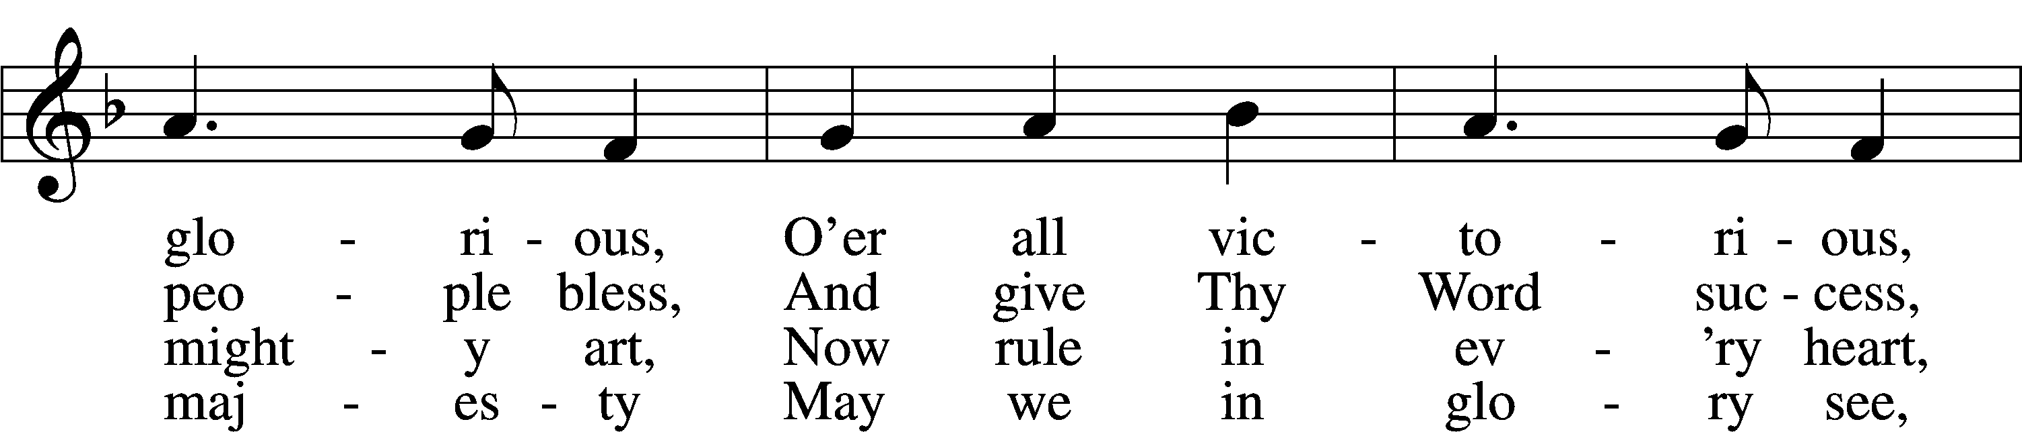
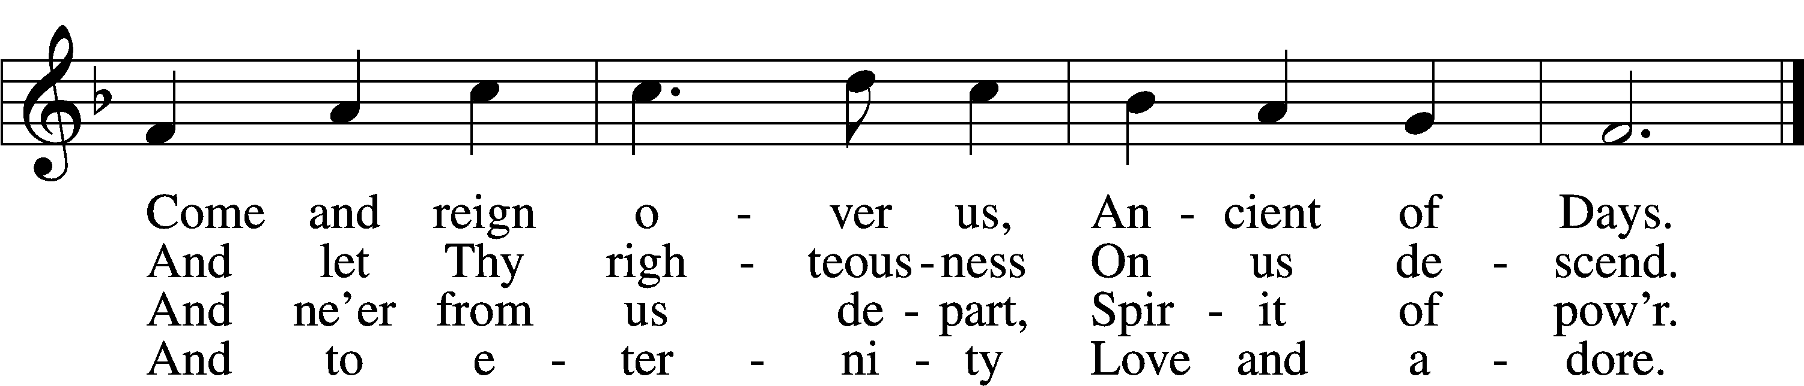
Text: English, before 1760, alt. Tune: Felice de Giardini, 1716–96 Text and tune: Public domain


Confession and Absolution
The sign of the cross may be made by all in remembrance of their Baptism.

P In the name of the Father and of the T Son and of the Holy Spirit.
C Amen.

P Our help is in the name of the Lord,
C who made heaven and earth.

P If You, O Lord, kept a record of sins, O Lord, who could stand?
C But with You there is forgiveness; therefore You are feared.

P Since we are gathered to hear God’s Word, call upon Him in prayer and praise, and receive the body and blood of our Lord Jesus Christ in the fellowship of this altar, let us first consider our unworthiness and confess before God and one another that we have sinned in thought, word, and deed, and that we cannot free ourselves from our sinful condition. Together as His people let us take refuge in the infinite mercy of God, our heavenly Father, seeking His grace for the sake of Christ, and saying: God, be merciful to me, a sinner.

Pause for reflection...

C Almighty God, have mercy upon us, forgive us our sins, and lead us to everlasting life. Amen.

P Almighty God, in His mercy has given His Son to die for you and for His sake forgive you all you sins. As a called servant of Christ, and by His authority, I therefore forgive you all your sins in the name of the Father and of the T Son and of the Holy Spirit.
C Amen.

Service of the Word
Invitatory for Trinitytide
The Lord has sanctified us in the true faith
O come, let us worship Him.
Lord, teach me to do Your will.
Let Your good Spirit lead me on level ground.
Psalm 143:10
Introit Psalm 55:1, 12–14, 16; antiphon: v. 22
Cast your burden on the Lord, and he will sus- | tain you;*
he will never permit the righteous to | be moved.
Give ear to my prayer, | O God,*
and hide not yourself from my plea for | mercy!
For it is not an enemy who taunts me—then I could | bear it;*
it is not an adversary who deals insolently with me—then I could | hide from him.
But it is you, a man, my | equal,*
my companion, my fa- | miliar friend.
We used to take sweet counsel to- | gether;*
within God’s house we walked | in the throng.
But I | call to God,*
and the Lord will | save me.
Glory be to the Father and | to the Son*
and to the Holy | Spirit;
as it was in the be- | ginning,*
is now, and will be forever. | Amen.
Cast your burden on the Lord, and he will sus- | tain you;*
he will never permit the righteous to | be moved.
Kyrie 204

P In Peace, let us pray to the Lord
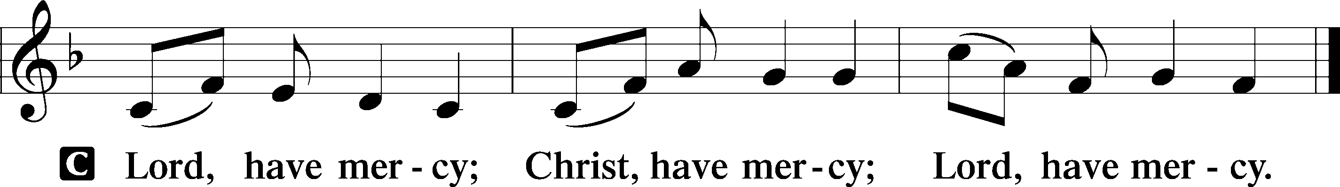
P For the peace of the whole world, for the well being of the Church of God and for the unity of all; let us pray to the Lord.

P For this holy House, and all who offer their worship and praise; let us pray to the Lord.

This Is the Feast LSB 155
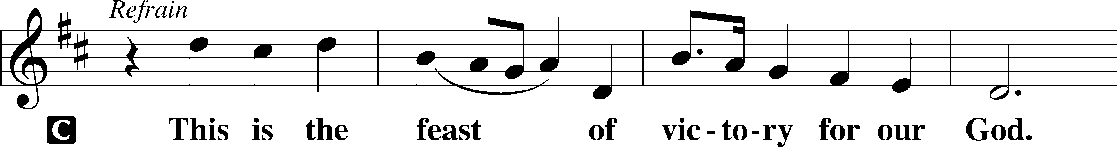
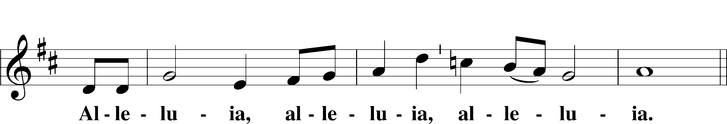
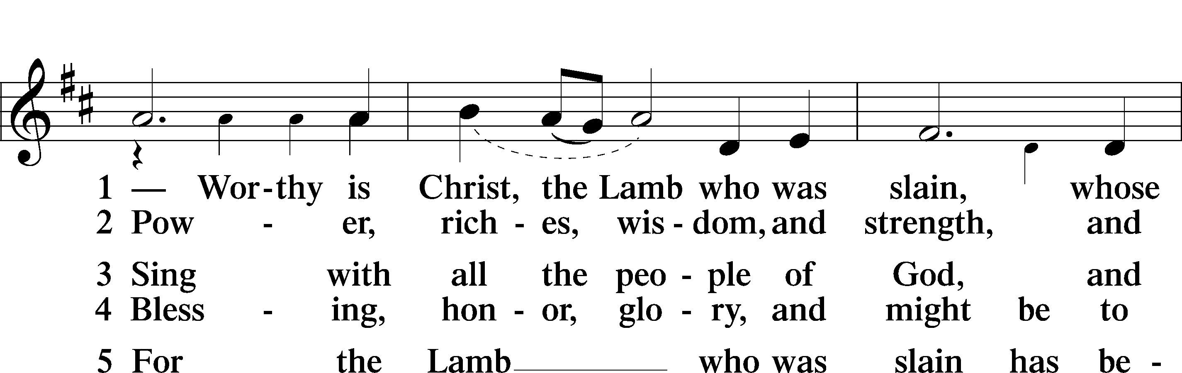
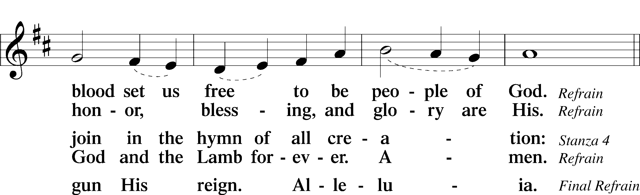
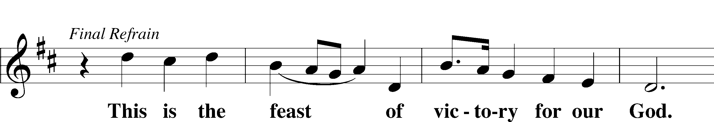
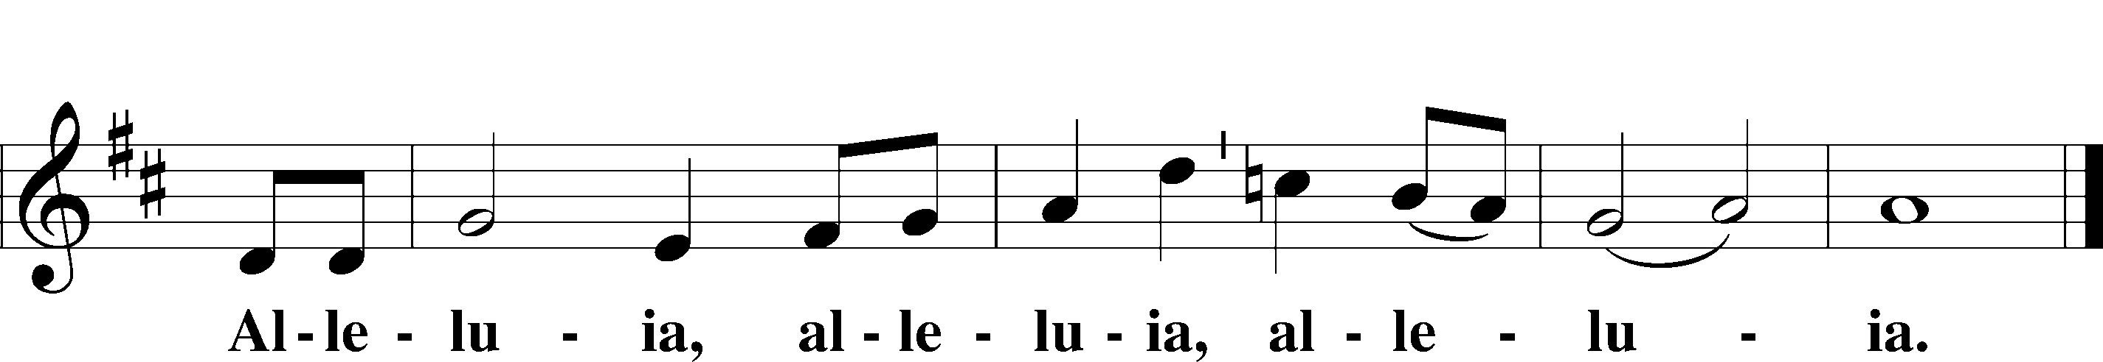

Salutation and Collect of the Day
P The Lord be with you.
C And also with you.

P Let us pray.
Merciful Lord, cleanse and defend Your Church by the sacrifice of Christ. United with Him in Holy Baptism, give us grace to receive with thanksgiving the fruits of His redeeming work and daily follow in His way; through the same Jesus Christ, Your Son, our Lord, who lives and reigns with You and the Holy Spirit, one God, now and forever.

C Amen.
Sit
Old Testament Reading Jeremiah 23:16–29

A The Old Testament read from the 23rd book of Jeremiah.

16Thus says the Lord of hosts: “Do not listen to the words of the prophets who prophesy to you, filling you with vain hopes. They speak visions of their own minds, not from the mouth of the Lord. 17They say continually to those who despise the word of the Lord, ‘It shall be well with you’; and to everyone who stubbornly follows his own heart, they say, ‘No disaster shall come upon you.’”
18For who among them has stood in the council of the Lord to see and to hear his word, or who has paid attention to his word and listened?
19Behold, the storm of the Lord! Wrath has gone forth,
a whirling tempest; it will burst upon the head of the wicked.
20The anger of the Lord will not turn back
until he has executed and accomplished the intents of his heart.
In the latter days you will understand it clearly.
21“I did not send the prophets, yet they ran;
I did not speak to them, yet they prophesied.
22But if they had stood in my council,
then they would have proclaimed my words to my people,
and they would have turned them from their evil way,
and from the evil of their deeds.
23“Am I a God at hand, declares the Lord, and not a God afar off? 24Can a man hide himself in secret places so that I cannot see him? declares the Lord. Do I not fill heaven and earth? declares the Lord. 25I have heard what the prophets have said who prophesy lies in my name, saying, ‘I have dreamed, I have dreamed!’ 26How long shall there be lies in the heart of the prophets who prophesy lies, and who prophesy the deceit of their own heart, 27who think to make my people forget my name by their dreams that they tell one another, even as their fathers forgot my name for Baal? 28Let the prophet who has a dream tell the dream, but let him who has my word speak my word faithfully. What has straw in common with wheat? declares the Lord. 29Is not my word like fire, declares the Lord, and like a hammer that breaks the rock in pieces?”

A This is the Word of the Lord.
C Thanks be to God.

Psalm Psalm 119:81–88; antiphon: v. 81
Kaph
81My soul longs for your sal- | vation;*
I hope | in your word.
82My eyes long for your | promise;*
I ask, “When will you | comfort me?”
83For I have become like a wineskin | in the smoke,*
yet I have not forgotten your | statutes.
84How long must your ser- | vant endure?*
When will you judge those who perse- | cute me?
85The insolent have dug pit- | falls for me;*
they do not live according | to your law.
86All your command- | ments are sure;*
they persecute me with falsehood; | help me!
87They have almost made an end of me | on earth,*
but I have not forsaken your | precepts.
88In your steadfast love | give me life,*
that I may keep the testimonies | of your mouth.

Epistle Hebrews 11:17—12:3

A The Epistle is read from the 11th chapter of Hebrews.

17By faith Abraham, when he was tested, offered up Isaac, and he who had received the promises was in the act of offering up his only son, 18of whom it was said, “Through Isaac shall your offspring be named.” 19He considered that God was able even to raise him from the dead, from which, figuratively speaking, he did receive him back. 20By faith Isaac invoked future blessings on Jacob and Esau. 21By faith Jacob, when dying, blessed each of the sons of Joseph, bowing in worship over the head of his staff. 22By faith Joseph, at the end of his life, made mention of the exodus of the Israelites and gave directions concerning his bones.
23By faith Moses, when he was born, was hidden for three months by his parents, because they saw that the child was beautiful, and they were not afraid of the king’s edict. 24By faith Moses, when he was grown up, refused to be called the son of Pharaoh’s daughter, 25choosing rather to be mistreated with the people of God than to enjoy the fleeting pleasures of sin. 26He considered the reproach of Christ greater wealth than the treasures of Egypt, for he was looking to the reward. 27By faith he left Egypt, not being afraid of the anger of the king, for he endured as seeing him who is invisible. 28By faith he kept the Passover and sprinkled the blood, so that the Destroyer of the firstborn might not touch them.
29By faith the people crossed the Red Sea as if on dry land, but the Egyptians, when they attempted to do the same, were drowned. 30By faith the walls of Jericho fell down after they had been encircled for seven days. 31By faith Rahab the prostitute did not perish with those who were disobedient, because she had given a friendly welcome to the spies.
(32And what more shall I say? For time would fail me to tell of Gideon, Barak, Samson, Jephthah, of David and Samuel and the prophets— 33who through faith conquered kingdoms, enforced justice, obtained promises, stopped the mouths of lions, 34quenched the power of fire, escaped the edge of the sword, were made strong out of weakness, became mighty in war, put foreign armies to flight. 35Women received back their dead by resurrection. Some were tortured, refusing to accept release, so that they might rise again to a better life. 36Others suffered mocking and flogging, and even chains and imprisonment. 37They were stoned, they were sawn in two, they were killed with the sword. They went about in skins of sheep and goats, destitute, afflicted, mistreated— 38of whom the world was not worthy—wandering about in deserts and mountains, and in dens and caves of the earth.
39And all these, though commended through their faith, did not receive what was promised, 40since God had provided something better for us, that apart from us they should not be made perfect.)
1Therefore, since we are surrounded by so great a cloud of witnesses, let us also lay aside every weight, and sin which clings so closely, and let us run with endurance the race that is set before us, 2looking to Jesus, the founder and perfecter of our faith, who for the joy that was set before him endured the cross, despising the shame, and is seated at the right hand of the throne of God.
3Consider him who endured from sinners such hostility against himself, so that you may not grow weary or fainthearted.

A This is the Word of the Lord.
C Thanks be to God.

Stand
Alleluia and Verse

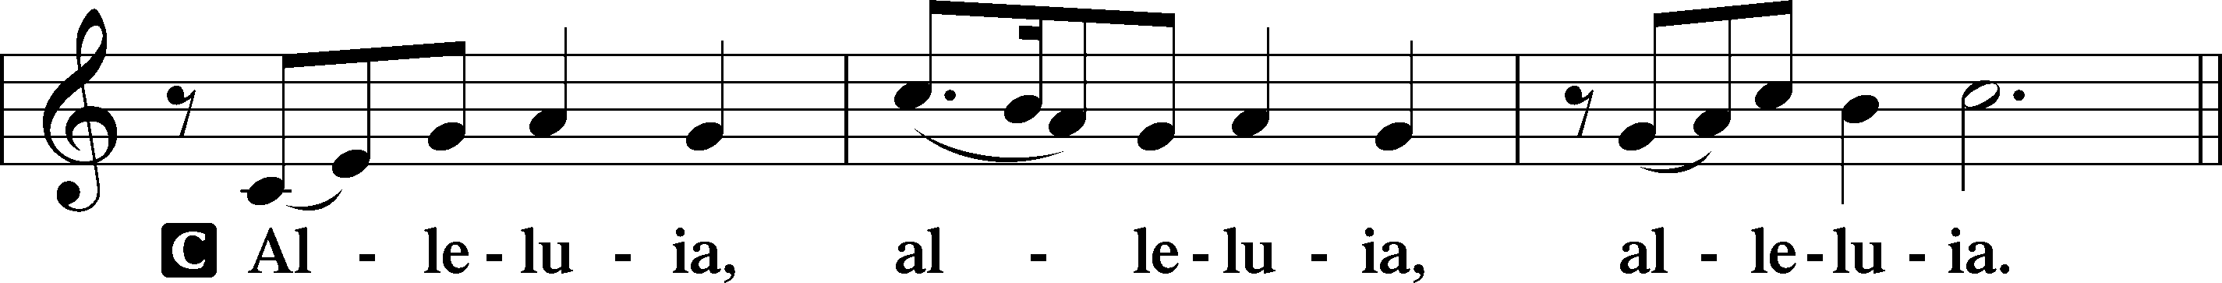

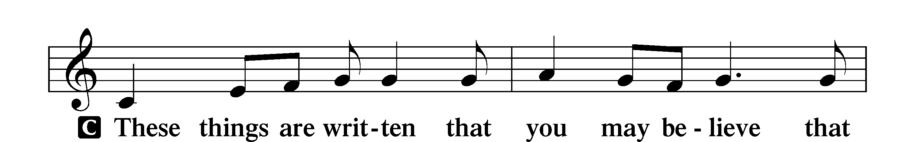
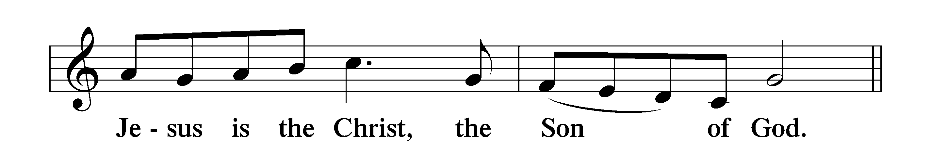

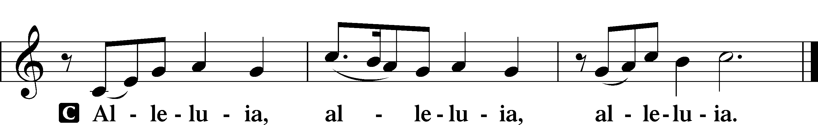

Holy Gospel Luke 12:49–56
P The Holy Gospel according to St. Luke, the twelfth chapter.
C Glory to You, O Lord.

49[Jesus said:] “I came to cast fire on the earth, and would that it were already kindled! 50I have a baptism to be baptized with, and how great is my distress until it is accomplished! 51Do you think that I have come to give peace on earth? No, I tell you, but rather division. 52For from now on in one house there will be five divided, three against two and two against three. 53They will be divided, father against son and son against father, mother against daughter and daughter against mother, mother-in-law against her daughter-in-law and daughter-in-law against mother-in-law.”
54He also said to the crowds, “When you see a cloud rising in the west, you say at once, ‘A shower is coming.’ And so it happens. 55And when you see the south wind blowing, you say, ‘There will be scorching heat,’ and it happens. 56You hypocrites! You know how to interpret the appearance of earth and sky, but why do you not know how to interpret the present time?”
P This is the Gospel of the Lord.
C Praise to You, O Christ.

Sit

702 My Faith Looks Up to Thee
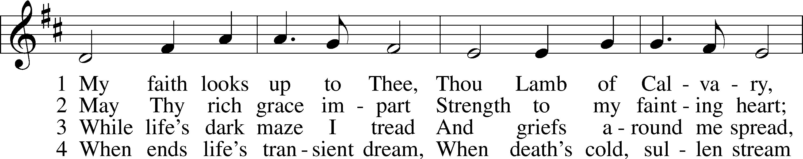
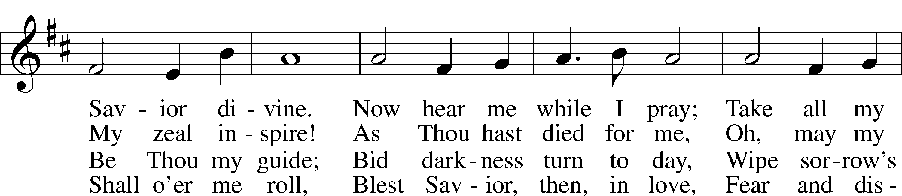
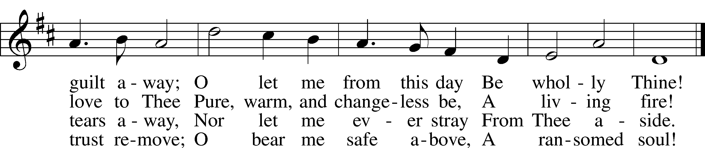
Text: Ray Palmer, 1808–87
Tune: Lowell Mason, 1792–1872
Text and tune: Public domain

Sermon

Stand

Apostles’ Creed

C I believe in God, the Father Almighty,
maker of heaven and earth.

And in Jesus Christ, His only Son, our Lord,
who was conceived by the Holy Spirit, born of the virgin Mary,
suffered under Pontius Pilate, was crucified, died and was buried.
He descended into hell.
The third day He rose again from the dead.
He ascended into heaven and sits at the right hand of God
the Father Almighty.
From thence He will come to judge the living and the dead.

I believe in the Holy Spirit, the holy Christian Church,
the communion of saints, the forgiveness of sins,
the resurrection of the body, and the life T everlasting. Amen.

Prayer of the Church

Offering & Sharing of the Peace

Service of Holy Communion
Communion Statement

The Lord’s Supper is celebrated at this congregation in the confession and glad confidence that, as He says, our Lord gives into our mouths not only bread and wine but His very body and blood to eat and to drink for the forgiveness of sins and to strengthen our union with Him and with one another. Our Lord invites to His table those who trust His words, repent of all sin, and set aside any refusal to forgive and love as He forgives and loves us, that they may show forth His death until He comes.

Because those who eat and drink our Lord’s body and blood unworthily do so to their great harm and because Holy Communion is a confession of the faith which is confessed at this altar, any who are not yet instructed, in doubt, or who hold a confession differing from that of this congregation and the Lutheran Church Missouri Synod, and yet desire to receive this sacrament, are asked to speak with the Pastor.
* See more about the Lutheran teaching on communion in the Hymnal p 329.

Stand

Preface LSB 208
P The Lord be with you.
C And also with you.

P Lift up your hearts.
C We lift them to the Lord.

P Let us give thanks to the Lord our God.
C It is right to give Him thanks and praise.

P It is truly good, right, and salutary that we should at all times and in all places give thanks to You, O Lord, holy Father, almighty and everlasting God, for the countless blessings You so freely bestow on us and all creation. Above all, we give thanks for Your boundless love shown to us when You sent Your only-begotten Son, Jesus Christ, into our flesh and laid on Him our sin, giving Him into death that we might not die eternally. Because He is now risen from the dead and lives and reigns to all eternity, all who believe in Him will overcome sin and death and will rise again to new life. Therefore with angels and archangels and with all the company of heaven we laud and magnify Your glorious name, evermore praising You and saying:

Sanctus LSB 208
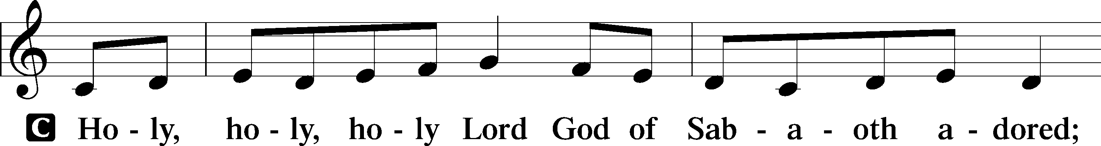
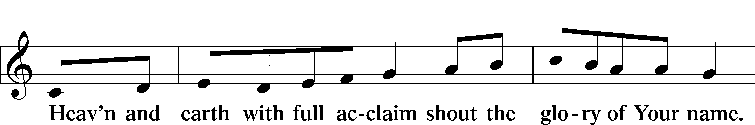
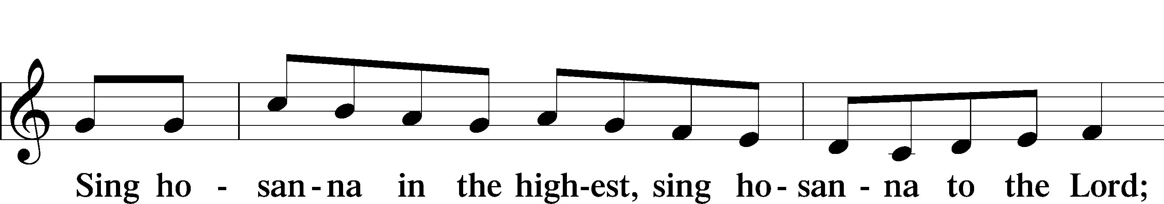
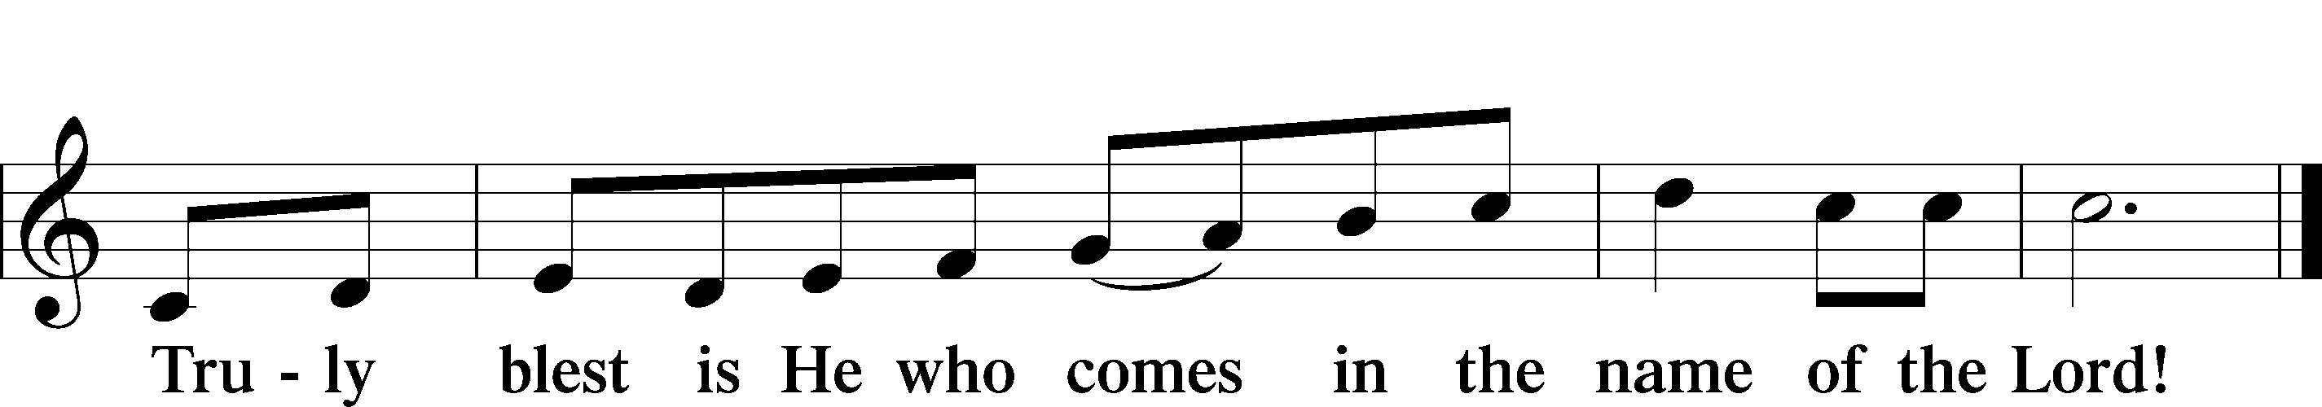
Text: Stephen P. Starke

Prayer of Thanksgiving
P Blessed are You, O Lord our God, king of all creation, for You have had mercy on us and given Your only-begotten Son that whoever believes in Him should not perish but have eternal life.

In these last days, You have poured out Your Holy Spirit on Your Church that Your sons and daughters might proclaim the wonders of Your salvation in Christ Jesus our Lord. Pour out Your Holy Spirit upon Your gathered people that, faithfully eating and drinking the body and blood of Your Son, we may go forth to proclaim His salvation to the ends of the earth.

Hear us as we pray in His name and as He has taught us:

Lord’s Prayer
C Our Father who art in heaven, hallowed be Thy name,
Thy kingdom come, Thy will be done on earth
as it is in heaven;
give us this day our daily bread; and forgive us our trespasses
as we forgive those who trespass against us;
and lead us not into temptation, but deliver us from evil.
For Thine is the kingdom and the power and the glory
forever and ever. Amen.

The Words of Our Lord
P Our Lord Jesus Christ, on the night when He was betrayed, took bread, and when He had given thanks, He broke it and gave it to the disciples and said: “Take, eat; this is My T body, which is given for you. This do in remembrance of Me.”

In the same way also He took the cup after supper, and when He had given thanks, He gave it to them, saying: “Drink of it, all of you; this cup is the new testament in My T blood, which is shed for you for the forgiveness of sins. This do, as often as you drink it, in remembrance of Me.”

Pax Domini
P The peace of the Lord be with you always.
C Amen.

Agnus Dei LSB 210
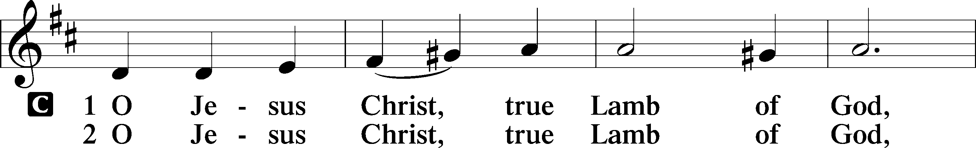
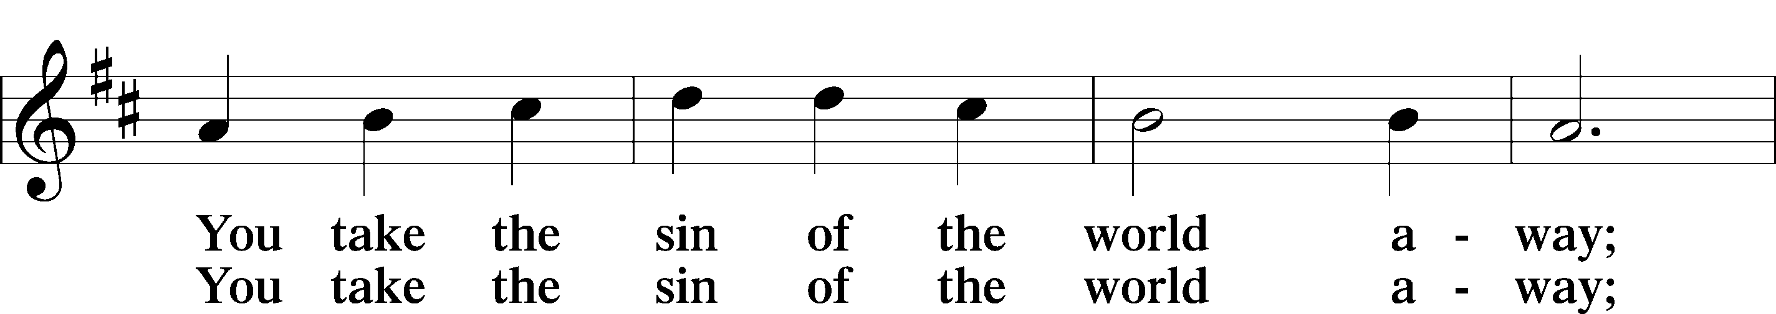
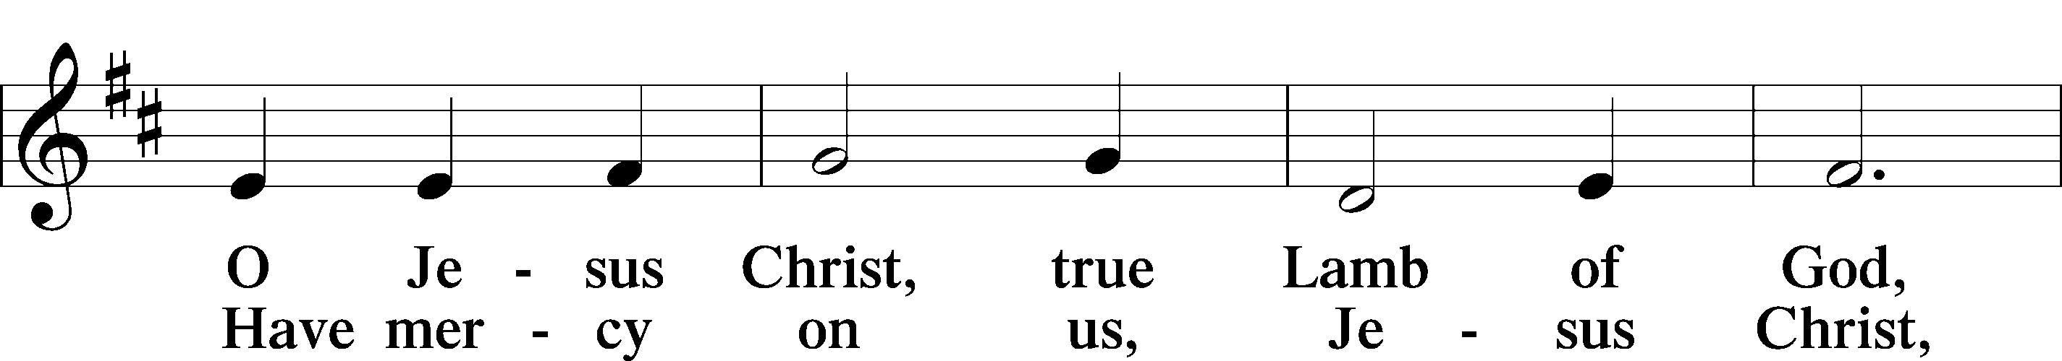
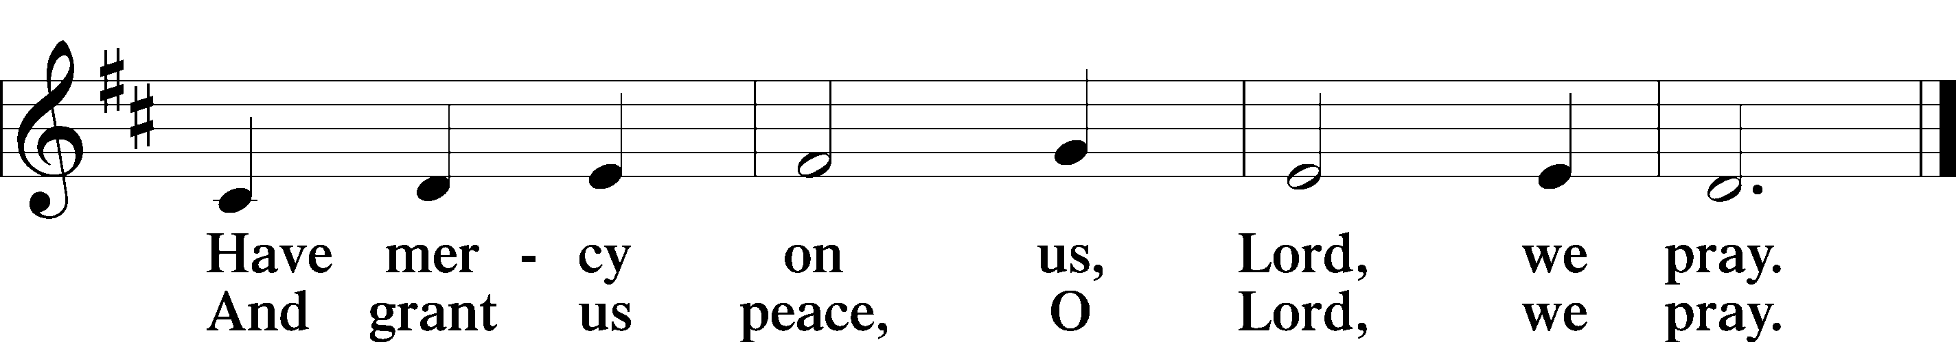
Text: Stephen P. Starke

Sit



Distribution Hymn

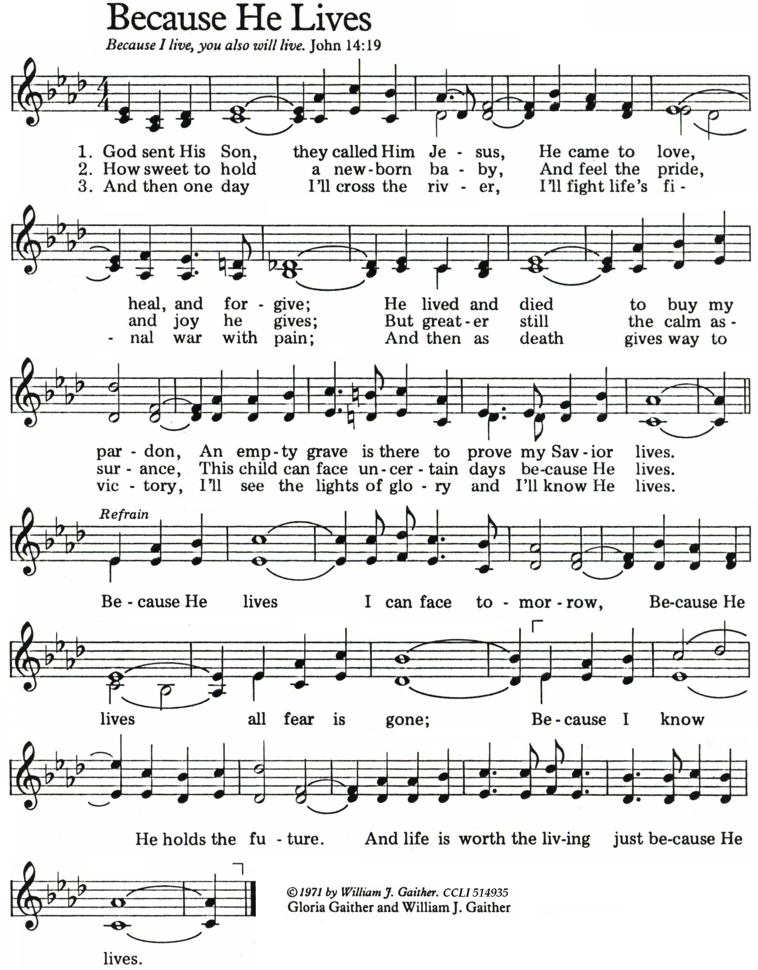
Stand
Nunc Dimittis LSB 211
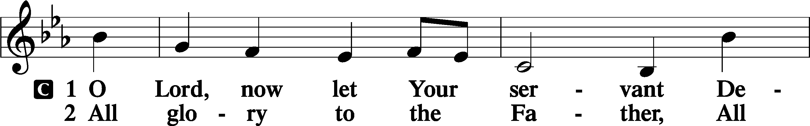
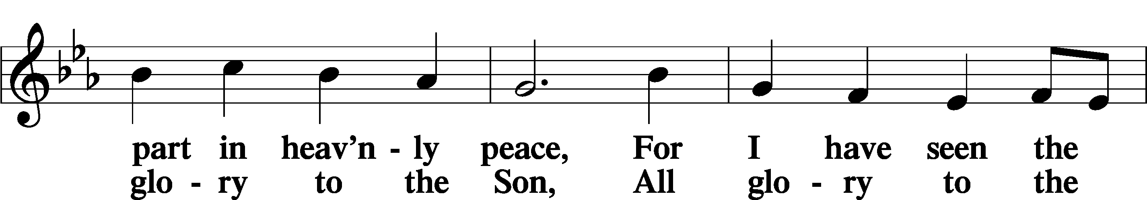
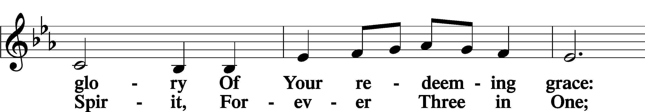
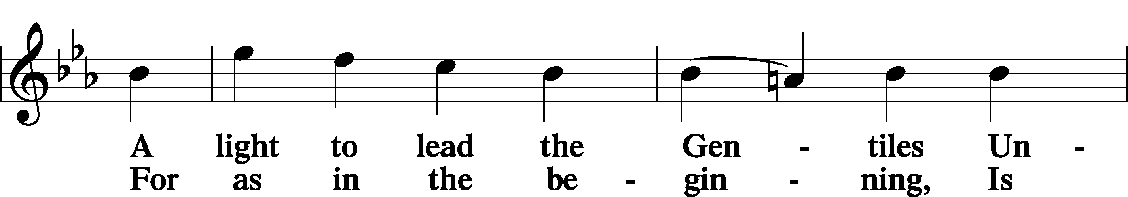
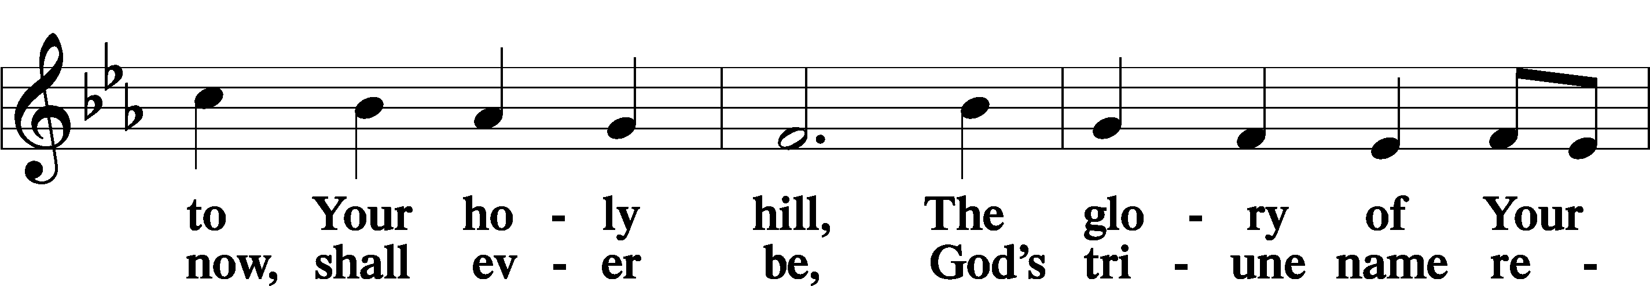
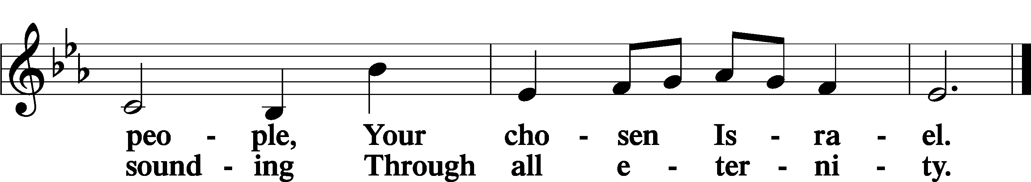

Post-Communion Collect
A Let us pray.
We give thanks to You, almighty God, that You have refreshed us through this salutary gift, and we implore You that of Your mercy You would strengthen us through the same in faith toward You and in fervent love toward one another; through Jesus Christ, Your Son, our Lord, who lives and reigns with You and the Holy Spirit, one God, now and forever.
C Amen.

Verse Jeremiah 23:29a, 28b
Alleluia. Is not my word like fire, declares the Lord?
What has straw in common with wheat? Alleluia.

Benedicamus LSB 212
A Let us bless the Lord.
C Thanks be to God.

Benediction
P The Lord bless you and keep you.
The Lord make His face shine on you and be gracious to you.
The Lord look upon you with favor and T give you peace.
C Amen.

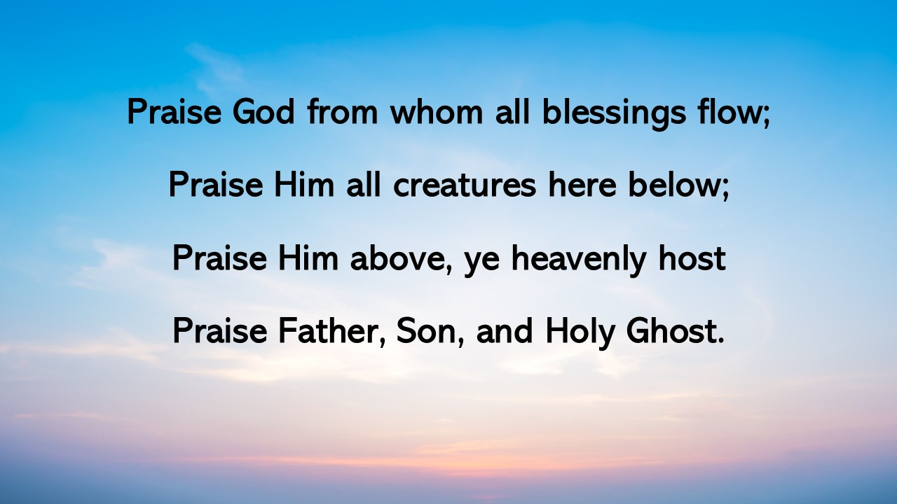

804 O Worship the King sts. 1–4
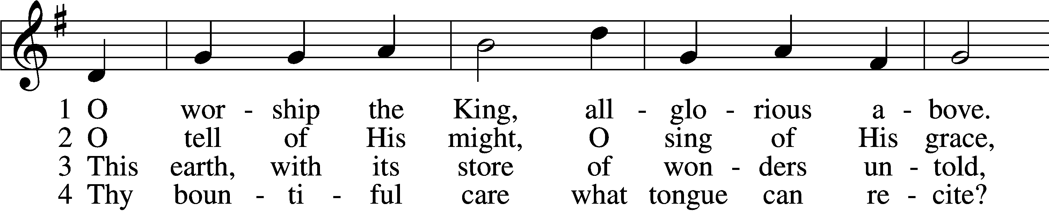
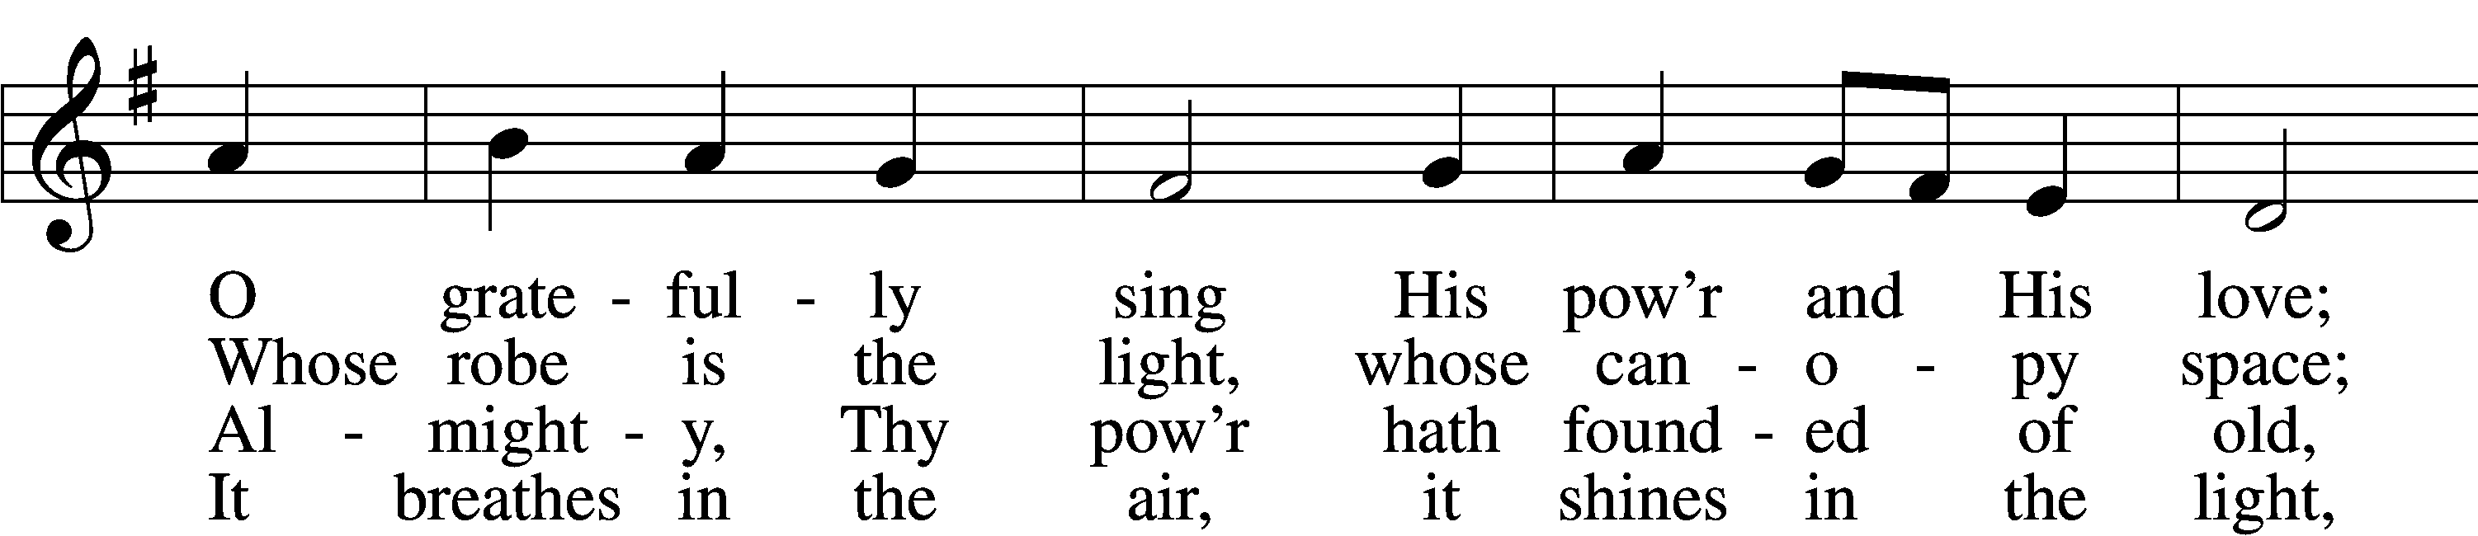
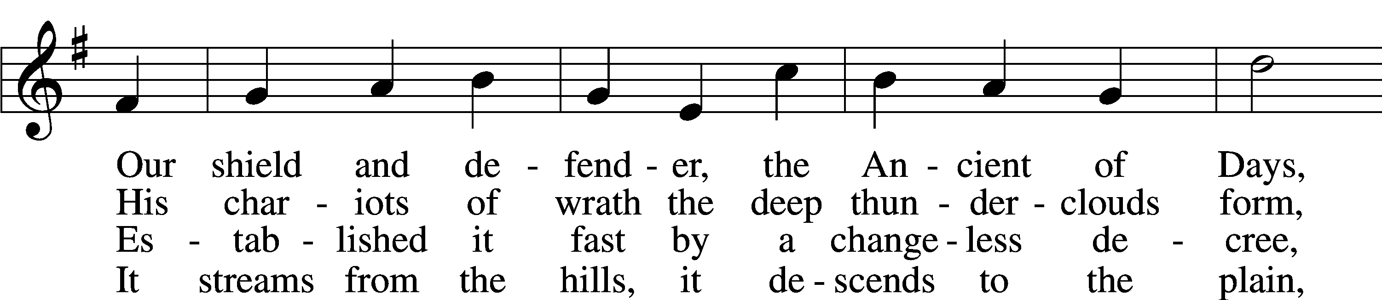
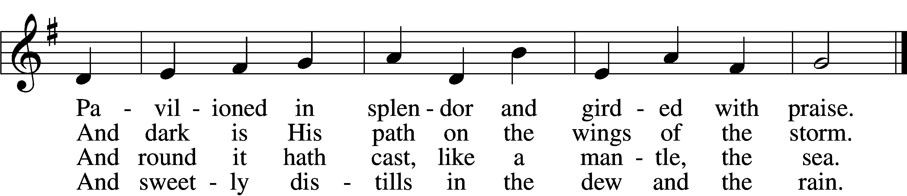
Text: Robert Grant, 1779–1838, alt.
Tune: William Croft, 1678–1727
Text and tune: Public domain

Acknowledgments Divine Service, Setting Four from Lutheran Service Book Unless otherwise indicated, Scripture quotations are from the ESV® Bible (The Holy Bible, English Standard Version®), copyright © 2001 by
Crossway, a publishing ministry of Good News Publishers. Used by permission. All rights reserved. Created by Lutheran Service Builder © 2025 Concordia Publishing House.
Seasons of the Church Year

The non-celebratory half of the Church year is called the “Time of The Church”, or traditionally the “Time of Trinity” (Trinitytide). These weeks are marked by counting the Sundays after Pentecost. This is the longest season of the church year. The color of the season is green, to represent growth and the power of the Lord working in mission.

Prayers of the Church
This week, we lift up:

Angela H (surgery on 13th), Sheila, Elaine, Bob, Angie Z, Angela C,
Ross, & Kathy H.

Family of the week: Angelina Zak

*If you have any prayer request let us know.

Last week: Attendance 25 Offering $1325

Serving Next Week (8/24/25)  Guest Pastor: Rev Doyle Boykin  Music Minister: Vicar Previn Hudetz  Worship Assistant: Charlie M  Reader: Samantha Tenant  Refreshments: -Angie Z  Altar Guild: Angie Z & Sheila S  Greeter: Juanita | Readings Next Week  Eleventh Sunday after Pentecost  Isaiah 66:18-23  Psalm 50:1-15  Hebrews 12:4-29  Luke 13:22-30  *Please sign up to help during service.*
Announcements  Birthdays: Last weeks: Peggy 8/3, This week: Angelina 8/10, Pastor John 8/11, Joanna 8/12,  Jim C 8/19  This Week at OSLC:  Bible Study: After Service  Bible Study: Thursday 10am | Coming Up:  Congregational Meeting to confirm & elect Council Members.  September 28, 2025  Following service
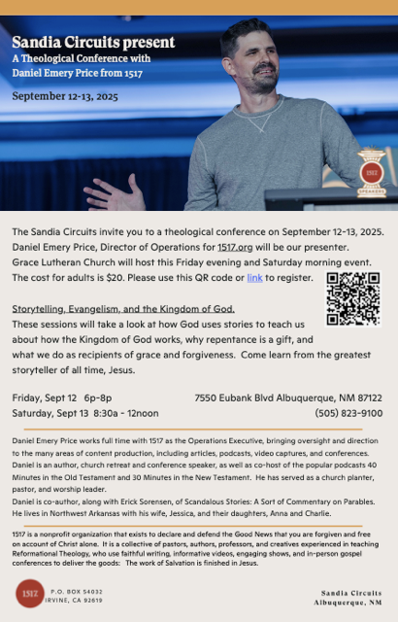



This Friday!