

And there was a widow in that city who kept coming to him and saying, ‘Give me justice against my adversary.’

Luke 18:3

Our Savior Lutheran Church (LCMS)
4301 Atrisco Drive NW
Albuquerque, New Mexico
Website: OSLCNM.COM
Phone: 505.836.7007
Email: oslcabq@gmail.com

Nineteenth Sunday after Pentecost
October 19th,2025
The Time of the Church (Trinitytide)
Nineteenth Sunday after Pentecost
October 19th, 2025

Welcome to Our Savior Lutheran Church (LCMS).  We are glad you are here as we worship, praise, and give thanks to our loving Lord, Jesus Christ. Please join us immediately after service for fellowship and snacks. Adult Bible Study starts at 10:30. If you have any questions about our service or need other assistance, please contact one of our worship assistants. | Hymns  Opening # 773 & 686  Sermon # 739  Distribution # 727  Closing # 924

Today’s Message
Before God, men, women, and children plead incessantly for justice in the face of rebellion and adversity. Those who know and confess Jesus bear the weight of guilt and need His Word of undeserved acquittal. God’s Word is the solitary source of that promise. It teaches, corrects, declares righteousness, and equips us for every good work. Scripture, in its entirety, is that living, breathing, vibrant account of God continually striving by the side of His chosen people—delivering them from sin.

+++
Serving Today
Service Leader: Vicar Previn Hudetz
Communion Celebrant: Pastor John Heffelfinger
Communion Assistant: Jim C
Worship Assistant: Charlie Mike
Reader: Samantha T
Refreshments: Rebecca V
Altar Guild: Angie Z & Sheila S
Greeter: Juanita
Welcome
Divine Service I

773 Hear Us, Father, When We Pray
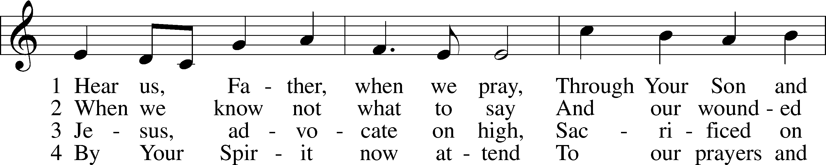
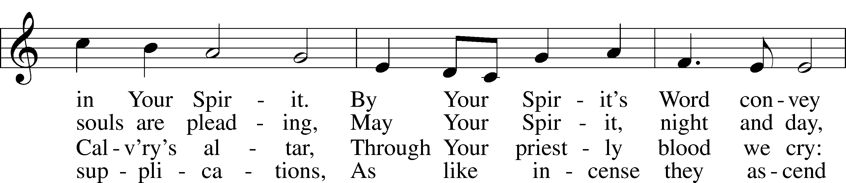
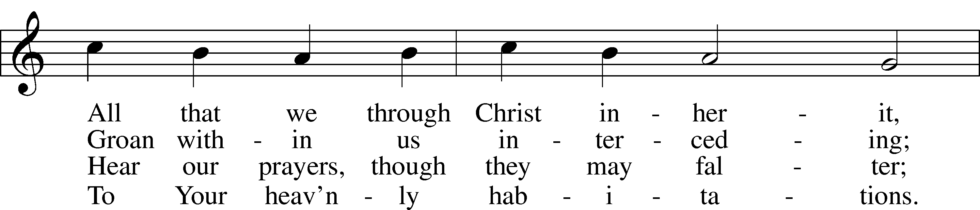
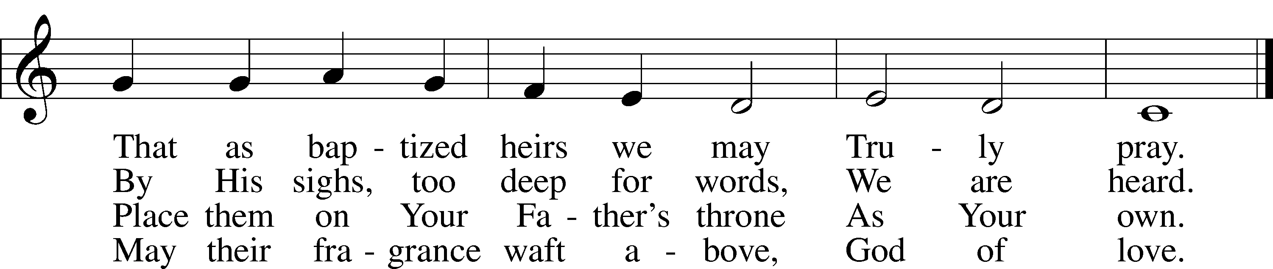
Text: Chad L. Bird, 1970
Tune: Geist-reiches Gesang-Buch, 1704, Halle, ed. Johann A. Freylinghausen
Text: © Chad L. Bird. Used by permission: LSB Hymn License no. 110003995
Tune: Public domain

686 Come, Thou Fount of Every Blessing
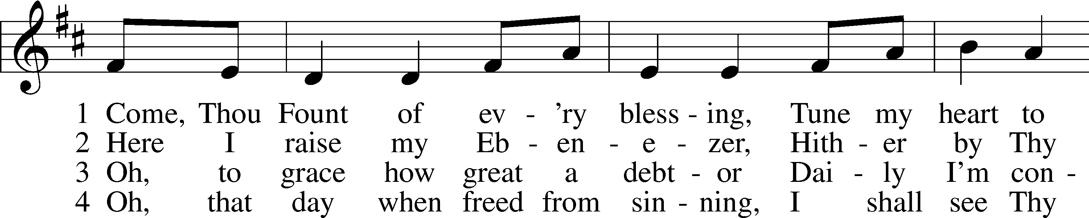
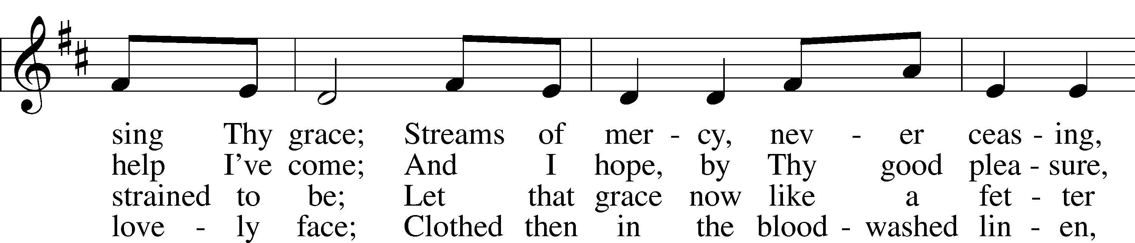
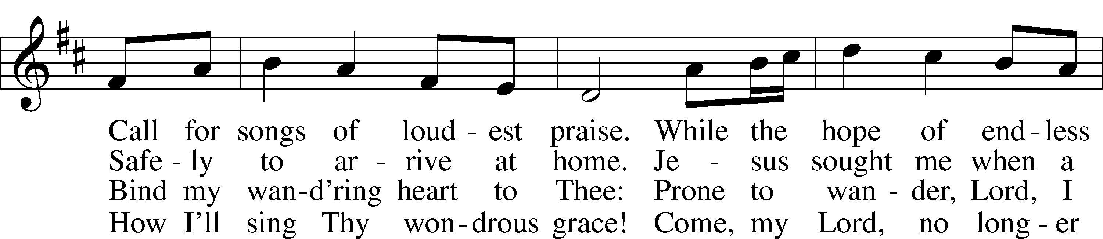
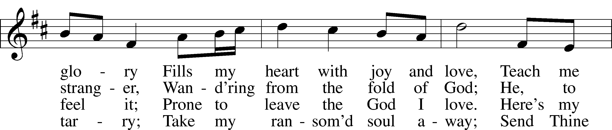
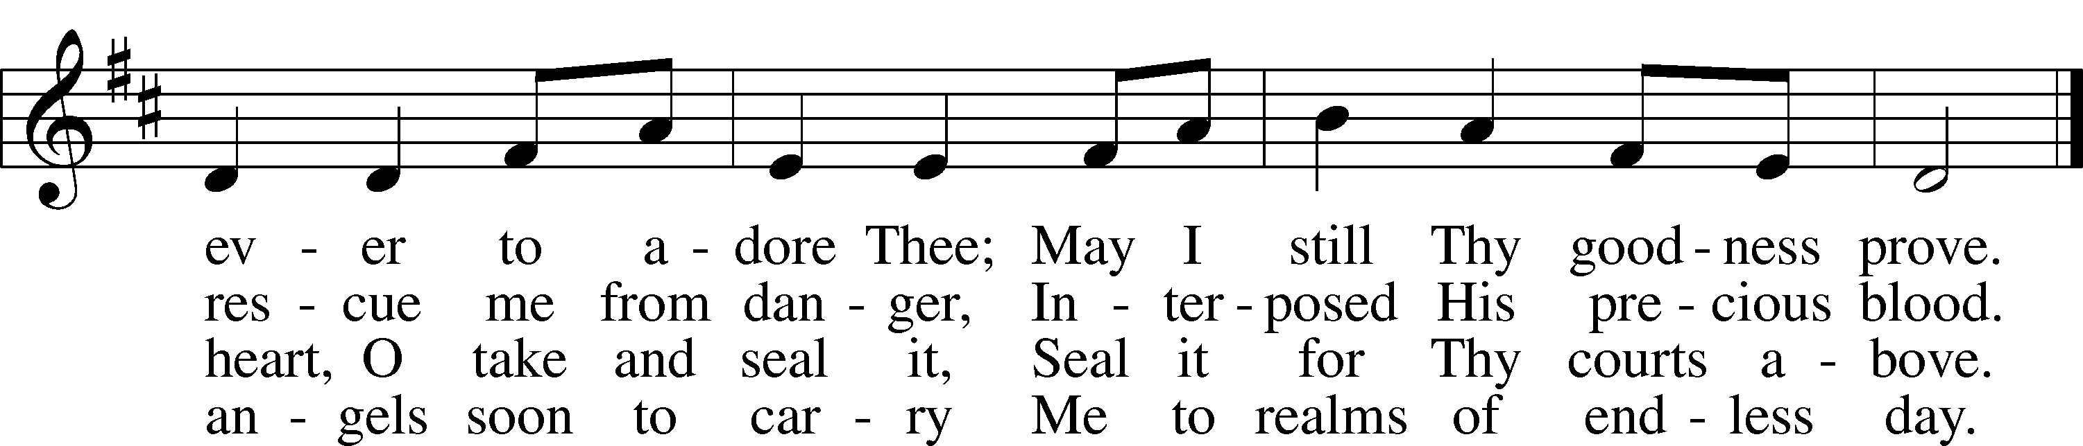
Text: Robert Robinson, 1735–90, alt.
Tune: Repository of Sacred Music, Part Second, 1813, Harrisburg
Text and tune: Public domain

Confession and Absolution
Stand

The sign of the cross may be made by all in remembrance of their Baptism.

P In the name of the Father and of the T Son and of the Holy Spirit.
C Amen.

P If we say we have no sin, we deceive ourselves, and the truth is not in us.
C But if we confess our sins, God, who is faithful and just, will forgive our sins and cleanse us from all unrighteousness.

Silence for reflection on God’s Word and for self-examination.

P Let us then confess our sins to God our Father.
C Most merciful God, we confess that we are by nature sinful and unclean. We have sinned against You in thought, word, and deed, by what we have done and by what we have left undone. We have not loved You with our whole heart; we have not loved our neighbors as ourselves. We justly deserve Your present and eternal punishment. For the sake of Your Son, Jesus Christ, have mercy on us. Forgive us, renew us, and lead us, so that we may delight in Your will and walk in Your ways to the glory of Your holy name. Amen.

P Almighty God in His mercy has given His Son to die for you and for His sake forgives you all your sins. As a called servant of Christ, and by His authority, I therefore forgive you all your sins in the name of the Father and of the T Son and of the Holy Spirit.
C Amen.

Stand
Service of the Word
Invitatory for Trinitytide
L The Lord has enlightened us in the true faith
O come, let us worship him
C Send out Your light and Your truth;
Let them lead me! Psalm 43:3

Introit Psalm 74:18–19, 21, 20a, 22a; antiphon: v. 2a
Remember your congregation, which you have pur- | chased of old,*
which you have redeemed to be the tribe of your | heritage!
Remember this, O Lord, how the en- | emy scoffs,*
and a foolish people re- | viles your name.
Do not deliver the soul of your dove to the | wild beasts;*
do not forget the life of your poor for- | ever.
Let not the downtrodden turn | back in shame;*
let the poor and needy | praise your name.
Have regard for the | covenant;*
arise, O God, de- | fend your cause.
Glory be to the Father and | to the Son*
and to the Holy | Spirit;
as it was in the be- | ginning,*
is now, and will be forever. | Amen.
Remember your congregation, which you have pur- | chased of old,*
which you have redeemed to be the tribe of your | heritage!

Kyrie LSB 152

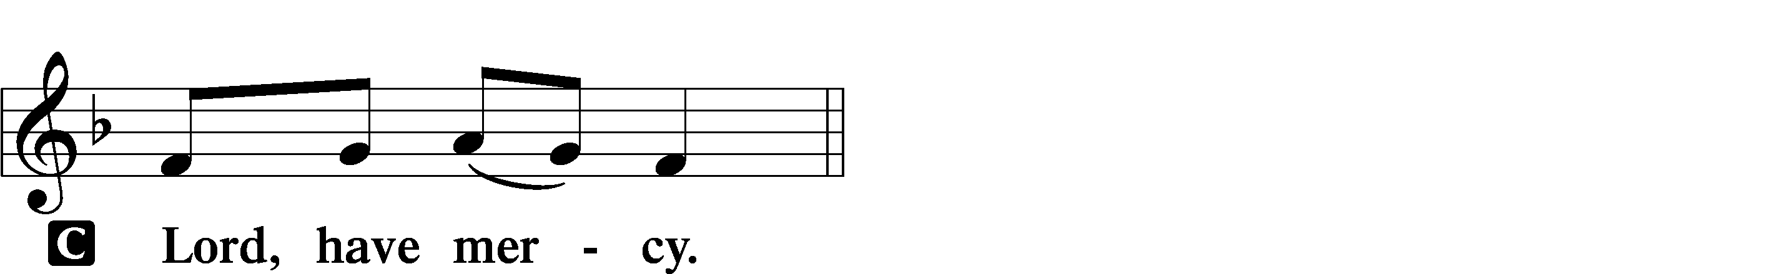

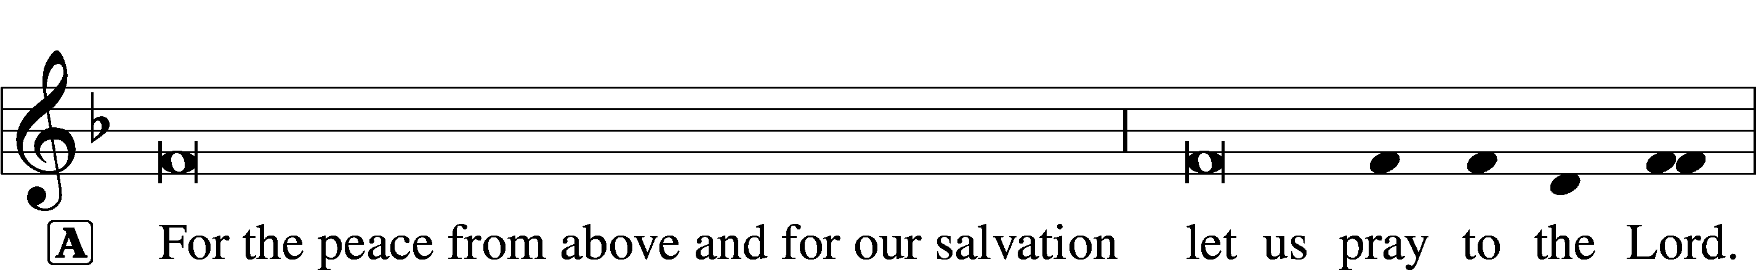
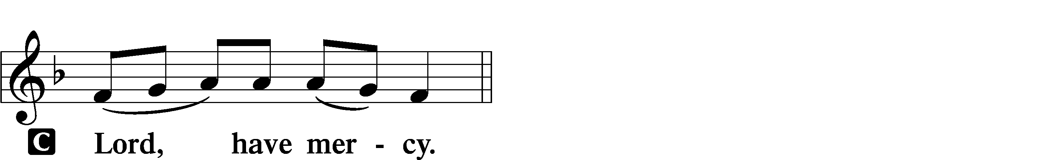

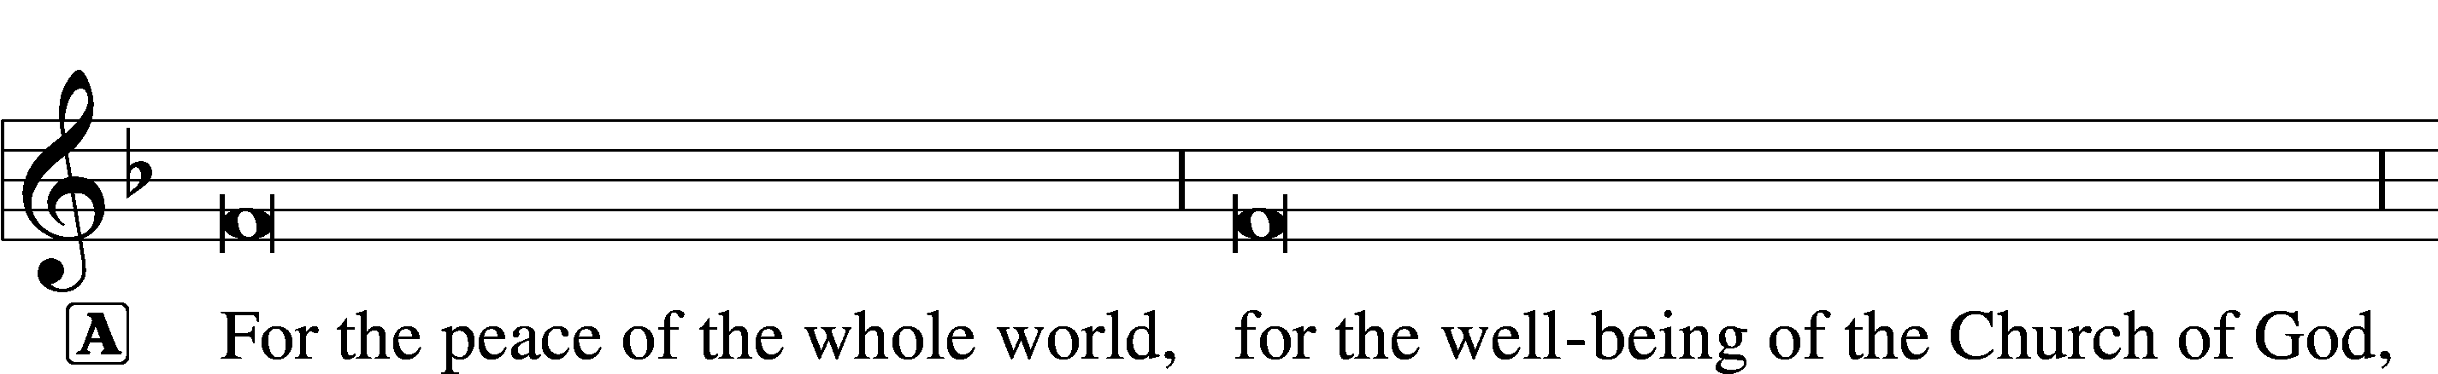
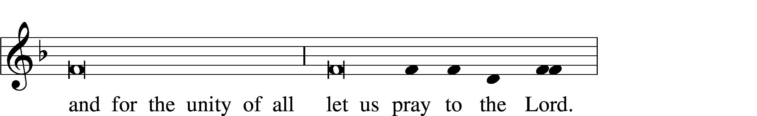
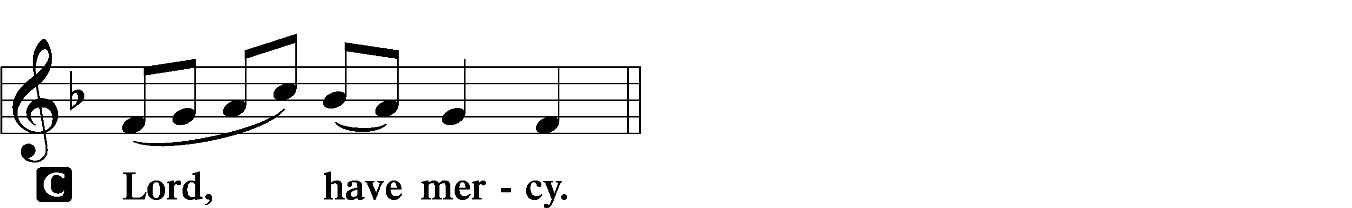

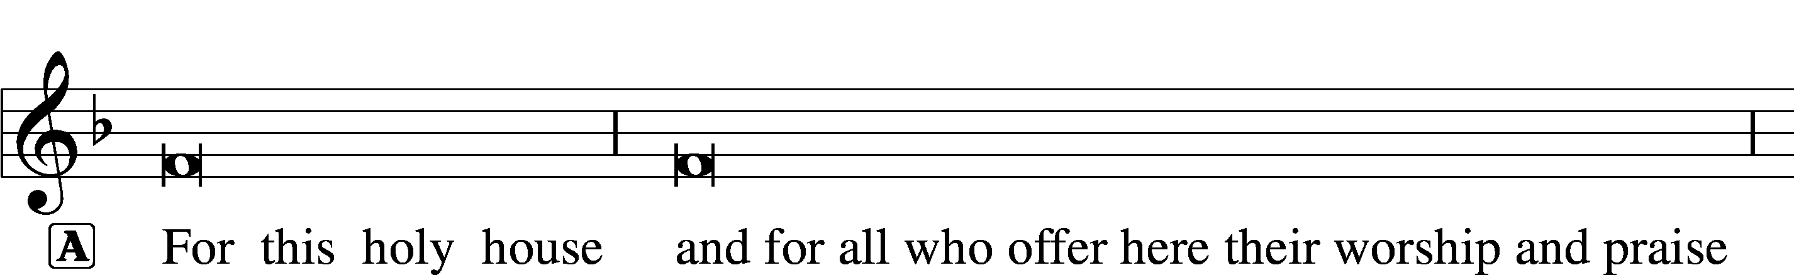

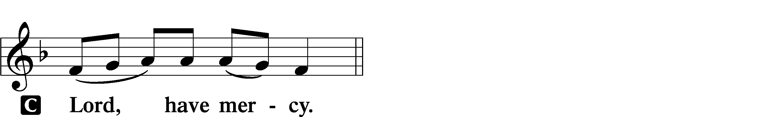




This Is the Feast LSB 155
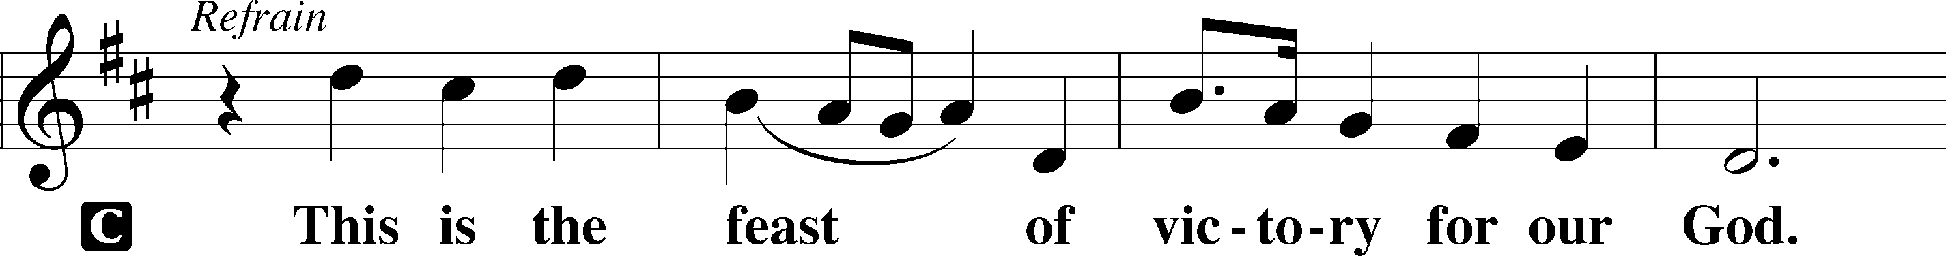
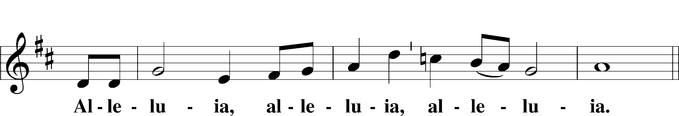
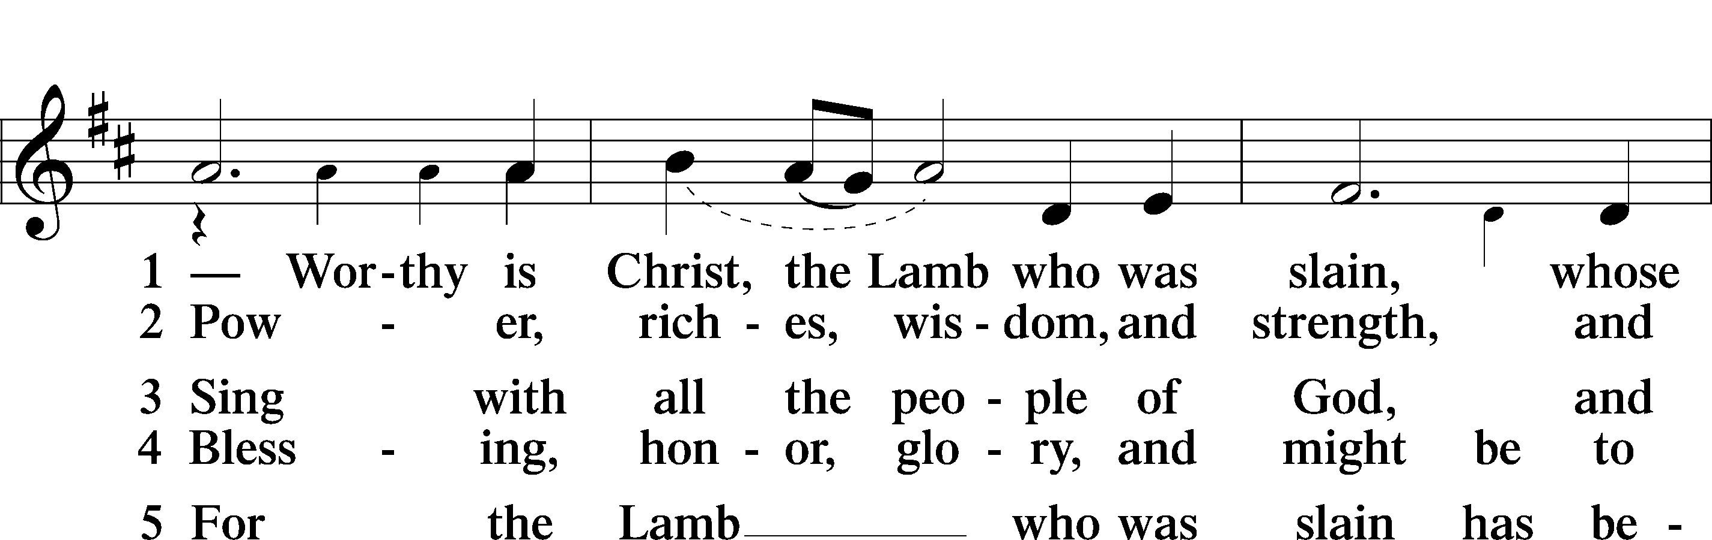
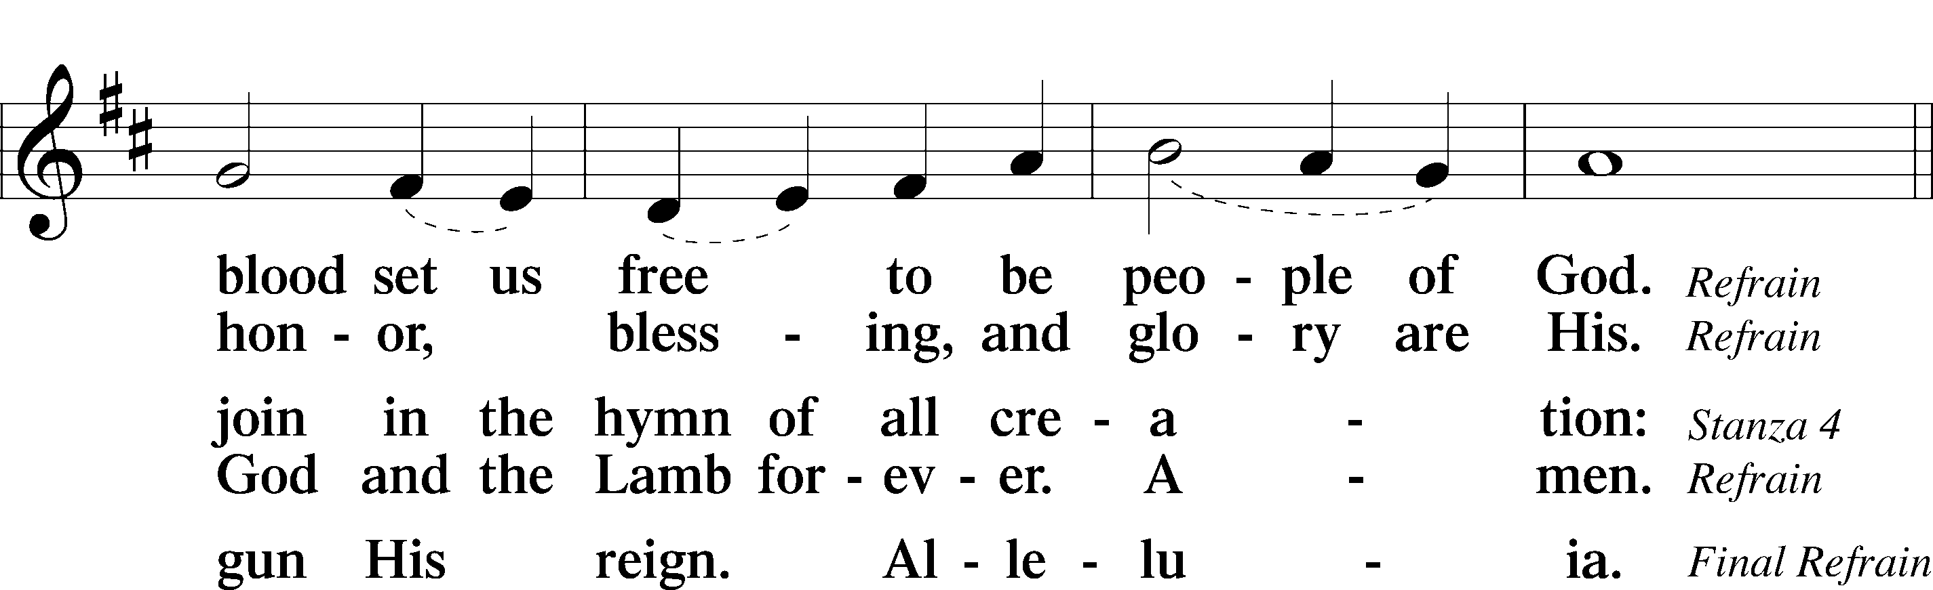
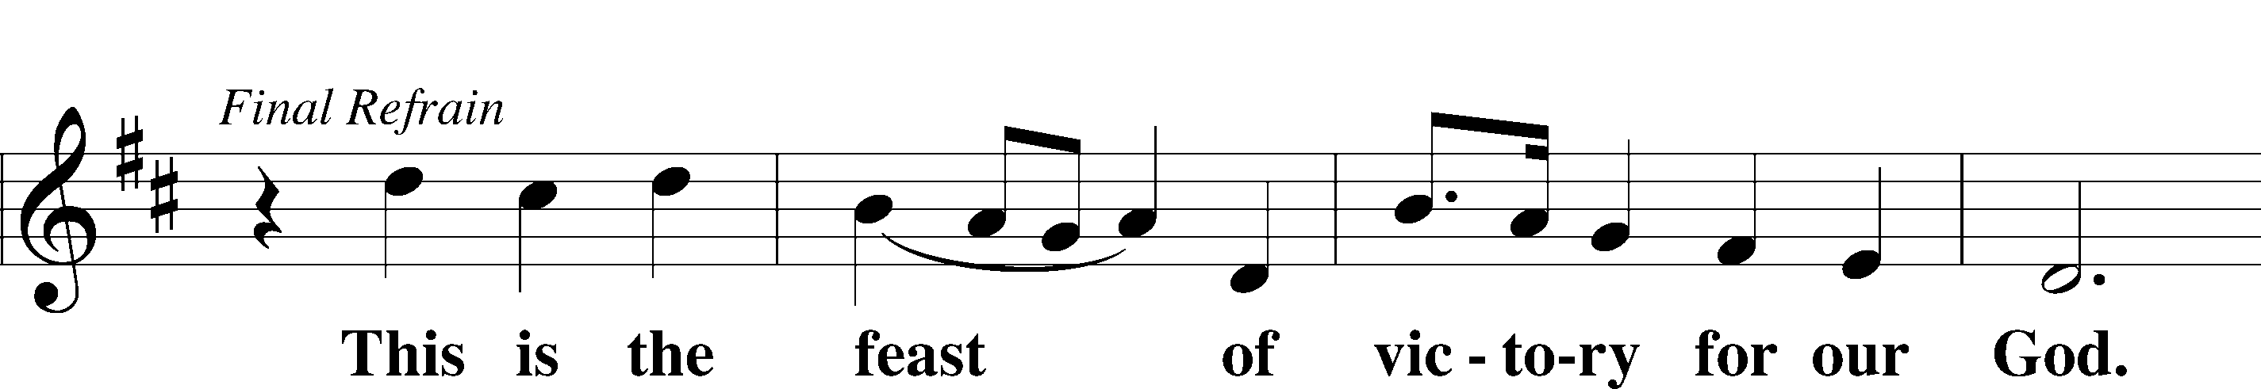
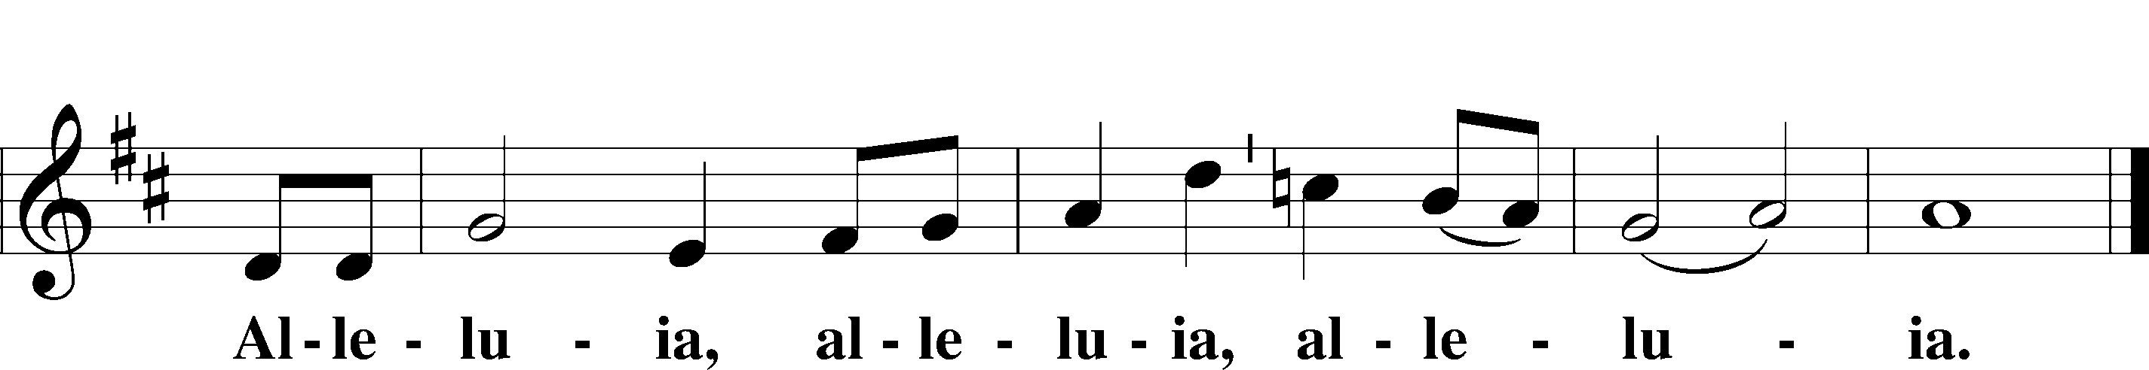

Salutation and Collect of the Day
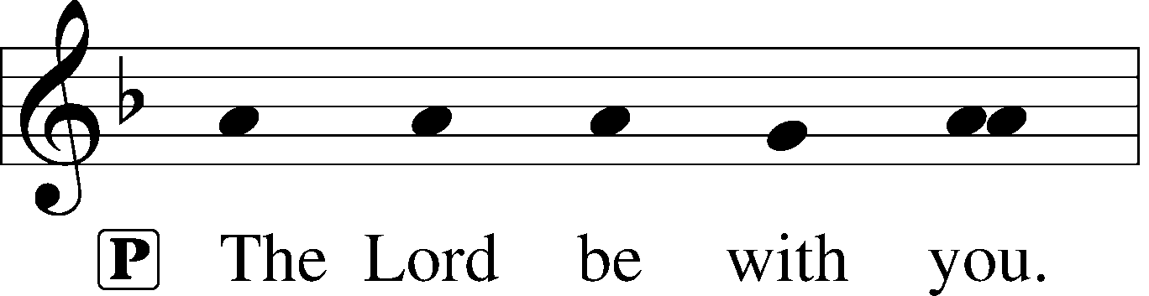
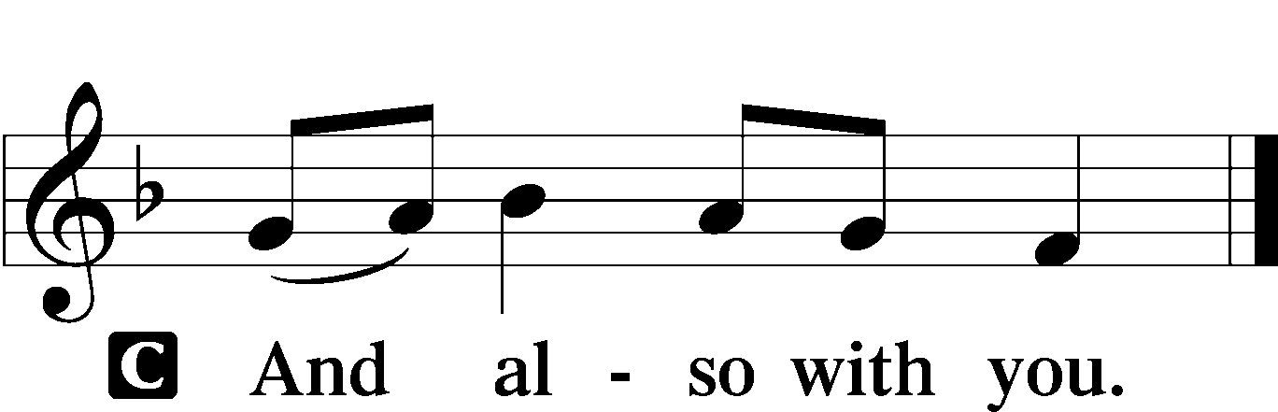

P Let us pray.
O Lord, almighty and everlasting God, You have commanded us to pray and have promised to hear us. Mercifully grant that Your Holy Spirit may direct and govern our hearts in all things that we may persevere with steadfast faith in the confession of Your name; through Jesus Christ, Your Son, our Lord, who lives and reigns with You and the Holy Spirit, one God, now and forever.

C Amen.

Sit

Old Testament Reading- Genesis 32:22–30

Jacob is named Israel.

22The same night [Jacob] arose and took his two wives, his two female servants, and his eleven children, and crossed the ford of the Jabbok. 23He took them and sent them across the stream, and everything else that he had. 24And Jacob was left alone. And a man wrestled with him until the breaking of the day. 25When the man saw that he did not prevail against Jacob, he touched his hip socket, and Jacob’s hip was put out of joint as he wrestled with him. 26Then he said, “Let me go, for the day has broken.” But Jacob said, “I will not let you go unless you bless me.” 27And he said to him, “What is your name?” And he said, “Jacob.” 28Then he said, “Your name shall no longer be called Jacob, but Israel, for you have striven with God and with men, and have prevailed.” 29Then Jacob asked him, “Please tell me your name.” But he said, “Why is it that you ask my name?” And there he blessed him. 30So Jacob called the name of the place Peniel, saying, “For I have seen God face to face, and yet my life has been delivered.”

A This is the Word of the Lord.
C Thanks be to God.

Psalm Psalm 121; antiphon: vv. 1–2
“My help comes from the Lord, who made heaven and earth.”
1I lift up my eyes | to the hills.*
From where does my | help come?
2My help comes | from the Lord,*
who made | heaven and earth.
3He will not let your | foot be moved;*
he who keeps you will not | slumber.
4Behold, he who keeps | Israel*
will neither slum- | ber nor sleep.
5The Lord is your | keeper;*
the Lord is your shade on your | right hand.
6The sun shall not strike | you by day,*
nor the | moon by night.
7The Lord will keep you from all | evil;*
he will | keep your life.
8The Lord will keep
your going out and your | coming in*
from this time forth and for- | evermore.

Epistle- 2 Timothy 3:14—4:5
“Continue in what you have learned… Preach the word.”
14As for you, continue in what you have learned and have firmly believed, knowing from whom you learned it 15and how from childhood you have been acquainted with the sacred writings, which are able to make you wise for salvation through faith in Christ Jesus. 16All Scripture is breathed out by God and profitable for teaching, for reproof, for correction, and for training in righteousness, 17that the man of God may be competent, equipped for every good work.
1I charge you in the presence of God and of Christ Jesus, who is to judge the living and the dead, and by his appearing and his kingdom: 2preach the word; be ready in season and out of season; reprove, rebuke, and exhort, with complete patience and teaching. 3For the time is coming when people will not endure sound teaching, but having itching ears they will accumulate for themselves teachers to suit their own passions, 4and will turn away from listening to the truth and wander off into myths. 5As for you, always be sober-minded, endure suffering, do the work of an evangelist, fulfill your ministry.

A This is the Word of the Lord.
C Thanks be to God.
Stand

Alleluia and Verse LSB 156
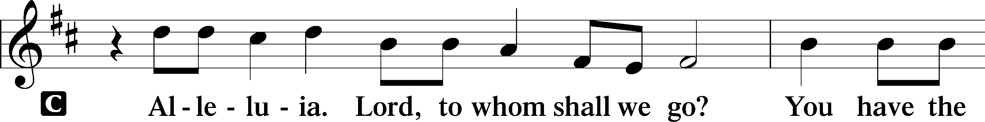
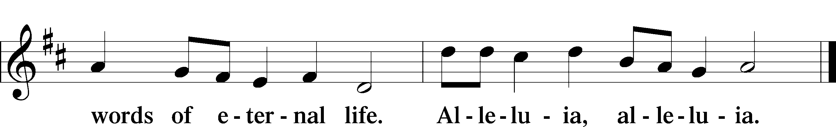

Holy Gospel – “Will not God give justice to His elect?” Luke 18:1–8
P The Holy Gospel according to St. Luke, the eighteenth chapter.
C Glory to You, O Lord.

1[Jesus] told them a parable to the effect that they ought always to pray and not lose heart. 2He said, “In a certain city there was a judge who neither feared God nor respected man. 3And there was a widow in that city who kept coming to him and saying, ‘Give me justice against my adversary.’ 4For a while he refused, but afterward he said to himself, ‘Though I neither fear God nor respect man, 5yet because this widow keeps bothering me, I will give her justice, so that she will not beat me down by her continual coming.’” 6And the Lord said, “Hear what the unrighteous judge says. 7And will not God give justice to his elect, who cry to him day and night? Will he delay long over them? 8I tell you, he will give justice to them speedily. Nevertheless, when the Son of Man comes, will he find faith on earth?”

P This is the Gospel of the Lord.
C Praise to You, O Christ.

Sit

739 Precious Lord, Take My Hand
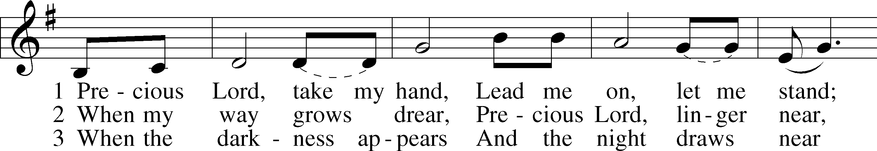
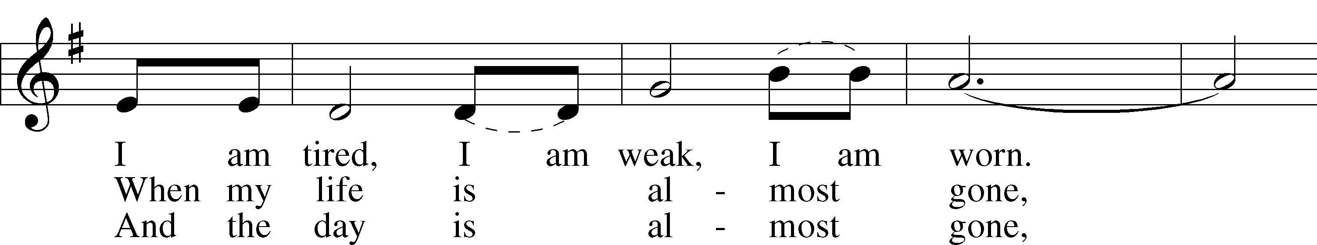
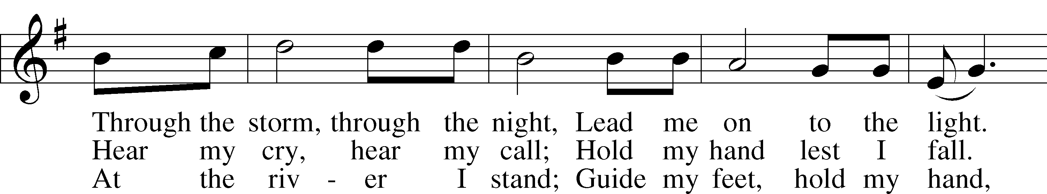
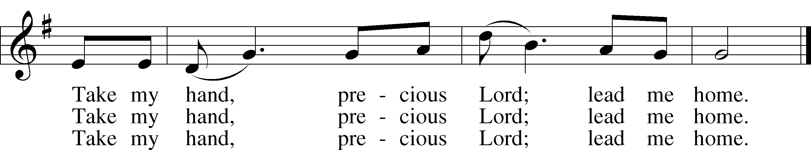
Text and tune: Thomas A. Dorsey, 1899–1993
Text and tune: © 1938 (renewed) Warner-Tamerlane Publishing Corp., admin. Alfred Music. Used by permission: LSB Hymn License no. 110003995

Sermon

Stand
Apostles’ Creed
C I believe in God, the Father Almighty, maker of heaven and earth.

And in Jesus Christ, His only Son, our Lord,
who was conceived by the Holy Spirit, born of the virgin Mary,
suffered under Pontius Pilate, was crucified, died and was buried.
He descended into hell.
The third day He rose again from the dead.
He ascended into heaven
and sits at the right hand of God the Father Almighty.
From thence He will come to judge the living and the dead.

I believe in the Holy Spirit, the holy Christian Church,
the communion of saints, the forgiveness of sins,
the resurrection of the body, and the life T everlasting. Amen.

Prayer of the Church & Sharing of the Peace

Following the prayers, the people may greet one another in the name of the Lord, saying,
“Peace be with you,” as a sign of reconciliation and of the unity of the Spirit in the bond of peace
(Matt. 5:22–24; Eph. 4:1–3).

Sit

Offering & Offertory
Stand
LSB 159
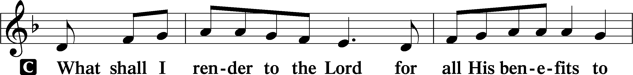
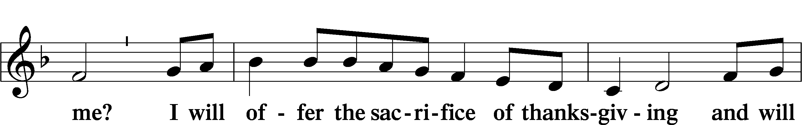
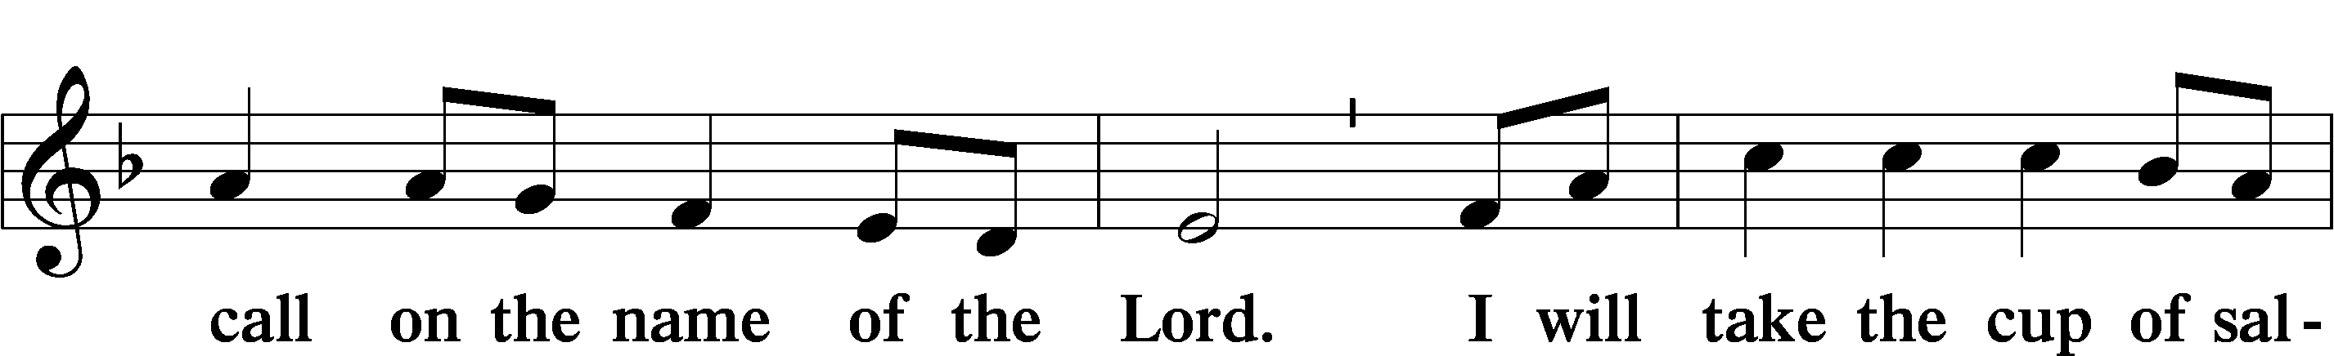
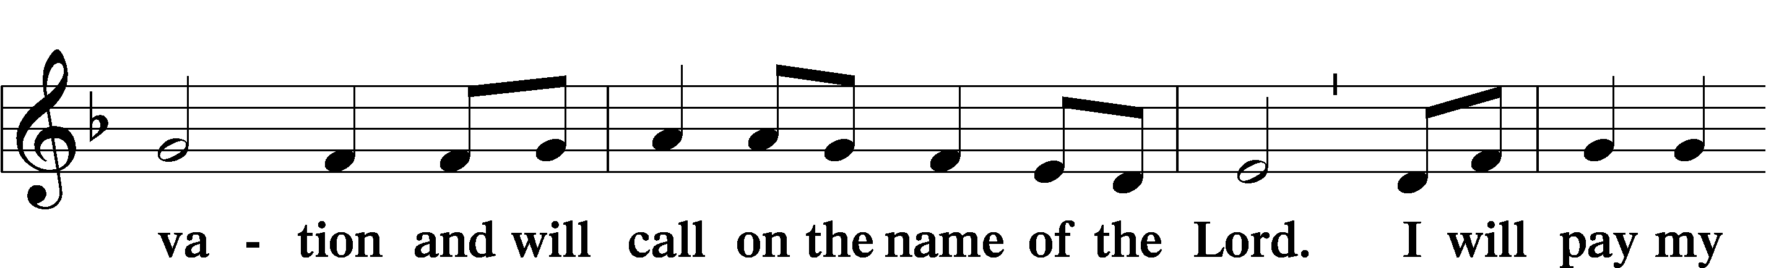
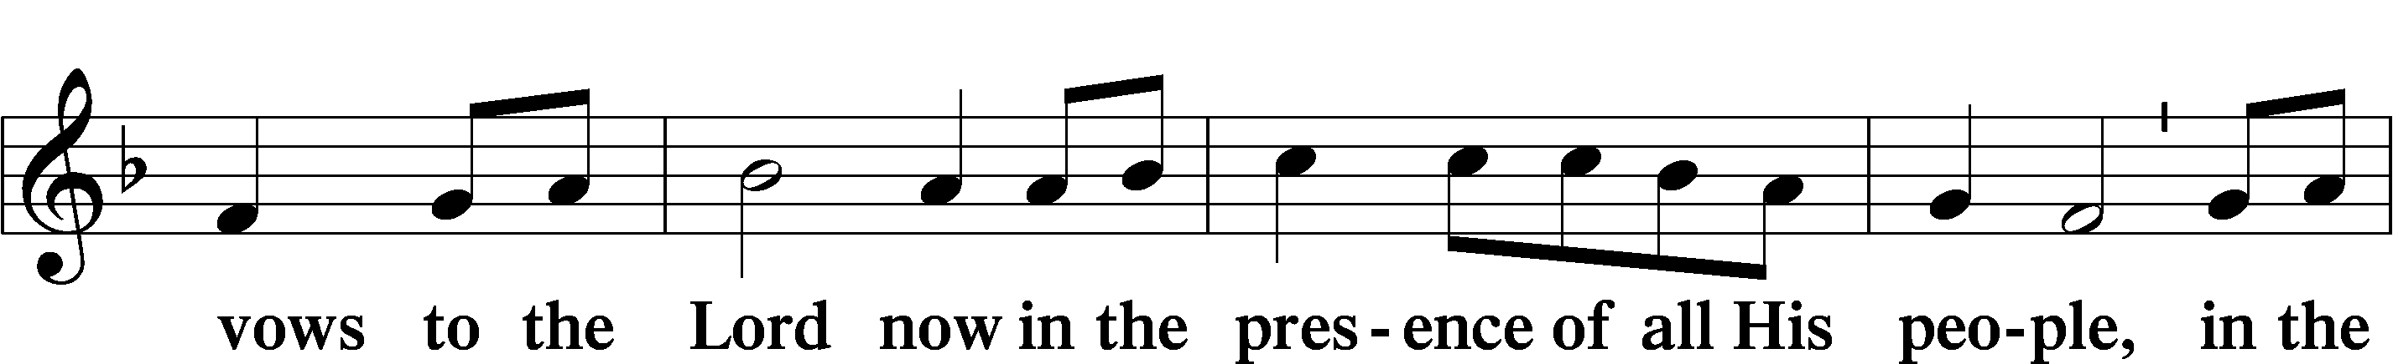
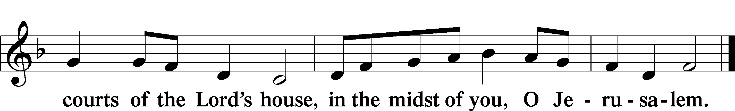
Service of Holy Communion
Communion Statement

The Lord’s Supper is celebrated at this congregation in the confession and glad confidence that, as He says, our Lord gives into our mouths not only bread and wine but His very body and blood to eat and to drink for the forgiveness of sins and to strengthen our union with Him and with one another. Our Lord invites to His table those who trust His words, repent of all sin, and set aside any refusal to forgive and love as He forgives and loves us, that they may show forth His death until He comes.

Because those who eat and drink our Lord’s body and blood unworthily do so to their great harm and because Holy Communion is a confession of the faith which is confessed at this altar, any who are not yet instructed, in doubt, or who hold a confession differing from that of this congregation and the Lutheran Church Missouri Synod, and yet desire to receive this sacrament, are asked to speak with the Pastor.
* See more about the Lutheran teaching on communion in the Hymnal p 329.

Preface LSB 160


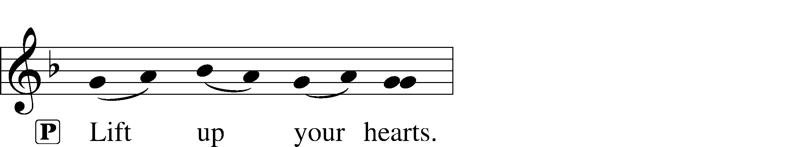


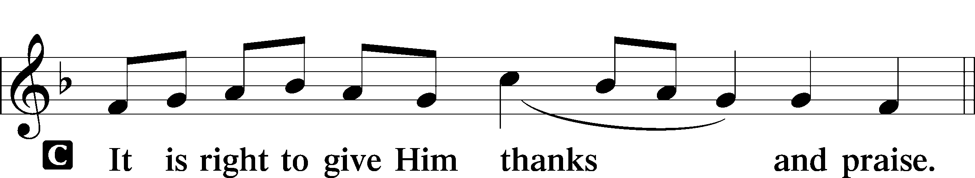
P It is truly good, right, and salutary that we should at all times and in all places give thanks to You, holy Lord, almighty Father, everlasting God, through Jesus Christ, our Lord, who on this day overcame death and the grave and by His glorious resurrection opened to us the way of everlasting life. Therefore with angels and archangels and with all the company of heaven we laud and magnify Your glorious name, evermore praising You and saying:

Sanctus LSB 161
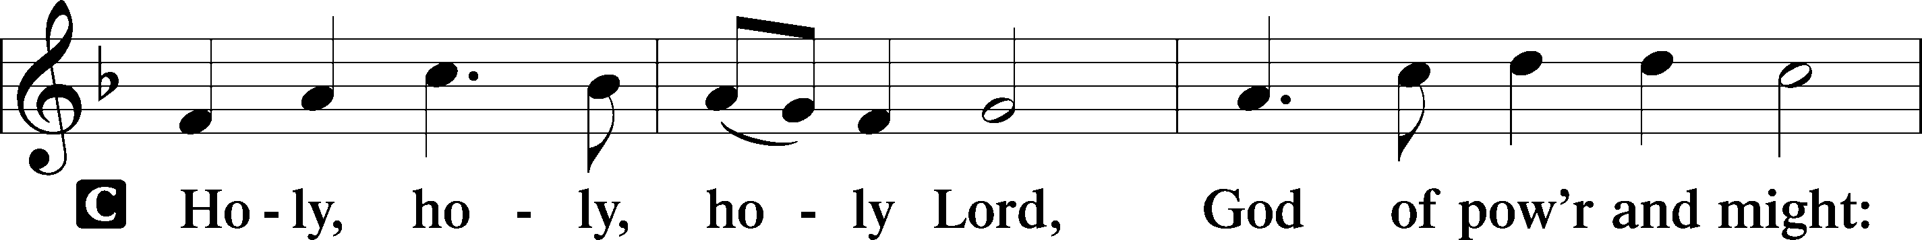
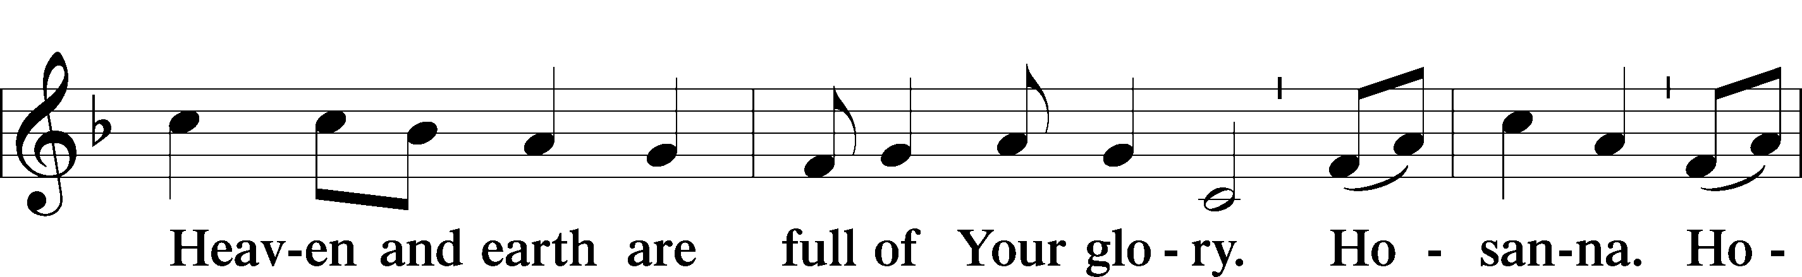
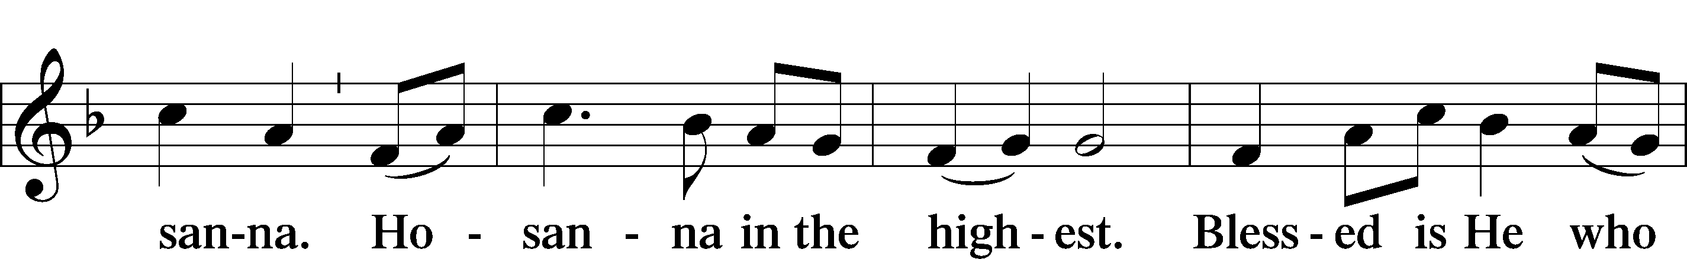
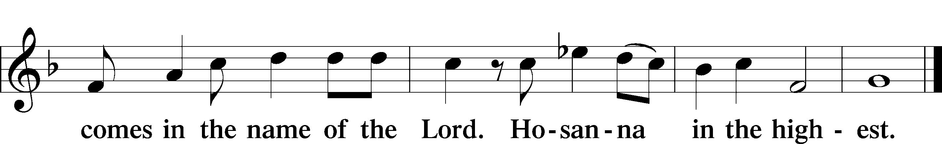

Prayer of Thanksgiving LSB 161
P Blessed are You, Lord of heaven and earth, for You have had mercy on those whom You created and sent Your only-begotten Son into our flesh to bear our sin and be our Savior. With repentant joy we receive the salvation accomplished for us by the all-availing sacrifice of His body and His blood on the cross.

Gathered in the name and the remembrance of Jesus, we beg You, O Lord, to forgive, renew, and strengthen us with Your Word and Spirit. Grant us faithfully to eat His body and drink His blood as He bids us do in His own testament. Gather us together, we pray, from the ends of the earth to celebrate with all the faithful the marriage feast of the Lamb in His kingdom, which has no end. Graciously receive our prayers; deliver and preserve us. To You alone, O Father, be all glory, honor, and worship, with the Son and the Holy Spirit, one God, now and forever.
C Amen.

The Words of Our Lord
P Our Lord Jesus Christ, on the night when He was betrayed, took bread, and when He had given thanks, He broke it and gave it to the disciples and said: “Take, eat; this is My T body, which is given for you. This do in remembrance of Me.”

In the same way also He took the cup after supper, and when He had given thanks, He gave it to them, saying: “Drink of it, all of you; this cup is the new testament in My T blood, which is shed for you for the forgiveness of sins. This do, as often as you drink it, in remembrance of Me.”
P As often as we eat this bread and drink this cup, we proclaim the Lord’s death until He comes.
C Amen. Come, Lord Jesus.

P O Lord Jesus Christ, only Son of the Father, in giving us Your body and blood to eat and to drink, You lead us to remember and confess Your holy cross and passion, Your blessed death, Your rest in the tomb, Your resurrection from the dead, Your ascension into heaven, and Your coming for the final judgment. So remember us in Your kingdom and teach us to pray:

Lord’s Prayer
C Our Father who art in heaven, hallowed be Thy name,
Thy kingdom come, Thy will be done on earth as it is in heaven;
give us this day our daily bread;
and forgive us our trespasses as we forgive those
who trespass against us; and lead us not into temptation,
but deliver us from evil.
For Thine is the kingdom and the power and the glory
forever and ever. Amen.
Pax Domini LSB 163
P The peace of the Lord be with you always.
C Amen.

Agnus Dei (Spoken)

The pastor elevates the chalice and host and says:

P Behold, the Lamb of God that takes away the sins of the world.
C Lord, have mercy upon us.

Agnus Dei LSB 163
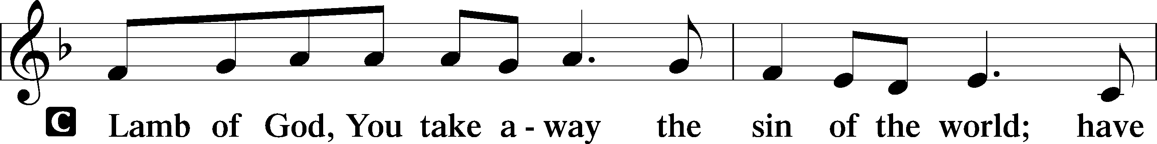
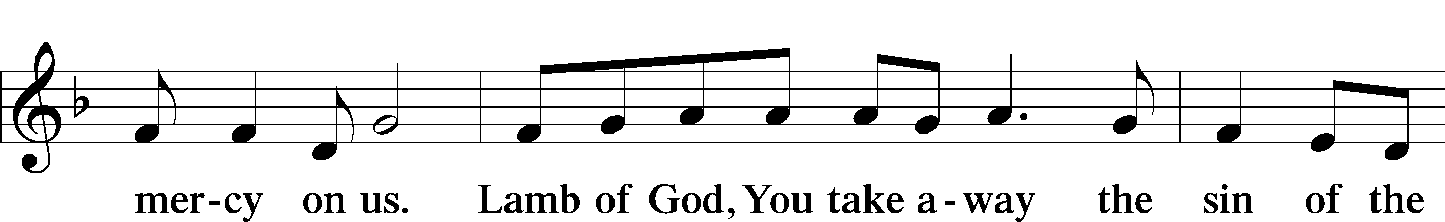
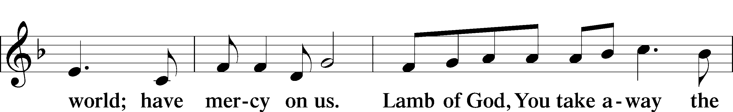
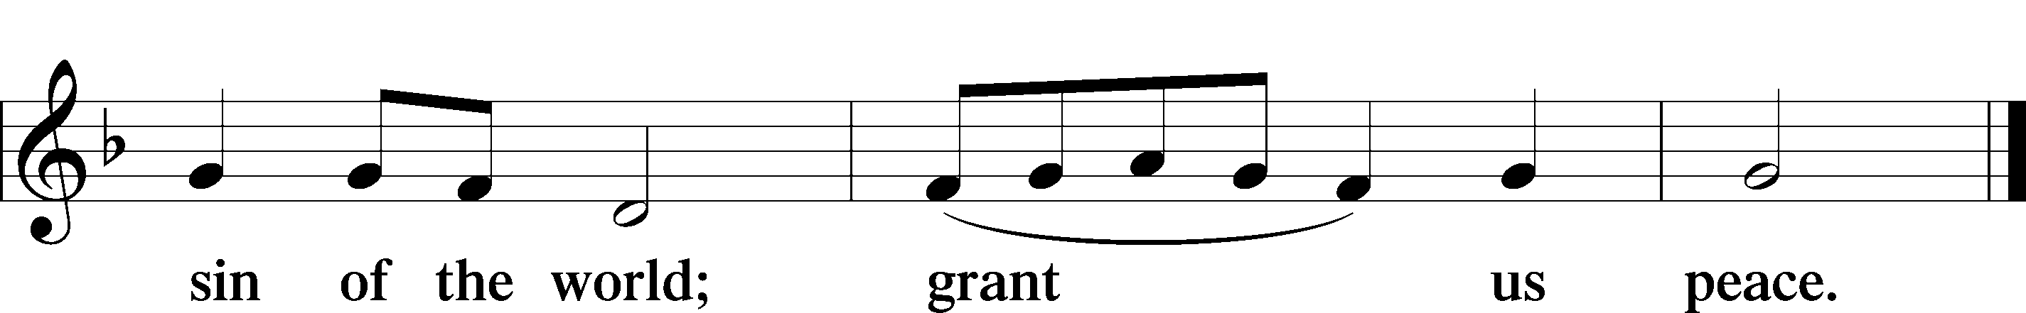

Sit
Distribution


727 On Eagles’ Wings
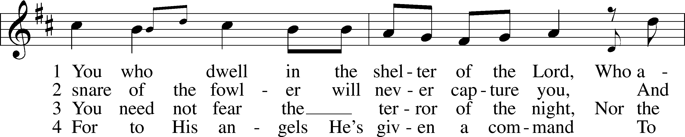
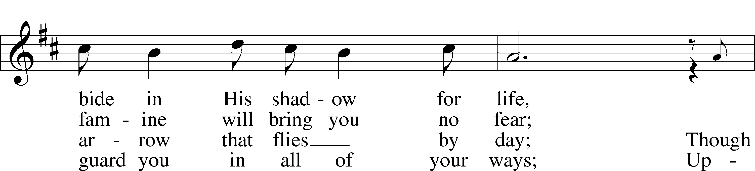
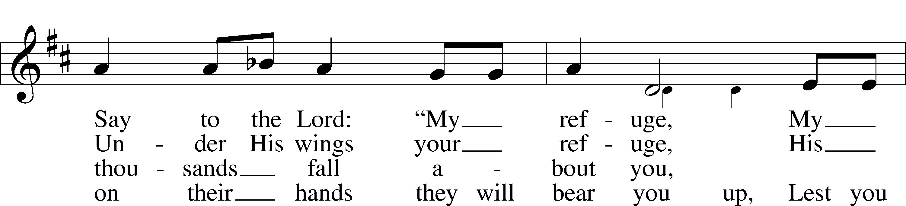
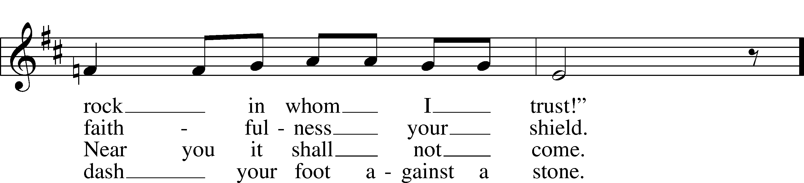
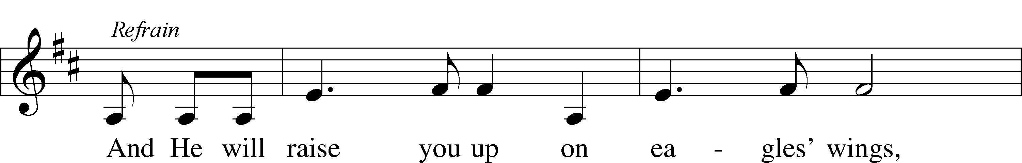
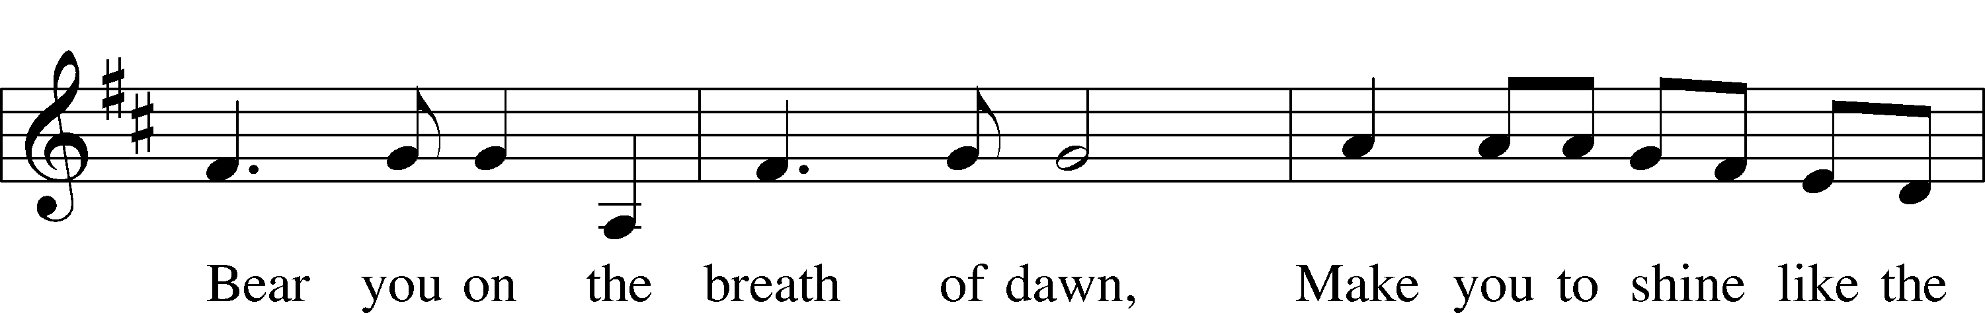
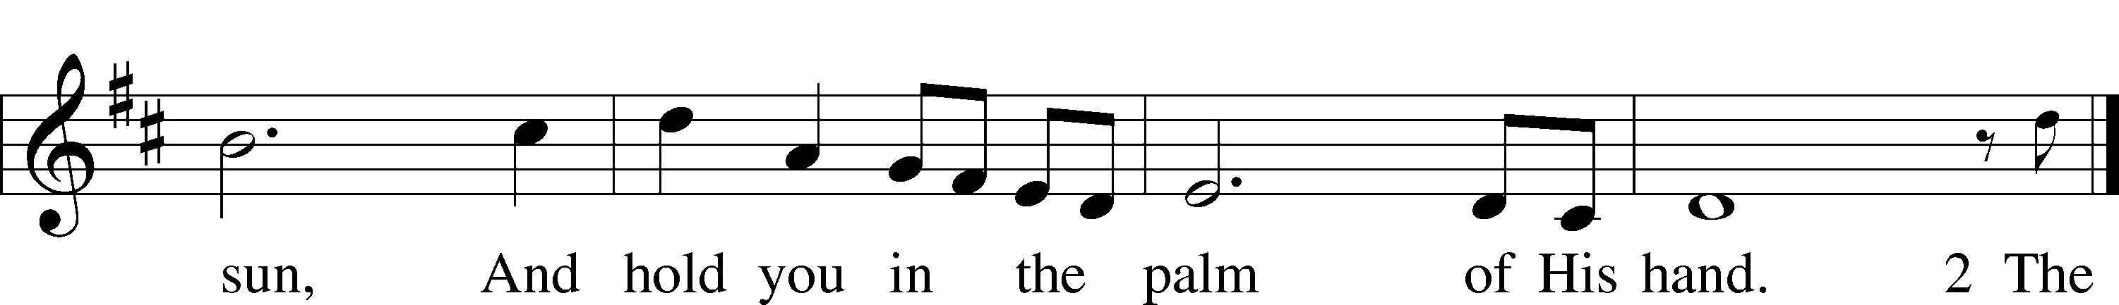
Text and tune: Michael Joncas, 1951
Text and tune: © OCP Publications. Used by permission: LSB Hymn License no. 110003995

Stand

Thank the Lord LSB 164
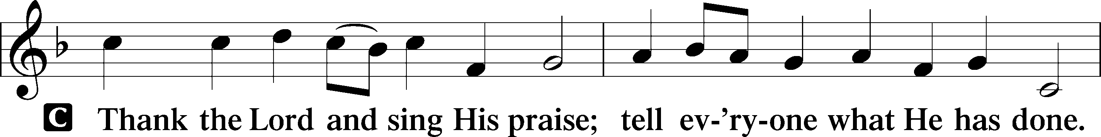
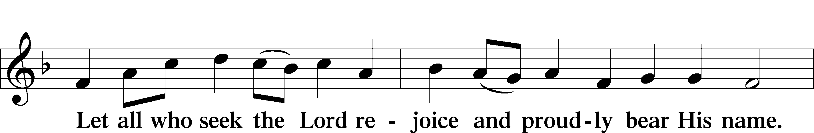
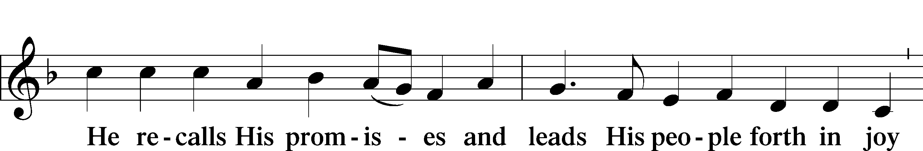
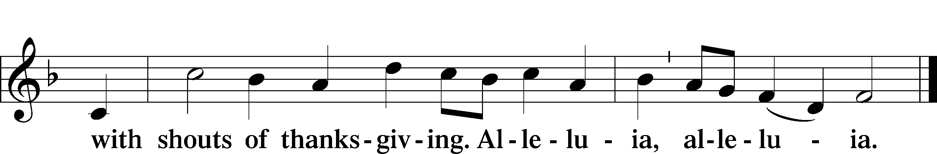

Post-Communion Collect
A Let us pray.
We give thanks to You, almighty God, that You have refreshed us through this salutary gift, and we implore You that of Your mercy You would strengthen us through the same in faith toward You and in fervent love toward one another; through Jesus Christ, Your Son, our Lord, who lives and reigns with You and the Holy Spirit, one God, now and forever.
C Amen.

Verse of the Day Luke 18:8

A Alleluia! I tell you, he will give justice to them speedily.
C Nevertheless, when the Son of Man comes,
will he find faith on earth? Alleluia!

Benediction LSB 166
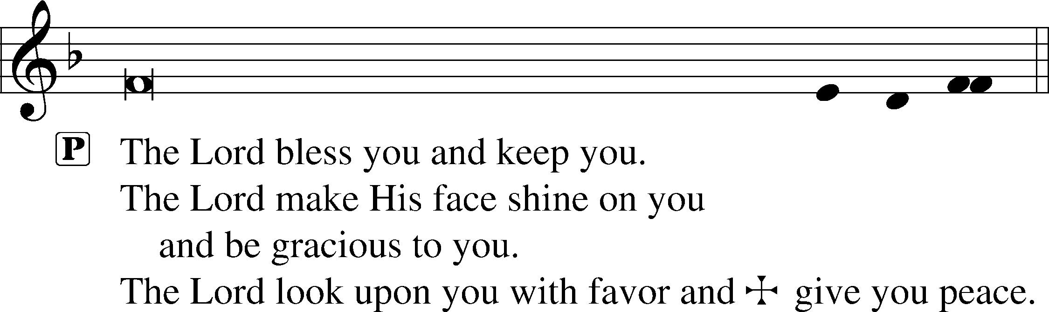


924 Lord, Dismiss Us with Your Blessing
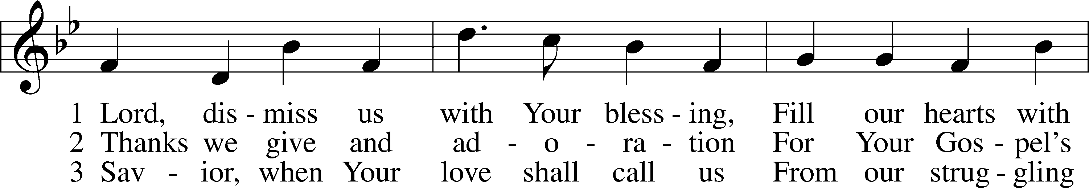
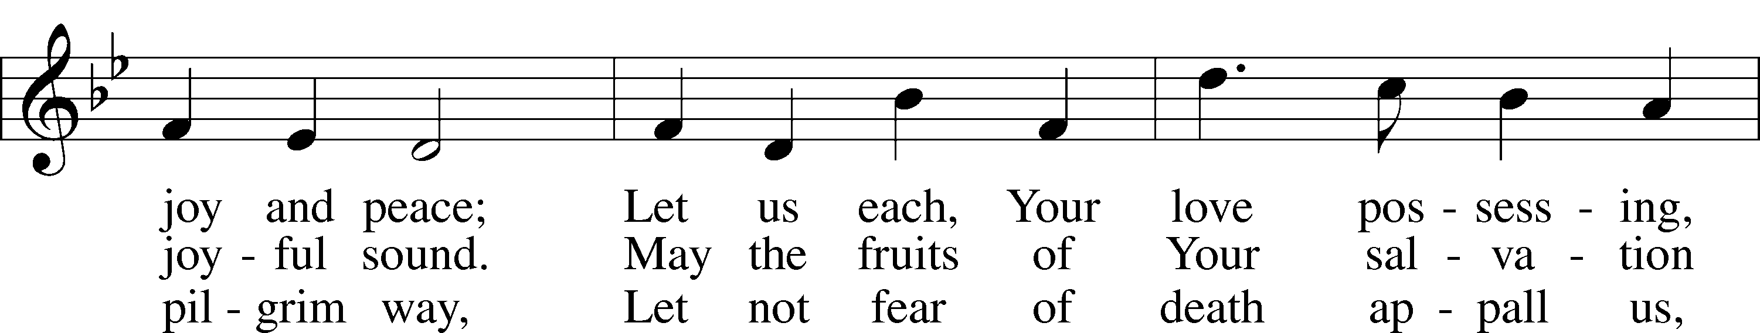
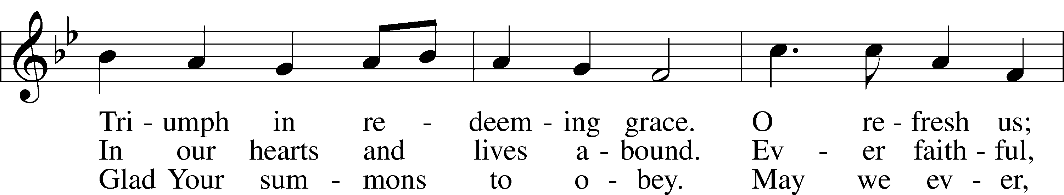
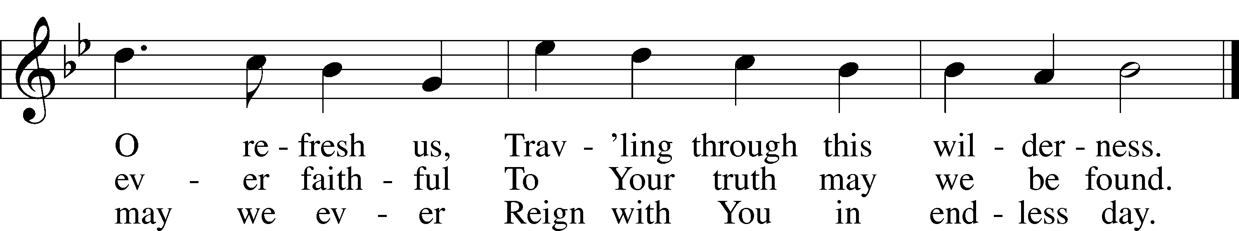
Text (sts. 1–2): attr. John Fawcett, 1740–1817, alt.; (st. 3): Godfrey Thring, 1823–1903, alt.
Tune: Henry T. Smart, 1813–79
Text and tune: Public domain
Acknowledgments Divine Service, Setting One from Lutheran Service Book Unless otherwise indicated, Scripture quotations are from the ESV® Bible (The Holy Bible, English Standard Version®), copyright © 2001 by Crossway, a publishing ministry of Good News Publishers. Used by permission. All rights reserved. Created by Lutheran Service Builder © 2025 Concordia Publishing House.

Prayers of the Church
This week, we lift up:

Angela H, Bob C, Mike Y, Sheila, Elaine, Angie Z, Angela C, Ross, & Kathy H.

Family of the week: Rev Doyle Boykin and Family

*If you have any prayer request let us know.

Last week: Attendance 32 Offering $1,116

Serving Next Week (10/26/25)  Guest Pastor: Rev Doyle Boykin  Music Minister: Vicar Previn Hudetz  Communion Assistant: Jim C  Worship Assistant: Charlie M  Reader: Tania V  Refreshments: Tania V  Altar Guild: Angie Z & Sheila S  Greeter: Juanita | Readings Next Week  Twentieth Sunday after Pentecost  - Genesis 4:1-15  - Psalm 5  - 2 Timothy 4:6-8, 16-18  - Luke 18:9-17  *Please sign up to help during service.*
Announcements  Birthdays: Angela Castenada 22nd  This Week at OSLC:  Bible Study: After Service  Bible Study: Thursday 10am | Coming Up:  - Wear RED for Reformation Sunday (Next Week) on 10/26/25  - All Saints Sunday 11/2/2025
All Saints Sunday (11/2)

For generations, November 1st, has been known as “All Saints' Day”, it commemorates all the believers of the church, both living and departed, what we Lutheran’s call the “Communion of Saints”. Unless the day falls on a Sunday, the celebration is usually held the next Sunday. Liturgy of Names - During the Prayers of the Church on All Saints Day, it is tradition that the names of congregants and family members who have passed into glory over the last few years are read aloud. If you would like to honor a loved one this way, please give their name to the office staff to be included.

Do you not know that all of us who have been baptized into
Christ Jesus were baptized into his death?
We were buried therefore with him by baptism into death,
in order that, just as Christ was raised from the dead by the glory of the Father, we too might walk in newness of life.
Romans 6.3-4

Stewardship Thoughts…

1 Corinthians 1:4 – “I give thanks to my God always for you because of the grace of God that was given you in Christ Jesus.”

The grace of God and thanksgiving go together. God has given us everything we possess and everything that we are. He is the Giver. Once we realize this, then thankfulness wells up inside of us. How could it not? And as Paul shows us here, it’s not only the grace given to us individually that causes us to give thanks. It’s even the grace given to others. We certainly have much to be thankful for when we look at the gifts of grace all around us. And how do we say thank you to the Lord? In any number of ways — in prayer, in sacrificial giving to His mission and in imitating His love and kindness to those around us.
Lcms.org/stewardship


Seasons of the Church Year

Color: Green • Symbol: Hourglass or Watchful Eye
As we move into the last weeks of Trinitytide, the focus of the Church’s worship turns toward the end of all things. The lectionary readings call us to watchfulness, repentance, and readiness for Christ’s return. Though the paraments remain green, these final Sundays remind us that God is bringing His kingdom to completion and that His people live in hope, awaiting the day when all things are made new.

Lectionary Summaries

Overview of Today’s Assigned Reading (19 October 2025)

Faith Clings to the Word and Promises of God and Perseveres in Prayer
Genesis 32:22–30 / 2 Timothy 3:14–4:5 / Luke 18:1–8

“Left alone,” Jacob wrestled through the night with the Lord, “until the breaking of the day” (Gen. 32:24). Though “Jacob’s hip was put out of joint as he wrestled with him” (Gen. 32:25), he would not let go until the Lord blessed him. At times, we, too, strive with God; He strives with us and blesses us by grace.

So Jesus teaches us “always to pray and not lose heart” (Luke 18:1). Jesus speaks of “a judge who neither feared God nor respected man” and of a widow “who kept coming to him and saying, ‘Give me justice against my adversary’” (Luke 18:2–3). Because of her persistence, the judge agreed to “give her justice” (Luke 18:5). Our Lord dispenses justice generously and swiftly, giving “justice to his elect, who cry to him day and night” (Luke 18:7). He does so according to the Gospel.

Therefore, His ministers are to persevere faithfully in their vocation, in what they “have learned and have firmly believed” (2 Tim. 3:14). On the basis of “the sacred writings” (2 Tim. 3:15), they are to “preach the word” at all times and not lose heart (2 Tim. 4:2).

