

For which of you, desiring to build a tower, does not first sit down and count the cost, whether he has enough to complete it?
Luke 14:28

Our Savior Lutheran Church (LCMS)
4301 Atrisco Drive NW
Albuquerque, New Mexico
Website: OSLCNM.COM
Phone: 505.836.7007
Email: oslcabq@gmail.com

Thirteenth Sunday after Pentecost
September 7th,2025
The Time of the Church (Trinitytide)
Thirteenth Sunday after Pentecost
September 7th, 2025

Welcome to Our Savior Lutheran Church (LCMS).  We are glad you are here as we worship, praise, and give thanks to our loving Lord, Jesus Christ. Please join us immediately after service for fellowship and snacks. Adult Bible Study starts at 10:30. If you have any questions about our service or need other assistance, please contact one of our worship assistants. | Hymns  Opening # 790  Sermon # 537  Distribution # Blessed Assurance  Closing # At The Cross

Today’s Message

Love the Lord first, last, temporally—eternally! This commandment intimately connects us to incalculable blessings of knowing and being known by Jesus. Where there is love for the Lord, life pulsates in joy, obedience, and commitment to His Word. Christians gravitate to other believers whose love is grounded in Christ. In the face of adversity, love builds up. In the face of hatred, love boasts of triumph, refreshing the heart, revitalizing faith, comforting with peace.

+++
Serving Today
Service Leader: Vicar Previn Hudetz
Communion Celebrant: Rev John Heffelfinger
Worship Assistant: Charlie
Reader: Jim C
Refreshments: Potluck
Altar Guild: Angie Z & Sheila S
Greeter: Bob

Welcome
Divine Service IV

790 Praise to the Lord, the Almighty
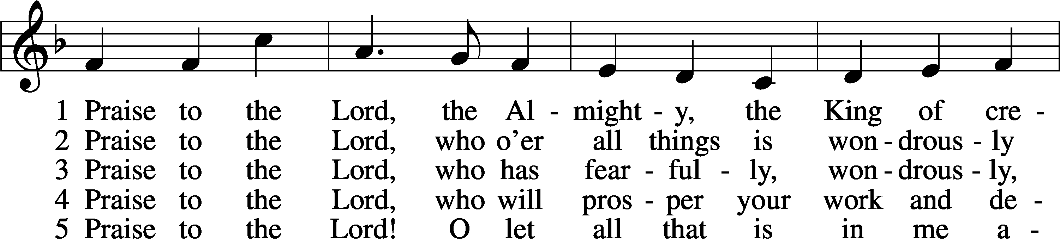
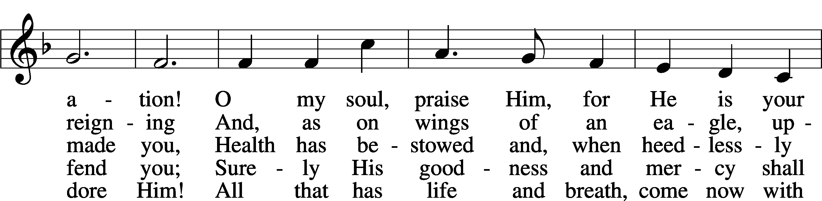
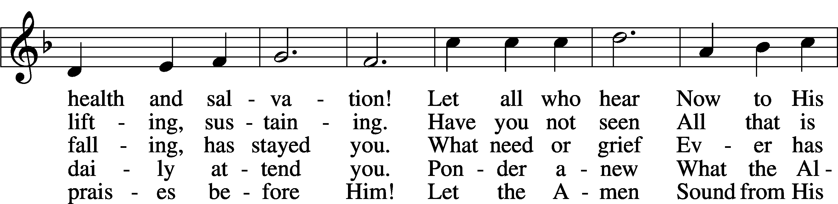
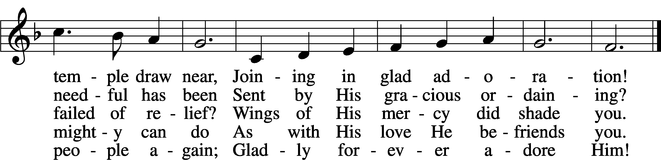
Text: Joachim Neander, 1650–80; tr. Catherine Winkworth, 1827–78, alt.
Tune: Ander Theil Des Erneuerten Gesang-Buchs, 1665, Stralsund
Text and tune: Public domain

Confession and Absolution
Stand
The sign of the cross may be made by all in remembrance of their Baptism.

P In the name of the Father and of the T Son and of the Holy Spirit.
C Amen.
P Our help is in the name of the Lord,
C who made heaven and earth.
P If You, O Lord, kept a record of sins, O Lord, who could stand?
C But with You there is forgiveness; therefore You are feared.

P Since we are gathered to hear God’s Word, call upon Him in prayer and praise, and receive the body and blood of our Lord Jesus Christ in the fellowship of this altar, let us first consider our unworthiness and confess before God and one another that we have sinned in thought, word, and deed, and that we cannot free ourselves from our sinful condition. Together as His people let us take refuge in the infinite mercy of God, our heavenly Father, seeking His grace for the sake of Christ, and saying: God, be merciful to me, a sinner.

Pause for reflection

C Almighty God, have mercy upon us, forgive us our sins, and lead us to everlasting life. Amen.

P Almighty God, in His mercy has given His Son to die for you and for His sake forgive you all you sins. As a called servant of Christ, and by His authority, I therefore forgive you all your sins in the name of the Father and of the T Son and of the Holy Spirit.
C Amen.

Stand
Service of the Word
Invitatory for trinitytide
The Lord has sanctified us in the true faith,
O come, let us worship Him.*
We know no other God except the Lord,
in whom we trust. *
Introit Psalm 119:28–32; antiphon: v. 27
Make me understand the way of your | precepts,*
and I will meditate on your | wondrous works.
My soul melts away for | sorrow;*
strengthen me according | to your word!
Put false ways | far from me*
and graciously teach | me your law!
I have chosen the way of | faithfulness;*
I set your just decrees be- | fore me.
I cling to your testimonies, | O Lord;*
let me not be | put to shame!
I will run in the way of your com- | mandments*
when you en- | large my heart!
Glory be to the Father and | to the Son and to the Holy | Spirit;
as it was in the be- | ginning, is now, and will be forever. | Amen.
Make me understand the way of your | precepts,*
and I will meditate on your | wondrous works.
Kyrie 204

P In Peace, let us pray to the Lord
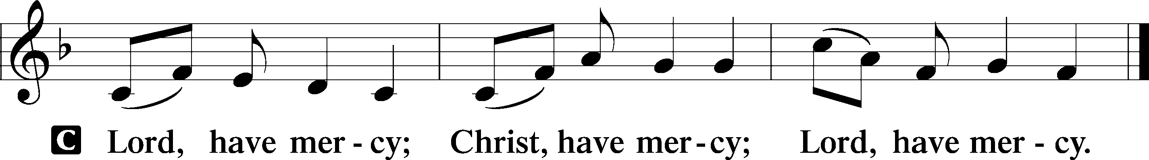

P For the peace of the whole world, for the wellbeing of the Church of God and for the unity of all; let us pray to the Lord.

P For this holy House, and all who offer here their worship and praise; let us pray to the Lord.
This Is the Feast LSB 155
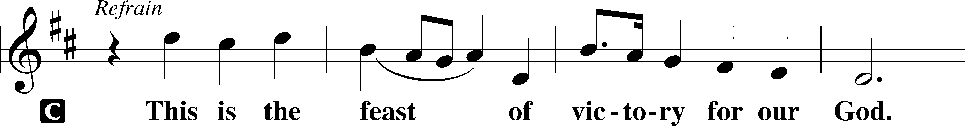
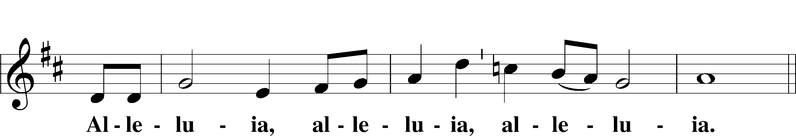
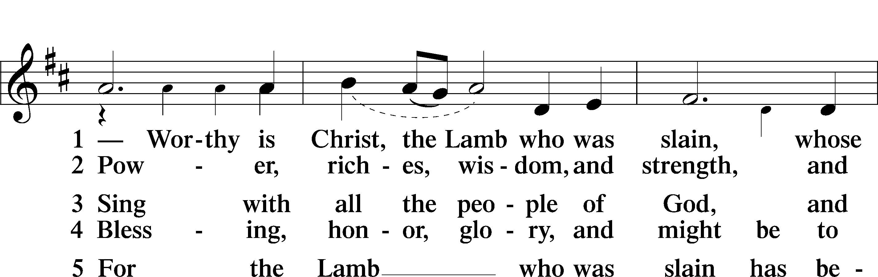
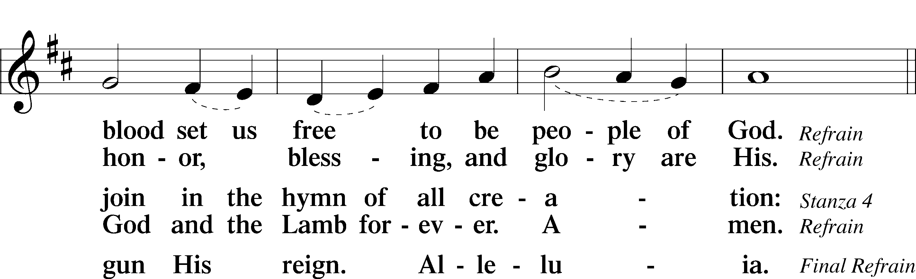
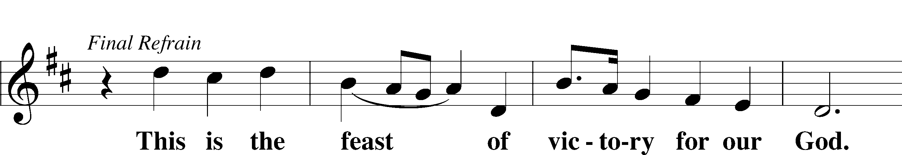
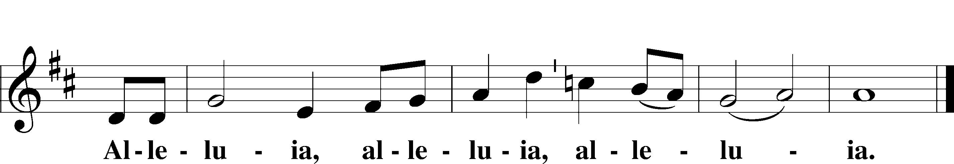

Salutation and Collect of the Day
P The Lord be with you.
C And also with you.

P Let us pray.
O merciful Lord, You did not spare Your only Son but delivered Him up for us all. Grant us courage and strength to take up the cross and follow Him, who lives and reigns with You and the Holy Spirit, one God, now and forever.
C Amen.

Sit

Old Testament Reading Deuteronomy 30:15–20
A The Old Testament Read from Deuteronomy chapter 30.

15“See, I have set before you today life and good, death and evil. 16If you obey the commandments of the Lord your God that I command you today, by loving the Lord your God, by walking in his ways, and by keeping his commandments and his statutes and his rules, then you shall live and multiply, and the Lord your God will bless you in the land that you are entering to take possession of it. 17But if your heart turns away, and you will not hear, but are drawn away to worship other gods and serve them, 18I declare to you today, that you shall surely perish. You shall not live long in the land that you are going over the Jordan to enter and possess. 19I call heaven and earth to witness against you today, that I have set before you life and death, blessing and curse. Therefore choose life, that you and your offspring may live, 20loving the Lord your God, obeying his voice and holding fast to him, for he is your life and length of days, that you may dwell in the land that the Lord swore to your fathers, to Abraham, to Isaac, and to Jacob, to give them.”
A This is the Word of the Lord.
C Thanks be to God.
Psalm Psalm 1; antiphon: v. 6
1Blessèd is the man
who walks not in the counsel of the | wicked,*
nor stands in the way of sinners,
nor sits in the seat of | scoffers;
2but his delight is in the law | of the Lord,*
and on his law he meditates | day and night.
3He is like a tree planted by streams of water
that yields its fruit in its season, *
and its leaf does not | wither.
In all that he does, he | prospers.
4The wicked | are not so,*
but are like chaff that the wind | drives away.
5Therefore the wicked will not stand in the | judgment,*
nor sinners in the congregation of the | righteous;
6for the Lord knows the way of the | righteous,*
but the way of the wicked will | perish.
Epistle Philemon 1–21
A The Epistle from the book of Philemon chapter 1.

1Paul, a prisoner for Christ Jesus, and Timothy our brother,
To Philemon our beloved fellow worker 2and Apphia our sister and Archippus our fellow soldier, and the church in your house:
3Grace to you and peace from God our Father and the Lord Jesus Christ.
4I thank my God always when I remember you in my prayers, 5because I hear of your love and of the faith that you have toward the Lord Jesus and all the saints, 6and I pray that the sharing of your faith may become effective for the full knowledge of every good thing that is in us for the sake of Christ. 7For I have derived much joy and comfort from your love, my brother, because the hearts of the saints have been refreshed through you.
8Accordingly, though I am bold enough in Christ to command you to do what is required, 9yet for love’s sake I prefer to appeal to you—I, Paul, an old man and now a prisoner also for Christ Jesus— 10I appeal to you for my child, Onesimus, whose father I became in my imprisonment. 11(Formerly he was useless to you, but now he is indeed useful to you and to me.) 12I am sending him back to you, sending my very heart. 13I would have been glad to keep him with me, in order that he might serve me on your behalf during my imprisonment for the gospel, 14but I preferred to do nothing without your consent in order that your goodness might not be by compulsion but of your own free will. 15For this perhaps is why he was parted from you for a while, that you might have him back forever, 16no longer as a slave but more than a slave, as a beloved brother—especially to me, but how much more to you, both in the flesh and in the Lord.
17So if you consider me your partner, receive him as you would receive me. 18If he has wronged you at all, or owes you anything, charge that to my account. 19I, Paul, write this with my own hand: I will repay it—to say nothing of your owing me even your own self. 20Yes, brother, I want some benefit from you in the Lord. Refresh my heart in Christ.
21Confident of your obedience, I write to you, knowing that you will do even more than I say.
A This is the Word of the Lord.
C Thanks be to God.

Stand

Alleluia and Verse

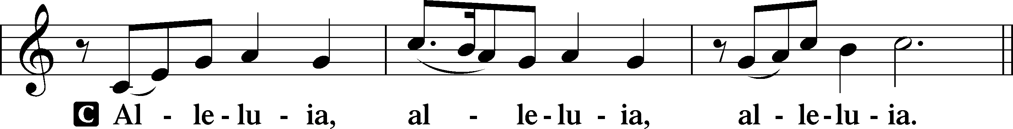
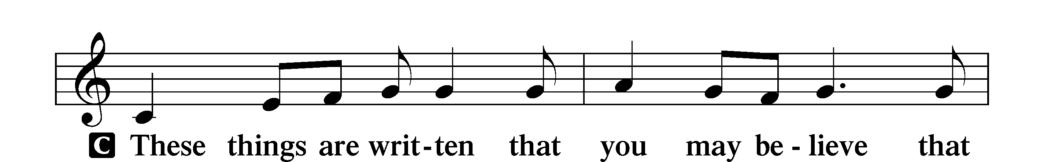
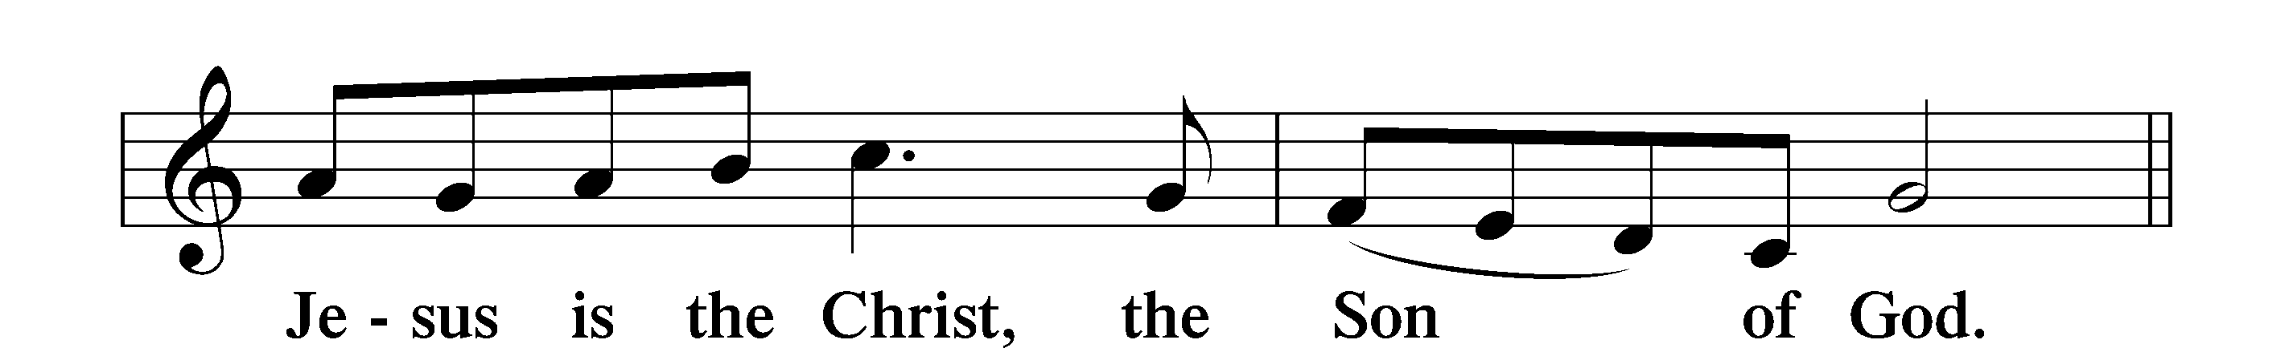

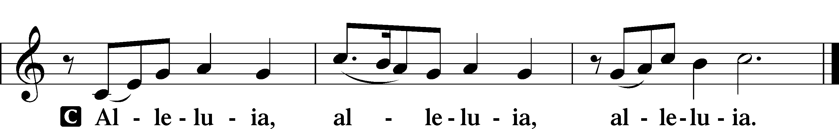

Holy Gospel Luke 14:25–35
P The Holy Gospel according to St. Luke, the fourteenth chapter.
C Glory to You, O Lord.

25Now great crowds accompanied [Jesus], and he turned and said to them, 26“If anyone comes to me and does not hate his own father and mother and wife and children and brothers and sisters, yes, and even his own life, he cannot be my disciple. 27Whoever does not bear his own cross and come after me cannot be my disciple. 28For which of you, desiring to build a tower, does not first sit down and count the cost, whether he has enough to complete it? 29Otherwise, when he has laid a foundation and is not able to finish, all who see it begin to mock him, 30saying, ‘This man began to build and was not able to finish.’ 31Or what king, going out to encounter another king in war, will not sit down first and deliberate whether he is able with ten thousand to meet him who comes against him with twenty thousand? 32And if not, while the other is yet a great way off, he sends a delegation and asks for terms of peace. 33So therefore, any one of you who does not renounce all that he has cannot be my disciple.
34“Salt is good, but if salt has lost its taste, how shall its saltiness be restored? 35It is of no use either for the soil or for the manure pile. It is thrown away. He who has ears to hear, let him hear.”

P This is the Gospel of the Lord.
C Praise to You, O Christ.

Sit
537 Beautiful Savior
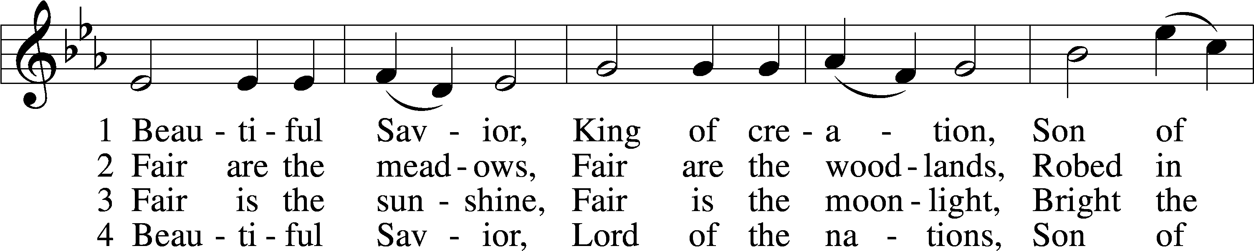
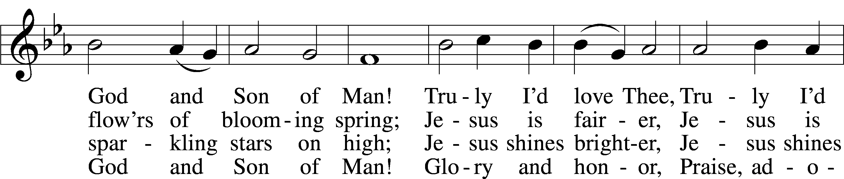
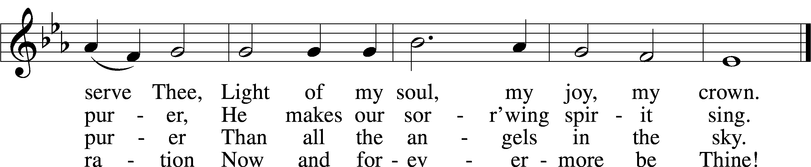
Text: Münsterisch Gesangbuch, 1677, Münster; tr. Joseph A. Seiss, 1823–1904 Tune: Silesian, 19th cent. Text and tune: Public domain
Sermon

Stand

Apostles’ Creed

C I believe in God, the Father Almighty,
maker of heaven and earth.
And in Jesus Christ, His only Son, our Lord,
who was conceived by the Holy Spirit, born of the virgin Mary,
suffered under Pontius Pilate, was crucified, died and was buried.
He descended into hell.
The third day He rose again from the dead.
He ascended into heaven and sits at the right hand of God
the Father Almighty.
From thence He will come to judge the living and the dead.
I believe in the Holy Spirit, the holy Christian Church,
the communion of saints, the forgiveness of sins,
the resurrection of the body, and the life T everlasting. Amen.
Prayer of the Church

Following the prayers, the people may greet one another in the name of the Lord, saying,
“Peace be with you,” as a sign of reconciliation and of the unity of the Spirit in the bond of peace
(Matt. 5:22–24; Eph. 4:1–3).

Sit

Offering & Sharing of the Peace

Service of Holy Communion
Communion Statement

The Lord’s Supper is celebrated at this congregation in the confession and glad confidence that, as He says, our Lord gives into our mouths not only bread and wine but His very body and blood to eat and to drink for the forgiveness of sins and to strengthen our union with Him and with one another. Our Lord invites to His table those who trust His words, repent of all sin, and set aside any refusal to forgive and love as He forgives and loves us, that they may show forth His death until He comes.

Because those who eat and drink our Lord’s body and blood unworthily do so to their great harm and because Holy Communion is a confession of the faith which is confessed at this altar, any who are not yet instructed, in doubt, or who hold a confession differing from that of this congregation and the Lutheran Church Missouri Synod, and yet desire to receive this sacrament, are asked to speak with the Pastor.
* See more about the Lutheran teaching on communion in the Hymnal p 329.

Stand

Preface LSB 208
P The Lord be with you.
C And also with you.

P Lift up your hearts.
C We lift them to the Lord.

P Let us give thanks to the Lord our God.
C It is right to give Him thanks and praise.

P It is truly good, right, and salutary that we should at all times and in all places give thanks to You, O Lord, holy Father, almighty and everlasting God, for the countless blessings You so freely bestow on us and all creation. Above all, we give thanks for Your boundless love shown to us when You sent Your only-begotten Son, Jesus Christ, into our flesh and laid on Him our sin, giving Him into death that we might not die eternally. Because He is now risen from the dead and lives and reigns to all eternity, all who believe in Him will overcome sin and death and will rise again to new life. Therefore with angels and archangels and with all the company of heaven we laud and magnify Your glorious name, evermore praising You and saying:

Sanctus LSB 208
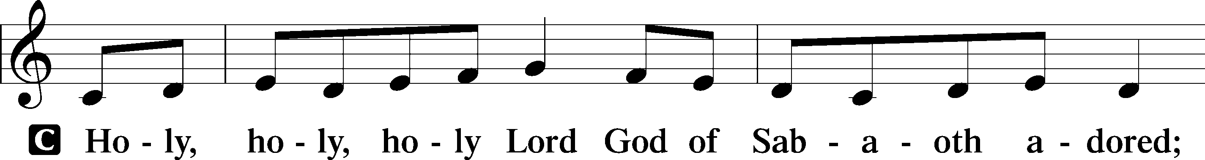
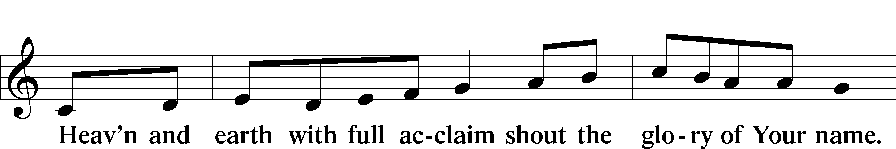
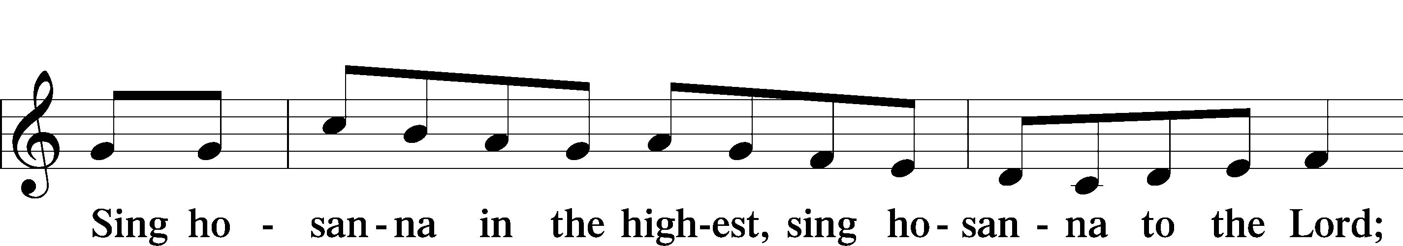
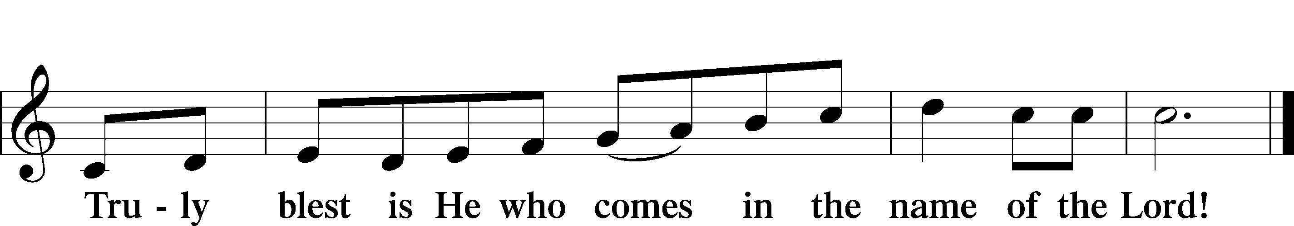
Text: Stephen P. Starke

Prayer of Thanksgiving
P Blessed are You, O Lord our God, king of all creation, for You have had mercy on us and given Your only-begotten Son that whoever believes in Him should not perish but have eternal life.

In Your righteous judgment You condemned the sin of Adam and Eve, who ate the forbidden fruit, and You justly barred them and all their children from the tree of life. Yet, in Your great mercy, You promised salvation by a second Adam, Your Son, Jesus Christ, our Lord, and made His cross a life-giving tree for all who trust in Him.

We give You thanks for the redemption You have prepared for us through Jesus Christ. Grant us Your Holy Spirit that we may faithfully eat and drink of the fruits of His cross and receive the blessings of forgiveness, life, and salvation that come to us in His body and blood.

Hear us as we pray in His name and as He has taught us:

Lord’s Prayer
C Our Father who art in heaven,
hallowed be Thy name,
Thy kingdom come,
Thy will be done on earth
as it is in heaven;
give us this day our daily bread;
and forgive us our trespasses
as we forgive those
who trespass against us;
and lead us not into temptation,
but deliver us from evil.
For Thine is the kingdom
and the power and the glory
forever and ever. Amen.

The Words of Our Lord
P Our Lord Jesus Christ, on the night when He was betrayed, took bread, and when He had given thanks, He broke it and gave it to the disciples and said: “Take, eat; this is My T body, which is given for you. This do in remembrance of Me.”

In the same way also He took the cup after supper, and when He had given thanks, He gave it to them, saying: “Drink of it, all of you; this cup is the new testament in My T blood, which is shed for you for the forgiveness of sins. This do, as often as you drink it, in remembrance of Me.”

Pax Domini
P The peace of the Lord be with you always.
C Amen.

Agnus Dei LSB 210
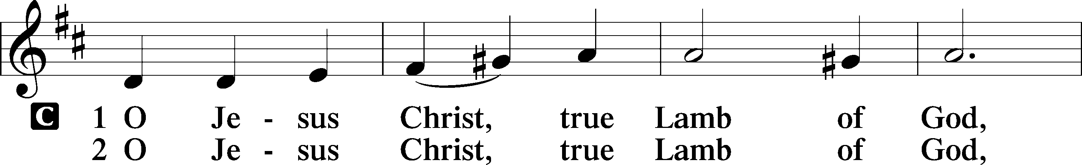
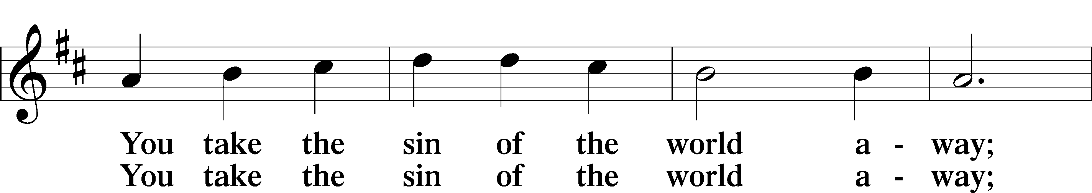
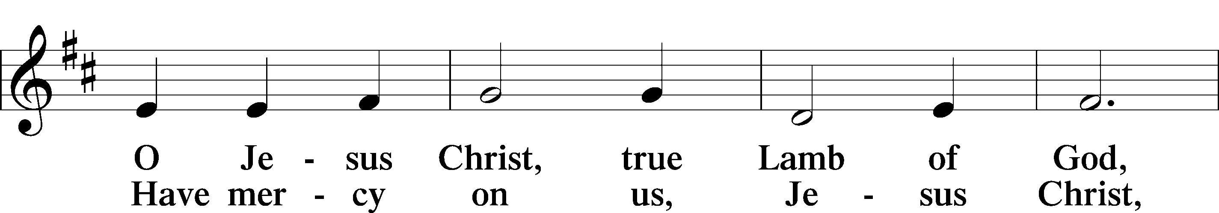
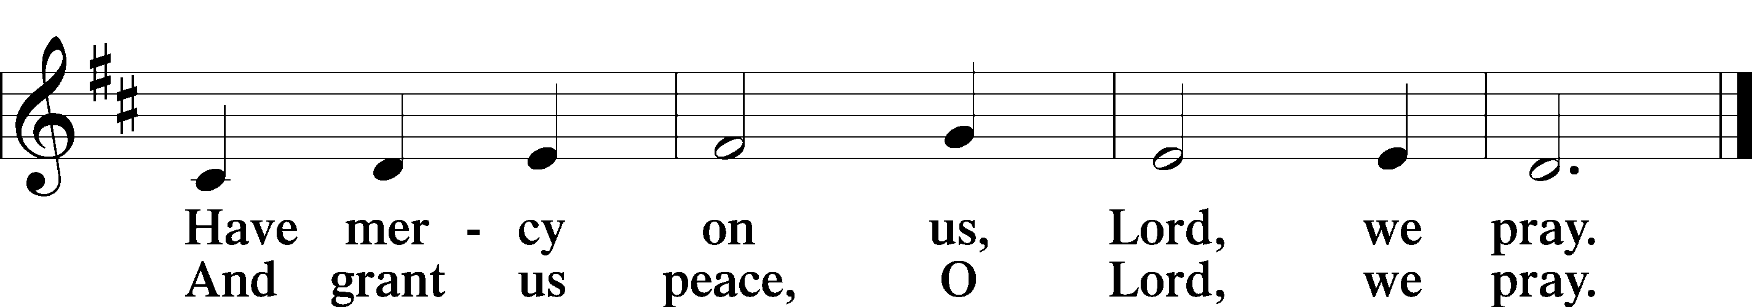
Text: Stephen P. Starke

Sit

Communion


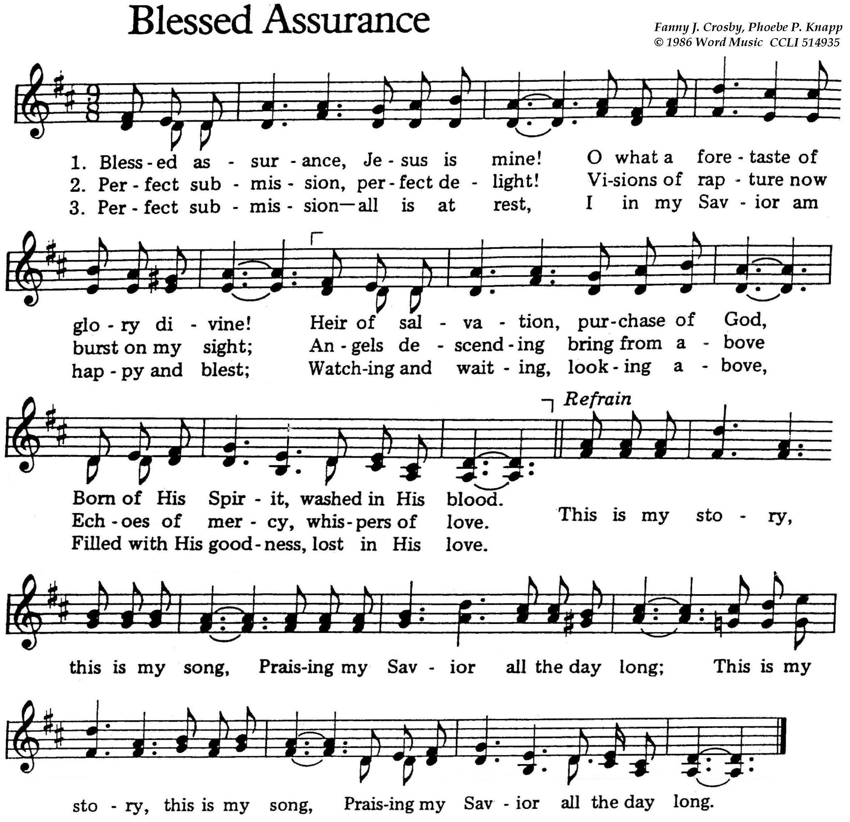

Stand

Nunc Dimittis LSB 211
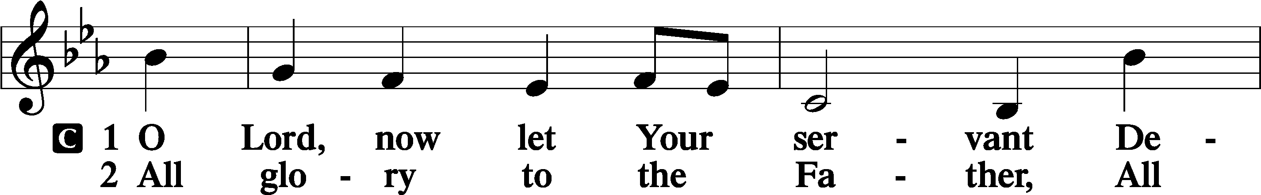
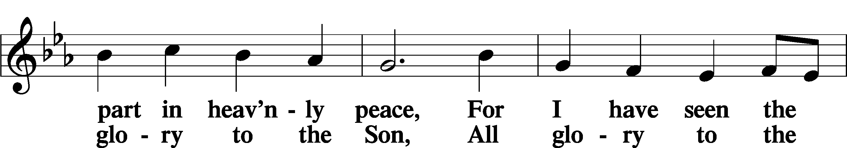
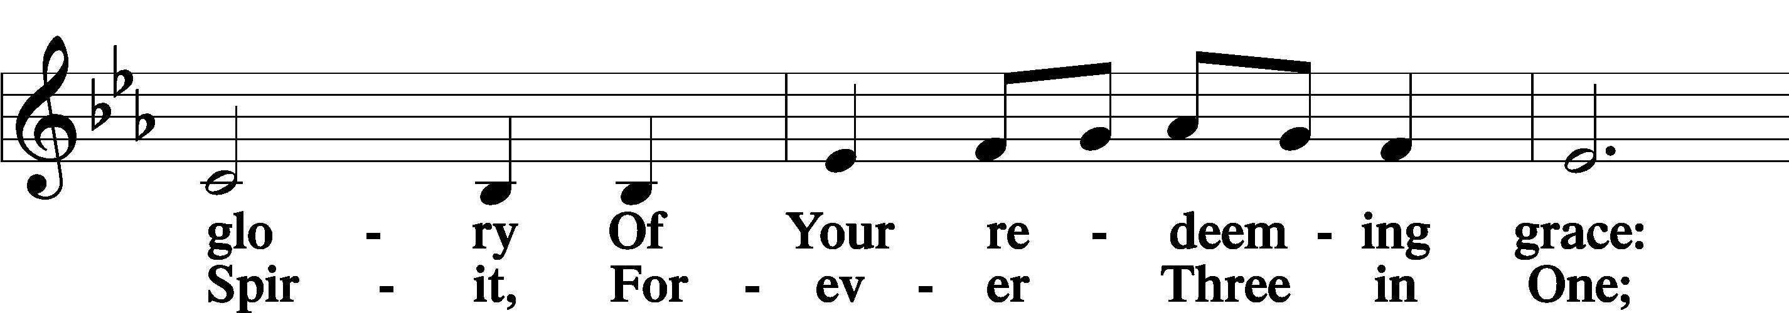
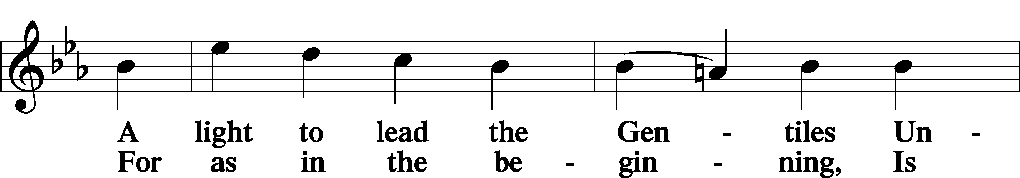
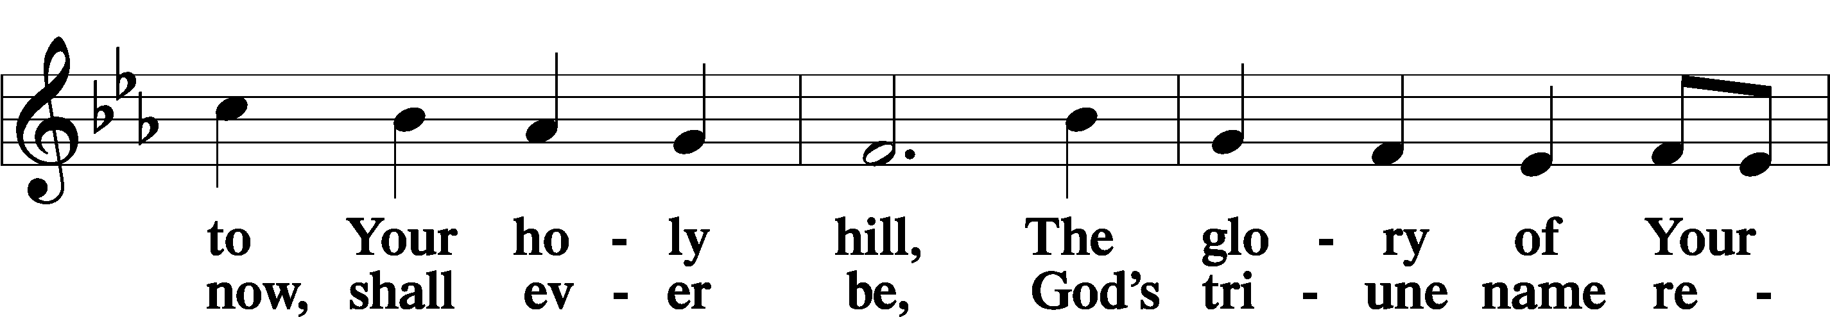
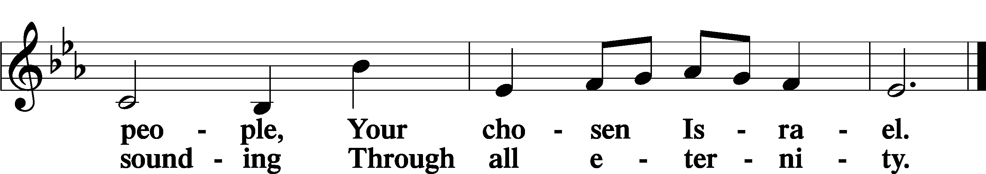

Post-Communion Collect
A Let us pray.
We give thanks to You, almighty God, that You have refreshed us through this salutary gift, and we implore You that of Your mercy You would strengthen us through the same in faith toward You and in fervent love toward one another; through Jesus Christ, Your Son, our Lord, who lives and reigns with You and the Holy Spirit, one God, now and forever.
C Amen.

Verse of the Day Galatians 6:14
A Alleluia. Far be it from me to boast except in the cross of our Lord Jesus Christ,
C by which the world has been crucified to me, and I to the world. Alleluia.

Benedicamus LSB 212
A Let us bless the Lord.
C Thanks be to God.

Benediction
P The Lord bless you and keep you.
The Lord make His face shine on you and be gracious to you.
The Lord look upon you with favor and T give you peace.
C Amen.


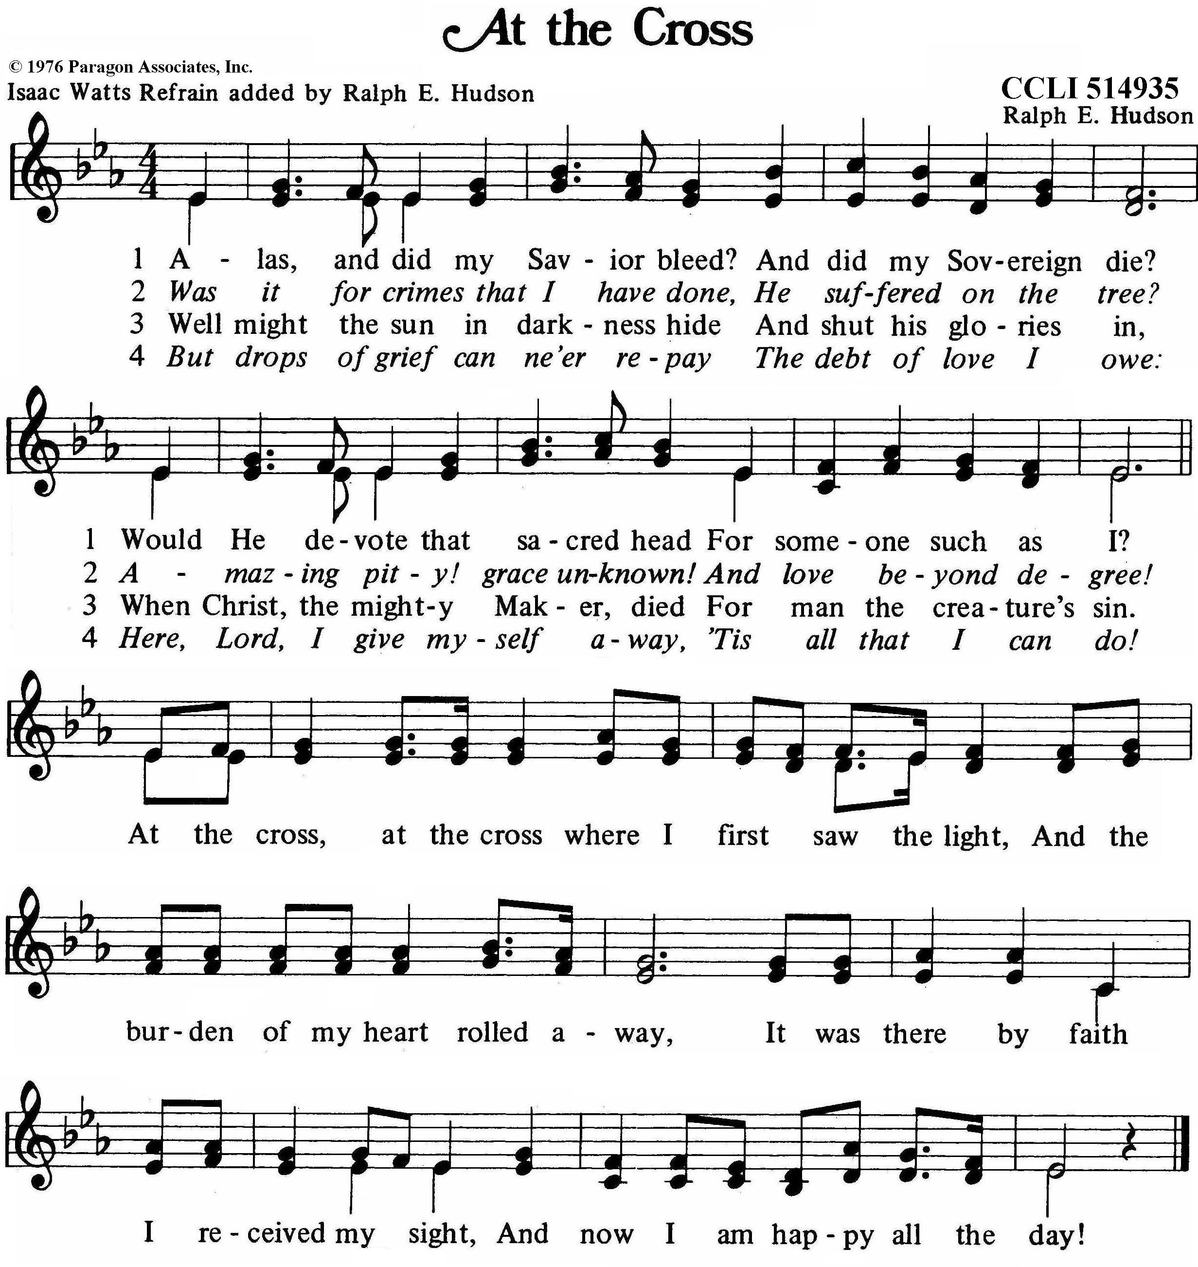
Acknowledgments
Divine Service, Setting Four from Lutheran Service Book
Unless otherwise indicated, Scripture quotations are from the ESV® Bible (The Holy Bible, English Standard Version®), copyright © 2001 by Crossway, a publishing ministry of Good News Publishers. Used by permission. All rights reserved.
Created by Lutheran Service Builder © 2025 Concordia Publishing House.

Prayers of the Church
This week, we lift up:

Angela H (surgery on 13th), Sheila, Elaine, Bob, Angie Z, Angela C,
Ross, & Kathy H.

Family of the week: Angelina Zak

*If you have any prayer request let us know.

Last week: Attendance - Offering -

Serving Next Week (9/14/25)  Guest Pastor: Rev Doyle Boykin  Music Minister: Vicar Previn Hudetz  Worship Assistant: Charlie M  Reader: Sheila S.  Refreshments: -Tania  Altar Guild: Angie & Sheila  Greeter: TBD | Readings Next Week  Fourteenth Sunday after Pentecost  Ezekiel 34:11-24  Psalm 119:169-176  1 Timothy 1:12-17  Luke 15:1-10  *Please sign up to help during service.*
Announcements  Birthdays:  This Week at OSLC:  Bible Study: After Service  Bible Study: Thursday 10am | Coming Up:  Congregational Meeting to confirm & elect Council Members.  September 28, 2025  Following service

