

Father Abraham, have mercy on me, and send Lazarus to dip the end of his finger in water and cool my tongue, for I am in anguish in this flame.

Luke 16:24

Our Savior Lutheran Church (LCMS)
4301 Atrisco Drive NW
Albuquerque, New Mexico
Website: OSLCNM.COM
Phone: 505.836.7007
Email: oslcabq@gmail.com

Sixteenth Sunday after Pentecost
September 28th,2025

The Time of the Church (Trinitytide)
Sixteenth Sunday after Pentecost
September 28th, 2025

Welcome to Our Savior Lutheran Church (LCMS).  We are glad you are here as we worship, praise, and give thanks to our loving Lord, Jesus Christ. Please join us immediately after service for fellowship and snacks. Adult Bible Study starts at 10:30. If you have any questions about our service or need other assistance, please contact one of our worship assistants. | Hymns  Opening # 549 & 686  Sermon # 905  Distribution # 437  Closing # 804

Today’s Message

Of Wealth & Giving – Today’s readings remind us that everything we have is a gift from God. We are called to be faithful stewards of His creation, using our resources wisely and generously. True faith trusts that the Lord will provide for our needs, regardless of the size of our bank account. What God blesses us with in life is meant not only for the care and support of our families but also for the benefit and relief of others in need.

+++
Serving Today
Service Leader: Vicar Previn Hudetz
Communion Celebrant: Rev John Heffelfinger
Worship Assistant: TBD
Reader: Sheila S
Refreshments: Juanita
Altar Guild: Angie Z & Sheila S
Greeter: Tania

Welcome
Divine Service IV

549 All Hail the Power of Jesus’ Name sts. 1–4, 7
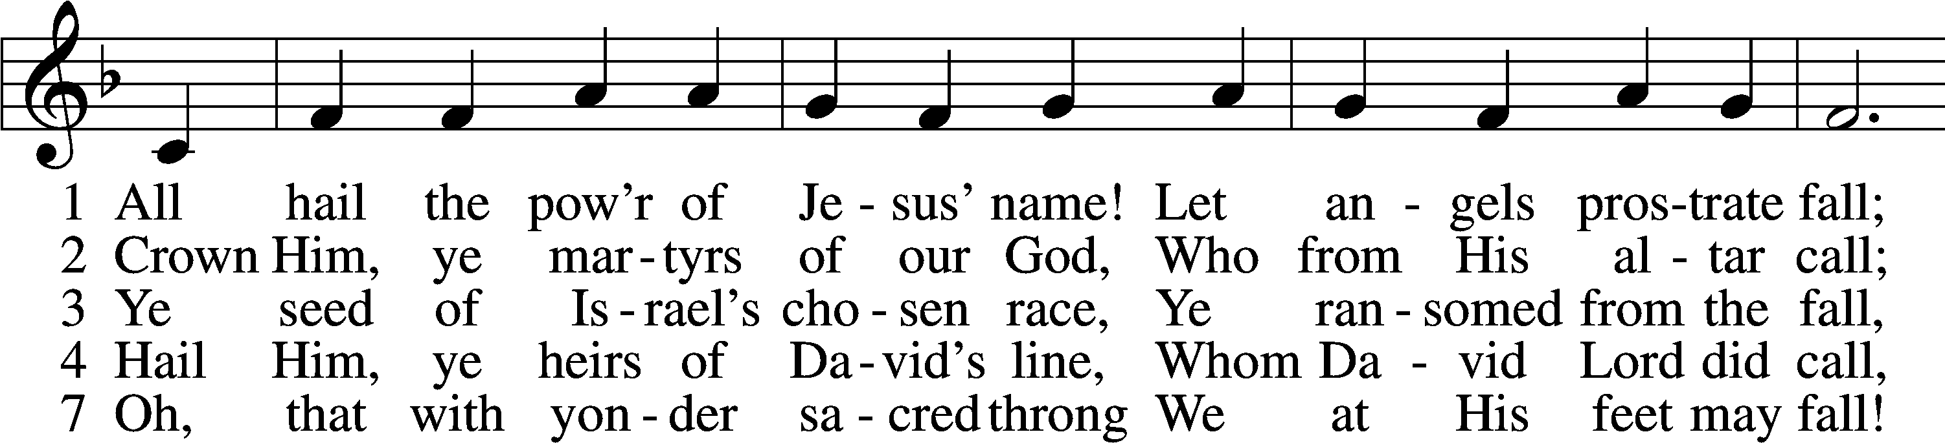
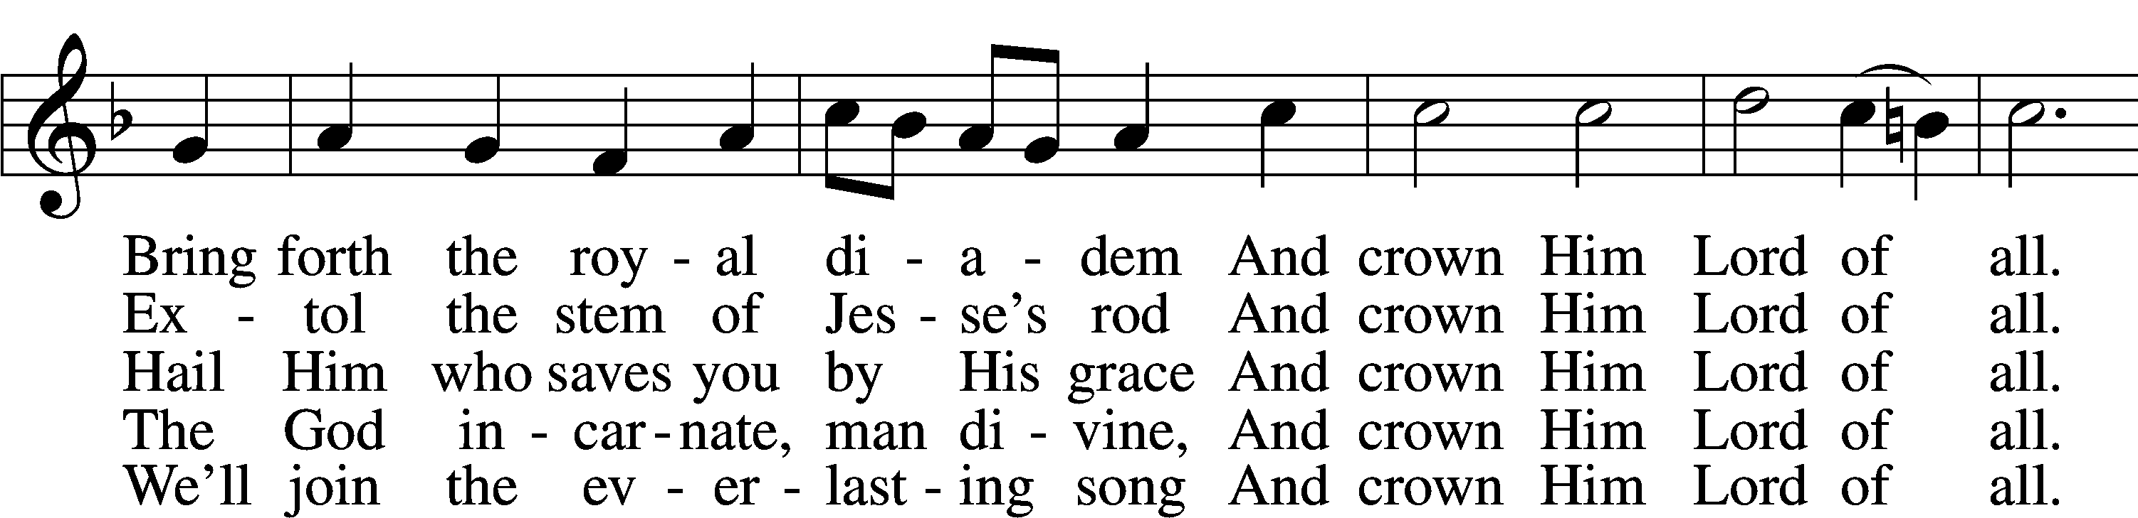
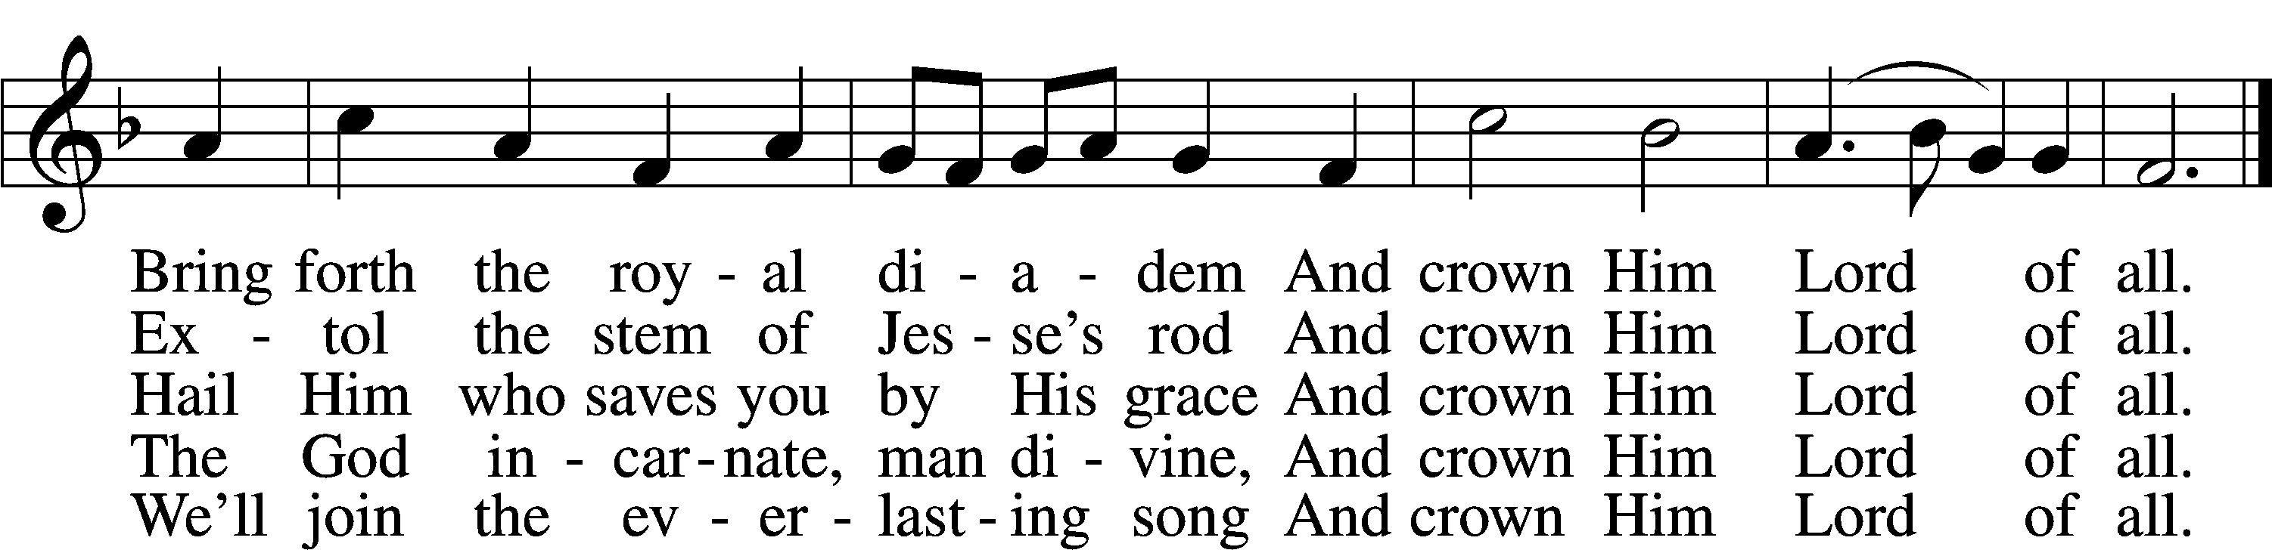
Text (sts. 1–4): Edward Perronet, 1726–92, alt.; (st. 7): A Selection of Hymns, 1787, London, alt.
Tune: Oliver Holden, 1765–1844
Text and tune: Public domain

686 Come, Thou Fount of Every Blessing
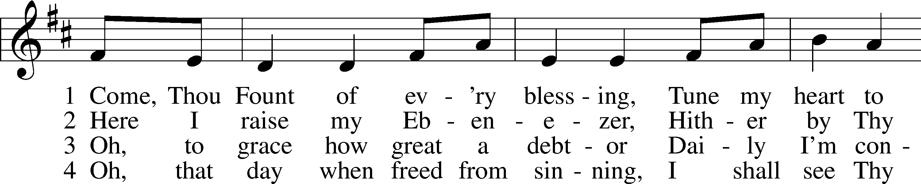
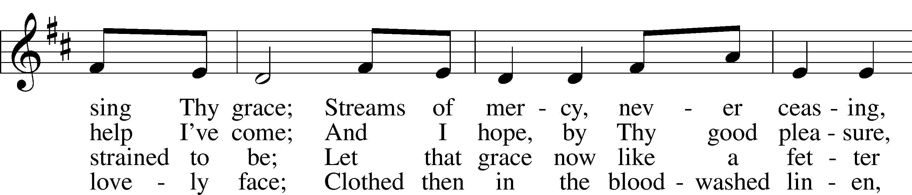
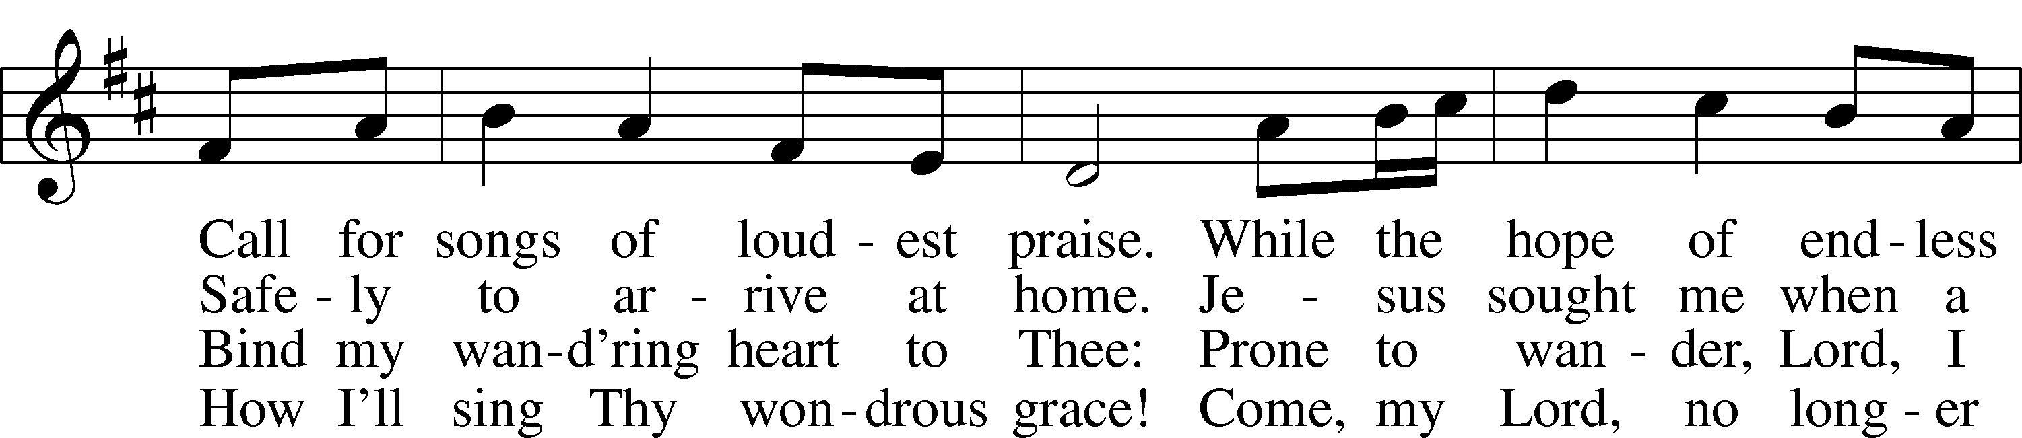
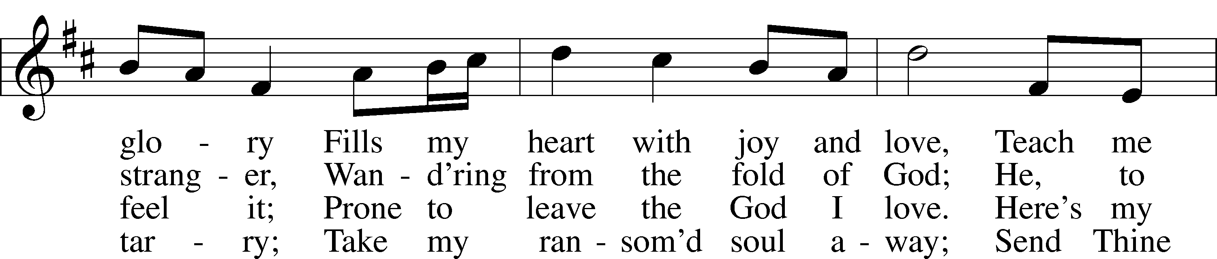
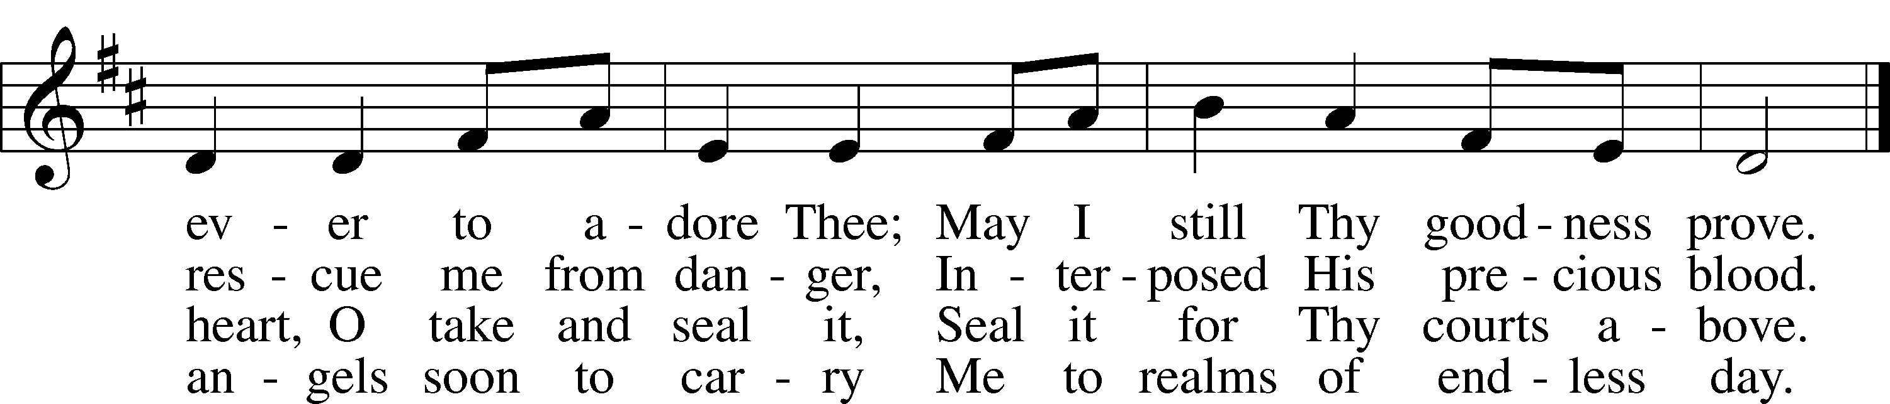
Text: Robert Robinson, 1735–90, alt.
Tune: Repository of Sacred Music, Part Second, 1813, Harrisburg
Text and tune: Public domain
Confession and Absolution
Stand

The sign of the cross may be made by all in remembrance of their Baptism.

P In the name of the Father and of the T Son and of the Holy Spirit.
C Amen.

P Our help is in the name of the Lord,
C who made heaven and earth.

P If You, O Lord, kept a record of sins, O Lord, who could stand?
C But with You there is forgiveness; therefore You are feared.

P Since we are gathered to hear God’s Word, call upon Him in prayer and praise, and receive the body and blood of our Lord Jesus Christ in the fellowship of this altar, let us first consider our unworthiness and confess before God and one another that we have sinned in thought, word, and deed, and that we cannot free ourselves from our sinful condition. Together as His people let us take refuge in the infinite mercy of God, our heavenly Father, seeking His grace for the sake of Christ, and saying: God, be merciful to me, a sinner.

Pause for Reflection

C Almighty God, have mercy upon us, forgive us our sins, and lead us to everlasting life. Amen.

P In the mercy of almighty God, Jesus Christ was given to die for us, and for His sake God forgives us all our sins. To those who believe in Jesus Christ He gives the power to become the children of God and bestows on them the Holy Spirit. May the Lord, who has begun this good work in us, bring it to completion in the day of our Lord Jesus Christ.
C Amen.

Stand
Service of the Word
Invitatory for Trinitytide
The Lord has enlightened us in the true faith
O come, let us worship Him. *
Oh, fear the Lord, you His saints, for those
who fear him lack nothing. Psalm 34:9

Introit Psalm 119:73–75, 77; antiphon: v. 76
Let your steadfast love | comfort me*
according to your promise to your | servant.
Your hands have made and | fashioned me;*
give me understanding that I may learn your com- | mandments.
Those who fear you shall see me | and rejoice,*
because I have hoped | in your word.
I know, O Lord, that your just decrees are | righteous,*
and that in faithfulness you have af- | flicted me.
Let your mercy come to me, that | I may live;*
for your law is | my delight.
Glory be to the Father and | to the Son*
and to the Holy | Spirit;
as it was in the be- | ginning,*
is now, and will be forever. | Amen.
Let your steadfast love | comfort me*
according to your promise to your | servant.
Kyrie 204

P In Peace, let us pray to the Lord
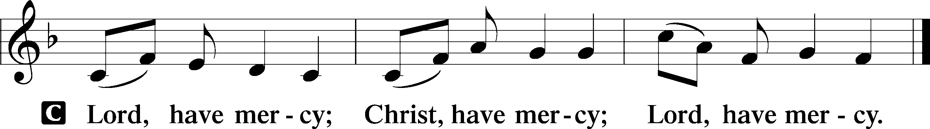

P For the peace of the whole world, for the wellbeing of the Church of God and for the unity of all; let us pray to the Lord.

P For this holy House, and all who offer here their worship and praise; let us pray to the Lord.



This Is the Feast LSB 155
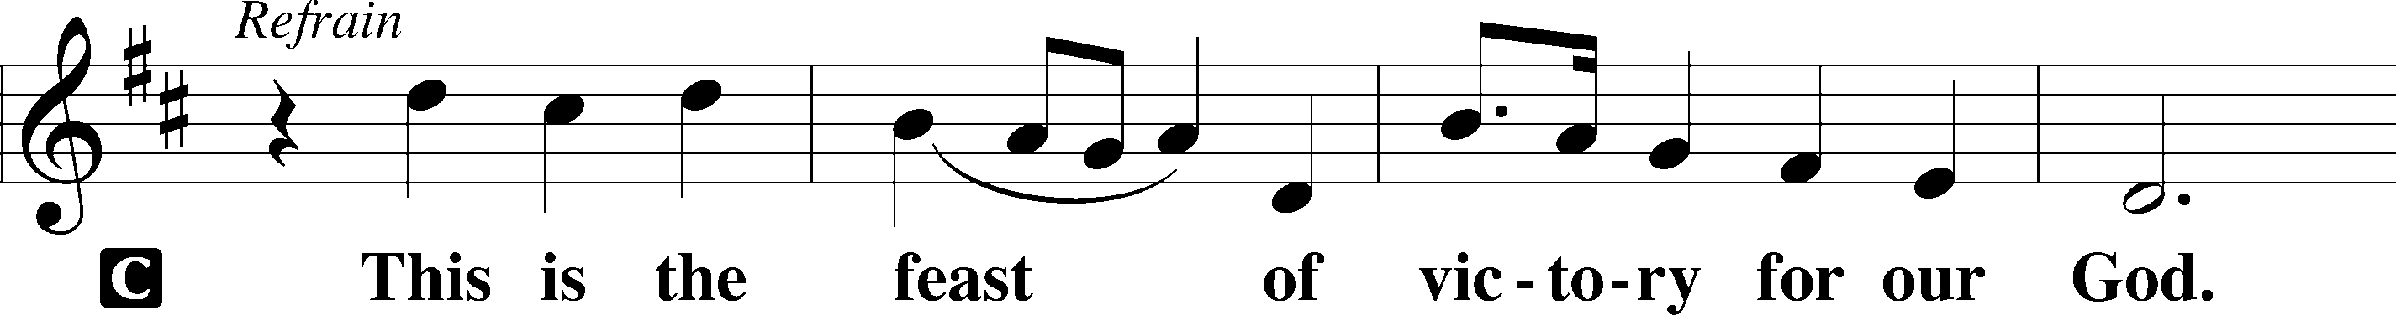
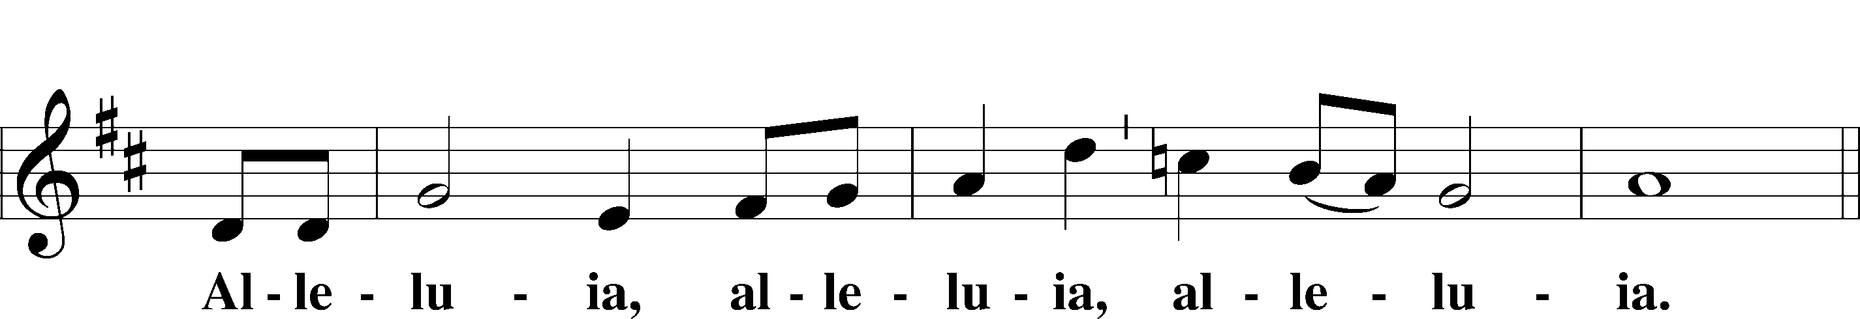
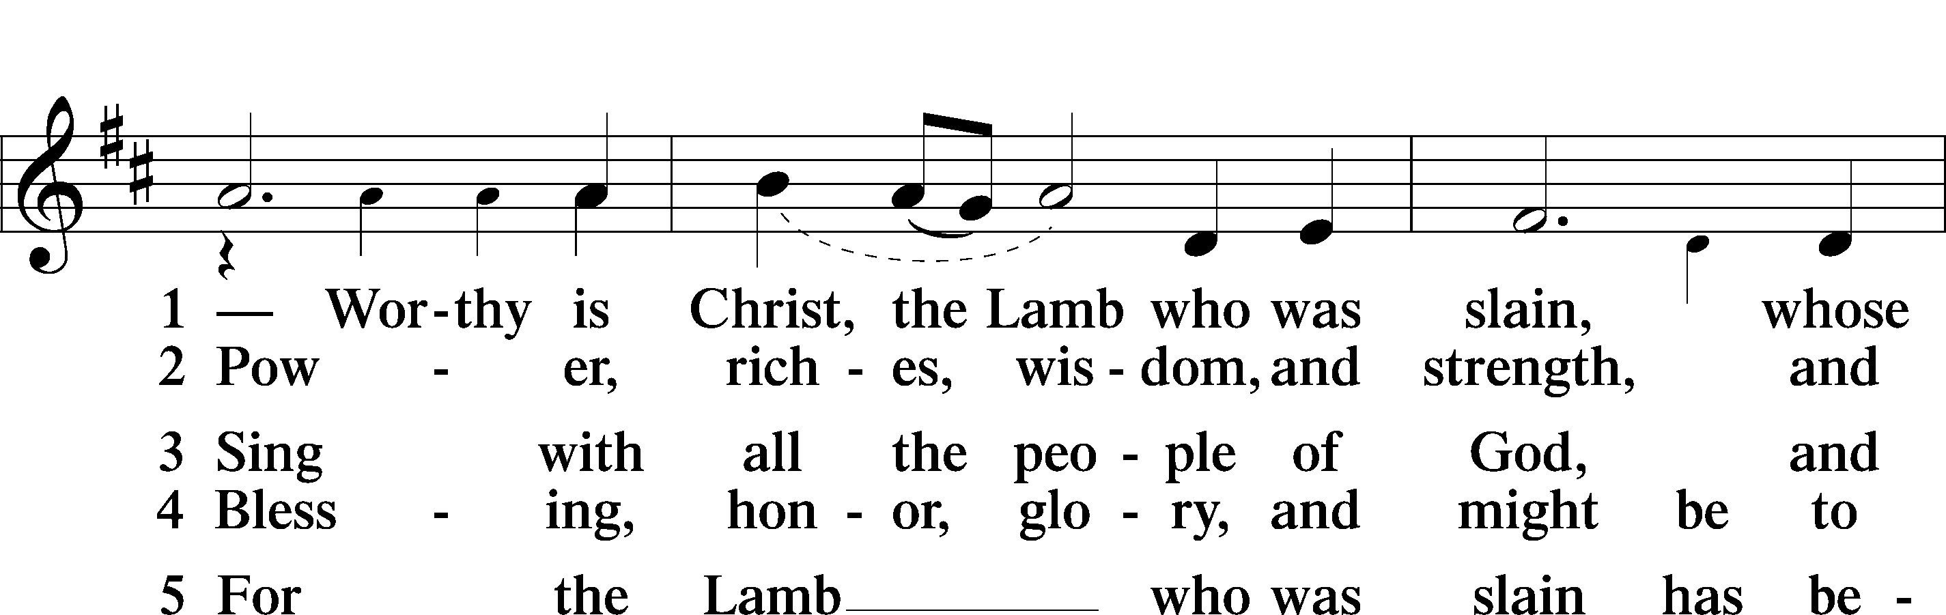
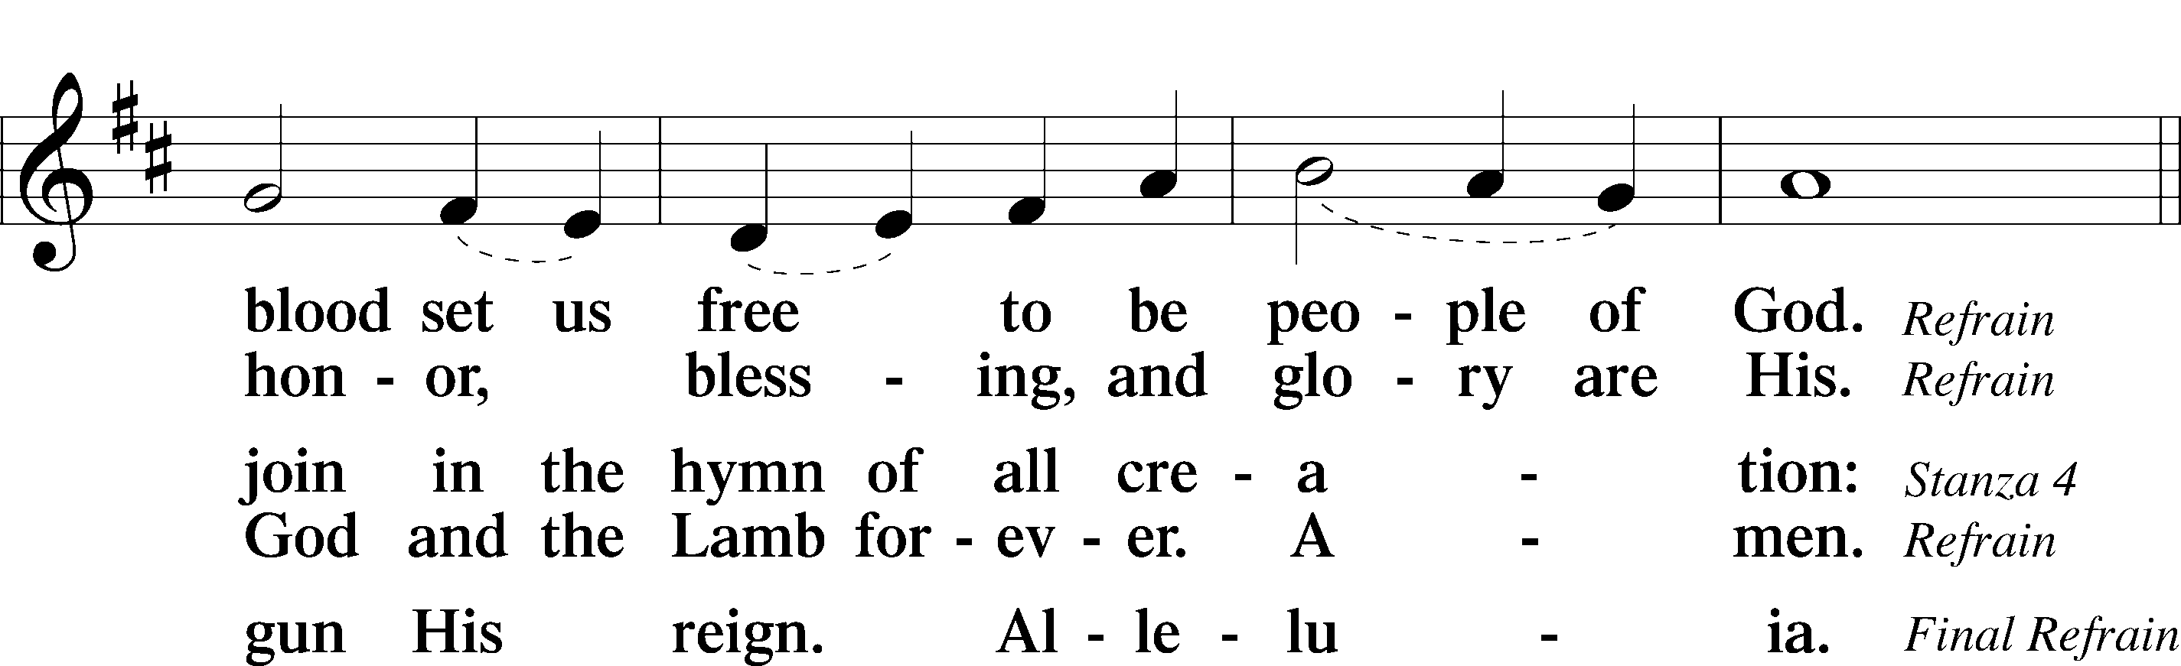
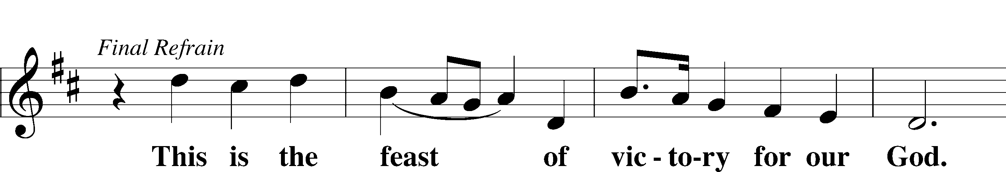
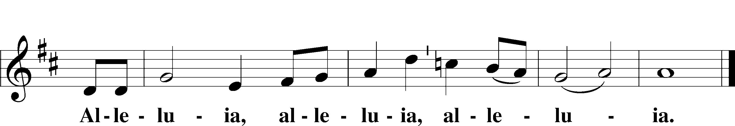

Salutation and Collect of the Day
P The Lord be with you.
C And also with you.

P Let us pray.
O God, You are the strength of all who trust in You, and without Your aid we can do no good thing. Grant us the help of Your grace that we may please You in both will and deed; through Jesus Christ, Your Son, our Lord, who lives and reigns with You and the Holy Spirit, one God, now and forever.

C Amen.
Sit

Old Testament Reading Amos 6:1–7

A The Old Testament is read from the book of Amos chapter 6.
1“Woe to those who are at ease in Zion,
and to those who feel secure on the mountain of Samaria,
the notable men of the first of the nations,
to whom the house of Israel comes!
2Pass over to Calneh, and see,
and from there go to Hamath the great;
then go down to Gath of the Philistines.
Are you better than these kingdoms?
Or is their territory greater than your territory,
3O you who put far away the day of disaster
and bring near the seat of violence?
4“Woe to those who lie on beds of ivory
and stretch themselves out on their couches,
and eat lambs from the flock
and calves from the midst of the stall,
5who sing idle songs to the sound of the harp
and like David invent for themselves instruments of music,
6who drink wine in bowls
and anoint themselves with the finest oils,
but are not grieved over the ruin of Joseph!
7Therefore they shall now be the first of those who go into exile,
and the revelry of those who stretch themselves out shall pass away.”

A This is the Word of the Lord.
C Thanks be to God.

Psalm Psalm 146; antiphon: v. 2
1Praise | the Lord!*
Praise the Lord, | O my soul!
2I will praise the Lord as long | as I live;*
I will sing praises to my God while I have my | being.
3Put not your trust in | princes,*
in a son of man, in whom there is no sal- | vation.
4When his breath departs he returns | to the earth;*
on that very day his plans | perish.
5Blessèd is he whose help is the God of | Jacob,*
whose hope is in the | Lord his God,
6who made heaven and earth,
the sea, and all that is | in them,*
who keeps faith for- | ever;
7who executes justice for | the oppressed,*
who gives food to the | hungry.
The Lord sets the prisoners free; *
8The Lord opens the eyes | of the blind.
The Lord lifts up those who are bowed down; *
the Lord loves the | righteous.
9The Lord watches over the sojourners;
he upholds the widow and the | fatherless,*
but the way of the wicked he brings to | ruin.
10The Lord will reign for- | ever,*
your God, O Zion, to all generations. | Praise the Lord!
Epistle 1 Timothy 3:1–13
A The Epistle is read from the 3rd chapter of 1st Timothy.

1The saying is trustworthy: If anyone aspires to the office of overseer, he desires a noble task. 2Therefore an overseer must be above reproach, the husband of one wife, sober-minded, self-controlled, respectable, hospitable, able to teach, 3not a drunkard, not violent but gentle, not quarrelsome, not a lover of money. 4He must manage his own household well, with all dignity keeping his children submissive, 5for if someone does not know how to manage his own household, how will he care for God’s church? 6He must not be a recent convert, or he may become puffed up with conceit and fall into the condemnation of the devil. 7Moreover, he must be well thought of by outsiders, so that he may not fall into disgrace, into a snare of the devil.
8Deacons likewise must be dignified, not double-tongued, not addicted to much wine, not greedy for dishonest gain. 9They must hold the mystery of the faith with a clear conscience. 10And let them also be tested first; then let them serve as deacons if they prove themselves blameless. 11Their wives likewise must be dignified, not slanderers, but sober-minded, faithful in all things. 12Let deacons each be the husband of one wife, managing their children and their own households well. 13For those who serve well as deacons gain a good standing for themselves and also great confidence in the faith that is in Christ Jesus.

A This is the Word of the Lord.
C Thanks be to God.

Stand

Alleluia and Verse

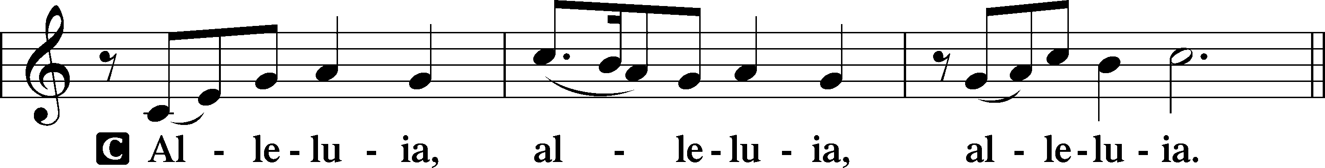

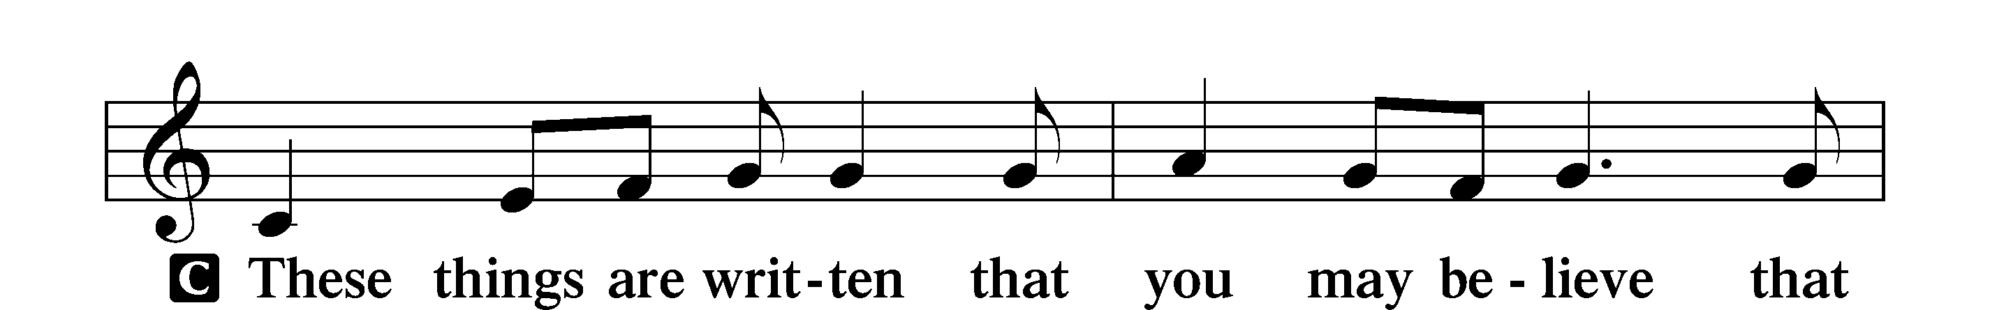
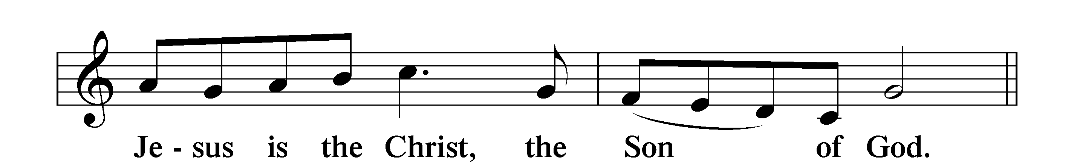

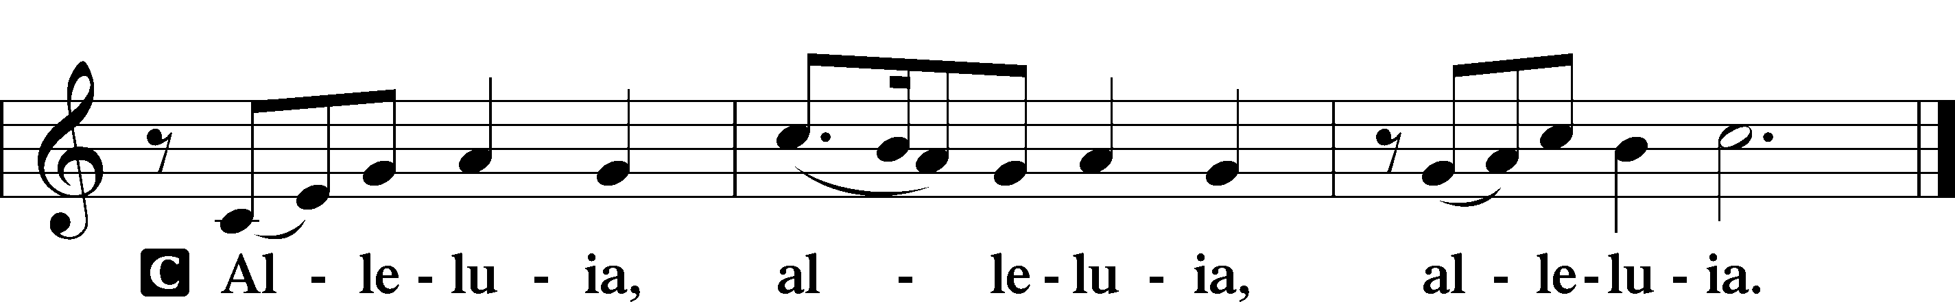

Holy Gospel Luke 16:19–31

P The Holy Gospel according to St. Luke, the sixteenth chapter.
C Glory to You, O Lord.
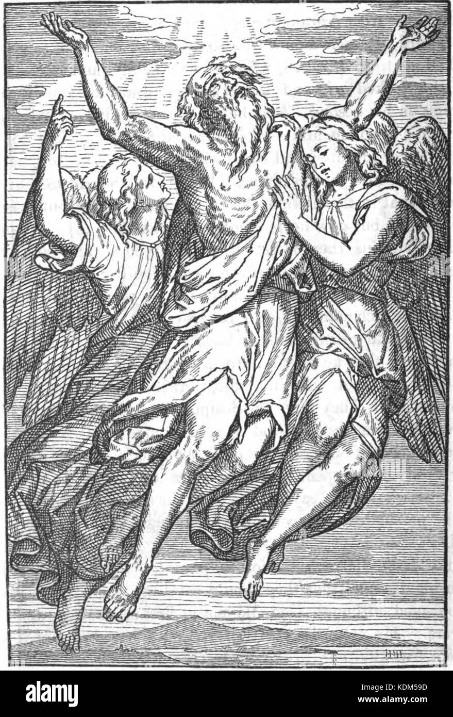
19[Jesus said:] “There was a rich man who was clothed in purple and fine linen and who feasted sumptuously every day. 20And at his gate was laid a poor man named Lazarus, covered with sores, 21who desired to be fed with what fell from the rich man’s table. Moreover, even the dogs came and licked his sores. 22The poor man died and was carried by the angels to Abraham’s side. The rich man also died and was buried, 23and in Hades, being in torment, he lifted up his eyes and saw Abraham far off and Lazarus at his side. 24And he called out, ‘Father Abraham, have mercy on me, and send Lazarus to dip the end of his finger in water and cool my tongue, for I am in anguish in this flame.’ 25But Abraham said, ‘Child, remember that you in your lifetime received your good things, and Lazarus in like manner bad things; but now he is comforted here, and you are in anguish. 26And besides all this, between us and you a great chasm has been fixed, in order that those who would pass from here to you may not be able, and none may cross from there to us.’ 27And he said, ‘Then I beg you, father, to send him to my father’s house— 28for I have five brothers—so that he may warn them, lest they also come into this place of torment.’ 29But Abraham said, ‘They have Moses and the Prophets; let them hear them.’ 30And he said, ‘No, father Abraham, but if someone goes to them from the dead, they will repent.’ 31He said to him, ‘If they do not hear Moses and the Prophets, neither will they be convinced if someone should rise from the dead.’”

P This is the Gospel of the Lord.
C Praise to You, O Christ.

Sit

905 Come, Thou Almighty King
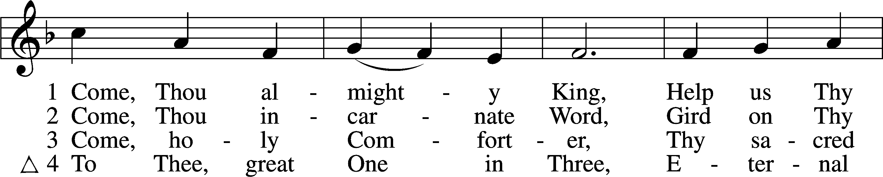
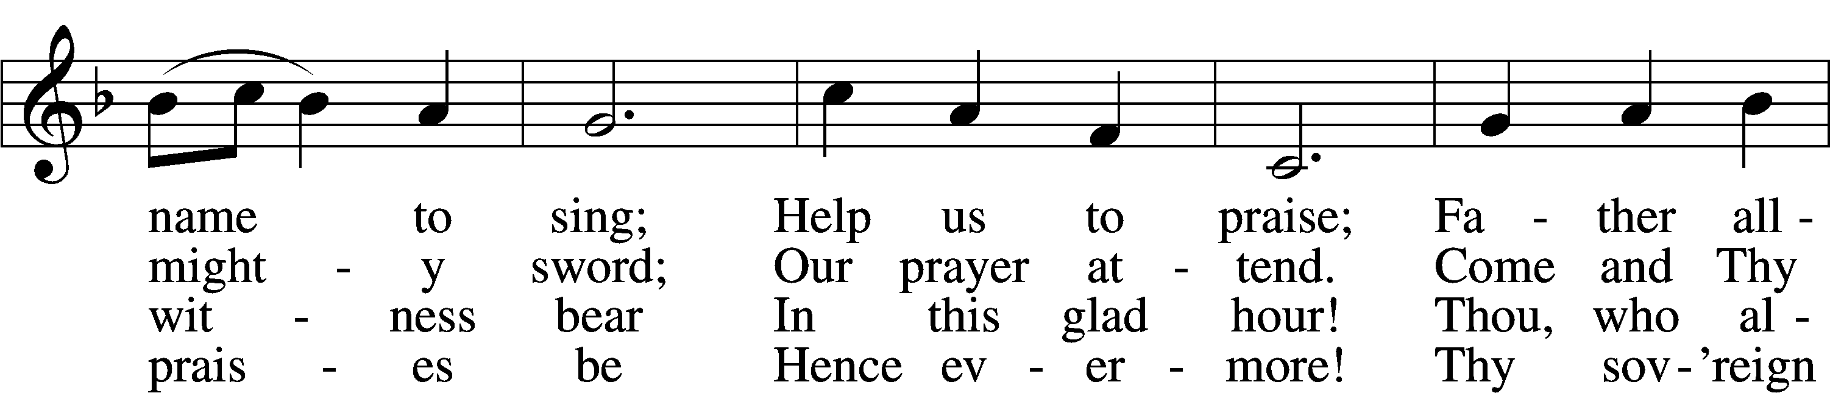
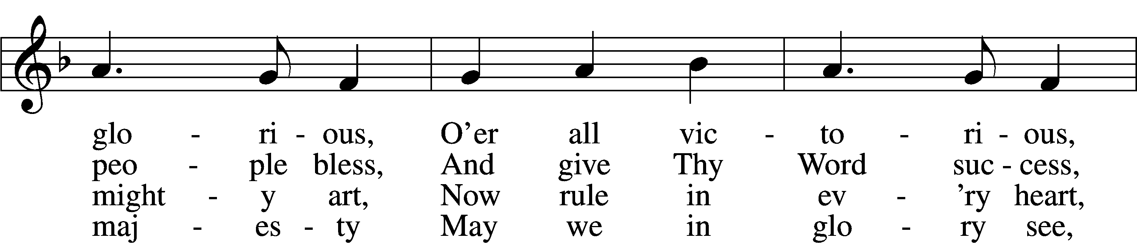
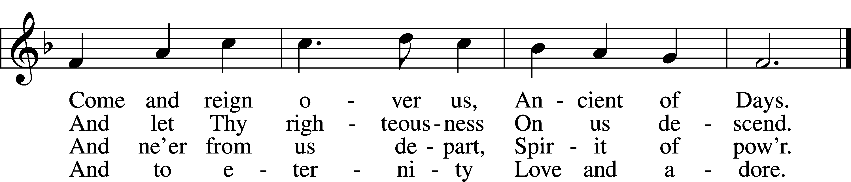
Text: English, before 1760, alt.
Tune: Felice de Giardini, 1716–96
Text and tune: Public domain

Sermon
Stand

Nicene Creed
C I believe in one God, the Father Almighty,
maker of heaven and earth and of all things visible and invisible.

And in one Lord Jesus Christ, the only-begotten Son of God,
begotten of His Father before all worlds,
God of God, Light of Light, very God of very God,
begotten, not made, being of one substance with the Father,
by whom all things were made;
who for us men and for our salvation came down from heaven
and was incarnate by the Holy Spirit of the virgin Mary
and was made man; and was crucified also for us under
Pontius Pilate. He suffered and was buried.
And the third day He rose again according to the Scriptures
and ascended into heaven and sits at the right hand of the Father.
And He will come again with glory to judge both the living and
the dead, whose kingdom will have no end.

And I believe in the Holy Spirit, the Lord and giver of life,
who proceeds from the Father and the Son,
who with the Father and the Son together is worshiped
and glorified, who spoke by the prophets.
And I believe in one holy Christian and apostolic Church,
I acknowledge one Baptism for the remission of sins,
and I look for the resurrection of the dead
and the life T of the world to come. Amen.
Stand
Prayer of the Church & Sharing of Peace

Following the prayers, the people may greet one another in the name of the Lord,
saying, “Peace be with you,” as a sign of reconciliation and of
the unity of the Spirit in the bond of peace
(Matt. 5:22–24; Eph. 4:1–3).
Sit
Offering

Offertory LSB 159
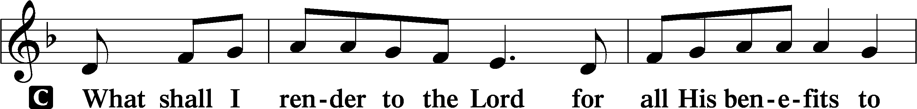
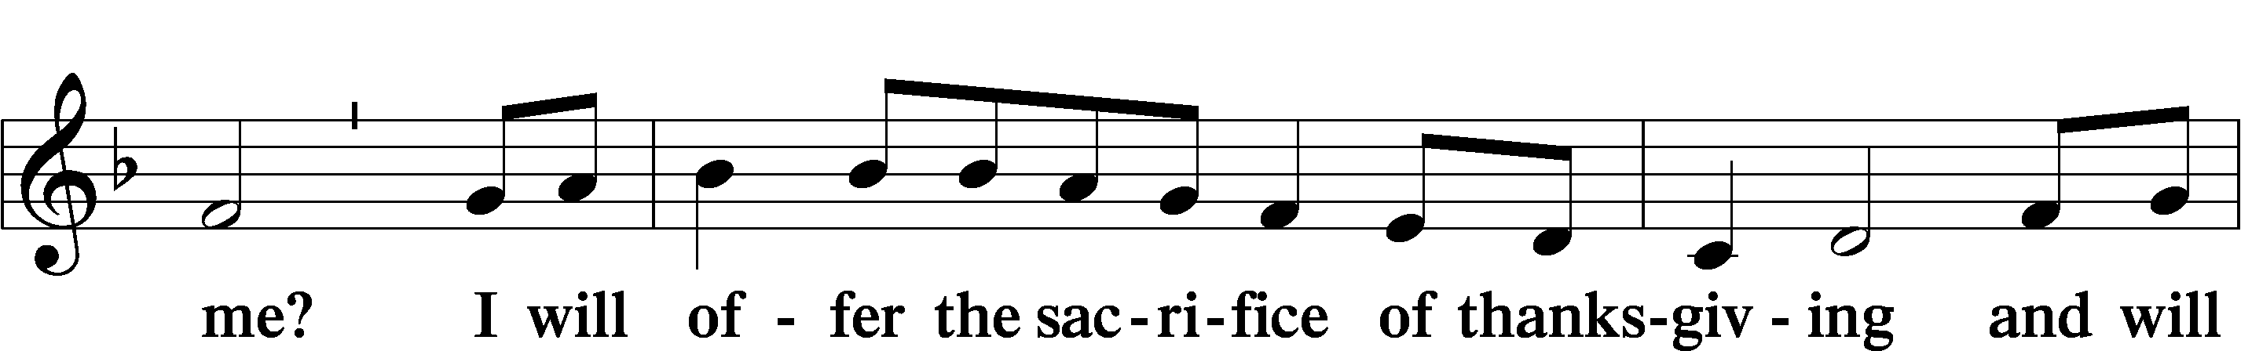
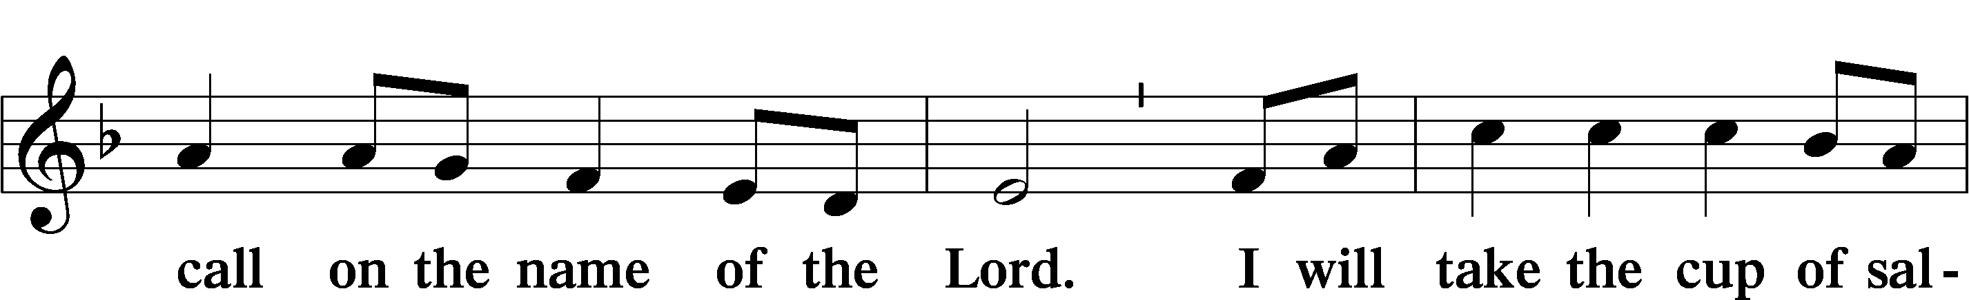
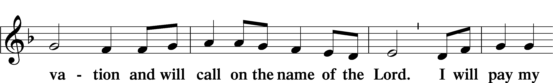
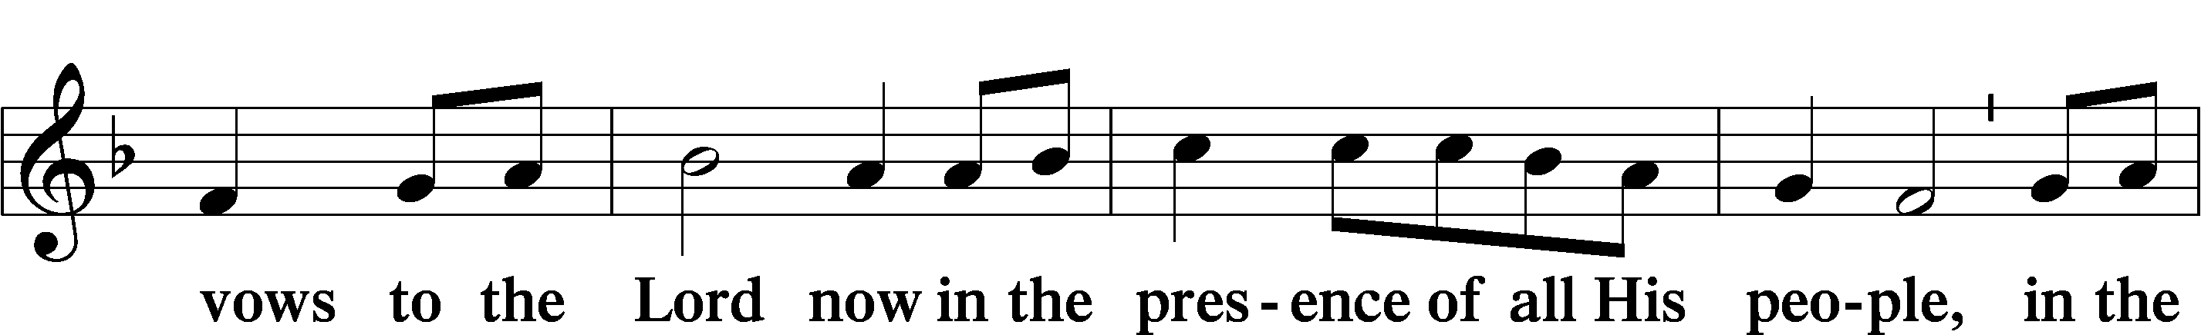
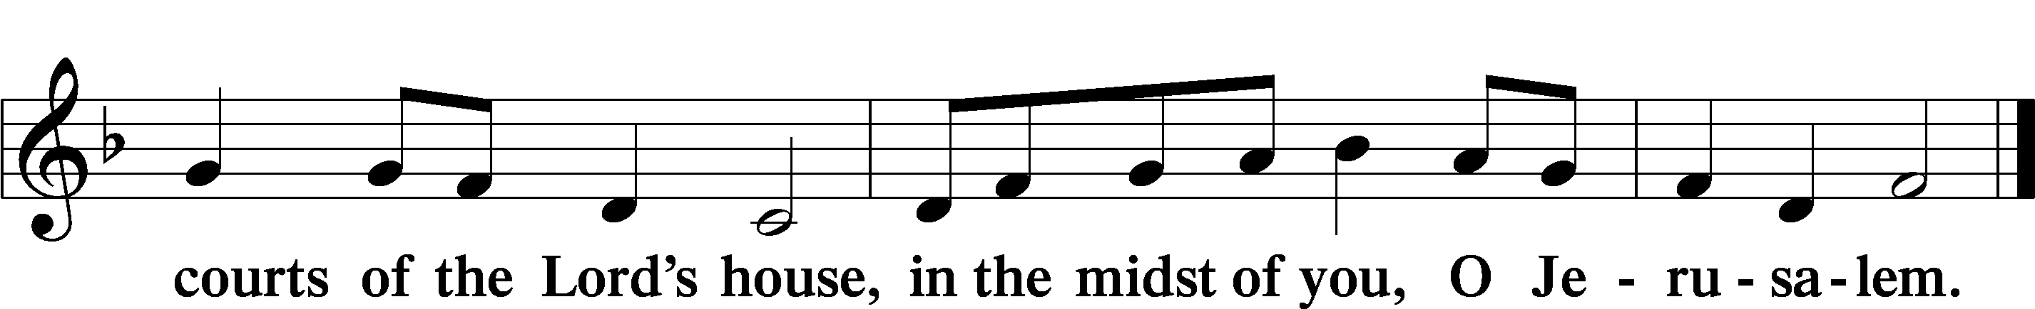



Service of Holy Communion
Communion Statement

The Lord’s Supper is celebrated at this congregation in the confession and glad confidence that, as He says, our Lord gives into our mouths not only bread and wine but His very body and blood to eat and to drink for the forgiveness of sins and to strengthen our union with Him and with one another. Our Lord invites to His table those who trust His words, repent of all sin, and set aside any refusal to forgive and love as He forgives and loves us, that they may show forth His death until He comes.

Because those who eat and drink our Lord’s body and blood unworthily do so to their great harm and because Holy Communion is a confession of the faith which is confessed at this altar, any who are not yet instructed, in doubt, or who hold a confession differing from that of this congregation and the Lutheran Church Missouri Synod, and yet desire to receive this sacrament, are asked to speak with the Pastor.
* See more about the Lutheran teaching on communion in the Hymnal p 329.

Stand

Preface LSB 208
P The Lord be with you.
C And also with you.
P Lift up your hearts.
C We lift them to the Lord.
P Let us give thanks to the Lord our God.
C It is right to give Him thanks and praise.
P It is truly good, right, and salutary that we should at all times and in all places give thanks to You, O Lord, holy Father, almighty and everlasting God, for the countless blessings You so freely bestow on us and all creation. Above all, we give thanks for Your boundless love shown to us when You sent Your only-begotten Son, Jesus Christ, into our flesh and laid on Him our sin, giving Him into death that we might not die eternally. Because He is now risen from the dead and lives and reigns to all eternity, all who believe in Him will overcome sin and death and will rise again to new life. Therefore with angels and archangels and with all the company of heaven we laud and magnify Your glorious name, evermore praising You and saying:

Sanctus LSB 208
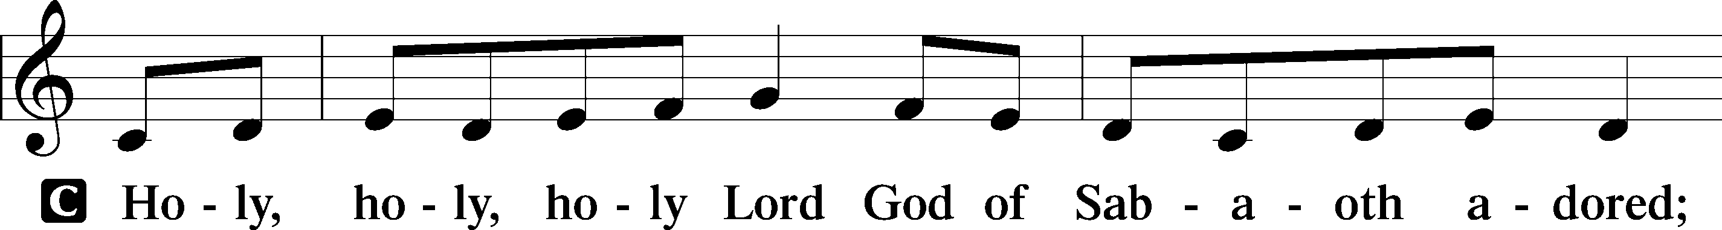
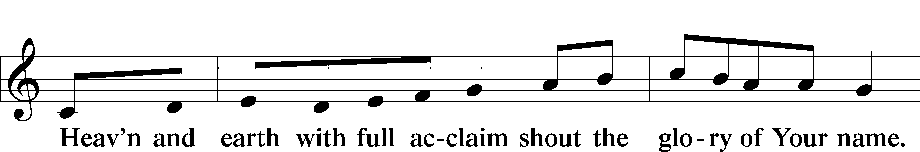
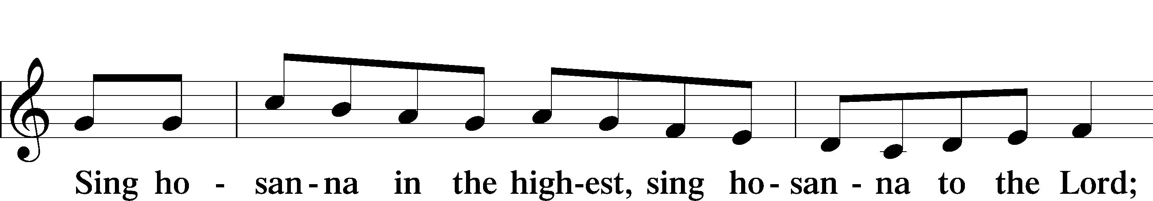
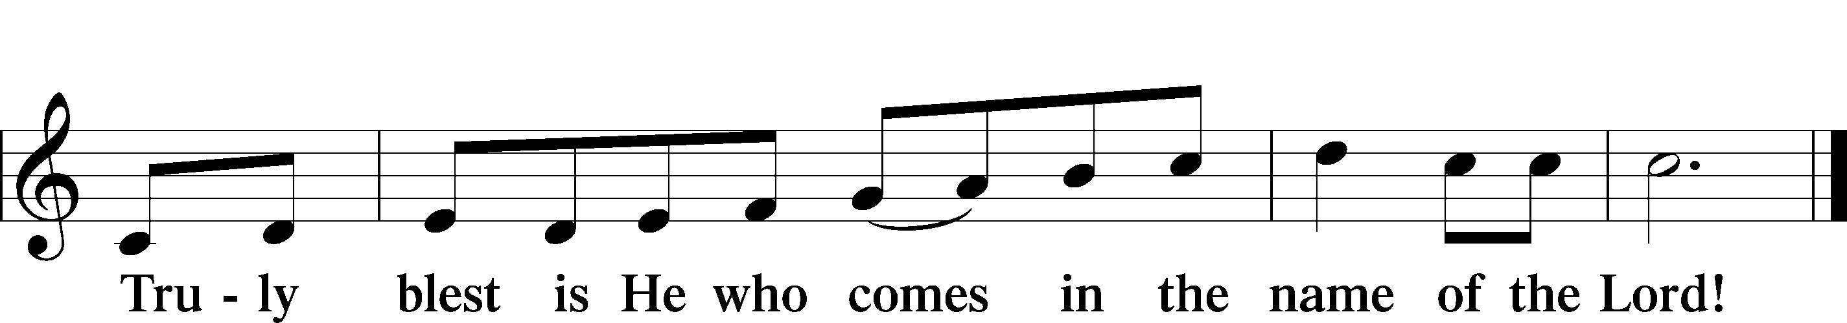
Text: Stephen P. Starke

Prayer of Thanksgiving
P Blessed are You, O Lord our God, king of all creation, for You have had mercy on us and given Your only-begotten Son that whoever believes in Him should not perish but have eternal life.

In Your righteous judgment You condemned the sin of Adam and Eve, who ate the forbidden fruit, and You justly barred them and all their children from the tree of life. Yet, in Your great mercy, You promised salvation by a second Adam, Your Son, Jesus Christ, our Lord, and made His cross a life-giving tree for all who trust in Him.

We give You thanks for the redemption You have prepared for us through Jesus Christ. Grant us Your Holy Spirit that we may faithfully eat and drink of the fruits of His cross and receive the blessings of forgiveness, life, and salvation that come to us in His body and blood.

Hear us as we pray in His name and as He has taught us:

Lord’s Prayer
C Our Father who art in heaven, hallowed be Thy name,
Thy kingdom come, Thy will be done on earth
as it is in heaven; give us this day our daily bread;
and forgive us our trespasses as we forgive those
who trespass against us; and lead us not into temptation,
but deliver us from evil.
For Thine is the kingdom and the power and the glory
forever and ever. Amen.

The Words of Our Lord
P Our Lord Jesus Christ, on the night when He was betrayed, took bread, and when He had given thanks, He broke it and gave it to the disciples and said: “Take, eat; this is My T body, which is given for you. This do in remembrance of Me.”

In the same way also He took the cup after supper, and when He had given thanks, He gave it to them, saying: “Drink of it, all of you; this cup is the new testament in My T blood, which is shed for you for the forgiveness of sins. This do, as often as you drink it, in remembrance of Me.”

Pax Domini
P The peace of the Lord be with you always.
C Amen.

Agnus Dei LSB 210
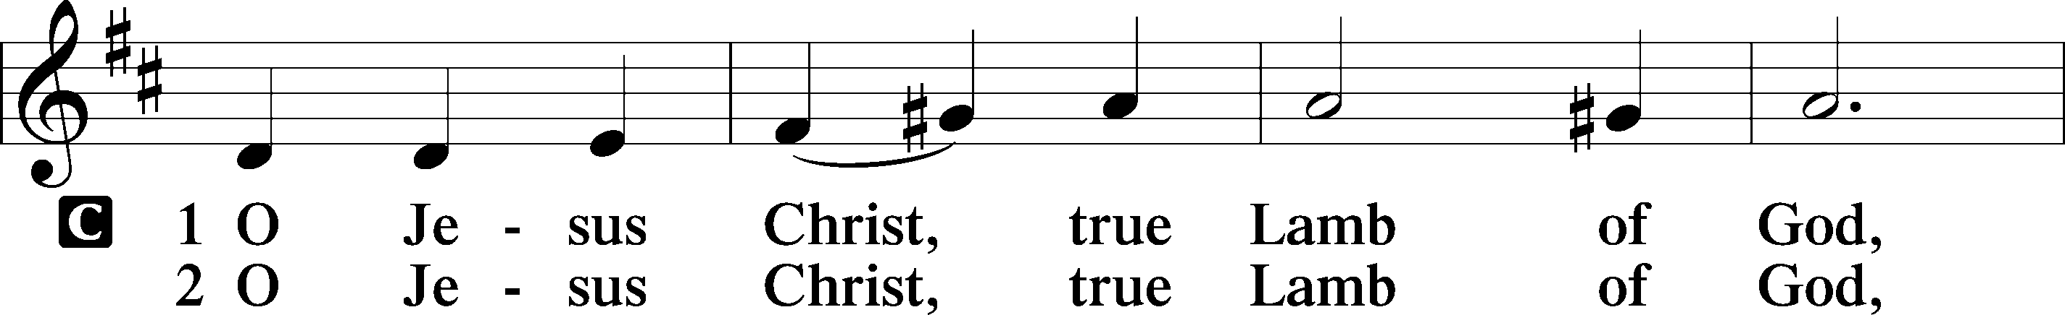
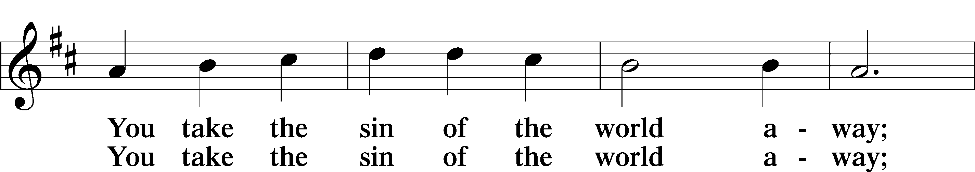
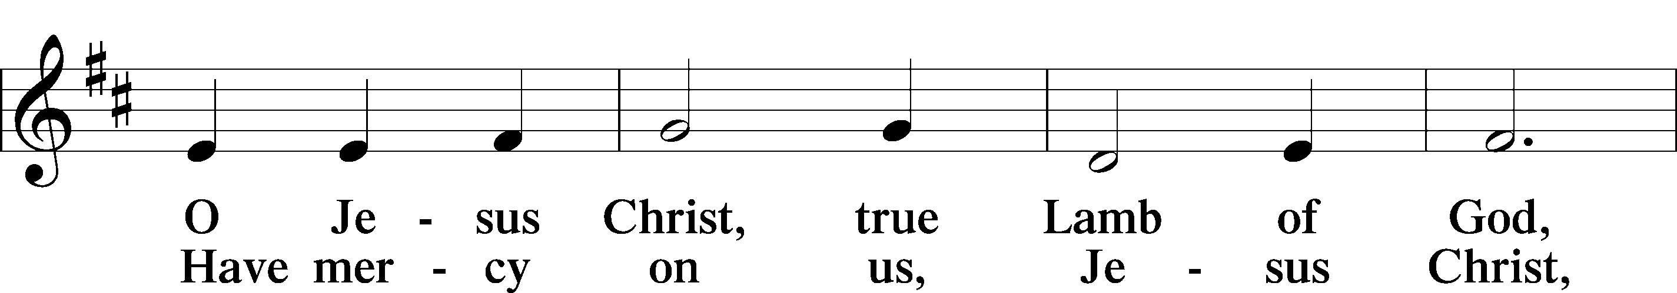
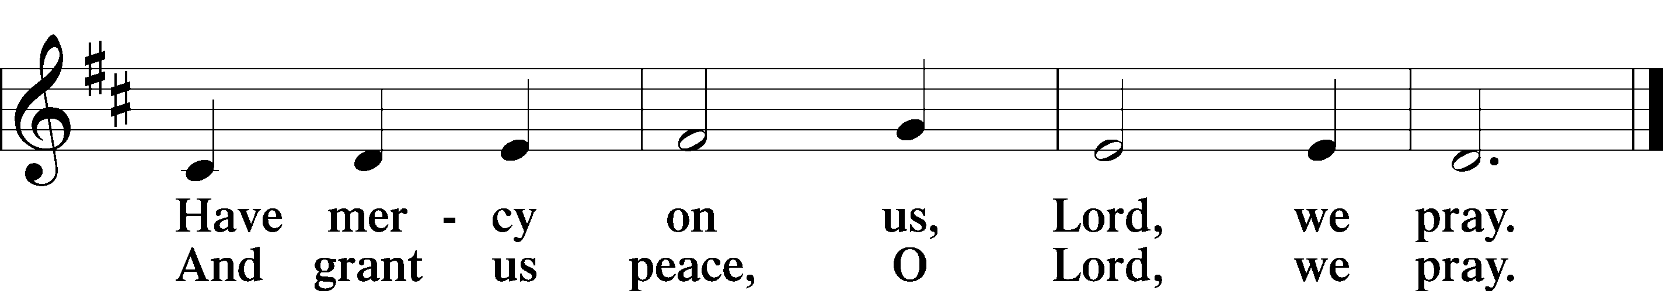
Text: Stephen P. Starke
Sit

Communion Distribution

437 Alas! And Did My Savior Bleed
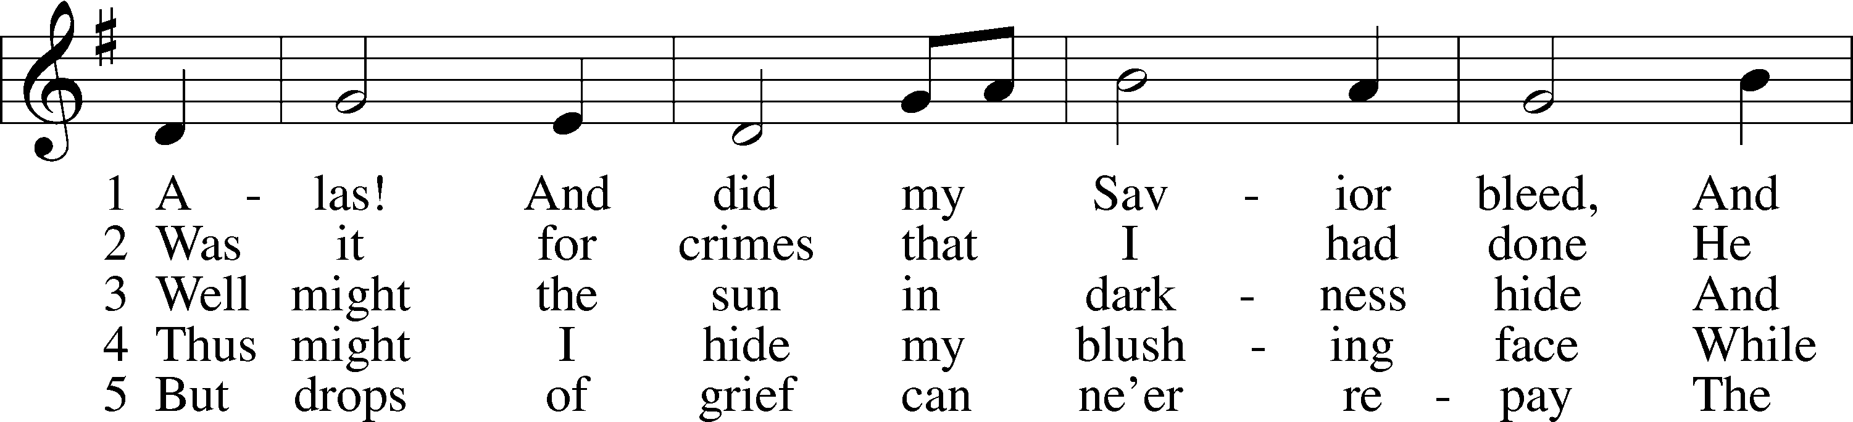
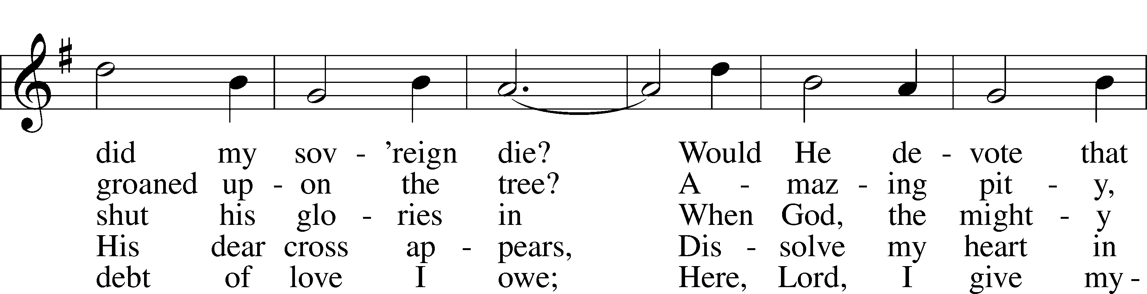
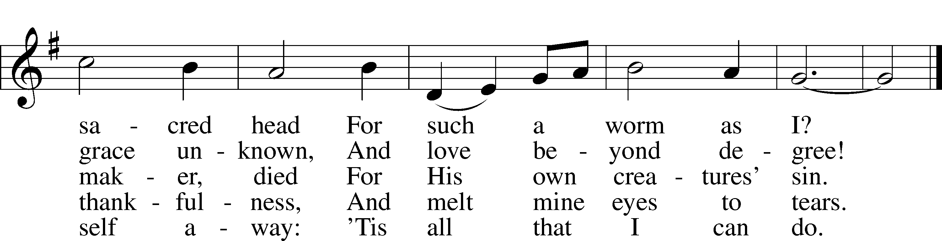
Text: Isaac Watts, 1674–1748, alt. Tune: Hugh Wilson, 1764–1824 Text and tune: Public domain

Stand
Nunc Dimittis LSB 211
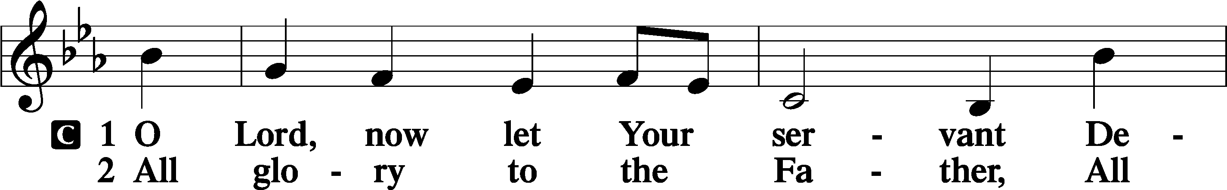
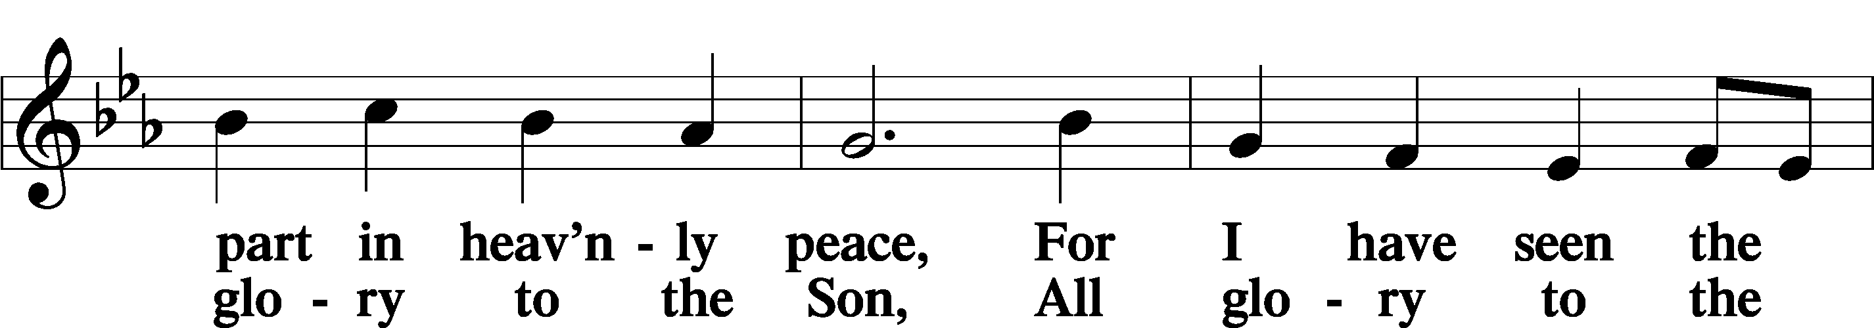
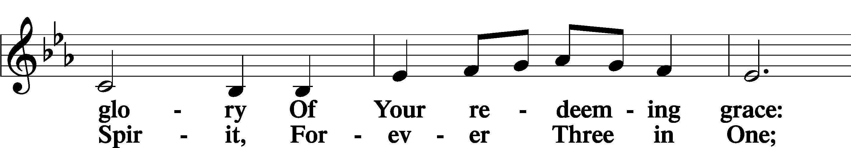
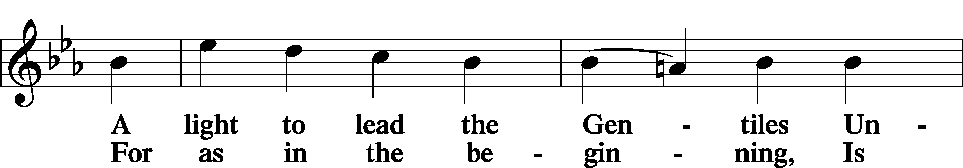
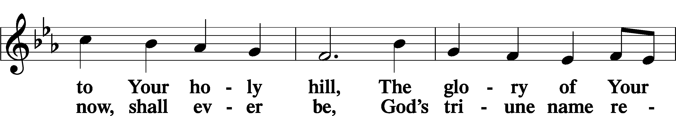
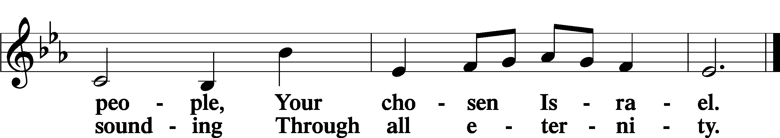

Post-Communion Collect
A Let us pray.
We give thanks to You, almighty God, that You have refreshed us through this salutary gift, and we implore You that of Your mercy You would strengthen us through the same in faith toward You and in fervent love toward one another; through Jesus Christ, Your Son, our Lord, who lives and reigns with You and the Holy Spirit, one God, now and forever.
C Amen.

Verse of the Day Luke 16:31
Alleluia! If they do not hear Moses and the Prophets,
Neither will they be convinced if someone should rise from the dead. Alleluia!

Benedicamus
LSB 212
A Let us bless the Lord!
C Thanks be to God!

Benediction

P The Lord bless you and keep you.
The Lord make His face shine on you and be gracious to you.
The Lord look upon you with favor and T give you peace.
C Amen.



804 O Worship the King sts. 1–2, 4, 6
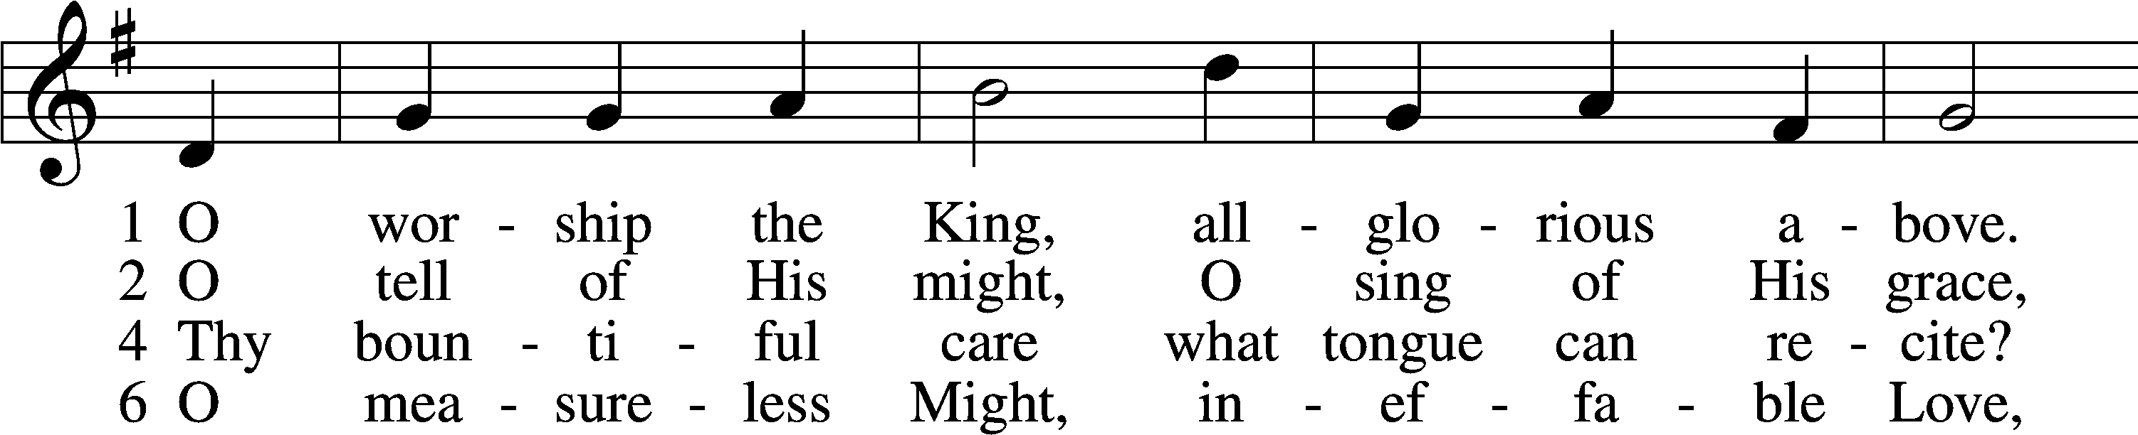
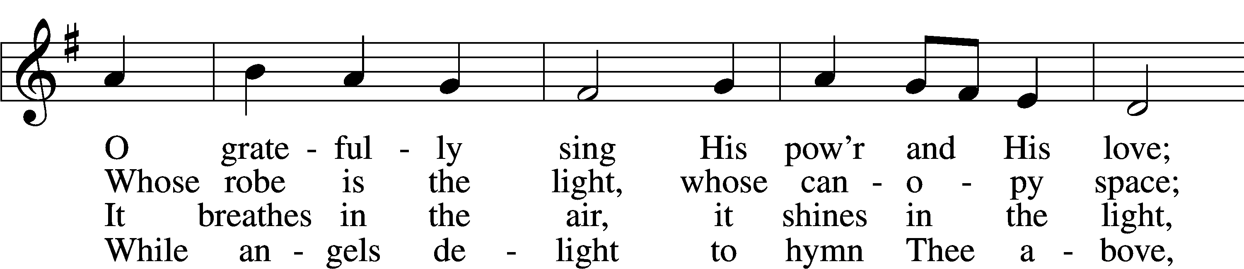
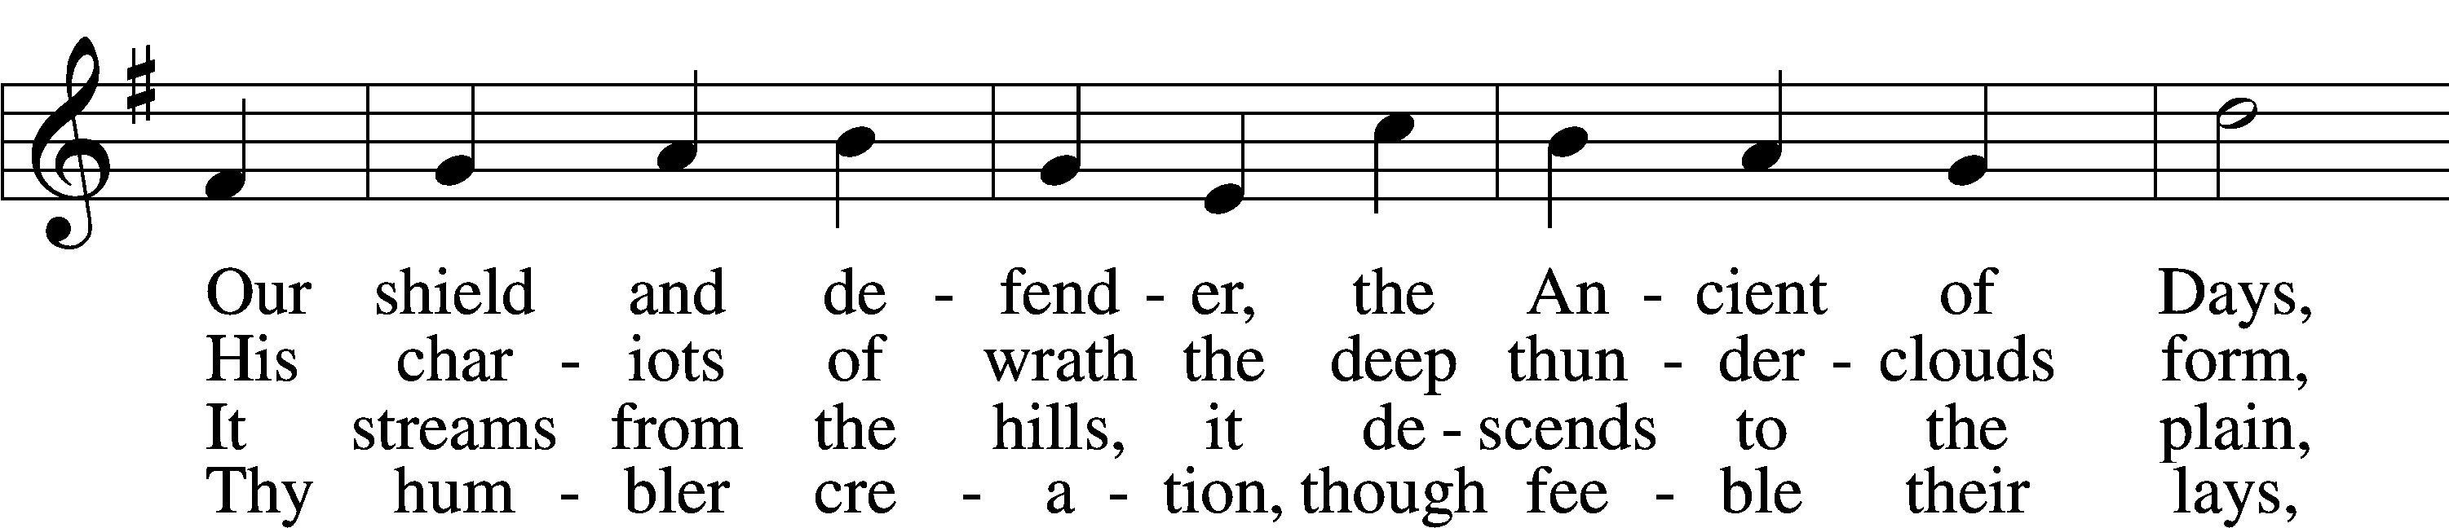
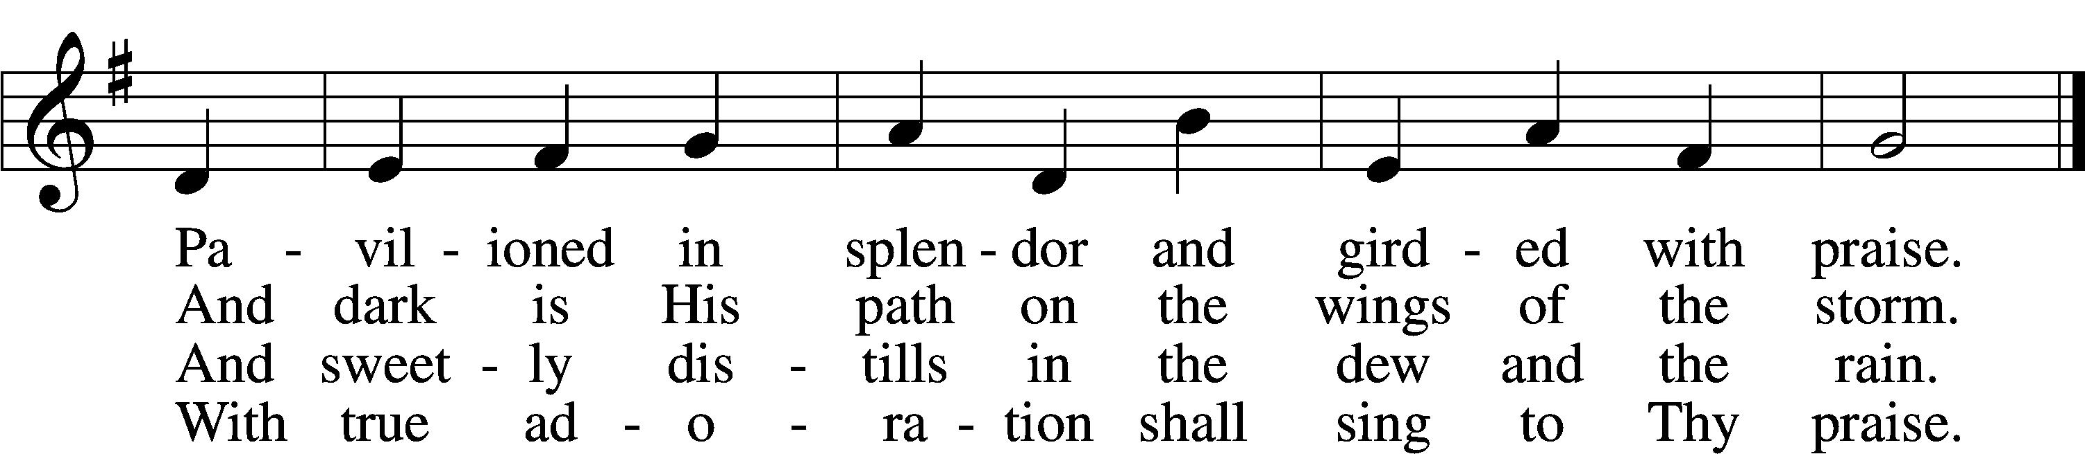
Text: Robert Grant, 1779–1838, alt.
Tune: William Croft, 1678–1727
Text and tune: Public domain

Acknowledgments
Divine Service, Setting Four from Lutheran Service Book
Unless otherwise indicated, Scripture quotations are from the ESV® Bible (The Holy Bible, English Standard Version®), copyright © 2001 by Crossway, a publishing ministry of Good News Publishers. Used by permission. All rights reserved. Created by Lutheran Service Builder © 2025 Concordia Publishing House.

Prayers of the Church
This week, we lift up:

Bob C, Mike Y, Angela H, Sheila, Elaine, Angie Z, Angela C, Ross, & Kathy H.

Family of the week: Angela, Carlos and Nathanael Castaneada

*If you have any prayer request let us know.

Last week: Attendance 35 Offering $640

Serving Next Week (10/5/25)  Service Leader: Vicar Previn Hudetz  Communion Celebrant: Rev John Heffelfinger  Communion Assistant: Jim C  Worship Assistant: TBD  Reader: Sheila S  Refreshments: Pot Luck  Altar Guild: Angie Z & Sheila S  Greeter: Juanita | Readings Next Week  Seventeenth Sunday after Pentecost  - Habakkuk 1:1-4; 2:1-4  - Psalm 62  - 2 Timothy 1:1-14  - Luke 17:1-10  *Please sign up to help during service.*
Announcements  Birthdays:  This Week at OSLC:  Bible Study: After Service  Bible Study: Thursday 10am | Coming Up:  Congregational Meeting to confirm & elect Council Members.  TODAY!



Congregational Meeting Today

Council Positions voting in-

New
President: Jim Chmelicek
Spiritual Life & Worship: Pastor John Heffelfinger
Mission & Evangelism (Outreach): Paul and Samantha Tennant

Reinstall
Treasurer: Rebecca Haulenbeek
Secretary & Christian Education: Sheila Small
Finance & Stewardship: Tania Vigil

Open
Property & Maintenance
Seasons of the Church Year

Color: Green • Symbol: Lamp or Open Bible
As the season of Trinitytide moves toward its close, the readings emphasize perseverance, prayer, and trust in the Lord. These Sundays encourage us to stay faithful amid life’s trials, confident that God’s kingdom is coming. The green of the season still calls us to grow the church, but also to look ahead with hope to the fulfillment of God’s promises.


Stewardship Thoughts…

Amos 6:1a – “Woe to those who are at ease in Zion.”

The Book of Amos is a warning to God’s people who have been given great material wealth. As Jesus Himself mentions, material blessing can turn into temptations- chiefly the temptation to think of ourselves as self-sufficient and independent. What does Amos suggest as a way to combat this temptation? First, faith in the Lord and dependence upon Him! And if our faith is right, we will want to follow the rest of Amos’ instructions – to bless the poor with our alms and to make sure the Lord’s House is properly cared for. In other words, we are called to align our actions with God’s priorities and put others ahead of ourselves.
Lcms.org/stewardship

