

For everyone who exalts himself will be humbled,
and he who humbles himself will be exalted.
Luke 14:11

Our Savior Lutheran Church (LCMS)
4301 Atrisco Drive NW
Albuquerque, New Mexico
Website: OSLCNM.COM
Phone: 505.836.7007
Email: oslcabq@gmail.com

Twelfth Sunday after Pentecost
August 31st,2025
The Time of the Church (Trinitytide)
Twelfth Sunday after Pentecost
August 31st, 2025

Welcome to Our Savior Lutheran Church (LCMS).  We are glad you are here as we worship, praise, and give thanks to our loving Lord, Jesus Christ. Please join us immediately after service for fellowship and snacks. Adult Bible Study starts at 10:30. If you have any questions about our service or need other assistance, please contact one of our worship assistants. | Hymns  Opening # 660  Sermon # 842  Distribution # Because He Lives  Closing # 649

Today’s Message

Before kings, authorities, and leaders, we are not to think of ourselves more highly than we ought. Rather, we should posture ourselves to be humble servants, ready to hope for and receive gestures of grace, hospitality, and wisdom. Divine love permeates actions; divine speech evokes truth; divine contentment curbs the propensity toward avarice. Divine forgiveness destroys sin’s consequence. Without merit, we receive the grace of Christ—grace that invites us to His feast of forgiveness.

+++
Serving Today
Service Leader: Vicar Previn Hudetz
Communion Celebrant: Rev John Heffelfinger
Worship Assistant: Charlie M
Reader: Sheila S
Refreshments: Sheila
Altar Guild: Angie Z & Sheila S
Greeter: Juanita S

Welcome
Divine Service IV

660 Stand Up, Stand Up for Jesus
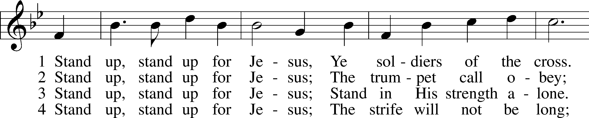
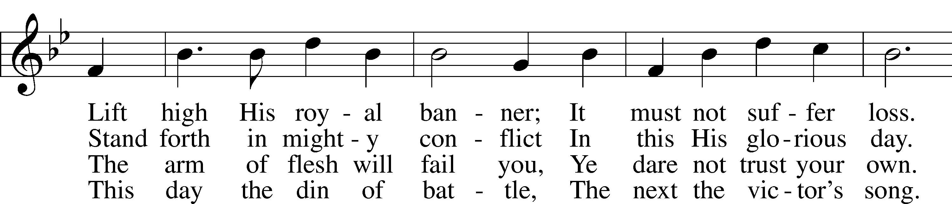
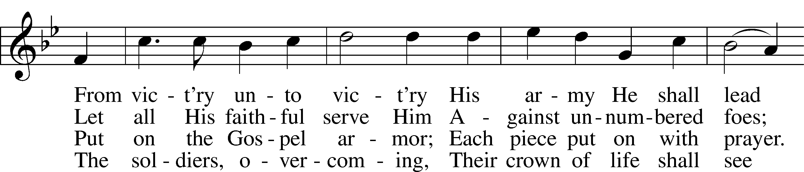
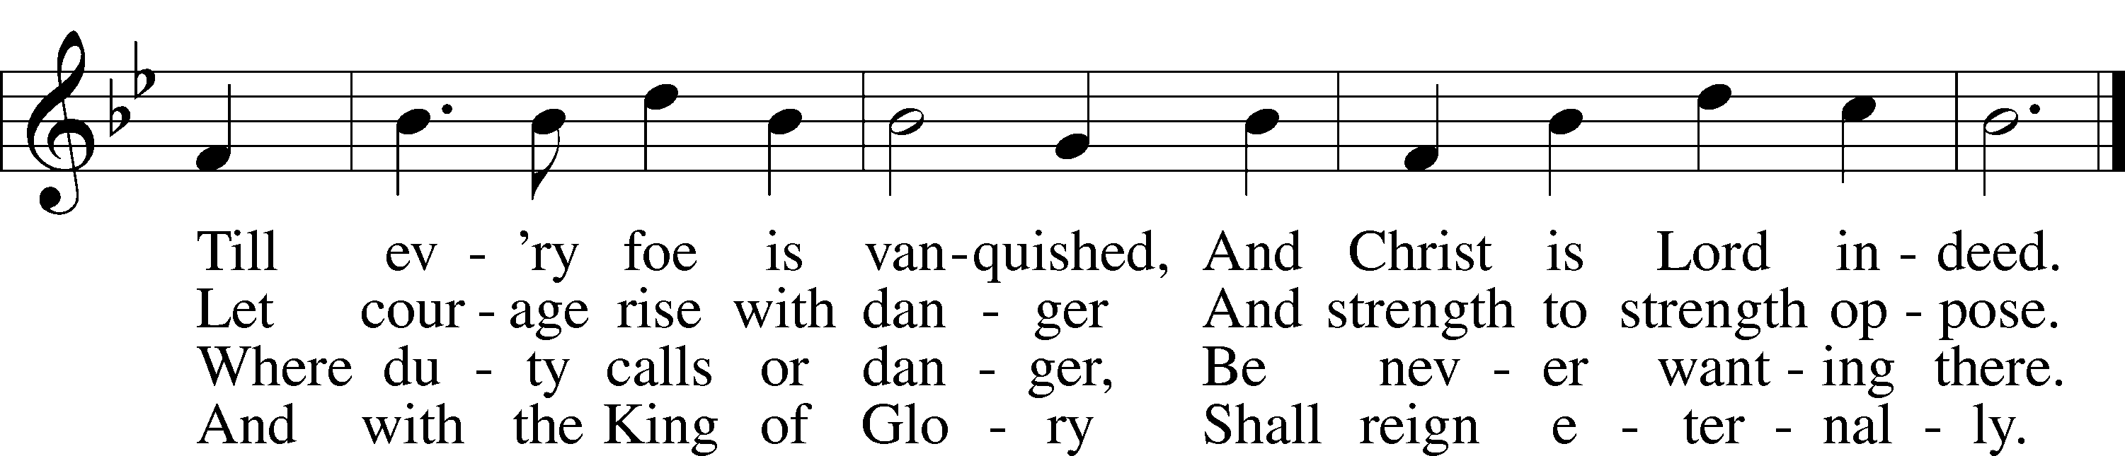
Text: George Duffield, Jr., 1818–88, alt. Tune: George J. Webb, 1803–87 Text and tune: Public domain
Confession and Absolution
The sign of the cross may be made by all in remembrance of their Baptism.

P In the name of the Father and of the T Son and of the Holy Spirit.
C Amen.

P Our help is in the name of the Lord,
C who made heaven and earth.
P If You, O Lord, kept a record of sins, O Lord, who could stand?
C But with You there is forgiveness; therefore You are feared.

P Since we are gathered to hear God’s Word, call upon Him in prayer and praise, and receive the body and blood of our Lord Jesus Christ in the fellowship of this altar, let us first consider our unworthiness and confess before God and one another that we have sinned in thought, word, and deed, and that we cannot free ourselves from our sinful condition. Together as His people let us take refuge in the infinite mercy of God, our heavenly Father, seeking His grace for the sake of Christ, and saying: God, be merciful to me, a sinner.

Pause for reflection

C Almighty God, have mercy upon us, forgive us our sins, and lead us to everlasting life. Amen.

P Almighty God, in His mercy has given His Son to die for you and for His sake forgive you all you sins. As a called servant of Christ, and by His authority, I therefore forgive you all your sins in the name of the Father and of the T Son and of the Holy Spirit.
C Amen.

Stand

Service of the Word

Invitatory for Trinitytide .
The Lord has sanctified us in the true faith,
O come, let us worship Him. *
Let us seek His mercy
with tears and humble ourselves before Him.

Introit Psalm 75:1–2, 6, 9; antiphon: v. 7
It is God who executes | judgment,*
putting down one and lifting up an- | other.
We give thanks to you, O God; we give thanks, for your | name is near.*
We recount your | wondrous deeds.
At the set time that | I appoint*
I will judge with | equity.
For not from the east or | from the west*
and not from the wilderness comes | lifting up.
But I will declare it for- | ever;*
I will sing praises to the God of | Jacob.
Glory be to the Father and | to the Son*
and to the Holy | Spirit;
as it was in the be- | ginning,*
is now, and will be forever. | Amen.
It is God who executes | judgment,*
putting down one and lifting up an- | other.

Kyrie 204

P In Peace, let us pray to the Lord
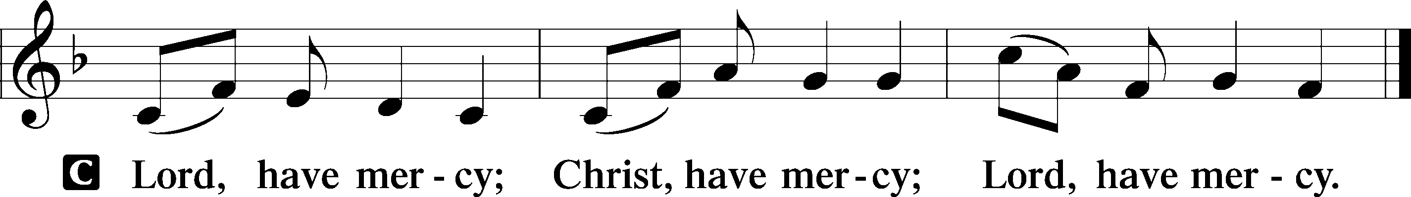

P For the peace of the whole world, for the wellbeing of the Church of God and for the unity of all; let us pray to the Lord.

P For this holy House, and all who offer their worship and praise; let us pray to the Lord.

This Is the Feast LSB 155
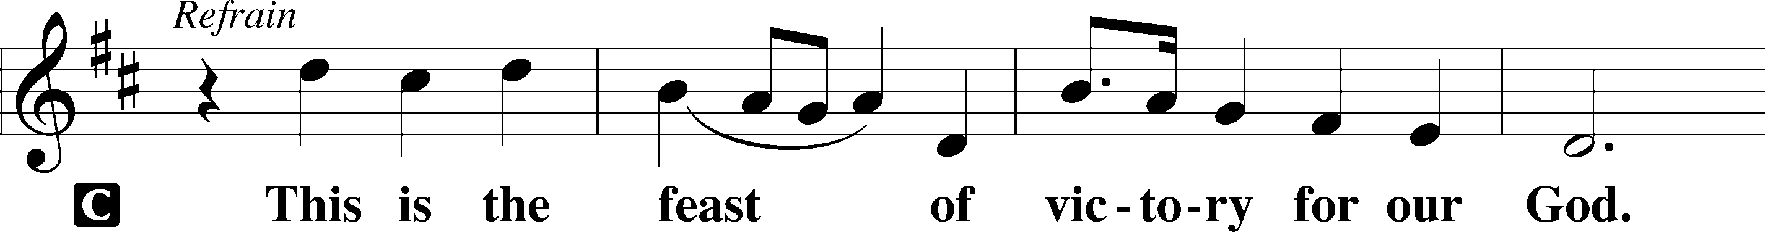
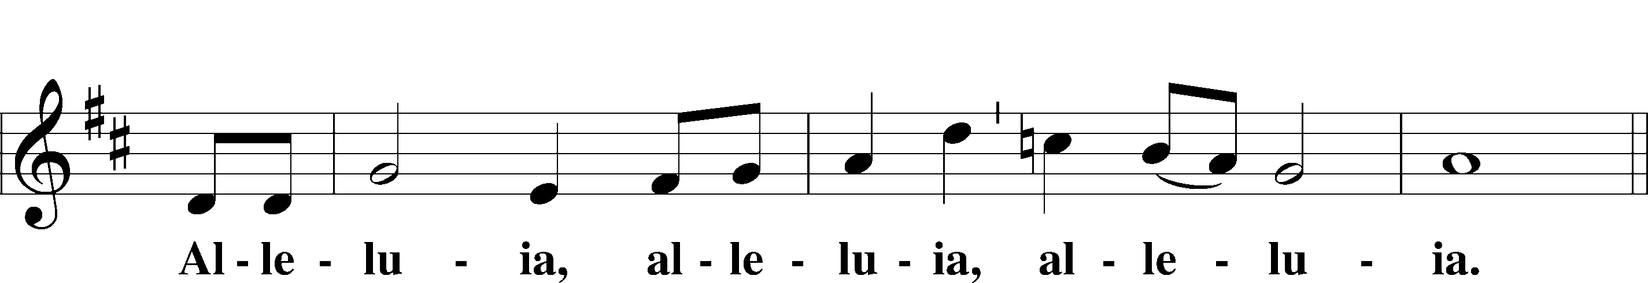
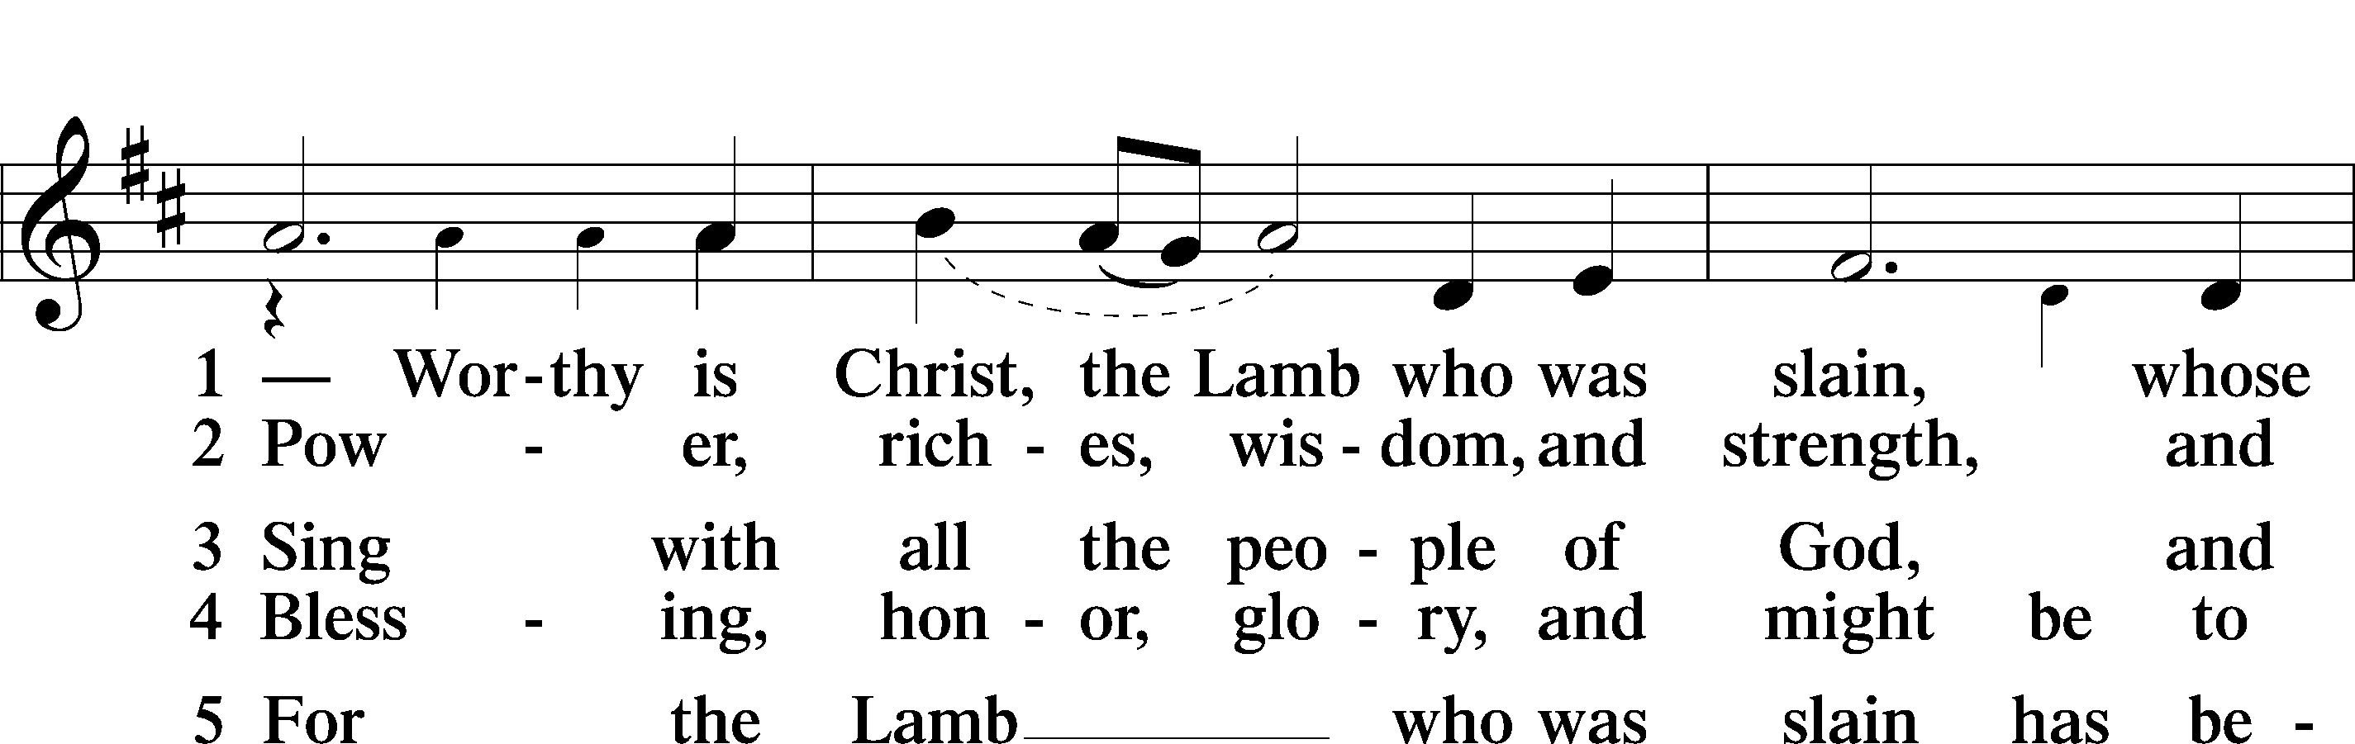
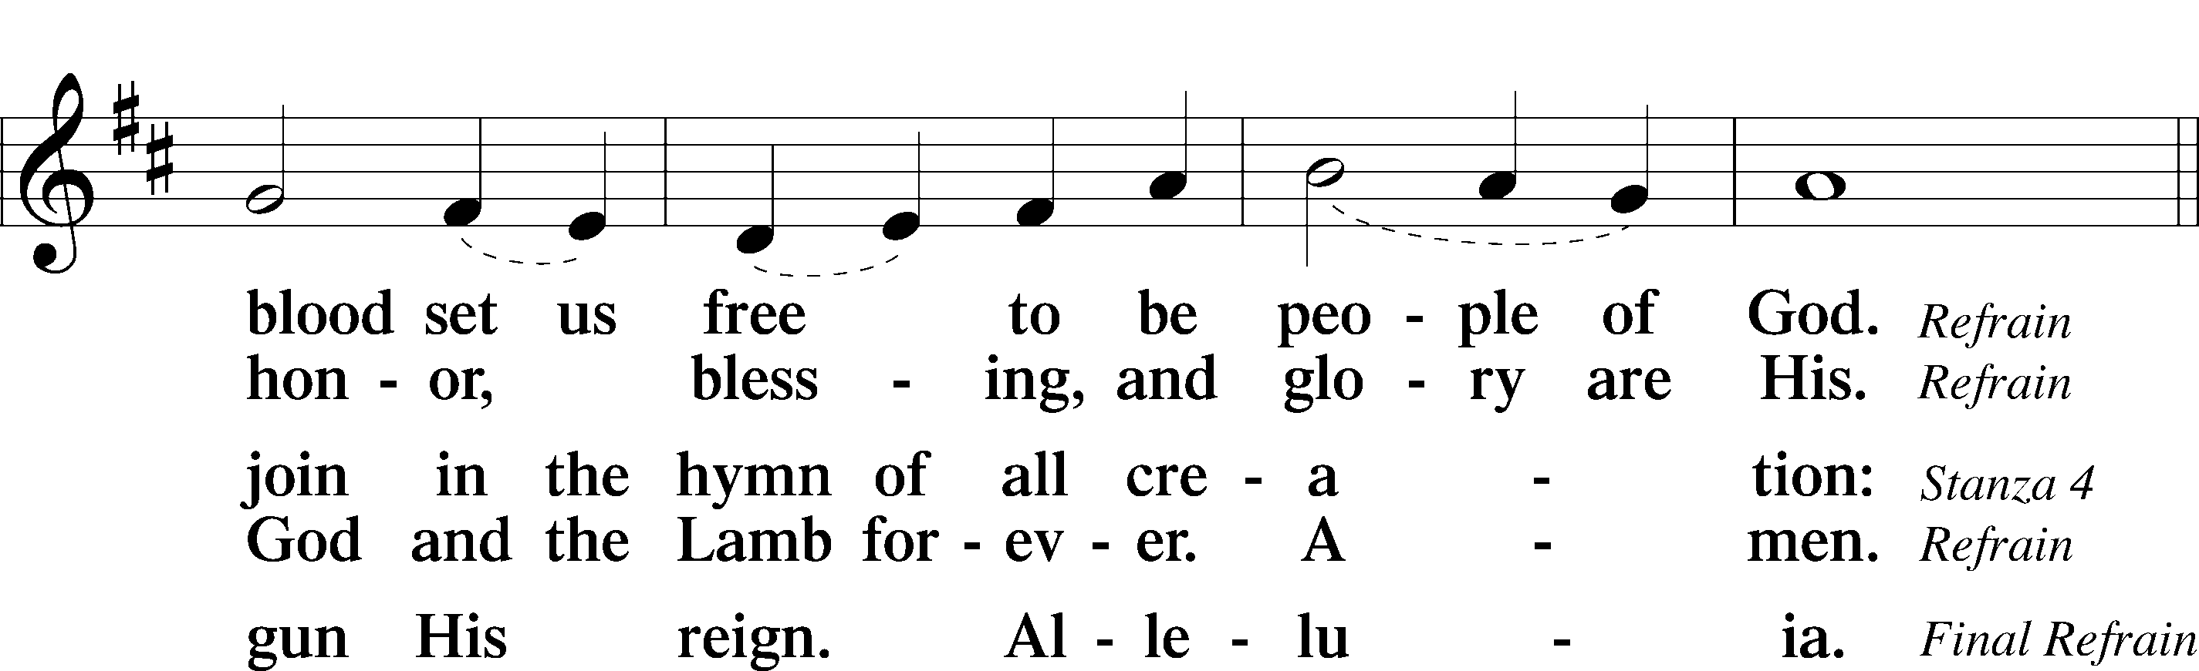
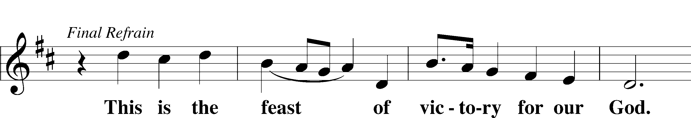
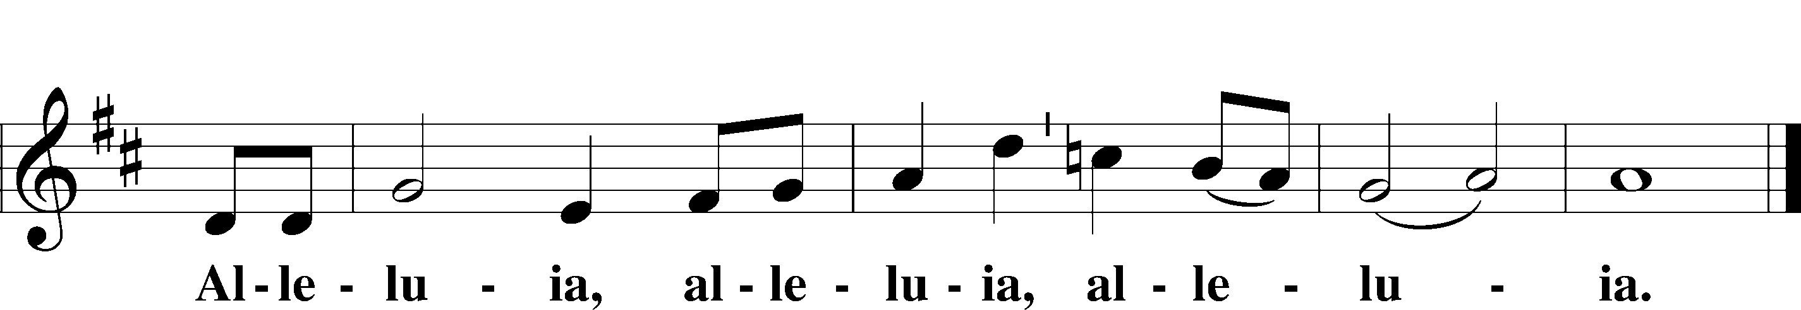

Salutation and Collect of the Day
P The Lord be with you.
C And also with you.

P Let us pray.
O Lord of grace and mercy, teach us by Your Holy Spirit to follow the example of Your Son in true humility, that we may withstand the temptations of the devil and with pure hearts and minds avoid ungodly pride; through the same Jesus Christ, our Lord, who lives and reigns with You and the Holy Spirit, one God, now and forever.
C Amen.
Sit

Old Testament Reading Proverbs 25:2–10

A The Old Testament read from the 25th book of Proverbs.
2It is the glory of God to conceal things,
but the glory of kings is to search things out.
3As the heavens for height, and the earth for depth,
so the heart of kings is unsearchable.
4Take away the dross from the silver,
and the smith has material for a vessel;
5take away the wicked from the presence of the king,
and his throne will be established in righteousness.
6Do not put yourself forward in the king’s presence
or stand in the place of the great,
7for it is better to be told, “Come up here,”
than to be put lower in the presence of a noble.
What your eyes have seen
8do not hastily bring into court,
for what will you do in the end,
when your neighbor puts you to shame?
9Argue your case with your neighbor himself,
and do not reveal another’s secret,
10lest he who hears you bring shame upon you,
and your ill repute have no end.
A This is the Word of the Lord.
C Thanks be to God.

Psalm Psalm 131; antiphon: v. 2
1O Lord, my heart is not lifted up;
my eyes are not | raised too high;*
I do not occupy myself with things
too great and too marvel- | ous for me.
2But I have calmed and quieted my soul,
like a weaned child with its | mother;*
like a weaned child is my soul with- | in me.
3O Israel, hope | in the Lord*
from this time forth and for- | evermore.

Epistle Hebrews 13:1–17

A The Epistle read from the 13th chapter of Hebrews.

1Let brotherly love continue. 2Do not neglect to show hospitality to strangers, for thereby some have entertained angels unawares. 3Remember those who are in prison, as though in prison with them, and those who are mistreated, since you also are in the body. 4Let marriage be held in honor among all, and let the marriage bed be undefiled, for God will judge the sexually immoral and adulterous. 5Keep your life free from love of money, and be content with what you have, for he has said, “I will never leave you nor forsake you.” 6So we can confidently say,
“The Lord is my helper;
I will not fear;
what can man do to me?”
7Remember your leaders, those who spoke to you the word of God. Consider the outcome of their way of life, and imitate their faith. 8Jesus Christ is the same yesterday and today and forever. 9Do not be led away by diverse and strange teachings, for it is good for the heart to be strengthened by grace, not by foods, which have not benefited those devoted to them. 10We have an altar from which those who serve the tent have no right to eat. 11For the bodies of those animals whose blood is brought into the holy places by the high priest as a sacrifice for sin are burned outside the camp. 12So Jesus also suffered outside the gate in order to sanctify the people through his own blood. 13Therefore let us go to him outside the camp and bear the reproach he endured. 14For here we have no lasting city, but we seek the city that is to come. 15Through him then let us continually offer up a sacrifice of praise to God, that is, the fruit of lips that acknowledge his name. 16Do not neglect to do good and to share what you have, for such sacrifices are pleasing to God.
17Obey your leaders and submit to them, for they are keeping watch over your souls, as those who will have to give an account. Let them do this with joy and not with groaning, for that would be of no advantage to you.

A This is the Word of the Lord.
C Thanks be to God.

Stand

Alleluia and Verse

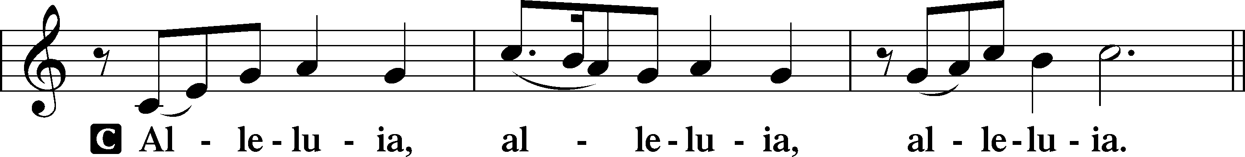

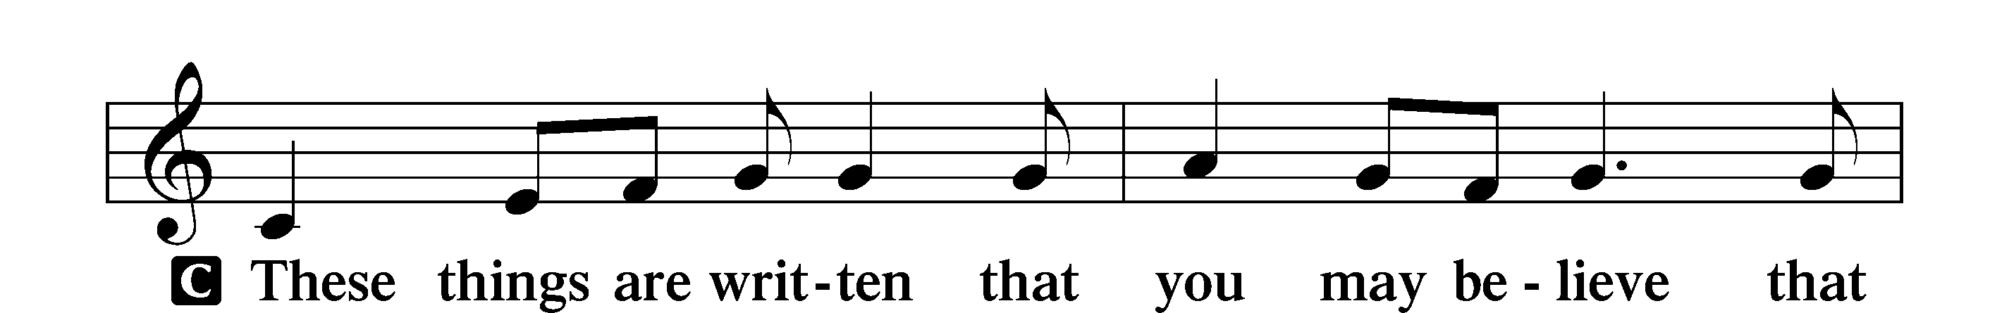
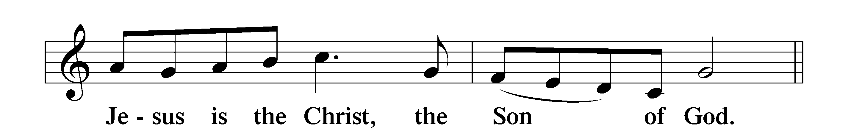

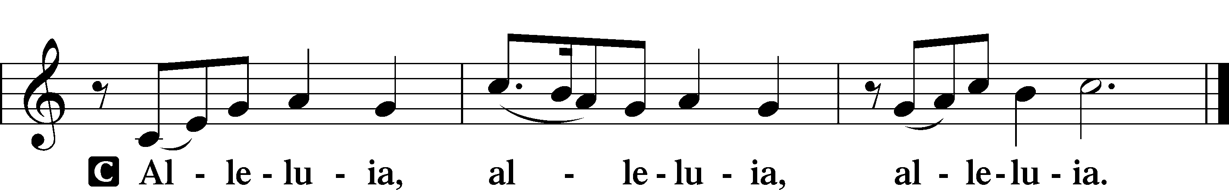

Holy Gospel Luke 14:1–14
P The Holy Gospel according to St. Luke, the fourteenth chapter.
C Glory to You, O Lord.

1One Sabbath, when [Jesus] went to dine at the house of a ruler of the Pharisees, they were watching him carefully. 2And behold, there was a man before him who had dropsy. 3And Jesus responded to the lawyers and Pharisees, saying, “Is it lawful to heal on the Sabbath, or not?” 4But they remained silent. Then he took him and healed him and sent him away. 5And he said to them, “Which of you, having a son or an ox that has fallen into a well on a Sabbath day, will not immediately pull him out?” 6And they could not reply to these things.
7Now he told a parable to those who were invited, when he noticed how they chose the places of honor, saying to them, 8“When you are invited by someone to a wedding feast, do not sit down in a place of honor, lest someone more distinguished than you be invited by him, 9and he who invited you both will come and say to you, ‘Give your place to this person,’ and then you will begin with shame to take the lowest place. 10But when you are invited, go and sit in the lowest place, so that when your host comes he may say to you, ‘Friend, move up higher.’ Then you will be honored in the presence of all who sit at table with you. 11For everyone who exalts himself will be humbled, and he who humbles himself will be exalted.”
12He said also to the man who had invited him, “When you give a dinner or a banquet, do not invite your friends or your brothers or your relatives or rich neighbors, lest they also invite you in return and you be repaid. 13But when you give a feast, invite the poor, the crippled, the lame, the blind, 14and you will be blessed, because they cannot repay you. You will be repaid at the resurrection of the just.”

P This is the Gospel of the Lord.
C Praise to You, O Christ.

Sit

842 Son of God, Eternal Savior
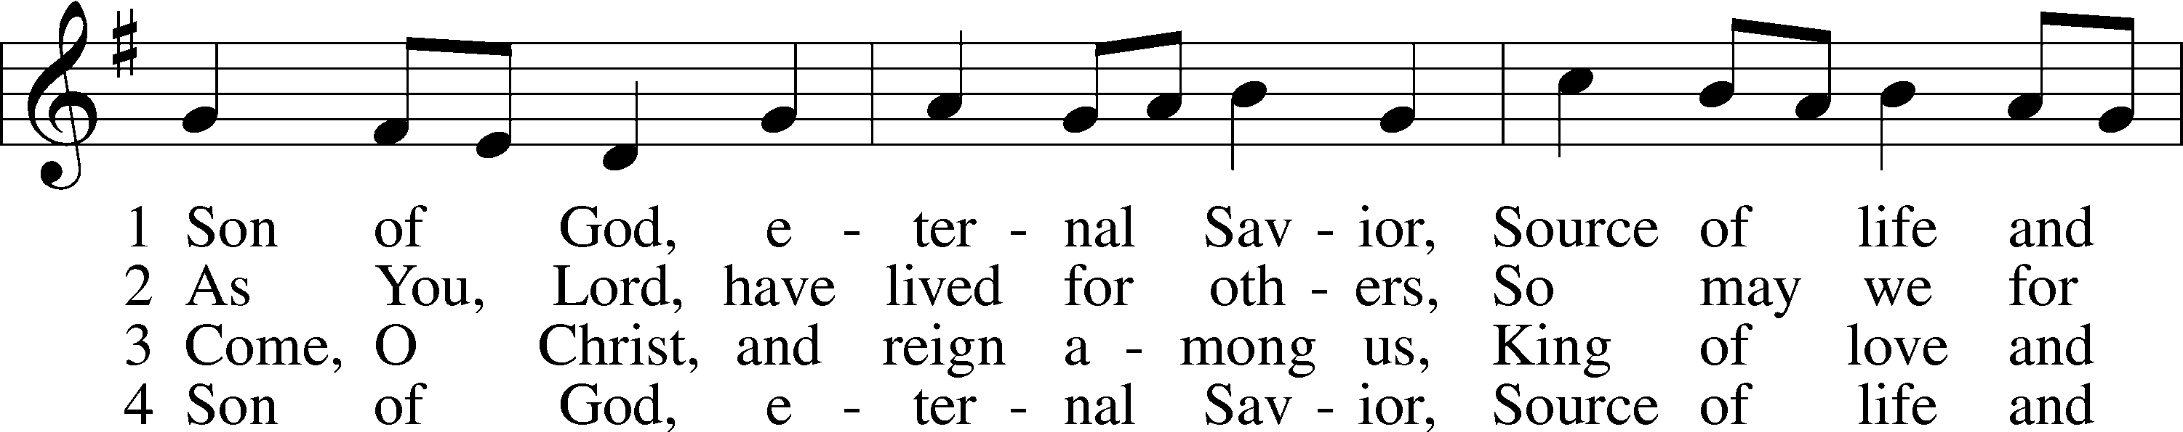
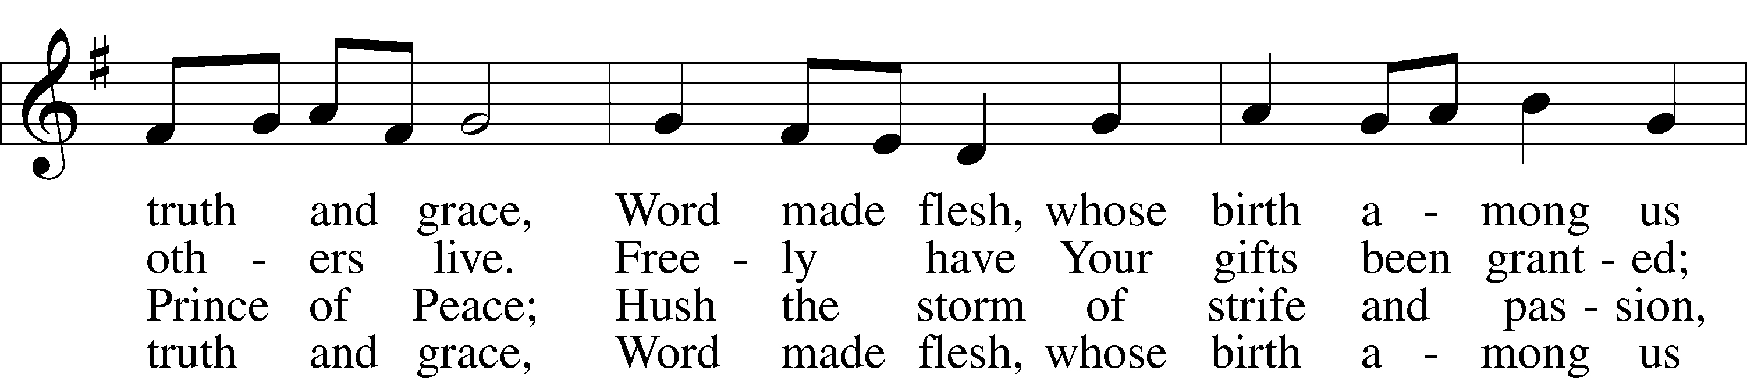
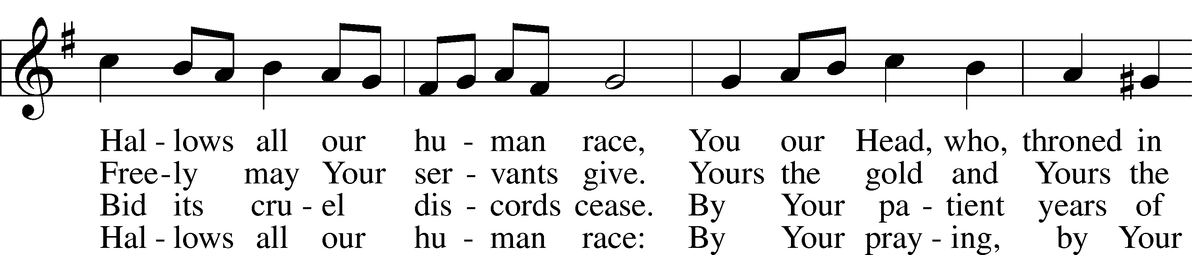
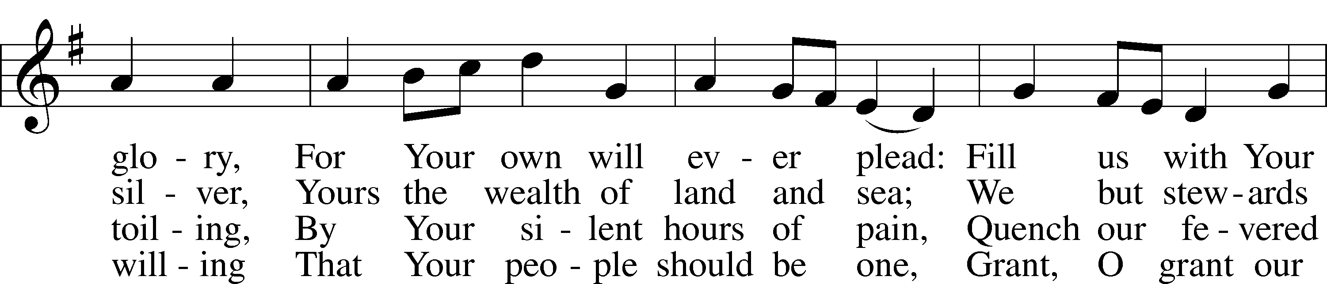
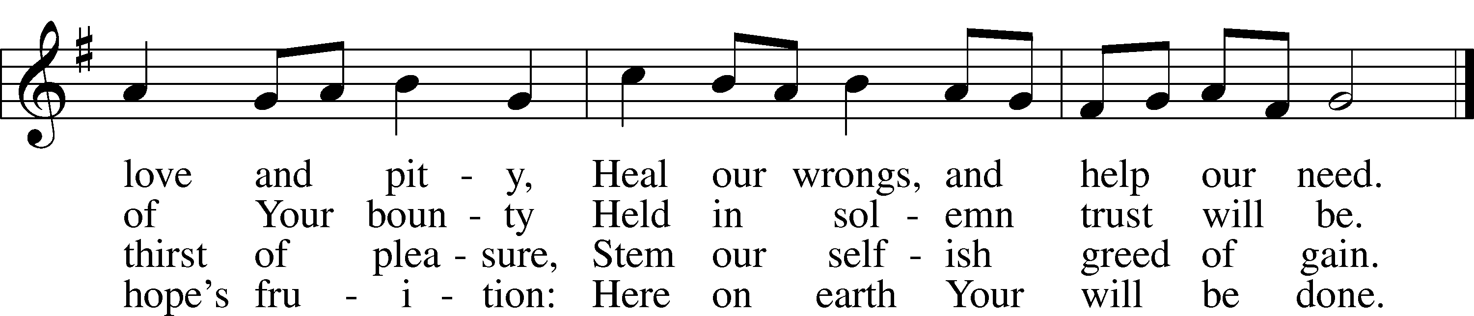
Text: Somerset T. C. Lowry, 1855–1932, alt.
Tune: Oude en Nieuwe Hollantse . . . Contredansen, c. 1710, Amsterdam
Text and tune: Public domain

Sermon

Stand

Apostles’ Creed
C I believe in God, the Father Almighty, maker of heaven and earth.

And in Jesus Christ, His only Son, our Lord, who was conceived
by the Holy Spirit, born of the virgin Mary,
suffered under Pontius Pilate, was crucified, died and was buried.
He descended into hell.
The third day He rose again from the dead.
He ascended into heaven
and sits at the right hand of God the Father Almighty.
From thence He will come to judge the living and the dead.

I believe in the Holy Spirit, the holy Christian Church,
the communion of saints, the forgiveness of sins,
the resurrection of the body, and the life T everlasting. Amen.

Prayer of the Church
Following the prayers, the people may greet one another in the name of the Lord, saying,
“Peace be with you,” as a sign of reconciliation and of the unity of the Spirit in the bond of peace
(Matt. 5:22–24; Eph. 4:1–3).

Offering & Sharing of the Peace

Service of Holy Communion
Communion Statement

The Lord’s Supper is celebrated at this congregation in the confession and glad confidence that, as He says, our Lord gives into our mouths not only bread and wine but His very body and blood to eat and to drink for the forgiveness of sins and to strengthen our union with Him and with one another. Our Lord invites to His table those who trust His words, repent of all sin, and set aside any refusal to forgive and love as He forgives and loves us, that they may show forth His death until He comes.

Because those who eat and drink our Lord’s body and blood unworthily do so to their great harm and because Holy Communion is a confession of the faith which is confessed at this altar, any who are not yet instructed, in doubt, or who hold a confession differing from that of this congregation and the Lutheran Church Missouri Synod, and yet desire to receive this sacrament, are asked to speak with the Pastor.
* See more about the Lutheran teaching on communion in the Hymnal p 329.
Stand
Preface LSB 208
P The Lord be with you.
C And also with you.
P Lift up your hearts.
C We lift them to the Lord.
P Let us give thanks to the Lord our God.
C It is right to give Him thanks and praise.

P It is truly good, right, and salutary that we should at all times and in all places give thanks to You, O Lord, holy Father, almighty and everlasting God, for the countless blessings You so freely bestow on us and all creation. Above all, we give thanks for Your boundless love shown to us when You sent Your only-begotten Son, Jesus Christ, into our flesh and laid on Him our sin, giving Him into death that we might not die eternally. Because He is now risen from the dead and lives and reigns to all eternity, all who believe in Him will overcome sin and death and will rise again to new life. Therefore with angels and archangels and with all the company of heaven we laud and magnify Your glorious name, evermore praising You and saying:
Sanctus LSB 208
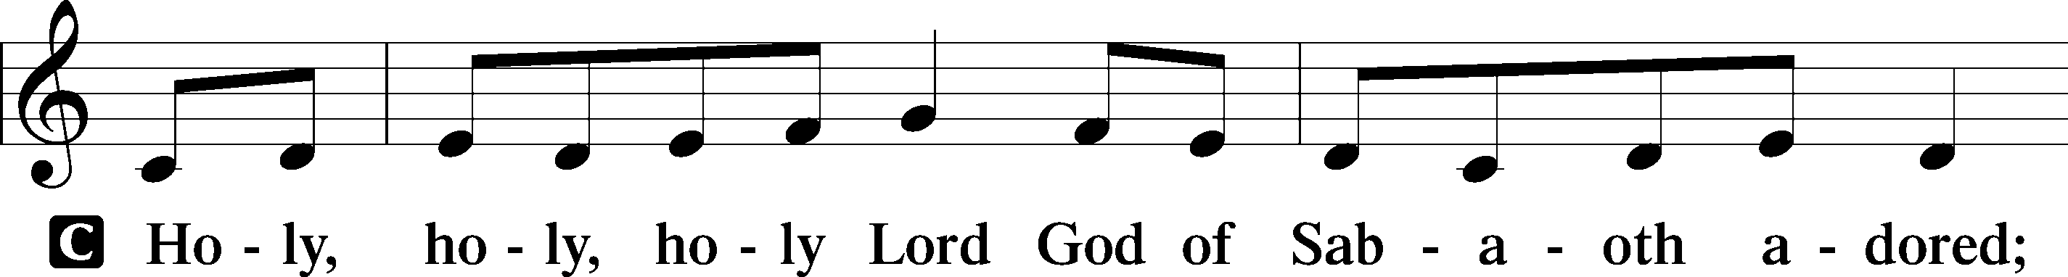
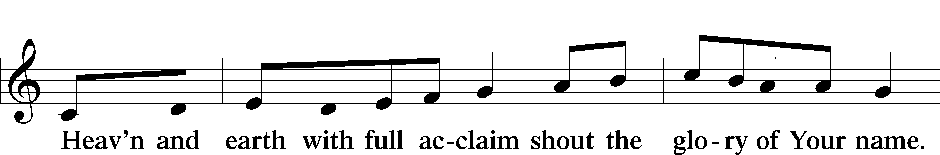
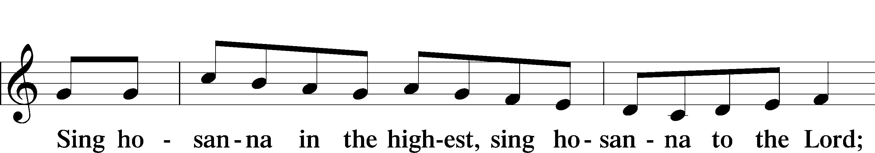
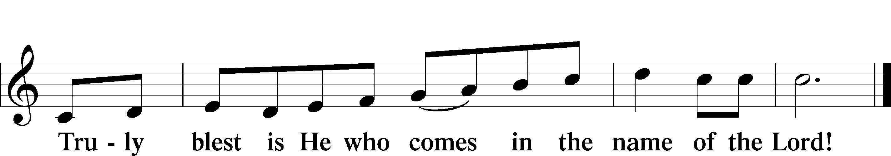
Text: Stephen P. Starke
Prayer of Thanksgiving
P Blessed are You, O Lord our God, king of all creation, for You have had mercy on us and given Your only-begotten Son that whoever believes in Him should not perish but have eternal life.

In these last days, You have poured out Your Holy Spirit on Your Church that Your sons and daughters might proclaim the wonders of Your salvation in Christ Jesus our Lord. Pour out Your Holy Spirit upon Your gathered people that, faithfully eating and drinking the body and blood of Your Son, we may go forth to proclaim His salvation to the ends of the earth.

Hear us as we pray in His name and as He has taught us:

Lord’s Prayer
C Our Father who art in heaven, hallowed be Thy name,
Thy kingdom come, Thy will be done on earth
as it is in heaven;
give us this day our daily bread; and forgive us our trespasses
as we forgive those who trespass against us;
and lead us not into temptation, but deliver us from evil.
For Thine is the kingdom and the power and the glory
forever and ever. Amen.

The Words of Our Lord
P Our Lord Jesus Christ, on the night when He was betrayed, took bread, and when He had given thanks, He broke it and gave it to the disciples and said: “Take, eat; this is My T body, which is given for you. This do in remembrance of Me.”

In the same way also He took the cup after supper, and when He had given thanks, He gave it to them, saying: “Drink of it, all of you; this cup is the new testament in My T blood, which is shed for you for the forgiveness of sins. This do, as often as you drink it, in remembrance of Me.”

Pax Domini
P The peace of the Lord be with you always.
C Amen.

Agnus Dei LSB 210
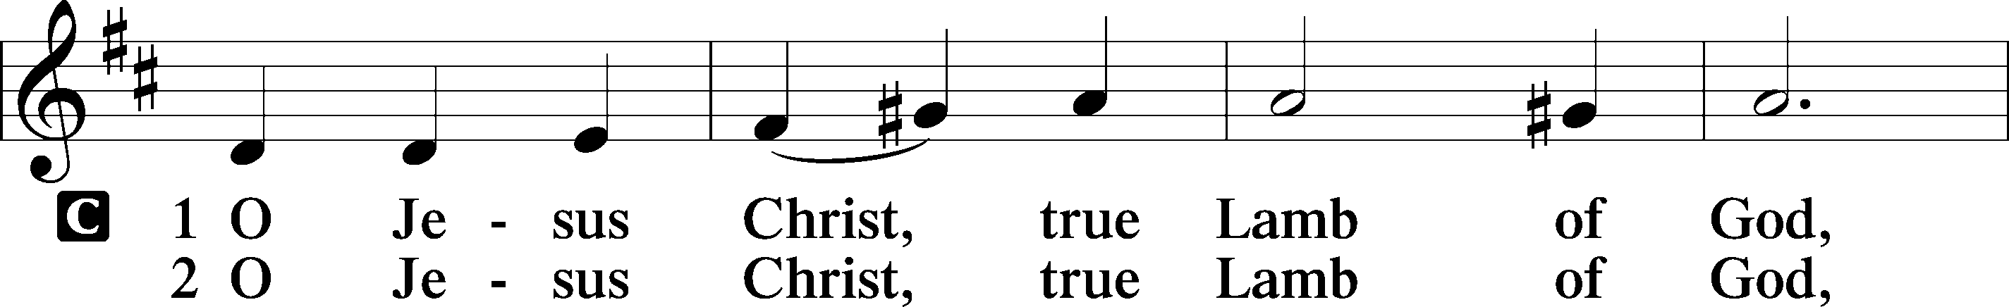
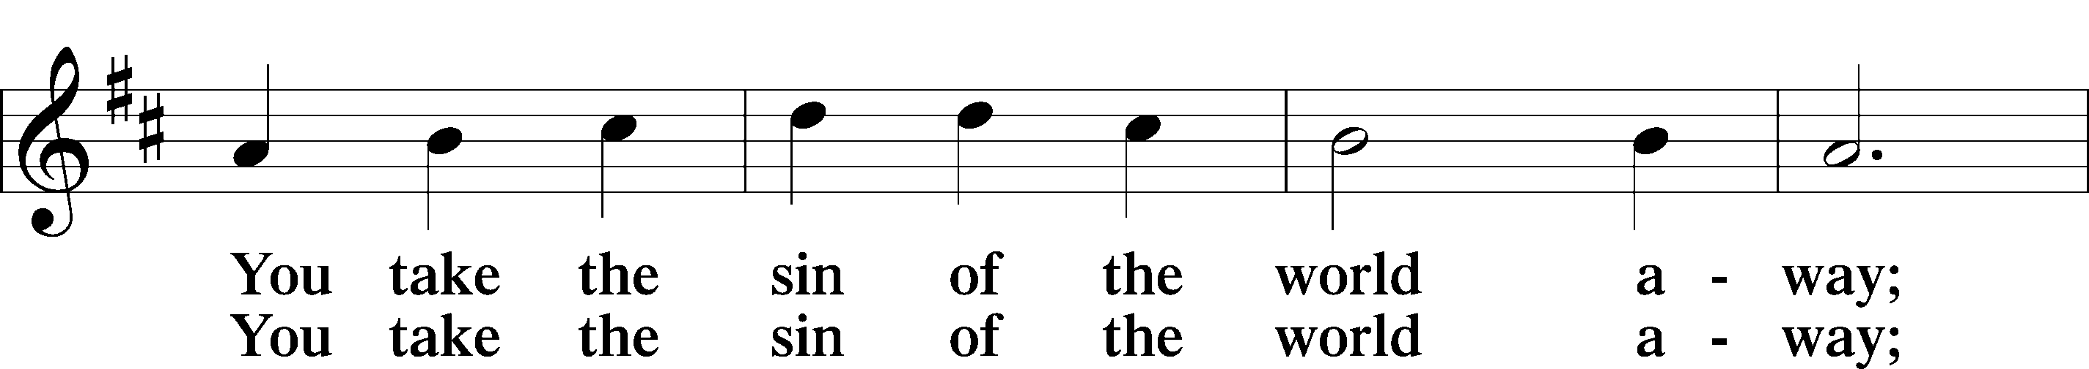
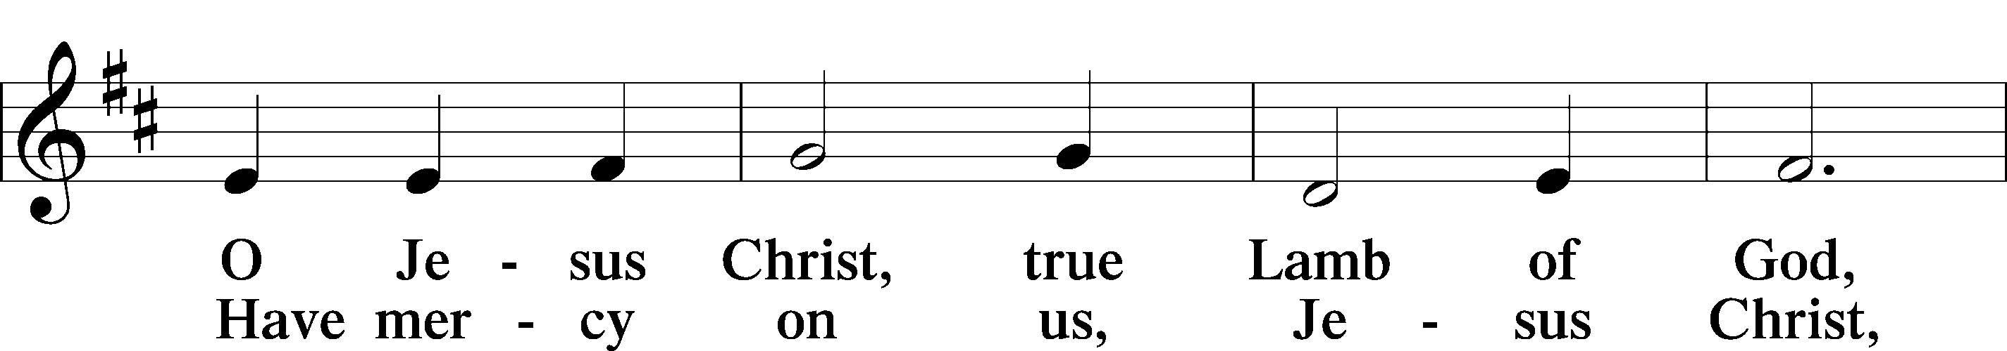
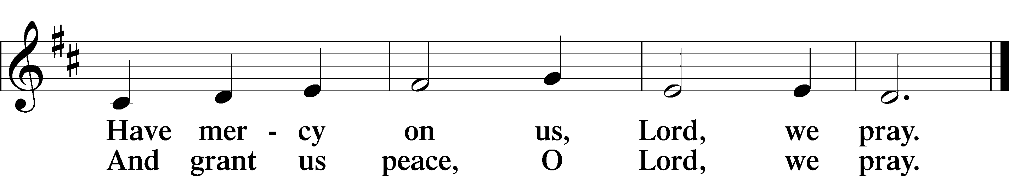
Text: Stephen P. Starke

Sit

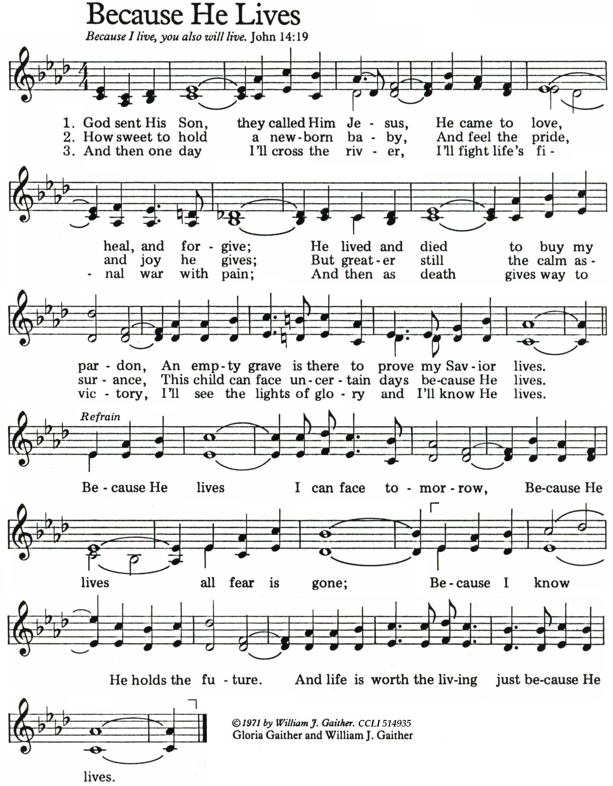Stand

Nunc Dimittis LSB 211
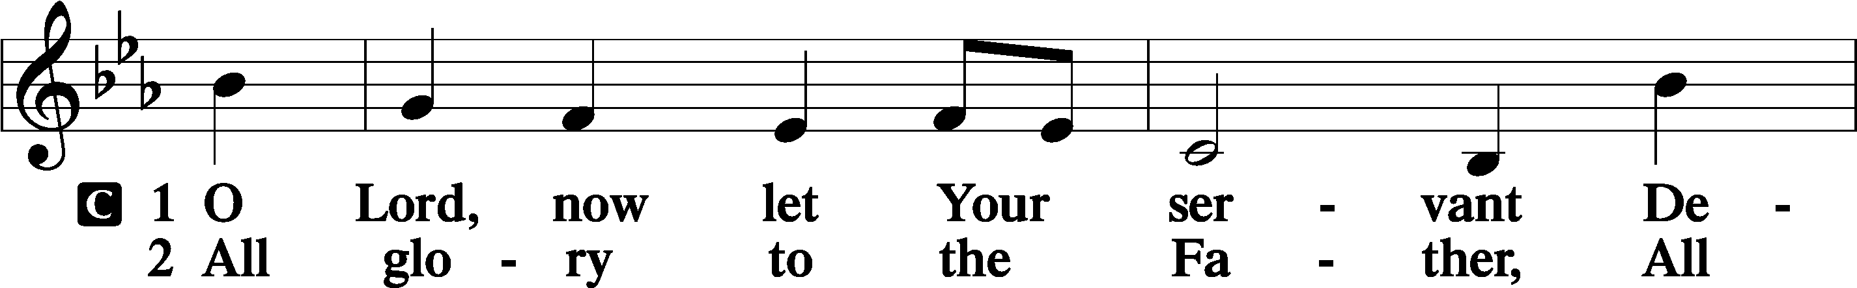
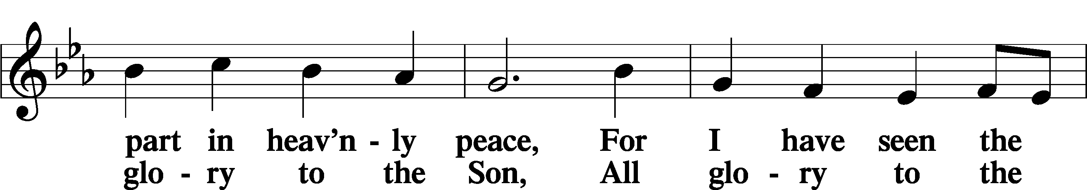
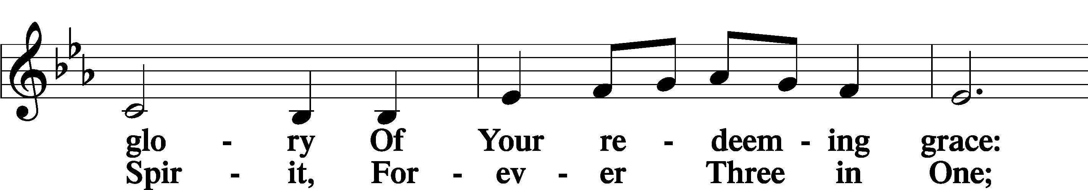
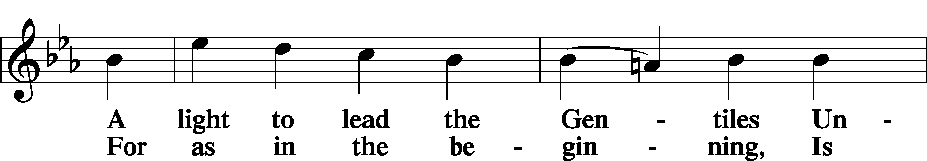
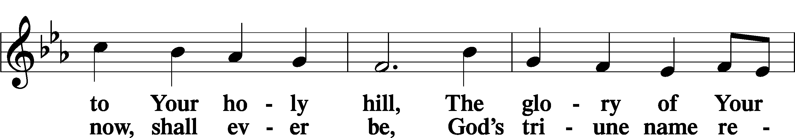
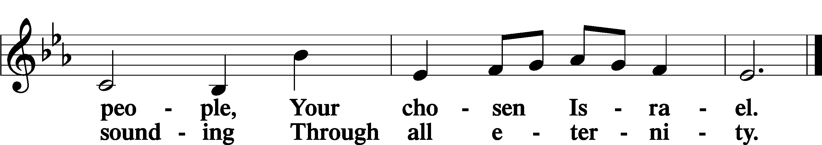

Post-Communion Collect
A Let us pray.
We give thanks to You, almighty God, that You have refreshed us through this salutary gift, and we implore You that of Your mercy You would strengthen us through the same in faith toward You and in fervent love toward one another; through Jesus Christ, Your Son, our Lord, who lives and reigns with You and the Holy Spirit, one God, now and forever.
C Amen.

Verse of the day Luke 14:11
A Alleluia. Everyone who exalts himself will be humbled,
C and he who humbles himself will be exalted. Alleluia.

Benedicamus LSB 212
A Let us bless the Lord.
C Thanks be to God.

Benediction
P The Lord bless you and keep you.
The Lord make His face shine on you and be gracious to you.
The Lord look upon you with favor and T give you peace.
C Amen.

649 Blest Be the Tie That Binds
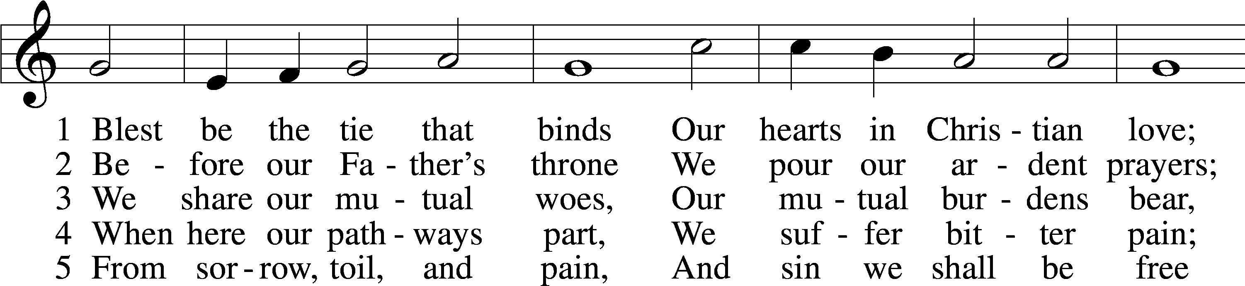
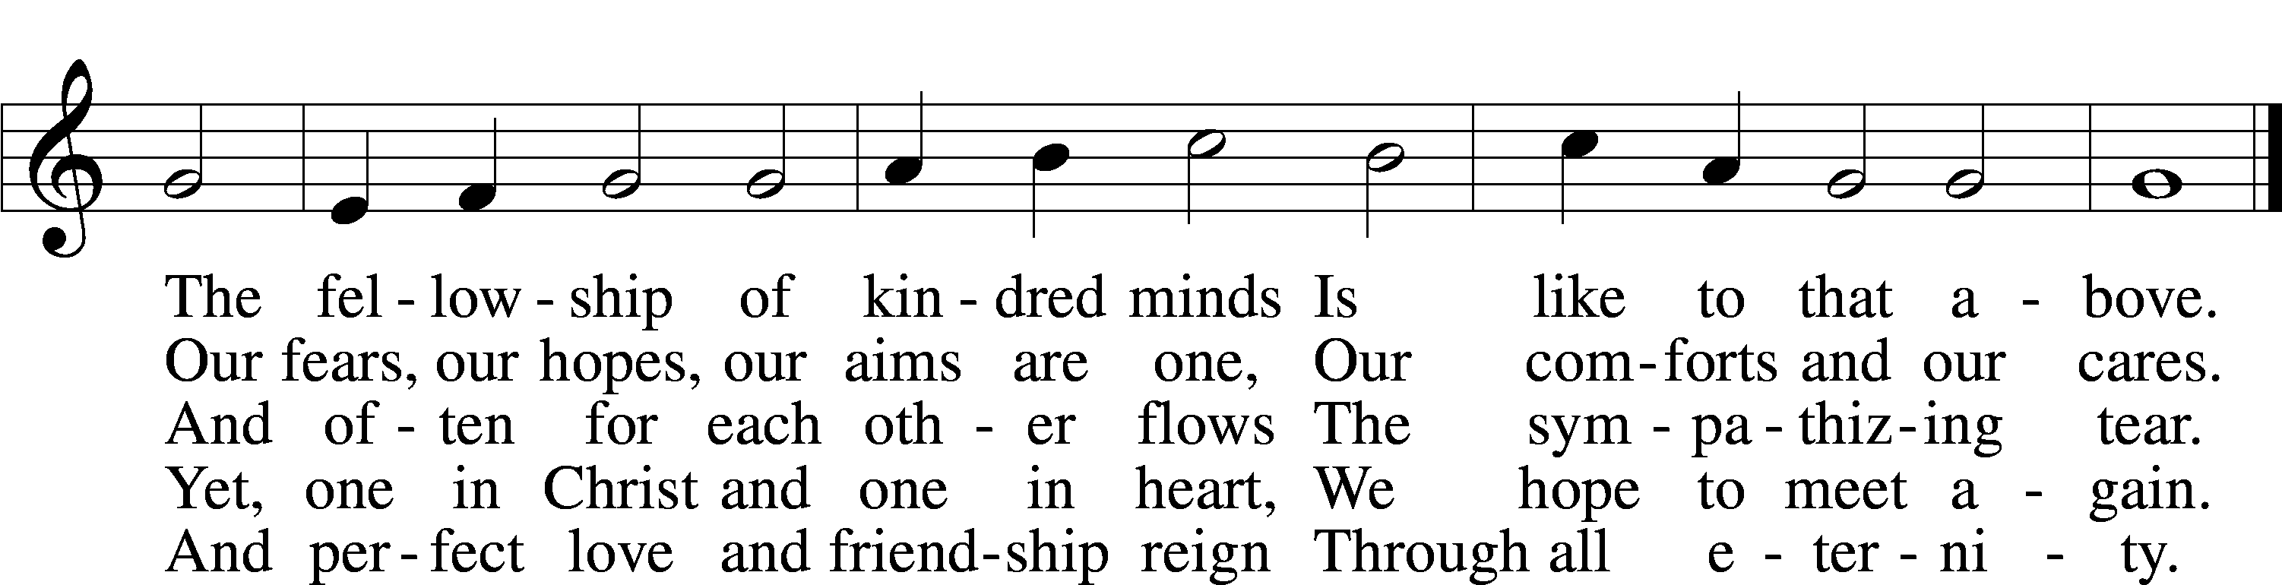
Text: John Fawcett, 1740–1817, alt.
Tune: Lowell Mason, 1792–1872, alt.
Text and tune: Public domain

Acknowledgments
Divine Service, Setting Four from Lutheran Service Book
Unless otherwise indicated, Scripture quotations are from the ESV® Bible (The Holy Bible, English Standard Version®), copyright © 2001 by Crossway, a publishing ministry of Good News Publishers. Used by permission. All rights reserved.
Created by Lutheran Service Builder © 2025 Concordia Publishing House.

Prayers of the Church
This week, we lift up:

Angela H (surgery on 13th), Sheila, Elaine, Bob, Angie Z, Angela C,
Ross, & Kathy H.

Family of the week: JoAn Anders
*If you have any prayer request let us know.

Last week: Attendance 27 Offering $741.00

Serving Next Week (9/7/25)  Service Leader: Vicar Previn Hudetz  Communion Celebrant: Rev John Heffelfinger  Worship Assistant: Charlie  Reader: Jim C  Refreshments: POTLUCK  Altar Guild: Angie Z & Sheila S  Greeter: Bob C | Readings Next Week  Thirteenth Sunday after Pentecost  Deuteronomy 30:15-20  Psalm 1  Philemon 1-21  Luke 14:25-35  *Please sign up to help during service.*
Announcements  Birthdays: 8/25 Elaine Cook!  This Week at OSLC:  Bible Study: After Service  Bible Study: Thursday 10am | Coming Up:  Congregational Meeting to confirm & elect Council Members.  September 28, 2025  Following service

Seasons of the Church Year

The non-celebratory half of the Church year is called the “Time of The Church”,
or traditionally the “Time of Trinity” (Trinitytide). These weeks are marked by counting the Sundays after Pentecost. This is the longest season of the church year. The color of the season is green, to represent growth and the power of the Lord working in mission.



