

When Naomi saw that Ruth was determined to go with her,
she said no more.

Ruth 1:18

Our Savior Lutheran Church (LCMS)
4301 Atrisco Drive NW
Albuquerque, New Mexico
Website: OSLCNM.COM
Phone: 505.836.7007
Email: oslcabq@gmail.com

Eighteenth Sunday after Pentecost
October 12th,2025
The Time of the Church (Trinitytide)
Eighteenth Sunday after Pentecost
October 12th, 2025

Welcome to Our Savior Lutheran Church (LCMS).  We are glad you are here as we worship, praise, and give thanks to our loving Lord, Jesus Christ. Please join us immediately after service for fellowship and snacks. Adult Bible Study starts at 10:30. If you have any questions about our service or need other assistance, please contact one of our worship assistants. | Hymns  Opening # 806 & 528  Sermon # 685  Distribution # Near the Cross  Closing # 924

Today’s Message

“Your People / My People” – Ruth is one of the most beloved women in the Bible, remembered for her compassion and sacrifice toward Naomi. She is called a “Christ-type,” because like Jesus, she gave up her own safety and future for the good of another. Jesus gave up the comfort of heaven to win redemption and eternal security for all people. From Ruth we learn loyalty and compassion; from Jesus we receive the greatest gift of all — forgiveness and eternal life.

+++
Serving Today
Guest Pastor: Rev Doyle Boykin
Music Minister: Vicar Previn Hudetz
Communion Assistant: Jim C
Worship Assistant: Charlie Mike
Reader: Sheila S
Refreshments: Tania V
Altar Guild: Angie Z & Sheila S
Greeter: ???
Welcome - Divine Service I
806 Give Thanks with a Grateful Heart

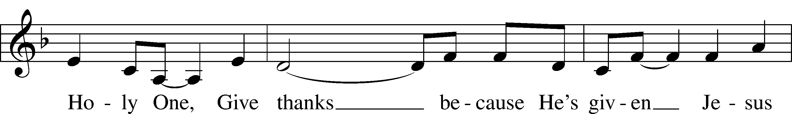
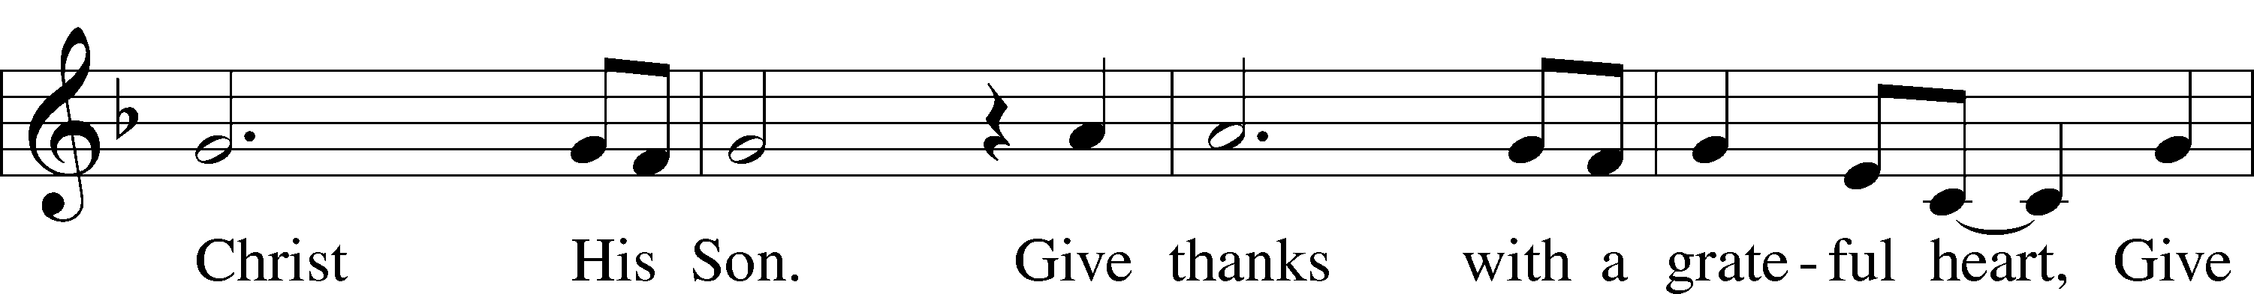
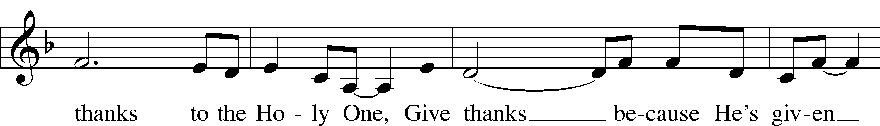
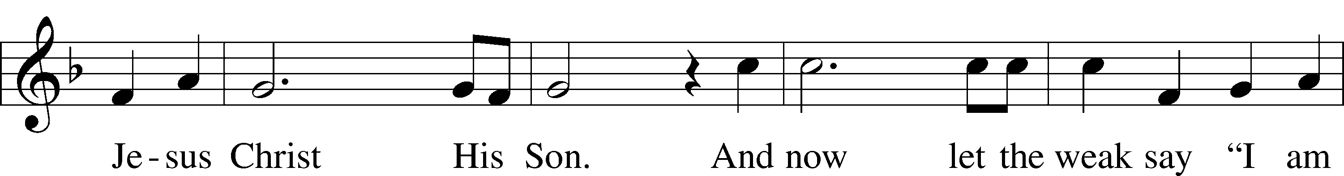
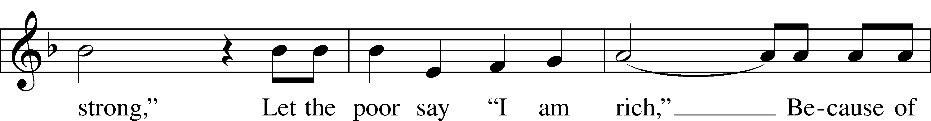

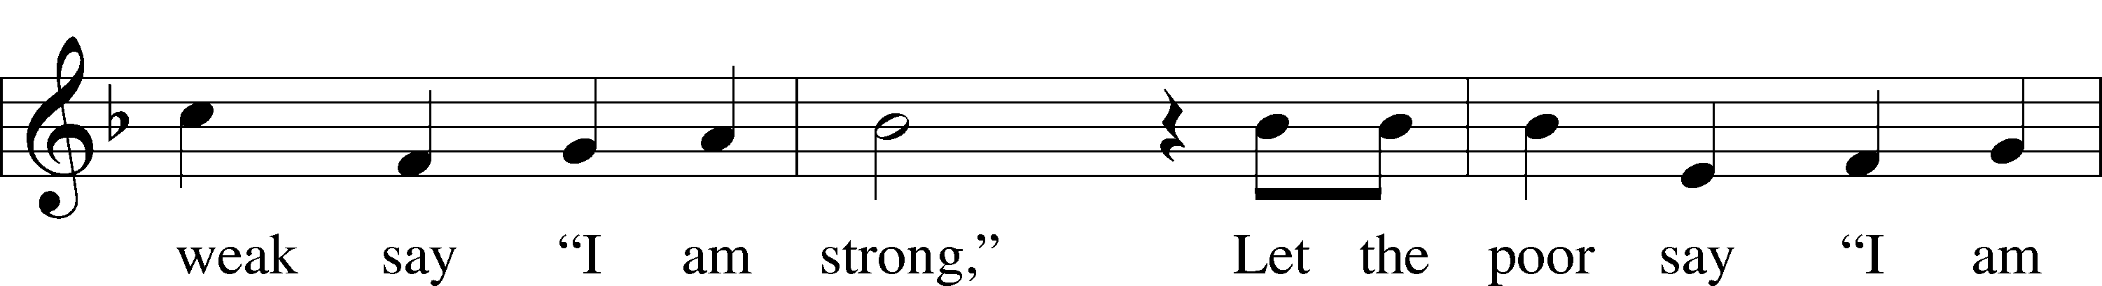
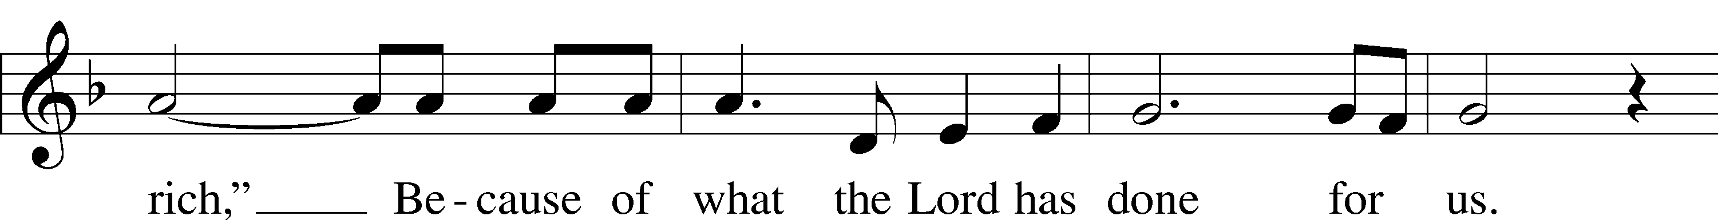

528 Oh, for a Thousand Tongues to Sing sts. 1–4, 7
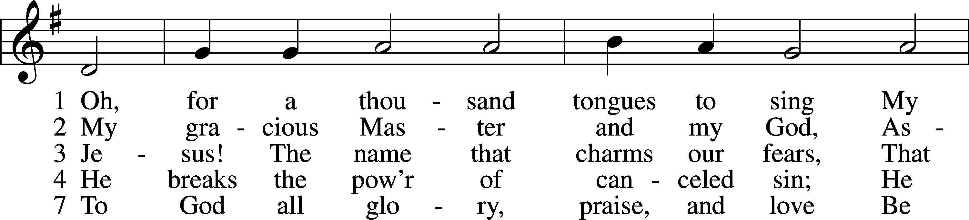
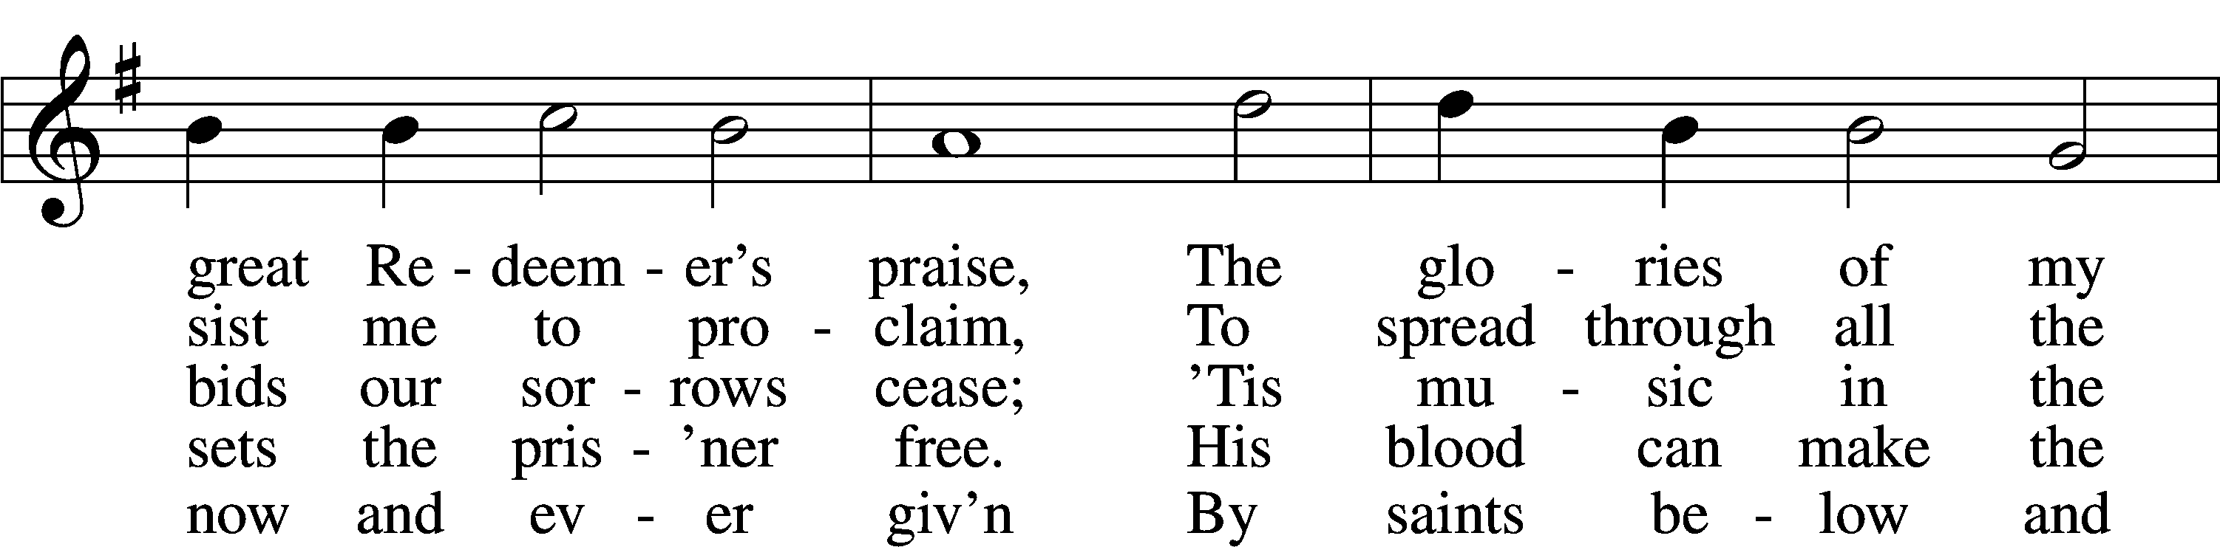
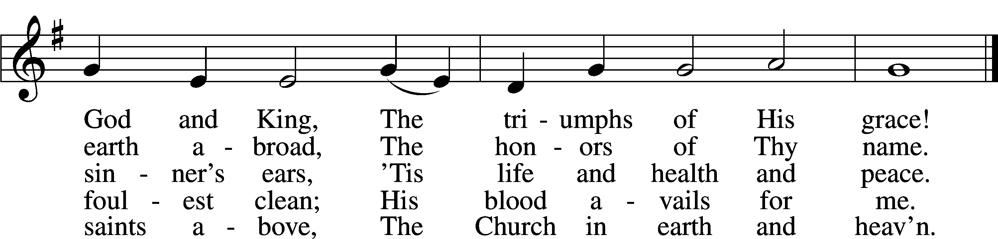
Text: Charles Wesley, 1707–88, alt. Tune: Carl G. Gläser, 1784–1829 Text and tune: Public domain

Confession and Absolution
Stand

The sign of the cross may be made by all in remembrance of their Baptism.

P In the name of the Father and of the T Son and of the Holy Spirit.
C Amen.

P If we say we have no sin, we deceive ourselves, and the truth is not in us.
C But if we confess our sins, God, who is faithful and just, will forgive our sins and cleanse us from all unrighteousness.

Silence for reflection on God’s Word and for self-examination.

P Let us then confess our sins to God our Father.
C Most merciful God, we confess that we are by nature sinful and unclean. We have sinned against You in thought, word, and deed, by what we have done and by what we have left undone. We have not loved You with our whole heart; we have not loved our neighbors as ourselves. We justly deserve Your present and eternal punishment. For the sake of Your Son, Jesus Christ, have mercy on us. Forgive us, renew us, and lead us, so that we may delight in Your will and walk in Your ways to the glory of Your holy name. Amen.

P Almighty God in His mercy has given His Son to die for you and for His sake forgives you all your sins. As a called and ordained servant of Christ, and by His authority, I therefore forgive you all your sins in the name of the Father and of the T Son and of the Holy Spirit.
C Amen.

Stand
Service of the Word

Invitatory for Trinitytide

P The Lord has enlightened us in the true faith.
Oh come, let us worship Him.
C O Lord, You hear the desire of the afflicted;
You will strengthen their heart; You will incline Your ear.
Psalm 10:17

Introit
Great is the Lord and greatly | to be praised*
in the city | of our God!
My soul makes its boast | in the Lord;*
let the humble hear | and be glad.
Oh, magnify the | Lord with me,*
and let us exalt his name to- | gether!
I sought the Lord, and he | answered me*
and delivered me from | all my fears.
When the righteous cry for help, the | Lord hears*
and delivers them out of all their | troubles.
Glory be to the Father and | to the Son*
and to the Holy | Spirit;
as it was in the be- | ginning,*
is now, and will be forever. | Amen.
Great is the Lord and greatly | to be praised*
in the city | of our God!
Kyrie LSB 152



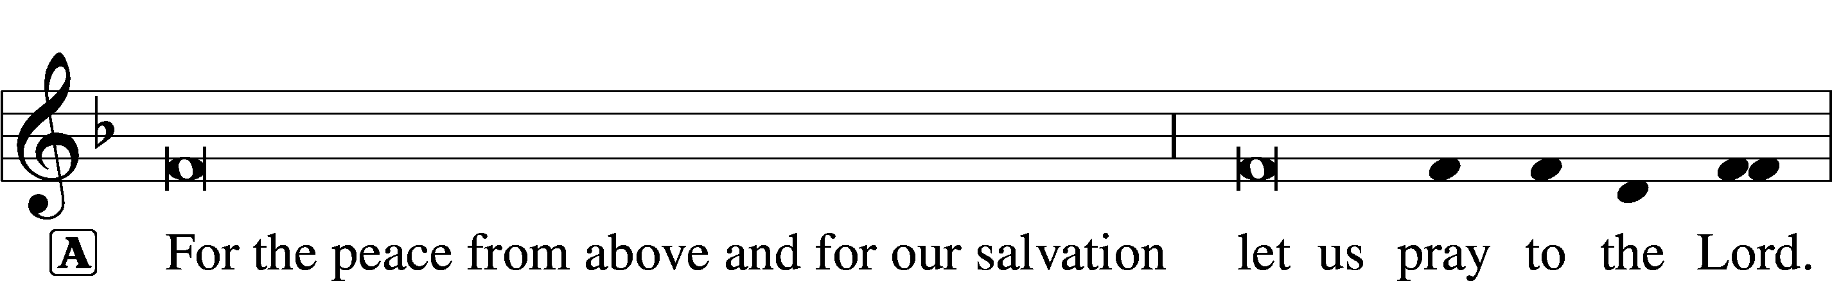


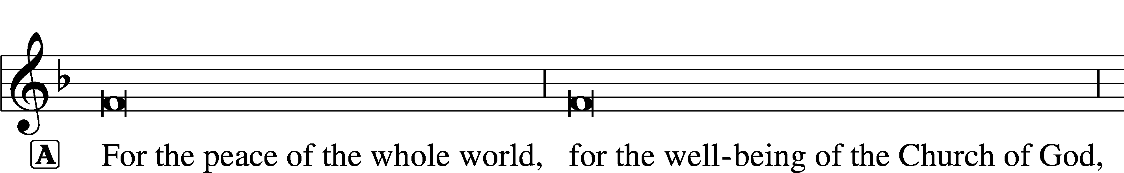



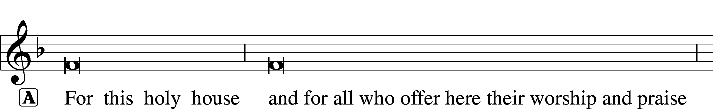






Gloria in Excelsis LSB 154

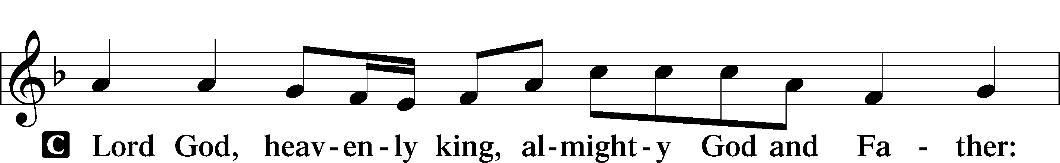

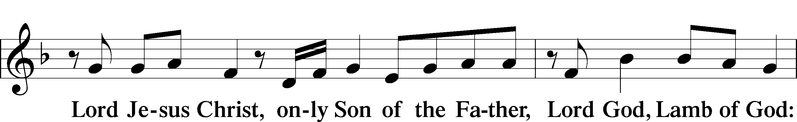
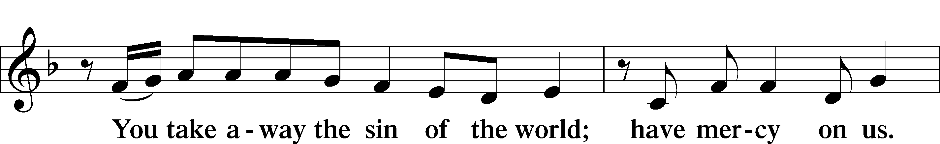
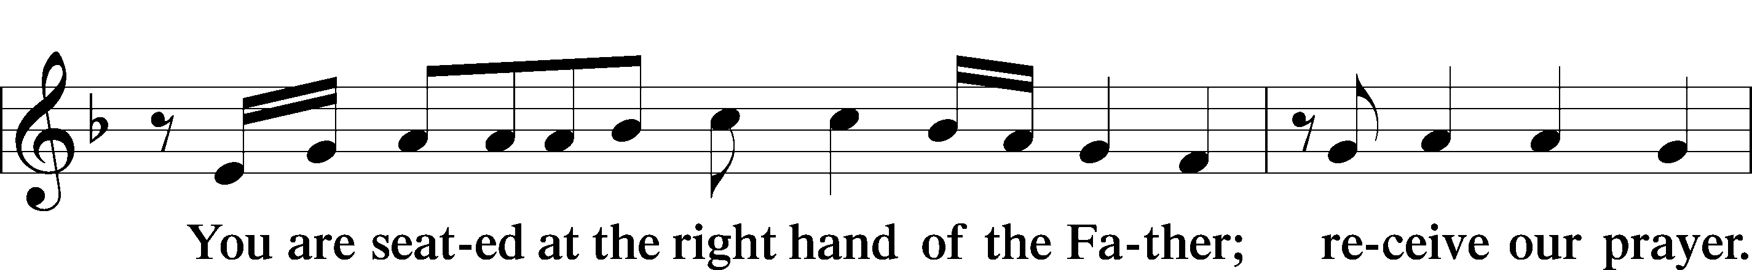
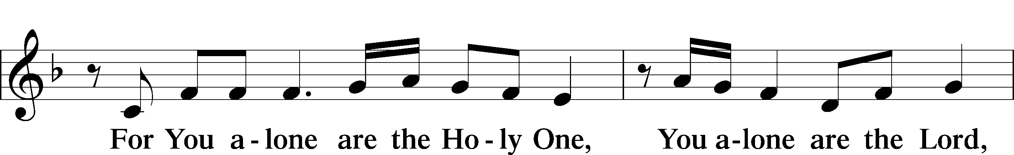
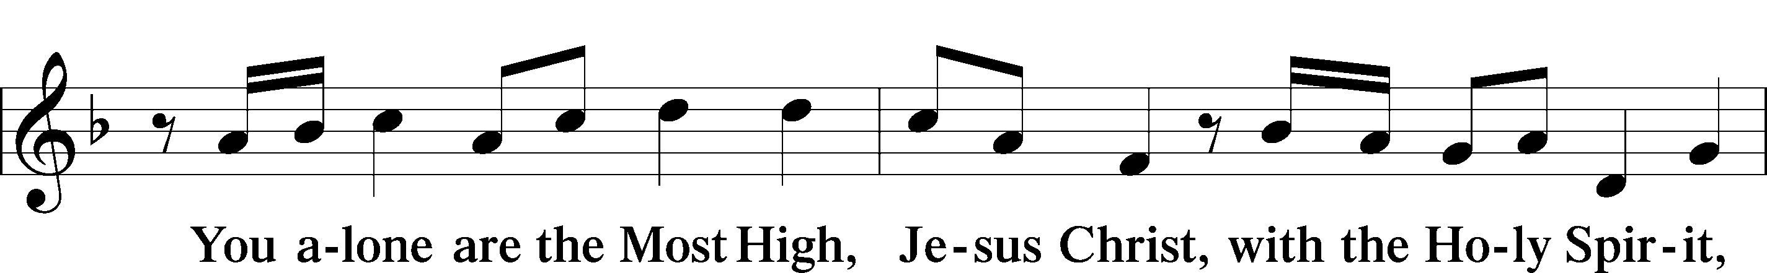
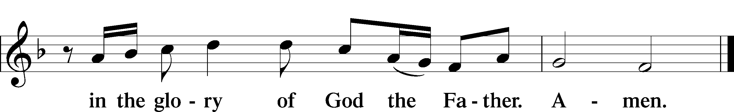

Salutation and Collect of the Day
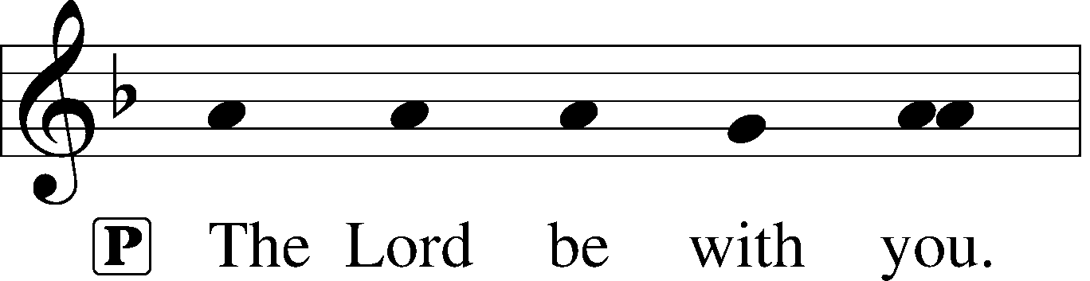
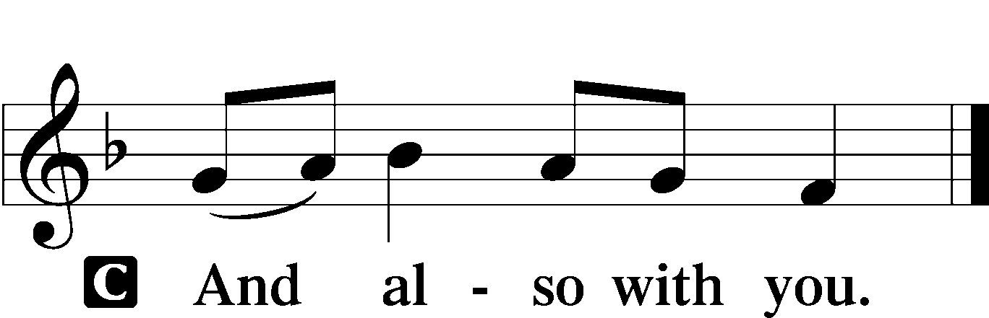

P Let us pray.
Almighty God, You show mercy to Your people in all their troubles. Grant us always to recognize Your goodness, give thanks for Your compassion, and praise Your holy name; through Jesus Christ, Your Son, our Lord, who lives and reigns with You and the Holy Spirit, one God, now and forever.

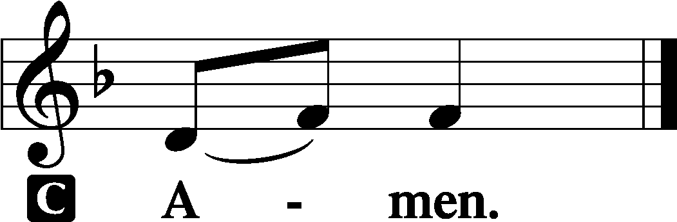

Sit

Old Testament Reading - Naomi and Ruth Ruth 1:1–19a

1In the days when the judges ruled there was a famine in the land, and a man of Bethlehem in Judah went to sojourn in the country of Moab, he and his wife and his two sons. 2The name of the man was Elimelech and the name of his wife Naomi, and the names of his two sons were Mahlon and Chilion. They were Ephrathites from Bethlehem in Judah. They went into the country of Moab and remained there. 3But Elimelech, the husband of Naomi, died, and she was left with her two sons. 4These took Moabite wives; the name of the one was Orpah and the name of the other Ruth. They lived there about ten years, 5and both Mahlon and Chilion died, so that the woman was left without her two sons and her husband.
6Then she arose with her daughters-in-law to return from the country of Moab, for she had heard in the fields of Moab that the Lord had visited his people and given them food. 7So she set out from the place where she was with her two daughters-in-law, and they went on the way to return to the land of Judah. 8But Naomi said to her two daughters-in-law, “Go, return each of you to her mother’s house. May the Lord deal kindly with you, as you have dealt with the dead and with me. 9The Lord grant that you may find rest, each of you in the house of her husband!” Then she kissed them, and they lifted up their voices and wept. 10And they said to her, “No, we will return with you to your people.” 11But Naomi said, “Turn back, my daughters; why will you go with me? Have I yet sons in my womb that they may become your husbands? 12Turn back, my daughters; go your way, for I am too old to have a husband. If I should say I have hope, even if I should have a husband this night and should bear sons, 13would you therefore wait till they were grown? Would you therefore refrain from marrying? No, my daughters, for it is exceedingly bitter to me for your sake that the hand of the Lord has gone out against me.” 14Then they lifted up their voices and wept again. And Orpah kissed her mother-in-law, but Ruth clung to her.
15And she said, “See, your sister-in-law has gone back to her people and to her gods; return after your sister-in-law.” 16But Ruth said, “Do not urge me to leave you or to return from following you. For where you go I will go, and where you lodge I will lodge. Your people shall be my people, and your God my God. 17Where you die I will die, and there will I be buried. May the Lord do so to me and more also if anything but death parts me from you.” 18And when Naomi saw that she was determined to go with her, she said no more.
19So the two of them went on until they came to Bethlehem.

A This is the Word of the Lord.
C Thanks be to God.

Psalm Psalm 111; antiphon: v. 10
“I will give thanks to the Lord with my whole heart.”
1Praise the Lord!
I will give thanks to the Lord with my | whole heart,*
in the company of the upright, in the congre- | gation.
2Great are the works | of the Lord,*
studied by all who de- | light in them.
3Full of splendor and majesty | is his work,*
and his righteousness endures for- | ever.
4He has caused his wondrous works to be re- | membered;*
the Lord is gracious and | merciful.
5He provides food for those who | fear him;*
he remembers his covenant for- | ever.
6He has shown his people the power | of his works,*
in giving them the inheritance of the | nations.
7The works of his hands are faith- | ful and just;*
all his precepts are | trustworthy;
8they are established forever and | ever,*
to be performed with faithfulness and up- | rightness.
9He sent redemption to his people;
he has commanded his covenant for- | ever.*
Holy and awesome | is his name!
10The fear of the Lord is the beginning of wisdom;
all those who practice it have a good under- | standing.*
His praise endures for- | ever!
Epistle “If we have died with Him, w will also live with Him.” 2 Timothy 2:1–13

1You then, my child, be strengthened by the grace that is in Christ Jesus, 2and what you have heard from me in the presence of many witnesses entrust to faithful men who will be able to teach others also. 3Share in suffering as a good soldier of Christ Jesus. 4No soldier gets entangled in civilian pursuits, since his aim is to please the one who enlisted him. 5An athlete is not crowned unless he competes according to the rules. 6It is the hard-working farmer who ought to have the first share of the crops. 7Think over what I say, for the Lord will give you understanding in everything.
8Remember Jesus Christ, risen from the dead, the offspring of David, as preached in my gospel, 9for which I am suffering, bound with chains as a criminal. But the word of God is not bound! 10Therefore I endure everything for the sake of the elect, that they also may obtain the salvation that is in Christ Jesus with eternal glory. 11The saying is trustworthy, for:
If we have died with him, we will also live with him;
12if we endure, we will also reign with him;
if we deny him, he also will deny us;
13if we are faithless, he remains faithful—
for he cannot deny himself.

A This is the Word of the Lord.
C Thanks be to God.

Stand

Alleluia and Verse LSB 156

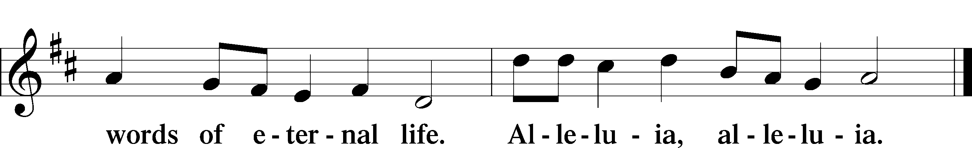

Holy Gospel Healing of the ten lepers Luke 17:11–19

P The Holy Gospel according to St. Luke, the seventeenth chapter.
C Glory to You, O Lord.

11On the way to Jerusalem [Jesus] was passing along between Samaria and Galilee. 12And as he entered a village, he was met by ten lepers, who stood at a distance 13and lifted up their voices, saying, “Jesus, Master, have mercy on us.” 14When he saw them he said to them, “Go and show yourselves to the priests.” And as they went they were cleansed. 15Then one of them, when he saw that he was healed, turned back, praising God with a loud voice; 16and he fell on his face at Jesus’ feet, giving him thanks. Now he was a Samaritan. 17Then Jesus answered, “Were not ten cleansed? Where are the nine? 18Was no one found to return and give praise to God except this foreigner?” 19And he said to him, “Rise and go your way; your faith has made you well.”

P This is the Gospel of the Lord.
C Praise to You, O Christ.

Sit
LWML Presentation


685 Let Us Ever Walk with Jesus
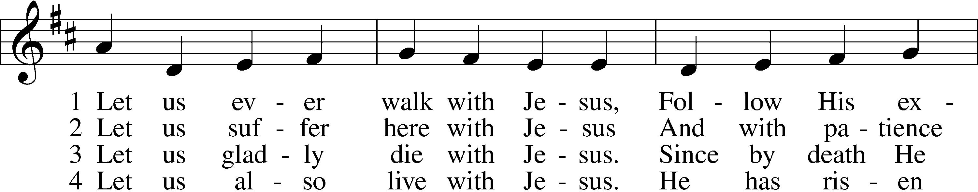
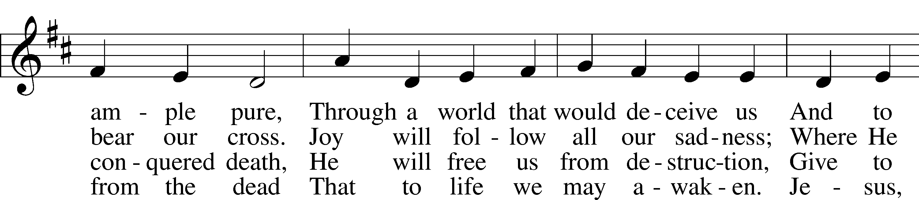
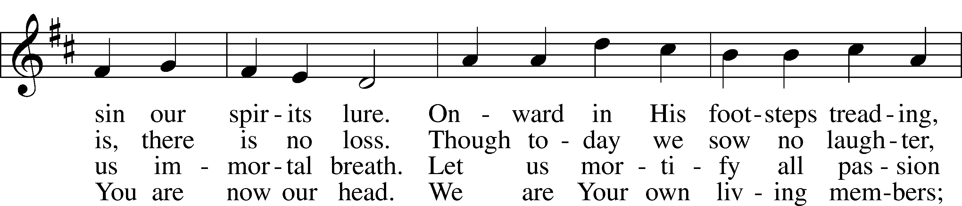
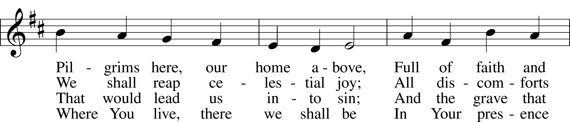
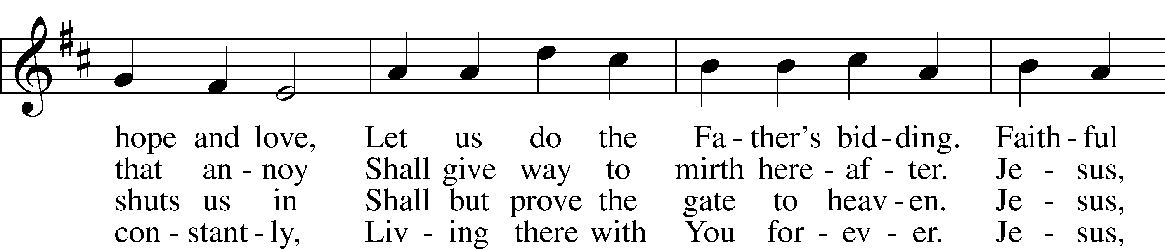
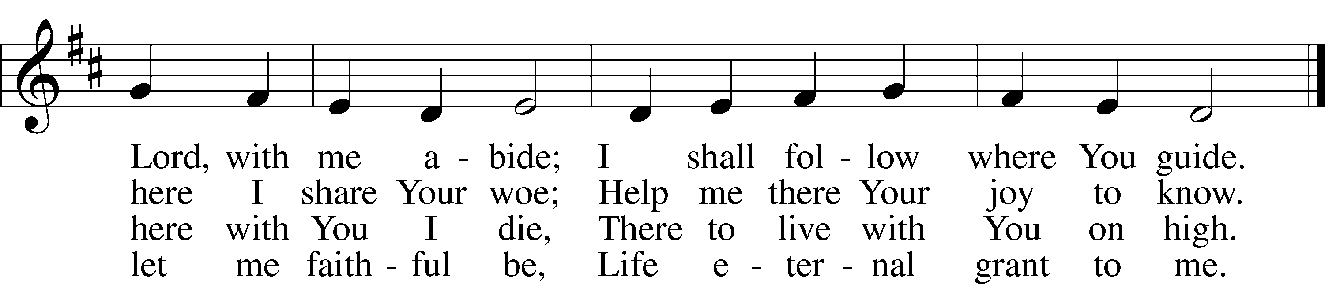
Text: Sigismund von Birken, 1626–81; tr. Lutheran Book of Worship, 1978, alt. Tune: Georg G. Boltze, 18th cent.
Text: © 1978 Lutheran Book of Worship. Used by permission: LSB Hymn License no. 110003995 Tune: Public domain

Sermon

Stand

Nicene Creed
C I believe in one God, the Father Almighty,
maker of heaven and earth and of all things visible and invisible.

And in one Lord Jesus Christ, the only-begotten Son of God,
begotten of His Father before all worlds,
God of God, Light of Light, very God of very God,
begotten, not made, being of one substance with the Father,
by whom all things were made;
who for us men and for our salvation came down from heaven
and was incarnate by the Holy Spirit of the virgin Mary
and was made man;
and was crucified also for us under Pontius Pilate.
He suffered and was buried. And the third day He rose
again according to the Scriptures and ascended into heaven
and sits at the right hand of the Father.
And He will come again with glory to judge both the living and
the dead, whose kingdom will have no end.

And I believe in the Holy Spirit, the Lord and giver of life,
who proceeds from the Father and the Son,
who with the Father and the Son together is worshiped
and glorified, who spoke by the prophets.
And I believe in one holy Christian and apostolic Church,
I acknowledge one Baptism for the remission of sins,
and I look for the resurrection of the dead
and the life T of the world to come. Amen.

Prayer of the Church & Sharing of the Peace

Following the prayers, the people may greet one another in the name of the Lord, saying,
“Peace be with you,” as a sign of reconciliation and of the unity of the Spirit in the bond of peace
(Matt. 5:22–24; Eph. 4:1–3).
Sit
Offering & Offertory LSB 159

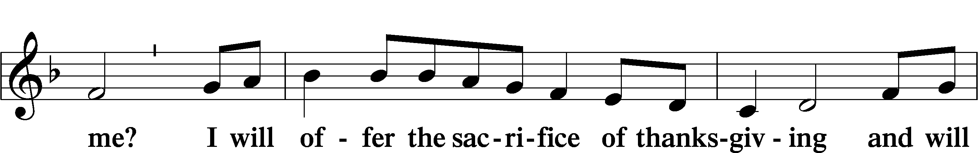
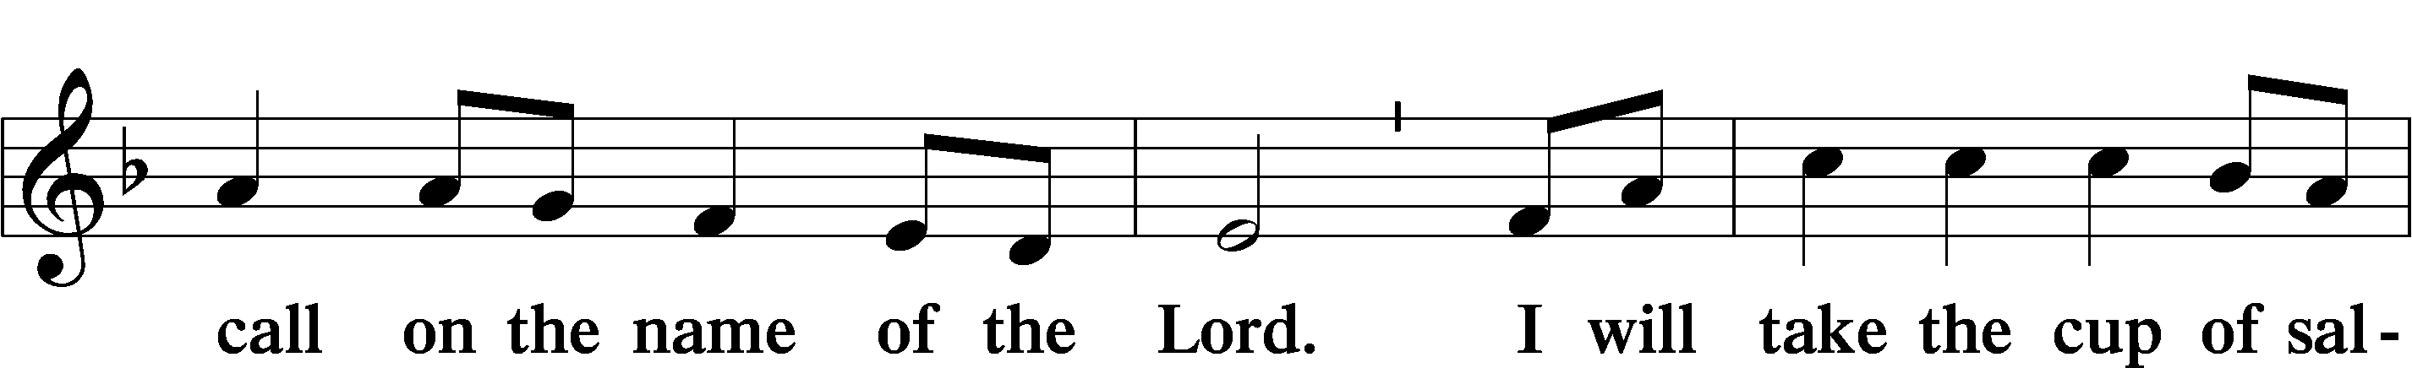
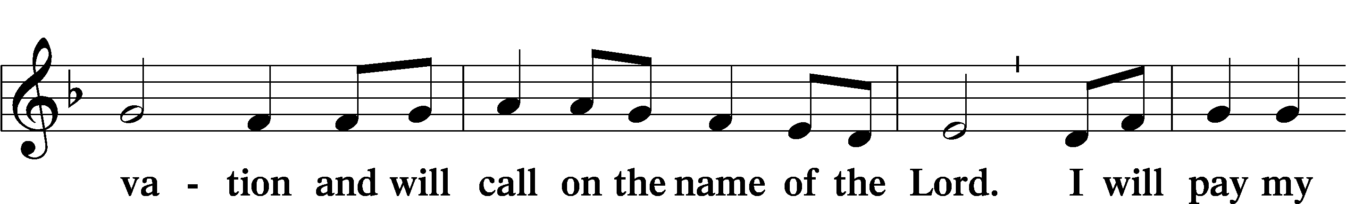
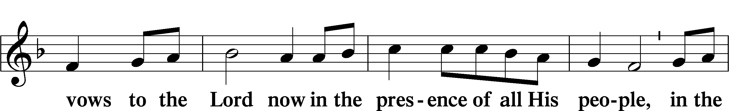
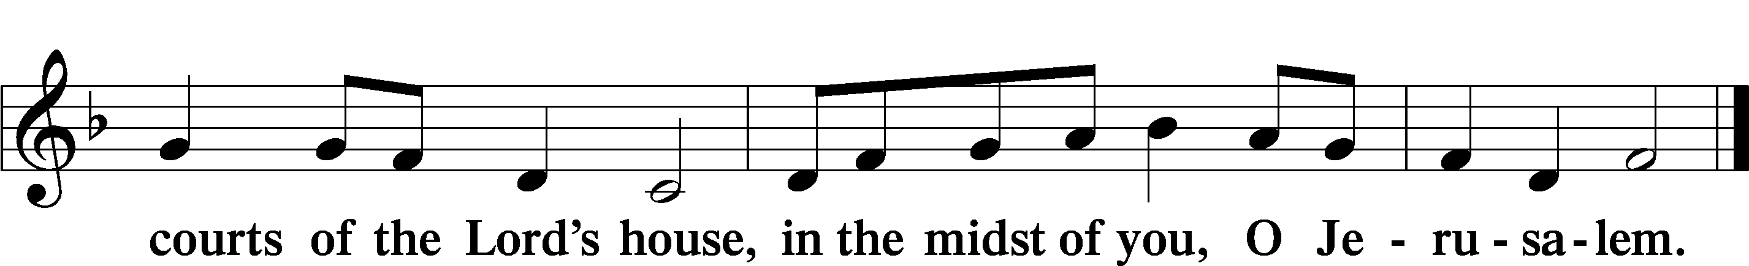

Service of Holy Communion
Communion Statement

The Lord’s Supper is celebrated at this congregation in the confession and glad confidence that, as He says, our Lord gives into our mouths not only bread and wine but His very body and blood to eat and to drink for the forgiveness of sins and to strengthen our union with Him and with one another. Our Lord invites to His table those who trust His words, repent of all sin, and set aside any refusal to forgive and love as He forgives and loves us, that they may show forth His death until He comes.

Because those who eat and drink our Lord’s body and blood unworthily do so to their great harm and because Holy Communion is a confession of the faith which is confessed at this altar, any who are not yet instructed, in doubt, or who hold a confession differing from that of this congregation and the Lutheran Church Missouri Synod, and yet desire to receive this sacrament, are asked to speak with the Pastor.
* See more about the Lutheran teaching on communion in the Hymnal p 329.
Stand

Preface LSB 160





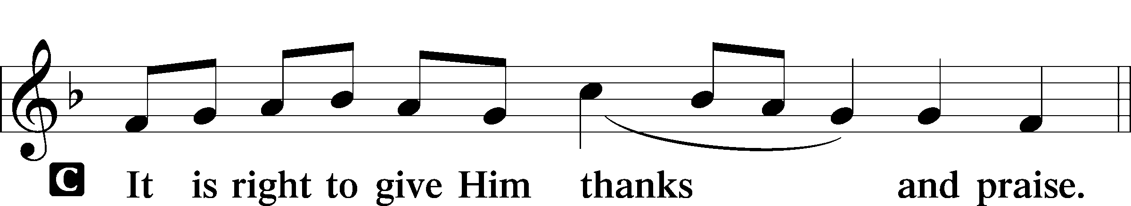
P It is truly good, right, and salutary that we should at all times and in all places give thanks to You, holy Lord, almighty Father, everlasting God, through Jesus Christ, our Lord, who, having created all things, took on human flesh and was born of the virgin Mary. For our sake He died on the cross and rose from the dead to put an end to death, thus fulfilling Your will and gaining for You a holy people. Therefore with angels and archangels and with all the company of heaven we laud and magnify Your glorious name, evermore praising You and saying:

Sanctus LSB 161
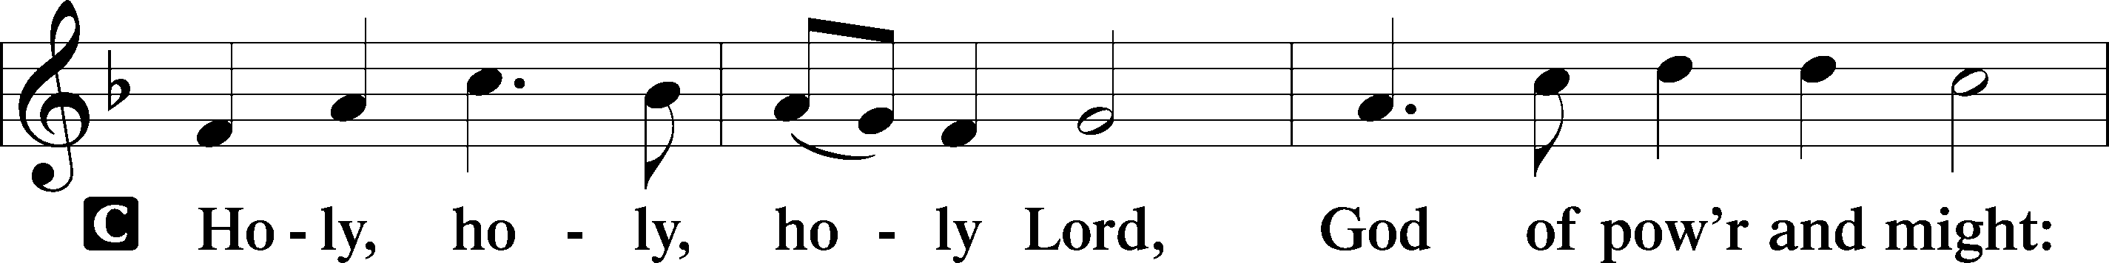
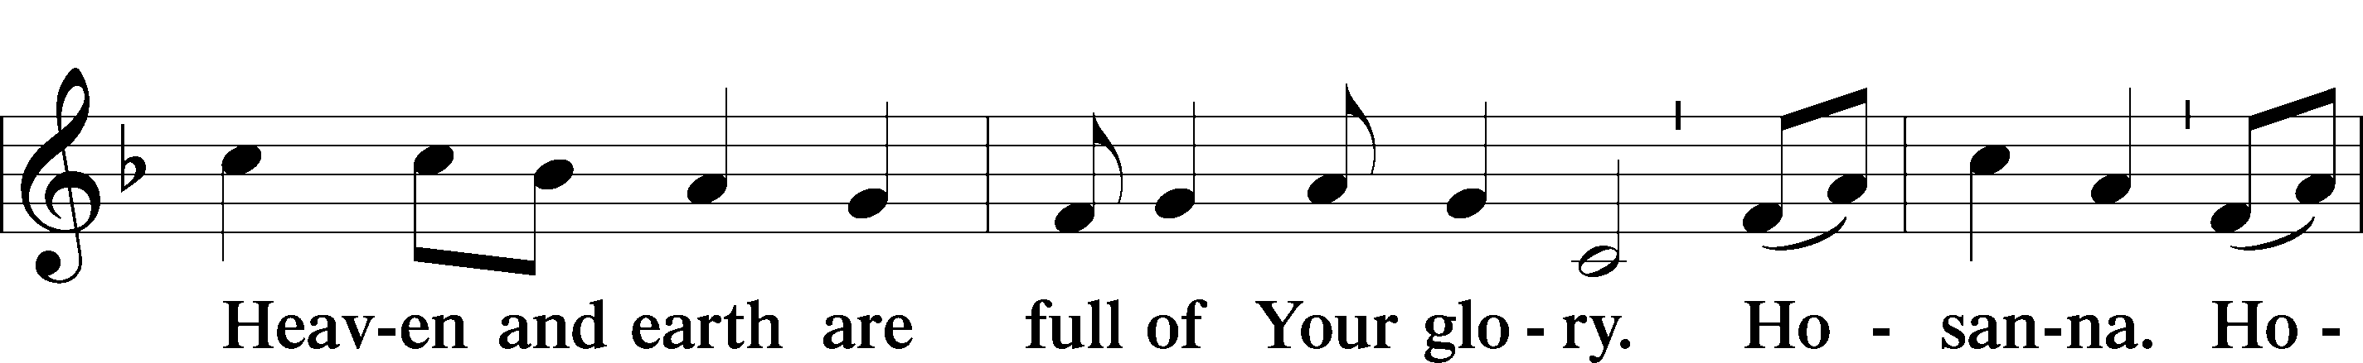
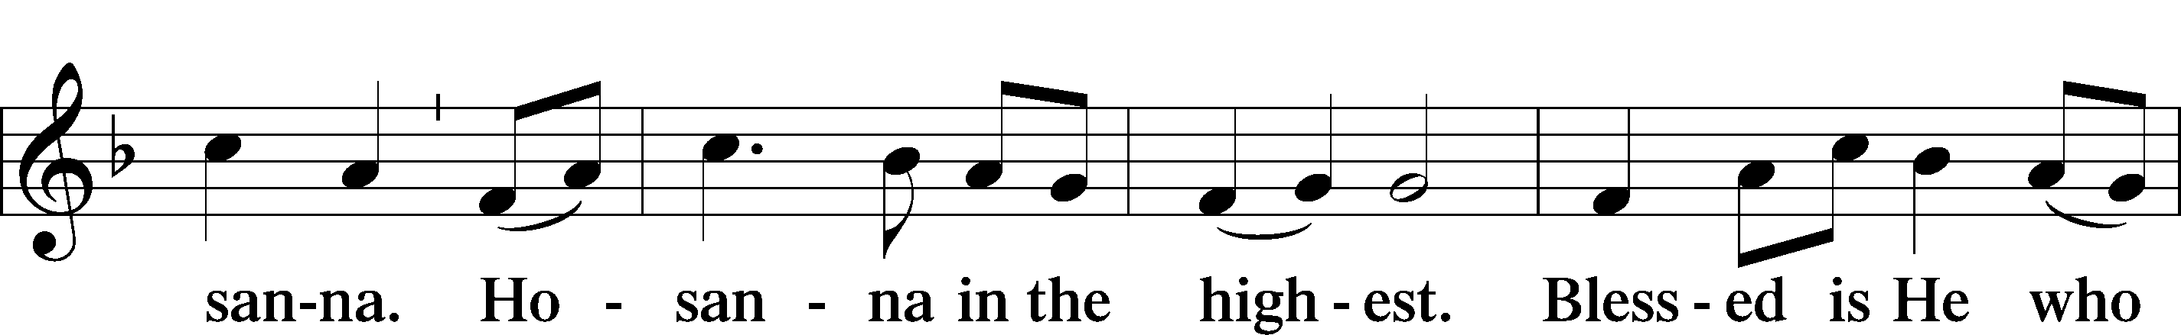
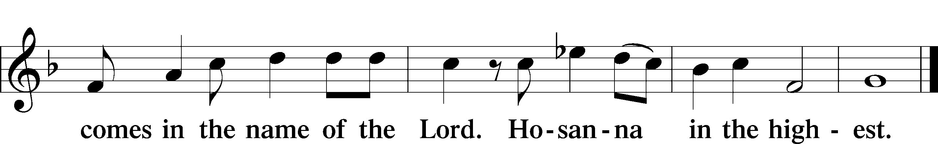

Prayer of Thanksgiving LSB 161

P Blessed are You, Lord of heaven and earth, for You have had mercy on those whom You created and sent Your only-begotten Son into our flesh to bear our sin and be our Savior. With repentant joy we receive the salvation accomplished for us by the all-availing sacrifice of His body and His blood on the cross.

Gathered in the name and the remembrance of Jesus, we beg You, O Lord, to forgive, renew, and strengthen us with Your Word and Spirit. Grant us faithfully to eat His body and drink His blood as He bids us do in His own testament. Gather us together, we pray, from the ends of the earth to celebrate with all the faithful the marriage feast of the Lamb in His kingdom, which has no end. Graciously receive our prayers; deliver and preserve us. To You alone, O Father, be all glory, honor, and worship, with the Son and the Holy Spirit, one God, now and forever.
C Amen.

The Words of Our Lord
P Our Lord Jesus Christ, on the night when He was betrayed, took bread, and when He had given thanks, He broke it and gave it to the disciples and said: “Take, eat; this is My T body, which is given for you. This do in remembrance of Me.”

In the same way also He took the cup after supper, and when He had given thanks, He gave it to them, saying: “Drink of it, all of you; this cup is the new testament in My T blood, which is shed for you for the forgiveness of sins. This do, as often as you drink it, in remembrance of Me.”

P As often as we eat this bread and drink this cup, we proclaim the Lord’s death until He comes.
C Amen. Come, Lord Jesus.

P O Lord Jesus Christ, only Son of the Father, in giving us Your body and blood to eat and to drink, You lead us to remember and confess Your holy cross and passion, Your blessed death, Your rest in the tomb, Your resurrection from the dead, Your ascension into heaven, and Your coming for the final judgment. So remember us in Your kingdom and teach us to pray:

Lord’s Prayer
C Our Father who art in heaven, hallowed be Thy name,
Thy kingdom come, Thy will be done on earth as it is in heaven;
give us this day our daily bread;
and forgive us our trespasses as we forgive those
who trespass against us; and lead us not into temptation,
but deliver us from evil.
For Thine is the kingdom and the power and the glory
forever and ever. Amen.

Pax Domini LSB 163
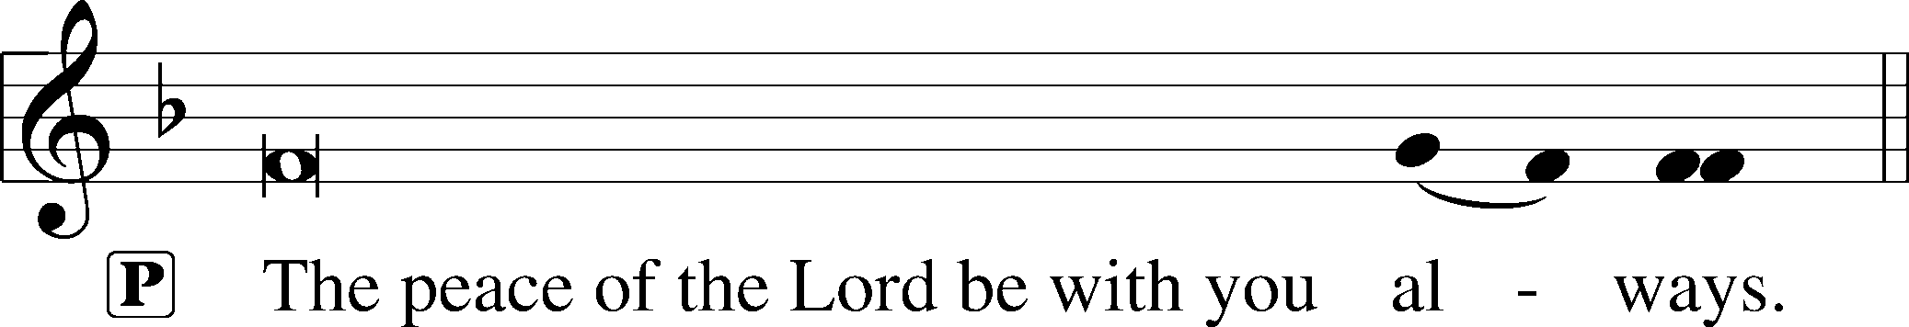


Agnus Dei (Spoken)

The pastor elevates the chalice and host and says:

P Behold, the Lamb of God that takes away the sins of the world.
C Lord, have mercy upon us.

Agnus Dei LSB 163
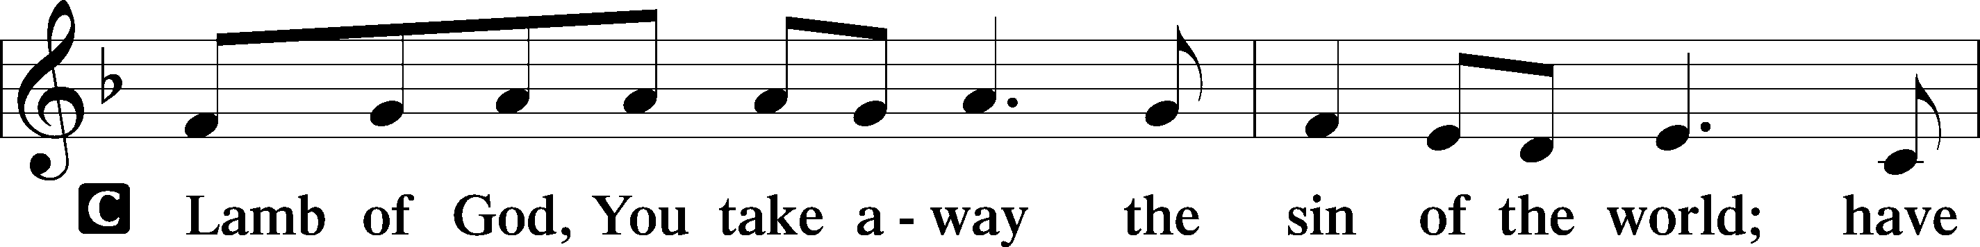
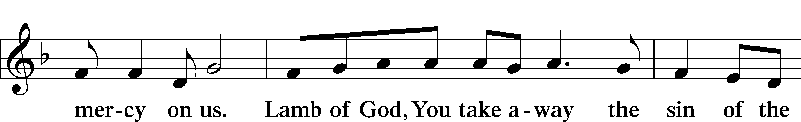

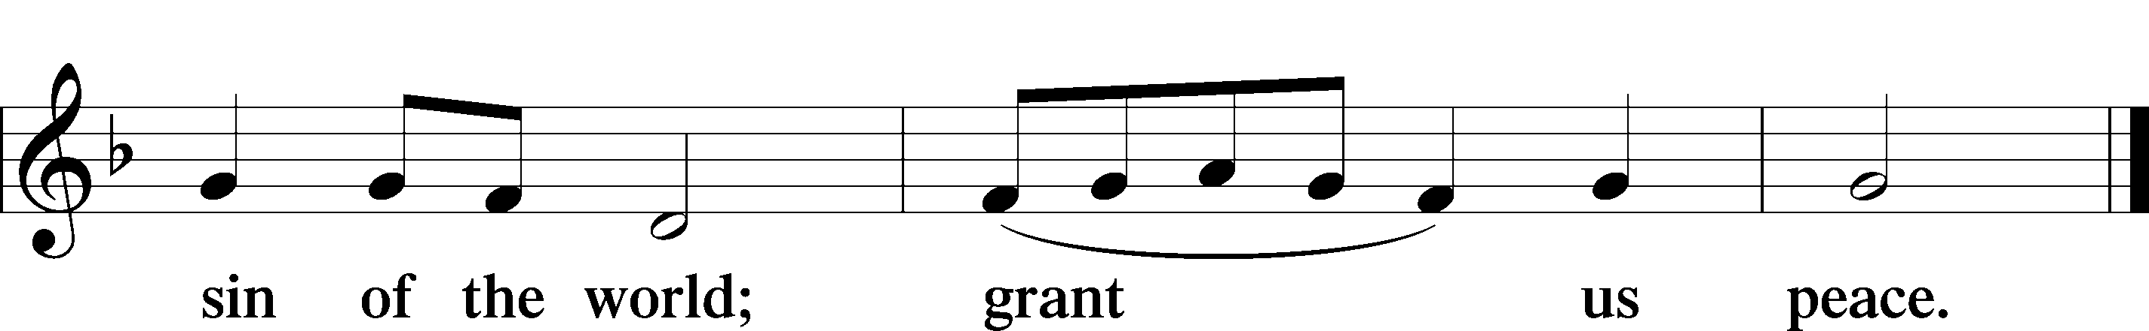

Sit

Distribution

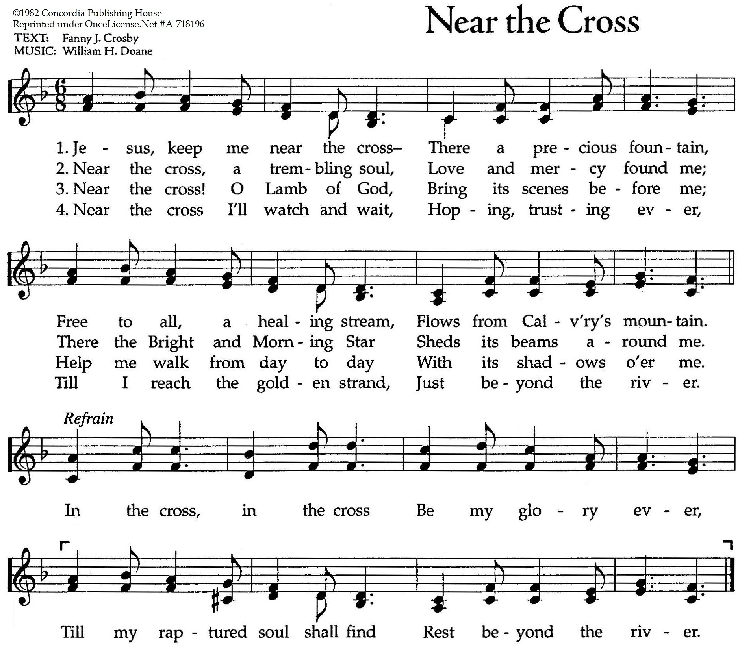

Stand

Thank the Lord LSB 164
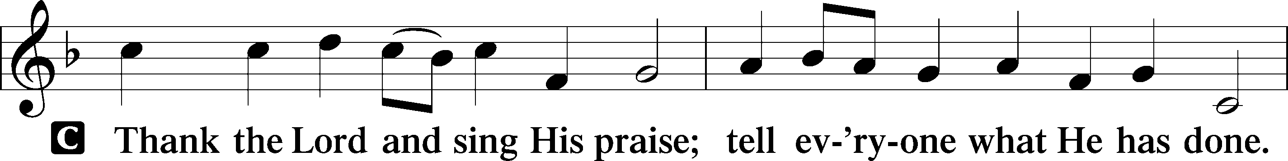
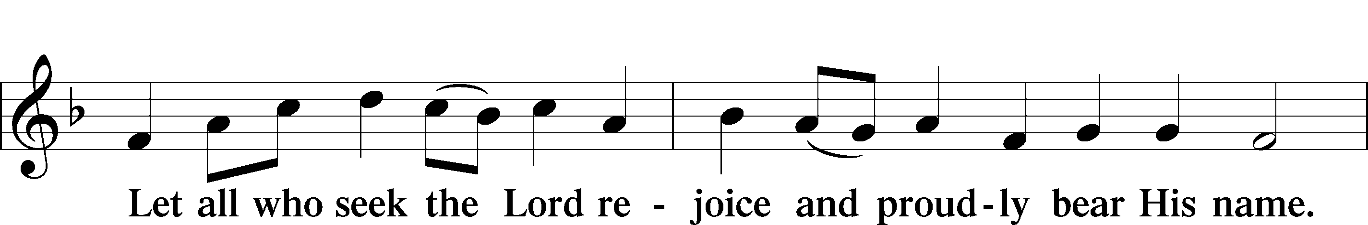
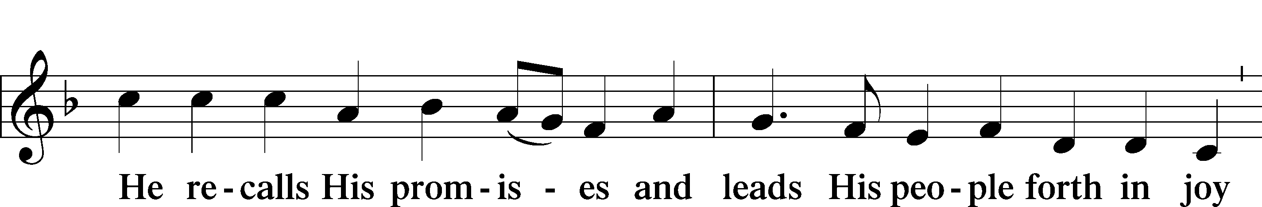
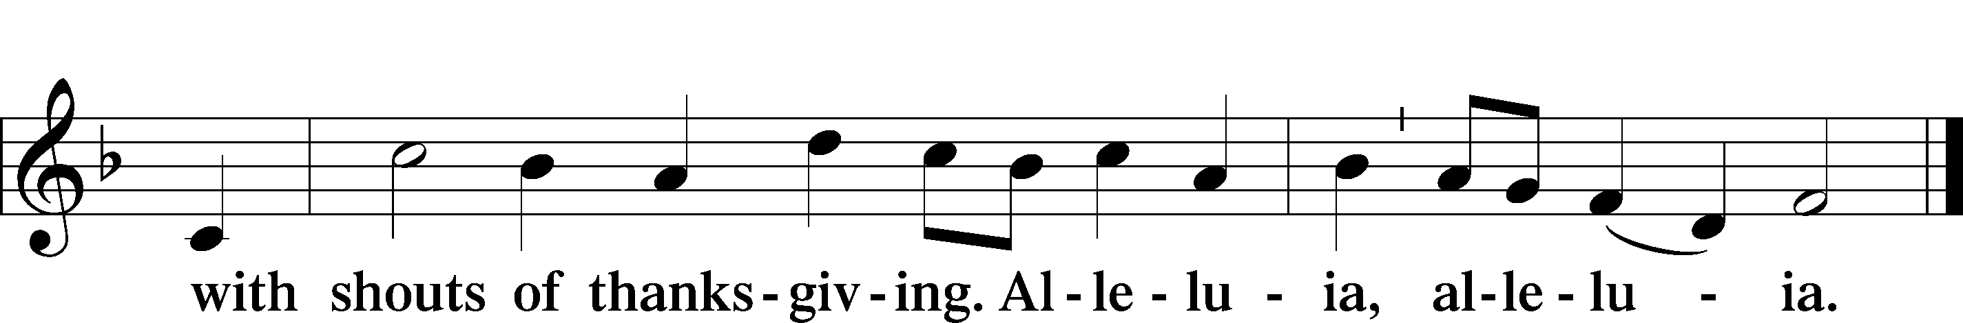

Post-Communion Collect
A Let us pray.
We give thanks to You, almighty God, that You have refreshed us through this salutary gift, and we implore You that of Your mercy You would strengthen us through the same in faith toward You and in fervent love toward one another; through Jesus Christ, Your Son, our Lord, who lives and reigns with You and the Holy Spirit, one God, now and forever.
C Amen.

Verse of the Day Luke 5:15

P Alleluia! Now even more the report about him went abroad,
C and great crowds gathered to hear him and to be healed of their infirmities. Alleluia!

Benediction LSB 166
P The Lord bless you and keep you.
The Lord make His face shine on you and be gracious to you.
The Lord look upon you with favor and T give you peace.


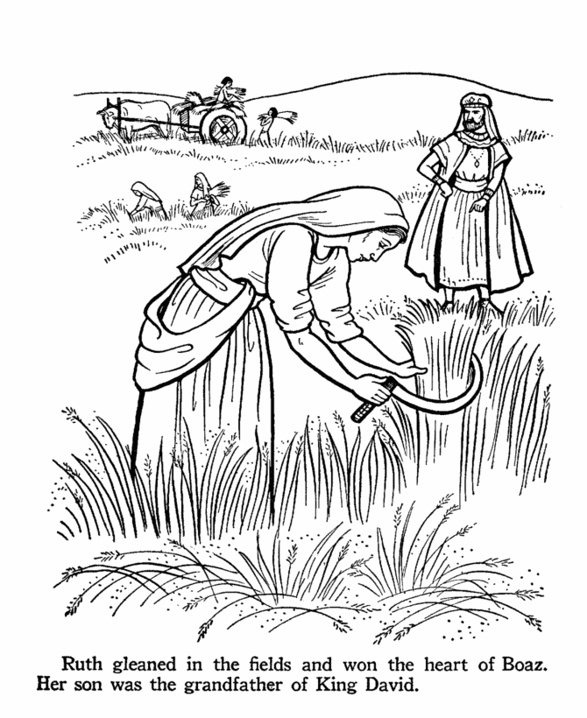
924 Lord, Dismiss Us with Your Blessing
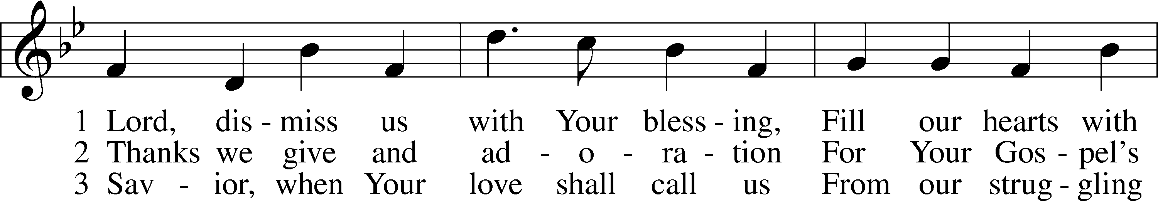
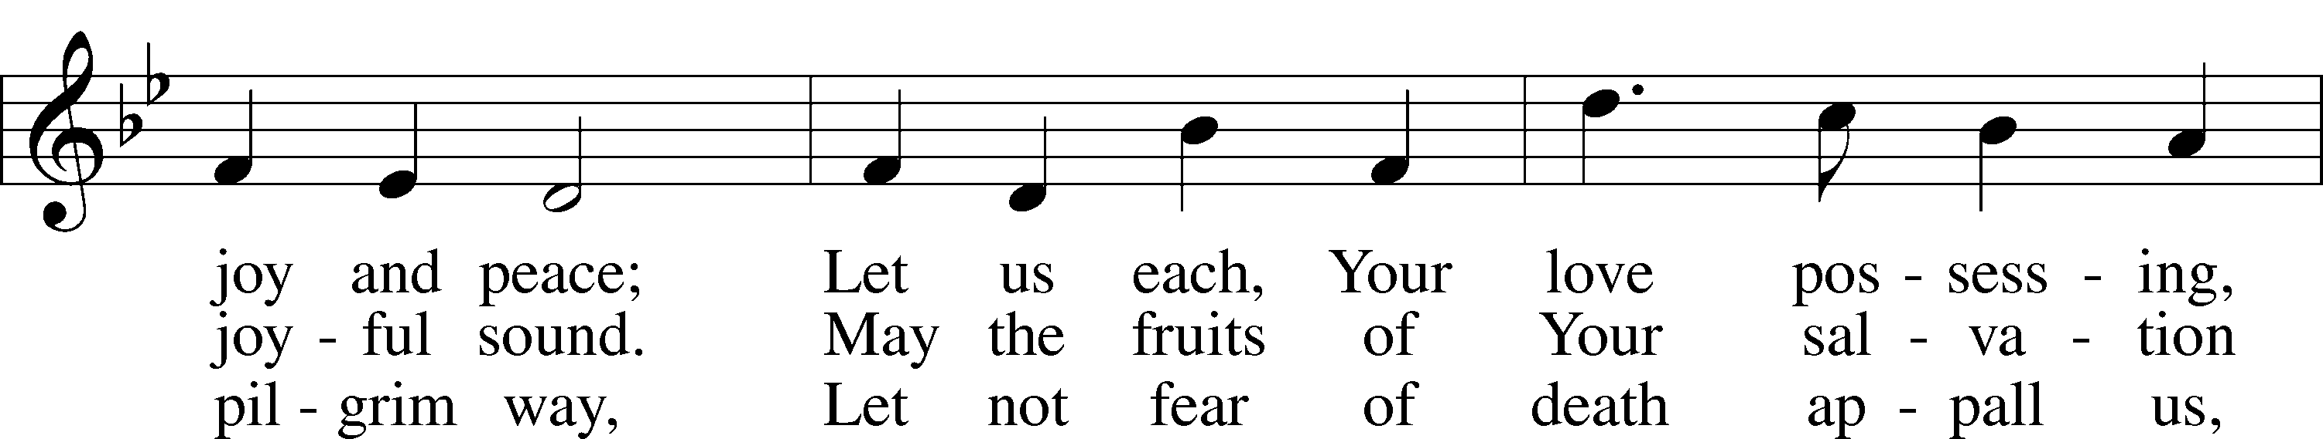
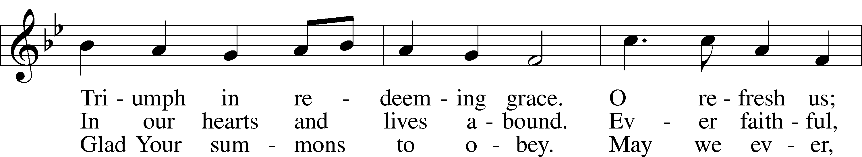
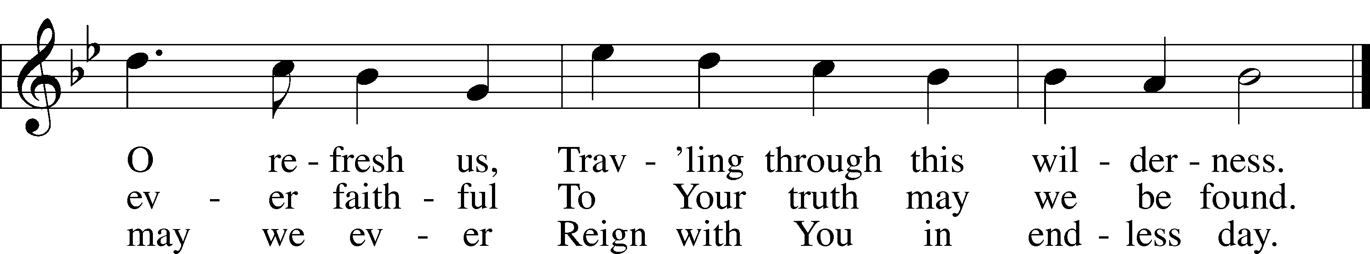
Text (sts. 1–2): attr. John Fawcett, 1740–1817, alt.; (st. 3): Godfrey Thring, 1823–1903, alt.
Tune: Henry T. Smart, 1813–79
Text and tune: Public domain

Acknowledgments
Divine Service, Setting One from Lutheran Service Book
Unless otherwise indicated, Scripture quotations are from the ESV® Bible (The Holy Bible, English Standard Version®), copyright © 2001 by Crossway, a publishing ministry of Good News Publishers. Used by permission. All rights reserved.
Created by Lutheran Service Builder © 2025 Concordia Publishing House.

Prayers of the Church
This week, we lift up:

Angela H, Bob C, Mike Y, Sheila, Elaine, Angie Z, Angela C, Ross, & Kathy H.

Family of the week: Rev Don & Kathy Neidigk

*If you have any prayer request let us know.

Last week: Attendance 35 Offering $1799

Serving Next Week (10/19/25)  Service Leader: Vicar Previn Hudetz  Communion Celebrant: Rev John Heffelfinger  Communion Assistant: Jim C  Worship Assistant: Charlie M  Reader: Samantha T  Refreshments: Tania  Altar Guild: Angie Z & Sheila S  Greeter: Juanita | Readings Next Week  Ninteenth Sunday after Pentecost  - Genesis 32.22-30  - Psalm 121  - 2 Timothy 3:14 - 4:55  - Luke 18:1-8  *Please sign up to help during service.*
Announcements  Birthdays:  This Week at OSLC:  Bible Study: After Service  Bible Study: Thursday 10am | Coming Up:  - Wear RED for Reformation Sunday on 10/28/25  - All Saints Sunday 11/2/2025

Stewardship Thoughts…

Luke 14:11 – “For everyone who exalts himself will be humbled, and he who humbles himself will be exalted.”

“The fear of the Lord is the beginning of wisdom” (Prov. 9:10). That’s called humility. The Lord is God, and we are not. With that in mind, how could we not seek to follow His Word in all aspects of life? Once we see His love for us in the cross of Christ, how could we not trust Him? He knows what He is talking about, and we don’t. He loves us and wants to bless us. If you believe that, then striking out on a path of faithfulness in the realm of stewardship is a lot easier. It just makes sense.

Lcms.org/stewardship

Seasons of the Church Year

Color: Green • Symbol: Hourglass or Watchful Eye
As we move into the last weeks of Trinitytide, the focus of the Church’s worship turns toward the end of all things. The lectionary readings call us to watchfulness, repentance, and readiness for Christ’s return. Though the paraments remain green, these final Sundays remind us that God is bringing His kingdom to completion and that His people live in hope, awaiting the day when all things are made new.

